Chapter 5: Distribution of health needs in Wales

The aim of this section is to identify health needs within Wales. Thus, available measures are initially explored as raw counts of mortality and morbidity: unstandardised, as each case is an indicator of a health need. However, there is an obvious tendency for areas with high populations to demonstrate high levels of health need, particularly if they contain a relatively high proportion of older people. Hence, some of the datasets have been subsequently standardised according to the age and sex structures of the populations of each area, which enables excessively high, and excessively low, rates of disease to be identified.

In addition to exploring health need using current figures available, it is helpful to look at changes over time and comparisons between areas, using as small an areal unit as is practicable. For these comparisons to be effected, data need to be collected and compiled over consistent areal units. Such units are commonly those designated for administrative purposes in local government and for the NHS. It is a source of some frustration that electoral and health boundaries are far from constant, for example, Local Authority districts and wards have been changed both between the 1981 and 1991 Censuses of Population and subsequent to the 1991 Census. In Wales, substantial changes were made to form the boundaries of the new Unitary Authorities (UAs) which are not direct aggregations of 1991 Census wards.

Mechanisms exist to transform datasets between one set of units and another: for example, to map 1981 Census data using 1991 ward boundaries. However, whenever this occurs there is a loss of accuracy and data quality is compromised, although considerable efforts are made to minimise this. There are two further geographical considerations.

The modifiable areal unit problem arises whenever arbitrary boundaries such as administrative units are employed. Essentially, measures calculated for these areas can change substantially depending upon how the boundaries are constructed (see, for example, the work of Openshaw and Taylor, 1979; Green and Flowerdew, 1996). Adjusting the boundaries can have substantial effects on calculated indicators.

Further, statistical modelling generally assumes that observations are independent. However, it is often the case that processes can be operating at a local scale, with the result that the independence is compromised, ie places which are near to one another are more likely to share similar characteristics than places which are further away, and this can affect the data which are collected. Spatial autocorrelation techniques (Goodchild, 1987) can be used to assess whether this appears to be in evidence.

To supplement the tabulation of results, some data are geographically mapped in this section to facilitate visual exploration. In this way, areas with similar health measures can be seen and geographically close areas with similar rates are more easily identified. The data for the areas are grouped into four or five class intervals and each class is shaded. The darker the shading, the higher the absolute count of cases, or disease rate. Hence, a cluster of areas with dark shading will indicate a geographical concentration of a high occurrence of mortality or morbidity.

Data are available at a variety of spatial scales, generally limited by the requirement that individuals should not be identifiable. The data here are explored at as disaggregated a scale as is feasible. The base level is that of 1991 Census wards (the UA boundaries are superimposed but are not necessarily coterminous). A reasonable expectation would be that the major causes of both mortality and morbidity would follow the distribution of the population at risk. As a guideline, the ward populations for those aged 55 and over are shown as Map 1. Here, the areas of dark green on the map show the relatively high ward populations in Cardiff, Swansea, south Wales and the northern coastal towns. This generally indicates urban areas.

However, different diseases have different geographies, even where the age and sex structures of the wards are similar. An example is the contrast between lung cancer, where high rates will be evident in urban areas with high levels of deprivation, and skin cancers, which are apparent both in rural areas and some more affluent urban areas.

Mortality from heart disease (1998) can be seen in Map 2a (for males) and Map 2b (for females). These maps show the total number of deaths for 1996 to 1998. High values can be seen where they are expected, ie in south Wales and north-east Wales. However, there are comparatively low values for female mortality in Pembrokeshire and Powys. Maps 2c and 2d show data for the same years but these have been standardised by a subset of older age categories to produce comparable rates for the ward population structures. Hence, 100 is the ‘average’ rate over Wales. Clearly the excessive rates, shaded dark green, are more widely dispersed, particularly over south-west Wales and through central areas. The pattern is similar for females showing that, for example, there is no evidence of unusually high rates in Cardiff.

Mortality from respiratory disease (Map 3) follows a broadly similar pattern to heart disease, though more concentrated perhaps due to occupational risk, ie with much lower totals in central Wales.

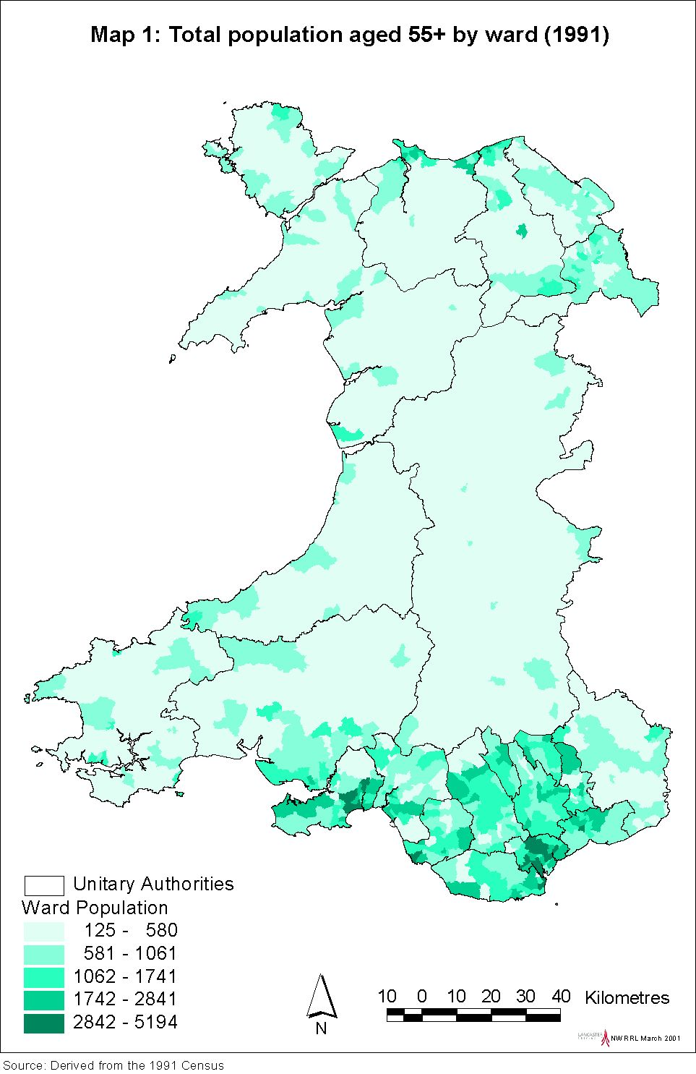
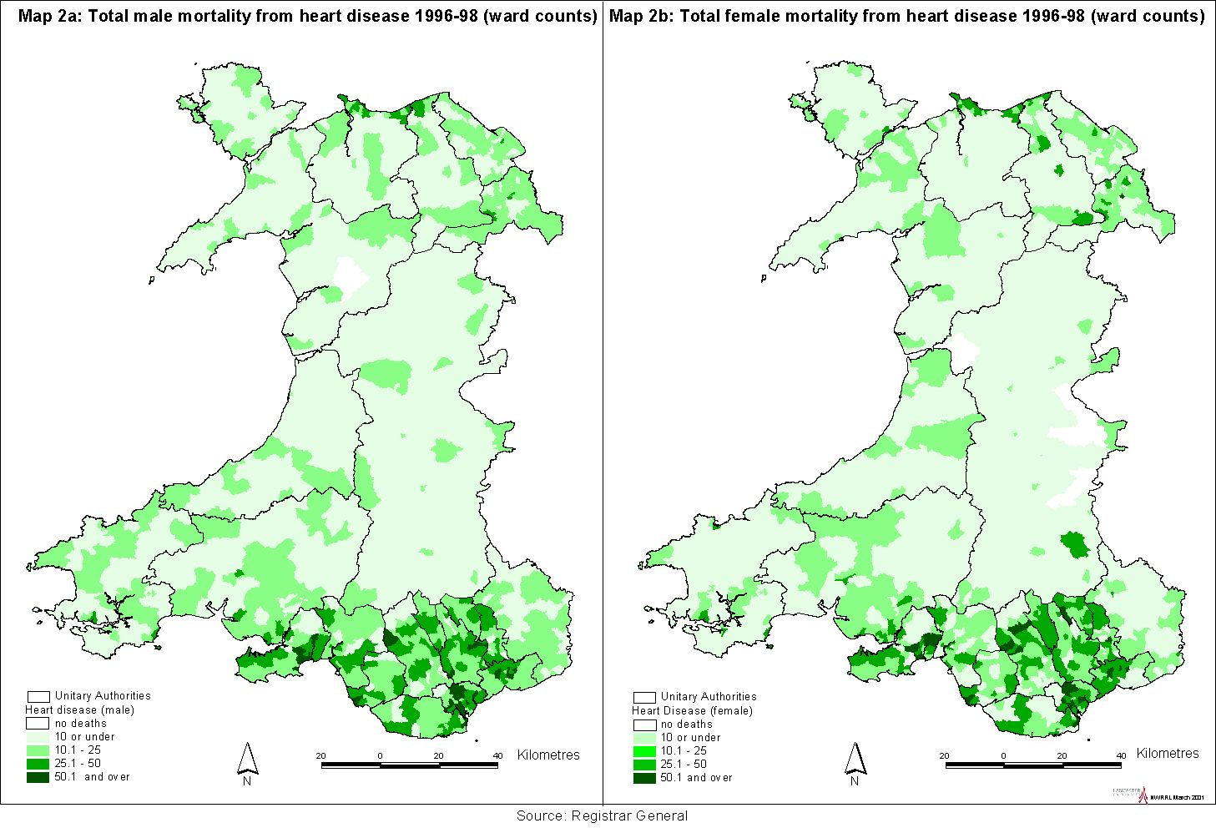
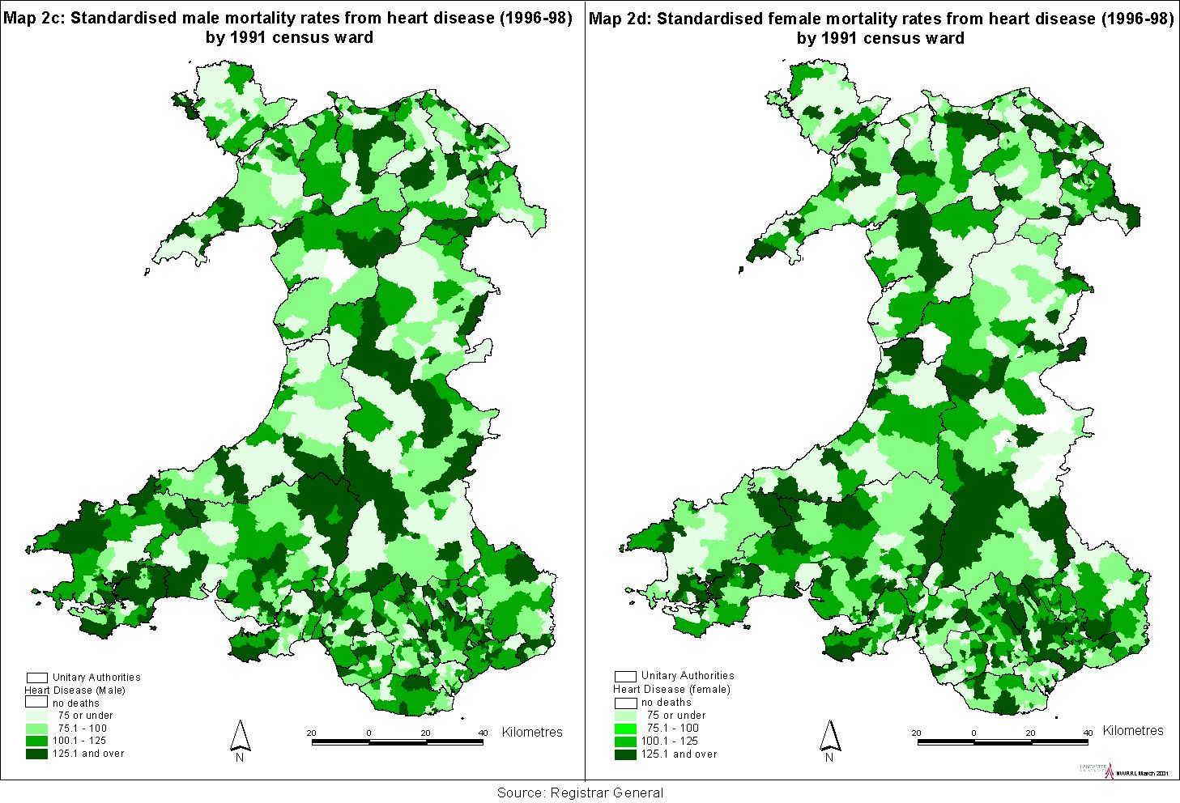
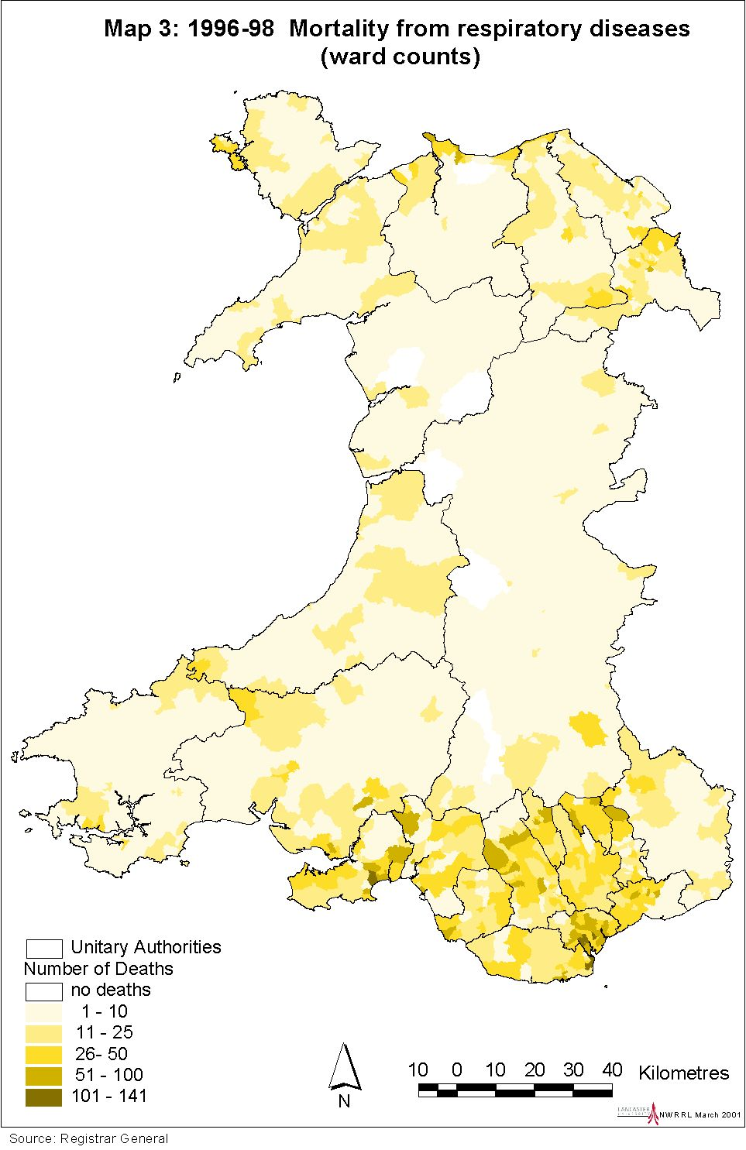
Cancer (within Wales)
As approximately one in three people will develop cancer before the age of 75, it is a major health concern, forming a substantial burden on health services, in addition to those of the sufferers and their families. Across Wales, there are some 20,000 cases per year, resulting in 80,000 hospital admission episodes and 8000 deaths (Welsh Cancer Intelligence and Surveillance Unit). Three aspects of cancer statistics can be explored: mortality, incidence and survival.

Mortality from cancers between 1996 to 1998 are mapped at ward level. Maps 4a and 4b show the total numbers of cancer deaths for males and females, with Maps 4c and 4d showing the standardised rates for comparison, which are again more widely dispersed. The geographical distribution of cancer mortality is not the same as that of cancer incidence. The distributions in Maps 4a and 4b can be compared with Map 5, which shows cancer incidence (total number of registrations) for the four year period from 1994 to 1997. Incidence seems relatively high in Ceredigion and Pembrokeshire and lower in Monmouthshire.

Incidence for the more common sites of cancer have also been mapped. The highest incidence for male lung cancer (Map 6a) is in south and north-east Wales, whereas female lung cancer is more evident in south-east Wales. Male and female incidence of colorectal cancer is more consistent (Maps 7a,7b). Female breast cancer is more dispersed than either lung or colorectal cancer, notably in Carmarthenshire and Ceredigion. Map 8a shows total incidence, whereas Map 8b illustrates the standardised rates.

Table 5.1 indicates the most recent survival figures available for specific cancers by Health Authority. North Wales and Morgannwg would seem to have rather better five year survival rates than the other authorities.

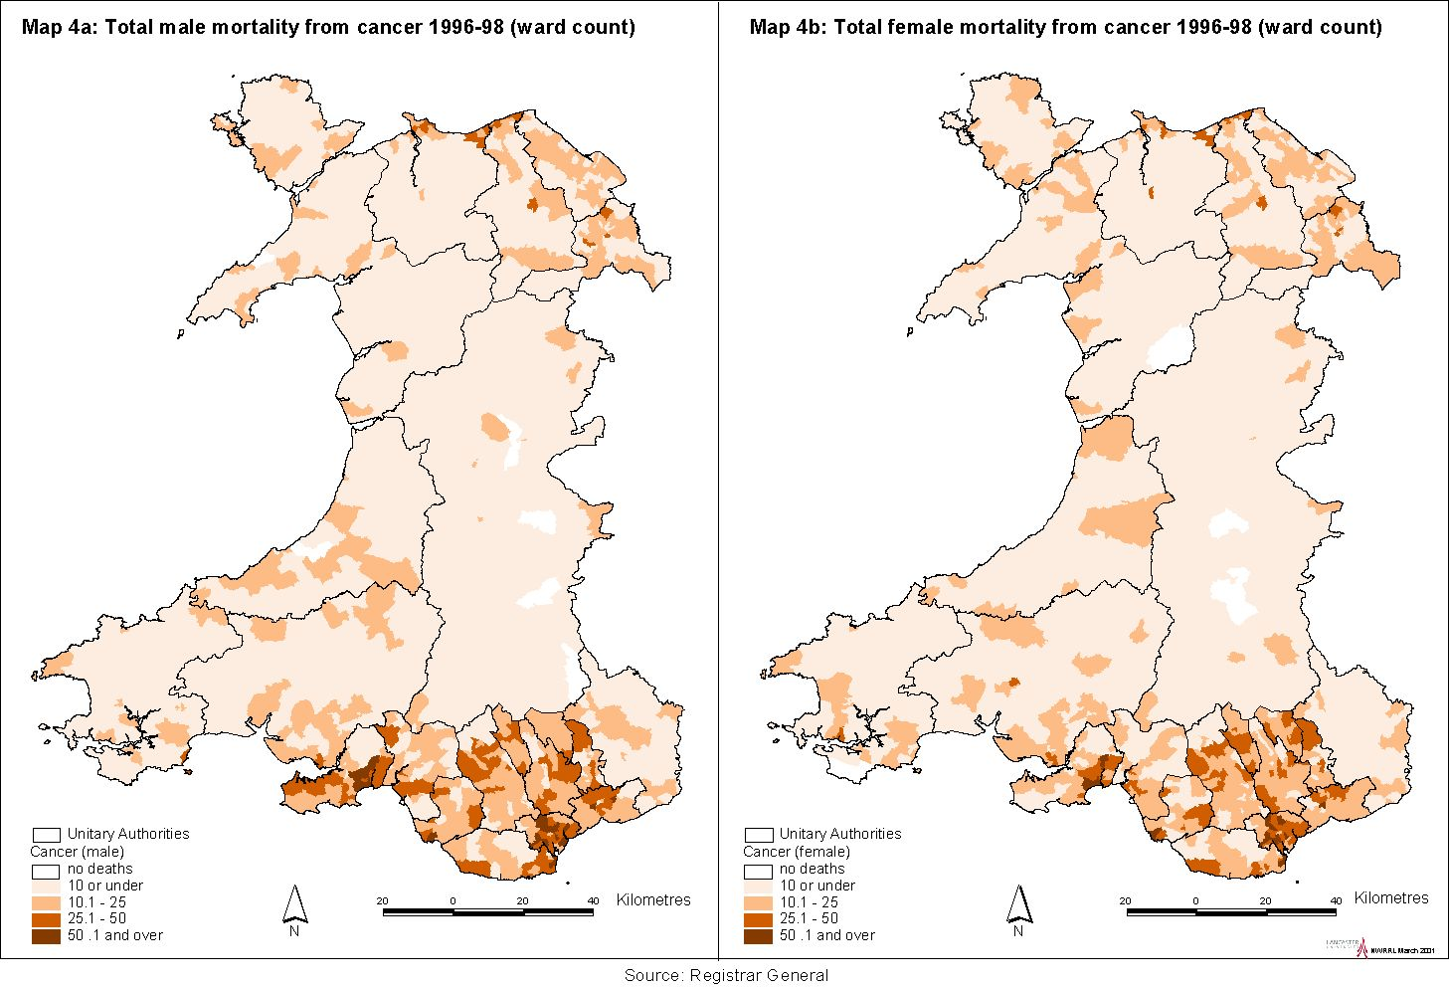

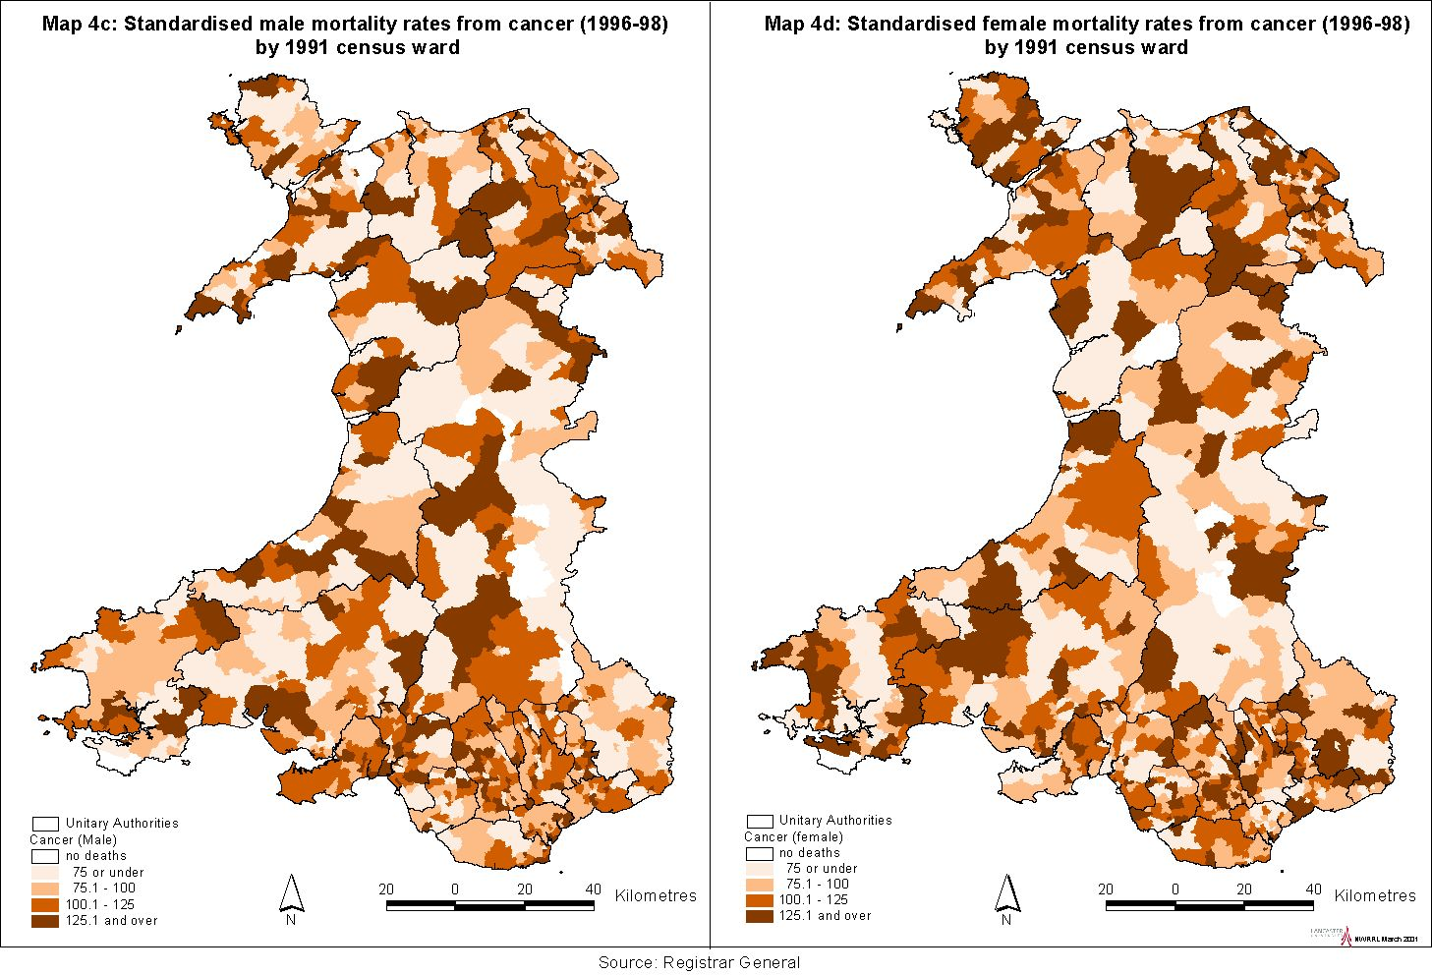

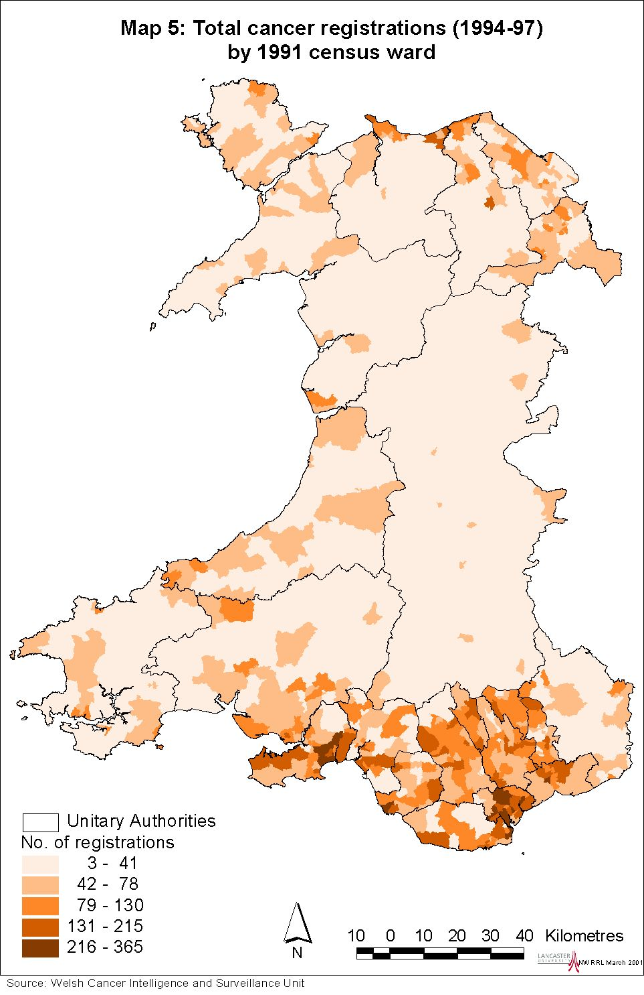

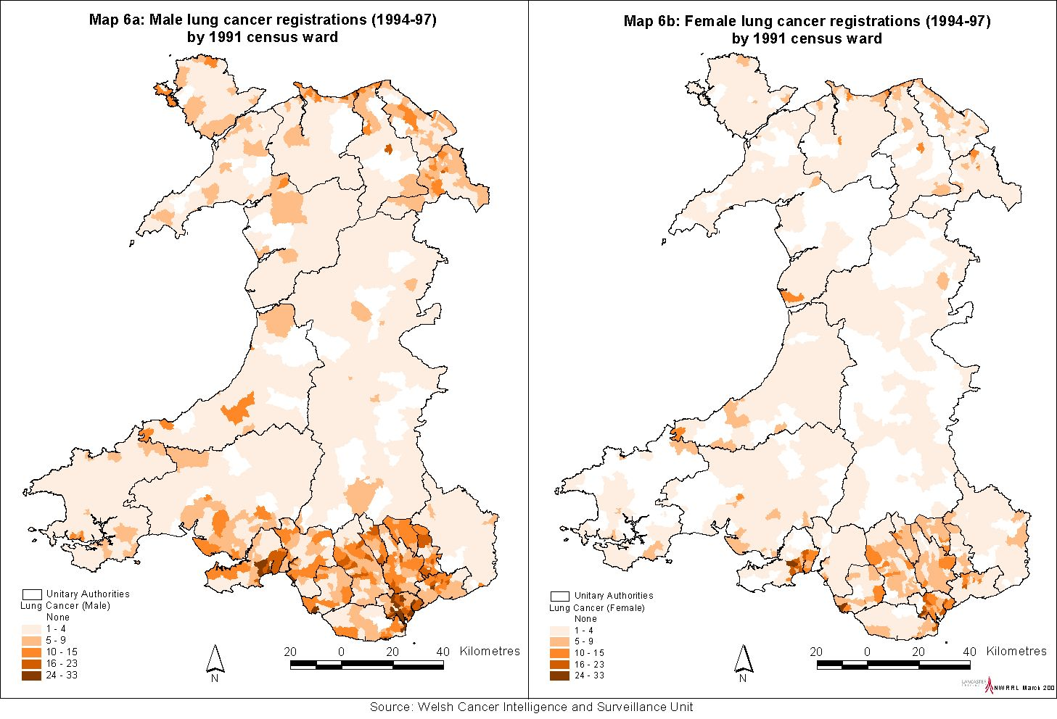

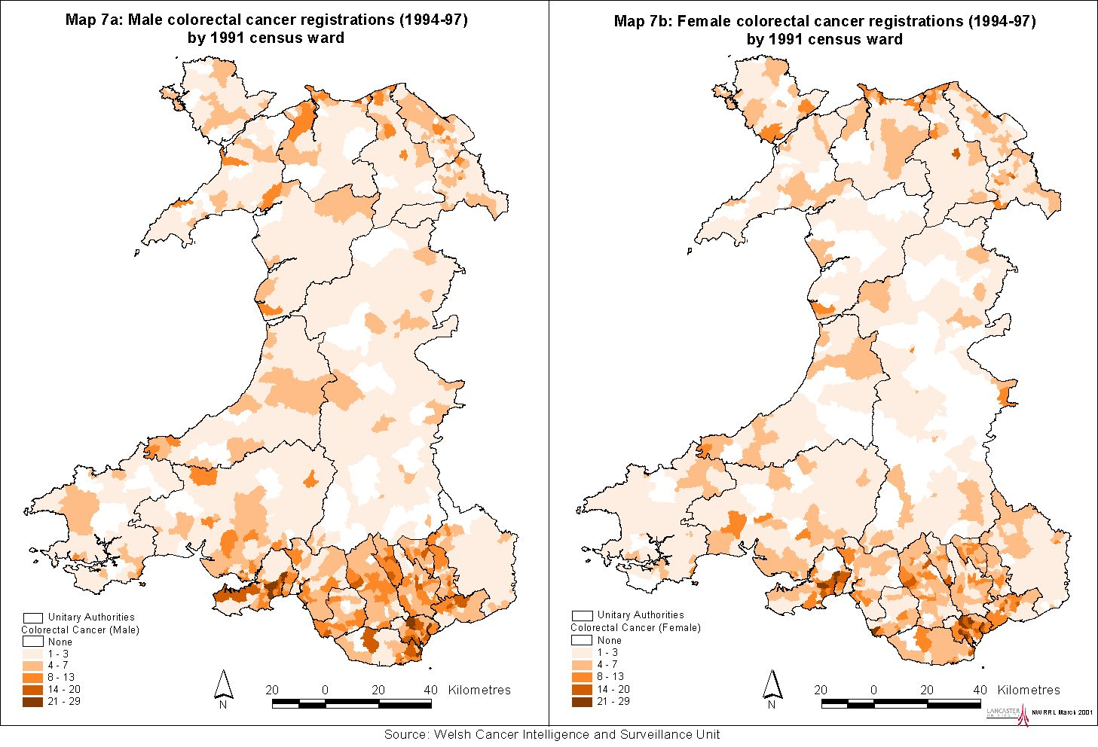

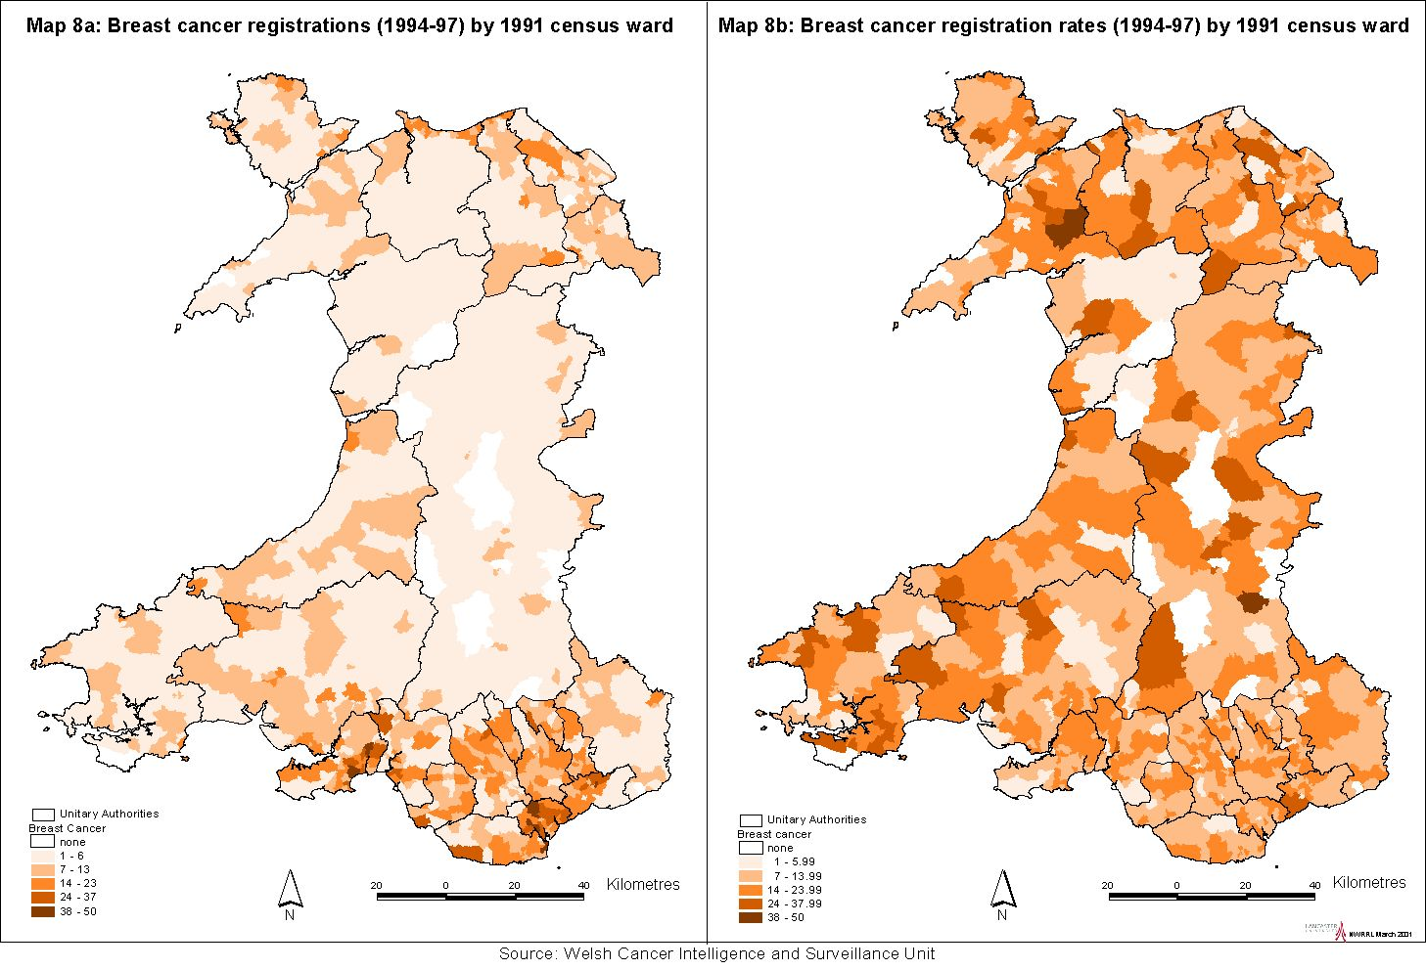

Table 5.1: Cancer survival rates

 |  | Relative Survival
 |  | 1 year (%) | 5 year  (%)
Breast – Female | Gwent | 83 | 62
 | Bro-Taf | 82 | 60
 | Dyfed-Powys | 85 | 66
 | North Wales | 85 | 67
 | Morgannwg | 87 | 67
 | All Wales | 85 | 65
Lung – Male | Gwent | 23 | 9
 | Bro-Taf | 22 | 10
 | Dyfed-Powys | 20 | 8
 | North Wales | 21 | 10
 | Morgannwg | 20 | 8
 | All Wales | 22 | 9
Lung - Female | Gwent | 22 | 7
 | Bro-Taf | 22 | 10
 | Dyfed-Powys | 23 | 12
 | North Wales | 25 | 11
 | Morgannwg | 24 | 11
 | All Wales | 24 | 11
Colorectal - Male | Gwent | 59 | 37
 | Bro-Taf | 57 | 35
 | Dyfed-Powys | 56 | 34
 | North Wales | 61 | 43
 | Morgannwg | 65 | 43
 | All Wales | 60 | 39
Colorectal - Female | Gwent | 60 | 38
 | Bro-Taf | 60 | 42
 | Dyfed-Powys | 59 | 38
 | North Wales | 61 | 43
 | Morgannwg | 63 | 44
 | All Wales | 61 | 42
Note: based on 1985-89 registrations, ages 0 to 84.
Source: Welsh Cancer Intelligence and Surveillance Unit, per comm.

Breast cancer screening
Two rounds of the three-year breast screening cycle (of women aged 50-64) are complete. There is considerable variation in screening uptake and of particular concern is Cardiff where, for both rounds, uptake was less than 70%. Rates are also relatively low in much of north Wales, plus Vale of Glamorgan, Neath Port Talbot and Rhondda, Cynon, Taff, where uptake is below 76%. Breast Test Wales is closely monitoring the situation by, for example, conducting research into screening uptake by women from ethnic minority groups.

Health status
Table 5.2 gives male and female life expectancies at UA level. The figures reveal five year differentials for males, from 76.1 in Ceredigion down to 70.1 in Merthyr Tydfil. The gap is slightly smaller for females, from 80.8 in Monmouthshire down to 76.7 in Merthyr Tydfil.

Table 5.2: Life expectancy at birth by Unitary Authority, 1995-97

 | Males | Females
Blaenau Gwent | 72.5 | 77.5
Bridgend | 73.2 | 79.3
Caerphilly | 73.5 | 77.6
Cardiff | 74.2 | 80.0
Carmarthenshire | 73.7 | 78.9
Ceredigion | 76.1 | 80.6
Conwy | 74.9 | 80.3
Denbighshire | 74.1 | 80.0
Flintshire | 74.4 | 79.0
Gwynedd | 75.2 | 80.6
Isle of Anglesey | 74.6 | 79.7
Merthyr Tydfil | 71.1 | 76.7
Monmouthshire | 75.8 | 80.8
Neath Port Talbot | 72.5 | 79.1
Newport | 73.7 | 79.3
Pembrokeshire | 74.3 | 79.7
Powys | 75.5 | 80.2
Rhondda, Cynon, Taff | 72.5 | 77.8
Swansea | 74.1 | 79.2
Torfaen | 73.5 | 78.4
The Vale of Glamorgan | 74.9 | 79.8
Wrexham | 73.5 | 78.5
Source: ONS (2001)

Statistics relating to morbidity are not routinely collected as comprehensively and consistently as those for mortality. One exception is the decennial Census whereby, in 1991, a question was asked relating to limiting long-term illness in households. The results are displayed in Maps 9a and 9b, showing the lowest rates for both males and females in Monmouthshire and The Vale of Glamorgan, and high rates for the cluster of UAs from Neath Port Talbot to Blaenau Gwent.

Conditions reported in the WHS 1998 are also mapped (see Maps 13a to 13n). This set of maps again illustrates health need, by displaying total counts. Heart disease seems concentrated in Rhondda, Cynon, Taff and Cardiff; high reported occurrences of respiratory illness include Swansea. Both heart and respiratory disease greatly exceed cancers, although poor outcomes for cancers may explain this, as the diseases were self-reported. Ceredigion is the only UA that is consistently in the lowest class for major diseas
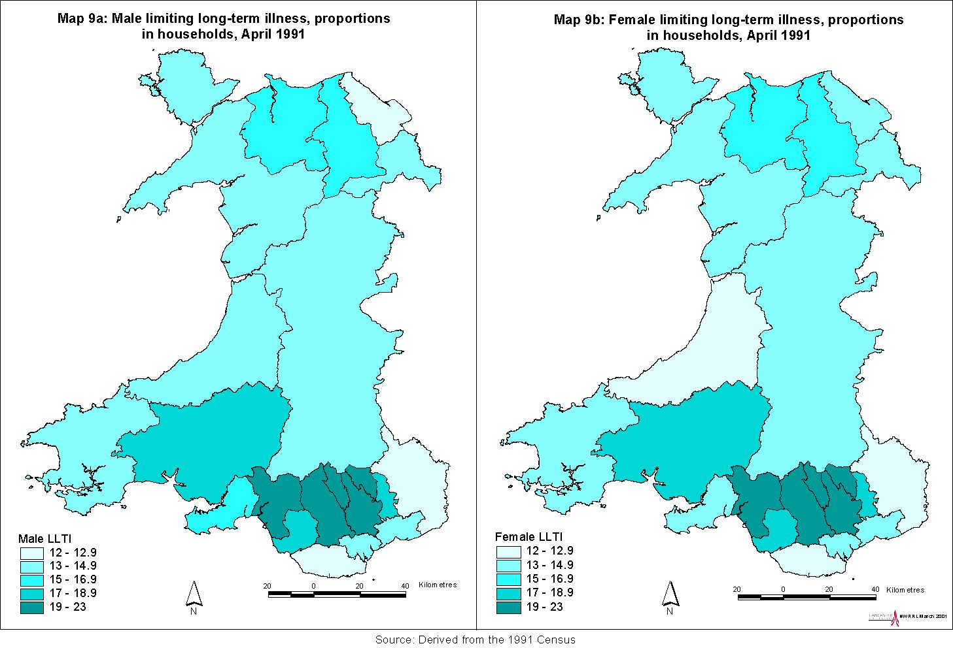
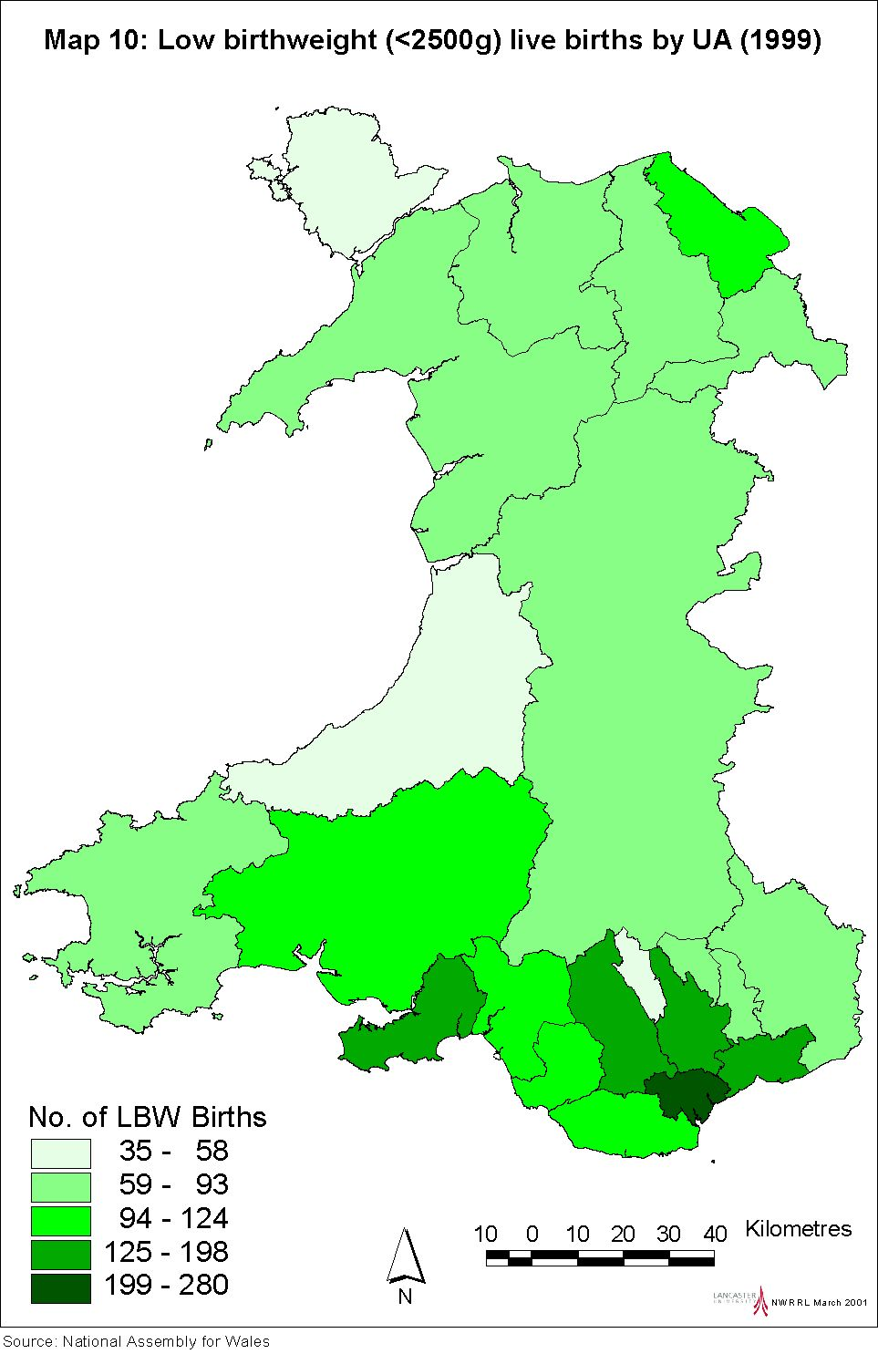

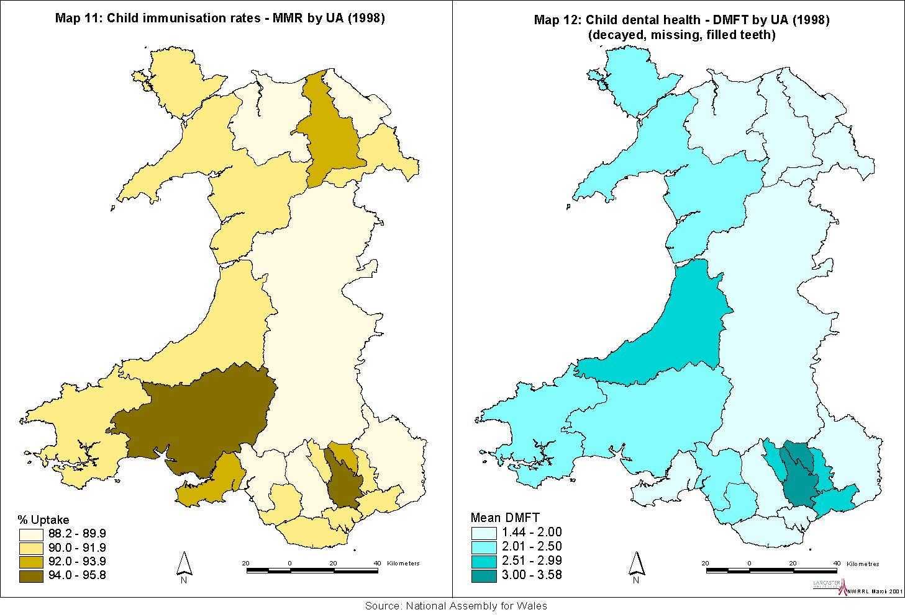
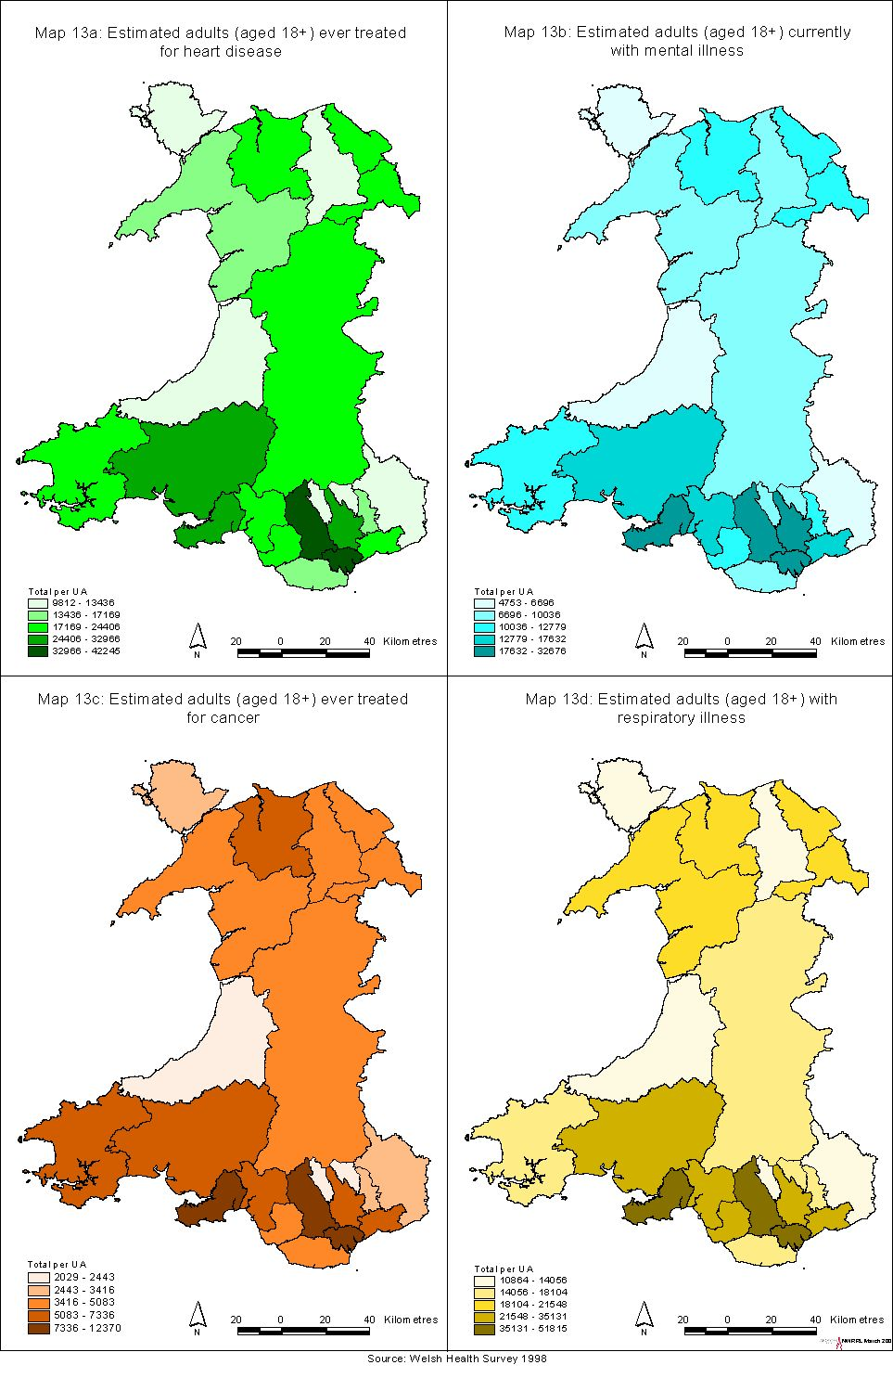
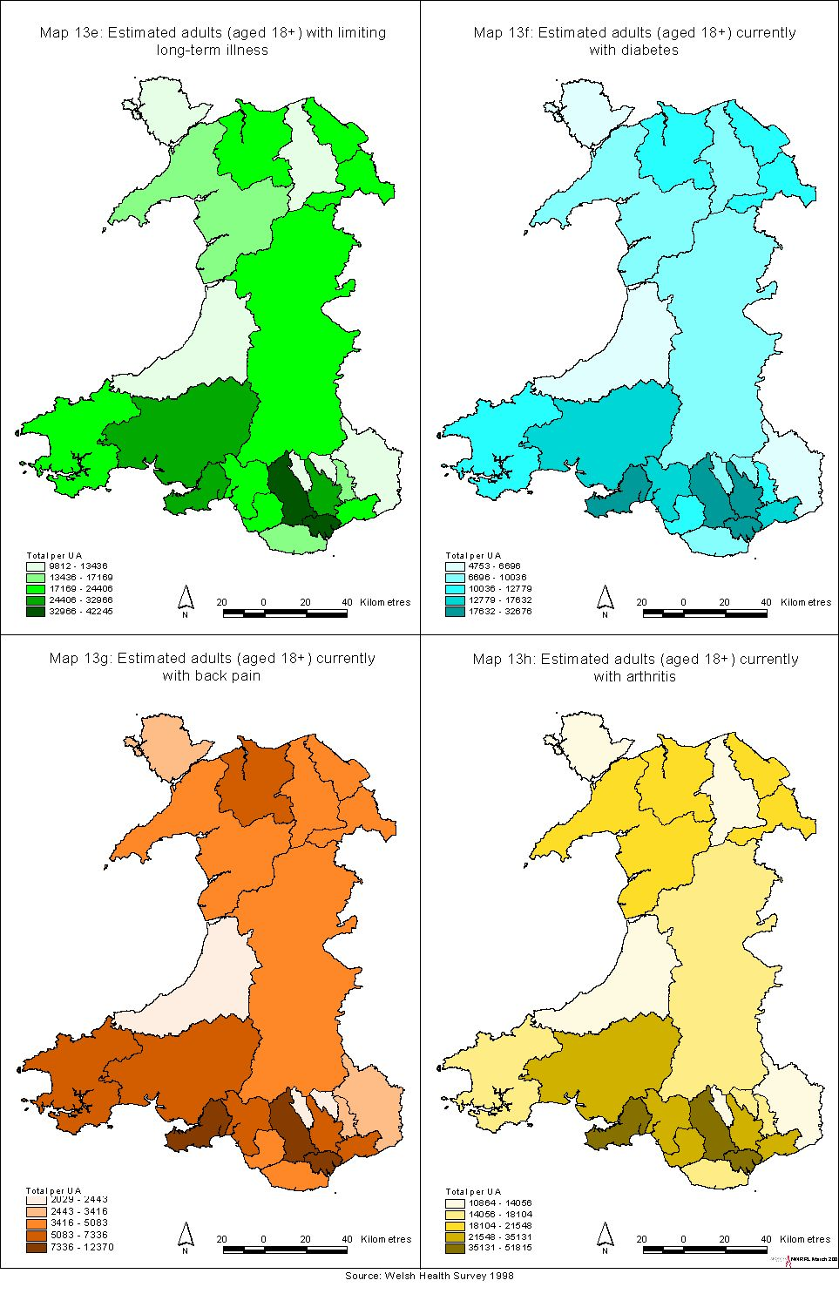
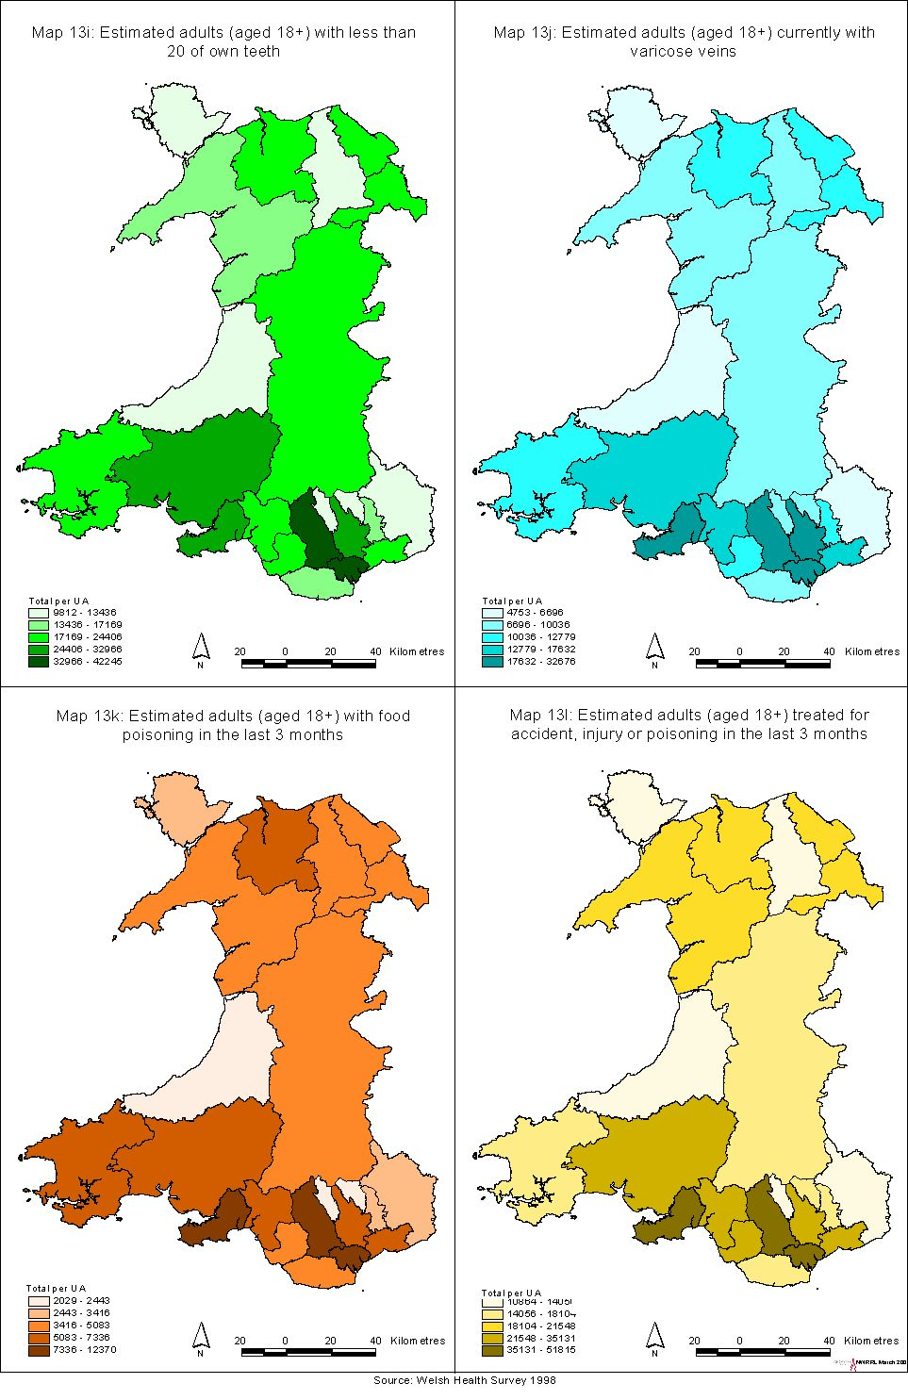
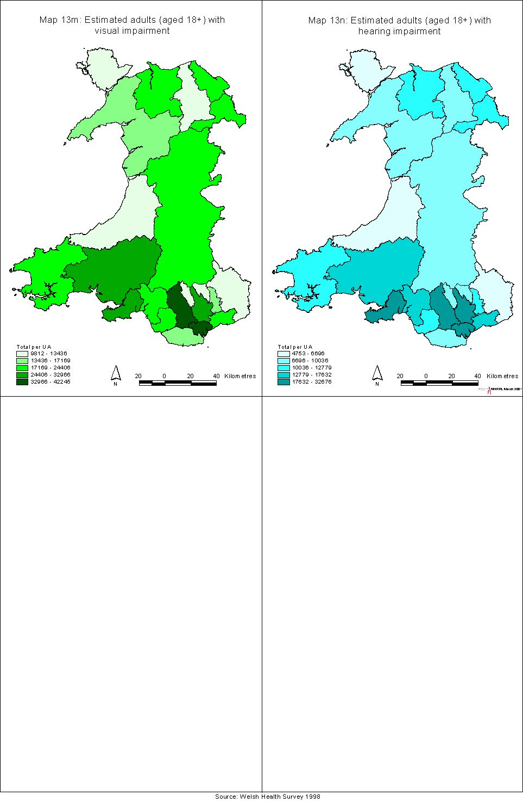
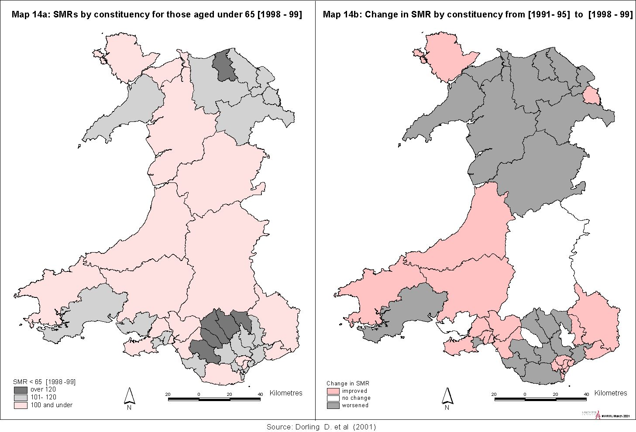
Arthritis and back pain are major causes of morbidity, although they seldom appear on death certificates. They are closely linked with figures for limiting long-term illness and impose a considerable burden upon the health service.

Comparative scores for physical and mental health status derived from the 1995 and 1998 WHS show, for the most part, overall improvements over time (Table 5.3). However, improvements in physical health scores for males in Blaenau Gwent and Merthyr Tydfil are counterbalanced by a worsening in the female scores. This is also apparent in Blaenau in the mental health scores. A guideline for interpretation is that differences in scores of over 1.0 are likely to be statistically significant, hence there are significant variations across the Unitary Authorities.

Table 5.3: Physical and mental health status scores

 | Physical health summary score |  |  |  | Mental health summary score
 | Males |  | Females |  | Males |  | Females
 | 1995 | 1998 | 1995 | 1998 | 1995 | 1998 | 1995 | 1998
Isle of Anglesey | 48.6 | 49.2 | 49.1 | 48.0 | 52.7 | 52.2 | 49.5 | 51.3
Gwynedd | 49.0 | 49.4 | 48.0 | 48.2 | 52.4 | 51.5 | 49.9 | 49.7
Conwy | 48.5 | 48.4 | 47.3 | 47.3 | 50.5 | 50.8 | 50.5 | 50.4
Denbighshire | 48.1 | 49.1 | 47.2 | 47.9 | 51.0 | 51.5 | 50.0 | 49.6
Flintshire | 49.6 | 49.3 | 49.1 | 48.4 | 51.7 | 51.5 | 49.2 | 48.3
Wrexham | 48.8 | 50.0 | 48.8 | 48.4 | 50.3 | 50.4 | 48.4 | 48.8
Powys | 48.1 | 49.1 | 47.2 | 48.9 | 51.1 | 51.0 | 49.1 | 49.5
Ceredigion | 48.8 | 49.2 | 47.4 | 48.8 | 50.5 | 50.9 | 49.5 | 49.4
Pembrokeshire | 48.7 | 48.7 | 47.6 | 48.1 | 51.4 | 51.5 | 49.4 | 50.0
Carmarthenshire | 46.8 | 47.8 | 46.6 | 46.2 | 50.7 | 50.5 | 47.8 | 49.1
Swansea | 48.7 | 48.6 | 46.8 | 47.0 | 51.1 | 51.1 | 48.4 | 48.7
Neath Port Talbot | 47.2 | 47.5 | 46.3 | 45.2 | 50.8 | 50.7 | 47.6 | 48.4
Bridgend | 47.8 | 48.0 | 47.9 | 48.0 | 51.2 | 50.8 | 47.7 | 47.4
Vale of Glamorgan | 49.7 | 49.8 | 48.8 | 49.1 | 50.3 | 51.9 | 49.3 | 49.5
Cardiff | 49.6 | 49.9 | 48.2 | 48.9 | 50.2 | 50.0 | 48.2 | 47.5
Rhondda, Cynon, Taff | 47.2 | 48.4 | 46.5 | 47.1 | 49.6 | 49.9 | 46.8 | 47.2
Merthyr Tydfil | 45.4 | 46.5 | 46.5 | 45.9 | 48.8 | 47.8 | 44.9 | 47.1
Caerphilly | 47.3 | 46.9 | 47.7 | 46.1 | 49.7 | 49.4 | 47.3 | 46.8
Blaneau Gwent | 45.3 | 46.6 | 47.3 | 45.2 | 49.1 | 49.5 | 47.6 | 45.6
Torfaen | 48.4 | 48.0 | 47.3 | 47.7 | 50.8 | 49.7 | 47.8 | 46.4
Monmouthshire | 49.6 | 49.2 | 48.6 | 48.8 | 51.8 | 51.1 | 48.7 | 50.0
Newport | 49.5 | 49.0 | 47.6 | 47.7 | 50.4 | 50.1 | 48.6 | 47.4
Source: Welsh Health Surveys (1995; 1998)

Child health

Child health indicators, at UA level, have been mapped for:

low birth weight (Map 10), which is an acknowledged indicator of poorer subsequent life chances;

immunisation rates (MMR) (Map 11);

dental health (Map 12), as measured by the mean DMFT score ie the numbers of decayed, missing or filled teeth.

There are substantially more low birth weight babies born in Cardiff than elsewhere; however, the rate for Cardiff is around the average for Wales. Some comparative birth statistics are shown in Table 5.4 below. Particularly high conception rates for girls aged under 16 are noticeable in Caerphilly and Blaenau Gwent.

Across all Unitary Authorities, child immunisation rates for all categories (diphtheria, whooping cough, polio, etc) are above 90%, with the exception of the rates for MMR immunisation which are below 90% in six UAs (the lowest rates being for Flintshire and Monmouthshire). Poor dental health is most evident in the large urban areas.

Table 5.4: Birth indicators

 | Total births  (1998) | % low birth weight (1998) | Under 16 conceptions 1995-97 average (rate) | Births to mothers under 20 (1998)
Isle of Anglesey | 732 | 6.0 | 19 ( 4.9) | 56
Gwynedd | 1305 | 5.9 | 51 ( 8.0) | 108
Conwy | 1178 | 8.8 | 65 (11.6) | 103
Denbighshire | 1037 | 6.4 | 37 ( 7.7) | 96
Flintshire | 1795 | 6.7 | 74 ( 9.0) | 125
Wrexham | 1495 | 7.6 | 83 (11.1) | 138
Powys | 1269 | 5.8 | 43 ( 6.3) | 90
Ceredigion | 649 | 7.3 | 19 ( 5.2) | 46
Pembrokeshire | 1277 | 8.8 | 36 ( 5.3) | 124
Carmarthenshire | 1745 | 5.9 | 72 ( 7.6) | 186
Swansea | 2436 | 7.9 | 177 (14.0) | 278
Neath Port Talbot | 1455 | 8.2 | 73 ( 9.1) | 160
Bridgend | 1508 | 7.1 | 104 (14.3) | 182
Vale of Glamorgan | 1436 | 7.6 | 62 ( 8.8) | 142
Cardiff | 4063 | 8.3 | 165 ( 9.5) | 405
Rhondda,Cynon,Taff | 2824 | 8.4 | 211 (15.3) | 374
Merthyr Tydfil | 709 | 8.6 | 49 (13.6) | 108
Caerphilly | 2154 | 7.1 | 165 (16.1) | 278
Blaenau Gwent | 830 | 7.5 | 68 (16.6) | 130
Torfaen | 1086 | 7.9 | 64 (12.3) | 138
Monmouthshire | 868 | 6.0 | 28 ( 5.7) | 46
Newport | 1769 | 7.4 | 83 (10.5) | 210
Source: Digest of Welsh Local Area Statistics (2000)

Health comparators
Table 1.9 (this report) gives rankings for ‘worst health’ to ‘best health’ constituencies across Britain, using under 65 SMRs (over the period 1991-95) as a measure of premature mortality. The authors of that work have conducted a similar analysis which allows a comparison over time, ie between the SMR for 1991-95 and those for the subsequent years 1996-97, and 1998-99. The results can be seen in Table 5.5 which shows SMRs over the three time periods. The constituencies are mapped in order of the most recent data. In Britain, there are 62 constituencies with ‘worse’ outcomes than the poorest SMR in Wales, for Merthyr Tydfil and Rhymney. Worthy of note are the better health chances enjoyed by the 89 constituencies ranking above Monmouth.

The 1998/99 SMRs for Wales can be seen in Map 14a. Map 14b highlights those constituencies where the SMRs do not show an improvement over the original figures. Improvements are apparent in Cardiff, Swansea and Wrexham but not in most of the north or the valley communities of south Wales.

Table 5.5: Welsh constituencies, ‘worst health’ and ‘best health’, using SMRs for those aged under 65

SMR rank | Constituency | SMR<65 1991-95 | 1996-97 | 1997-98
[1
63 | Merthyr Tydfil & Rhymney | 121 | 140 | 130
71 | Ogmore | 114 | 118 | 128
102 | Rhondda | 124 | 126 | 124
108 | Cynon Valley | 121 | 114 | 123
112 | Blaenau Gwent | 114 | 117 | 123
114 | Vale of Clwyd | 107 | 117 | 122
143 | Caerphilly | 105 | 118 | 117
150 | Carmarthen W & S Pembrokeshire | 93 | 99 | 116
173 | Clwyd West | 93 | 103 | 113
185 | Cardiff South and Penarth | 116 | 123 | 112
199 | Newport West | 104 | 106 | 111
202 | Swansea West | 103 | 108 | 110
216 | Torfaen | 113 | 112 | 109
221 | Cardiff West | 115 | 102 | 109
235 | Alyn and Deeside | 102 | 91 | 108
240 | Delyn | 105 | 111 | 108
247 | Pontypridd | 101 | 101 | 107
248 | Swansea East | 115 | 113 | 107
262 | Clwyd South | 101 | 112 | 106
285 | Bridgend | 97 | 93 | 104
291 | Llanelli | 103 | 113 | 103
300 | Wrexham | 106 | 114 | 103
309 | Islwyn | 102 | 102 | 102
313 | Caernarfon | 98 | 85 | 102
321 | Neath | 113 | 121 | 100
323 | Conwy | 96 | 96 | 100
324 | Merionnydd nant Conwy | 94 | 94 | 100
335 | Aberavon | 111 | 114 | 99
337 | Montgomeryshire | 91 | 84 | 98
341 | Newport East | 107 | 105 | 98
342 | Ynys Mon | 106 | 89 | 98
361 | Preseli Pembrokeshire | 100 | 86 | 96
371 | Brecon and Radnor | 95 | 90 | 95
380 | Vale of Glamorgan | 92 | 99 | 94
437 | Gower | 91 | 87 | 89
473 | Cardiff Central | 95 | 102 | 86
490 | Carmarthen East & Dinefwr | 105 | 106 | 85
491 | Ceredigion | 95 | 85 | 85
538 | Cardiff North | 88 | 82 | 80
552 | Monmouth | 80 | 87 | 79
[641
Source: Dorling et al (2001)

If we examine the highest UA rate: lowest UA rate ratio in Wales, for all age mortality rates from 1991-7, the highest rate is for Merthyr Tydfil (1200). The lowest rate is for Monmouthshire (870), giving an ‘inequality ratio’ of 1.4 (Fitzpatrick and Kelleher, 2000).

For Scotland, the equivalent is Glasgow City (1420): East Renfrewshire (920), which is 1.5. However, whereas the figure for Merthyr Tydfil produces 70 ‘excess deaths’ (over the expected number if the mortality rate was the same as the UK figure), the ‘excess deaths’ figure for Glasgow City was 1040. The highest Local Authority figure in England was for Manchester at 1280; the lowest being East Dorset (700).

If the focus is restricted to the 15-44 age group, the inequality for Wales (males) is 1.6 (Merthyr Tydfil 150: Ceredigion 90), and for females 1.4 (Merthyr Tydfil 80: Ceredigion 50) but the inequalities are not as wide as those between the regions of England.

Health improvement
Recent research conducted at the Universities of Leeds and Bristol for the Joseph Rowntree Foundation (Mitchell et al, 2000) sought to estimate the potential impact of certain current government policies on premature death in Britain. These three policies are:

- A modest redistribution of wealth. A steady widening of the wealth gap between rich and poor took place in Britain between the 1980s and the 1990s. The growing differences in wealth between the rich and poor were mirrored by differences in their health, measured by mortality rates (where social class is used a proxy for wealth). The modest redistribution of wealth referred to here is one which would return the inequalities in mortality their 1983 levels.

- Achieving full employment. The definition of full employment used in this research adheres to the government’s preferred definition in which, whilst people may be temporarily between jobs, no-one is in longer term receipt of unemployment benefit.

- Eradicating child poverty: To estimate the effect of achieving the government’s aim of eradicating child poverty, the life chances of the 20% of children whose parents work in (had been working in, or were associated with) the most poorly paid occupations were raised to equal those of their peers not living in poverty. This is a slightly more conservative definition of eradicating child poverty than the government’s but one which is more reliably tested.

The results for Britain as a whole, and for Wales, are as follows:

- Annually, some 7500 deaths in Britain amongst people younger than 65 (including 414 in Wales) could be prevented if inequalities in wealth narrowed to their 1983 levels.

- Some 2500 deaths per year in Britain amongst those aged less than 65, including 134 in Wales, would be prevented were full employment to be achieved.

- Some 1,400 lives amongst those under 15 would be saved per year in Britain, including 85 in Wales, if child poverty were eradicated.

This gives a total of 633 potential lives saved in Wales, annually, were these policies to be achieved. Lives would be saved in those areas which currently have the highest rates of mortality. The redistribution of wealth would have the greatest absolute effect (in terms of numbers of lives saved) because it would improve the lives of the largest number of people. Eradication of child poverty has the greatest relative effect (in terms of the proportion of lives saved).

Clearly, whilst the health of the population in parts of Wales is not as poor as in parts of Scotland, there is a large proportion of the UAs where health measures are well below average for the UK, and showing few signs of improvement. Health gains will not become apparent in the short, or even the medium term; remedies must be substantial, and sustained over the long term.

