Wales NHS Resource Allocation Review

Independent Report of the Research Team

by

David Gordon*
Elizabeth Lloyd*
Martyn Senior#
Jan Rigby±
Mary Shaw*
Yoav Ben Shlomo*

* University of Bristol
# University of Cardiff
± University of Lancaster
June 2001

Final Report of the Research Team

Contents

Acknowledgements ii

Introduction 1

Chapter 1: The growth of health inequalities in Britain 6

Chapter 2: Health in Wales and the United Kingdom 16

Chapter 3: A review of health resource allocation formulae
and their relevance to the Welsh situation 24

Chapter 4: Developing an NHS resource allocation formula for Wales 46

Chapter 5: Distribution of health needs in Wales 72

Chapter 6: Policy options on reducing inequalities in health 100

Chapter 7: The role of the NHS in reducing inequitable receipt
of health care 111

Chapter 8: Conclusions and recommendations 127

Bibliography 129

Appendix 1: Welsh Health Survey 137

Appendix 2: Resource Allocation Calculations 148
Acknowledgements

The Research Team would like to thank Nick Patel, Ken Alexander, Leah Price and Robin Jones for their help, advice and support. They have provided us with a huge amount of help and advice throughout this research project. In particular, Robin Jones has helped steer us through the maze of Welsh health cost statistics.

Stephen Sutch undertook a considerable amount of work for the research team in converting and making available the DRG Hospital costs in a usable form. Similarly, John Evans and Joe Hunt produced a lot of data for the research team from the GP Morbidity database at very short notice.

We would also like to thank Clive Lewis for access to the Vital Statistics, Gwyneth Thomas for child health data, Maria Morgan for BASCD dental health data, Rachel Lloyd for National Assembly for Wales Schools Census: Special Education Needs Data, Daniel Thomas from CDSC for access to food poisoning Notifiable Disease statistics for Wales and the Cancer Registry for cancer statistics for Wales.

We would like to thank Ruth Hall, Mary Cotter, Paul Demery, Cath Roberts, Claire Jones, Alison Macfarlane, David Hall, Margaret Lynch, Fiona van Zwannenberg, Ade Omoseyin and Tom Hutcheson for comments, help and advice. We would also like to thank all the Task Group participants for their helpful comments and suggestions.

Finally, we would like to thank Helen Anderson for her help with the editing of this report.
Introduction

The major purpose of this report is to outline the most scientifically accurate and reliable methods for NHS resource allocation in Wales. In August 2000, the National Assembly commissioned the University of Bristol to assemble a research team to produce an independent report. This report has been written by a very experienced, multidisciplinary team comprising some of the UK’s leading experts in the fields of clinical epidemiology, medical geography, medical sociology and policy studies from the Universities of Bristol, Cardiff and Lancaster. Additional external statistical work has been undertaken by the Office for National Statistics.

This report proposes that Welsh NHS resources be allocated using a novel and innovative method based on a range of direct indicators of health need. Previous health resource allocations in Wales and other countries in the UK have been based mainly upon the population size weighted by the age and sex distribution of people who have recently died under the age of 75 (eg standardised mortality rate under 75). However, there are a number of problems with the current methodology:

- The NHS mainly provides services for people who are alive, not dead. In particular, it provides the bulk of its services for the ‘sick’ rather than the ‘healthy’.

- The NHS provides a considerable number of services for people with health conditions that only very rarely result in death eg tooth decay, back pain, food poisoning, arthritis, etc.

- The geographical distribution of health need and death are not the same.

- A large number of people in Wales require NHS services in any given year but only a relatively small number will die under the age of 75 (approximately 15,000 people per year).

It is much more valid to distribute NHS resources using statistics that directly measure the need for NHS services rather than using indirect indicators of health need such as death rates. For example, it makes sense to allocate money for maternity services on the basis of the number of babies born or the number of pregnant women in an area rather than on the basis of the number of people who have died. More detailed discussion of these points can be found in Chapters 3 and 4.

Principles
The principles employed by the research team are:

- The RAR is about producing a formula for allocating money, NOT resources. The research team is not going to consider either the current distribution nor reallocation of personnel, buildings and equipment.

- The RAR formula is designed to allocate money between geographical areas, NOT health programme areas, eg it is about how much money Wrexham and Anglesey get and not about how much money mental health services and ambulances services get.

- The amount of money an area should receive can be given by the following general formula: Area resource allocation = Health needs X Costs of meeting the health needs.

- The primary aim of this formula is to provide money to help ensure equal access for equal need by geographic areas.

The context
The idea of the Welfare State is one of the greatest British Social Policy inventions of the 20th Century. It has been exported around the world and has arguably done more to alleviate human suffering and improve health than any other single invention, including that of antibiotics. The National Health Service is a keystone of the Welfare State in the UK. It not only provides efficient and effective health care for the whole population but also provides a major contribution of income ‘in kind’ to the poorest groups in society.

Most ‘economic’ studies of income and wealth tend to ignore the importance of services in raising the standard of living of households. This failure often makes international comparisons, based on cash incomes alone, of only limited value. The services (in-kind benefits) provided by the Welfare State eg NHS, education, local government services, have a greater effect on increasing the standard of living of the lowest income households than do the combined values of wages and salaries, Income Support and retirement pensions available to these households. Table I.1 shows the contribution that earnings, cash benefits and in-kind services had on the poorest and richest 10% of all UK households in 1996-97.

Table I.1: Income, taxes and benefit contribution to the average incomes of the poorest and richest 10% of households in the UK in 1996-97 (£)

Income | Poorest 10% of Households  (N=2,245,000) | Richest 10% of Households  (N=2,245,000)
Wages and Salaries | 1,026 | 36,599
Other Income | 822 | 18,762
Total Income | 1,848 | 55,361
Retirement Pension | 1,227 | 506
Income Support | 1,205 | 6
Child Benefit | 434 | 141
Housing Benefit | 536 | 8
Other Cash Benefits | 766 | 245
Total Cash Benefits | 4,168 | 906
Direct Taxes (Income, Council, etc) | 719 | 13,166
Total Disposable Income | 5,297 | 43,101
Indirect Taxes (VAT, etc) | 1,926 | 5,916
Post Tax Income | 3,371 | 37,184
Benefits in Kind
National Health Service | 1,894 | 1,240
Education | 1,959 | 385
Other Benefits in Kind | 210 | 165
Total Benefits in Kind | 4,063 | 1,790
Final Income | 7,433 | 38,974
Source: recalculated from data in Economic Trends and Social Trends (see Gordon and Townsend, 2000)

Table I.1 shows that the richest 10% of households in the UK have an average final income of £38,974 (after accounting for the contribution of benefits and the effects of taxation). This is more than five times larger than the average final income of the poorest 10% of households (ie £7,433). It also illustrates the huge importance of services to the poorest households. Over half of the income (£4,063) that the poorest 10% of households receive is in the form of ‘benefits-in-kind’. The poorest households received £1,894 worth of services from the NHS, representing over a quarter of their final income. If the NHS was not a free service, the poorest households would be 25% poorer. The contribution of NHS services to the final income of the poorest 10% of retired households (629,000 households) is even greater. They received £2,639 worth of NHS services in 1996-97, representing almost half of their final incomes of £5,475 per year.

Table I.1 (above) illustrates the effectiveness of the Welfare State system in alleviating poverty. Cash and in-kind benefits raise the incomes of the poorest households from £1,848 to a final income of £7,433; a four-fold increase. This was not, however, sufficient to raise the poorest 10% of households out of poverty, which would have required (approximately) a five to six-fold increase in original income in 1996-97. However, the Welfare State prevented the poorest households from sinking into a state of absolute destitution. There is no doubt that, properly funded, the Welfare State system in Britain could be used to rapidly reduce inequalities in health and bring an end to poverty.

The NHS is also an extremely cost-effective method of providing high quality health care to the population. The World Health Organisation (WHO) recently calculated that, in 1997, the UK spent, on average, $1,193 per person on health compared with $3,724 per person in the USA (using comparable international dollars). The UK spent less than a third of the amount on health care per person than the USA. However, the WHO ranked the UK 18th in the World and the USA only 37th, when comparing the overall performance of the health systems. This means that the USA spent three times as much per person as the UK but only achieved a health system ranking 19 places below the UK (WHO, 2000).

The problem of inequalities in health
When the NHS was founded, over 50 years ago, it was believed that providing health services ‘free at the point of use’ would remove all barriers to access and result in the narrowing of inequalities in health. Although this did not happen, the NHS helped dramatically to improve the health of the population as a whole (see Chapter 1). Both overall mortality and morbidity rates have consistently declined for the past 50 years, however, the gap in health between ‘rich’ and ‘poor’ people and ‘rich’ and ‘poor’ areas has widened. The health of the ‘rich’ has improved at a much faster rate than the health of ‘poor’ (see Chapters 1 and 2).

The evidence that poverty and inequality in material well-being underlie inequalities in health and early death is now overwhelming. In 1980, the Black Committee on Inequalities in Health concluded that:

“While the Health care service can play a significant part in reducing inequalities in health, measures to reduce differences in material standards of living at work, in the home and in everyday social and community life are of even greater importance”.

Sir Donald Acheson, in his final report as Britain’s Chief Medical Officer, On the State of the Public Health, for the year 1990, said:

"the issue is quite clear in health terms: that there is a link, has been a link and, I suspect, will continue to be a link between deprivation and ill health"
and

"analysis has shown that the clearest links with the excess burden of ill health are:

- low income;
- unhealthy behaviour: and
- poor housing and environmental amenities."

Similarly, the latest World Health Organisation’s annual report (WHO 1998) states that:

“On the unfinished agenda for health, poverty remains the main item. The priority must be to reduce it in the poorest countries of the world, and to eliminate the pockets of poverty that exist within countries. Policies directed at improving health and ensuring equity are the keys to economic growth and poverty reduction.”

The 1995 World Health Report (WHO, 1995) argued that poverty is the world's most ruthless killer and the greatest cause of suffering on earth. Poverty is the main reason why babies are not vaccinated, clean water and sanitation are not provided, curative drugs and other treatments are unavailable and why mothers die in childbirth. Poverty is the main cause of reduced life expectancy, of handicap and disability and of starvation. Poverty is a major contributor to mental illness, stress, suicide, family disintegration and substance abuse.

It should be noted that the following report does not contain an extensive discussion on the causal link between poverty and ill health or on the distribution of inequalities in health in Wales by socio-demographic sub-groups. The details of these very important issues have been included in the final report to the National Assembly and this information has therefore not been included here in order to avoid duplication.

The NHS can do relatively little to change the levels of poverty in Britain although it can have some effect on the health of the poorest groups and areas (see Chapters 6 and 7). An impediment to greater health equity are the barriers to access of health services that exist for the poorest people. Although poor people tend to have worse health, they also are liable to receive less health care. In many countries, this trend is related to the deterrent effects of pricing but the situation also applies in the UK NHS, which is nominally free at the point of delivery. The Black Report (DHSS, 1980) identified two main classes of explanation. The first explanations are cultural: the demand for health care is different from different groups. People in lower social classes are said to be less able to explain medical complaints to middle-class doctors, less able to demand resources and more willing to tolerate illness. The second explanations are practical ones. Working-class people are less likely to have access to a telephone, less likely to have cars and less free to take time off work without losing pay. Doctors' surgeries are more likely to be in salubrious areas and so are difficult to reach (Townsend, Davidson and Whitehead, 1988).

The term 'inverse care law' was coined by Tudor Hart (1971) to describe the general observation that "the availability of good medical care tends to vary inversely with the need of the population served." A primary aim of this review is to identify the best method or methods of allocation in order to distribute resources on the basis of health needs and thereby alleviate the problems caused by the ‘inverse care law’.

Chapter 1: The growth of health inequalities in Britain

It is now firmly established that there are social and spatial inequalities in health in Britain and that these have been widening since the late 1970s/early 1980s. Since the publication of the hugely influential Black Report (DHSS, 1980), a substantial body of research, deriving both from academic researchers and from official government sources, has documented the growth of health inequalities in Britain. These increasing inequalities in health have been observed, in socio-economic terms, using a variety of indicators and, in spatial terms, at various geographical levels.

Widening inequalities have occurred against a background of general improvements in life expectancy which have been observed since records were first reliably collected. Table 1.1 shows, in concise form, the general improvements in overall life expectancy that have been enjoyed, since the 1840s, in England and Wales. Increases have been fairly steady over the time period and show no sign of dwindling. Interestingly, the life expectancy gap between men and women has grown from two to five years (thought to be at least partly due to improvements in maternal mortality) and has, recently, narrowed very slightly. Figure 1.1 shows the data from Table 1.1 in graphic form.

In a recent paper considering this phenomenon of improving life expectancy, Dunnell and Dix (2000) note that, over the most recent decade, it is in the age-group 55-64 (approximately 10% of the population) that death rates have fallen most markedly. However, despite increasingly life expectancy, the healthy life expectancy of this group has increased at a slower pace and socio-economic inequalities in health outcomes persist. Kelly et al (2000) also note that, while life expectancy is improving, healthy life expectancy (ie free from long-standing illness) is not improving at the same pace. As well as these general trends, however, we need to be aware of how mortality and morbidity are distributed throughout the population.

Table 1.1: Expectation of years of life, at birth (rounded to whole years)

Decade | Men | Women | Female advantage
1840s | 40 | 42 | 2
1850s | 40 | 42 | 2
1860s* | 40 | 44 | 4
1870s | 41 | 45 | 4
1880s | 44 | 47 | 3
1890s | 44 | 48 | 4
1900s | 49 | 52 | 3
1910s | 52 | 55 | 3
1920s | 56 | 60 | 4
1930s | 59 | 63 | 4
1940s* | 63 | 68 | 5
1950s | 66 | 72 | 6
1960s | 68 | 74 | 6
1970s | 69 | 75 | 6
1980s | 71 | 77 | 6
1990s | 74 | 79 | 5
*estimated due to missing data. Note: rounded to whole numbers. Source: ONS, 1997.

Figure 1.1: Expectation of years of life, at birth (rounded to whole years)

Socio-economic inequalities in health
Whether we consider socio-economic patterns in health in terms of occupational social class, housing tenure, car access or by indices of deprivation, widening inequalities emerge.

Table 1.2 shows inequalities in mortality by social class from the 1920s to the 1990s (for men only), using Standard Mortality Ratios (SMRs). SMRs which are greater than 100 indicate higher chances of mortality and those less than 100 indicate lower chances of mortality, all relative to the national average, which is set at 100. Class inequalities were high in the 1920s but only reached this extreme again in the period 1959-1963. Inequalities then declined during the 1960s and 1970s but rose to their highest levels in the early 1980s and have since continued to rise.

Table 1.2: SMRs - From the 1920s to the 1990s, men aged 20-64, England and Wales

Year | SMR by Social Class
 | I | II | III | IV | V | Ratio V:I
1921-23 | 82 | 94 | 95 | 101 | 125 | 1.52
1930-32 | 90 | 94 | 97 | 102 | 111 | 1.23
1942 | 88 | 93 | 99 | 103 | 115 | 1.30
1949-1953 | 86 | 92 | 101 | 104 | 118 | 1.37
1959-1963 | 76 | 81 | 100 | 103 | 143 | 1.91
1970-1972 | 77 | 81 | 103 | 114 | 137 | 1.78
1981-1983 | 66 | 76 | 100 | 116 | 165 | 2.50
1991-1993 | 66 | 72 | 113* | 116 | 189 | 2.86
Sources: 1921-23, 1930-32, 1949-53, 1959-63, 1970-72: Lawton (1982); 1981-83: Blaxter (1991); 1991-93: Drever (1997). Note*: SMRs for Social Classes IIIN and IIIM in 1991-93 have been amalgamated for comparability with the earlier series.

Also using this traditional measure of the Registrar General’s occupational social class and data from the ONS Longitudinal Study, Hattersley (1999) reports that, while life expectancy has increased for all social classes since 1972, this increase disguises an underlying trend of growing inequality. For men, the difference in life expectancy at birth between Social Classes I and V had risen from 5.5 years in 1972-76 to 9.5 years by 1996. For women, this difference had risen less dramatically, from 5.3 to 6.4 years (see Table 1.3 and Figures 1.2 and 1.3).

Table 1.3: Life expectancy by social class, men and women, England and Wales, 1972-96

Men
Social Class | 1972-76 |  | 1977-81 | 1982-86 | 1987-91 | 1992-96
I | 72.0 |  | 74.7 | 75.1 | 76.7 | 77.7
II | 71.7 |  | 72.4 | 73.8 | 74.4 | 75.8
IIIN | 69.5 |  | 70.8 | 72.2 | 73.5 | 75.0
IIIM | 69.8 |  | 70.0 | 71.4 | 72.4 | 73.5
IV | 68.4 |  | 68.8 | 70.6 | 70.4 | 72.6
V | 66.5 |  | 67.0 | 67.7 | 67.9 | 68.2
All men | 69.2 |  | 70.0 | 71.4 | 72.3 | 73.9

Women
Social Class | 1972-76 | 1977-81 |  | 1982-86 | 1987-91 | 1992-96
I | 79.2 | 79.9 |  | 80.4 | 80.9 | 83.4
II | 77.0 | 78.1 |  | 78.5 | 80.0 | 81.1
IIIN | 78.0 | 78.1 |  | 78.6 | 79.4 | 80.4
IIIM | 75.1 | 76.1 |  | 77.1 | 77.6 | 78.8
IV | 75.0 | 76.1 |  | 77.3 | 77.0 | 77.7
V | 73.9 | 74.9 |  | 75.3 | 76.2 | 77.0
All women | 75.1 | 76.3 |  | 77.1 | 77.9 | 79.3
Source: Hattersley (1999)

Figure 1.2: Life expectancy by social class, men, England and Wales, 1972-96
Source: Hattersley (1999)
Figure 1.3: Life expectancy by social class, women, England and Wales, 1972-96
Source: Hattersley (1999)

Using the alternative indicators of housing tenure and car access, the work of Filakti and Fox (1995) has shown that owner occupiers have the best life chances, followed by private renters, with Local Authority tenants having the worst life chances (see Table 1.4). Moreover, the differences between these groups have widened. This was updated by Smith and Harding (1997) who reported mortality data up to 1992. Again, whilst the death rates of all groups had fallen, the owner occupiers had enjoyed the greatest fall and the Local Authority tenants the least.

Table 1.4: Direct age standardised rate ratios for deaths under 65 by housing tenure and car access: England and Wales, 1971 and 1981 Census cohorts (Longitudinal Study data)

Tenure | Men |  | Women
 | 1971-81 | 1981-89 | 1971-81 | 1981-89
Owner occupiers | 1.0 | 1.0 | 1.0 | 1.0
Private renters | 1.32 | 1.38 | 1.32 | 1.38
LA tenants | 1.35 | 1.62 | 1.42 | 1.44
1+cars | 1.0 | 1.0 | 1.0 | 1.0
No cars | 1.44 | 1.57 | 1.40 | 1.56
Source: adapted from Filakti and Fox (1995).

A number of studies have shown that unemployment is associated with increased morbidity and mortality risks. In the Government publication, Health Inequalities (Drever and Whitehead, 1997), Bethune reports mortality differences between the unemployed and employed (figures are only available for men). Although the absolute rates for both groups have been falling, the death rate ratio has increased (see Table 1.5).

Table 1.5: Mortality rates of men of working ages by economic activity at the 1971 and 1981 Censuses (1971 and 1981 LS Cohorts), England and Wales

Economic activity: | Rates per 100,000 people
 | 1971-79 | 1981-89
Employed | 302 | 227
Unemployed* | 410 | 319
Death rate ratio | 1.36 | 1.41
Note*: For both these time periods, unemployment was defined as seeking work or waiting to take up a job in the week preceding the Census. Source: Bethune (1997)

Another way of looking at this phenomenon is to consider years of life lost. This is higher among those working in unskilled occupations (Acheson Report, 1998). Table 1.6 shows that, if all men in the age group 20-64 had the same death rates as those in Classes I and II, then it is estimated that there would have been more than 17,000 fewer deaths each year from 1991 to 1993. While deaths from accidents and suicide are smaller in number compared to coronary heart disease, because they tend to occur at relatively young ages, they account for almost as many years of working life lost.

Table 1.6: Estimates of the numbers of lives and working man-years lost per year, selected causes, men aged 20-64, England and Wales, 1991-93

Cause of death | Number of lives lost | Working man-years lost | Proportion of deaths from these diseases
Coronary heart disease | 5,000 | 47,000 | 28%
Accidents, etc | 1,500 | 41,000 | 43%
Suicide, etc | 1,300 | 39,000 | 40%
Lung cancer | 2,300 | 16,500 | 42%
Other neoplasms | 1,700 | 21,000 | 13%
Respiratory disease | 1,500 | 12,500 | 47%
Stroke | 900 | 9,000 | 32%
All diseases | 17,200 | 240,000 | 29%
Source: Acheson Report (1998)

Thus, using a range of indicators of socio-economic position and different measures of health, widening inequalities in health in Britain are apparent, especially for men.

Spatial inequalities in health in Britain
Britain has long been scarred by geographical inequalities in health. Differences in mortality rates between rural and urban areas have been reported, with the latter usually experiencing higher rates (Bentham, 1984; Britton, 1990; Watt et al, 1994).

Recent research shows that spatial inequalities in mortality persist at the level of country, Government Office Region (GOR) and Local Authority (LA) (Fitzpatrick and Kelleher, 2000). Table 1.7 shows that, for both males and females, there is substantial geographical variation in mortality, both between countries of the UK and between regions of England.

At the country level, mortality rates at all ages, and for both males and females, are lowest in England. Wales ranks 2nd, followed by Northern Ireland. Scotland has the highest mortality rates in the UK.

At the regional level within England, there is evidence of a clear north-south divide. For deaths at all ages, the north east and north west have the highest mortality, and the south east, south west and east of England have the lowest mortality rates. This regional inequality is less marked for deaths occurring at younger ages.

Table 1.7: Age-standardised mortality rates for all causes of death by country and GOR, males and females, United Kingdom, 1991-97 (rates per 100,000)

 | Males |  |  |  |  | Females
 | All ages¹ | 1-14 | 15-44 | 45-64¹ | 65 and over | All ages¹ | 1-14 | 15-44 | 45-64¹ | 65 and over
United Kingdom | 980 | 23 | 113 | 810 | 6500 | 620 | 17 | 60 | 490 | 4200
Great Britain | 980 | 22 | 112 | 800 | 6500 | 620 | 17 | 60 | 490 | 4200
England and Wales | 960~ | 22 | 109~ | 780~ | 6400~ | 610~ | 17 | 59~ | 480~ | 4200~
England | 960~ | 22 | 109~ | 780~ | 6400~ | 610~ | 17 | 59~ | 470~ | 4100~
North East | 1100* | 24 | 108~ | 950* | 7300* | 700* | 18 | 58 | 580* | 4700*
North West | 1060* | 25* | 124* | 920* | 7000* | 680* | 18 | 66* | 550* | 4600*
Yorks and the Humber | 1000* | 25* | 105~ | 820* | 6600* | 640* | 20* | 60 | 500 | 4300*
East Midlands | 950~ | 22 | 103~ | 750~ | 6400 | 620~ | 17 | 59 | 480~ | 4200~
West Midlands | 1000* | 23 | 105~ | 810 | 6700* | 630* | 17 | 60 | 490 | 4300*
East | 870~ | 20~ | 93~ | 650~ | 6000~ | 570~ | 16 | 53~ | 420~ | 3900~
London | 970~ | 22 | 129* | 830* | 6300~ | 600~ | 17 | 61 | 480~ | 4000~
South East | 870~ | 19~ | 97~ | 670~ | 5900~ | 570~ | 14~ | 54~ | 410~ | 3900~
South West | 870~ | 20 | 103~ | 670~ | 5800~ | 550~ | 16 | 56~ | 420~ | 3800~
Wales | 1000* | 24 | 117* | 830* | 6600* | 630* | 17 | 63 | 510* | 4300*
Scotland | 1140* | 25 | 144* | 1050* | 7300* | 730* | 19* | 74* | 620* | 4900*
Northern Ireland | 1070* | 26* | 125* | 870* | 7100* | 660* | 20 | 59 | 520* | 4500*
Country inequality+ | 1.19 | 1.16 | 1.33 | 1.35 | 1.14 | 1.20 | 1.19 | 1.25 | 1.32 | 1.20
Region inequality+ | 1.26 | 1.31 | 1.38 | 1.46 | 1.26 | 1.27 | 1.38 | 1.24 | 1.41 | 1.24
1 rounded to the nearest 10.
2 rounded to the nearest 100.
* 95% confidence interval excludes and is higher than the UK rate.
~ 95% confidence interval excludes and is lower than the UK rate.
+ ratio between the rate in the country of the UK or the region of England with the highest rate and that with the lowest rate.
Source: Fitzpatrick and Kelleher (2000)

A recent paper also highlights the geographical differences in life chances in Britain – by country, region and local authority - in terms of life expectancy (Griffiths and Fitzpatrick, 2001). This is an accessible summary measure of mortality at every age that allows comparisons to be made between areas and time periods. For the time period 1995-97, life expectancy in the UK as a whole was 74.4 years for males and 79.6 years for females. For Wales, these figures were: males = 74.0, females = 79.2; for England: males = 74.7, females = 79.8; for Scotland: males = 72.3, females = 77.8; and for Northern Ireland: males = 73.9 and females = 79.3 (Griffiths and Fitzpatrick, 2001). Life expectancies for regions and local authorities are also given. The size of the life expectancy gap by local authority for men is similar to that between Social Classes I and V, as cited above (Hattersley, 1999) – there is a 10.0 year life expectancy gap between Chiltern (78.4 years) and Glasgow City (68.4 years). In comparison within Wales, life expectancy for males ranges by five years from 71.1 years in Merthyr Tydfil to 76.1 in Ceredigion. For women in the UK, life expectancy by Local Authority varies by 8.1 years, from 83.5 in East Dorset to 75.4 in Glasgow City. Within Wales life expectancy varies by from 3.9 years, 80.6 in Ceredigion and Monmouthshire to 76.7 in Merthyr Tydfil. The extent of this gap means that there are Local Authorities in Wales where life expectancy in 1995-97 had not yet reached the 1986 UK national levels (Merthyr Tydfil for men; Merthyr Tydfil, Blaenau Gwent and Caerphilly for women).

A recent study by Mitchell et al (2000) considers the geography of mortality in Britain at a smaller geographical scale and, over time, from the 1950s to the late 1990s. In order to look at the geographical health gap over time in the context of changing administrative boundaries, ‘frozen’ boundaries are employed. This allows trends since the 1950s to be observed (see Dorling, 1997, for more details). The geographical units used are the old County Boroughs and, for each time period for which data are available, Britain is divided into ten equal-sized groups of areas in terms of population (deciles). The age-sex standardised mortality ratio (SMR) for deaths under 65 is then calculated for each decile. Table 1.8 (and Figure 1.4) present these SMRs for the 1950s through to the late 1990s.

Table 1.8: Standardised mortality ratios for deaths under 65 in Britain by deciles of population (grouped by old County Borough and ordered by SMR), Britain 1950-1998, men and women

Decile | 1950-53 | 1959-63 | 1969-73 | 1981-85 | 1986-89 | 1990-92 | 1993-95 | 1996-98
1 | 131 | 136 | 131 | 135 | 139 | 142 | 147 | 150
2 | 118 | 123 | 116 | 119 | 121 | 121 | 121 | 122
3 | 112 | 117 | 112 | 114 | 114 | 111 | 113 | 114
4 | 107 | 111 | 108 | 110 | 107 | 105 | 107 | 108
5 | 103 | 105 | 103 | 102 | 102 | 99 | 99 | 99
6 | 99 | 97 | 97 | 96 | 96 | 94 | 95 | 96
7 | 93 | 91 | 92 | 92 | 92 | 91 | 92 | 93
8 | 89 | 88 | 89 | 89 | 89 | 87 | 87 | 88
9 | 86 | 83 | 87 | 84 | 83 | 80 | 80 | 80
10 | 82 | 77 | 83 | 79 | 78 | 76 | 75 | 75
Ratio 10:1 | 1.60 | 1.75 | 1.58 | 1.70 | 1.78 | 1.87 | 1.98 | 2.01
Source: Mitchell et al (2000)

Figure 1.4: Standardised mortality ratios for deaths under 65 in Britain by deciles of population (grouped by old County Borough and ordered by SMR), Britain 1950-1998, men and women

Source: Mitchell et al (2000)

The table and figure show that inequalities in health narrowed between the late 1950s/early 1960s and early 1970s but that, since the early 1980s, they have been steadily widening. The gap between the highest and lowest mortality deciles is such that, in the period 1996-98, those living in the highest mortality areas are now over two times as likely to die before the age of 65. The relative mortality ratios have also risen for the second, third and fourth deciles which illustrates that the polarisation of life chances has not only affected the most extreme group. This is clear evidence of increasing geographical health inequalities in Britain.

Using the smaller geographical units of British parliamentary constituencies, Shaw et al, (1999) demonstrated not only how social and spatial inequalities in health have been widening but how they coincide and interact. To illustrate the size of the health gap between constituencies and the other socio-economic gaps that cause and are a consequence of poor health, the ‘extremes’ of Britain are compared. The one million people with the ‘best health’ are compared with the one million people with the ‘worst health’; each group contains enough people to ensure that the statistics shown are not the product of random events. The measure of health used is mortality before the age of 65, as this is the most robust and most direct measure of the health gap. Mortality over the period 1991 to 1995 is considered, using the latest data available, and a range of other socio-economic variables are also included. Box 1 provides a summary of the method employed.

Box 1: Method: Comparing the extreme health areas of Britain

Source of data: | ONS & GRO(S) digital mortality records
Geographical units: | Constituencies, using 1997 boundaries
Population included: | All those under 65 using mid-year estimates
Years covered: | 1991-95 to show the extent of the current gap  Comparing 1981-95 to 1991-1995 to show the widening gap
Health measure: | Standardised mortality ratios (SMRs) for deaths under 65
‘Worst health million’: | The 15 constituencies, with the population under 65 totalling approximately one million, with the highest SMRs
‘Best health million’: | The 13 constituencies, with the population under 65 totalling approximately one million, with the lowest SMRs
Other sources of data: | The Population Censuses of Britain carried out in 1981 and 1991
 | The Breadline Britain survey of 1,831 adults carried out in 1990
 | School exam performance data from DFEE, and the Welsh and Scottish Offices

Table 1.9 lists the 15 Parliamentary Constituencies which contain the million people aged under 65 with the highest, and the 13 Parliamentary Constituencies with the lowest, age-sex standardised mortality ratios in Britain between 1991 and 1995. The ‘worst health’ areas of Britain are to be found in Glasgow, the northern conurbations and in the centre of London. Conversely, the ‘best health’ areas are mostly in the south of England. Table 1.9 also shows the percentage of households with children living in poverty (using the Breadline Britain index), the percentage of men aged 16-64 who were unemployed and the number of households with 3+ cars, for these extreme areas. The stark differences between these areas in socio-economic terms is clear.

Table 1.9: Constituencies where people are most at risk of premature death (mortality rates under 65) in Britain, 1991-95, and other socio-economic indicators

Rank | Name | SMR<65 | % with children in poverty | Unemployed | Households with 3+cars
 | Ratio of ‘worst health’ to ‘best health’ | 2.6 | 4.2 | 3.9 | 9.1
1 | Glasgow Shettleston | 234 | 59 | 22.9 | 92
2 | Glasgow Springburn | 217 | 60 | 25.0 | 63
3 | Glasgow Maryhill | 196 | 63 | 21.6 | 116
4 | Glasgow Pollok | 187 | 52 | 19.8 | 181
5 | Glasgow Anniesland | 181 | 51 | 18.5 | 224
6 | Glasgow Baillieston | 180 | 54 | 21.0 | 254
7 | Manchester Central | 173 | 59 | 23.6 | 345
8 | Glasgow Govan | 172 | 46 | 16.1 | 317
9 | Liverpool Riverside | 172 | 57 | 26.3 | 275
10 | Manchester Blackley | 169 | 49 | 18.8 | 336
11 | Greenock and Inverclyde | 164 | 43 | 14.9 | 363
12 | Salford | 163 | 48 | 18.5 | 371
13 | Tyne Bridge | 158 | 55 | 22.2 | 208
14 | Glasgow Kelvin | 158 | 38 | 14.0 | 199
15 | Southwark North and Bermondsey | 156 | 57 | 18.5 | 352
 | ‘Worst health’ million | 178 | 53 | 20.3 | 3696
Rank | Name
1 | Wokingham | 65 | 9 | 4.4 | 2,709
2 | Woodspring | 65 | 12 | 5.5 | 2,378
3 | Romsey | 65 | 12 | 5.7 | 2,617
4 | Sheffield Hallam | 66 | 9 | 6.1 | 1,246
5 | South Cambridgeshire | 66 | 13 | 4.4 | 2,474
6 | Chesham and Amersham | 67 | 11 | 4.7 | 3,546
7 | South Norfolk | 69 | 15 | 5.2 | 2,407
8 | West Chelmsford | 69 | 16 | 6.1 | 2,152
9 | South Suffolk | 69 | 17 | 6.1 | 2,227
10 | Witney | 69 | 17 | 5.0 | 2,602
11 | Esher and Walton | 69 | 12 | 5.4 | 3,261
12 | Northavon | 70 | 11 | 5.3 | 3,045
13 | Buckingham | 71 | 11 | 4.8 | 2,837
 | ‘Best health’ million | 68 | 13 | 5.3 | 33,501
 | Britain | 100 | 27 | 9.8 | 873,053
Note: SMR<65 = Standardised mortality ratio for deaths under 65, men and women.
Source: Shaw et al (1999)

Summary
There is a great deal of evidence to show that, over the past two decades in Britain, inequalities in health have been widening, in both social and spatial terms. However, the fact that inequalities in health have narrowed in the past shows that this polarisation is not inevitable, nor immovable. Inequalities in health can be reduced.
Chapter 2: Health in Wales and the United Kingdom

This section uses statistics from a range of sources to compare health outcomes in Wales with the remainder of the United Kingdom.

Population trends
Annual population growth rates for the countries of the UK show that rates between 1991 and 1998 are less than from 1981 to 1991 for Wales and England but not for Scotland and Northern Ireland.

Table 2.1: Annual growth rates (percentages)

 | 1981-1991 | 1991-1998
Wales | 2.8 | 1.4
England | 3.0 | 2.7
Scotland | -1.4 | 0.3
Northern Ireland | 4.1 | 5.1
Source: Registrar General for Scotland (2000)

Based on 1998 figures, the proportion of the population aged 0-4 years is lowest in Wales, whilst the proportion aged 80 and over is highest.

Health trends
Although health need is the baseline, complete, current measures of this are problematic to compile. Mortality data are often used as surrogates for comparative purposes, as the data provide a comprehensive coverage and are considered to be relatively accurate and up-to-date. However, such data can be misleading in terms of the full extent of ill-health: conditions such as back pain, rheumatism and arthritis account for most of limiting long-term illness but are not commonly recorded as causes of death. This discussion will explore both mortality and morbidity data.

Key indicators of health are mortality rates for both full populations and for infants and life expectancy figures. These are shown in Table 2.2.

Table 2.2: Key demographic and health indicators

Age-standardised mortality rate (per million population)
Year | Wales | England | Scotland | Northern Ireland
1971 | 11175 | 10278 | 11444 | 11607
1981 | 9846 | 9298 | 10849 | 10567
1991 | 8074 | 7941 | 9254 | 8564
1998 | 7366 | 7128 | 8533 | 7438
1999* | 7532 | 7062 | 8618 | 7672
Infant mortality rate (per 1000 live births)
Year | Wales | England | Scotland | Northern Ireland
1971 | 18.4 | 17.5 | 19.9 | 22.7
1981 | 12.6 | 10.9 | 11.3 | 13.2
1991 | 6.6 | 7.3 | 7.1 | 7.4
1998 | 5.6 | 5.6 | 5.6 | 5.6
1999* | 6.1 | 5.7 | 5.0 | 6.4
Expectation of life, in years, at birth: males
Year | Wales | England | Scotland | Northern Ireland
1981 | 70.4 | 71.1 | 69.1 | 69.2
1991 | 73.2 | 73.4 | 71.4 | 72.6
1998* | 74.5 | 74.9 | 72.6 | 74.3
Expectation of life, in years, at birth: females
Year | Wales | England | Scotland | Northern Ireland
1981 | 76.4 | 77.0 | 75.3 | 75.5
1991 | 78.9 | 79.0 | 77.1 | 78.4
1998* | 79.5 | 80.0 | 78.1 | 79.5
Source: ONS (2001a)
* provisional figures

Recent trends in major health indicators show substantial improvements, although provisional figures for 1999 do not always seem to show a continuance. It must be noted that a change over one year cannot be considered a trend. Infant mortality rates for Wales are higher than those for England and Scotland; the age-standardised mortality rates are also higher than those in England. Life expectancy for both males and females is lower in Wales than in England.

Low birth weight (under 2500g) is a useful marker for subsequent morbidity. Encouragingly, rates (the proportion of low birth weights as a percentage of all live births) for Wales are consistently lower than those for England (rates are not routinely reported by Scotland). In 1983, the figure for England was 7.0 compared with 6.8 for Wales. In 1999, England recorded 7.6 to 7.4 for Wales (ONS, 2000a). Variations within Wales are explored later, in Chapter 5. In 1993, all but one of the health regions in England had lower rates for sudden infant death than Wales but, by 1998, the rates for Wales had dropped by 52%. Figures for 1999 show an increase although this is consistent with other regions (ONS 2000c).

Causes of mortality
Detailed mortality statistics are available in the UK on causes of death by age, sex and area. Age-adjusted mortality rates for common causes of death are illustrated below. Figure 2.1 is a comparison of ischaemic heart disease within the UK. For both males and females, rates for Wales are above those for England but below the levels of Scotland and Northern Ireland.

Figure 2.1: Age-adjusted mortality rates for ischaemic heart disease (1998)

Source: ONS (2001b)
Note: age-adjusted mortality rates per 100,000 population

A similar comparison for cerebrovascular disease can be made using Figure 2.2. Here, rates for females in all four countries are well above those for males. Again, relative rates show Wales to have higher mortality than England but lower than Scotland and Northern Ireland.

Figure 2.2 Age-adjusted mortality rates for cerebrovascular disease (1998)

Source: ONS (2001b)
Note: age-adjusted mortality rates per 100,000 population

There are related conditions where the figures for Wales are a particular concern. Table 2.3 shows standardised mortality ratios for cerebral infarctions in Wales, where the rates for females are the highest in the UK. SMRs for hypertensive disease are highest for Wales (Table 2.4) and this is also true for hypertensive heart disease. Chronic rheumatic heart disease mortality for females in Wales has an SMR of 154 for 1998, compared with under 100 elsewhere.

Table 2.3: SMRs for cerebral infarctions (1998)

 | Males | Females
Wales | 113 | 123
England | 97 | 97
Scotland | 123 | 108
Northern Ireland | 97 | 107
Source: ONS (2000d)

Table 2.4: SMRs for hypertensive disease (1998)

 | Males | Females
Wales | 126 | 132
England | 99 | 97
Scotland | 91 | 100
Northern Ireland | 105 | 127
Source: ONS (2000d)

Respiratory disease rates (excluding cancers) are in Figure 2.3 below. Perhaps surprisingly, the 1998 rates for Wales are the lowest of the four countries, for both males and females.

Figure 2.3: Age-adjusted mortality rates for respiratory disease (1998)

Source: ONS (2001b)
Note: age-adjusted mortality rates per 100,000 population

Comparative figures for mortality from cancers in 1998 (Figure 2.4) show a slightly different picture, with rates for females in Wales being above those for England and Northern Ireland. The rates are particularly high in Wales for cancers of the digestive organs, female breast and genito-urinary classes but lower than Scotland for respiratory cancers.

Figure 2.4: Age-adjusted mortality rates for cancers (1998)

Source: ONS (2001b)
Note: age-adjusted mortality rates per 100,000 population

Diseases of the nervous system and sense organs (ICD 320-389) yield high rates in Wales, although not for the sub-categories of Parkinson’s Disease, multiple sclerosis or epilepsy.

Table 2.5: SMRs for diseases of the nervous system and sense organs (1998)

 | Males | Females
Wales | 106 | 113
England | 100 | 100
Scotland | 97 | 98
Northern Ireland | 96 | 84
Source: ONS (2000d)

These findings are paralleled by figures for diabetes (Table 2.6), where the 1980 figures are shown in brackets. Clearly, the 1998 figures for Northern Ireland are curious and require confirmation. These apart, the increase for males in Wales is much greater than those elsewhere.

Table 2.6: SMRs for diabetes 1998 (1980)

 | Males | Females
Wales | 121 (95) | 118 (121)
England | 99 (98) | 100 (96)
Scotland | 112 (120) | 103 (117)
Northern Ireland | 33 (105) | 38 (121)
Source: ONS (2000d); OPCS (1983)

Excess mortality for Wales can also be noted for bronchitis, emphysema and asthma, and pneumoconiosis. SMRs for 1997 for bronchitis and emphysema were 130 (males) and 142 (females) compared with 98 for both conditions in England (ONS, 1999).

Cancer
In the ten years from 1985 to 1994, age-standardised rates for cancers have increased by 0.4% per annum for men and by just under 0.3% p.a. for women. It should be noted that the national breast screening programme for women was introduced during this time, which will have led to an increase in breast cancer diagnoses.

In males, there has been a significant increase in prostate cancer and a significant decrease in cancers of the trachea, bronchus and lung. In women, the anticipated increase in the diagnosis of breast cancer is noted, with a significant decrease in cervical cancer (where there is also a national screening programme in effect to detect pre-cancerous conditions). Comparative figures for incidence of the more common cancers follow. It can be seen that, figures for Wales are poorer than those for England but, for several sites, better than those for Scotland.

Table 2.7: Cancer incidence (1996-7)

 | Stomach |  | Colorectal |  | Lung |  | Breast | Prostate
 | m | f | m | f | m | f | f | m
Wales^{b} | 18.1 | 6.7 | 38.3 | 24.7 | 51.1 | 24.0 | 90.1 | 37.7
England ^{b} | 14.2 | 4.8 | 33.8 | 22.8 | 57.6 | 22.8 | 77.3 | 32.9
Scotlandª | 14.4 | 6.7 | 46.2 | 30.4 | 70.7 | 38.1 | 78.0 | 46.9
N Irelandª | 14.7 | 7.0 | 45.0 | 30.3 | 49.6 | 22.4 | 75.8 | 37.8
Source: Quinn et al (2001)

Note: rates are per 100,000 standardised to the world-standard population.
ª 1996 incidence
^{b} 1997 incidence

Incidence is highest for Wales for leukaemia (10.4 for males and 6.4 for females) compared with the UK rates of 8.3 and 5.6 respectively.

Regional variations
Table 2.1 showed variations in life expectancy at national level in the UK. Variation also exists at regional and Local Authority levels. A recent analysis by Griffiths and Fitzpatrick (2001) found a ten year differential between the highest life expectancy for males in Chiltern (78.4 years) compared with Glasgow City (68.4 years). This equates to the difference in male life expectancy between Social Classes I and V (1992-96), which was 9.5 years. Their investigation of Local Authorities with life expectancies at birth (1995-97) at or below the UK figure 10 years earlier (ie 1986) identifies Merthyr Tydfil among the 16 authorities listed for males, and Merthyr Tydfil, Blaenau Gwent and Caerphilly in the 25 authorities listed for females. Figures for life expectancy at UA level within Wales are given in Chapter 5.

Self-reported limiting longstanding illness is shown in Table 2.8 below and demonstrates a substantial excess in Wales:

Table 2.8: Percentages of limiting longstanding illness (unstandardised)

 | Males | Females
Wales | 24 | 30
England | 19 | 21
North West | 21 | 22
South East | 16 | 17
Scotland | 17 | 21
Source: ONS (2000b)

Evidence relating to a number of major sources of morbidity is routinely collected by sampling General Practitioners. A series of statistics is given in Box 2. These show conditions by region and by age-groups of particular interest. Figures for heart disease, for both males and females, are higher in Wales than in England and are comparable with the worst regions in England. Hypertension figures are highest for Wales. Additionally, figures for raised blood pressure also indicate that Wales has a relatively high prevalence.

Reported asthma in children under five in Wales is not exceptional but, for the age groups 5-15 and 16-24, it exceeds the prevalence figures in all other regions. The rates are again high for older age groups, although this is likely to be connected with the generally high level of respiratory disease.

The prevalence of insulin-treated diabetes is higher for males in Wales (6.1 per 1000 compared with 5.1 per 1000 in England) but not for females, where prevalence in Wales (4.6 per 1000) is exceeded by the Northern and Yorkshire region, and the Anglia and Oxford region (both 4.8). With reference to non-insulin-treated diabetes, the figures for Wales (males 10.2 and females 7.5) are slightly higher than those for England. Some individual regions have figures which exceed those for Wales. Male depression rates are also high for Wales.

This chapter has compared statistics for major health conditions in Wales with the other countries of the United Kingdom and highlighted particular conditions where rates in Wales are notably high. However, overall statistics at a national level mask variations in health outcomes at more local scales. These variations are explored in detail in Chapter 5.

Box 2: Regional variations in morbidity

Prevalence of treated coronary heart disease per 1000 patients
Male Female
45-54 55-64 65-74 75-84 All 45-54 55-64 65-74 75-84 All

Wales 29.4 109.4 195.7 235.6 39.6 15.9 59.4 114.4 175.0 23.7
England 26.9 89.1 168.1 211.9 34.3 11.9 45.4 106.3 159.2 20.6
North & Yorks 33.4 107.7 195.9 242.5 40.7 17.2 68.1 136.0 191.0 27.2
South Thames 22.0 73.3 147.1 193.6 29.7 10.5 33.6 82.0 141.3 16.7
West Midlands 25.6 85.7 161.7 199.6 32.9 12.0 42.6 103.6 145.8 19.7
North West 36.2 116.6 193.2 221.9 41.3 16.7 63.2 125.7 179.9 25.6
(all = age standardised)

Prevalence of hypertension per 1000 patients
Male Female
45-54 55-64 65-74 75-84 All 45-54 55-64 65-74 75-84 All

Wales 31.6 57.4 86.3 89.1 22.2 32.8 67.9 109.3 127.5 25.7
England 20.1 41.7 69.3 80.7 16.4 21.5 50.5 90.1 115.5 20.0
South Thames 16.4 35.5 62.2 71.9 14.5 20.1 45.5 78.2 106.3 18.2
North West 21.9 46.5 68.3 87.2 17.7 22.0 51.1 88.5 116.9 20.3

Prevalence of treated depression or anxiety per 1000 patients
Male Female
45-54 55-64 75-84 85+ All 45-54 55-64 75-84 85+ All

Wales 56.8 64.3 85.1 94.4 36.9 128.7 136.6 178.2 183.9 83.3
England 57.8 62.7 76.4 85.9 36.2 127.5 131.9 158.9 158.1 81.8
North & Yorks 67.1 75.8 91.8 76.8 42.2 140.7 149.8 163.1 178.8 91.1
South Thames 50.7 53.4 66.4 82.0 31.4 119.2 112.0 141.4 147.8 72.4
West Midlands 50.8 61.0 68.8 62.2 32.0 123.6 125.6 159.7 139.4 78.1
North West 73.3 78.1 83.4 93.9 44.4 144.7 157.5 186.4 195.6 94.9

Prevalence of treated asthma per 1000 patients
Male Female
0-4 5-15 16-24 65-74 All 0-4 5-15 16-24 65-74 All

Wales 80.9 129.5 78.7 78.7 72.3 54.7 97.7 92.7 82.7 72.5
England 95.2 122.4 70.0 68.1 66.4 59.9 97.2 66.8 73.9 68.2
North& Yorks 98.6 125.6 63.1 62.5 65.1 62.0 91.9 76.6 67.4 66.8
South Thames 88.7 114.9 72.2 59.2 62.1 58.6 90.8 79.4 69.5 65.2
West Midlands 90.0 122.5 65.6 68.9 63.6 49.9 98.8 72.5 68.8 64.5
North West 92.6 121.1 72.7 76.1 68.4 59.1 95.9 74.0 82.8 68.2

Source: ONS (1998)

Chapter 3: A review of the health resource allocation formulae and their relevance to the Welsh situation

General features of weighted capitation formulae in the UK
Capitation (or risk adjustment) systems are widely used throughout the developed world (see the review by Rice and Smith in ACRA (1999) 09) and the driving force behind most of them is the need to control expenditure. Their general purpose is to devolve health care responsibilities from a central funder (national government in the UK) to health care ‘plans’ organised geographically (as in the UK), or as sickness funds (eg Germany) or as insurance pools (eg USA). Each ‘plan’ is intended to provide for the needs of the population it serves within a pre-set budget for a given time period.

Capitation methods are used for equity and efficiency reasons, although it is equity which is prominent in public health systems controlled by central governments. Thus, all UK resource allocation formulae operate on the principle of fairness or equity. They have the objective of equalising access to health care for equal need. As the health care system in the UK is geographically based, this means that ‘health areas’ in equal need of health care should receive equal resource allocations. Following the Acheson Report (1998), a new, additional objective for resource allocation, to contribute to the reduction in avoidable health inequalities, was introduced by the English government in 1998 and by the National Assembly for Wales in 2000. Research is being undertaken to determine how this new objective can best be met (see: ACRA papers; Sutton and Lock, 2000).

Capitation methods are centrally concerned with how to allocate limited resources between health care ‘plans’ (eg health authorities and local health groups). The weighted capitation formulae used in the UK typically address most, if not all, of the following:

- Population estimates
- Age-gender weights, reflecting the resource costs of (or numbers) utilising health services
- Additional health needs over and above those related to age and gender
- Unavoidable extra costs of healthcare provision, particularly those due to:
- providing services to sparse and/or remote populations
- market forces factors (that is, variations in staff, land, building and equipment costs)
- other unavoidable costs (eg. in the English formula, due to ethnic minorities with English language difficulties and to the extra costs of treating rough sleepers)
- Special allocations for specific services (eg. for drug misuse; HIV prevention)

The Welsh, English, Scottish and Northern Irish formulae all rely on health service utilisation data and proxy socio-economic and/or mortality indicators to estimate health needs indirectly. Thus, they may all be criticised for not accurately reflecting true need and for assuming that past utilisation is an adequate guide to future requirements, including unmet need. The best available statistical methods have, however, been used in England, Northern Ireland and Scotland (but not Wales) to try to disentangle demand, supply and needs effects on utilisation.

Deficiencies of the Welsh Formula
The essential features of the Welsh Resource Allocation Formula, as applied in 2000/1, are summarised in Figure 3.1.

The Welsh formula fails substantially to reflect what is considered as ‘best current practice’ in England, Scotland and Northern Ireland for the following reasons:

- Weak evidence base
The under-75 SMR is the sole proxy indicator of additional health needs and is widely viewed as an inadequate measure. For example, it is inappropriate (and thus not used) to reflect the additional needs for mental health services. Moreover, this SMR indicator has not been validated and weighted against any health service utilisation data. Rather, it has been assumed to have a weighting of one.

- Use of out-of-date information
- The age-gender weights and sparsity cost adjustments for community health services are based on data from 1982/3.

- The expenditure shares (%s) used to combine resource estimates for each health sector (in-patient, out-patient, community health, ambulance and mental illness) are based on expenditures in 1990/1.

- No control of supply effects when using utilisation data
Health service utilisation data will reflect not only needs but also the differential availability of supply. Statistical methods used to separate out these need and supply influences on utilisation have not been used in the construction of the Welsh formula.

The Welsh Office/NHS RAWG (1998) review of the Welsh formula made the following recommendations (which were not implemented):

- Include socio-economic indicators of need used in the English formula with weightings modified using Welsh expenditure.

- Despite lack of hard evidence, replace the current sparsity factors for community health and ambulance services with a Rural Cost Premium.

- That, on the basis of wage differentials, no benefit was to be had from developing a Market Forces Factor (MFF). However, it was noted that a Capital Charges Working Group (CCWG) would consider the valuation of land and buildings. The CCWG subsequently recommended the use of a land MFF.

Figure 3.1: Welsh resource allocation

Population by Age/Sex
Population by Age/Sex

Prescribing:
based on historic costs (not formula); cash-limited from 2000/1
Need
Extra Costs
Need
Extra Costs

HCHS: Hospital & Community Health Services
GMSCL: General Medical Services, Cash Limited
22 Age-Sex groups

Additional Needs
not statistically weighted

under-75 SMR
(applied to under 75 age groups)
12 Age-Sex groups: time weights reflect consultations
Additional Needs

under-75 SMR
SMR = standardised mortality ratio

HCHS, GMSCL & Prescribing are 3 separate budgets

%s in round brackets are sector shares of HCHS allocation.

%s in square brackets are sub-sector shares of community health allocation
Mental Illness Inpatients
(6.9%): length of stay weights
Non-Psychiatric Inpatients (62.2%): cost weights
(cost per day*patient days)
Outpatients (12.6%):
attendance weights
Community Health (14.7%): time weights for:

Health visitors [14.5%]
District nurses [27.8%]
Midwives [8.2%]
Auxiliary Nurses [5.4%]

Other community [36.9%]

Ambulance Services (3.6%): weights=combination of inpatient & outpatient weighted populations
Community travel [7.3%]
Sparsity

Road length per 1000 popn
Mean travel distance to patient
combined distance-modified population shares
Sparsity:

Road length per 1000 population
Lessons for Wales from Scotland
The essential features of the Scottish Resource Allocation Formula are summarised in Figure 3.2 (see also SEHD, 1999a; 1999b; 2000).

- Overall Approach. It represents current best practice for constructing a resource allocation formula using indirect evidence of health needs. However, the approach is very data demanding, requires the use of complex statistical analyses (which hinder transparency and comprehensibility) and took two and a half years to complete. It should be noted that the Scottish NHS has a better range and quality of health service utilisation data available than the Welsh NHS. Moreover, the availability of Census data by postcode sector facilitated the Scottish use of postcoded patient data. Some of the Scottish findings on the costs of health provision and on population estimates (see below) are of relevance to both direct and indirect approaches to resource allocation.

- Coverage of health services. Arbuthnott developed formulas for GP prescribing and both Cash-Limited and Non-Cash Limited General Medical Services (GMSCL and GMSNCL). The unified budget in Scotland (and England) includes HCHS (Hospitals and Community Health Services), prescribing and GMSCL. There are currently three separate budgets in Wales and prescribing is based on historic costs rather than a formula. Historic cost approaches emphasise past patterns of utilisation and supply and are thus less responsive to changing needs.

- Extent and testing of evidence on health needs. Premature mortality and a wide range of socio-economic and demographic (‘indirect’) measures of health needs, as well as limiting long-term illness, have been rigorously examined to establish (statistically) their influence on the utilisation of health services (SEHD, 1999a; 1999b). However, use of a large number of proxy need indicators led to instability between care programmes and adjacent years in the significant influences identified.

- Identification of the most important (and updateable) needs indicators. To avoid instability, a restricted number of the more important need indicators have been identified and combined into the composite ‘Arbuthnott’ index. This also helps to make the construction of a formula more transparent, more comprehensible and less time-consuming. Additionally, three of the indicators chosen can be updated between Censuses (they are; under 65 SMR; the unemployment rate; the proportion of elderly on income support). The other indicators can be updated when the 2001 Census results become available in 2003. These latter indicators are: unemployed or permanently sick head of household; low socio-economic group; overcrowding; large households; lone parent families; all-elderly households. If an indirect approach is required in Wales, the Scottish and Northern Ireland studies suggest key indicator data that will be needed.

- In-patient treatment costs. Arbuthnott recommended more transparent and accurate costing of hospital episodes using fixed treatment and variable length-of-stay costs. Medical, theatre and laboratory costs were treated as fixed per episode, while other costs were taken as related to length of stay. While such cost data are available in Scotland, this split of costs does not appear to be routinely available for Wales. However, it is recommended that the product of numbers of births and costs per birth be used for maternity services in Wales, rather than the current (and rather obscure) practice of absorbing such costs into the age weights of females in the childbearing age groups. In Scotland, maternity costs are available by age of mother.

- Excess costs in rural/remote areas. The findings on the delivery of health services to rural and remote areas in mainland Scotland (but not the islands) may be of some relevance in Wales, especially for community services. Several rural, mainland health boards in Scotland are estimated to need up to 10% additional resources per head to cover additional costs of hospital services, and up to 23% for GMS costs (SEHD, 1999a; 1999b). For both hospital and general medical services, population densities and the proportion of the population living in settlements of various sizes were shown to be (statistically) related to health boards’ hospital expenditures (total and disaggregated by sector) and GMS costs (SEHD, 1999b). In the final report (SEHD, 2000), road kilometres per thousand population was the sole preferred remoteness indicator for estimating the extra costs of (total) hospital services. The GMS formula in the final report was developed using data for over one thousand practices (rather than health boards), and controlled for age/gender characteristics of practice patients, health board policy, list inflation and deprivation (GMS Working Group, 2000). Additionally, the proportion of practice populations qualifying as ‘road mileage’ patients was included as an additional significant influence. For travel-intensive community health services in Scotland, consultants (NERA, 1999) took account of settlement location and size in developing an excess cost index for district nursing and health visiting to reflect provision, travel times and the employment of higher-grade nurses.

The Scottish remoteness formulas for hospital expenditure and GMS costs have now been exemplified for Wales (Senior and Rigby, 2001) and some appropriate caveats mentioned. For example, it is not clear that the Highland health board in Scotland, which attracts the largest remoteness adjustments of the mainland boards, is closely comparable with any health authority in Wales. Preferably, the costs of rurality/remoteness should be examined using Welsh data, rather than transferring formulas calibrated on Scottish evidence.

- Market Forces Factors (staff, land and building costs). It was concluded that there was no evidence to support the use of a staff market forces factor and that a land/buildings factor would make little difference. This aspect of resource allocation should probably not be a priority for Wales, especially if staff grade inflation is built into a rural cost adjustment.

- Population statistics. The Arbuthnott reports (SEHD, 1999a; 2000) provided evidence that mid-year population estimates are significantly more reliable than population projections. Thus, mid-year estimates should continue to be used in Wales. However, as GPs are paid according to their registered patients, the use of registered populations for the General Medical Services part of the resource allocation was recommended (SEHD, 2000).

- Unmet need and health inequalities. The Arbuthnott consultation report (SEHD, 1999a), although presenting some evidence on inequalities in health care, did not recommend an immediate adjustment to the resource allocation formula. Instead, it argued for further research. On-going research in Scotland on these issues (eg Sutton and Lock, 2000) is attracting wider attention (eg by ACRA in England) and should be kept under review.

Figure 3.2: Scottish “Fair Shares” resource allocation formulas

Need
Extra costs
Extra costs
Need
Estimated Population by Age/ Sex
HCHS: Hospital & Community Health Services
Registered Population by Age/Sex
Need

Prescribing
General Medical Services

Cost weights by Age/sex groups (number) for:

Acute (16)
Mental Illness (16)
Care of Elderly (10)
Maternity (7)
Learning Disabilities (16)
Community Health (16)

For acute, mental illness and care of elderly sectors,
inpatient cases costed using fixed & variable costs by specialty

Additional Needs
Arbuthnott Index comprising:
- under 65 SMR
- unemployment rate
- elderly on income support
- households with two or more deprivation indicators (from 6 census measures: unemployed or permanently sick head of household; lone parent families; low socio-economic group; overcrowding; large households; all-elderly households)
Index is weighted by (disease) classes: cancer, circulatory, respiratory, digestive system, injuries & poisonings, other acute, dementia, schizophrenia, non-psychotic, substance misuse, other mental illness, care of elderly, maternity, learning disabilities, district nursing and health visiting
Remote/Rural
Cost Adjustments for:

- all Hospital Services (related to road kms per 1000 population)
- Community Health: cost index for district nursing & health visiting (reflecting increased travel times, staff costs & skill mix) applied to all travel intensive services;
- GMS cost index applied to clinic-based community services

SCOTR-PUs: Age, Sex & Temporary Resident Prescribing Units: cost weights
Additional Needs

Arbuthnott Index weighted by disease class: gastrointestinal, circulatory, mental illness, infections, musculoskeletal & joints, and other

Remote/
Rural
Cost Adjustment:

GMS cost index includes:
population sparsity,
% people in settlements of <500, &
% “road mileage” patients
7 Age groups: time weights reflect consultations & home visits.

Temporary residents: weight of 1.5 contacts

Additional Needs

Arbuthnott Index
weighted by disease class
SMR = standardised mortality ratio

NOTES:
- A common formula is proposed for Cash-Limited & Non-Cash-Limited General Medical Services. The formula is indicative for the Non-Cash- Limited component.
- The unified budget covers HCHS, Prescribing & GMSCL.

GMSCL
GMSNCL

Lessons for Wales from Northern Ireland
The essential features of Northern Ireland’s Resource Allocation Formula are summarised in Figure 3.3.

Social Services. Resource allocation in Northern Ireland covers Social Services, not just Health, so care must be taken in drawing lessons, especially from the elderly care programme.

- Formula review and development. The formula has been developed incrementally since the mid-1990s (as in England) under the auspices of the Capitation Formula Review Group. Hence, best practice research is incorporated as the formula is developed.

Members of the National Assembly for Wales may therefore wish to consider setting up a small review group in Wales to monitor the operation of the new formula, to suggest fine-tuning of it and to recommend improvements. There are arguments about not changing the new formula in the short-term in the interests of promoting stability (and allocations for three years might be preferable to annual ones). However, there are counter-arguments that a formula should not be allowed to become outdated as that might require more abrupt and disruptive changes in the medium to longer term. Commenting on this issue in the Scottish review, the Arbuthnott consultation report (SEHD, 1999a, p179) stated: “In order for Scotland not to fall behind again the Steering Group is agreed that it would be beneficial to mount more regular reviews of the method of allocating resources”.

- Additional needs indicators. A number of distinctive additional needs indicators are used in Northern Ireland, notably receipt of family credit and, for maternity services, no previous births and multiple births. The availability of these in Wales should be investigated.

- Rural cost adjustment. The analysis of digital road networks to find efficient routes for delivering health services in rural areas is worthy of further scrutiny, especially in relation to the approach of NERA (1999) for Scotland.

Figure 3.3: Northern Ireland: proposals (October 2000)
Need
Cost Adjustments

Health & Social Services

Acute (40%):
36 age-sex cost weights
Maternity & Child Health (5.3%): births

Family & Child Care (6.2%): 8 age-sex weights
Elderly Care (24.5%):
6 age-sex cost weights
Mental Health (8.5%):
14 age-sex cost weights
Learning Disabilities (7.1%): 14 age-sex cost weights
Physical & Sensory Disability (3.1%):
3 age-sex cost weights

Health Promotion & Disease Prevention (2.1%): equal weights
Primary Health & Adult Community (3.0%): equal weights across 16-64 ages

Additional Needs

Acute:

Over 75 living alone;
Income support;
Not receiving family credit;
SMR all ages;
Low birth weight

Maternity:
Mother’s age;
Low birth weight;
No previous births;
Multiple births

Community Child Health:
Under 75 SMR

Family & Child Care:
% Children 0-15 without limiting long-term illness;
% dependent children 0-18 not in social rented housing;
% Lone parents on income support

Elderly Care
Under 65 SMR;
65-74 SMR;
Over 75 chronic illness ratio;
% Pensioners 85+
Mental Health:
Age stand.ised sickness ratio;
Households without 2 cars;
Student population;
Not receiving family credit

Learning Disabilities (LD)
1 Inpatients: Under 75 SMR;
2 Numbers of LD clients using non-hospital services

Under 75 SMR

Rurality
adjustments based on efficient road routes between supply and need locations
Income Adjustments for Elderly Care
reflect payments by clients and by Social Security

Lessons for Wales from England
The essential features of the English Resource Allocation Formula, as applied in 2000/1, are summarised in Figure 3.4.

- Formula review and development. The English formula has been subject to continual development and improvement and it has influenced substantially the reviews in Scotland and Northern Ireland. It was substantially revised in the mid-1990s following analyses using 1991 Census data by the University of York’s Centre for Health Economics. Subsequent work by the Universities of Kent and Plymouth (1996) led to revisions of the formulas for community health. Additionally, a study of the costs of providing health services in rural areas (MHA and Operational Research in Health Ltd, 1997) has informed the introduction of an Emergency Ambulance Cost Adjustment (EACA) in 1998 and the prescribing formula has recently been revised and implemented (Rice et al, 1999). In recent years, the resource allocation formula has been kept under almost permanent review, first by the Resource Allocation Group and then, since September 1997, by the Advisory Committee on Resource Allocation (ACRA). There has been a freeze on further changes to the English formula since November 1998, pending a wide-ranging review, under the auspices of ACRA, of the possibilities of reducing health inequalities.

This experience further reinforces the recommendation to consider setting up a formula review group in Wales (see under Northern Ireland above).

- Additional needs indicators. While a wide range of indicators have been validated and weighted for the English formula, most are from the Census and thus not readily updated between Censuses. For this reason, the RAWG proposals in Wales (Welsh Office/NHS RAWG, 1998) to adopt a modified English formula would be unwise, especially as the English formula is due for major review.

- Market forces factors. England has the most sophisticated treatment of such factors, especially for staff costs. However, its relevance to Wales is questionable, especially as Wales does not appear to have the equivalent of a ‘London and South East’ effect, particularly on wages and salaries (see Welsh Office/NHS RAWG, 1998). On the other hand, given the recommendation of the Capital Charges Working Group in favour of including land values, the English treatment of land values for NHS Trusts should be of interest in Wales.

- Population figures. The English use of population projections instead of mid-year estimates is not recommended for Wales because of evidence from Scotland that the latter are more accurate. However, the intention to move as soon as possible to registered populations in England serves as a reminder that the problem of GP list inflation should be remedied quickly.

- In-patient treatment costs. Consultants (Mallendar Hancock Associates, 1998) were commissioned to derive the fixed and variable costs associated with 12 specialties. Unless the results of such work can be adapted for the Welsh context, then this more transparent and accurate treatment of in-patient costs cannot be implemented in Wales.

- Prescribing. The English resource allocation was the first to move to a formula-based, rather than historic costs approach, to prescribing, and to incorporate the latter in an unified budget. Scotland and Northern Ireland (Rice, 1999) have followed suit. Wales still uses a historic costs approach, which runs the risk of being insufficiently sensitive to needs. The formula-based approach includes a weight for temporary residents, which is particularly relevant to those areas of Wales attracting tourists.

- Rurality and the emergency ambulance cost adjustment (EACA). Specially commissioned research (Mallendar Hancock Associates and Operational Research in Health Ltd, 1997) examined the effects of rurality on the costs of providing:

- emergency ambulance services
- patient transport services
- Accident and Emergency (A&E) services.

No convincing evidence was found that rurality led to extra costs of providing patient transport services. Although a greater requirement for smaller (and less efficient) A&E departments in rural rather than urban areas was suggested, there were compensating diseconomies of more specialities in larger, urban A&E facilities. Thus, there was no clear relationship between Health Authority expenditure on A&E and rurality.

However, unit costs for emergency ambulance services were found to be significantly related to a rurality index but also to scale economies (that is, the number of journeys) and to case-mix (the proportion of journeys classed as emergencies). A variety of population density measures were used to reflect rurality. The preferred one was population weighted geometric mean density, built up for each health authority from ward-level data. It was argued that this geometric measure captures both differences in population density and relative differences in population clustering or dispersion between health authorities.

- Unavoidable costs of ethnicity. Research by the University of Warwick (CRER and CHESS, 1998; CHESS and CRER, 1998) has examined the need for, and use of, interpreter, advocacy and translation (IAT) services for ethnic minority patients who have difficulties with the English language. A statistical relationship was developed relating IAT costs and the estimated proportions (based on country of birth) of Health Authorities’ populations with such language problems. A cash supplement reflecting these IAT is paid to qualifying English Health Authorities. ACRA expressed concern about the materiality of this addition to the formula but it was considered important to respond to this ethnic minority issue. In principle, the English IAT formula could be applied in Wales, although it would allocate only a tiny level of resources (about £30 per resident with English language difficulties in 1999/2000).

- Non-cash-limited General Medical Services. There are plans in England to bring the currently separate non-cash-limited GMS resources within the unified budget. ACRA has been charged with developing a methodology for this (see ACRA paper (2000) 11).

Figure 3.4: English resource allocation: the unified formula
Population Projections by Age
(& Sex for Prescribing)

Need
Extra costs
Need
Extra costs
Need
HCHS: Hospital & Community Health Services (82%)
Prescribing (15%)
GMSCL: General Medical Services, Cash Limited (3%)
Market Forces: staff, land & building costs
Emergency Ambulance Cost Adjustment comprising:
* rurality,
* scale economies & * case-mix factors ( % emergencies)
ASTRO-PUs: Age, Sex & Temporary Resident Prescribing Units: cost weights
Market Forces: staff, land, building and computer costs
7 Age groups: time weights reflect consultations & home visits
Additional Needs

under-75 SLTI

Birth & 7 Age groups: cost weights totalled from 26 programmes. Inpatient & day cases costed using fixed & variable costs for 12 specialties

Additional Needs
Need Indices (combining statistically weighted indicators) for 4 sectors:

1 Acute (: under-75 SLTI; under-75 SMR; unemployment; lone pensioners; dependants in single carer households)
2 Psychiatric (born in new commonwealth; lone pensioners; persons in lone parent households; dependants with no carer; adults permanently sick; under-75 SMR)

3 Non-psychiatric community
(no car; households with 3+ children; no central heating; under-75 SMR; single parents; lone elderly; marital status; born in new commonwealth; dependants with no carer; single carer households; educational qualifications).

4 Community psychiatric
(no car; marital status; single parents; under-75 SMR)

Additional Needs
4 weighted indicators:
* permanent sickness;
*dependants in
no carer households;
* students (to reflect less need);
* estimated number of babies
SMR = standardised mortality ratio

SLTI = standardised long-term illness ratio

NOTES:
1. Before April 1999, HCHS, prescribing & GMSCL were separate allocations

2. It is intended that funds for Non-Cash Limited General Medical Services should become part of the unified formula

Cash Supplements: adjustments for:
- Rough sleepers
- English language difficulties

Special Allocations for:
- Drug misuse
- HIV prevention

ACRA and inequalities in health in England
ACRA (Advisory Committee on Resource Allocation) has been particularly concerned with the new resource allocation objective of contributing to the reduction in avoidable health inequalities. ACRA’s view is that much of the NHS functions as a sickness service largely unrelated to addressing health inequalities. Consequently, resource allocation for these core services should not seek to meet the new inequalities objective but continue to be based on a traditional utilisation approach, which is now in need of updating in England. To make progress on the inequalities objective a separate budget should be established, underpinned by a new methodology.

This advice from ACRA has now been accepted by English Ministers, who have announced a new health inequalities budget (and Wales, but not yet Scotland, has followed suit). ACRA are suggesting an interim ‘top-down’ approach, using aggregate area-based measures, to allocating these health inequalities resources. Research has focussed on cardiovascular diseases and cancers (especially of the lung and stomach), because they: (i) have well defined health inequality gradients; (ii) are known to be leading causes of premature death and morbidity; and (iii) are preventable by effective and timely health service interventions. Attention has focussed on ‘Years of Life Lost’ as an indicator of need for health inequalities resources.

In the longer-term, ACRA would like to see a ‘bottom-up’ approach informing the allocation of both core and health inequality resources. This would be based on individual level data, and the Swedish system is often held up as a good example. Essentially a capitation matrix, involving a cross-classification of person attributes and health needs/service utilisation would be developed, with a ‘bounty’ placed on each person-treatment category. There are many problems with developing a ‘bottom-up’ approach, so it is only likely to be usable in the long term.

ACRA notes that resource allocation is only an enabling device for tackling health inequalities. How the resources are used is the key issue. Thus, performance management will be essential and Ministers are keen to build performance rewards into the allocations.

International comparisons
Rice and Smith (1999) (ACRA paper (1999) 09) have undertaken a broad international survey of approaches to capitation in health systems. They have categorised health ‘plans’ into those that are geographically based (as in the UK) and those that are sickness funds or insurance schemes. They have further classified the factors used in deriving capitations into individual-level, plan-level and others. Their findings are summarised in Tables 3.1 and 3.2.

Virtually all the schemes they have examined rely heavily on empirical evidence, although political judgement may figure prominently (eg in Norway). With the exception of New Zealand, adjustments are not normally made for under-utilisation (unmet need) of health services. Supply-induced demand is of concern and its effects are sometimes eliminated from the calculations (eg in Belgium). Similarly, standard or national costs are often used so as not to reward inefficiencies in service delivery. However, unavoidable cost variations are recognised, such as the higher costs in rural or remote areas (eg in Canada, Finland, New South Wales and New Zealand).

Two main approaches to setting capitations are employed. One is the ‘index’ approach, which uses aggregate measures (eg from censuses) to indicate relative needs (as in Belgium). The other is the ‘matrix’ approach, such as that used in Sweden, which has already been mentioned above (see the section on ACRA). The systems in the UK can be regarded as mixed approaches, as population data are cross-classified by age and sex, but not by other dimensions of socio-economic variation, which are handled in an aggregate manner. The specific factors used in the formulae are summarised in Tables 3.1 and 3.2 (derived from Rice and Smith, 1999).

On the basis of their survey, Rice and Smith make the following recommendations:

- The scope for using (a) individual data, (b) data on prior (non-discretionary) use of health care, and (c) information on certain (high expenditure) patients should be examined.

- Variations in the costs of providing standard levels of health care should be more rigorously researched.

- The tendency to develop formulas for increasingly disaggregated categories of service should be reviewed, as the possibility of substitution of treatments between sectors may be missed.

- Some formulas may have become too complex (notably in the UK). A thorough review is needed of the materiality of the adjustments made.

Table 3.1: Geographically-based health resource allocation schemes

Country | Scheme | Plans | Individual Level | Plan Level | Other Factors
Australia | New South Wales Resource Distribution Formula | 17 Area Health Services | Age; Sex; Ethnic Group; Homelessness | Mortality; Education level; Rurality | Private utilisation; Cross-boundary flows; Cost variation
Canada | Alberta Population Based Funding Model | 17 Regional Health Authorities | Age; Sex; Ethnicity  Welfare status | Remoteness | Cross-boundary flows;  Funding loss protection; Cost variations
Finland | State Subsidy System | 452 Municipalities | Age  Disability | Archipelago  Remoteness | Tax base
France | Regional Resource Allocation | 25 Regions | Age |  | Phased implementation
Italy | Regional Financing Scheme | 21 Regional Governments | Age  Sex | Mortality | Damping mechanism
New Zealand | Health Funding Agency Population Based Funding Formulae | 4 Regional Health Authorities | Age; Sex; Welfare status; Ethnicity | Rurality | Phased implementation
Norway | Local Government Finance System | 19 County Governments | Age  Sex | Mortality; Elderly living alone;  Marital status | Tax base
Spain | Regional resource allocation system | 7 regions |  |  | Cross-boundary flows  Declining population adjustment
Sweden | Stockholm County Hospital resource allocation formula | 26 county councils | Age; Living alone  Employment status; Housing tenure; Previous in-patient diagnosis |  | Phased implementation
USA | Veterans Equitable Resource Allocation | 22 Veterans Integrated Service Networks | Dependency (x2) | Labour costs | Phased implementation
Table 3.2: Non geographically-based health resource allocation schemes

Country | Scheme | Plans | Individual Level | Plan Level | Other Factors
Belgium | National Institute for Sickness and Disability Insurance Risk Adjustment Scheme | 100 sickness funds |  | Age; Sex; Disability; Unemployment; Mortality; Urbanisation
Germany | Federal Insurance Office Risk Adjustment Scheme | sickness funds | Age; Sex |  | Income base
Israel | National Risk Adjustment Scheme | 4 sickness funds | Age
Netherlands | Central Sickness Fund Board Risk Adjustment Scheme | 26 sickness funds | Age; Sex:  Welfare/Disability status | Urbanisation | Retrospective adjustments; Income base
Switzerland | Federal Association of Sickness Funds Risk Adjustment Scheme | sickness funds | Age; Sex; Region |  | Income base
USA | Medicare + Choice  (from 2000) | Healthcare Maintenance Organisations | Age; Sex; Disability; Welfare status; Previous in-patient diagnosis; county of residence

Characteristics and requirements of an indirect approach to building a health resource allocation formula (with particular reference to the Scottish “Fair Shares” model)

The National Steering Group requires that both direct and indirect approaches to resource allocation should be investigated. This section uses the review of resource allocation formulae elsewhere in the United Kingdom, particularly in Scotland, to identify the features of current best practice for the indirect approach. It identifies the broad data and analytical requirements of such an approach and seeks to inform the discussion and planning of an indirect approach.

The components of an indirect approach
The resources required by a health authority are taken to be proportional to:

Population by age/sex multiplied by:
(1) cost or volume weights by age/sex group
(2) index of additional needs
(3) index of unavoidable excess costs of service provision

Both the direct and indirect approaches require similar (national) costs of treatment data and both should account for unavoidable excess costs of providing health services. Their major difference relates to health care needs. The direct approach uses morbidity data to measure such needs. The indirect approach relies on health service utilisation data by sector to measure those needs in two stages: basic needs by age and sex (1); and additional needs due to influences (eg deprivation) over and above the age/sex effects (2).

Stage (1): Needs by age and sex
Health service utilisation data typically required are:

- hospital episodes by specialty and length of stay, and births for maternity services
- visits by community health service type
- GP consultations
- dispensed prescriptions

Hospital episodes and prescriptions are costed by age and sex group. Hospital episodes have traditionally been costed on a bed day basis but the English and Scottish formulas now use more accurate and transparent treatment and length of stay costs. Maternity costs in Scotland are costs per birth, with variations by age of mother.

For Community Health and General Medical Services (GMS) in Scotland, volume measures (numbers of visits and consultations) by patients’ age and sex are used as weights without any attached costing. In England, community health expenditure is allocated in proportion to activity by age group and GMS weights are consultation times, including home visits.

National age-sex weights are calculated by summing these costed and volume utilisation figures to give total health sector resources consumed by each age-sex group. An average cost/volume per head by age-sex group is obtained by dividing by the population in each group.

Stage (2): Additional needs
Additional needs are estimated statistically by relating utilisation of health services to proxy need measures, usually reflecting the socio-economic and, possibly, premature mortality and morbidity, characteristics of the population. The following diagram presents a simplified picture of this process.

Figure 3.5

Estimated Utilisation
Expected Utilisation

The statistical analysis computes a best-fit line through the small area data points. The slope of the line is the evidence-based weight used in a resource allocation formula to estimate by how much, say, deprivation causes utilisation to change

Proxy need indicators (e.g. SMR or Townsend or Arbuthnott index)

O indicates a small area (eg a ward)

As the concern is with additional needs (that is, over and above those caused by age and sex), utilisation of health services is expressed as the following age-sex standardised ratio (compare the calculation of SMRs):

(Estimated cost or volume of utilisation by small area)
(Expected cost or volume of utilisation when national age-sex utilisation rates are applied to the small area population)

The national age-sex utilisation rates are those calculated at stage 1 above.

Ideally, the relationships between utilisation and socio-economic and/or mortality factors would be investigated using data on individual patients. Given the lack of socio-economic information at this level, small area analyses are seen as the next best alternative. Areas should not be too large to avoid substantial intra-area variations in socio-economic conditions being hidden.

Best practice analysis for estimating additional needs
One of the drawbacks of the indirect approach is the lack of transparency and comprehensibility of the statistical analysis required to derive the additional needs part of a resource allocation formula. ACRA (1999) have recognised these problems in their evaluation criteria for such formulae, which state:

“Transparency

In general the formula should be simple to understand although the detail may be more complex. Analytical techniques should normally be capable of objective quality assessment, such as is provided by tests of statistical significance. Ideally, although this is difficult to quantify, the outcome of the process should command a wide degree of acceptance, ie “felt to be fair” on the ground.

Comprehensibility to non-specialists

The formula, and the means by which it has been arrived at, should be capable of common sense justification to non-specialists. This means that the substantive effect of analytical techniques should be capable of explanation in plain English, even if the process of calculation is understood only by specialists”.

The complex analyses used in the English and Scottish formulas are based on the following more readily understandable conceptual framework (Figure 3.6).

In the absence of adequate direct needs data, the main problem is to separate out the effects of true need on utilisation (links A and B in Figure 3.6) from the effects of existing supply and demand. Resources should only be allocated to try to meet needs and neither in relation to past patterns of supply nor in response to differential levels of demand for the same underlying needs. The Arbuthnott report in Scotland (SEHD, 1999b, p33) uses statistical techniques to “disentangle supply and need” and makes “a judgement about whether some of the indicators of morbidity and life circumstances reflect need or demand”. Essentially, the analysis examines two relationships:

Current utilisation is influenced by:

- Needs
- Supply of services
- Socio-economic factors

Figure 3.6

Social, economic & demographic factors
(eg deprivation)

Healthcare Needs
(morbidity; need for preventative services)
Utilisation of Health Services

Supply of Health Services
(access to facilities: hospitals, GPs, clinics, community services etc.)
A

B

feedback of supply on current utilisation

Supply of services has been influenced by:

1. Previous utilisation
2. Socio-economic factors

Service supply is ‘endogenous’ meaning that it both influences utilisation and is itself influenced by previous utilisation. If this is not recognised in the statistical analyses (through the use of ‘instrumental variable’ techniques), biased weights on the proxy need indicators of health needs (like SMR or the Townsend or Arbuthott indexes) will result. If reference is made back to Figure 3.5, a biased weight means that the slope of the line has been mis-estimated as either too steep or too gentle.

A further complication is the effect on utilisation of variations in policies between health authorities (eg possibly greater use of community services for post-operative care in some authorities than others). Health Authority effects should be built into the statistical analyses to allow for such policy influences. For GP prescribing, additional supply characteristics (such as number of partners in the practice; practice’s dispensing and training status) which have been identified as affecting prescribing costs are typically included in the statistical analyses (Rice et al, 1999). Again, biased weights on health needs indicators can occur if these policy and supply effects are ignored in the analyses.

The indirect approach for Wales: data and analytical requirements
- The indirect approach is very demanding in data and analytical terms and this has implications for the time and cost commitments that have to be devoted to developing a formula.

- Obtaining and processing utilisation data is likely to be (much) more problematic than assembling social, economic and demographic data as proxies for health care needs.

- The NHS in Scotland has relatively good data compared with Wales.

- Post coded utilisation data are automatically allocated to postcode sectors for small area analyses in Scotland, whereas in Wales (and England) procedures must be used to locate patients by wards or electoral divisions using either a Geographical Information System (GIS) or a postcode/area look-up table.

- Various short-cuts need to be evaluated for acceptability in pursuing the indirect approach in Wales.

Utilisation data will be required for:

- Hospital patient episodes by age, sex, specialty, diagnosis, postcode and length of stay. The Patient Episode Database for Wales (PEDW) can be used.

- Births and abortions by age of mother, length of stay and postcode. Obstetric episodes from PEDW can be used.

- Number of visits by community health service type and by each patient’s age, sex and postcode. Data on duration of visits would be preferable to just numbers. In Scotland, data were available from four Community Trusts and, in England, activity data were obtained from the Korner returns.

- GP consultations and home visits by each patient’s age, (possibly sex), diagnosis and postcode. As for community health services, duration of consultations and visits would be more informative. In Scotland, the Continuous Morbidity Recording project, covering 11% of the registered population, was the source of information. In England, use is made of the Morbidity Statistics from General Practice (MSGP4). In Wales, the GP Morbidity Database, covering just over 10% of the population, could be used. It includes data on consultations and prescribing.

Cost data are required for:

- Hospital episodes by specialty. Only national average costs are required and these have already been obtained by Diagnostically Related Group (DRG) for the direct approach.

- Prescribing expenditure by practice, preferably by main BNF (British National Formulary) chapters. Additionally, to standardise these expenditures, age-sex and temporary resident cost weights are required. Sample data from priced prescription forms will thus be needed, unless the English or Scottish weights are used.

Demographic and socio-economic (deprivation) data:

- Mid-year population estimates by age and sex for Health Authorities and local health groups are readily available.

- It would seem unnecessary, given the Scottish experience, to examine a large number of social, economic and mortality indicators of need, especially as the 1991 Census was the source of many of them. Moreover, the 2001 Census data by small areas will not be available until 2003 and so cannot be used for formula development in the short-term. It would be preferable to test indicators (such as unemployment) which can be updated between Censuses. It has already been recommended that the indicators in the Arbuthnott index, now used in Scotland, be assembled for small areas in Wales. These indicators are:

- the under 65 SMR;
- the unemployment rate;
- the proportion of elderly on income support; and
- households with two or more deprivation indicators (chosen from six Census measures: unemployed or permanently sick head of household; low socio-economic group; overcrowding; large households; lone parent families; all-elderly households).

Recommendations
- Population. Mid-year estimates should continue to be used until such time as registered population databases have been purged of list inflation.

- Costs. Hospital cost data needs to be improved, particularly to identify separately fixed treatment costs and variable length of stay costs by age, gender and, preferably, socio-economic status. This is important to reflect the longer average lengths of stay of the elderly and deprived patients. Similarly, maternity costs should preferably be identified by mother’s age.

- Community health. There are serious data deficiencies for this sector which ought to be rectified as a priority. The Scottish practice of using data from community trusts should be examined in Wales.

- Deprivation. Should an indirect approach to resource allocation be required, the Scottish experience of using a limited range of largely updateable indicators should be followed. Testing an excessive number of deprivation indicators can lead to unjustifiable differences in significant variables between care programmes and years. The English practice of relying very heavily on Census data should be avoided for indicators that cannot be updated between Censuses.

- Rurality and transferring formulas from elsewhere. Exemplification of Scottish remoteness formulas for Wales has produced highly contestable results. This should serve as a warning about transferring any component of a resource allocation formula from another country; hence the RAWG suggestion of borrowing from England is very questionable too. Welsh evidence is required, although the methodologies used in Scotland, England and Northern Ireland offer various possibilities for assessing that evidence.

- Market forces factors. The evidence from Scotland and RAWG suggests no adjustments for these factors are required, with the possible exception of land costs.

- Prescribing. A direct or indirect needs-based formula should replace the present historic costs approach to allocating prescribing resources. Temporary residents should be included in the formula.

- General Medical Services. The inclusion of non-cash-limited GMS resources in a formula should be considered, given developments in England and Scotland.

- Health Inequalities. On-going research in England and particularly Scotland should be kept under review.

- Formula Stability and Review. A move from annual to, say three year allocations, might be considered, especially if the Welsh Health Survey was to be undertaken on a regular three year cycle. However, whatever the form of a new resource allocation formula, it should not be allowed to become outdated, so a review after five or six years would seem appropriate.

Chapter 4: Developing an NHS resource allocation formula for Wales

In order to construct an adequate resource allocation formula that correctly assigns NHS monies on the basis of equal access for equal health needs, it is necessary to utilise a needs-based budgeting approach.

Needs-based budgeting
This review is designed to identify the best method or methods for NHS resource allocation in order to both improve the overall health of the population and to reduce inequalities in health in Wales. These two aims will often but not always overlap. The most obvious method to fulfil these aims is a needs-based budgeting approach which requires two stages:

- The overall budget must be apportioned between the various categories of service provision, eg a decision must be made that X% of the budget should be spent on providing services for mental health and that Y% of the budget on ambulance services, etc. Apportionment of a budget requires ‘political’ decisions to be made about priorities. It is important to ensure that significant changes in budget allocations between areas do not occur too rapidly. For the purposes of this review, the current apportionment between health care areas that is currently used by the five health authorities will be used.

- Once the budget has been apportioned between different areas of activity, it can then be allocated between different health areas on the basis of the ‘objectively’ measured levels of need and inequality in each area. It is for this second stage that evidence-based research advice will be provided.

Approaches to resource allocation in Wales
The amount of money an area should receive can be given by the following general formula:

Area resource allocation = Amount of Health needs * Costs of meeting the health needs

For example, if the population of an area of Wales contained 10,000 people with a health need and the average cost of meeting a health need was £100 per person then this area should receive £1,000,000 (eg 10,000*100).

There are three different ways that this review could proceed to provide estimates of both health needs and costs:

- Continue with the current Welsh formula of population weighted by age and sex utilisation rates, SMRs and some cost factors (the current Welsh formula is described in outline in Chapter 3);

- Adopt an approach similar to that used in England and proposed for Scotland, ie statistically analyse the patterns of existing age-sex standardised utilisation of health services to identify the best explanatory variables. Typically, these will be SMR or SIR (Standardised Illness Ratio) and socio-economic measures of deprivation which act as proxy indicators for health need;

- Develop an alternative approach based on directly measuring health needs, possibly combined with information on the epidemiology of disease (that is, the distribution of disease in the population), using appropriate Welsh data sources.

Under all three options, the population base needs to be adjusted to reflect the responsibilities of health authorities for the registered population of local health groups (see Chapter 3).

Pros and cons of the options
- The existing formula would require no development work. However, it is generally regarded as out-of-date and failing to address concerns about deprivation and inequality. There is no obvious way in which it could be updated because it is fundamentally flawed - not being based on a repeatable statistical analysis but rather a on general consensus (originating with the English RAWP report in 1976) that SMR is an appropriate need factor, together with assessments of costs based on old data sources.

- The proxy indicators approach requires extensive statistical testing and validation of data as discussed in Chapter 3. The research team has undertaken a feasibility study of the possibilities of constructing a resource allocation formula using the indirect method. There are a number of incompatibilities with the recording of health needs and costing data between the existing five Health Authorities in Wales (which have recently been abolished) and a number of authorities have experienced computer problems in the past. Health needs and cost data are not currently available in a form that can readily provide age and gender rates. The research team and the National Assembly have begun to collect the relevant data that would be needed to produce an indirect formula as requested by the NSG. However, it is very unlikely that all the necessary data will become available before 2003. It is therefore not possible to complete this work in the current review timetable. Although an indirect approach is to be used in Scotland and is used currently in England, reviews in both countries suggested a more direct measurement of need would be preferable if the data were available. Since indirect allocation formula are not transparent as variables which are not obviously related to health need may be included, eg the English formula uses variables such as car ownership.

- The alternative direct approach relies heavily on data sources which are available in Wales (eg Vital Statistics, Hospital Episode Statistics, Cancer Registry, Welsh Health Survey, GP Morbidity Database, Notifiable Disease Statistics, etc.). The suitability of these data has to be proved. The major advantage of the direct approach is that it is potentially a far more accurate and fair method for resource allocation than the other two options. Therefore, this is the option that the research team strongly recommends and it is discussed below in more detail.

Mortality and hospital utilisation data
The current RAR formula in Wales, like health RAR formulas in other parts of the UK, uses mortality data as an indicator of health need and hospital usage data as an indicator of both health need and costs (see Chapter 3). There are obvious problems with this approach:

- The NHS provides services for the living not the dead. In particular, it provides the bulk of its services for the ‘sick’ rather than the ‘healthy’.

- Hospital usage data is not, on its own, a comprehensive ‘needs based indicator’ of either costs or health need as it is not independent of the availability and location of hospitals. Nor does it provide a sensitive indicator of the need and cost of primary care services.

Mortality data have been collected in Britain since the 16th Century. In London, in the 1530s, the Parish Clerks were required to submit weekly reports on the number of plague deaths. These ‘Bills of Mortality’ were meant to tell the authorities when public health measures should be taken against epidemics. Although using SMRs as an indicator of health need is an advance on simple mortality rates, it should be possible to find a more valid and reliable indicator of health need in the 21st Century than was available in the 16th Century. Medical science has advanced a lot over the past 500 years, particularly in producing a reliable taxonomy of disease, and we should by now be able to make use of these scientific advances to produce a more accurate and precise area based resource allocation formula.

Resource distribution by area
In order to measure health needs accurately, it is essential that the indicators used are relatively independent of the current level of service provided. One of the simplest (and crudest) methods of allocating health services budgets is on a per capita basis. This very simple (and simplistic) method would allocate money on the basis of the proportion of the Welsh population that lives in a given area. The map on the next page illustrates the percentage of health resources each Local Authority would receive if the allocation were based only on their current population levels eg Merthyr Tydfil would receive the least money (1.9%) since it has the smallest population and Cardiff the most money (10.9%) since it has the largest population.

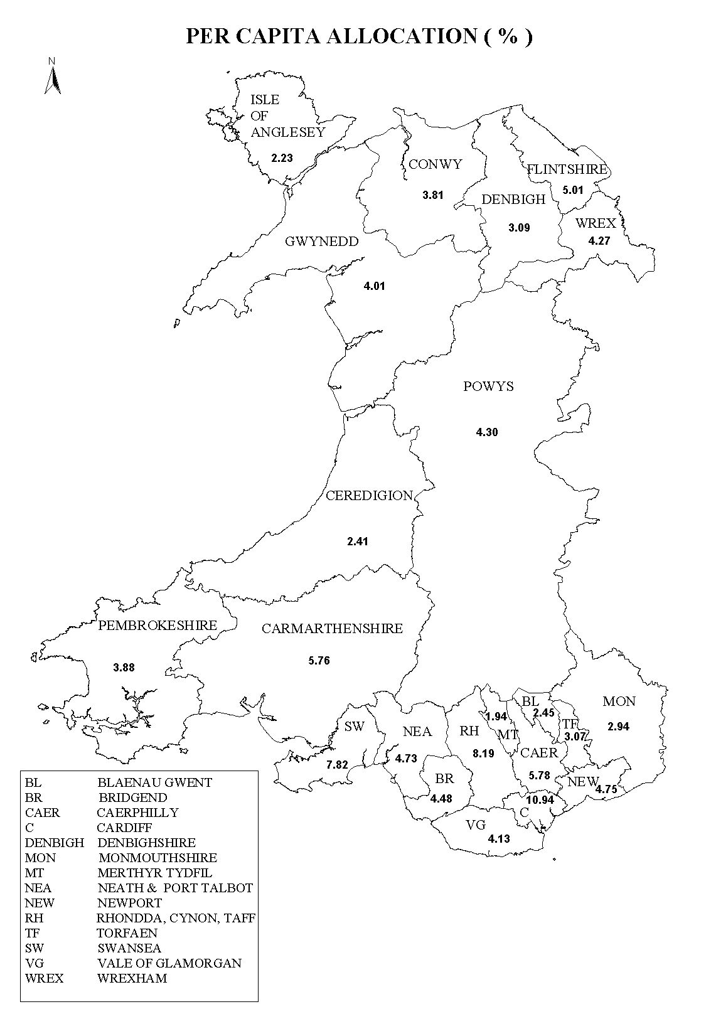

Most health resource allocation formulas, used in the UK and in other European countries, employ indirect measures of health need rather than direct measures because of the unavailability of high quality health data at small area level. Typically, the health needs of an area are estimated from its population characteristics eg its age and gender profiles and, in some cases, its social class or deprivation profiles (see Chapter 3). It is assumed that national prevalence rates of health need for each socio-demographic group can be applied to each local area.

The major problem with this approach is that it takes no account of the history of an area’s population. Life course research on health has shown that a person’s past, as well as present circumstances, can affect their health. For example, poverty in childhood can have long term health consequences. Similarly, the past history of an area’s population can affect its present health needs. National prevalence rates of health need may not always be a good model at the local level.

Several studies have demonstrated that lifetime social circumstances are strongly related to morbidity and mortality in adulthood (Mare, 1990; Davey Smith et al, 1997; Lynch et al, 1997; Power et al, 1998). For example, Davey Smith et al (1997) demonstrated that cumulative social class (indexed by the number of occasions from childhood to adulthood an individual was in a manual social class location) together with the deprivation level of current area of residence are powerful predictors of mortality risk. Childhood and adult social circumstances make independent contributions to the risk of dying. Cumulative experience during adult life is also important. Individuals with average or higher income who experience fluctuating reductions to low income levels have higher mortality rates than those who remain on average or high incomes (McDonough, 1997). The highest mortality rates by a considerable degree are seen among those with persistently low incomes (see Davey Smith (1999) and Davey Smith and Gordon (2000) for discussion).

Nevertheless, most health resource allocation formulas have used this indirect approach to estimating the health needs of an area. The health indicator that is most widely used (including in the existing Welsh formula) is mortality rates. The first map overleaf illustrates how health resources would be allocated in Wales at Local Authority level if this was done solely on the basis of the number of deaths in each area; eg Merthyr Tydfil would receive the least money (2.1%) and Cardiff the most money (9.1%) since it has the greatest number of deaths.

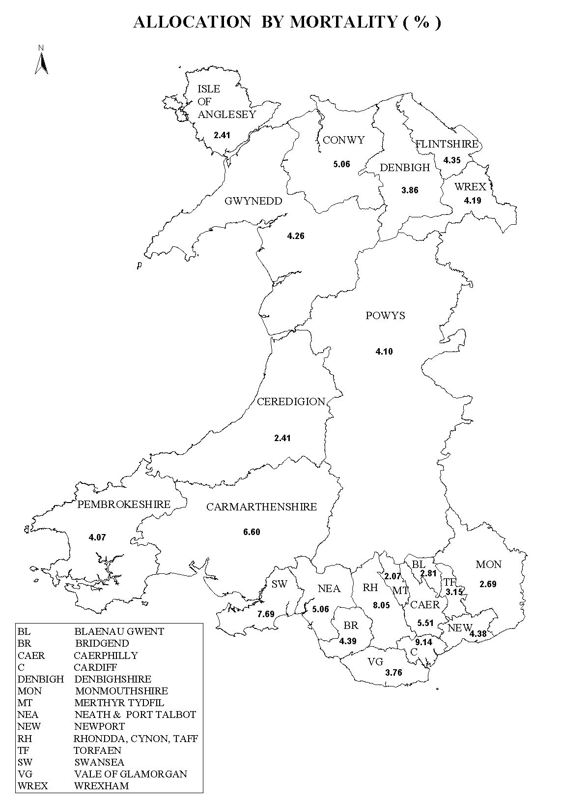
However, despite their widespread use, mortality data are acknowledged not to be the best indicators of health needs for resource allocation, since the NHS tends to deal mainly with ‘sick’ people and sickness and death have somewhat different geographical distributions. This fact is illustrated in Table 4.1 below which shows how health resources would be allocated at Local Authority level if this were solely based on the number of people reporting in the 1991 Census that they had a long term illness or disability that limits their activities (LLTI). On this basis, Rhondda, Cynon, Taff (with 49,016 ‘sick’ people) would receive 10.7% of all health resources and Anglesey (with 9,463 ‘sick’ people) would receive 2.1% of NHS resources. Therefore, Local Health Group/Unitary Authority areas would receive different amounts of money if health resources were allocated on the basis of limiting long term illness rather than on the basis of numbers of deaths or the size of the population.

Table 4.1: Self-reported LLTI in the 1991 Census, distribution at Local Authority level

Local Authority | Number of people reporting a LLTI in the 1991 Census | Percentage Distribution of LLTI in Wales | Standardised Limiting Long Term Illness Ratio  (SIR)
Isle of Anglesey | 9,463 | 2.1 | 106.7
Blaenau Gwent | 15,291 | 3.3 | 169.1
Bridgend | 22,716 | 5.0 | 145.2
Caerphilly | 32,665 | 7.1 | 166.9
Cardiff | 38,360 | 8.4 | 113.4
Carmarthenshire | 30,326 | 6.6 | 131.8
Ceredigion | 8,320 | 1.8 | 95.8
Conwy | 16,140 | 3.5 | 102.7
Denbighshire | 14,180 | 3.1 | 112.5
Flintshire | 18,093 | 3.9 | 110.7
Gwynedd | 15,522 | 3.4 | 102.2
Merthyr Tydfil | 12,819 | 2.8 | 179.1
Monmouthshire | 9,653 | 2.1 | 96.1
Neath Port Talbot | 28,799 | 6.3 | 160.4
Newport | 19,657 | 4.3 | 122.8
Pembrokeshire | 15,239 | 3.3 | 107.1
Powys | 15,523 | 3.4 | 97.8
Rhondda, Cynon, Taff | 49,016 | 10.7 | 172.4
Swansea | 37,951 | 8.3 | 132.9
Torfaen | 15,535 | 3.4 | 145.2
The Vale of Glamorgan | 14,886 | 3.3 | 105.9
Wrexham | 17,868 | 3.9 | 122.2
Total | 458,022 | 100 | 100.0

Potential direct health needs indicators for Wales
Although the 1991 Census did record the number of people who had a limiting long term illness or disability, these data are now almost ten years old and are no longer ideal for current allocation purposes. The 2001 Census data, which should become available by 2003, will provide several direct measures of ill health which could be used for resource allocation (eg the General Health Question and Limiting Long Term Illness). However, a new health resource allocation formula is required in Wales before 2003 (see Appendix 1 for further discussion about 1991 Census health data).

Fortunately, there are more up-to-date high quality health need data available for Wales, down to Local Health Group/Unitary Authority level, which could be used to calculate a needs-based budget allocation formula. In particular, data are available from the Vital Statistics, Hospital Episode Statistics, Cancer Registry, British Association for the Study of Community Dentistry Surveys, Child Health System, GP Morbidity Database (GPMD), Notifiable Disease Statistics and the two Welsh Health Surveys (details are discussed below).

Children’s health needs indicators
There are a number of systems for monitoring children’s health in Wales but not all of these will be available for use in this review - given the short time frame. The following four direct children’s health needs indicators have been used:

- Birth weight. The distribution of birth weight by Unitary Authority is available as a standard output (VS2) from ONS. This gives numbers under 1000g, 500g bands up to 4000g, and over 4000g. Low birth weight is a good proxy for poor child health as is the gradient in the distribution of birth weights (David Hands per comm.). However, reduction in low birth weight should not be used as a target for strategies for tackling deprivation, as the increase in low birth weight is in part a result of the increase in multiple births. Although there are no data to prove it, this increase is likely to be among people who can get access to ovarian stimulants and assisted conception (Alison Macfarlane per comm.) – see also Macfarlane and Mugford (2000).

- Educational Statements. Health needs data is available from the schools collections in Wales, on the numbers of children in the following categories: Moderate Learning Difficulties, Severe Learning Difficulties, Profound and Multiple Difficulties, Specific Learning Difficulties, Physical Disabilities, Autism, Hearing Impairment, Visual Impairment, Hearing and Visual Impairment, Speech and Communication Difficulties, Emotional and Behavioural Difficulties, Other.

- Children's dental health. There is information available, at Local Authority level, from sample surveys by the British Association for the Study of Community Dentistry (BASCD). Each year, one age group is studied: five year olds are surveyed alternate years and, in the intervening year, 12 and 14 year olds alternate. The measure available are the DMFT score - number of decayed, missing and filled teeth - and variations on it such as the percentage of children with some decayed, missing or filled teeth (DT>0).

It must be noted that the Child Health System records a considerable amount of additional information on the health of children in Wales (for example, developmental delay recorded by Health Visitors), however, some of these data may not be available in comparative format for the whole of Wales at UA level. A number of additional sources of information are available on children’s health needs, such as the National Congenital Anomaly System which monitors 23% of births in England and all births in Wales (Macfarlane et al, 2000; ONS, 2001). Recently proposed statistical advances will make this a potentially valuable data source in the future (see Botting and Abrahams, 2000 for discussion)

The Welsh Health Survey
The Welsh Health Surveys (WHS) in 1995 and 1998 obtained detailed information on the health of approximately 1,000 adults in each Unitary Authority area. These two surveys are a unique resource for morbidity data which is available in Wales but not in other UK countries. The suggestion by the research team that some of the morbidity information collected in the WHS could be used as part of a resource allocation formula initially caused some controversy. Therefore, this section will firstly examine what data are available from WHS and what are the advantages and problems with using these data.

Analysis by the research team and the Office for National Statistics has established that the 1998 WHS data are accurate and reliable at Local Health Group/Unitary Authority level after suitable weighting factors have been applied (see Appendix 1). There appears to be no systematic biases in these data that would prevent their use for comparing relative rates of ill health at Unitary Authority level.

The two WHS contain a number of direct measures of ill health which have been used in combination in this report as health needs measures in a resource allocation formula. These include self-reported rates of (percentages in brackets are for Wales in 1998):

- Heart Disease (21%)
  - Hypertension
  - Angina
  - Heart Attack
  - Heart Failure
  - Other

- Cancer (5%)
  - Skin
  - Breast
  - Bowel
  - Lung
  - Other

- Respiratory Illness (23%)
  - Asthma
  - Bronchitis
  - Emphysema
  - Pleurisy
  - Tuberculosis
  - Cystic Fibrosis
  - Other

- Mental Illness (14%)
  - Depression
  - Anxiety
  - Schizophrenia
  - Alzheimer’s disease
  - Other

- Diabetes (4%)
  - Treated by tablets
  - Treated by diet only
  - Treated by injection

- Back Pain (30%)
- Arthritis (25%)
- Varicose veins (11%)
- Stroke (1%)
- Epilepsy (1%)
- Parkinson’s disease (0.2%)
- Pressure sores (0.2%)
- Food Poisoning in UK (19%)
- Injury in Accidents (8%)
  - Break or fracture
  - Cut or puncture
  - Head injury
  - Burn
  - Poisoning
  - Other

- Dental Health – fewer than 20 teeth (31%)
- Visual Impairment (8%)
- Hearing Impairment (13%)

Note: Respondents were asked if they had ‘ever’ had heart disease or cancer. However, they were asked if they had the rest of the diseases ‘now’.

The distribution of the major health need categories measured in the WHS are shown in Chapter 5 (Maps 13a to 13n). It is important to note that different diseases have different patterns of distribution at UA level eg back pain and food poisoning do not have identical distributions.

Summary measures of health
The WHS data also contain three summary measures of general health and well-being. All these three measures have been widely used and validated. The SF-36 is a standard set of 36 health status questions which have been used to measure eight aspects of health and well-being:

- Limiting Long Term Illness (34%)
- International General Health Question (eg would you say your health is ‘Excellent’, ‘Very Good’, Good’, ‘Fair’, ‘Poor’)
- SF-36
  - Physical functioning
  - Role-physical
  - Bodily pain
  - General health
  - Vitality
  - Social functioning
  - Role-emotional
  - Mental health

These eight measures in the SF-36 can be combined into two summary measures of physical and mental health – the Physical Component Summary (PCS) and the Mental Component Summary (MCS).

The SF-36 was originally constructed in the USA to satisfy minimum psychometric standards necessary for group comparisons involving generic health concepts - that is, concepts that are not specific to any age, disease, or treatment group. The eight health measures (described above) were selected from 40 included in the Medical Outcomes Study (MOS) (Stewart and Ware, 1992) to represent those thought to most affected by disease and treatment (Ware et al, 1993; Ware, 1995).

Service use indicators
The 1998 WHS measured the following health service usage in the past year:

Primary care
- Family Doctor (GP)
  - In past 3 months (47%)
  - In past 12 months (78%)
- Optician (46%)
- Dentist (65%)
- Chiropodist (11%)
- Health Visitor or District Nurse (11%)
- Home Help or family aid (2%)
- Meals on wheels (1%)
- Social worker or welfare officer (4%)
- Mental health worker (3%)
- Midwife (3%)
- Alternative medical worker (3%)
- Speech or occupational therapist (1%)
- Physiotherapist (4%)

Secondary care services
- Hospital in-patient
  - Past 3 months (5%)
  - Past 12 months (13%)
- Hospital out-patient
  - Past 3 months (16%)
  - Past 12 months (30%)
- Visited casualty department
  - Past three months (7%)
  - Past 12 months (20%)

In addition, WHS respondents were asked if they had bought any medicines over the past four weeks and if they were on any regular medication prescribed by a doctor (regular meant for a year or more).

Measuring health needs using the Welsh Health Survey
Although the WHS measured a wide range of health needs it should not be considered a universal panacea. Better data are available from other sources for some health needs. For example, the Vital Statistics provide a much more reliable and accurate measure of the number of births and the number of low birth weight babies born at UA level. Similarly, there are better information on food poisoning and cancer morbidity form the Notifiable Statistics and the Cancer Registry than is available from the WHS. Hospital Episode Statistics on admissions for myocardial infarction and unstable angina for heart disease may provide a better indicator for CHD than the information available in the WHS since these admissions are likely to be largely need driven and not subject to significant supply constraints (see Chapter 7). The resource allocation formula has use the best available health needs data at UA level whatever its source. Multiple sources of health needs and costings have been used to construct the resource allocation formula (see below and Appendix 2).

However, the WHS does record a range of information on morbidity and health need which is not available from other sources. The key question is therefore whether the WHS data are sufficiently robust to provide useful estimates on the relative rates of health need between UA areas for the morbidity variables that cannot be provided from other sources.

What is the ‘ideal’ health need information for use in resource allocation?
Over the past hundred years, considerable efforts have been made by epidemiologists to develop instruments that reveal the ‘true’ level of disease in populations, ie the amount of disease that exists after allowing for the fact that some people in a population will think they are ill when in fact there is no objective evidence to support this eg a hypochondria effect. This epidemiological model has resulted in a number of significant advances in the health of the British population. However, it would not be appropriate to just use measures of the ‘true’ level of disease for resource allocation, as any population will always contain some people who think they are ill (even when they are not) and who will seek out and receive some medical care. If the NHS was funded solely on the basis of the cost of treating the ‘true’ level of ill health, then it would run out of money before the end of the financial year since it is impossible not to spend some NHS resources on providing health care for people who ‘feel’ ill, even in the absence of a known specific disease.

There is no way to prevent people from going to see their doctor when they think they are ill and it is people’s perception of their own health status rather than the ‘true’ level of disease that results in people seeking and receiving health care. Therefore, a population’s perceived level of health need, which results in health care expenditure, is a better measure for resource allocation purposes than epidemiological measures of the ‘true’ level of disease prevalence in a population.

The NHS is a ‘health’ service and it does more than just provide treatment for ‘sick’ people who have specific diseases. An adequate resource allocation formula should ideally move beyond a narrow ‘disease’ model of health which defines health need solely in terms of pathological abnormalities which are indicated by signs and symptoms. A broader ‘social’ model of health is required for resource allocation which acknowledges that people may legitimately require health services even when there is no disease currently detectable by medical science (Bowling, 1997). The need for a broader conception of health was acknowledged by the World Health Organisation (WHO) in its definition of health as “a complete state of physical, mental and social well-being and not just the absence of disease and infirmity” (WHO, 1974)

Postal surveys

The WHS is a large postal survey and is therefore known to suffer from a number of problems that are inherent in surveys of this kind. In particular, the responses that people give to health questions in a postal questionnaire are known to sometimes differ from the responses they give to an interviewer or in a clinical study. In general, when people are answering a questionnaire on their own they sometimes claim to have a worse health state than, for example, when answering questions in a doctor’s surgery or when faced with a ‘friendly’ interviewer. The perceived level of ill health recorded in a postal survey such as the WHS is often greater than the ‘true’ level of ill health measured in a clinical study. Because of this, many people consider that postal health status surveys only provide ‘soft’ information on health status in comparison with the ‘hard’ information gained in clinical surveys conducted by health professionals. However, as discussed above, it is precisely this ‘soft’ perceived level of health need that drives NHS expenditure, particularly GMS expenditure. Therefore, the information collected in the Welsh Health Survey provides a useful measure of health need for resource allocation purposes even though the WHS is of more limited value for epidemiological purposes. Soft measures of health need, such as limiting long term illness rates, are often better predictors of GP expenditure than ‘hard’ epidemiological measures of disease prevalence. Indeed, Limiting Long Term Illness and/or Permanent Sickness rate are used in the English, Scottish and Northern Ireland resource allocation formulas (see Chapter 3 for details).

Postal surveys like the WHS are also know to suffer from a number of systematic biases. In particular, they generally have lower response rates amongst:

- the very elderly
- the very sick
- the poorest and most deprived
- ethnic minority respondents (particularly where English is a second language)
- the functionally illiterate
- people with certain disabilities (eg learning, seeing, hearing)
- young single people (particularly young men)

These biases mean that the results from postal surveys need to be treated with caution if they are to be used to compare illness rates between socioeconomic and demographic groups. However, these systematic biases are not so problematic when comparing areas, since the postal survey bias is between groups and not between areas, eg poorer people are equally unlikely to respond to the questionnaire in both Anglesey and Cardiff (see Appendix 1). This means that, although the absolute rates of ill health recorded in the Welsh Health Survey at UA level may well be incorrect, the relative rates of ill health between areas are much more reliably measured. The resource allocation formula is designed to allocate money to each area on the basis of its relative health need, not its absolute health need, therefore the limitations of the WHS for measuring absolute health need are not problematic for resource allocation.

The research discussed in Appendix 1 demonstrates that there are no detectable systematic biases in the WHS data between UA areas, which would prevent the use of these data for resource allocation purposes.

A simplified worked example of how WHS data can be used for resource allocation
The costs of in-patient and day-patient treatment in Wales are available by Diagnostically Related Group (DRG) code. These 800+ DRG codes can be grouped into 25 Major Diagnostic Categories (MDC), which are listed below:

MDC MDC Description
1 Diseases & disorders of the nervous system
2 Diseases & disorders of the eye
3 Diseases & disorders of the ear, nose, mouth & throat
4 Diseases & disorders of the respiratory system
5 Diseases & disorders of the circulatory system
6 Diseases & disorders of the digestive system
7 Diseases & disorders of the hepatobiliary system & pancreas
8 Diseases & disorders of the musculoskeletal system & connective tissue
9 Diseases & disorders of the skin, subcutaneous tissue & breast
10 Endocrine, Nutritional and Metabolic diseases & disorders
11 Diseases & disorders of the kidney and urinary tract
12 Diseases & disorders of the male reproductive system
13 Diseases & disorders of the female reproductive system
14 Pregnancy, childbirth and the puerperium
15 Newborn and other neonates with conditions originating in the perinatal period
16 Diseases & dis.of the blood and blood forming organs and immunological disorders
17 Myeloproliferative Diseases & disorders, and poorly differentiated neoplasms
18 Infectious and parasitic diseases
19 Mental diseases & disorders
20 Alcohol/Drug use and alcohol/drug induced organic mental disorders
21 Injuries, poisonings & toxic effects of drugs
22 Burns
23 Factors influencing health status and other contacts with health services
24 Human immunodeficiency infections
25 Multiple significant trauma

As can be seen, MDC 5 includes the cost of treating hospital in-patient and day-patient diseases and disorders of the circulatory system. However, there are in total 31 major DRG sub-headings that deal with the treatment costs of heart and circulatory disease (eg the treatment costs of hypertension, angina, ischaemic heart disease, etc). The most up-to-date information on heart and circulatory disease in Wales for 1998/99 is summarised below:

Table 4.2: DRG costing for Wales for heart and circulatory disease

Disease area | Total Wales (activity) | Total Wales (cost) | Outside Wales (activity) | Outside Wales (cost) | Total cost | Average cost per activity (in & outside Wales)
Heart & Circulatory Disease | 76737 | £98,532,532 | 1410 | £1,774,015 | £100,306,547 | £1,284

Table 4.2 shows that a total of £98,532,532 was spent on hospital in-patient and day-patient care for heart and circulatory disease in Wales in 1998/99. Furthermore, an additional £1,774,015 was spent by the Welsh NHS on services for treating patients with heart and circulatory diseases outside Wales. This total comprised the treatment of 78,147 patients at an average cost of approximately £1,284 (eg 78,147*£1,283.56p = £100,306,547).

The 1998 Welsh Health Survey measured the following heart and circulatory disease variables:

1) Heart Disease (21%)
  - Hypertension (15%)
  - Angina (6%)
  - Heart Attack (3%)
  - Heart Failure (1%)
  - Other (3%)

Note: figures in brackets are for Wales, eg 21% of people have been treated for at least one type of heart disease.

The distribution of heart disease at UA level recorded in the 1998 WHS is shown in Table 4.3 below:

Table 4.3: Rates of heart disease recorded in the 1998 WHS by UA area

Unitary Authority | Q28. Have you ever been treated for any of these heart diseases? |  | Total
 | No Heart Disease | Heart Disease
Anglesey | 77.7% | 22.3% | 100%
Gwynedd | 80.6% | 19.4% | 100%
Conwy | 78.2% | 21.8% | 100%
Denbighshire | 80.5% | 19.5% | 100%
Flintshire | 81.1% | 18.9% | 100%
Wrexham | 80.1% | 19.9% | 100%
Powys | 80.3% | 19.7% | 100%
Ceredigion | 80.9% | 19.1% | 100%
Pembrokeshire | 77.3% | 22.7% | 100%
Carmarthenshire | 76.9% | 23.1% | 100%
Swansea | 80.9% | 19.1% | 100%
Neath & Port Talbot | 76.6% | 23.4% | 100%
Bridgend | 77.6% | 22.4% | 100%
Vale of Glamorgan | 81.4% | 18.6% | 100%
Cardiff | 81.9% | 18.1% | 100%
Rhondda, Cynon, Taff | 77.6% | 22.4% | 100%
Merthyr Tydfil | 76.3% | 23.7% | 100%
Caerphilly | 76.8% | 23.2% | 100%
Blaenau Gwent | 74.8% | 25.2% | 100%
Torfaen | 76.9% | 23.1% | 100%
Monmouthshire | 82.2% | 17.8% | 100%
Newport | 80.4% | 19.6% | 100%
Wales | 79.2% | 20.8% | 100%

Table 4.3 shows that, in Wales as a whole, nearly 21% of people reported that they had suffered from a heart condition in response to Q28 which asked “Have you ever been treated for any of these Heart Diseases?”. Respondents were asked to indicate all conditions that applied from the following list:

- Yes, Angina,
- Heart Attack (or coronary),
- Heart Failure,
- High Blood Pressure (or Hypertension),
- Another heart Disease
- No, have not had any Heart Disease.

The rate of self-reported heart disease varied considerably across Wales at UA level, from nearly 18% in Monmouthshire to just over 25% in Blaenau Gwent. This is not surprising given that a number of studies have shown that self-reported heart disease rates vary with the level of poverty in Britain.

Table 4.4 provides an illustration of how this 1998 WHS data can be used to apportion resources for the in-patient and day-patient treatment of heart disease across the UAs in order to meet health need more fairly.

Table 4.4: Illustration of using the WHS to allocate hospital in-patient and day-patient resources for treatment of heart disease

Unitary Authority | Q28. Have you ever been treated for any of these Heart Diseases? |  |  | Initial Needs Based Resource Allocation for Heart Disease | Final Resource Allocation adjusted to 1998/99 control total
 | No Heart Disease | Heart Disease | Total % with a Heart Disease | £ | £
Anglesey | 499 | 143 | 2 | £184,101 | £2,419,180
Gwynedd | 939 | 226 | 4 | £290,474 | £3,816,977
Conwy | 882 | 246 | 4 | £315,246 | £4,142,492
Denbighshire | 721 | 175 | 3 | £224,496 | £2,949,993
Flintshire | 1,169 | 272 | 5 | £348,965 | £4,585,580
Wrexham | 984 | 244 | 4 | £313,325 | £4,117,246
Powys | 1,001 | 245 | 4 | £314,476 | £4,132,372
Ceredigion | 588 | 139 | 2 | £178,432 | £2,344,693
Pembrokeshire | 840 | 246 | 4 | £315,872 | £4,150,718
Carmarthenshire | 1,297 | 389 | 7 | £499,094 | £6,558,350
Swansea | 1,838 | 435 | 7 | £558,963 | £7,345,055
Neath & Port Talbot | 1,036 | 316 | 5 | £405,479 | £5,328,206
Bridgend | 989 | 285 | 5 | £365,305 | £4,800,296
Vale of Glamorgan | 929 | 212 | 4 | £272,193 | £3,576,750
Cardiff | 2,533 | 559 | 9 | £717,068 | £9,422,635
Rhondda, Cynon, Taff | 1,807 | 521 | 9 | £669,123 | £8,792,618
Merthyr Tydfil | 409 | 127 | 2 | £163,497 | £2,148,429
Caerphilly | 1,258 | 379 | 6 | £487,009 | £6,399,547
Blaenau Gwent | 524 | 177 | 3 | £226,968 | £2,982,475
Torfaen | 670 | 201 | 3 | £257,528 | £3,384,055
Monmouthshire | 711 | 154 | 3 | £197,241 | £2,591,842
Newport | 1,053 | 256 | 4 | £328,529 | £4,317,037
TOTAL for Wales | 22,677 | 5,947 | 100 | £7,633,384 | £100,306,547

The second column in Table 4.4 shows the weighted number of people who self-reported that they had ever suffered from a heart condition in the 1998 WHS. The third column shows the percentage distribution of heart disease in Wales at UA level, eg the 559 people who self-reported depressive illness in Cardiff represent 9% of all people in Wales self-reporting a heart condition. The next column in Table 4.4 shows the illustrative allocations of monies at UA level for the in-patient and day-patient treatment of Heart Disease, eg Cardiff gets £717,068 and Anglesey gets £184,101. However, the WHS only asked a sample of people in Wales about their health, so not everybody in Wales who has suffered from heart disease was included in the survey. For example, the 1998 WHS found 5,947 people who had suffered from heart disease whereas, during 1998/99, 78,141 Welsh people received hospital in-patient and day-patient treatment for heart disease (see Table 4.2). Therefore, the initial resource allocation needs to be increased so that it reflects the amount of money that was actually spent by the Welsh NHS on treating heart disease in 1998/99. The final column in Table 4.4 shows this final allocation, eg Cardiff receives £9,422,635 and Anglesey receives £2,419,180.

It is important to note that Anglesey would receive this notional allocation in the RAR formula even if there were no facilities on Anglesey for the in-patient and day-patient treatment of heart disease, ie no hospital.

It is also important to note that average national costs of treatment have been used rather than local costs. This has been done to avoid unfairly penalising areas which are highly efficient (can provide high quality treatment at a low cost) and rewarding areas that are inefficient (provide treatment only at a high cost). Local cost data are currently unavailable for all areas due to computer and data problems experienced by some Health Authorities, however, even when they do become available their use should be avoided to ensure that perverse incentives are not built into the Resource Allocation Formula.

By using direct measures of health need, from a range of sources discussed above (including the WHS), a considerable amount of current NHS expenditure can be allocated at UA level. It seems preferable to allocate resources for the treatment of mental illness and other diseases on the basis of reliable measurements of morbidity rather than on the age, sex and social class distribution of the population, weighted by death rates.

Health condition indicators
The health condition indicators used in the Welsh NHS resource allocation formula are shown below along with details of the source of the statistics and the sample size. Details of the resource allocation calculations are given in Appendix 2.

- Medical, surgical and other hospital in-patient and day-patient allocations excluding paediatrics and psychiatrics (Total 1998/99 expenditure = £691,026,391)

Health condition indicator | Data source | Number with health condition in sample
Heart Disease | WHS, 1998 | 5,947
Cancer | Cancer Registry  (average 1995-1997) | 15,009
Respiratory Illness | WHS, 1998 | 6,623
Arthritis | WHS, 1998 | 7,236
Back Pain | WHS, 1998 | 8,816
Epilepsy | WHS, 1998 | 255
Stroke | WHS, 1998 | 349
Diabetes | WHS, 1998 | 1.056
Varicose veins | WHS, 1998 | 3,141
Hearing Impairment | WHS, 1998 | 3,711
Injury in Accidents | WHS, 1998 | 2,187
Dental Health | WHS, 1998 | 8,828
Food Poisoning in UK | Notifiable Statistics  (average 1997-2000) | 21,796
Total |  | 83,899

- Total children’s health costs (Total 1998/99 expenditure =£83,584,614)

Health condition indicator | Data source | Number with health condition in sample
Number of Births | Vital Statistics  (Average 1994-1998) | 41,407
Number of Low Birth Weight Babies | Vital Statistics  (Average 1994-1998) | 2,486
Physical and profound multiple disabilities | Welsh Schools, Jan 2000 | 1,797
Children with dt > 0 (ie some decayed, missing or filled teeth) 1998-9 | BASCD, 1998-99 | 176,135
Number of Children Under 16 | Population Statistics, 1998 | 599,100
Total |  | 820,925
Note: despite the range of information collected on children’s health needs, it proved impossible to relate many of these health needs to the relevant cost information. Therefore, the distribution of the child population under 16 from the 1998 mid-year population estimates was used to allocate some of the costs on a per capita basis, eg indirectly).

- Total maternity costs (Total 1998/99 expenditure = £68,572,443)

Health condition indicator | Data source | Number with health condition in sample
Number of Births | Vital Statistics  (Average 1994-1998) | 41,407
Number of Low Birth Weight Babies | Vital Statistics  (Average 1994-1998) | 2,486
Total |  | 43,893

- Total psychiatric costs (Total 1998/99 expenditure = £230,663,665)

Health condition indicator | Data source | Number with health condition in sample
Mental or Nervous Illness | WHS, 1998 | 3,897
Learning Disabilities | Learning Disability Register, 1999 | 12,363
Children with Special Education needs | Welsh Schools, Jan 2000 | 16,984
Total |  | 33,244

- Total Accident & Emergency costs (Total 1998/99 expenditure =£45,314,758)

Health condition indicator | Data source | Number with health condition in sample
Injury in Accidents | WHS, 1998 | 2,187
Total |  | 2,187

- Medical, surgical and other specialities out-patients costs (Total 1998/99 expenditure = £170,548,870)

Health condition indicator | Data source | Number with health condition in sample
Heart Disease | WHS, 1998 | 5,947
Cancer | WHS, 1998 | 1,479
Respiratory Illness | WHS, 1998 | 6,623
Arthritis | WHS, 1998 | 7,236
Back Pain | WHS, 1998 | 8,816
Epilepsy | WHS, 1998 | 255
Stroke | WHS, 1998 | 349
Diabetes | WHS, 1998 | 1,056
Varicose veins | WHS, 1998 | 3,141
Hearing Impairment | WHS, 1998 | 3,711
Seeing Impairment | WHS, 1998 | 2,343
Dental Health | WHS, 1998 | 8,828
Food Poisoning in UK | WHS, 1998 | 5,880
Total |  | 55,664
Note: Out-patient attendance rates by health condition during the past 12 months are from the WHS.

- General Medical Service costs (Total 1998/99 expenditure = £186,934,000)

Health condition indicator | Data source | Number with health condition in sample
Heart Disease | WHS, 1998 | 5,947
Cancer | WHS, 1998 | 1,479
Respiratory Illness | WHS, 1998 | 6,623
Arthritis | WHS, 1998 | 7,236
Back Pain | WHS, 1998 | 8,816
Epilepsy | WHS, 1998 | 255
Stroke | WHS, 1998 | 349
Diabetes | WHS, 1998 | 1,056
Varicose veins | WHS, 1998 | 3,141
Hearing Impairment | WHS, 1998 | 3,711
Seeing Impairment | WHS, 1998 | 2,343
Dental Health | WHS, 1998 | 8,828
Food Poisoning in UK | WHS, 1998 | 5,880
Mental Illness | WHS, 1998 | 2,187
Injury in Accidents | WHS, 1998 | 3,897
Total |  | 61,748
Note: General Practice attendance rates by health condition are from the GP Morbidity Database and based on 33 practices across Wales covering approximately 300,000 people. These average national rates are multiplied through using the 15 health conditions in the WHS at LHG area level to yield a relative volume allocation, eg it is assumed that each consultation has the same GMS cost whatever the health condition.

- Community Nursing costs (Total 1998/99 expenditure = £59,353,168)

Health condition indicator | Data source | Number with health condition in sample
Heart Disease | WHS, 1998 | 5,947
Cancer | WHS, 1998 | 1,479
Respiratory Illness | WHS, 1998 | 6,623
Arthritis | WHS, 1998 | 7,236
Back Pain | WHS, 1998 | 8,816
Epilepsy | WHS, 1998 | 255
Stroke | WHS, 1998 | 349
Diabetes | WHS, 1998 | 1,056
Varicose veins | WHS, 1998 | 3,141
Hearing Impairment | WHS, 1998 | 3,711
Seeing Impairment | WHS, 1998 | 2,343
Dental Health | WHS, 1998 | 8,828
Food Poisoning in UK | WHS, 1998 | 5,880
Total |  | 55,664
Note: District Nurse and Health Visitor service rates by health condition during the past 12 months are from the WHS.

- Chiropody costs (Total 1998/99 expenditure = £6,754,612)

Health condition indicator | Data source | Number with health condition in sample
Heart Disease | WHS, 1998 | 5,947
Cancer | WHS, 1998 | 1,479
Respiratory Illness | WHS, 1998 | 6,623
Arthritis | WHS, 1998 | 7,236
Back Pain | WHS, 1998 | 8,816
Epilepsy | WHS, 1998 | 255
Stroke | WHS, 1998 | 349
Diabetes | WHS, 1998 | 1,056
Varicose veins | WHS, 1998 | 3,141
Hearing Impairment | WHS, 1998 | 3,711
Seeing Impairment | WHS, 1998 | 2,343
Dental Health | WHS, 1998 | 8,828
Food Poisoning in UK | WHS, 1998 | 5,880
Total |  | 55,664
Note: Chiropody service rates by health condition during the past 12 months are from the WHS.

As can be seen from the tables above, the Welsh NHS resource allocations are based on a wide range of statistical indicators of health need from a range of sources, including: 15 health condition indicators from the 1998 WHS, Cancer Registry Statistics, Notifiable Disease Statistics on food poisoning, Learning Disability Register statistics, Special Education Needs statistics from Welsh Schools, Vital Statistics on births and low birth weight babies and BASCD statistics on children’s dental health. In addition, service utilisation data from the GP Morbidity Database and the WHS has been used as have the 1998 mid year population estimates for Unitary Authorities. Costings data has been drawn from the DRG hospital cost system, the TRF2 financial returns and for GMS expenditure the purchase of primary healthcare statistics reported in Table 14.6 of Health Statistics Wales 1999 (p194).

Additionally, prescribing rates for the 15 health conditions measured in the WHS by major British National Formulary (BNF) Category (01 Gastro-Intestinal System drugs to 13 Skin drugs) have been calculated from eight GP practices with the relevant computer systems that are participants in the GP Morbidity Database. These rates have been used to provide a notional resource allocation at Local Health Group level for prescription drugs. However, prescription drugs are demand-led so this allocation is illustrative and should not be used as a cash limit for prescribing. The majority of General Medical Service expenditure is also demand-led so the GMS allocation should also be viewed as illustrative only.

There is little direct cost data available for GMS, prescribing or community health services. Therefore, these allocations have had to be based upon a slightly different method from the hospital service allocations previously discussed (eg treatment of heart disease in hospitals – see above). A volume-based allocation has been used in these cases and an illustrative example is discussed below.

A simplified worked example of a volume based notional resource allocation: prescribing of cardiovascular system drugs

A wide range of drugs and preparations are used in Wales as part of medical treatments. These drugs have been grouped into 15 major categories in the BNF and aggregated financial information is available in this form. In 1998/99, for example, 9,074,212 prescriptions were issued for cardiovascular system drugs. These drugs cost, on average, £7.87p per prescription, giving a total cost of £71,437,818 for cardiovascular drugs for the whole of Wales during 1998/99 (see Appendix 2 for details).

Cardiovascular system drugs are often prescribed for the treatment of heart disease but they are also used in the treatment of a wide range of medical conditions. Cardiovascular system drugs include:

2.1 Positive inotropic drugs
2.2 Diuretics
2.3 Anti-arrhythmic drugs
2.4 Beta-adrenoceptor blocking drugs
2.5 Drugs affecting the reninangiotensin system
2.6 Nitrates, calcium-channel blockers, and potassium channel activators
2.7 Sympathomimetics
2.8 Anticoagulants and protamine
2.9 Antiplatelet drugs
2.10 Myocardial infraction and fibinolysis
2.11 Antifibrinolytic drugs
2.12 Lipid-regulating drugs
2.13 Local sclerosants

Information on the prescribing of drugs by BNF category is available from the General Practice Morbidity Database. This information has been collected from 33 GP practices across Wales which serve approximately 300,000 patients. Table 4.5 below shows the number of prescriptions for cardiovascular system drugs during 1998/99 in eight of these practices (with advanced computer records) by the health condition of the patient.

Table 4.5 Prescriptions for cardiovascular system drugs by health condition

Health condition |  | Number of prescriptions for Cardiovascular System drugs |  | Percent of prescriptions for Cardiovascular System drugs
Heart | 3,230 |  | 44.1
Cancer | 84 |  | 1.1
Respiratory | 1,086 |  | 14.8
Arthritis | 929 |  | 12.7
Back pain | 462 |  | 6.3
Epilepsy | 10 |  | 0.1
Stroke | 52 |  | 0.7
Varicose veins | 61 |  | 0.8
Diabetes | 249 |  | 3.4
Food Poisoning | 35 |  | 0.5
Hearing | 41 |  | 0.6
Seeing | 5 |  | 0.1
Teeth | 86 |  | 1.2
Mental | 609 |  | 8.3
Accident | 383 |  | 5.2
Total | 7,322 |  | 100

Unsurprisingly, Table 4.5 shows that the majority of cardiovascular system drugs were prescribed to patients with heart disease (3,230 prescriptions, representing 44.1% of total cardiovascular system prescriptions) or respiratory illness (1,084 prescriptions, 14.8% of the total). However, smaller numbers of cardiovascular system drugs were also prescribed for patients with a wide range of other health conditions. For example, there were 10 cardiovascular system prescriptions given to patients with epilepsy and 609 to patients with mental illness, which may illustrate the fact that some patients can have complex and multiple needs, eg ‘serious’ epilepsy and ‘minor’ heart disease.

The GPMD database contains too few GP practices to provide a reliable estimate of the number of prescriptions for cardiovascular system drugs at LHG area level. However, it can provide a reliable estimate of the distribution of cardiovascular system drug prescriptions by health condition at national level (eg for Wales as a whole). In order to produce an estimate of the number of cardiovascular system drug prescriptions at LHG level, it is necessary to use the distribution of disease measured by the 1998 WHS and make the assumption that people with heart disease in different areas (Gwynedd, Bridgend, Cardiff, etc.) are equally likely to require cardiovascular system drugs for treatment as people are in Wales as a whole. The rates of cardiovascular system drug prescriptions shown in the final column in Table 4.5 were applied to the prevalence rates of disease measured in the WHS. In order to then obtain a notional resource allocation for each LHG area, it was assumed that all prescriptions for cardiovascular system drugs in every LHG area cost the same as the national average (ie £7.87p each).

Table 4.6 shows the notional resource allocation for cardiovascular system drugs at local health group area level by health condition. The allocation is notional as prescribing is demand-led and should not be subject to cash limits in a resource allocation formula.

Table 4.6: Notional resource allocation for cardiovascular system drugs at Local Health Group (LHG) area level, by health condition

Unitary Authority | Heart | Cancer | Respiratory | Arthritis | Back | Epilepsy | Stroke | Varicose
Isle of Anglesey | £760,046 | £22,792 | £231,267 | £182,497 | £96,731 | £2,478 | £15,392 | £13,301
Gwynedd | £1,199,199 | £32,794 | £393,555 | £339,252 | £164,509 | £1,441 | £17,912 | £25,581
Conwy | £1,301,468 | £45,051 | £381,008 | £348,624 | £174,216 | £3,845 | £17,902 | £27,438
Denbighshire | £926,814 | £30,177 | £295,013 | £285,257 | £141,378 | £3,284 | £25,128 | £19,017
Flintshire | £1,440,675 | £36,373 | £449,993 | £404,501 | £220,663 | £4,358 | £15,180 | £28,446
Wrexham | £1,293,536 | £31,561 | £419,145 | £371,313 | £184,770 | £4,927 | £11,809 | £24,823
Powys | £1,298,288 | £29,092 | £374,378 | £318,102 | £188,614 | £4,699 | £19,692 | £28,126
Ceredigion | £736,644 | £17,507 | £239,204 | £191,824 | £108,893 | £2,270 | £7,613 | £14,276
Pembrokeshire | £1,304,052 | £38,484 | £361,349 | £333,706 | £168,173 | £2,425 | £16,703 | £24,487
Carmarthenshire | £2,060,470 | £52,990 | £617,810 | £548,453 | £268,712 | £4,117 | £39,115 | £34,812
Swansea | £2,307,633 | £62,897 | £851,182 | £741,703 | £358,696 | £5,854 | £36,512 | £47,761
Neath Port Talbot | £1,673,989 | £38,205 | £613,318 | £502,203 | £256,882 | £5,471 | £18,144 | £32,543
Bridgend | £1,508,133 | £29,850 | £505,592 | £411,895 | £206,959 | £3,154 | £17,438 | £25,867
Vale of Glamorgan | £1,123,726 | £33,543 | £363,956 | £328,419 | £174,441 | £2,493 | £22,081 | £21,431
Cardiff | £2,960,357 | £90,310 | £1,101,604 | £834,154 | £415,904 | £11,485 | £65,480 | £52,423
Rhondda, Cynon, Taff | £2,762,421 | £60,458 | £970,562 | £854,484 | £394,366 | £10,277 | £48,693 | £46,079
Merthyr Tydfil | £674,983 | £14,377 | £258,701 | £225,082 | £96,446 | £2,425 | £13,915 | £12,246
Caerphilly | £2,010,578 | £50,699 | £738,090 | £626,473 | £272,438 | £4,895 | £26,865 | £35,921
Blaenau Gwent | £937,019 | £17,921 | £318,702 | £275,082 | £131,593 | £4,137 | £15,213 | £15,891
Torfaen | £1,063,186 | £21,355 | £339,501 | £278,725 | £140,988 | £3,660 | £28,394 | £19,740
Monmouthshire | £814,292 | £24,994 | £265,228 | £221,538 | £118,446 | £2,749 | £8,143 | £19,582
Newport | £1,356,305 | £38,123 | £506,509 | £440,596 | £223,733 | £7,123 | £20,018 | £25,361
Wales | £31,513,815 | £819,554 | £10,595,666 | £9,063,880 | £4,507,549 | £97,566 | £507,343 | £595,153

Unitary Authority | Diabetes | Food | Hearing | Seeing | Teeth | Accident | Mental | Total
Isle of Anglesey | £43,676 | £6,078 | £8,587 | £908 | £17,621 | £117,913 | £60,261 | £1,579,548
Gwynedd | £103,006 | £11,616 | £13,552 | £1,614 | £26,959 | £246,680 | £111,037 | £2,688,706
Conwy | £106,201 | £13,391 | £13,617 | £1,401 | £35,625 | £265,182 | £139,852 | £2,874,820
Denbighshire | £71,460 | £9,674 | £10,598 | £1,280 | £27,158 | £152,081 | £100,729 | £2,099,047
Flintshire | £107,431 | £16,170 | £15,153 | £1,929 | £37,173 | £319,344 | £154,551 | £3,251,942
Wrexham | £92,125 | £16,223 | £20,143 | £2,037 | £35,940 | £239,931 | £149,680 | £2,897,961
Powys | £95,485 | £12,767 | £12,799 | £1,463 | £36,020 | £197,832 | £121,509 | £2,738,866
Ceredigion | £32,671 | £7,852 | £7,148 | £889 | £20,140 | £107,018 | £85,801 | £1,579,752
Pembrokeshire | £90,553 | £11,714 | £13,054 | £1,807 | £34,111 | £208,596 | £137,597 | £2,746,810
Carmarthenshire | £164,202 | £17,942 | £25,476 | £2,948 | £56,372 | £406,910 | £219,498 | £4,519,828
Swansea | £209,703 | £28,302 | £30,665 | £3,567 | £66,946 | £463,201 | £290,759 | £5,505,380
Neath Port Talbot | £157,693 | £16,421 | £22,486 | £3,037 | £47,250 | £303,782 | £192,652 | £3,884,077
Bridgend | £92,134 | £16,265 | £19,453 | £2,623 | £37,668 | £248,943 | £159,172 | £3,285,146
Vale of Glamorgan | £62,703 | £14,018 | £13,787 | £1,755 | £28,891 | £228,599 | £114,782 | £2,534,625
Cardiff | £220,885 | £40,732 | £36,852 | £4,726 | £69,758 | £585,212 | £411,772 | £6,901,654
Rhondda, Cynon, Taff | £237,309 | £29,260 | £38,570 | £5,195 | £74,819 | £566,577 | £357,814 | £6,456,884
Merthyr Tydfil | £54,422 | £6,168 | £11,473 | £1,522 | £18,593 | £141,940 | £111,086 | £1,643,380
Caerphilly | £168,279 | £19,979 | £31,709 | £3,524 | £54,126 | £371,235 | £289,322 | £4,704,132
Blaenau Gwent | £93,143 | £9,591 | £13,197 | £1,765 | £24,919 | £159,671 | £126,965 | £2,144,809
Torfaen | £91,050 | £12,194 | £14,325 | £1,503 | £28,680 | £226,242 | £154,681 | £2,424,223
Monmouthshire | £40,668 | £8,289 | £10,175 | £1,312 | £21,499 | £120,007 | £67,505 | £1,744,426
Newport | £94,596 | £16,835 | £17,202 | £1,982 | £38,799 | £264,871 | £179,750 | £3,231,802
Wales | £2,429,393 | £341,481 | £400,021 | £48,783 | £839,068 | £5,941,769 | £3,736,777 | £71,437,818

The final column in Table 4.6 shows the notional resource allocation for cardiovascular system drug prescriptions. The Welsh NHS total expenditure on these types of drugs in 1998/99 was £71,437,818, of which Anglesey has been allocated £1,579,548 and Newport has been allocated £3,231,802.

In order to obtain a notional resource allocation for the whole prescribing budget, the procedure discussed above was repeated for each category of drug by major BNF grouping and the results then aggregated to produce a final total notional allocation by LHG area. This is shown in Table 4.8 below and in Appendix 2.

Final resource allocations
Brief details of the stages of the resource allocation calculations are given in Appendix 2. The allocations are based upon the actual expenditure detailed in the TRF 2 financial returns for 1998/99. The TRF 2 returns are financial summaries by major expenditure category based on the NHS Trust Accounts.

Table 4.7: TRF 2 Welsh NHS expenditure, by major financial category (£)

Expenditure category | 1997/98 | 1998/99 | 1999/00
Medical | 372,341,436 | 412,909,684 | 448,698,089
Surgical | 372,649,395 | 408,871,113 | 431,650,720
Maternity | 54,794,366 | 58,606,228 | 65,168,221
Psychiatric | 155,987,932 | 168,584,636 | 175,855,520
Other | 93,229,036 | 92,162,258 | 99,860,549
Accident & Emergency | 35,405,241 | 41,684,705 | 44,994,451
Day care | 33,465,910 | 35,003,773 | 33,230,378
Community | 213,014,057 | 230,075,103 | 282,928,467
Total | 1,330,887,373 | 1,447,897,501 | 1,582,386,395

Table 4.7 gives summary details of the categories of the £1.447 billion of NHS expenditure in the 1998/99 financial year. The largest category of expenditure was on hospital medical services (£412 million) and the smallest category of expenditure was on day care (£35 million). The resource allocation formula assumes that the amount spent on these expenditure categories in 1998/99 was correct and allocates resources at Local Health Group level based upon this apportionment. There has been no redistribution between expenditure categories, for example, the formula allocates £168 million of psychiatric and £58 million of maternity expenditure to LHG level. It does NOT examine if more (or less) should have been spent on psychiatric or maternity services.

Table 4.8 (below) shows the final aggregate allocations for the TRF 2 NHS financial returns and also a notional allocation for prescribing and General Medical Service costs at LHG level, using the methods described above and in Appendix 2.

Table 4.8: Final NHS resource and notional prescribing cost allocations at LHG level

Unitary Authority | Total TRF 2 allocation  (1998/99) | Total notional prescribing allocation | Total notional GMS allocation  (1998/99)
Isle of Anglesey | £29,542,454 | £6,901,757 | £3,936,208
Gwynedd | £51,833,991 | £12,067,735 | £6,789,420
Conwy | £54,780,361 | £12,787,157 | £7,414,572
Denbighshire | £40,626,953 | £9,415,417 | £5,575,410
Flintshire | £61,282,841 | £14,691,894 | £8,424,861
Wrexham | £54,703,174 | £13,131,548 | £7,798,858
Powys | £52,557,501 | £11,944,859 | £7,138,658
Ceredigion | £30,075,936 | £7,108,739 | £4,123,668
Pembrokeshire | £51,114,325 | £11,939,967 | £7,009,582
Carmarthenshire | £84,642,402 | £19,959,755 | £11,511,956
Swansea | £107,119,168 | £25,548,271 | £14,749,173
Neath Port Talbot | £71,380,755 | £17,825,225 | £10,284,422
Bridgend | £60,637,817 | £14,778,123 | £8,532,037
Vale of Glamorgan | £48,860,650 | £11,516,004 | £6,695,806
Cardiff | £135,475,343 | £32,140,475 | £18,113,943
Rhondda, Cynon, Taff | £121,336,340 | £29,584,802 | £16,909,468
Merthyr Tydfil | £31,394,743 | £7,672,425 | £4,336,723
Caerphilly | £86,497,335 | £21,686,942 | £12,332,251
Blaenau Gwent | £39,554,102 | £9,692,974 | £5,640,124
Torfaen | £47,509,902 | £10,925,042 | £6,304,093
Monmouthshire | £32,483,953 | £7,818,006 | £4,645,291
Newport | £62,557,954 | £15,135,604 | £8,667,477
Wales | £1,355,818,521 | £324,272,720 | £186,934,000

Table 4.8 shows that £1.355 billion of NHS resources detailed in the TRF 2 financial return have been allocated by the formula. It has not been possible to allocate £92 million of expenditure using the formula. This unallocated expenditure is mainly for supra-regional and supra-district services (such as organ transplants) where a formula based allocation at LHG level would be unwarranted or for community health service expenditure (health promotion, other services, etc), where there is insufficient information to allow allocation at LHG level. The TRF 2 allocations in Table 4.8 range from £135 million for Cardiff to £30 million for Anglesey. The needs-based resource allocation formula has the effect of allocating more NHS resources to the more deprived LHG areas of Wales than would a per capita or mortality-based allocation. This is also true for the notional prescribing and GMS allocations where, in general, the more deprived districts receive a higher allocation and the wealthier districts a lower allocation than they would purely on a per capita basis (ie based on the size of their populations).

However, it must be emphasised that, even if a needs-based NHS resource allocation is implemented, this will not by itself reduce the current wide inequalities in health in Wales. In order for health inequalities to be reduced, specific resources need to be allocated for this purpose and health equity policies implemented. Chapters 5, 6 and 7 examine these issues.

Chapter 5: Distribution of health needs in Wales

The aim of this section is to identify health needs within Wales. Thus, available measures are initially explored as raw counts of mortality and morbidity: unstandardised, as each case is an indicator of a health need. However, there is an obvious tendency for areas with high populations to demonstrate high levels of health need, particularly if they contain a relatively high proportion of older people. Hence, some of the datasets have been subsequently standardised according to the age and sex structures of the populations of each area, which enables excessively high, and excessively low, rates of disease to be identified.

In addition to exploring health need using current figures available, it is helpful to look at changes over time and comparisons between areas, using as small an areal unit as is practicable. For these comparisons to be effected, data need to be collected and compiled over consistent areal units. Such units are commonly those designated for administrative purposes in local government and for the NHS. It is a source of some frustration that electoral and health boundaries are far from constant, for example, Local Authority districts and wards have been changed both between the 1981 and 1991 Censuses of Population and subsequent to the 1991 Census. In Wales, substantial changes were made to form the boundaries of the new Unitary Authorities (UAs) which are not direct aggregations of 1991 Census wards.

Mechanisms exist to transform datasets between one set of units and another: for example, to map 1981 Census data using 1991 ward boundaries. However, whenever this occurs there is a loss of accuracy and data quality is compromised, although considerable efforts are made to minimise this. There are two further geographical considerations.

The modifiable areal unit problem arises whenever arbitrary boundaries such as administrative units are employed. Essentially, measures calculated for these areas can change substantially depending upon how the boundaries are constructed (see, for example, the work of Openshaw and Taylor, 1979; Green and Flowerdew, 1996). Adjusting the boundaries can have substantial effects on calculated indicators.

Further, statistical modelling generally assumes that observations are independent. However, it is often the case that processes can be operating at a local scale, with the result that the independence is compromised, ie places which are near to one another are more likely to share similar characteristics than places which are further away, and this can affect the data which are collected. Spatial autocorrelation techniques (Goodchild, 1987) can be used to assess whether this appears to be in evidence.

To supplement the tabulation of results, some data are geographically mapped in this section to facilitate visual exploration. In this way, areas with similar health measures can be seen and geographically close areas with similar rates are more easily identified. The data for the areas are grouped into four or five class intervals and each class is shaded. The darker the shading, the higher the absolute count of cases, or disease rate. Hence, a cluster of areas with dark shading will indicate a geographical concentration of a high occurrence of mortality or morbidity.

Data are available at a variety of spatial scales, generally limited by the requirement that individuals should not be identifiable. The data here are explored at as disaggregated a scale as is feasible. The base level is that of 1991 Census wards (the UA boundaries are superimposed but are not necessarily coterminous). A reasonable expectation would be that the major causes of both mortality and morbidity would follow the distribution of the population at risk. As a guideline, the ward populations for those aged 55 and over are shown as Map 1. Here, the areas of dark green on the map show the relatively high ward populations in Cardiff, Swansea, south Wales and the northern coastal towns. This generally indicates urban areas.

However, different diseases have different geographies, even where the age and sex structures of the wards are similar. An example is the contrast between lung cancer, where high rates will be evident in urban areas with high levels of deprivation, and skin cancers, which are apparent both in rural areas and some more affluent urban areas.

Mortality from heart disease (1998) can be seen in Map 2a (for males) and Map 2b (for females). These maps show the total number of deaths for 1996 to 1998. High values can be seen where they are expected, ie in south Wales and north-east Wales. However, there are comparatively low values for female mortality in Pembrokeshire and Powys. Maps 2c and 2d show data for the same years but these have been standardised by a subset of older age categories to produce comparable rates for the ward population structures. Hence, 100 is the ‘average’ rate over Wales. Clearly the excessive rates, shaded dark green, are more widely dispersed, particularly over south-west Wales and through central areas. The pattern is similar for females showing that, for example, there is no evidence of unusually high rates in Cardiff.

Mortality from respiratory disease (Map 3) follows a broadly similar pattern to heart disease, though more concentrated perhaps due to occupational risk, ie with much lower totals in central Wales.

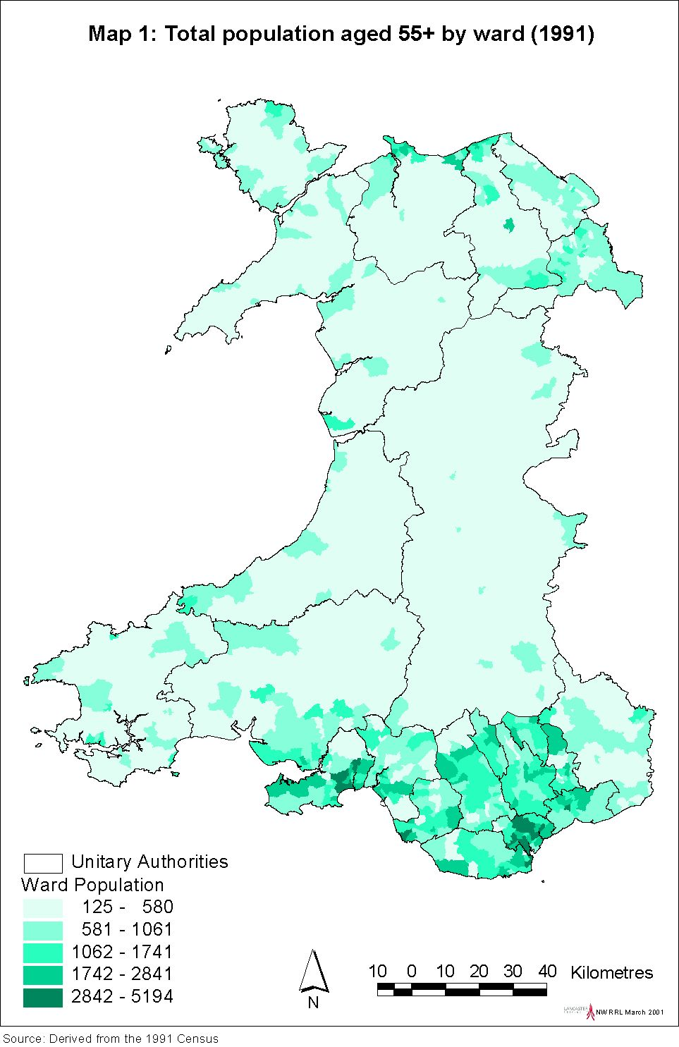
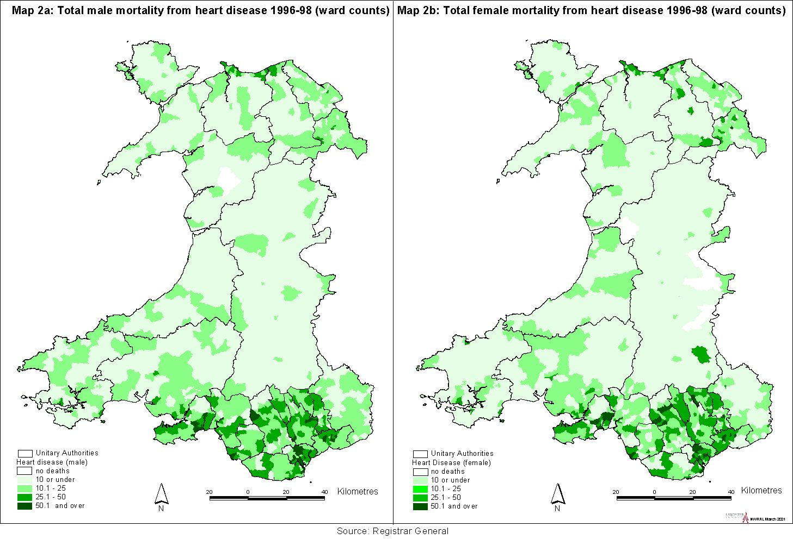
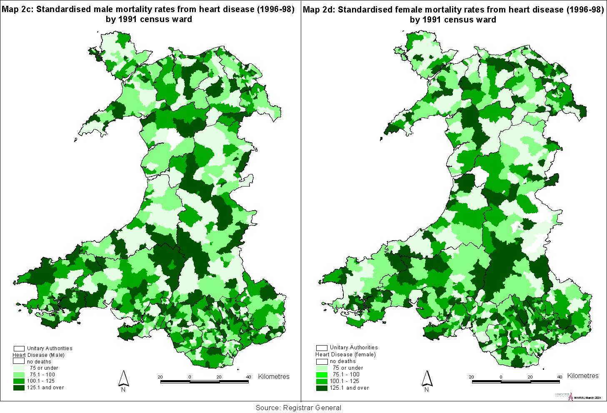
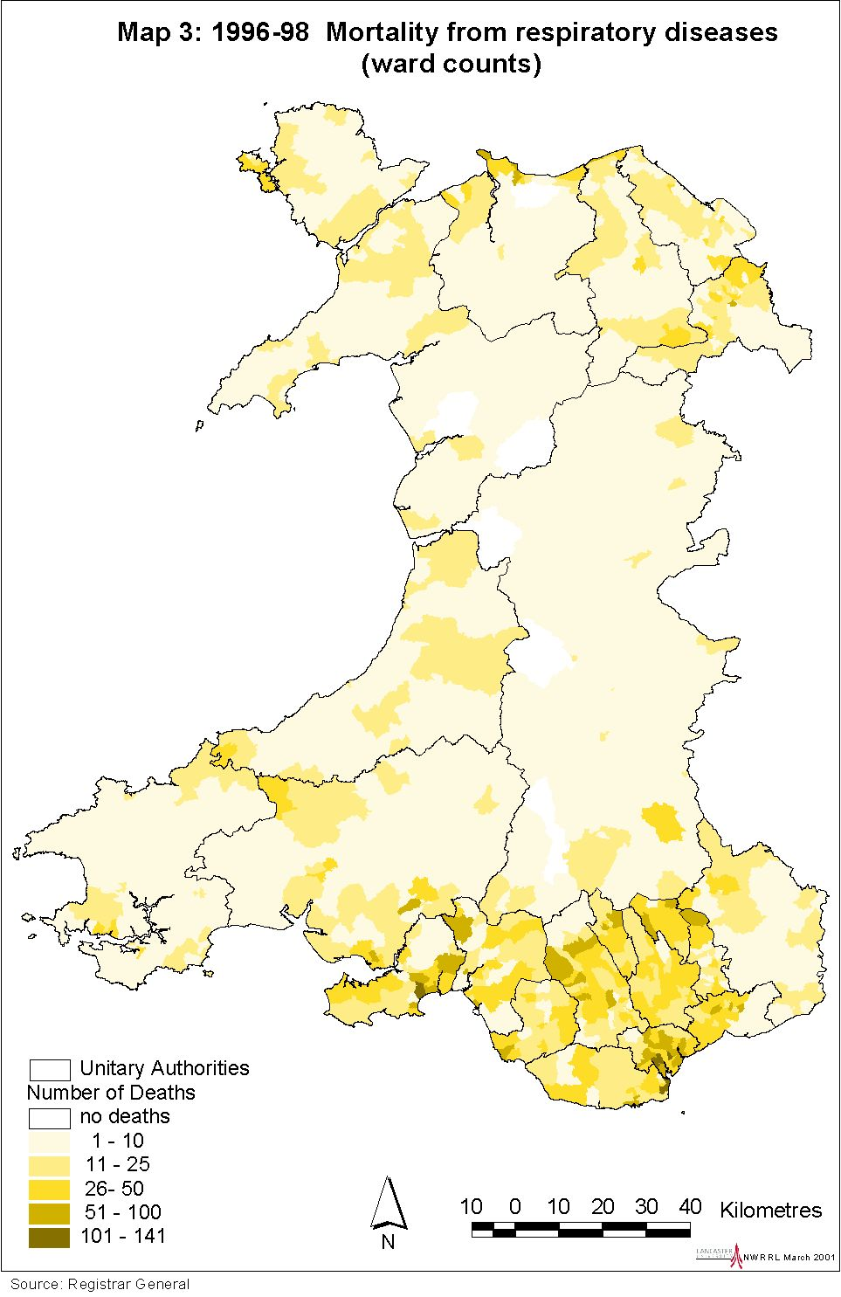
Cancer (within Wales)
As approximately one in three people will develop cancer before the age of 75, it is a major health concern, forming a substantial burden on health services, in addition to those of the sufferers and their families. Across Wales, there are some 20,000 cases per year, resulting in 80,000 hospital admission episodes and 8000 deaths (Welsh Cancer Intelligence and Surveillance Unit). Three aspects of cancer statistics can be explored: mortality, incidence and survival.

Mortality from cancers between 1996 to 1998 are mapped at ward level. Maps 4a and 4b show the total numbers of cancer deaths for males and females, with Maps 4c and 4d showing the standardised rates for comparison, which are again more widely dispersed. The geographical distribution of cancer mortality is not the same as that of cancer incidence. The distributions in Maps 4a and 4b can be compared with Map 5, which shows cancer incidence (total number of registrations) for the four year period from 1994 to 1997. Incidence seems relatively high in Ceredigion and Pembrokeshire and lower in Monmouthshire.

Incidence for the more common sites of cancer have also been mapped. The highest incidence for male lung cancer (Map 6a) is in south and north-east Wales, whereas female lung cancer is more evident in south-east Wales. Male and female incidence of colorectal cancer is more consistent (Maps 7a,7b). Female breast cancer is more dispersed than either lung or colorectal cancer, notably in Carmarthenshire and Ceredigion. Map 8a shows total incidence, whereas Map 8b illustrates the standardised rates.

Table 5.1 indicates the most recent survival figures available for specific cancers by Health Authority. North Wales and Morgannwg would seem to have rather better five year survival rates than the other authorities.

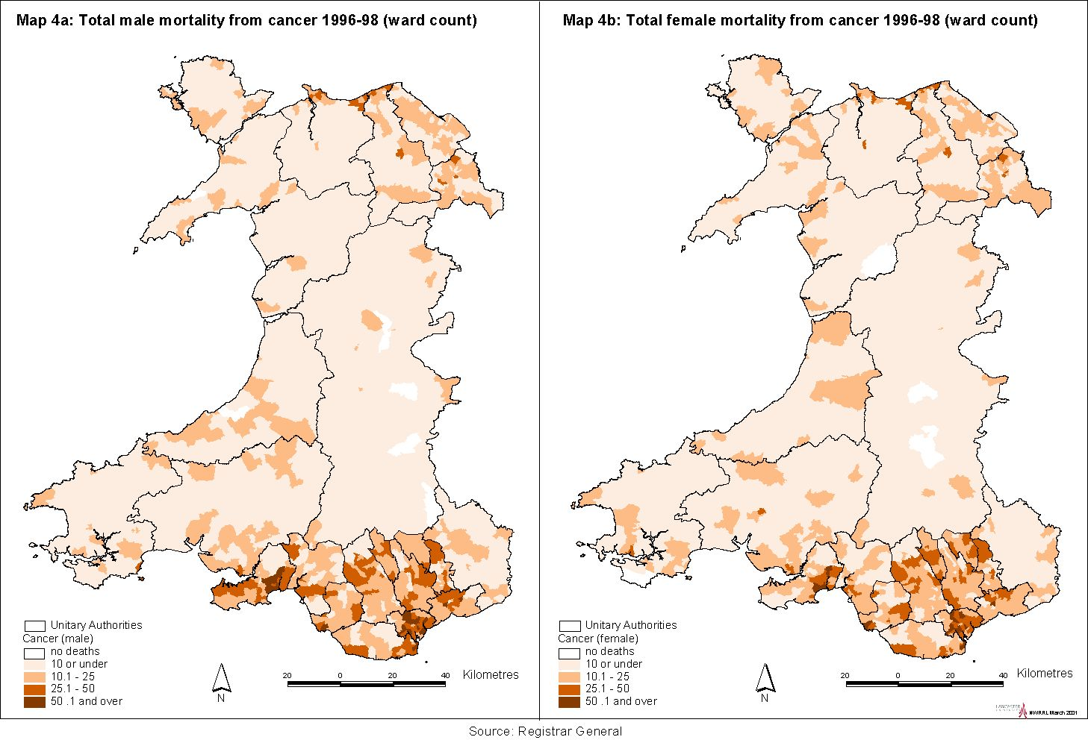

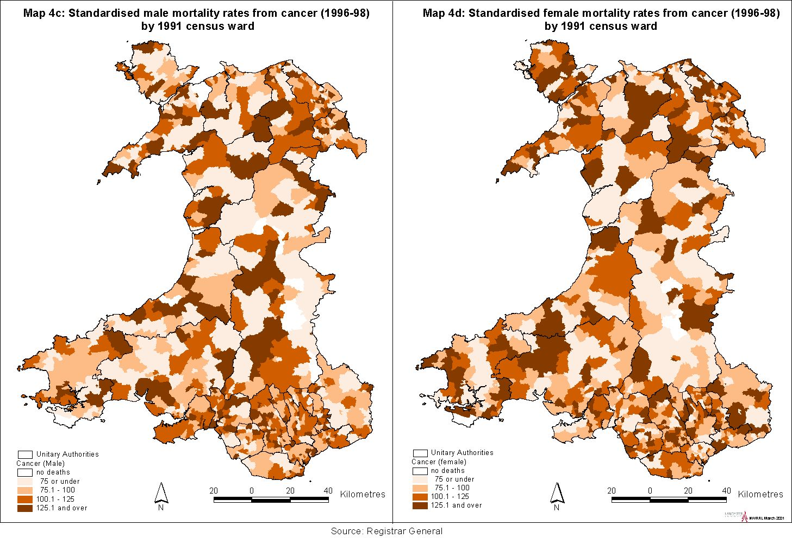

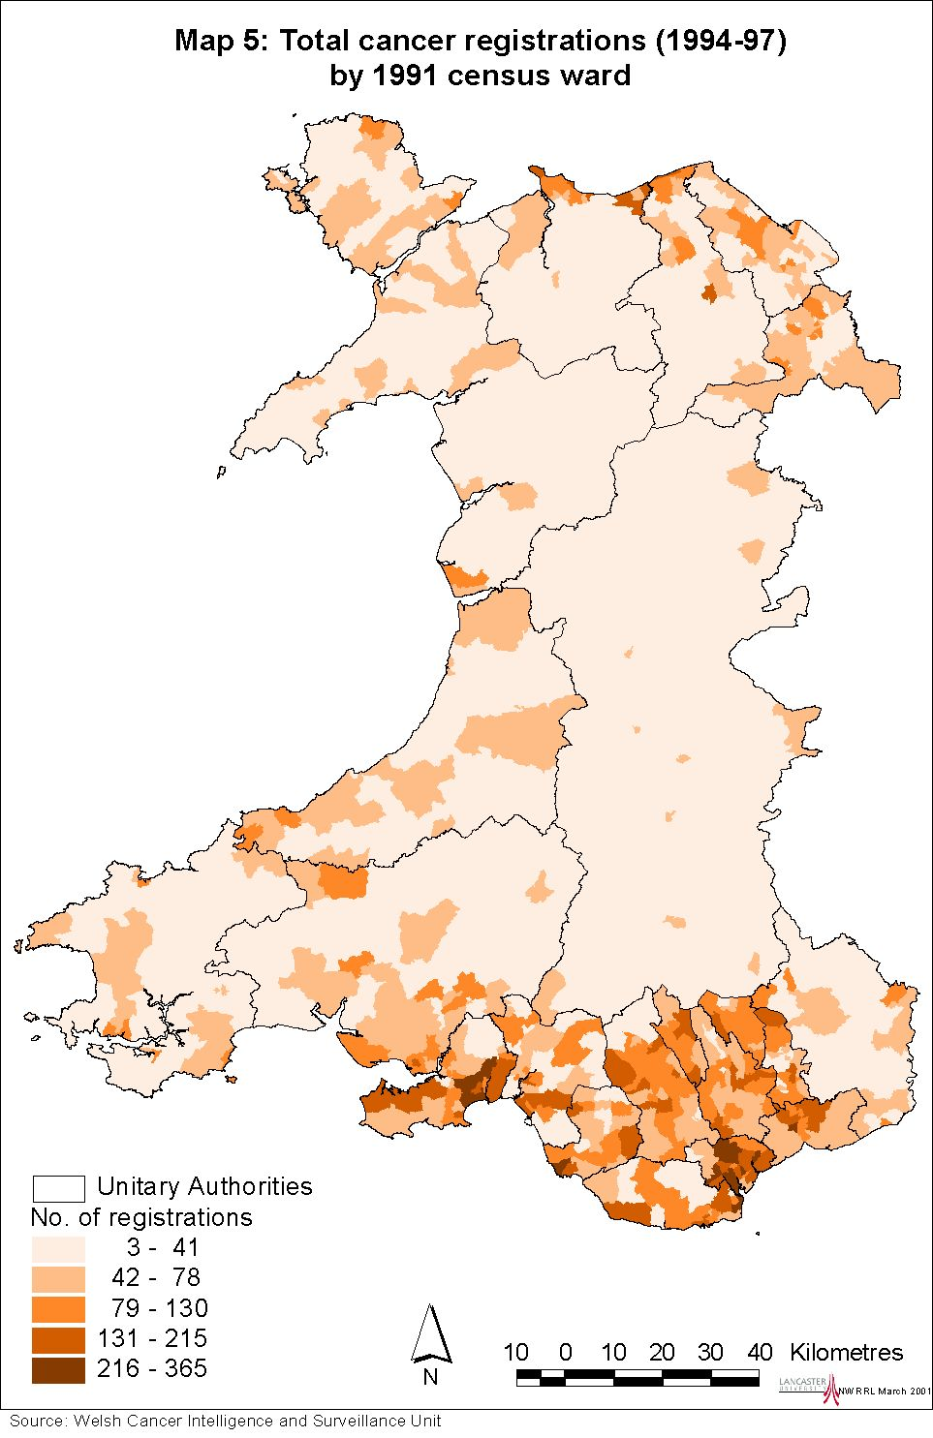

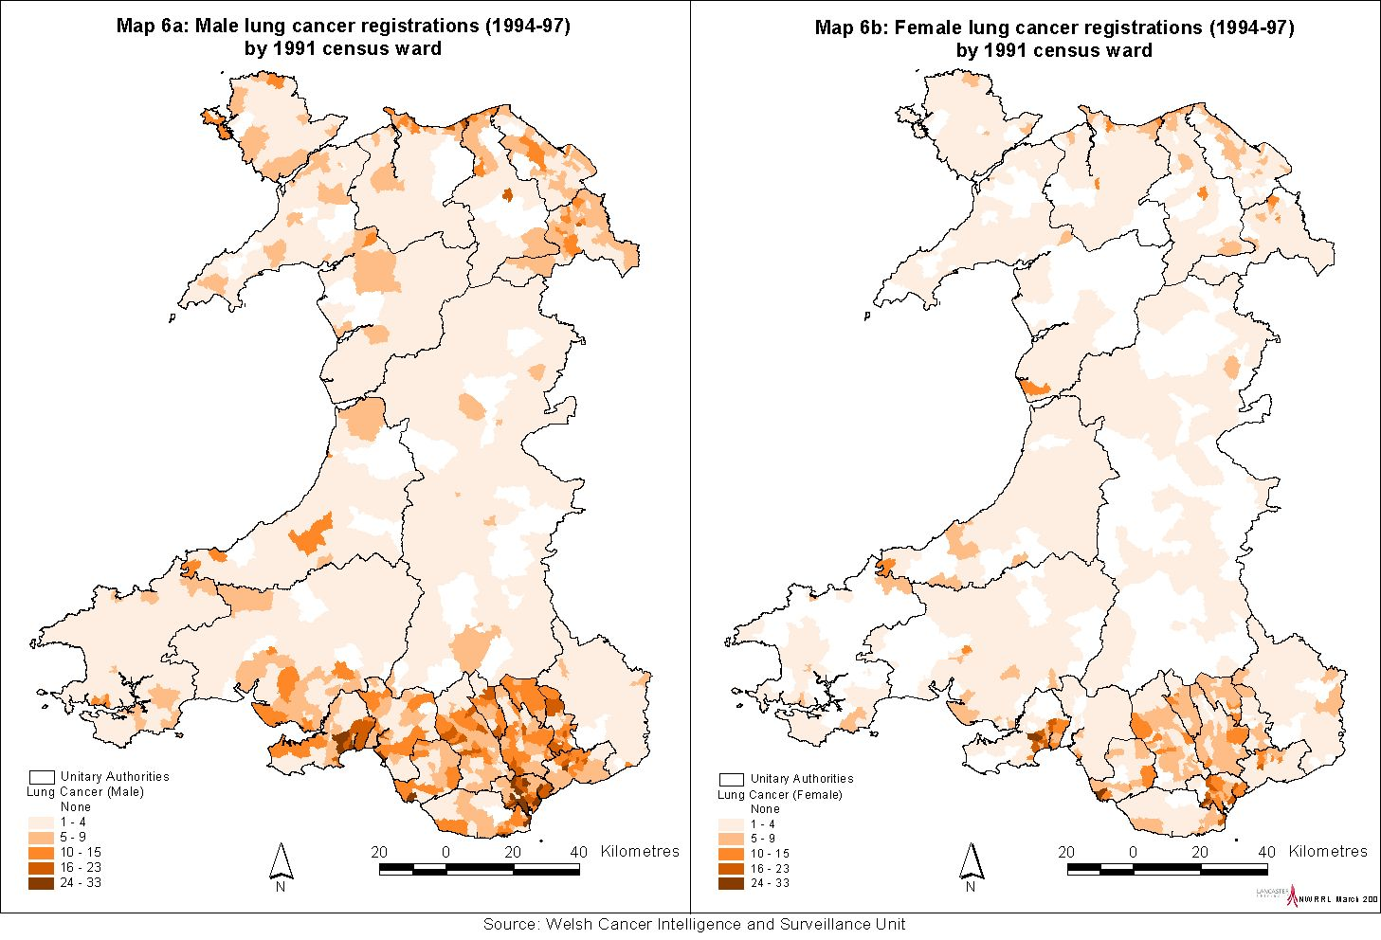

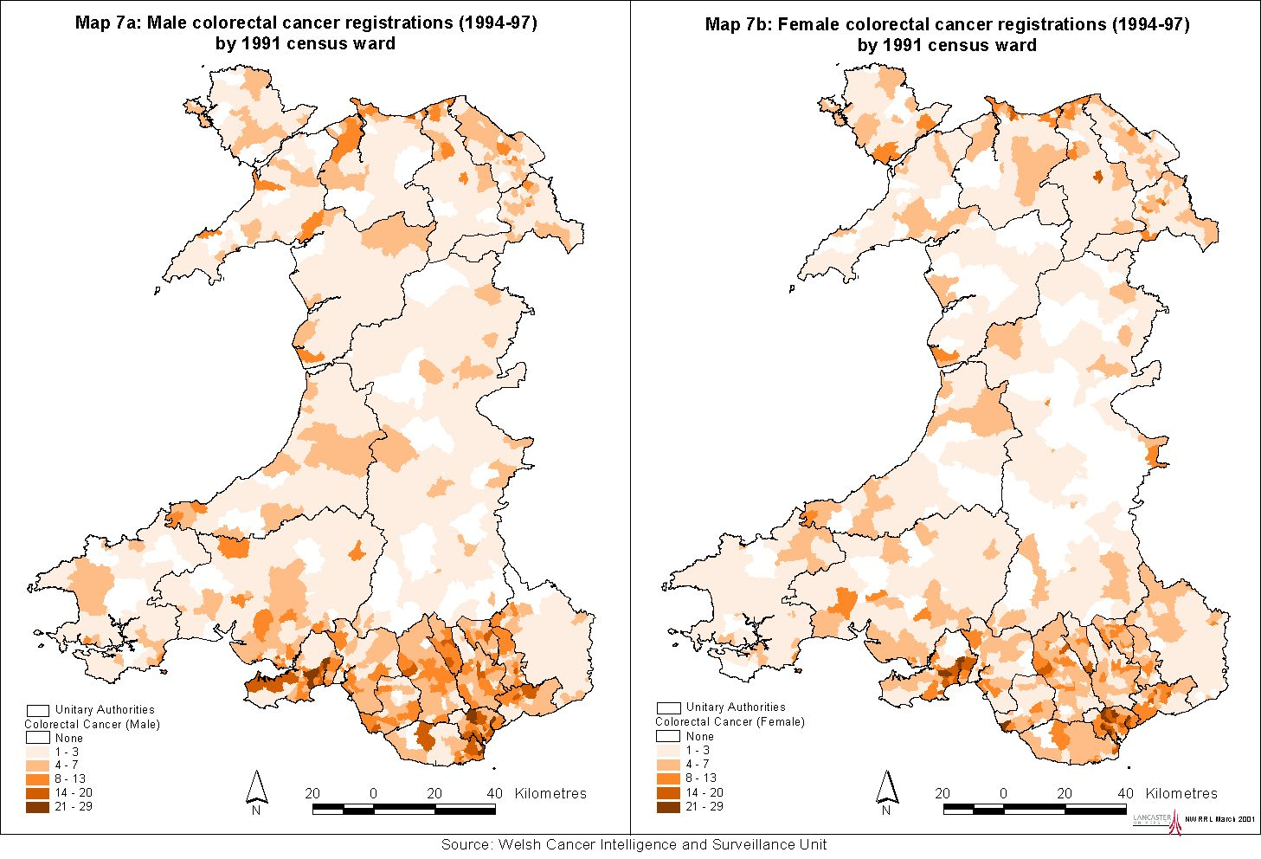

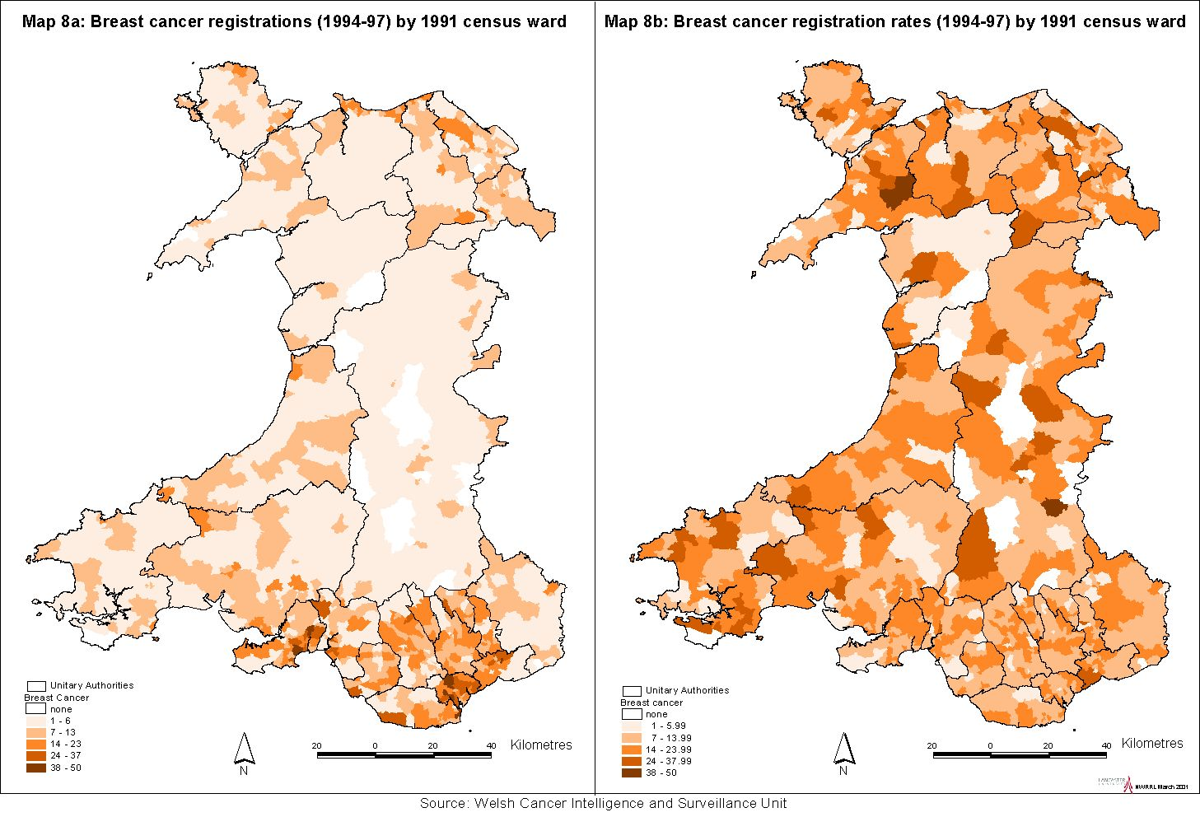

Table 5.1: Cancer survival rates

 |  | Relative Survival
 |  | 1 year (%) | 5 year  (%)
Breast – Female | Gwent | 83 | 62
 | Bro-Taf | 82 | 60
 | Dyfed-Powys | 85 | 66
 | North Wales | 85 | 67
 | Morgannwg | 87 | 67
 | All Wales | 85 | 65
Lung – Male | Gwent | 23 | 9
 | Bro-Taf | 22 | 10
 | Dyfed-Powys | 20 | 8
 | North Wales | 21 | 10
 | Morgannwg | 20 | 8
 | All Wales | 22 | 9
Lung - Female | Gwent | 22 | 7
 | Bro-Taf | 22 | 10
 | Dyfed-Powys | 23 | 12
 | North Wales | 25 | 11
 | Morgannwg | 24 | 11
 | All Wales | 24 | 11
Colorectal - Male | Gwent | 59 | 37
 | Bro-Taf | 57 | 35
 | Dyfed-Powys | 56 | 34
 | North Wales | 61 | 43
 | Morgannwg | 65 | 43
 | All Wales | 60 | 39
Colorectal - Female | Gwent | 60 | 38
 | Bro-Taf | 60 | 42
 | Dyfed-Powys | 59 | 38
 | North Wales | 61 | 43
 | Morgannwg | 63 | 44
 | All Wales | 61 | 42
Note: based on 1985-89 registrations, ages 0 to 84.
Source: Welsh Cancer Intelligence and Surveillance Unit, per comm.

Breast cancer screening
Two rounds of the three-year breast screening cycle (of women aged 50-64) are complete. There is considerable variation in screening uptake and of particular concern is Cardiff where, for both rounds, uptake was less than 70%. Rates are also relatively low in much of north Wales, plus Vale of Glamorgan, Neath Port Talbot and Rhondda, Cynon, Taff, where uptake is below 76%. Breast Test Wales is closely monitoring the situation by, for example, conducting research into screening uptake by women from ethnic minority groups.

Health status
Table 5.2 gives male and female life expectancies at UA level. The figures reveal five year differentials for males, from 76.1 in Ceredigion down to 70.1 in Merthyr Tydfil. The gap is slightly smaller for females, from 80.8 in Monmouthshire down to 76.7 in Merthyr Tydfil.

Table 5.2: Life expectancy at birth by Unitary Authority, 1995-97

 | Males | Females
Blaenau Gwent | 72.5 | 77.5
Bridgend | 73.2 | 79.3
Caerphilly | 73.5 | 77.6
Cardiff | 74.2 | 80.0
Carmarthenshire | 73.7 | 78.9
Ceredigion | 76.1 | 80.6
Conwy | 74.9 | 80.3
Denbighshire | 74.1 | 80.0
Flintshire | 74.4 | 79.0
Gwynedd | 75.2 | 80.6
Isle of Anglesey | 74.6 | 79.7
Merthyr Tydfil | 71.1 | 76.7
Monmouthshire | 75.8 | 80.8
Neath Port Talbot | 72.5 | 79.1
Newport | 73.7 | 79.3
Pembrokeshire | 74.3 | 79.7
Powys | 75.5 | 80.2
Rhondda, Cynon, Taff | 72.5 | 77.8
Swansea | 74.1 | 79.2
Torfaen | 73.5 | 78.4
The Vale of Glamorgan | 74.9 | 79.8
Wrexham | 73.5 | 78.5
Source: ONS (2001)

Statistics relating to morbidity are not routinely collected as comprehensively and consistently as those for mortality. One exception is the decennial Census whereby, in 1991, a question was asked relating to limiting long-term illness in households. The results are displayed in Maps 9a and 9b, showing the lowest rates for both males and females in Monmouthshire and The Vale of Glamorgan, and high rates for the cluster of UAs from Neath Port Talbot to Blaenau Gwent.

Conditions reported in the WHS 1998 are also mapped (see Maps 13a to 13n). This set of maps again illustrates health need, by displaying total counts. Heart disease seems concentrated in Rhondda, Cynon, Taff and Cardiff; high reported occurrences of respiratory illness include Swansea. Both heart and respiratory disease greatly exceed cancers, although poor outcomes for cancers may explain this, as the diseases were self-reported. Ceredigion is the only UA that is consistently in the lowest class for major diseas
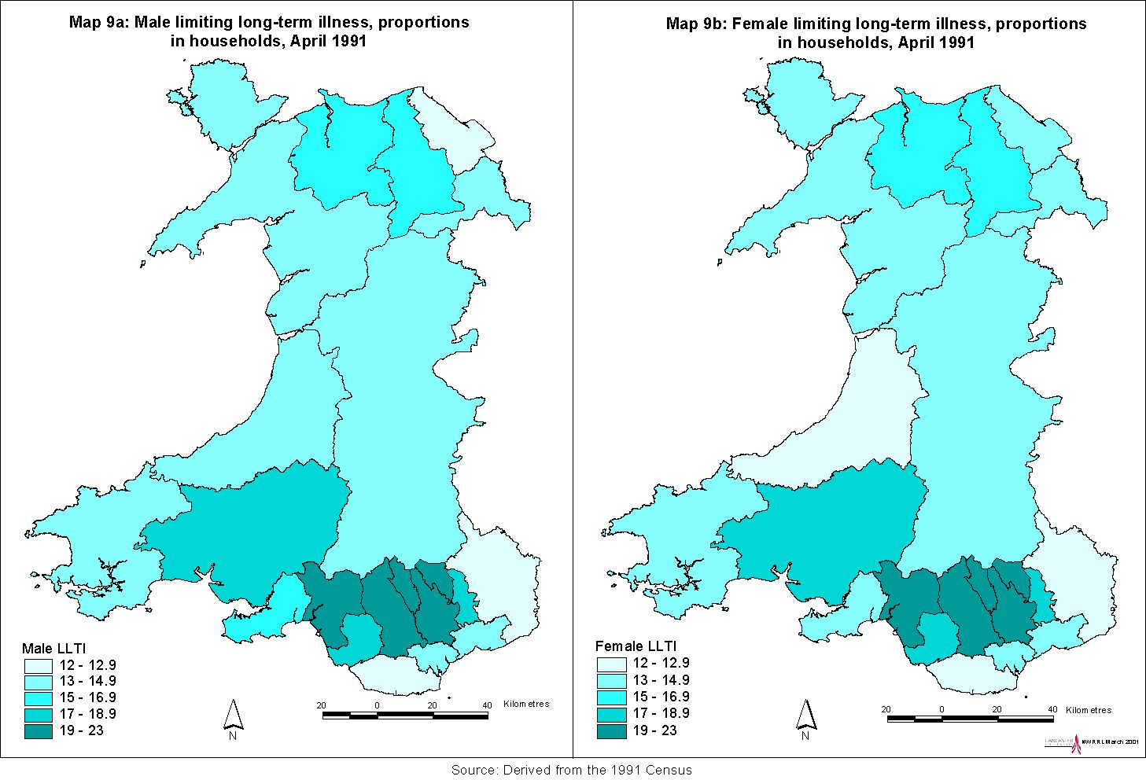
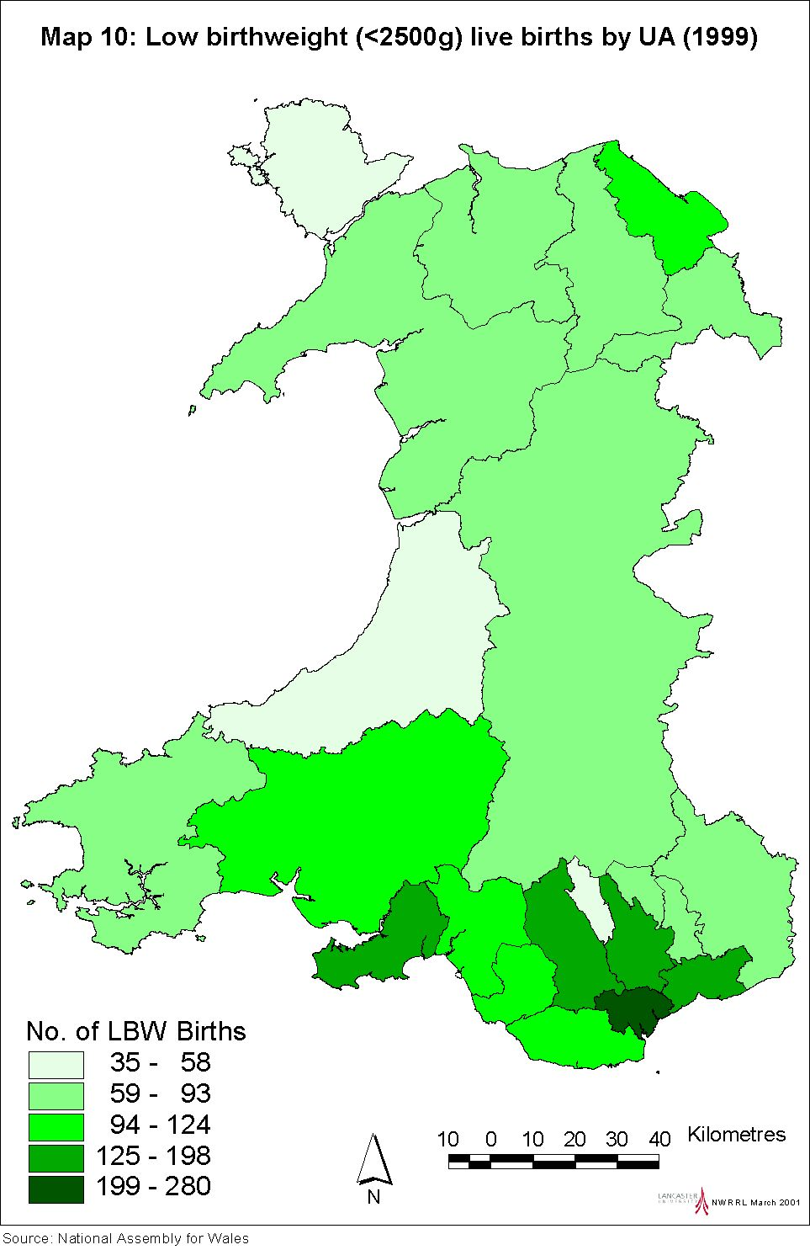

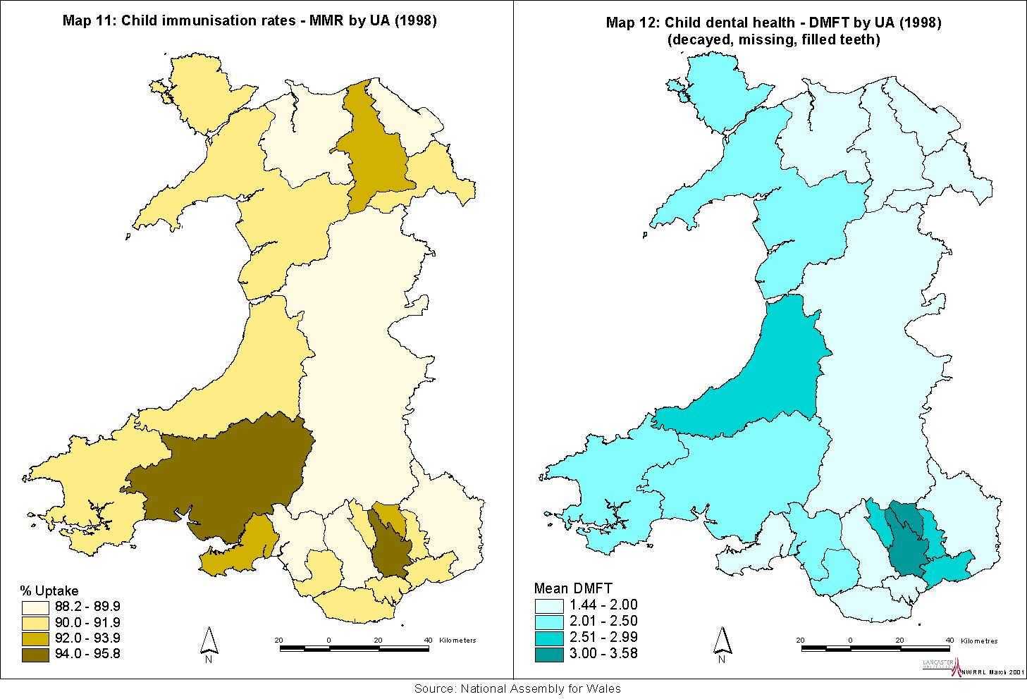
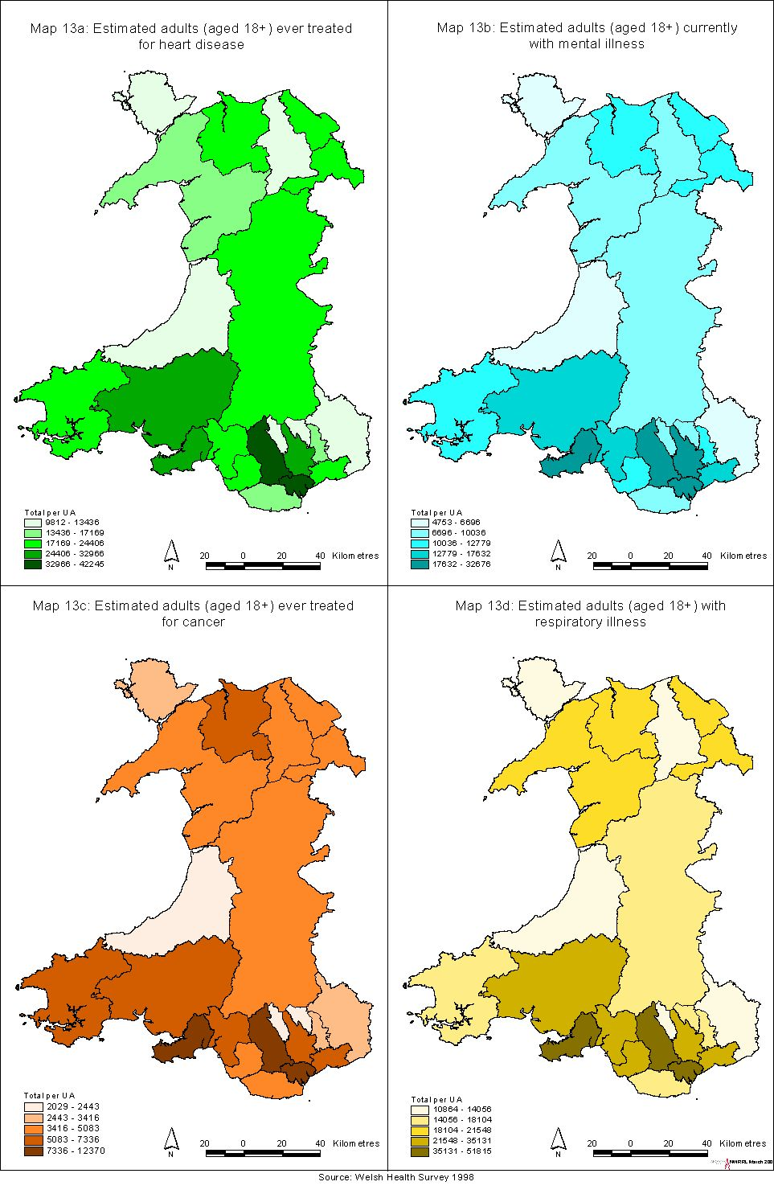
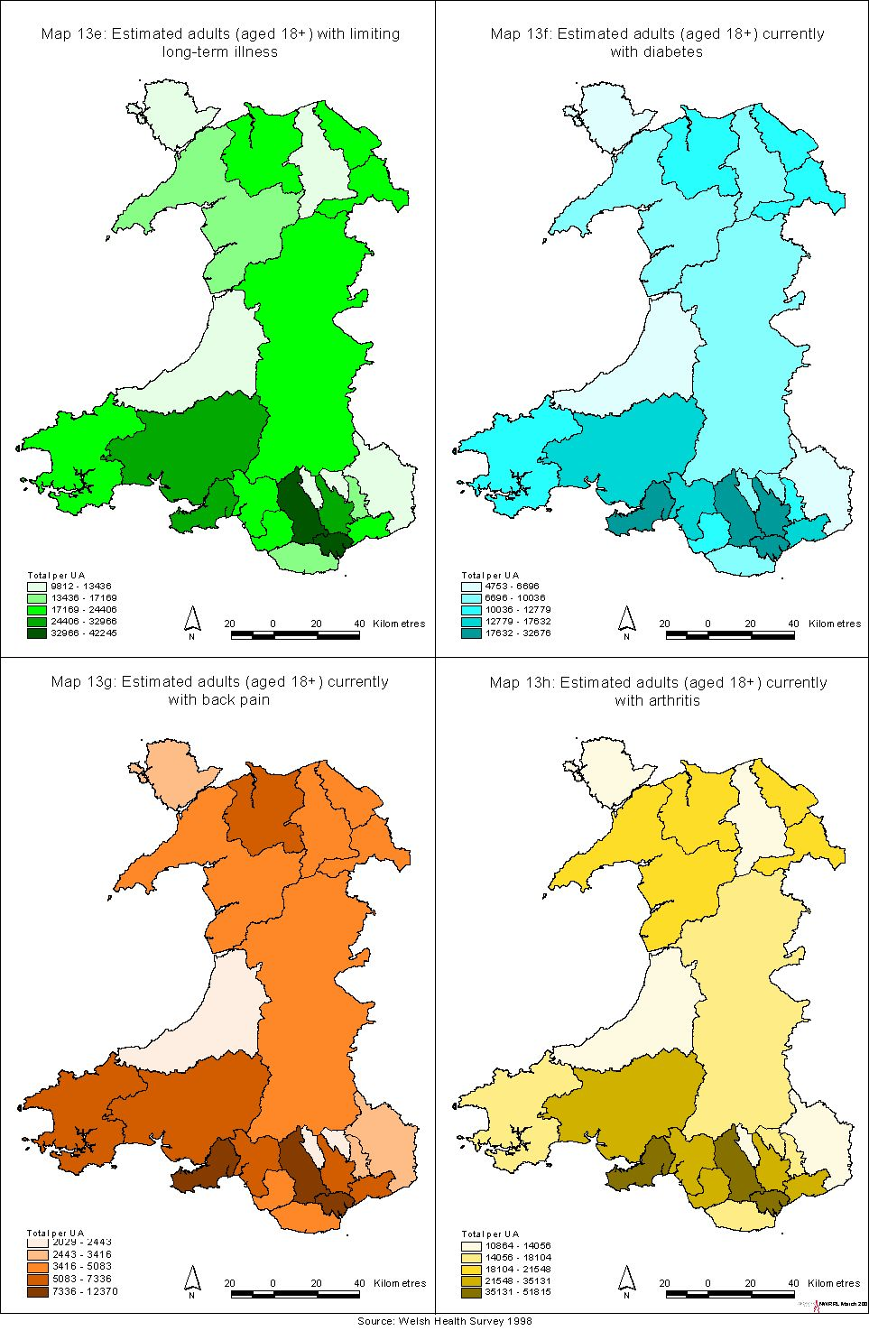
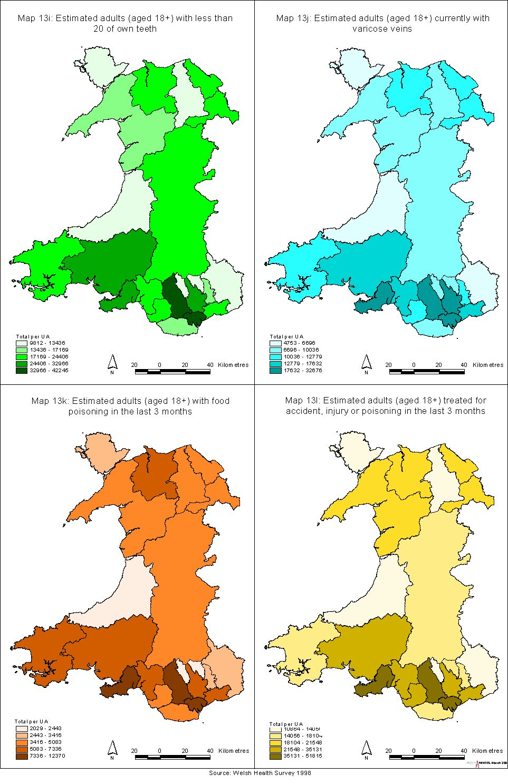
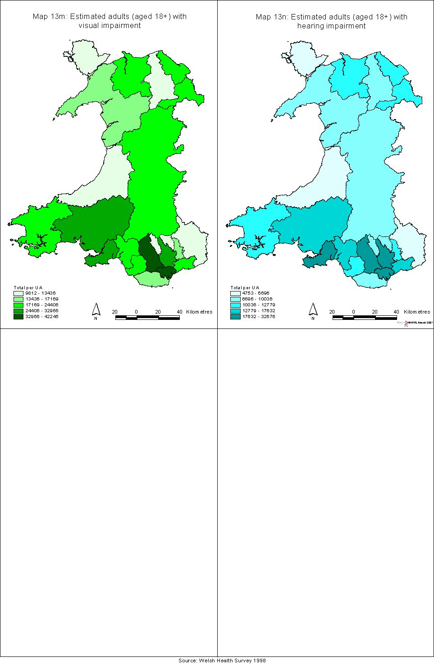
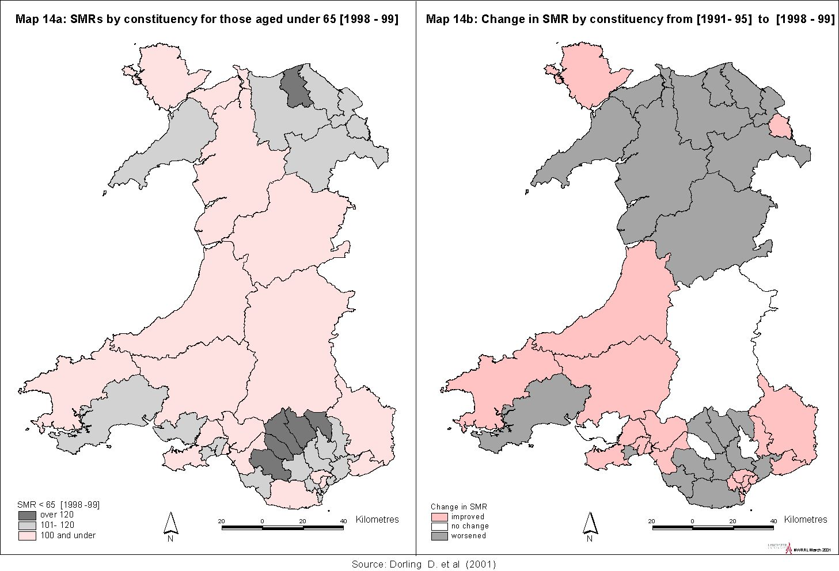
Arthritis and back pain are major causes of morbidity, although they seldom appear on death certificates. They are closely linked with figures for limiting long-term illness and impose a considerable burden upon the health service.

Comparative scores for physical and mental health status derived from the 1995 and 1998 WHS show, for the most part, overall improvements over time (Table 5.3). However, improvements in physical health scores for males in Blaenau Gwent and Merthyr Tydfil are counterbalanced by a worsening in the female scores. This is also apparent in Blaenau in the mental health scores. A guideline for interpretation is that differences in scores of over 1.0 are likely to be statistically significant, hence there are significant variations across the Unitary Authorities.

Table 5.3: Physical and mental health status scores

 | Physical health summary score |  |  |  | Mental health summary score
 | Males |  | Females |  | Males |  | Females
 | 1995 | 1998 | 1995 | 1998 | 1995 | 1998 | 1995 | 1998
Isle of Anglesey | 48.6 | 49.2 | 49.1 | 48.0 | 52.7 | 52.2 | 49.5 | 51.3
Gwynedd | 49.0 | 49.4 | 48.0 | 48.2 | 52.4 | 51.5 | 49.9 | 49.7
Conwy | 48.5 | 48.4 | 47.3 | 47.3 | 50.5 | 50.8 | 50.5 | 50.4
Denbighshire | 48.1 | 49.1 | 47.2 | 47.9 | 51.0 | 51.5 | 50.0 | 49.6
Flintshire | 49.6 | 49.3 | 49.1 | 48.4 | 51.7 | 51.5 | 49.2 | 48.3
Wrexham | 48.8 | 50.0 | 48.8 | 48.4 | 50.3 | 50.4 | 48.4 | 48.8
Powys | 48.1 | 49.1 | 47.2 | 48.9 | 51.1 | 51.0 | 49.1 | 49.5
Ceredigion | 48.8 | 49.2 | 47.4 | 48.8 | 50.5 | 50.9 | 49.5 | 49.4
Pembrokeshire | 48.7 | 48.7 | 47.6 | 48.1 | 51.4 | 51.5 | 49.4 | 50.0
Carmarthenshire | 46.8 | 47.8 | 46.6 | 46.2 | 50.7 | 50.5 | 47.8 | 49.1
Swansea | 48.7 | 48.6 | 46.8 | 47.0 | 51.1 | 51.1 | 48.4 | 48.7
Neath Port Talbot | 47.2 | 47.5 | 46.3 | 45.2 | 50.8 | 50.7 | 47.6 | 48.4
Bridgend | 47.8 | 48.0 | 47.9 | 48.0 | 51.2 | 50.8 | 47.7 | 47.4
Vale of Glamorgan | 49.7 | 49.8 | 48.8 | 49.1 | 50.3 | 51.9 | 49.3 | 49.5
Cardiff | 49.6 | 49.9 | 48.2 | 48.9 | 50.2 | 50.0 | 48.2 | 47.5
Rhondda, Cynon, Taff | 47.2 | 48.4 | 46.5 | 47.1 | 49.6 | 49.9 | 46.8 | 47.2
Merthyr Tydfil | 45.4 | 46.5 | 46.5 | 45.9 | 48.8 | 47.8 | 44.9 | 47.1
Caerphilly | 47.3 | 46.9 | 47.7 | 46.1 | 49.7 | 49.4 | 47.3 | 46.8
Blaneau Gwent | 45.3 | 46.6 | 47.3 | 45.2 | 49.1 | 49.5 | 47.6 | 45.6
Torfaen | 48.4 | 48.0 | 47.3 | 47.7 | 50.8 | 49.7 | 47.8 | 46.4
Monmouthshire | 49.6 | 49.2 | 48.6 | 48.8 | 51.8 | 51.1 | 48.7 | 50.0
Newport | 49.5 | 49.0 | 47.6 | 47.7 | 50.4 | 50.1 | 48.6 | 47.4
Source: Welsh Health Surveys (1995; 1998)

Child health

Child health indicators, at UA level, have been mapped for:

low birth weight (Map 10), which is an acknowledged indicator of poorer subsequent life chances;

immunisation rates (MMR) (Map 11);

dental health (Map 12), as measured by the mean DMFT score ie the numbers of decayed, missing or filled teeth.

There are substantially more low birth weight babies born in Cardiff than elsewhere; however, the rate for Cardiff is around the average for Wales. Some comparative birth statistics are shown in Table 5.4 below. Particularly high conception rates for girls aged under 16 are noticeable in Caerphilly and Blaenau Gwent.

Across all Unitary Authorities, child immunisation rates for all categories (diphtheria, whooping cough, polio, etc) are above 90%, with the exception of the rates for MMR immunisation which are below 90% in six UAs (the lowest rates being for Flintshire and Monmouthshire). Poor dental health is most evident in the large urban areas.

Table 5.4: Birth indicators

 | Total births  (1998) | % low birth weight (1998) | Under 16 conceptions 1995-97 average (rate) | Births to mothers under 20 (1998)
Isle of Anglesey | 732 | 6.0 | 19 ( 4.9) | 56
Gwynedd | 1305 | 5.9 | 51 ( 8.0) | 108
Conwy | 1178 | 8.8 | 65 (11.6) | 103
Denbighshire | 1037 | 6.4 | 37 ( 7.7) | 96
Flintshire | 1795 | 6.7 | 74 ( 9.0) | 125
Wrexham | 1495 | 7.6 | 83 (11.1) | 138
Powys | 1269 | 5.8 | 43 ( 6.3) | 90
Ceredigion | 649 | 7.3 | 19 ( 5.2) | 46
Pembrokeshire | 1277 | 8.8 | 36 ( 5.3) | 124
Carmarthenshire | 1745 | 5.9 | 72 ( 7.6) | 186
Swansea | 2436 | 7.9 | 177 (14.0) | 278
Neath Port Talbot | 1455 | 8.2 | 73 ( 9.1) | 160
Bridgend | 1508 | 7.1 | 104 (14.3) | 182
Vale of Glamorgan | 1436 | 7.6 | 62 ( 8.8) | 142
Cardiff | 4063 | 8.3 | 165 ( 9.5) | 405
Rhondda,Cynon,Taff | 2824 | 8.4 | 211 (15.3) | 374
Merthyr Tydfil | 709 | 8.6 | 49 (13.6) | 108
Caerphilly | 2154 | 7.1 | 165 (16.1) | 278
Blaenau Gwent | 830 | 7.5 | 68 (16.6) | 130
Torfaen | 1086 | 7.9 | 64 (12.3) | 138
Monmouthshire | 868 | 6.0 | 28 ( 5.7) | 46
Newport | 1769 | 7.4 | 83 (10.5) | 210
Source: Digest of Welsh Local Area Statistics (2000)

Health comparators
Table 1.9 (this report) gives rankings for ‘worst health’ to ‘best health’ constituencies across Britain, using under 65 SMRs (over the period 1991-95) as a measure of premature mortality. The authors of that work have conducted a similar analysis which allows a comparison over time, ie between the SMR for 1991-95 and those for the subsequent years 1996-97, and 1998-99. The results can be seen in Table 5.5 which shows SMRs over the three time periods. The constituencies are mapped in order of the most recent data. In Britain, there are 62 constituencies with ‘worse’ outcomes than the poorest SMR in Wales, for Merthyr Tydfil and Rhymney. Worthy of note are the better health chances enjoyed by the 89 constituencies ranking above Monmouth.

The 1998/99 SMRs for Wales can be seen in Map 14a. Map 14b highlights those constituencies where the SMRs do not show an improvement over the original figures. Improvements are apparent in Cardiff, Swansea and Wrexham but not in most of the north or the valley communities of south Wales.

Table 5.5: Welsh constituencies, ‘worst health’ and ‘best health’, using SMRs for those aged under 65

SMR rank | Constituency | SMR<65 1991-95 | 1996-97 | 1997-98
[1
63 | Merthyr Tydfil & Rhymney | 121 | 140 | 130
71 | Ogmore | 114 | 118 | 128
102 | Rhondda | 124 | 126 | 124
108 | Cynon Valley | 121 | 114 | 123
112 | Blaenau Gwent | 114 | 117 | 123
114 | Vale of Clwyd | 107 | 117 | 122
143 | Caerphilly | 105 | 118 | 117
150 | Carmarthen W & S Pembrokeshire | 93 | 99 | 116
173 | Clwyd West | 93 | 103 | 113
185 | Cardiff South and Penarth | 116 | 123 | 112
199 | Newport West | 104 | 106 | 111
202 | Swansea West | 103 | 108 | 110
216 | Torfaen | 113 | 112 | 109
221 | Cardiff West | 115 | 102 | 109
235 | Alyn and Deeside | 102 | 91 | 108
240 | Delyn | 105 | 111 | 108
247 | Pontypridd | 101 | 101 | 107
248 | Swansea East | 115 | 113 | 107
262 | Clwyd South | 101 | 112 | 106
285 | Bridgend | 97 | 93 | 104
291 | Llanelli | 103 | 113 | 103
300 | Wrexham | 106 | 114 | 103
309 | Islwyn | 102 | 102 | 102
313 | Caernarfon | 98 | 85 | 102
321 | Neath | 113 | 121 | 100
323 | Conwy | 96 | 96 | 100
324 | Merionnydd nant Conwy | 94 | 94 | 100
335 | Aberavon | 111 | 114 | 99
337 | Montgomeryshire | 91 | 84 | 98
341 | Newport East | 107 | 105 | 98
342 | Ynys Mon | 106 | 89 | 98
361 | Preseli Pembrokeshire | 100 | 86 | 96
371 | Brecon and Radnor | 95 | 90 | 95
380 | Vale of Glamorgan | 92 | 99 | 94
437 | Gower | 91 | 87 | 89
473 | Cardiff Central | 95 | 102 | 86
490 | Carmarthen East & Dinefwr | 105 | 106 | 85
491 | Ceredigion | 95 | 85 | 85
538 | Cardiff North | 88 | 82 | 80
552 | Monmouth | 80 | 87 | 79
[641
Source: Dorling et al (2001)

If we examine the highest UA rate: lowest UA rate ratio in Wales, for all age mortality rates from 1991-7, the highest rate is for Merthyr Tydfil (1200). The lowest rate is for Monmouthshire (870), giving an ‘inequality ratio’ of 1.4 (Fitzpatrick and Kelleher, 2000).

For Scotland, the equivalent is Glasgow City (1420): East Renfrewshire (920), which is 1.5. However, whereas the figure for Merthyr Tydfil produces 70 ‘excess deaths’ (over the expected number if the mortality rate was the same as the UK figure), the ‘excess deaths’ figure for Glasgow City was 1040. The highest Local Authority figure in England was for Manchester at 1280; the lowest being East Dorset (700).

If the focus is restricted to the 15-44 age group, the inequality for Wales (males) is 1.6 (Merthyr Tydfil 150: Ceredigion 90), and for females 1.4 (Merthyr Tydfil 80: Ceredigion 50) but the inequalities are not as wide as those between the regions of England.

Health improvement
Recent research conducted at the Universities of Leeds and Bristol for the Joseph Rowntree Foundation (Mitchell et al, 2000) sought to estimate the potential impact of certain current government policies on premature death in Britain. These three policies are:

- A modest redistribution of wealth. A steady widening of the wealth gap between rich and poor took place in Britain between the 1980s and the 1990s. The growing differences in wealth between the rich and poor were mirrored by differences in their health, measured by mortality rates (where social class is used a proxy for wealth). The modest redistribution of wealth referred to here is one which would return the inequalities in mortality their 1983 levels.

- Achieving full employment. The definition of full employment used in this research adheres to the government’s preferred definition in which, whilst people may be temporarily between jobs, no-one is in longer term receipt of unemployment benefit.

- Eradicating child poverty: To estimate the effect of achieving the government’s aim of eradicating child poverty, the life chances of the 20% of children whose parents work in (had been working in, or were associated with) the most poorly paid occupations were raised to equal those of their peers not living in poverty. This is a slightly more conservative definition of eradicating child poverty than the government’s but one which is more reliably tested.

The results for Britain as a whole, and for Wales, are as follows:

- Annually, some 7500 deaths in Britain amongst people younger than 65 (including 414 in Wales) could be prevented if inequalities in wealth narrowed to their 1983 levels.

- Some 2500 deaths per year in Britain amongst those aged less than 65, including 134 in Wales, would be prevented were full employment to be achieved.

- Some 1,400 lives amongst those under 15 would be saved per year in Britain, including 85 in Wales, if child poverty were eradicated.

This gives a total of 633 potential lives saved in Wales, annually, were these policies to be achieved. Lives would be saved in those areas which currently have the highest rates of mortality. The redistribution of wealth would have the greatest absolute effect (in terms of numbers of lives saved) because it would improve the lives of the largest number of people. Eradication of child poverty has the greatest relative effect (in terms of the proportion of lives saved).

Clearly, whilst the health of the population in parts of Wales is not as poor as in parts of Scotland, there is a large proportion of the UAs where health measures are well below average for the UK, and showing few signs of improvement. Health gains will not become apparent in the short, or even the medium term; remedies must be substantial, and sustained over the long term.

Chapter 6: Policy options on reducing inequalities in health

Introduction
This chapter considers the contemporary policy context of resource allocation strategies for tackling health inequalities. It highlights and discusses key policy initiatives and strategies and considers the significance of these for the National Assembly’s aim of reducing inequalities in health in Wales.

Debate continues over the potential of policy to address inequalities that stem from structural socio-economic inequalities at a wider level. Whitehead et al (2000) argue that preventive and curative health services have a role to play in promoting the health of disadvantaged groups. At the same time, the relationship between health and the broader policy context is increasingly seen as crucial to understanding and tackling health inequalities. The World Health Organisation (WHO) maintains that reducing inequalities requires inter-sectoral action to overcome the limited impact of action within health services (WHO, 1996).

Policies to reduce inequalities in health in the UK have been developed in the context of widening economic and social inequalities during the 1980s and 1990s. The present UK government has launched a number of initiatives on social security, employment and education that target help to the poorest sections of society and focus particularly on poverty in childhood. On the other hand, other UK social security measures can be seen to have the opposite effect. Townsend (2000) points, for example, to the abolition of the link between social security benefits and earnings, restraints on the value of Child Benefit, the abolition of lone parent allowances and earning-related addition to Incapacity Benefit and the promotion of means-tested benefits over universal social insurance and non-contributory benefits. He argues that policies affecting income should be examined for their impact on the structural distribution of income and the consequences for people’s health (Townsend, 2000, pxvii).

A further important point is that the effects of inter-sectoral action to tackle the root causes of health inequalities are more long-term. There is evidence that strategies to improve equity in health care provision can make a difference in the shorter term, particularly where resources are directed at particular groups (Abel-Smith et al, 1995; Whitehead et al, 2000). For example, strategies to improve access of particular groups to maternity or child health services can have a relatively short-term effect on health status.

A third point is that strategies within the health care system can incorporate services outside the system. A stronger public health orientation in health policy enables the broader determinants of health to be taken into account in the deployment of resources (Raphael, 2000). Commissioning powers in public health can be used to secure, for example, environmental or community services.

Aspects of inequalities (see also Chapter 1)
Inequalities in health and in access to health care are experienced differently between and within social groupings and classes. Key aspects include:

Geographical: These include urban and rural variations and the type and levels of inequalities within regions. Geographical factors are also relevant to policies on decentralisation of decision-making and the involvement of local people in the policy process.

Socio-economic: Various measures of socio-economic status, including education and housing, have been developed to expand on occupational class differences shown in the 1980 Black Report (Townsend and Davidson, 1982).

Ethnic/cultural: These include monitoring of variations in health of and the use of services by different ethnic and cultural groups, improving cultural awareness and race equality strategies in the health care system and measures to improve services of concern to particular minority groups such as sickle cell anaemia and thalassaemia.

Gender: Gender-based variations in health status and gender equity in health care are key considerations. At a broader level, the impact of changes in family structure and employment patterns on the health of men and women needs to be taken into account.

Age: Demographic and morbidity trends across Europe have resulted in a concentration of mortality in older age groups and higher levels of chronic illness among older people, leading to concern over escalating demand and costs. There is evidence of discrimination against older people and of rationing of particular services on the grounds of age.

Relationship between factors
There is a considerable degree of overlap between the above factors. For example, policies on improving maternal health need to take into account equity of access to health care for women in minority ethnic groups and women who live in housing estates occupied predominantly by poorer families. Thus, the development of strategic action to achieve tangible and measurable outcomes is a complex task, requiring both short and long-term perspectives.

There are also differences within and tensions between the above factors in terms of policy priorities. For example, the Acheson Report recommends placing a high priority on policies aimed at improving health and reducing inequalities between women of child-bearing age, expectant mothers and young children (DoH, 1998b). At the same time, there is rising demand to meet the needs of older, chronically sick people.

Life course perspectives
A further important issue to consider is the influence of factors over the whole life course – for example, the effect of poverty and deprivation in childhood on health in old age. The relationship between socio-economic factors and health over the life course is complex and a snap-shot of socio-economic status and health in adulthood produces only a partial picture. Benzeval et al (2000) identify ‘income potential’ and ‘health capital’ as potential mechanisms that link childhood and adult health. Income potential includes the accumulation of skills and education that affect adult employment capacity and, hence, socio-economic status. Health capital includes physical and psycho-social resources inherited and acquired in childhood that influence health in later life. The long-term consequences of childhood and early adulthood experiences, including formal education and family and community life, must be taken into account in developing policies to reduce inequalities over the life course (Benzeval et al, 2000).

The international policy context

Global perspectives
The World Health Organisation’s definition (WHO, 1974) of health as “… not merely the absence of disease, but a state of complete physical, mental, spiritual and social wellbeing” whilst open to criticism as utopian, reminds us that inequalities in health cannot be understood by reference to mortality and morbidity statistics alone. It begs the question of how health is understood, measured and defined in policy-making. The WHO has subsequently developed its social model of health, referring to health as a “resource for everyday life” and as “a positive concept emphasising social and personal resources as well as physical capabilities” (WHO, 1984). The basic guiding principles of the Healthy Cities Programme, for example, are the reduction of inequalities in health, working to achieve social development and a commitment to sustainable development (WHO, 1997).

In its Health 21 programme (which replaced Health for All 2000), the WHO continues to emphasise:

- Equity, promoting equal opportunities for health and health care, including action to combat poverty and social exclusion and measures to improve the health of minority ethnic groups,
- Community participation, promoting the capacity of local people to participate in action for health and decisions affecting their communities,
- Intersectoral collaboration, including action for health by a range of governmental and non-governmental organisations, the private and commercial sectors
- Sustainable development, including environmental strategies, such as energy efficient transport and housing.

European health policies
The Health for All 2000 programme has influenced policy in many countries and there is now widespread acceptance of its basic philosophical approach among governments in Europe (see for example Saving Lives: Our Healthier Nation, 1999, in the UK). It is also important to consider also how the ideas of the Health for All 2000 programme may continue indirectly to influence policy through community groups and voluntary organisations that are active in environmental and health-related activities. The Healthy Cities network, for example, has significant influence on community health projects that goes beyond the participating cities.

European governments vary in terms of the priority given to reducing inequalities. Germany, for example, showed little enthusiasm for the Health for All 2000 initiative. Primary care continues to be in a relatively weak position in Germany, although there is a high priority among policy-makers and the public on accessibility to services. In Norway, a similarly high priority is placed on improving access to health care. Specifically, investment has expanded the range of services available to older people, people with mental health problems and people with learning disabilities have (European Observatory on Health Care Systems, 2000).

Macroeconomic policies in all European countries are geared towards developing economic competitiveness and maintaining tight controls on public spending, including spending on health care. The WHO’s Regional Office for Europe notes the pressures on health care reform and the challenge of balancing the moral imperative of “maintaining solidarity and the social good character of health care” on the one hand and the fiscal imperative of “pursuing cost control” on the other (WHO, 1996, p4).

British health policy reflects these pressures, as the expectations of the public for improved health services and equity of access need to be balanced against the economic imperative of containing costs. However, where a high priority is placed on reducing inequalities it can be argued that additional costs should not be regarded as inefficiency but as a necessary aspect of achieving a policy goal.

Common trends in health policies identified by WHO Regional Office for Europe are:

- Re-examination of the structure of governance in health care systems and the relationship between state and market.
- Decentralisation of service provision both geographically and from state to private sector.
- Greater choice and involvement of service users and citizens in health care planning and provision.
- The evolving role of public health and awareness of health promoting activity outside health care systems.
(WHO, 1996)

None of these trends explicitly addresses inequalities in health, although they influence the range of possible strategies for tackling them. For example, the promotion of local partnerships is influenced by the changing role of the private sector. The promotion of public and primary health care interests is strongly associated with reducing inequalities. However, policy aspirations and statements on developing primary-led health services and strengthening public health functions are frequently not matched by action (Barker and Chalmers, 2000).

There are differences between countries in the extent to which health policies aim to improve overall standards of health rather than focus on inequalities in particular (Shaw et al, 1999). Achieving a balance between these two aims can be problematic, particularly in the context of rising consumer influence in health provision. Policies can also have unexpected results, for example, promoting screening and immunisation programmes across the board may in fact lead to increased levels of inequalities since higher income groups may make greater use of them (Abel-Smith et al, 1995).

The UK context
Health policy at the UK level continues to emphasise efficiency and effectiveness in the NHS whilst placing renewed emphasis on equity. Klein (2000) argues that the consequences of contemporary policy are likely to include heightened public expectations that will be difficult to balance against pressure to keep costs down. This tension is evident in the UK NHS Plan that stresses the importance of meeting public expectations for health care but stops short of covering the costs of long term care for older people. This decision has been roundly condemned by organisations of and for older people, such as Age Concern, and is contrary to the recommendations of the Royal commission on Long Term Care (Royal Commission on Long Term Care, 1999). It also contrasts with the decision of the Scottish Parliament on long term care for older people (Pollock, 2001).

The introduction of Primary Care Groups and Trusts is an important initiative to promote a primary-led service and to enhance the roles of a range of professionals at the operational level. At the same time the reduced role of Health Authorities demonstrates a centralisation of strategic planning and monitoring of standards. These organisational reforms have implications for the implementation of strategies to tackle inequalities in health and inequities in health care and the scope of action at the local level.

Evidence of inequalities in health
Contemporary health policies draw on evidence from a number of studies from the Black Report (1979) to the Acheson report (1998). Key findings include:

- The strength of the evidence of the links between socio-economic disadvantage and deprivation and poor health
- The broad scope of policies relevant to reducing inequalities
- The importance of long- and short-term strategies
- The role of primary health services in improving the health of the worst off.
- The inadequacy of attention to the health needs of ethnic minority groups
- The importance of up-to-date and accurate data on health at the local level.

Thus, the important connection between socio-economic and health inequalities is now more firmly established. Speaking at the Royal College of Physicians in February 2001, the Secretary of State for Health, Alan Milburn argued for the vicious cycle of ill health, unemployment and poverty to be broken (DoH, 2001). The European Observatory on health care systems notes the British approach as a significant shift (European Observatory on Health, 1999).

Resource allocation
Since the foundation of the NHS, equitable allocation of resources, particularly between regions, has been a challenge for policy makers almost throughout its history. In 1975, the Resource Allocation Working Party (RAWP) established a weighted capitation formula to address regional inequalities in health and ensure an equitable distribution of resources according to need. The Black Report (Townsend and Davidson, 1992) endorsed the underlying principles of the RAWP formula but identifies three inadequacies:

- Inadequate and inconsistent application of both the principles and the methodology of the formula.
- Inadequate measure of need in the formula itself. Attention was drawn to housing indicators, such as overcrowding that were omitted.
- Inadequate attention to the use as well as the level of resources allocated in any region.

In its analysis of health inequalities following the Black Report, The Health Divide (Whitehead, 1992) draws attention variations within regions and to sub-regional areas of deprivation that were actually worse off under the revised weighted capitation system introduced under the Conservative Government in 1992.

The Review of RAWP established in 1985, intended to fine-tune the RAWP formula, marked an important step in developing policy decisions on resource allocation based on empirical data on levels and types of need rather than on informed judgements.

The Acheson Report (DOH, 1998b) makes four specific recommendations (38.1-38.4) on resource allocation:
- A “pace of change” policy to enable health authorities furthest from their capitation targets to make faster progress.
- An extension of the “needs based weighting” principle to non-cash limited GMS resources and an assessment of the size and effectiveness of deprivation payments.
- A review of the size and effectiveness of the Hospital and Community Health Services formula and consideration of a stronger focus on health promotion and primary health care.
- A review of the relationship of the private sector to the NHS, with a suggestion that this compounds existing inequalities.

The Acheson Report also recommends that Directors of Public Health produce regular ‘equity profiles’ and triennial audits of progress towards achieving objectives of reducing inequalities in health. It also focuses on local partnerships to reduce inequalities and recommends that there should be a “duty of partnership between the NHS Executive and regional government to ensure that these partnerships work effectively” (DoH, 1998b Para, 39.1).

Key initiatives in reducing inequalities in health
The UK Government has introduced a number of measures that aim to reduce inequalities in health. The 1998 Green Paper, Our Healthier Nation (DoH, 1998a), and the White Paper, Saving Lives: Our Healthier Nation (DoH, 1999a), identify the following key aims:

- “To improve the health of the population as a whole, by increasing the length of people’s lives and the number of years people spend free of illness;

- To improve the health of the worst off in society and to narrow the health gap”
(DoH, 1998a, p5).

The NHS Plan (DoH, 2000) states as the ninth of its ten core principles:

The NHS will focus efforts on preventing, as well as treating, ill-health. Recognising that good health also depends upon social, environmental and economic factors such as deprivation, housing, education and nutrition, the NHS will work with other public services to intervene not just after but before ill health occurs. It will work with others to reduce inequalities. (DoH, 2000, p5)

The Modernisation Agency, to be established as part of the NHS Plan, will have as one of its responsibilities, to:

Support a ‘healthy communities’ collaborative to develop effective ways of improving health particularly in the most deprived areas. (DoH, 2000, p61)

This strategy demonstrates commitment to multi-sector, locally based partnership arrangements that are targeted on geographically defined areas of greatest poverty. These themes emerge frequently in UK health policy documents. An innovative approach to implementing central strategies at the local level is ‘earned autonomy’. The allocation of resources to health authorities classified as ‘green’, ‘yellow’ or red’ will be linked to their achievement of centrally determined national targets.

In his address to the Royal College of Physicians on 28th February 2001, the Rt Hon Alan Milburn, set two health inequality targets. Despite many pledges of commitment to the tackling and reduction health inequalities in Britain this was the first time that specific targets had been set. These targets were:

- By 2010, to reduce by at least 10% the gap in infant mortality between manual groups and the population as a whole. The national infant mortality rate was expected to fall for the first time below five deaths per thousand live births by 2006 and to result in approximately 3000 children’s lives being saved by 2010.

- to reduce the difference in life expectancy between areas with the lowest life expectancy and the national average. Starting with Health Authorities, by 2010, the gap between the fifth of areas with the lowest life expectancy at birth and the population as a whole will have been reduced by at least 10%.

Tackling health inequalities among children is also highlighted by the Children and Young People’s Unit in Tomorrow’s Future (2001). The initiatives which are aimed at this are

- The Healthy Schools Programme
- The National Healthy School Standard
- The Health Visitor and School Nurse Development Programme
- The National School Fruit Scheme
- The Welfare Foods Scheme
- The Personal, Social and Health Education framework
- Health Action Zones

as well as various aspects of the NHS Plan, published in July 2000, such as the Children’s Taskforce and the new National Service Framework for Children’s Services.

A recent initiative in Scotland (15th March 2001) has been the launch of health profiles for every constituency in Scotland (www.show.scot.nhs.uk/phis/constituencyprofiles). These profiles contain information on healthcare and illness, prosperity and poverty, crime and safety, deaths, physical functioning, educational attainment and lifestyle behaviour. The aim of making such data available to MSPs and others is to engage decision makers at parliamentary level in an ongoing analysis which will lead to action to improve health.

There have thus been a number of recent events which have added further to the tackling of health inequalities in Britain.

The Action Committee on Resource Allocation
The Action Committee on Resource Allocation (ACRA) was established in 1998. Their first report was published in July 1999, with a list of initial recommendations (ACRA, 1999). It covers a wide range of policy spheres, including income and living standards (tackling low income and social exclusion, in particular), education, employment, housing crime, transport and public health measures. A crucial underlying principle is that resources should be targeted at those in greatest need.

The ACRA Committee draws a distinction between ‘avoidable’ and ‘unavoidable’ inequalities. The term unavoidable inequalities suggests unfairness about variations in health but a limited capacity to do anything about them, whilst avoidable inequalities suggests that policy action can make a difference. Avoidable inequalities, or inequities, are more amenable to action within the health care system but action at a broader level (through employment strategies in particular) is proposed in contemporary British policies, so that ‘unavoidable inequalities’ are also tackled.

The evidence base of policy
The objective of raising standards in health care relies on new initiatives in data gathering (such as patient surveys) and is linked to the aim of reducing inequalities.

Outcome measures may be seen as an instrument for monitoring inequalities. For example, the National Service Framework on coronary heart disease requires health authorities to produce local health needs profiles and plans for tackling inequalities.

The implementation of Health Improvement Programmes, the NHS Performance Assessment Framework and the establishment of NICE are all identified as having a role to play in reducing inequalities, since the quality of health care received across the board will be subjected to monitoring and evaluation. However, Jacobson (2000, p109) notes that the NHS Performance Assessment Framework, whilst identifying important aspects of regional variations is insufficient in itself to monitor inequalities of treatment outcome because it fails to take ethnic and socio-economic factors into account.

Health impact assessment
Health impact assessments have been increasingly encouraged at the international and UK level. Assessing the impact on health of a range of economic, environmental and social policies is regarded as an effective tool in addressing health inequalities and ensuring that action is likely to have the desired effect. The Acheson Report (DoH, 1998b) recommends that as part of health impact assessment:

“all policies likely to have a direct or indirect effect on health should be evaluated in terms of their impact on health inequalities, and should be formulated I such a way that by favouring the less well off they will, wherever possible, reduce such inequalities” (Recommendation 1)

However, there are problems in making health impact assessments, not least of which is the difficulty of making accurate measurements of health impact and of taking into account macro- and micro-level factors. For example, the range of variables involved in measuring health would make it very difficult to assess the impact of an initiative such as Sure Start on the health of children. As Whitehead et al (2000) point out, the same initiative might have a differential effect on different groups and there are practical and political difficulties in identifying the impact of policies on the health of people. Variations between people mean that the impact of a single policy on one person will be very different from its impact on another. Additionally, the reliability of evidence on the impact of policies is sometimes open to question. For policy-makers, this can be a stumbling block. Whitehead et al (2000) call for a broad range of methodologies, both quantitative and qualitative, to measure multiple outcomes with a range of different population groups. This includes small-scale as well as large-scale studies and evidence from lay perspectives as well as clinical. The present framework for researching policy impact focuses on the different ‘pathways’ between social position and health consequences. Policies may influence:

- individuals’ social position (eg education)
- exposure to health hazards (eg housing, occupational health)
- the effect of being exposed to a hazardous factor (eg social security benefits for disadvantaged groups)
- the impact of being ill (eg access to healthcare services)

Their comparative study of the UK and Sweden concludes that the impact of policies on health inequalities should be evaluated at micro- and macro-level and take into account the complexities of the social context of policies.

Health impact assessments and health inequalities impact assessments are, therefore, important instruments for policy-makers but are relatively undeveloped. The framework of Whitehead et al (2000) is an important contribution, since it clarifies the links between broad aims of policies and the concrete realities of individuals’ everyday lives and ways of measuring these.

Partnership
UK Government policies on health improvement and reducing inequalities make frequent reference to partnership. Partnerships are particularly central to public health and primary care policies. The NHS Plan (2000) refers to new single, integrated public health groups and (by 2002) a Healthy Communities Collaborative. Health Improvement Programmes (HimPS), introduced in the 1999 White Paper, are an important strategy for engaging local community and private sector bodies in local plans to improve health. The 26 Health Action Zones (HAZ) are more particularly targeted at raising levels of health in the country’s most deprived areas through the promotion of collaborative working between the NHS, local government, local industry and voluntary organisations.

Targeting
Saving Lives, Our Healthier Nation targets key areas of high mortality and morbidity: cancer, coronary heart disease and stroke, accidents and mental health. Mortality and morbidity levels are highest among poorer groups in the population. The previous government’s Health of the Nation Strategy focused on the same four areas but the current strategy has revised targets for improvements, following the principle of ‘levelling up’ in order to reduce health inequalities. Similarly, Modernising Health and Social Services (1998) targets particular areas for action. These include strategies to reduce unwanted teenage pregnancies, ensure fair access to services for black and ethnic minority groups, reducing smoking, increasing childhood immunization rates and reducing drug dependency.

In Saving Lives: Our Healthier Nation there is a commitment to improving the health of black and minority ethnic groups but there is no specific targeting of resources for minority ethnic communities. Reference is made to the appropriateness for ethnic minorities, of the wider principle of targeting of resources at those in greatest need. The NHS Plan (2000) emphasises the needs of children, through an expansion of Sure Start, the creation of the Children’s Fund, and reform of the Welfare Foods Programme, as well as improved antenatal and neonatal screening.

Access to services (see also Chapter 7)
The NHS Plan announced the establishment of the Medical Education Standards Board, which is seen as an instrument for tackling the inverse care law. It will monitor the distribution of medical staff. In addition, 200 new Personal Medical Services schemes will provide incentives for staff to work in disadvantaged areas (DoH, 2000, pp13, 11). The impact of these initiatives will be influenced by market forces factors in employment patterns.

The Health Plan also announced the development of freely available translation and interpreting service through NHS Direct by 2003 and the development of accessible advice and information materials on cancer and dental services in particular.

The implications for Wales
The Welsh Health Plan sets a high priority on tackling inequalities, reflecting the trends and issues outlined above of pluralism and partnership in promoting health and tackling inequalities. Improving equity in access to health care is a priority for action and a life course perspective adopted.

The scope of policies in Wales
Relationships between levels of government and the relative powers of European, UK-wide, national and local government bodies have implications particularly for long-term strategies focused on the wider determinants of health. UK-wide employment and social security strategies, for example, will have an impact on the socio-economic status of people in Wales and, in turn, will affect Welsh strategies to reduce health inequalities.

Current high levels of congruence between policy aims at different levels should mean that the Assembly’s priorities are supported. In addition, the Assembly is committed to international collaboration and the use of international comparisons in developing benchmarks for services in Wales (National Assembly for Wales, 2001).

Health Impact Assessments are an important instrument in monitoring the effects of a policies on health and health inequalities. The flow of information between governments and agencies at different levels in the policy system should be improved by more accurate and focused data. In Wales, health impact assessment is regarded as an important tool to be used by a range of public, private and community bodies and the Assembly has committed itself to developing this tool through awareness-raising, training, support and guidance (National Assembly for Wales, 1999).

Public Health and health promotion
Health Improvement Programmes constitute the framework for the Assembly’s strategies to improve health and reduce inequalities (Hutt, 2000). These enable wide focus on the social, economic and personal dimensions of health and inequality. The Health Plan for Wales stresses the importance of health promotion and public health and draws attention specifically to the existence of a strong health promotion team. A review of the public health function in Wales is proposed and this should enable the Assembly to assess more clearly how the public health function can be effectively utilised in strategies to reduce inequalities. The potential of contracting as a tool for promoting inter-sectoral involvement in targeted health promotion might be considered in this review.

Reorganised health care system: decentralisation and partnerships
The proposed abolition of the Health Authorities in Wales and the strengthened roles of Local Health Groups and the National Assembly have implications for strategic planning and priority setting as well as for the implementation of policies. The challenge for the Assembly, as in other European countries, will be to manage a decentralised system with a strong strategic and regulatory function at Assembly level.

The Assembly’s initiative to modify the research and development strategy and to set up a separate funding stream to focus particularly on Assembly priorities is an important factor in shaping the agenda at the local level. The concept of ‘earned autonomy’ outlined in the British Government’s NHS Plan is an innovative approach to managing this tension. The recommendation of the Acheson Committee to develop ‘pace of change’ policy might also be taken into account in targeting resource at local groups that are furthest from their targets.

Partnerships at the local level
Local Health Groups are the focus for reducing inequalities and for developing multi-sectoral approaches. Partnership is a central theme in developing LHGs, drawing in social services, voluntary organisations and the private sector to promote health and reduce inequalities. The capacity of local partnerships to deliver the desired health outcomes will be tested through pilot schemes. An important issue for evaluation of the pilots will be the distribution of staff in different parts of Wales and the implications of this for equitable access to services.

The Public Involvement Framework outlined in the Health Plan for Wales proposes a wide-ranging role for the public in planning and decision-making, scrutiny of health services, access to information and exercising rights of complaints and redress. In the context of increased community and consumer activity, it is important to consider the impact of partnership on community groups and organisations that have traditionally played an advocacy role on behalf of patients. Advocacy and partnership are not always compatible and groups may experience conflicting demands that affect their functioning.

In Wales, as in other parts of Europe, perhaps the greatest challenge will be to implement effectively policies on health promotion and public health in the context of continued medical advances that raise expectations and demands for treatment. The envisaged involvement of the public in health care represents a major cultural shift and a challenge to professionals and policy-makers. The likelihood of conflict over resource allocation will increase as the public voice becomes more influential and Local Health Groups and the National Assembly will need to take this into account in developing long- and short-term strategies to reduce inequalities.

Chapter 7: The role of the NHS in reducing inequitable receipt of health care

Introduction

Inequalities in health are compounded by inequalities in access to health care. Whilst societal factors may be the key determinant of disease incidence rates, health care provision plays a key role in secondary and tertiary prevention and to a lesser degree in primary prevention.

Importance of new health technologies in reducing mortality, morbidity and quality of life
There have been marked improvements in both life expectancy and disease-specific mortality rates over the last 100 years. A cohort of men and women born in 1901 would have an expected average life expectancy at birth of 51 and 57 years, respectively. By contrast, the same cohort born in 1990 would expect, on average, to live for 77 and 83 years (Charlton and Murphy, 1997). However, as has been shown in Chapter 1, these improvements have been greater for more affluent members of society.

Health improvements are the result of both a reduction in disease incidence (number of new cases of disease) and reduced case fatality due to a combination of less severe disease and more effective treatments. An individual today is far less likely to contract certain diseases but, even if they do, they have a better prognosis and quality of life.

It is generally accepted that medical care has made only a limited contribution (McKeown et al, 1975; Mackenbach et al, 1990) to these marked secular trends (see earlier chapters in report). The proportion which may be attributed to societal changes rather than medical care remains controversial. However, recent advances in both surgical and medical interventions have led to a re-evaluation of medical services in terms of both preventing disease as well as reducing case fatality and improving quality of life.

Time trend analysis of mortality rates in five countries which have experienced marked growth in health services noted that the rate of decline for mortality that was potentially amenable to medical intervention was far more rapid than mortality for other causes (Charlton and Velez, 1986). However, the relationship between health care resources and "avoidable mortality" is weak, suggesting that how resources are used (quality of care) rather than the total allocation may be more important (Mackenbach et al, 1990). Calculations on the gains in life expectancy and quality of life associated with various interventions estimate that medical services in general add around five years of life expectancy, with the potential of another two or two-and-a-half years by extending access to effective treatments (Bunker et al, 1995). For example, it is possible to attribute around 3.5% of the decline in CHD mortality to the contribution of coronary artery bypass grafting (Goldman and Cook, 1984). Extending care to include surgery, medical treatments and coronary care units, it is estimated that life expectancy is prolonged by an additional 1.2 years at a population level, with around a 55% improvement in quality of life (Bunker et al, 1995). More dramatically, Capewell and colleagues (2000) have calculated that approximately half the decline in CHD mortality fall in New Zealand was attributable to medical therapies whilst the other half related to risk factor reductions.

Given the growing evidence base for effective medical therapies, it is essential that such services are provided to all on the basis of clinical need.

- Most effective medical interventions do not reduce disease incidence risk but may improve prognosis and quality of life through secondary and tertiary prevention.

- In order to reduce health inequalities it is essential that all segments of society share equally in these advances on the basis of clinical needs and not be influenced by spurious socio-demographic factors

Understanding the language and concepts around inequitable access to health care
It is important to be clear about the terminology used to discuss inequalities in health care. The debates around this topic tend to use the following terms (need, demand, provision, variations, access, equity or inequity) in a relatively inconsistent fashion. It is therefore important for the reader to understand how they will be used in this report.

Need is the concept that a patient has a clinical condition for which there is an effective intervention. It is therefore distinct from demand which indicates a patient’s desire or preference for an intervention which may or may not be needed. Provision reflects the process of actual medical care and hence is a major contributor to the spending of health care resources.

Much early work in this area focussed on the topic of variations in health care provision (McPherson et al, 1982). This simply documents how rates of interventions, eg hysterectomy, vary both between and within countries. As such, this work has been generally used to demonstrate the importance of ‘doctor-related’ factors in influencing medical interventions. In other words, the rates of variations are often so large, it is assumed to be unlikely that these variations reflect true ‘need’ but rather that doctors vary in their propensity to intervene for identical clinical scenarios. Therefore, surgeon X is more likely to operate on the same patient than surgeon Y. Clearly, resource issues, number of available beds, etc, as well as patient demand may influence this process but the main factor was assumed to be doctor-related. Such work, whilst enlightening, does not directly measure either access to or equity in health care.

‘Access’ is defined as the ability to make use of provided services and/or information, for example, attend general practice clinics or travel to hospital clinics. It reflects both patient socio-demographic factors, such as living in a rural area, as well as structural factors, such as the local provision of diagnostic tests, interventions or health care professionals. For example, if an area does not provide certain services, then patients in that area have no access to this regardless of whether or not this is equitable. ‘Equity’ or its counterpart, ‘inequity’, reflect a mismatch between need and provision, at any given level of access, so that patients' socio-demographic characteristics have an influence on their receipt of health care over and above their need. It may or may not be a reflection of access, demand or doctor behaviour. It is a measurable facet and hence has led to the concept of ‘equity audits’, distinct from clinical audit, which simply examines patterns of health care provision related to accepted consensus standards of care.

The critical conceptual issue around determining whether health care provision is equitable is dependent on the following question. Is the level of service provision commensurate with the clinical need? As Benzeval et al (1995) aptly state:

“What is not in doubt is that more disadvantaged social groups have higher than average rates of both morbidity and service use. The analytical problem arises in adjusting the one for the other.”

Domains of inequities – socio-economic status, gender, age, ethnicity, geography
Most research around equity of health care has focussed on the following domains: (a) area measures of deprivation, (b) individual measures of socio-economic status, (c) gender, (d) age, (e) ethnicity and (f) geography (rural versus urban).

Each socio-demographic factor may play an independent role or may confound each other. For example, a recent observational study from Yorkshire noted that women after a myocardial infarction were less likely than men to be treated with thrombolytic therapy, aspirin or beta-blockers (Hanratty et al, 2000). However, after adjustment for age, as women were older than their male counterparts, this disparity in treatment was almost abolished. However, these factors may also interact so that patients may experience a ‘double whammy’. Poor ethnic minority patients may be much worse than either poor patients or those from an ethnic minority per se.

Relevant examples of important interventions at primary, secondary and tertiary care levels
Much research has focussed on specialist or tertiary level interventions as they are costly and generally have a high profile. For example, there has been much work on coronary artery bypass grafting, renal replacement therapy and specialist oncology treatments. However, it is important to appreciate that less glamorous interventions at secondary care, eg hip and lens replacement are also important in alleviating pain and suffering. Primary care also has a key role both as the gatekeepers to specialist services but also in the provision of most pharmacological treatments, eg effective management of hypertension, as well as health promotion.

- Health care provision must be commensurate with clinical need and unbiased by socio-economic status. A mismatch between need and provision is inequitable.

- Evidence of clinical effectiveness is essential in interpreting patterns of service provision by socio-economic status as overprovision may be as harmful as under-provision.

- Inequity can function at various different domains such as age, socioeconomic status, geography, ethnicity and gender. These domains may act independently or additively.

- Inequity can occur at primary, secondary and tertiary care levels within the NHS.

International and UK evidence of inequitable health care
It is unsurprising that the first evidence supporting inequitable health care came from the USA where the two-tier health care system ensures a large vulnerable segment population who may not be able to afford major care expenditure (Hayward et al, 1988). In the UK, it is assumed that a free health care system will not deter poorer individuals from treatment. However, observational data consistently indicate that socio-demographic factors such as socio-economic status (Ben-Shlomo and Chaturvedi, 1995), gender (Petticrew et al, 1995), ethnicity (Shaukat et al, 1993) and other factors such as smoking status (Morris et al, 1995) have an influence on the likelihood of receiving health interventions.

Surprisingly, researchers have only recently begun to address methods to explicitly monitor equitable access to NHS services. Simulation models suggest that UK health system does broadly provide equal treatment for equal need (Propper, 1994). However, inequities appear to exist both for receiving surgery for heart disease (Ben-Shlomo and Chaturvedi, 1995) and other common conditions (Chaturvedi and Ben-Shlomo, 1995). Men living in more affluent areas were more likely to receive coronary revascularisation surgery despite having less need as measured by mortality rates (Ben-Shlomo and Chaturvedi, 1995). A more recent study has confirmed these findings with better data indicating that the most deprived wards had only about half the number of revascularisations per head of population with angina (Payne and Saul, 1997). In affluent wards, individuals with symptoms had almost three times the rate of coronary angiograms than those in poorer wards. Similarly, Asian patients with heart disease appear to wait almost twice as long from symptom onset to being seen by a cardiologist (Shaukat et al, 1993). Women are also less likely to receive surgical intervention for heart disease, even when they have had a heart attack (Dong et al, 1997) and have similar or worse prognosis to men (Hanratty et al, 2000).

A systematic review of equity of access to health care in the NHS published in 1998 (Goddard and Smith, 1997) concluded that, despite efforts to promote equity in resource allocation within the NHS and to maintain the principle of fair access,

“We have indeed found substantial recent evidence of certain inequities in access to health care in England...”

However, the same review identified that research in this area was not systematic. Most work had been in the areas of acute medicine or common adult surgical conditions, ignoring vast areas of clinical work such as paediatrics, obstetrics and gynaecology and mental health. The report also highlights the difficulty of establishing the relative importance of identified inequities in terms of public health benefit.

Potential reasons for inequitable health care
If we are to provide effective interventions that counter inequitable patterns of health care it is essential to understand the possible mechanisms behind these patterns. As the process of receiving health care is complex, it is necessary to break it down into its constituent parts so that one can identify barriers to equitable care. Below is a theoretical outline for potential problems, although little if any empirical work is available to test these various possibilities.

- Patient variations in health care seeking behaviour
- Doctor-patient interactions at a primary care level
- Variations in primary care referral patterns
- Variations in levels of investigation
- Deciding on treatment options
- Patient preferences

Review on role of health care based interventions to reduce inequalities in health
A recent Department of Health commissioned review examined all studies with an experimental design that targeted poorer sections of the population in order to reduce inequalities in health (Arblaster et al, 1995). From a large number of original papers, only 94 studies could be identified that met the inclusion criteria and many were of dubious methodological quality. The characteristics that were found to be associated with greater success were (a) needs assessment and community commitment prior to the intervention, (b) intensive, multidisciplinary, multifaceted, interventions delivered in a variety of settings, and (c) face-to-face, culturally appropriate interventions delivered by an appropriate agent with sufficient training. The authors concluded that:

“it is important that strategies developed to reduce inequalities are not assumed to be having a positive impact simply because the aim is ‘progressive’ and so rigorous evaluation evaluations of promising interventions are important.”

The paucity of evidence in support of interventions to reduce inequalities has led some to take a nihilistic view of health service interventions (Foster, 1996). Unfortunately, most randomised controlled trials do not explicitly address the issue of effectiveness by socioeconomic status and often fail to present results by relevant sub-groups. In addition, participants in trials are often unrepresentative of the general population. A recent re-analysis of the MRFIT trial clearly indicated an under-representation of poorer groups. However, despite the selection biases, limited evidence suggests that improvements in diastolic blood pressure, smoking cessation, and LDL-cholesterol, seen under trial conditions, are very similar for both well educated and less educated subjects; education being used as a marker of socio-economic status (Cutler and Grandits, 1995).

- Despite the NHS providing service free at the point of delivery, there is convincing evidence of inequitable health care provision. This is not uniform and there are no clear systematic reasons for discrepancies.

- The reasons for such inequities are complex and may be the result of patient and doctor related factors.

- There is a paucity of good quality evidence on how to reduce such inequities.

Case studies: empirical examples illustrating areas of concern
The following provide some examples from the published literature of different approaches to assessing the nature and degree of inequitable access to health care. It is important to appreciate that these examples merely highlight areas of concern which deserve further investigation, rather than provide definitive explanations as to why these patterns occur. This is clearly an essential prerequisite before more detailed studies are undertaken. Similarly, such approaches can be used to monitor changes in clinical guideline or policy changes.

Preventative care
It is traditionally accepted that most health education or promotion campaigns paradoxically increase the gap between rich and poor. The latter find it much harder to alter lifestyles or cannot afford healthier options such as diets rich in fresh fruit and vegetables. Screening and childhood vaccination campaigns are often less successful amongst poorer segments of society (Waller et al, 1990). Such differences are not insurmountable with additional effort and resources. For example, the use of home visits by district nurses was able, in one practice, to diminish much of the gap in vaccination rates between less and more affluent communities (Marsh and Channing, 1988).

Both practical and financial disincentives are important when considering reasons for differential use of services. A recent case control study of patients presenting with marked visual loss due to glaucoma noted that cases were much more likely to be of lower socio-economic status and of African Caribbean origin (Fraser et al, 2001). Some of these social differences were explained by the reduced likelihood for cases to have regularly visited an optometrist for a regular eye check up. At the time this study was undertaken, only individuals on Income Support would have been exempt from eye charges, though this has now been extended to all people over 60 years of age. It will be interesting to note whether the increased frequency of visual loss due to glaucoma amongst poor patients will be eliminated since the removal of charges.

Primary care
There has been a long standing debate about the equity of access to primary care (Collins and Klein, 1980; Blaxter, 1984). There is little doubt that patients of lower socio-economic status, ethnic minority status and women have higher attendance rates (McCormick et al, 1995). What is more problematic to decide is whether this is as great as one would expect given their respective levels of morbidity. However, there is little evidence about whether the quality of care differs between socio-demographic groups. Indirect support for such a hypothesis comes from examining referral patterns to secondary care. As primary care acts as the gate keeper to other services, any differential pattern of referral will have a marked influence on differential receipt of surgical or more complex medical investigation and care. Both a local study based in North London (Worrall et al, 1997) and more generalisable data from the Fourth National Morbidity Survey (Carr-Hill et al, 1996) suggest that, for consultations rated as non-trivial, poorer patients were less likely to be referred to a specialist given their higher attendance rates.

This observation is consistent with a study from South Glamorgan, which examined the patterns of emergency and elective admissions by an area-based measure of social deprivation in relation to diabetes and other illnesses (Morgan et al 1997). The rate of in-patient admissions was strongly positively related to increasing deprivation (correlation coefficient for non-diabetic patients 0.74, p<0.001) This is unsurprising given the association with morbidity. This linear association was even stronger with emergency admissions (0.87, p<0.001) but non-existent for elective admissions (0.06, p value reported as non-significant). These results were almost identical for the diabetic population but, in this case, there was a weaker positive association with elective admissions (0.30, p<0.05). This suggests that, in general, poorer areas with disease are less likely to be managed electively either because of late presentation by patients, failure to attend clinics or delays in referral. The study also noted that rates of non-attendance at out-patients was also strongly related to area deprivation. However, structural factors, like late notification of appointments, is an important determinant of failure to attend and may have a greater effect on patients of lower socio-economic status (Frankel et al, 1989). However, for the diabetic population, who are under more extensive scrutiny through regular out-patient clinics, this is less of a problem.

A more sophisticated approach to measure access to good quality primary care has been to examine conditions that may result in hospital admission if badly managed either by patient or physician at a community level. Such conditions include admissions for asthma, diabetes and angina. These studies repeatedly note that poorer areas (Ricketts et al, 2001) or poorer individuals are more likely to have such potentially ‘preventable’ admissions (Bindman et al, 1995) and, in the case of the individual-based study, were less likely to have seen their primary care doctor in the period preceding their acute illness. The ecological study failed to show that provision of subsidized clinics or the number of primary care doctors per 1000 population made any difference in the rates of hospital admissions (Ricketts et al, 2001). This disappointing observation must be tempered with the knowledge that poorer areas may also have more severe disease as well as the problems of poorer individuals in complying with expensive drug regimes and regular clinic follow-up within the American health care system. Such studies have so far been limited to the USA where limited health care insurance is a major issue.

There is little evidence to suggest that poorer individuals or those from ethnic minorities are any less willing to seek their General Practitioner or Accident & Emergency care when presented with a hypothetical health problem (Chaturvedi et al 1997; Adamson et al 2000). It is likely that, in this country, where structural and financial barriers to primary care are not such a major problem, any association between admission rates for preventable conditions may be a better reflection of quality, use and patient compliance with primary care services as well as disease severity.

Primary and secondary care interface
Asthma is condition of major importance, which can be well managed through good primary and secondary care services. Some - but not all - studies show associations with social deprivation (Duran-Tauleria and Rona, 1999) particularly for persistent wheeze. This suggests that poverty is either associated with more severe disease or that individuals in poorer areas are less recognised and/or sub-optimally managed. A study from Wales also noted that admissions for asthma were strongly correlated with area deprivation at all ages, whilst the prevalence of reported asthma and various degrees of wheeze was not significantly correlated with area deprivation (Burr et al, 1997). Importantly, there was a non-significant negative association between deprivation and regular use of inhaled steroids. Thus asthmatic children in poorer areas were probably less likely to receive prophylactic medicine that could either prevent an asthmatic attack or reduce its severity and hence the likelihood of hospital admission or mortality. Such studies merely highlight the possibility of less equitable care in poorer areas but do not exclude other possible explanations, such as less good compliance with medication.

Secondary care
Remarkably little research has examined equity of access to common secondary care conditions. Surgical conditions are easier to study as misclassification is less of an issue and it is possible to relate disease morbidity to a specific intervention.

By comparing rates of primary care consultations and surgical intervention for specific conditions, eg cataract, hip replacement and varicose veins, it is possible to show both concordant and discordant patterns of care (Chaturvedi and Ben-Shlomo, 1995). One condition of note was hip replacement, which demonstrated reduced rates of surgical intervention for poorer areas. This was despite greater rates of primary care consultation for poorer individuals. This apparent mismatch has been confirmed in a broader geographical analysis (Jacobson, 1999) as well as examining data from Wales.

Preliminary analyses of crude prevalence rates per 1000 population for arthritis (not including back pain), taken from the 1998 WHS show a positive correlation with deprivation scores by UA, using the Welsh index of multiple deprivation (National Statistics, 2000) as set out in Figure 7.1.

Figure 7.1: Association between self-reported arthritis morbidity and area deprivation score by Welsh Unitary Authorities (higher values of deprivation score equate with greater deprivation)

Whilst this question does not measure arthritis of the hip directly, this is likely to be a major contributor to the proportion of all arthritis morbidity. Similarly, no data is directly collected on pain or limitation of daily activities, although the SF-36 questionnaire, which is also included in the WHS provides some information on these topics. Further analysis of the original data could therefore be used to identify positive respondents who suffer significantly from their arthritis. Other data demonstrate that poorer individuals are not only more likely to have arthritis of the hip but their condition is also more likely to be of greater severity and hence more suitable for effective surgical intervention (Eachus et al, 1999). Crude hospital activity data (provided by Steve Sutch for 1998) also demonstrate increased hospital activity for osteoarthitis, which will mainly relate to hip or knee replacement, by area deprivation as one might expect (see Figure 7.2).

Figure 7.2: Association between hospital activity data for osteoarthritis and area deprivation score by Welsh Unitary Authorities (higher values of deprivation score equate with greater deprivation)

The association is much weaker given the greater scatter and less steep gradient for the regression line.

When these data are examined as a ratio of hospital activity with respect to self-reported morbidity (‘use to need’) we observe an inverse association so that so that poorer areas have rather less hospital activity given their much higher levels of morbidity (see Figure 7.3).

Figure 7.3: Association between use to need ratio for arthritis and area deprivation score by Welsh Unitary Authorities (higher values of deprivation score equate with greater deprivation)

(NB. These analyses have not been standardised for age and sex and require more detailed work so that specific operative procedures are examined rather than the broad associated DRG. In addition, HES data may be inaccurate and incomplete, so that it is important to ensure that such patterns are not artefactual due to poor quality of information. However, these marked patterns are unlikely to be fully explained by artefact)

Tertiary care
Several studies have highlighted that access to specialist areas such as coronary artery bypass grafting is inequitably distributed in relation to morbidity and area deprivation. In addition, geographical proximity also increases the probability of receiving such interventions. Such services are usually based at teaching hospitals which are often located in poor inner city areas, providing some degree of compensation (Ben-Shlomo and Chaturvedi, 1995). However, poor rural areas may be at most disadvantage in receiving such distal services. Whilst it is not totally clear where the barriers to intervention exist, it is likely to be at the angiography stage as once there is clear radiological evidence of disease, management is less likely to be distorted by other socio-demographic factors other than co-morbidity and smoking behaviour which may confound socio-economic status.

There is evidence that survival from several different cancers is also related to area deprivation. For example, significantly lower survival has been observed for colorectal, breast and bladder cancer but not lung cancer (Pollock and Vickers, 1997, Kogevinas et al, 1991). This is most evident for cancer sites where early intervention may be of some benefit. Again, the interpretation of this observation is complex and may relate to more aggressive disease in poorer individuals, worse co-morbidity or poorer compliance with treatment. However, there is evidence that management at specialist multi-disciplinary units is associated with better outcomes and hence it is vital that differential access to such care is not the reason for such worse outcomes (Selby et al, 1996).

Methods to tackle inequitable health care

Establishing priorities for interventions
The starting point for any policy to redress inequities in health care is to establish what areas of NHS activity are of major Public Health importance in terms of activity, cost and potential for intervention. This will require the analysis of routine data sources on hospital admissions, prescribing data, primary care provision and community health care services. For the sake of comprehensiveness, it is recommended that all major speciality areas: general medicine (including care of older people), general surgery (including orthopaedics), obstetrics and gynaecology, paediatrics, oncology and mental health are included in such a review as it is easy to omit some areas of health care, eg mental health, which may be perceived as Cinderella services.

Integrating top-down and bottom up approaches
Certain areas should be identified as priorities based on their public health importance or may be established through top-down initiatives such as the recent National Service Frameworks. However, it is also important to consider areas of local priorities, through involvement of both local clinicians, public health physicians, Health Authorities, patient groups and local community representatives. Bottom-up perceptions of a poor or inequitable service are equally valid even if subsequent monitoring fails to substantiate such claims. High profile cases of ‘post-code’ prescribing of expensive new treatments may predominate attention, even though they affect few individuals. Such cases are better dealt with through National or Regional guidance. Another area of local concern often relates to equity of structural factors such as the number of General Practitioners per 1000 population or the need to refurbish local hospitals. There is evidence that poorer areas tend to have worse access to primary care structures (for example, Benzeval and Judge, 1996). Such issues are clearly important and of local relevance. As such, they may be more easily identified and potentially tackled but avoid the more complex problem of measuring quality of care, which is ultimately of greater importance.

Establishing valid equity indicators of quality of health care treatment
It is essential to establish valid equity indicators that are comprehensive and wide ranging. Because of the enormous diversity of medical activity, it will never be possible to examine more than a small range of possible areas. A strategy of regularly monitoring major areas as well as sporadically monitoring possible problem areas is probably the best manageable approach.

Properties of an ideal indicator
Any ideal indicator for measuring and monitoring inequitable access to secondary health care should address the following six issues: It should (i) examine a condition which makes a substantial contribution to public health and is a major component of health care activity; (ii) choose an intervention that has been demonstrated to be clinically effective either in terms of reducing mortality, morbidity or improving quality of life; (iii) accommodate existing epidemiological data on the morbidity or need for intervention by various socio-demographic domains, such as socio-economic status, gender, age, ethnicity and geography (urban versus rural) as it is only with these data that one can even attempt to interpret the patterns of health care provision; (iv) have routinely available data on need or a proxy measure of need; (v) be relatively robust to artefactual variations simply as a result of random variation; (vi) be relatively easy to interpret with some measure of its potential policy implications.

What really works?
For each potential indicator, it is essential to ensure that existing evidence demonstrates its clinical effectiveness. This may be undertaken at a national level, through recommendations by the National Institute of Clinical Excellence or locally, by examining existing sources of high quality secondary research into clinical effectiveness: the Cochrane Library, clinical effectiveness reviews, evidence-based medicine journals. Potential indicator groups may be excluded at this stage if there is insufficient evidence of clinical effectiveness to support their inclusion as a measure of equity.

Who needs it?
There is already a body of existing epidemiological literature on the distribution of the disease, or the indications for treatment, in the UK with specific reference to gender, age, socio-economic group, ethnicity and geographic location. For example, published research work based on the SASH study could be used to develop a basic need-model for osteoarthritis of the hip and knee (Frankel et al, 1999). Where no UK data are available, data from other countries could be used assuming that whilst absolute levels of disease may differ, the relative rates between socio-demographic groups may still be valid. It may not be possible to derive such measures for all indicator groups and, again, some potential indicator groups may be excluded at this phase on the basis of insufficient knowledge of the epidemiology of these conditions.

Comparing need with provision
Routinely available datasets such as hospital episode statistics (HES) can be used to calculate age adjusted provision rates at an area level. In some cases, data already within HES can be used as a good proxy measure of need, eg admissions for myocardial infarction and unstable angina for heart disease. External data will also be required, such as that available from prescribing. Drug prescribing data can be used both as a proxy measure of need or itself may provide outcome data on intervention if this is a pharmacological intervention. Similarly, data from the WHS or, if necessary, the Health Survey for England, can provide rates for some causes of morbidity by age, gender, socio-economic status and geography. Using these sources of information, it is possible to compute ‘provision to need’ ratios for different socio-demographic domains (see Figure 7.3) at various levels of health care provision (Ferris et al, 1998).

The lowest geographic level of data organisation available within the HES data extract is ward, allowing aggregation to reflect other area classifications such as unitary authorities, or primary care groups. The robustness of each measure at different levels needs to be examined due to random variation because of small numbers of some events. Event rate ratios (and confidence intervals) can be calculated by Poisson regression modelling. Given the hierarchical nature of the data (eg wards within DHAs within Regions), multi-level modelling may also be appropriate.

The relative index of inequality, a tool used to quantify social inequalities in health, can be used to examine the magnitude of inequities. This calculates the difference in the number of events observed compared to expected assuming equal levels of morbidity across all socio-demographic domains. If there is equitable access, the need to provision ratios should all be around one across groupings (eg quintiles of area deprivation).

- Identify an area of public health or local importance

- Determine the epidemiology of the condition or proxy measures of need

- Determine whether there is evidence of effective interventions at any level of prevention and symptom relief

- Undertake an equity audit to examine whether there is a mismatch between need and provision

- Introduce either top-down or locally sensitive guidelines to address any observed discrepancies

- Review barriers to implementing policy.

Policy implications
Having identified important health care areas for which there is reasonable evidence that provision is not equitable, it is necessary to consider what interventions are likely to redress the problem.

At a clinical level
One obvious and simple way of reducing potential inequities of service delivery is by the use of explicit guidelines on referral and treatment criteria. Whilst it is not always easy to get clinicians to apply guidelines, it is clear that such a method may prevent extraneous demographic factors influencing the provision of health care.

The Hypertension Detection and Follow-up Program provides a case study example that medical care can help eradicate socio-economic differences in mortality by the appropriate management of hypertension (Hypertension Detection and Follow-up Program Cooperative Group, 1987). This randomised controlled trial, set up to examine the role of effective management of hypertension, compared patients randomised to either routine care (referred care) with a protocol-led guidelines approach (stepped care). This study had no a priori objective to examine whether such differences may help reduce inequities in health care.

Amongst the group who received routine medical care (referred care) there was a two-fold mortality gradient based on whether the subject did or did not receive high school education. In contrast, the special (stepped care) group showed almost non-existent gradients amongst both black and white subjects. Similarly, the SHEP anti-hypertension trial also found similar reductions in cardiovascular mortality for both educational groups with the less educated group showing, if anything, larger benefits (Cutler and Grandits, 1995).

Most recently, a large prospective study of patients undergoing angiography in London has highlighted the potential benefits of implementing consensus treatment guidelines (Hemingway et al, 2001). A nine member expert panel rated the appropriateness of revascularization as compared to medical therapy for a wide variety of clinical scenarios. Patients of non-white ethnicity, who were regarded as appropriate for either angioplasty of bypass grafting, were significantly less likely (between 5% to 6%) to be given revascularisation than their white counterparts. This was not explained by other confounding factors. Medically treated patients of all ethnicities, who were deemed by the expert panel to be suitable for surgical treatment, were more likely to remain symptomatic and, in the case of bypass grafting, to die or have a non-fatal heart attack. Had black patients been managed using the panel algorithm they would have been more likely to have received surgical treatment and had a better prognosis.

At a management level
Differences in equity of health care are not inevitable and have not always been found. In Northern Ireland, no differences were noted in access to coronary revascularisation surgery by area deprivation (Kee et al, 1993). A recent report from Finland similarly failed to find differences in the survival of diabetics by socio-economic status (Koskinen et al, 1996). Equitable health services has been an important goal in Finnish health policy for decades. This suggests that health care purchasers must not only explicitly contract for equitable service provision but also take an active role in monitoring this both through routine activity data and equity audits working with provider units (Majeed et al, 1994).

Collaborative working between purchasers and providers

 | Purchasers | Providers
Data specification and collection | Joint task
Data accuracy | contract specification | QA of data
Analysis | Joint task  Develop methods of tracking
Record linkage
Detailed studies | specify further research | collaborate
Feedback and change | Incorporate findings | respond to findings
Adapted from Majeed et al (1994)

Recent statements on national health policy have made it clear that “providing equitable access to effective care in relation to need should be a governing principle of all policies in the NHS”. This reinforcement of a long-standing principle has been combined with a commitment to monitor health service equity in practice. This is to be achieved at a high level through the inclusion of measures of “fair access to services” as performance indicators for NHS organisations, and locally through the development of equity profiles by Directors of Public Health, working on behalf of Health and Local Authorities. Initial measures of health service equity have been proposed and condition-specific high-level indicators have been recommended in the National Service Frameworks for Mental Health and Coronary Heart Disease. However, early indicator measures have been relatively crude and have not been validated by thorough methodological work. The development of valid, evidence-based measures of health service equity is clearly a priority for NHS policy makers and planners. The high costs of establishing new information to monitor equity means that the best use must be made of existing data.

Implications for data information requirements
Any effective monitoring process is reliant on good quality data. There are a wide variety of data sources for Wales that could be used for establishing and monitoring equity of access to health care (eg Welsh Health Survey, Cancer registry, mortality data, Welsh hospital episode statistics, Prescribing data, Primary care networks, etc). During the process of writing this section of the report, it became clear through discussions with relevant parties working in Wales that there is much opportunity to improve current information systems. The development of future health care information systems may greatly aid this task. It is essential that future developments in this area take into account the possible needs of monitoring equity prospectively rather than post hoc.

Most information systems rarely record any measure of disease severity or functional limitation beyond the crude diagnostic label. In particular, there are major problems in recording socio-economic status and ethnicity. This is the reason why most studies have been reliant on area based measures of deprivation. This is adequate for most purposes but does not exclude the ecological fallacy, that a measure of the group may not reflect the individual. For example, within poor areas, it may be the most affluent individuals who receive treatment. The implementation of specially designed software that prompts occupational details for successful classification could greatly enhance the collection of such data if it is seen as relevant to health care providers. Information linkage mechanisms between primary, secondary and tertiary care would enable synthetic disease cohorts to be established at relatively low cost. This would enable one to monitor the natural history of disease and treatment by equity domain. Primary care trusts may be ideal settings for such linkage but would need to pool information for other than the most common diseases.

Nothing has been so far mentioned about private health care. This is because nearly all studies in this area have simply not had any data on this sector. Absence of inequalities within the NHS may obviously be misleading if total health care activity, including the private sector, is mismatched to clinical need. Because of the commercial sensitivity of private sector data, little progress can be made until Government pressures force all health care providers to private relevant key data to enable monitoring of the whole population and not just the NHS component.

Conclusions and way forward
Despite equity being one of the founding principles of the NHS (Whitehead, 1994), there has been relatively little attention paid to it until recently. Much rhetoric is espoused about the importance of equitable access yet, despite a free health care system, there does appear to be evidence that, for some conditions, socio-demographic factors effect the likelihood of access to effective health care interventions. Rapid improvements in recent health care technologies suggest that, whilst disease incidence by socio-demographic groups may not be much changed by the NHS, case fatality and quality of life may be ameliorated. Such benefits are not just restricted to high cost interventions but apply to low cost interventions such as aspirin for secondary and tertiary prevention of heart disease.

Effective expenditure of health care resources depends on ensuring that the right interventions are given to those patients who have the greatest clinical need. This is particularly relevant to interventions where any clinical benefit must be counterbalanced by a potential adverse effect. In such cases, the cost benefit ratio or numbers need to treat to benefit are usually maximal when applied to patients with more severe disease or higher initial risk. In general, poorer patients not only have more disease but disease of greater severity. Thus, in the absence of detailed clinical information, it is reasonable to expect poorer individuals or poorer areas to receive relatively more health care interventions in proportion to their greater need. If this is not the case, then not only do we fail to achieve one of the fundamental moral principles of our health care system but also provide a less efficient service. It is essential that necessary monitoring structures are set in place both at a District and Regional level to ensure that equity of care remains a priority issue that is repeatedly re-examined. Only active monitoring can determine whether current provision is genuinely equitable. Such a process needs to be centrally coordinated but sufficiently flexible and receptive to local variations, enabling both top-down and bottom up areas to be identified. Adequate clinical information needs to be available as well as careful selection of indicator conditions. Once mismatch of need and provision has been identified, it is important to understand the reasons behind it. Both patient and clinician factors may be relevant. Institution of clear and accepted guidelines, or care pathways, are likely to be the most effective method to abolish such inequities, although this requires further empirical validation.

Chapter 8: Conclusion and recommendations

This report has detailed the wide and growing inequalities in health in Wales and suggested a number of ways that these inequalities might be addressed. A novel and innovative needs-based resource allocation formula has been developed which is both more accurate and reliable than pervious methods. If the formula is implemented it will result in a fairer allocation NHS resources, with the more deprived areas of Wales receiving proportionately greater health resources than at present.

It is clear that a direct health resource allocation formula has a greater validity than the current indirect formula. It is self-evident that allocating maternity resources on the basis of the distribution of births and resources for cancer treatment on the basis the distribution of cancer patients is better than allocating these resources on the basis of the geography of death or population size. Other countries in the UK have yet to develop direct resource allocation formulas of this kind as they lack the detailed local area health statistics that are now available in Wales. In particular, the Welsh Health Survey (WHS) and the General Practice Morbidity Database (GPMD) are unique Welsh health information resources which the other countries lack. The research team is therefore proposing a ‘Welsh’ solution to the problem of fairly allocating Welsh NHS resources.

The direct resource allocation formula is based upon the principle:

Area resource allocation = Amount of Health needs X Costs of meeting the health needs

This provides a very flexible allocation mechanism which is both independent of geography (it works equally well at both Local Health Group and Health Authority area level) and easy to amend to include additional factors (for example, an additional rural health cost factor). This is important as, although the proposed formula is the best that is currently achievable given the available information on health needs and the costs of meeting those needs, this approach allows new health information to be easily included as it becomes available. An indirect formula would not easily allow new information to be included.

There are a number of areas where future amendments to the formula may be desirable as improved health information becomes available:

- Additional rural costs – the current resource allocation formula does not include any allowance for the additional costs of providing health services in rural areas. There is currently a lack of information in Wales on the size of these additional costs. A number of cost adjustments are possible and these have been discussed in a separate report to the resource allocation review by the research team. If the National Assembly chooses to include additional rural health cost factors, then these can be added to the proposed formula.

- Children’s health - the information of the health needs of children and the cost of meeting those needs in Wales is currently not as complete as it is for adults. Although much health information is collected each year, it is often not available in a form that allows direct comparisons to be made between Health Authorities or Local Health Groups. There is a need to improve this situation in future particularly given the responsibilities under the United Nations Convention on the Rights of the Child (UNCRC) which established the principal that children in the UK now have rights which are co-equal and independent of adults. This include the right to health care and it is therefore necessary that NHS resources for children’s health needs are distributed as fairly as for adults health needs. The next Welsh Health Survey should include more questions on children’s health.

- The communal establishment population – the current formula does not make any additional allowances for the population resident in communal establishments, eg care homes, nursing homes, etc. There is currently insufficient information available on the health needs and costs of the non-household resident population. There is a need to improve the recording of the source of admission and discharge from hospital care so that residents in communal establishment can be better identified.

- Community services – there is currently very little information available on community services. There is no central information on, for example, who District Nurses, speech or occupational therapists visit, what health condition required their service, what services they provided or how much this cost. The lack of information on Community Health Service costs and services contrasts strongly with the wealth of information about hospital services and costs. There is a need to improve community health service information in Wales.

Tackling inequalities in health
There is an urgent need to reduce the widening inequalities in health in Wales. The implementation of a needs-based health resource allocation formula will not by itself reduce these inequalities. At best, it may arrest their growth. However, providing additional monies to more deprived areas will not reduce health inequalities unless it results in improved health services for ‘poorer’ people. More health resources are not just needed in ‘poorer’ areas but, once these additional resources have been allocated, it is essential that they are used to help improve the health of those in greatest need, who are often the ‘poorest’ people. Ultimately, who gets the health resources is much more important than which area receives the resources.

Equity of access to health service was one of the founding principles of the NHS, however, there is little evidence of pro-active policies in Wales to ensure this access. Julian Tudor Hart noted, in the 1970s, that an inverse care law existed in Wales. He stated that "the availability of good medical care tends to vary inversely with the need of the population served." (Tudor Hart, 1971) This issue needs to be addressed or health inequalities will widen and the inverse care law will remain in force.

Bibliography
Abel-Smith, B., Figueres, J., Holland, W., McKee and Mossialos, E. (1995) Choices in Health Policy: An Agenda for the European Union, Aldershot: Dartmouth Publishing.
Acheson Report (1998) Independent Inquiry into Inequalities in Health, Report of the Scientific Advisory Group, Chairman, Sir Donald Acheson, London: The Stationery Office.
Adamson, J.A., Donovan, J.L., Chaturvedi, N. and Ben-Shlomo, Y. (2000) Open SESAME – The impact of socio-economic status on health care seeking behaviour. Presentation at 44th Annual Scientific meeting of Society for Social Medicine, Norwich.
Advisory Committee on Resource Allocation (ACRA) (1999) Report of the Advisory Committee on Resource Allocation 1998, http://www.doh.gov.uk/allocations/1999-2000/
ACRA papers:
ACRA(1999) 01 “A brief history of resource allocation in the NHS 1948-98”
ACRA(1999) 02 “MPC/ACRA working group – position paper”
ACRA(1999) 03 “A new resource allocation objective”
ACRA(1999) 04 “A new resource allocation objective – summary of initial comments”
ACRA(1999) 05 “A new resource allocation objective – scoping some possible approaches”
ACRA(1999) 06 “Health inequalities – a literature review”
ACRA(1999) 07 “Population base group – position paper”
ACRA(1999) 08 “DETR – review of revenue grant distribution”
ACRA(1999) 09 “Resource allocation: a literature review”
Annex 2: “Approaches to capitation and risk adjustment in health care: an international survey” by Nigel Rice and Peter Smith
ACRA(1999) 10 “A new resource allocation objective – a position paper and next steps”
ACRA(1999) 11 “The new resource allocation objective – developing the options for specific allocations”
ACRA(1999) 12 “The new resource allocation objective a ‘Radical’ Approach”
ACRA(1999) 13 “A new resource allocation formula for the new NHS – scoping some options”
ACRA(2000) 01 “Population base group: report”
ACRA(2000) 02 “MPC/ACRA – update paper”
ACRA(2000) 03 “The new objective – the way forward”
ACRA(2000) 04 “Progress report on the local government review of resource allocation”
ACRA(2000) 05 “’Top-down’ health inequality approach – some preliminary analysis”
ACRA(2000) 06 “The ‘bottom-up’ approach: specification of a scoping study”
ACRA(2000) 07 “Health Inequalities and NHS Resource Allocation: two research notes”, namely:
Bevan, G. “Measuring ‘avoidable’ health inequalities for reduction by resource allocation: a role for Disability-Adjusted Life Years (DALYs)?”
Whitehead, M. “How are health inequalities best addressed in NHS resource allocation?”
ACRA(2000) 08 “Update on the local government revenue grant distribution review”
ACRA(2000) 09 “Assessing performance for resource allocation – a systematic framework”
ACRA(2000) 10 “A history of GP distribution”
ACRA(2000) 11 “Extracts from the NHS Plan”
ACRA(2000) 12 “’Top-down’ health inequality approach – some preliminary analysis”
ACRA(2000) 13 “’Top-down’ health inequality approach – interim adjustment based on years of life lost”
ACRA(2000) 14 “Review of drugs misuse allocation formula”
ACRA(2000) 15 “Personal Social Services resource allocation methodology”
Arblaster, L., Entwistle, V., Lambert, M., Forster, M., Sheldon, T. and Watt, I. (1995). Review of the research on the effectiveness of health service interventions to reduce variations in health (1st ed., Vol. part 1). York, England: CRD.
Barker, W and Chalmers, C. (2000) ‘Inequalities in health service provision: how research findings are ignored’ In Pantazis C. and Gordon, D. Tackling Inequalities: Where are we now and what can be done, Bristol: The Policy Press.
Ben-Shlomo, Y. and Chaturvedi, N. (1995). Assessing equity in access to health care provision in the UK: does where you live affect your chances of getting a coronary artery bypass graft? J. Epidemio. Community Health 49: 200-204.
Bentham, G. (1984) Mortality rates in the rural areas of England and Wales, Area 16: 219-226.
Benzeval, M. and Judge, K. (1996) Access to health care in England: continuing inequalities in the distribution of GPs. Journal of Public Health Medicine 18: 33-40.
Benzeval, M., Judge, K. and Whitehead, M. (1995) Tackling inequalities in health: an agenda for action. King’s Fund, London.
Benzeval, M., Taylor, J. and Judge, K. (2000) Evidence on the relationship between low income and poor health: is the government doing enough? Fiscal Studies 21(3): 375-399.
Bethune, A. (1997) ‘Unemployment and mortality’ In Drever, F. and Whitehead, M. (eds) Health Inequalities. ONS, Series DS No.15, London: The Stationery Office.
Bindman, A.B., Grumbach K., Osmond, D. et al (1995) Preventable Hospitalizations and Access to Health Care. JAMA 274: 305-311.
Blaxter, M. (1984) Equity and consultation rates in general practice. British Medical Journal 288: 1963-1966.
Blaxter, M. (1991) ‘Fifty years on - inequalities in health’ In Murphy, M. and Hobcraft, J. (eds) Population research in Britain: a supplement to Population Studies, vol 45, Cambridge: Cambridge University Press.
Bowling, A. (1997) Measuring Health. Buckingham, OUP.
Botting, B and Abrahams, C. (2000) Linking congenital anomaly and birth records. Health Statistics Quarterly, 8, 36-40.
Britton, M. (ed.) (1990) Mortality and Geography: a review in the mid-1980s, England and Wales. OPCS, Series DS No.9, London: HMSO.
Brooks, P., Evans, J. and Hunt, J. (1998) GP Morbidity Database: Annual Report 1998. Cardiff, Health Solutions Wales.
Bunker, J.P., Frazier, H.S. and Mosteller, F. (1994) Improving health: measuring effects of medical care. Milbank Quarterly 72: 225-258.
Burr, M.L., Verrall, C. and Kaur, B. (1997) Social deprivation and asthma. Respiratory Medicine 91: 603-8.
Capewell, S., Beaglehole, R., Seddon, M. and McMurray, J. (2000) Explanation for the decline in coronary heart disease mortality rates in Auckland, New Zealand, between 1982 and 1993. Circulation 102: 1511-1516.
Carr-Hill, R., Rice, N. and Roland, M. (1996) Socioeconomic determinants of rates of consultation in general practice based on fourth national morbidity survey of general practices. British Medical Journal 312: 1008-1013.
Charlton, J. and Murphy, M. (1997) The Health of Adult Britain 1841-1994. Volume 1. Decennial Supplement 12. HMSO, London.
Charlton, J.R.H. and Velez, R. (1986) Some international comparison of mortality amenable to medical intervention. British Medical Journal 292: 295-301.
Chaturvedi, N. and Ben-Shlomo, Y. (1995) From the surgery to the surgeon: does deprivation influence consultation and operation rates? Br J Gen Pract 45: 127-31.
Chaturvedi, N., Rai, H. and Ben-Shlomo, Y. (1997) Lay diagnosis and health care seeking behaviour for chest pain in south Asians and Europeans. Lancet 350: 1578-1583.
CHESS (Centre for Health Service Studies) and CRER (Centre for Research in Ethnic Relations) (1998) Assessment of the costs to the NHS arising from the need for interpreter, advocacy and translation services, Resource Allocation Research Paper (RARP) 20.
Children and Young People’s Unit (2001) Tomorrow’s Future: Building a Strategy for Children and Young People. Children and Young People’s Unit: London.
Collins, E. and Klein, R. (1980) Equity and the NHS: self-reported morbidity, access, and primary care. British Medical Journal 281: 1111-1115.
CRER (Centre for Research in Ethnic Relations) and CHESS (Centre for Health Service Studies) (1998) The Unavoidable Costs of Ethnicity: A review for the NHSE, Resource Allocation Research Paper (RARP) 16.
Cutler, J.A. and Grandits, G. (1995) ‘What have we learned about socioeconomic status and cardiovascular disease from large trials?’ In Stamler, J. and Hazuda, H.P. (eds.), Report of the conference on socioeconomic status and cardiovascular health and disease: November 6-7, 1995. Bethesda, Maryland: National Institutes of Health, pp145-152.
Davey Smith, G., Hart, C., Blane, D., Gillis, C. and Hawthorne, V. (1997) Lifetime socioeconomic position and mortality: prospective observational study. British Medical Journal 314: 547-52.
Davey Smith, G. (1999) ‘Poverty across the life-course and health’ In Gordon, D., Davey Smith, G., Dorling, D. and Shaw, M. (eds) Inequalities in Health: The evidence presented to the Independent Inquiry into Inequalities in Health. Bristol: The Policy Press, pp76-85.
Davey Smith, G. and Gordon, D. (2000) ‘Poverty across the life-course and health’ In Pantazis, C. and Gordon, D. (eds) Tackling inequalities: Where are we now and what can be done? Bristol: The Policy Press, pp141-158.
Department of Health and Social Security (1980) Inequalities in health: report of a working group. London: DHSS. (Black Report)
DoH (1998a) Our Healthier Nation, Cm 3852, London: Department of Health.
DoH (1998b), Independent Inquiry into Inequalities in Health: Report (Chairman: Sir Donald Acheson), London: The Stationery Office.
DoH (1999a) Reducing Inequalities in Health: An Action Report, London: Department of Health.
DoH (1999b) Saving Lives: Our Healthier Nation, Cm 4386, London: Department of Health.
DoH (2000) The NHS Plan, Cm 4818-1, London: Department of Health.
DoH (2001) ‘Breaking the link between poverty and ill health’ speech by Rt Hon Alan Milburn MP to the Long Term Medical Conditions Alliance Conference, Royal College of Physicians, 28th February 2001.
Dong, W., Colhoun, H., Ben-Shlomo, Y. and Chaturvedi, N. (1996) Cardiac surgery in England - do men and women have equal access? J Epidemiol Community Health 50: 590-591.
Dorling, D. (1997) Death in Britain: How local mortality rates have changed: 1950s - 1990s. York: Joseph Rowntree Foundation.
Dorling, D., Davey Smith, G., Shaw, M. and Mitchell, R. (2001) Health for all in the 20th Century?: monitoring inequalities in Britain 1981-2000 to be presented at the Annual Conference of the British Society for Population Studies, University of Leeds, September 2001.
Drever, F. (1997) ‘Appendix B’ In Drever, F. and Whitehead, M. (eds) Health Inequalities, London: The Stationery Office.
Drever, F. and Whitehead, M. (1997) (eds) Health Inequalities, London: The Stationery Office.
Dunnell, K. and Dix, D. (2000) Are we looking forward to a longer and healthier retirement? Health Statistics Quarterly 6: 18-25.
Duran-Tauleria, E. and Rona, R.J. (1999) Geographical and socioeconomic variation in the prevalence of asthma symptoms in English and Scottish children. Thorax 54: 476-81.
Eachus, J., Chan, P., Pearson, N., Propper, C. and Davey Smith, G. (1999) An additional dimension to health inequalities: disease severity and socioeconomic position. J Epidemiol Community Health 53: 603-611.
European Observatory on Health Care Systems (1999) Health Care systems in Transition: United Kingdom, Copenhagen: World Health Organisation.
European Observatory on Health Care Systems (2000) Health Care systems in Transition: Germany, Copenhagen: World Health Organisation.
Ferris, G., Roderick, P., Smithies et al (1998) An epidemiological needs assessment of carotid endarterectomy in an English Health Region. Is need being met? British Medical Journal 317: 447-51.
Filakti, H. and Fox, J. (1995) Differences in mortality by housing tenure and by car access from the OPCS Longitudinal Study, Population Trends 81: 27-30.
Fitzpatrick, J. and Kelleher, M. (2000) Geographic inequalities in mortality in the United Kingdom during the 1990s. Health Statistics Quarterly 7: 18-31.
Foster, P. (1996) Inequalities in health: what health systems can and cannot do. Journal of Health Services Research and Policy, pp179-82.
Frankel, S., Farrow, A. and West, R. (1989) Non-attendance or non-invitation? A case-control study of failed outpatient appointments. British Medical Journal 298:1343-1345.
Frankel, S., Eachus, J., Pearson, N. et al (1999) Population requirement for primary hip-replacement surgery: a cross-sectional study. Lancet 353: 1304-9.
Fraser, S., Bunce, C., Wormald, R. and Brunner, E. (2001) Deprivation and late presentation of glaucoma: case control study. British Medical Journal 322: 639-43.
GMS Working Group (2000) National Review of Resource Allocation. Report from the General Medical Services Working Group, unpublished report submitted to Sir John Arbuthnott’s Steering Group, 13th July 2000.
Goddard, M. and Smith, P. (1998) Equity of access to health care. Centre of Health Economics, York: University of York.
Goldman, L. and Cook, E.F. (1984) The decline in ischemic heart disease mortality rates: An analysis of the comparative effects of medical interventions and changes in lifestyle. Ann Intern Med 101: 825-836.
Goodchild, M. (1987) Spatial autocorrelation. Norwich: Geobooks.
Gordon, D., Davey Smith, G., Dorling, D. and Shaw, M. (1999) (eds) Inequalities in Health: The evidence presented to the Independent Inquiry into Inequalities in Health. Bristol: The Policy Press.
Gordon, D., Adelman, A., Ashworth, K., Bradshaw, J., Levitas, R., Middleton, S., Pantazis, C., Patsios, D., Payne, S., Townsend, P. and Williams, J. (2000) Poverty and social exclusion in Britain. York: Joseph Rowntree Foundation.
Gordon, D. and Townsend, P. (2000) (eds) Breadline Europe: The Measurement of Poverty. Bristol, The Policy Press.
Government Statistical Service (1998) The National Assembly for Wales Welsh Health Survey 1998, London: Government Statistical Service.
Green, M. and Flowerdew, R. (1996) ‘New evidence on the modifiable areal unit problem’ In Longley, P. and Batty, M. (eds) Spatial analysis: modelling in a GIS environment. Cambridge: Geoinformation International.
Griffiths, C. and Fitzpatrick, J. (2001) ‘Geographic inequalities in life expectancy in the United Kingdom, 1995-97’ In Office for National Statistics, Health Statistics Quarterly No 09: 16-28, London: The Stationery Office.
Hanratty, B., Lawlor, D.A., Sapsford, R. et al (2000) All’s fair in love and cardiology? Sex differences in risk factors, treatment and survival after acute myocardial infarction-a prospective study. Plenary presentation at 44th Annual Scientific meeting of Society for Social Medicine, Norwich.
Hattersley, L. (1999) Trends in life expectancy by social class - an update. Health Statistics Quarterly 2: 16-24.
Hayward, R.A., Shapiro, M.F., Freeman, H.E. and Corey, C.R. (1988) Inequities in health services among insured Americans. N Engl J Med 318: 1507-1512.
Health Promotion Division, National Assembly for Wales (1999) Developing Health Impact Assessment, Better Health Better Wales, Cardiff: National Assembly for Wales.
Hemingway, H., Crook, A., Feder, G. et al (2001) Underuse of coronary revascularization procedures in patients considered appropriate candidates for revascularization. N Engl J Med 344: 645-654.
Hutt, J. (2000) A Healthier Future for Wales. Statement to the plenary session of the National Assembly for Wales, Cardiff, 12/7/2000.
Jacobson, B. (2000) ‘Tackling inequalities in health and healthcare – the role of the NHS’ In Gordon, D., Shaw, M., Dorling, D. and Davey Smith, G. (eds) Inequalities in Health: the evidence presented to the Independent Inquiry into Inequalities in Health, chaired by Sir Donald Acheson, Bristol: The Policy Press.
Kee, F., Gaffney, B., Currie, S. and O'Reilly, D. (1993). Access to coronary catheterisation: fair shares for all? British Medical Journal 307: 1305-7.
Kelly, S., Baker, A. and Gupta, S. (2000) Healthy life expectancy in Great Britain, 1980-96, and its use as an indicator in United Kingdom Government strategies. Health Statistics Quarterly, 7: 32-37.
Klein, R. (2000) ‘Has the NHS a Future?’ In Appleby, J. and Harrison, A. (eds) Health Care UK, London: The King’s Fund.
Kogevinas, M., Marmot, M.G., Fox, A.J. and Goldblatt, P.O. (1991) Socioeconomic differences in cancer survival. J Epidemiol Community Health 45: 216-219.
Koskinen, S.V.P., Martelin, T.P. and Valkonen, T. (1996). Socioeconomic differences in mortality among diabetic people in Finland: five year follow up. British Medical Journal 313: 975-78.
Lawton, R. (1982) ‘People and work’ In House, J.W. (ed) The UK Space: resources, environment and the future. London: Weidenfeld and Nicolson.
Lynch, J.W., Kaplan, G.A. and Shema, S.J. (1997) Cumulative impact of sustained economic hardship on physical, cognitive, psychological and social functioning. N Engl J Med 337: 1889-95.
Macfarlane, A., Majeed, A., Vickers, N., Atkinson, P. and Watson, J. (2000) ‘Matters of life, death and illness: births, congenital anomalies, deaths, cancer and communicable diseases’ In Kerrison, S. and Macfarlane, A. (Eds) Offical Health Statistics: An Unofficial Guide. London, Arnold. 39-77.
Macfarlane, A. and Mugford, M. (2000) Birth Counts: Statistics of Pregnancy & Childbirth, 2 Vols, London, The Stationery Office.
Mackenbach, J.P., Bouvier-Colle, M.H. and Jougla, E. (1990) “Avoidable” mortality and health services: a review of aggregate data studies. Journal of Epidemol Community Health 44: 106-111.
Majeed, F.A., Chaturvedi, N., Reading, R. and Ben-Shlomo, Y. (1994) Equity in the NHS: Monitoring and promoting equity in primary and secondary care. British Medical Journal 308: 1426-29.
Mare, R.D. (1990) ‘Socio-economic careers and differential mortality among older men in the United States’ In Vallin, J., D'Souza, S. and Palloni, A. (eds) Measurement and analysis of mortality: new approaches. Oxford: Clarendon Press, pp362-87.
Marsh, G.N. and Channing, D.M. (1988) Narrowing the health gap between a deprived and an endowed community. British Medical Journal 296: 173-176.
McDonough, P., Duncan, G.J., Williams, D. and House, J. (1997) Income dynamics and adult mortality in the United States, 1972 through 1989. Am J Pub Health 87: 1476-83.
McCormick, A., Fleming, D. and Charlton, J. Morbidity statistics from general practice. Fourth national study 1991-1992. London: HMSO.
McKeown, T., Record, R.G. and Turner, R.D. (1975) An interpretation of the decline of mortality in England and Wales during the twentieth century. Population Studies 29: 391-421.
McPherson, K., Wennberg, J.E., Hovind, O.B. and Clifford, P. (1982) Small-area variations in the use of common surgical procedures: an international comparison of New England, England and Norway. N Engl J Med 307: 1310-1314.
MHA (Mallendar Hancock Associates) and Operational Research in Health Ltd (1997) Study of Costs of Providing Health Services in Rural Areas. Volumes 1 and 2. Resource Allocation Research Paper (RARP) 14.
MHA (Mallendar Hancock Associates) (1998) National Average Specialty Treatment and Hotel Costs.
Milburn, A. (2001) Breaking the link between poverty and ill health. Long-term medical conditions alliance conference, Royal College of Physicians. 28th February 2001.
Mitchell, R., Dorling, D. and Shaw, M. (2000) Inequalities in life and death: what if Britain were more equal? A Report for the Joseph Rowntree Foundation, Bristol: The Policy Press.
Morgan, C.L.I., Curie, C.J. and Peters, J.R. (1997) Hospital utilisation as a function of social deprivation: diabetes vs non-diabetes. Diabetic Med 14: 589-594.
Morris, R.W., McCallum, A.K., Walker, M., Whincup, P.H., Ebrahim, S. and Shaper, A.G. (1996) Cigarette smoking in British men and selection for coronary artery bypass surgery. Heart 75: 557-62.
National Assembly for Wales (2000a) Digest of Welsh Local Area Statistics 2000 Cardiff: National Assembly for Wales.
National Assembly for Wales (2000b) Improving Health in Wales: A Plan for the NHS with its Partners, Cardiff: National Assembly for Wales.
National Assembly for Wales (NAfW) and Welsh Local Government Association (WLGA) (2000) Standard Spending Assessments in Wales: Report of the Distribution Sub Group: A Consultation Paper.
National Statistics (2000) Welsh Index of Multiple Deprivation. National Assembly for Wales, Wales: The Stationery Office.
NERA (National Economic Research Associates) (1999) Assessing the excess costs of delivering community health services in remote and rural areas of Scotland. A report for the Scottish Office. Department of Health, NERA: London.
NHS Executive (1999) Resource Allocation: Weighted Capitation Formulas, http://www.doh.gov.uk/allocations/1999-2000/
Office for National Statistics (1997) Mortality Statistics: general. Review of the Register General on deaths in England and Wales, 1993-1995. Series DH1 No.28. London: The Stationery Office.
Office for National Statistics (1998) Key Health Statistics from General Practice 1996 London: The Stationery Office.
Office for National Statistics (1999) Mortality Statistics England and Wales 1997 London: The Stationery Office.
Office for National Statistics (2000a) Health Statistics Quarterly No 07 London: The Stationery Office.
Office for National Statistics (2000b) Living in Britain: results from the 1998 General Household Survey London: The Stationery Office.
Office for National Statistics (2000c) Health Statistics Quarterly No 05 London: The Stationery Office.
Office for National Statistics (2000d) 1998 Mortality Statistics Series DH1 No 31 London: The Stationery Office.
Office for National Statistics (2001) The National Congenital Anomaly System: A guide for data users and suppliers. London, ONS.
Office for National Statistics (2001a) Health Statistics Quarterly No 09 London: The Stationery Office
Office for National Statistics (2001b) Regional Trends Dataset 1998, http://www.statistics.gov.uk/statbase/xsdataset.asp
Office of Population Censuses and Surveys (1983) 1980 Mortality Statistics Series DH1 No 9 London: HMSO.
Openshaw, S. and Taylor, P.J. (1979) ‘A million or so correlation coefficients: three experiments on the modifiable areal unit problem’ In Wrigley, N. (ed) Statistical applications in the social sciences, London: Pion.
Pantazis, C. and Gordon, D. (2000) (eds) Tackling inequalities: Where are we now and what can be done? Bristol: The Policy Press.
Payne, N. and Saul, C. (1997) Variations in use of cardiology services in a health authority: comparison of coronary artery revascularisation rates with prevalence of angina and coronary mortality. British Medical Journal 314: 257-61.
Payne, S. (1991) Women, Health and Poverty: An Introduction. Hemel Hempsted: Harvester Wheatsheaf.
Payne, S.(1997) ‘Poverty and Mental Health’ In Gordon, D. and Pantazis, C. (eds) Breadline Britain in the 1990s. Aldershot: Ashgate, pp159-176.
Petticrew, M., McKee, M. and Jones, J. (1993) Coronary artery surgery: are women discriminated against? British Medical Journal 306: 1164-6.
Pion Economics and NWRRL (December 1999) The derivation of population distribution measures for use in the calculation of SSAs in Wales.
Pollock, A. (2001) Social Policy and Devolution, British Medical Journal 322: 311-312.
Pollock, A.M. and Vickers, N. (1997) Breast, lung and colorectal cancer incidence and survival in South Thames Region, 1987-1992: the effect of social deprivation. J Public Health Medicine 19: 288-294.
Power, C., Matthews, S. and Manor, O. (1998) Inequalities in self-rated health: explanations from different stages of life. Lancet 351: 1009-14.
Propper, C. (1994) Equity and the UK National Health Service: a review of the evidence. The Economic and Social Review 25: 343-65.
Quinn, M., Babb, P., Brock, A., Kirby, L. and Jones J. (2001) Cancer Trends in England and Wales 1950-1999 London: The Stationery Office.
Raphael, D. (2000) Health inequalities in Canada: current discourses and implications for public health action, Critical Public Health 10(2): 193-216.
Registrar General for Scotland (2000) Annual Report 1999 Edinburgh: General Register Office for Scotland.
Rice, N. (1999) Report of study to devise a formula to assist in allocating resources for general practice prescribing expenditure within Northern Ireland, Belfast: Department of Health and Social Services.
Rice, N. and Smith, P. (1999) Approaches to capitation and risk adjustment in health care: an international survey, unpublished ACRA paper (1999) 09.
Rice, N., Dixon, P., Lloyd, D.C.E.F. and Roberts, D. (1999) Derivation of a needs based capitation formula for allocating prescribing budgets, Occasional Paper, Centre for Health Economics: University of York
Royal Commission on Long Term Care (1999) With Respect to Old Age: Long Term Care – Rights and Responsibilities, Cm 4192-1, London: The Stationery Office.
SEHD (Scottish Executive Health Department) (1999a) Fair Shares For All. Report of the National Review of Resource Allocation for the NHS in Scotland. Edinburgh: Scottish Executive.
SEHD (Scottish Executive Health Department) (1999b) Fair Shares For All: Technical Report. The National Review of Resource Allocation for the NHS in Scotland. Edinburgh: Scottish Executive.
SEHD (Scottish Executive Health Department) (2000) Fair Shares For All: Final Report. Edinburgh: Scottish Executive.
Selby, P., Gillis, C. and Haward, R. (1996) Benefits from specialised cancer care. Lancet 348: 313-8.

Senior, M.L. and Rigby, J. (2001) Unavoidable costs of rurality and remoteness in NHS Resource Allocation: applying the Scottish evidence in Wales, Unpublished report.
Shaukat, N., de Bono, D.P. and Cruickshank, J.K. (1993) Clinical features, risk factors, and referral delay in British patients of Indian and European origin with angina matched for age and extent of coronary atheroma. British Medical Journal 307: 717-18.
Shaw, M., Gordon, D., Dorling, D. and Davey Smith, G. (1999) The widening gap: health inequalities and policy in Britain. The Policy Press: Bristol.
Smith, J. and Harding, S. (1997) Mortality of women and men using alternative social classifications. In Drever, F. and Whitehead, M. (eds) Health Inequalities: Decennial Supplement. ONS, London: The Stationery Office.
Sutton, M. and Lock, P. (2000) Regional differences in health care delivery: implications for a national resource allocation formula, Health Economics 9: 547-559.
Swansea University and Pion Economics (February 1999) Review of the approach to calculating Standard Spending Assessments in Wales.
Townsend, P. and Davidson, N. (1982) The Black Report, London: Penguin Books.
Townsend, P. (1999) ‘A structural plan needed to reduce inequalities of health’ In Gordon, D., Davey Smith, G., Dorling, D. and Shaw, M. (eds) Inequalities in Health: The evidence presented to the Independent Inquiry into Inequalities in Health. Bristol: The Policy Press.
Tudor Edwards, R. (September 2000) NHS Resource Allocation: striving for an equitable formula for Wales, draft paper.
Universities of Kent and Plymouth (1996) Interim Needs Indicators for Community Health Services.
Waller, D. Agass, M., Mant, D. et al (1990) Health checks in general practice: another example of inverse care? British Medical Journal 300: 1115-1118.
Watt, I.S., Franks, A.J. and Sheldon, T.A. (1994) Health and health care of rural populations in the UK: is it better or worse? Journal of Epidemiology and Community Health 48: 16-21.
Welsh Cancer Intelligence and Surveillance Unit Cancer Registration and Survival in Wales 1985-1994.
Welsh Institute of Health and Social Care (1999) Fair Shares For All (The Arbuthnott Report): an assessment of its application to the NHS in Wales, WIHSC, University of Glamorgan.
Welsh Office/NHS RAWG(Resource Allocation Working Group) (1998) Allocation of Health Authority Discretionary Resources in Wales: Consultation on a New Direction.
Whitehead, M. (1992) The Health Divide London: Penguin Books.
Whitehead, M. (1994) Who cares about equity in the NHS? British Medical Journal 308: 1284-1287.
Whitehead, M., Diderichsen, F and Burstrom, B. (2000) ‘Researching the impact of public policy on inequalities in health’ in Graham, H. (ed) Understanding Health Inequalities, Buckingham: Open University.
WHO (1974) Alma Ata Declaration, Geneva: World Health Organisation.
WHO (1984) Report of the Working Group on Concepts and Principles of Health Promotion, Copenhagen: World Health Organisation.
WHO (1996) European Health Care Reforms: Analysis of Current Strategies, World Health Organisation Regional Office for Europe.
WHO (1997) Healthy Cities Project Phase III, 1998-2002, World Health Organisation Regional Office for Europe.
Worrall, A., Rea, J.N. and Ben-Shlomo, Y. (1997) Counting the cost of social disadvantage in primary care: retrospective analysis of patient data. British Medical Journal 314: 38-42.

Appendix 1

Welsh Health Survey

Introduction
The Welsh Health Surveys (WHS) in 1995 and 1998 obtained detailed information on the health of approximately 1,000 adults in each Unitary Authority area. These two surveys are a unique resource for morbidity data which is available in Wales but not in other UK countries. The suggestion by the research team that some of the morbidity information collected in the WHS could be used as part of a resource allocation formula has caused some controversy, therefore, this Appendix examines the advantages and problems with using these data.

Further research into the accuracy and precision of the 1998 WHS data has been commissioned and is currently being undertaken by John Charlton and his colleagues who are experts in survey error measurement at the Office for National Statistics in London.

Representativeness of WHS 1998
The WHS is a large postal survey and is therefore known to suffer from a number of problems that are inherent in surveys of this kind (see Chapter 4 for discussion). Postal surveys like the WHS are also know to suffer from a number of systematic biases, in particular they generally have lower response rates amongst:

- the very elderly
- the very sick
- the poorest and most deprived
- ethnic minority respondents (particularly where English is a second language)
- the functionally illiterate
- people with certain disabilities (eg learning, seeing, hearing, etc)
- young single people (particularly young men)

An estimate of the size of these systematic response biases can be determined by examining the raw (un-weighted) counts of those who returned the WHS. Table A1 compares these WHS raw counts with the 1998 population figures in each Unitary Authority, also showing the population in each age band divided by the WHS count.

Table A1: Representativeness of the un-weighted 1998 WHS data by age group

 | Age group
 | 25-34 | 35-44 | 45-54 | 55-64 | 65-74 | 75+
Anglesey | 65.3 | 53.8 | 49.7 | 45.0 | 43.4 | 59.0
Gwynedd | 94.7 | 81.2 | 64.7 | 64.8 | 63.2 | 82.9
Conwy | 119.7 | 84.6 | 81.7 | 78.8 | 65.4 | 91.3
Denbighshire | 102.5 | 69.2 | 67.2 | 65.2 | 64.3 | 72.5
Flintshire | 103.6 | 80.7 | 80.0 | 71.1 | 65.6 | 79.7
Wrexham | 108.9 | 95.1 | 92.1 | 101.6 | 77.6 | 99.0
Powys | 108.2 | 97.7 | 70.9 | 61.7 | 66.5 | 73.9
Ceredigion | 60.0 | 65.5 | 54.9 | 55.3 | 45.2 | 60.7
Pembrokeshire | 119.2 | 78.6 | 77.1 | 61.6 | 58.3 | 89.3
Carmarthenshire | 104.5 | 101.8 | 88.0 | 87.1 | 83.1 | 97.6
Swansea | 104.9 | 81.0 | 71.2 | 68.9 | 63.6 | 77.6
Neath & Port Talbot | 100.0 | 90.6 | 70.5 | 68.8 | 60.2 | 74.2
Bridgend | 104.1 | 83.4 | 78.2 | 69.3 | 68.2 | 99.0
Vale of Glamorgan | 108.8 | 85.2 | 79.3 | 70.7 | 71.6 | 71.1
Cardiff | 89.6 | 90.6 | 73.4 | 70.0 | 66.0 | 70.7
Rhondda, Cynon, Taff | 105.8 | 88.7 | 75.5 | 66.4 | 69.6 | 85.6
Merthyr Tydfil | 74.3 | 57.0 | 47.1 | 32.6 | 35.7 | 45.1
Caerphilly | 100.0 | 91.1 | 77.7 | 75.4 | 65.3 | 91.6
Blaenau Gwent | 67.1 | 62.7 | 47.4 | 53.9 | 50.8 | 52.8
Torfaen | 94.6 | 82.5 | 59.8 | 51.1 | 59.7 | 84.2
Monmouthshire | 120.6 | 65.5 | 64.1 | 68.5 | 58.7 | 88.9
Newport | 111.1 | 97.0 | 79.1 | 65.3 | 77.6 | 87.6

The figures range from 32.6 up to 120.6, which is a substantial disparity. This means that, in the 55-64 age range in Merthyr Tydfil, one respondent ‘represents’ 32.6 people, whereas in the 25-34 age group in Monmouthshire, one respondent ‘represents’ 120.6 people, almost a four-fold difference.

The high figures are to be found in the youngest age group here, where ill-health should be much less prominent. Additionally, the better ratios are in Merthyr and Blaenau, which are relatively deprived. However, Ceredigion also has a good ratio and this is not a deprived area.

Welsh Health Survey: health conditions
The WHS records a range of information on morbidity and health need much of which is not available from other sources. Table A2 below gives the prevalence rates (percent) for different health conditions in 1998 in the WHS and the number of respondents in the survey who had these conditions (out of 29,874 respondents in total).

Table A2: Prevalence of health conditions: 1998 Welsh Health Survey

Health Condition | Percent | Number
Teeth (fewer than 20) | 31 | 9,634
Back Pain | 30 | 9,132
Arthritis | 25 | 7,872
Respiratory Illness | 23 | 6,842
Heart (ever) | 21 | 6,488
Food Poisoning (last 3 months) | 21 | 5,670
Mental Illness | 14 | 4,055
Hearing | 13 | 3,882
Varicose Veins | 11 | 3,427
Seeing | 8 | 2,419
Accidents (last 3 months) | 8 | 2,072
Cancer (ever) | 5 | 1,614
Diabetes | 4 | 1,166
Stroke | 1 | 380
Epilepsy | 1 | 251
Parkinson’s Disease | * | 76
Pressure Sores | * | 71

The most prevalent health condition was teeth problems (fewer than 20 teeth) which affected almost a third of respondents, followed by back pain (30%) and arthritis (25%). By contrast, less than 1% currently suffered from Parkinson’s Disease or pressure sores. However, it must be noted that not all of these health conditions were measured over the same time period. In most cases, the rates are based on respondents who had the health condition at the time of the survey. However, in the case of Cancer and Heart Disease, respondents were asked if they had ever ‘been treated for’ these diseases. Respondents were also asked if they had had an accident or suffered from the effects of food poisoning during the three months prior to the survey.

Face Validity
The health condition measures available from the WHS have a very high degree of face validity. Anastasi (1988) describes the concept of face validity as follows:

"Content validity should not be confused with face validity. The latter is not validity in the technical sense; it refers, not to what the test actually measures, but to what it appears superficially to measure. Face validity pertains to whether the test "looks valid" to the examinees who take it, the administrative personnel who decide on its use, and other technically untrained observers (p.144)."

Therefore, face validity is concerned with how a measure or procedure appears. Unlike content validity, face validity does not depend on established theories for support (Fink, 1995). The WHS attempts to measure a wide range of common health complaints such as Heart Disease, Arthritis, Back Pain and Respiratory Illness (see Table A1). It appears likely that an individual who suffers from these conditions may have a need for medical treatment and health resources. Conversely, resource allocation formulas that are based on death rates suffer from a lack of face validity since people who have died are unlikely to have further need of medical treatment. Similarly, many health needs that require treatment and resources do not usually result in death. To summarise, death rates have little face validity as measures of the need for health resources whereas illness rates have a much greater degree of face validity.

Criterion validity
Criterion-related validity, which is sometimes known as instrumental validity, is used to demonstrate the accuracy of a measure by comparing it with another measure which has been demonstrated to be valid. Table A3 shows the results of a criterion validity exercise at the individual level. Both limiting long term illness and respondents who rate their health as only ‘fair’ or ‘poor’ on the General Health Question have been shown to be valid indicators of health need which have been used in Britain for more than 30 years (Bowler, 1997). Column two in Table A3 shows the relative risk ratios (odds) of a respondent who has one or more of the 17 health condition measures in the WHS also considering that they have a limiting long term illness. Column three shows the relative risk ratios (odds) of a respondent who has one or more of the 17 health condition measures in the WHS also rating their health as only ‘fair’ or ‘poor’ on the General Health Question.

Table A3: Relative risk of suffering from a limiting long term illness or of having ‘fair’ or ‘poor’ health by WHS health condition

Health condition | Limiting long term illness | Health ‘fair’ or ‘poor’
Parkinson’s Disease | 65.7 | 17.0
Stroke | 38.0 | 10.3
Pressure Sores | 20.0 | 21.0
Epilepsy | 9.4 | 4.5
Diabetes | 7.4 | 4.6
Arthritis | 5.3 | 3.4
Heart (ever) | 4.4 | 3.3
Mental Illness | 3.6 | 3.9
Hearing | 3.4 | 3.0
Respiratory Illness | 3.0 | 3.0
Cancer (ever) | 3.0 | 2.6
Seeing | 2.8 | 3.1
Teeth (fewer than 20) | 2.7 | 2.5
Back Pain | 2.5 | 2.2
Varicose Veins | 2.2 | 1.9
Accidents (last 3 months) | 1.4 | 1.3
Food Poisoning (last 3 months) | 1.1 | 1.2

The risk ratios are all significant at the 5% level.

Reliability at Local Health Group Area level
All measurement is subject to error which can take the form of either random variations or systematic bias. (Stanley (1971) lists many causes of bias). Random errors of measurement can never be completely eliminated. However, if the error is only small relative to size of the phenomena being studied, then the measurement will be reliable. Reliable measurements are repeatable, they have a high degree of precision.

The theory of measurement error has been developed mainly by psychologists and educationalists and its origins can be traced to the work of Spearman (1904). The most widely used model is the Domain-Sampling Model, although many of the key equations can be derived from other models based on different assumptions (see Nunnally, 1981, Chapters 5-9, for detailed discussion). The Domain-Sampling Model assumes that there is an infinite number of questions (or, at least, a large number of questions) that could be asked about health need. If you had an infinite amount of time, patience and research grant, you could ask every person/household all of these questions and then you would know everything about their level of health need, ie you would know their ‘true’ health need score. The 17 questions used in the WHS 1998 can be considered to be a subset of this larger group (domain) of all possible questions about health.

Some questions will obviously be better at measuring health need than others, however, all of the questions that measure health will have some common core. If they do not, they are not measuring health need by definition. Therefore, all the questions that measure health should be intercorrelated such that the sum (or average) of all the correlations of one question, with all the others, will be the same for all questions (Nunnally, 1981). If this assumption is correct, then by measuring the average intercorrelation between the answers to the set of health questions, it is possible to calculate both:

1 an estimate of the correlation between the set of questions and the ‘true’ scores that would be obtained if the infinite set of all possible health questions had been asked; and

2 the average correlation between the set of questions asked (the health need index) and all other possible sets of health questions (health need indices) of equal length (equal number of questions).

Both these correlations can be derived from Cronbach’s Coefficient Alpha which, when transformed for use with dichotomous questions, is known as KR-20, short for Kurder-Richardson Formula 20 (Cronbach, 1951 and 1976; Cronbach et al, 1971; Kurder, 1970).

Cronbach’s Coefficient Alpha is 0.9233 for the 17 items used in the WHS 1998. This is the average correlation between these 17 questions and all the other possible sets of 17 questions that could be used to measure health need. The estimated correlation between the 17 WHS questions and the ‘true’ scores, from the infinite possible number of health questions, is the square root of Coefficient Alpha, ie 0.96.

Nunnally (1981) has argued that:

“in the early stages of research ... one saves time and energy by working with instruments that have modest reliability, for which purpose reliabilities of 0.70 or higher will suffice ... for basic research, it can be argued that increasing reliabilities much beyond 0.80 is often wasteful of time and funds, at that level correlations are attenuated very little by measurement error.”

Therefore, the Alpha Coefficient score of 0.92 for the WHS questions indicates that they have a very high degree of reliability at Local Health Group Area level and also that effectively similar results would have been obtained if any other reliable set of 17 health questions had been asked instead.

Coefficient alpha can also be used to test the reliability of individual questions and Table A5 shows how the Alpha Coefficient would change if any single question was deleted from the deprivation index. There are six questions (highlighted in bold) which would yield an increase in Alpha if they were removed and this increase would be in the third decimal place only.

Table A4: Reliability of the WHS health condition questions at Local Health Group Area level

Health condition | Corrected item total correlation | Alpha if item deleted
Arthritis | .9417 | .9086
Respiratory Illness | .9120 | .9095
Hearing | .8990 | .9099
Mental Illness | .8920 | .9104
Seeing | .8632 | .9127
Back Pain | .8590 | .9115
Teeth (fewer than 20) | .8369 | .9144
Heart (ever) | .8351 | .9134
Diabetes | .8270 | .9195
Accidents (last 3 months) | .7336 | .9189
Epilepsy | .5059 | .9254
Food Poisoning (last 3 months) | .4615 | .9230
Stroke | .3906 | .9253
Varicose Veins | .3423 | .9246
Parkinson’s Disease | .2630 | .9264
Cancer (ever) | .1283 | .9289
Pressure Sores | .1090 | .9268
Coefficients Alpha for the 17 items 0.9233

Despite the very high reliability of the WHS questions, it is instructive to examine if any of the six items that would increase Alpha if deleted should be dropped. In the case of Stroke, Epilepsy, Parkinson’s Disease and Pressure Sores, the reason for their relative ‘unreliability’ is that they affected only 1% or fewer respondents (see Table A1). Having ever been treated for cancer affected only 5% of respondents. Like heart disease, it is measured on a different basis (eg ‘ever treated’ rather than ‘having now’) from most of the other health conditions. The reason why having Varicose Veins is a relatively unreliable is less clear. Nevertheless, little would be gained from removing any of these six items from the resource allocation analysis since (as discussed above) they all appear to be valid measures of health need and a trade off always has to be made between increasing reliability and increasing validity when trying to measure any phenomena.

The exception that can be made is that, since contemporary and reliable cancer statistics are available from the Cancer Registry, then this would appear to be a better source of evidence than the WHS for this health need. Similarly, contemporary food poisoning prevalences are available from the Notifiable Disease statistics and these have also been used in preference to the food poisoning measure in the WHS. Both Pressure Sores and Parkinson’s Disease have been dropped from the analysis as they have very low prevalence rates (less than 1%) in the WHS.

Comparison with the 1991 Census
It is possible to try to estimate the reliability of the WHS at Local Health Group/Unitary Authority level by comparing the results with those from the 1991 Census and other surveys. Some researchers have expressed worries about comparing 1998 survey data with Census data collected seven years previously and the possibility of changes in health need over time must be acknowledged. However, recent work by members of the Poverty Research Centre at Bristol has shown that the detrimental effects of neighbourhood poverty on health can persist for over 100 years. Poverty can cause ill health at area level long after the death of all the people who originally lived in poverty in that area.

Figure A1 below illustrates the long term detrimental effects of neighbourhood poverty. Despite all the changes that have occurred in London over the past century, eg slum clearance, bombing, gentrification, industrial restructuring, etc, the areas that Charles Booth found to be poor in 1896 were, in general, still deprived in 1991 and still contained people who were more likely to die prematurely.

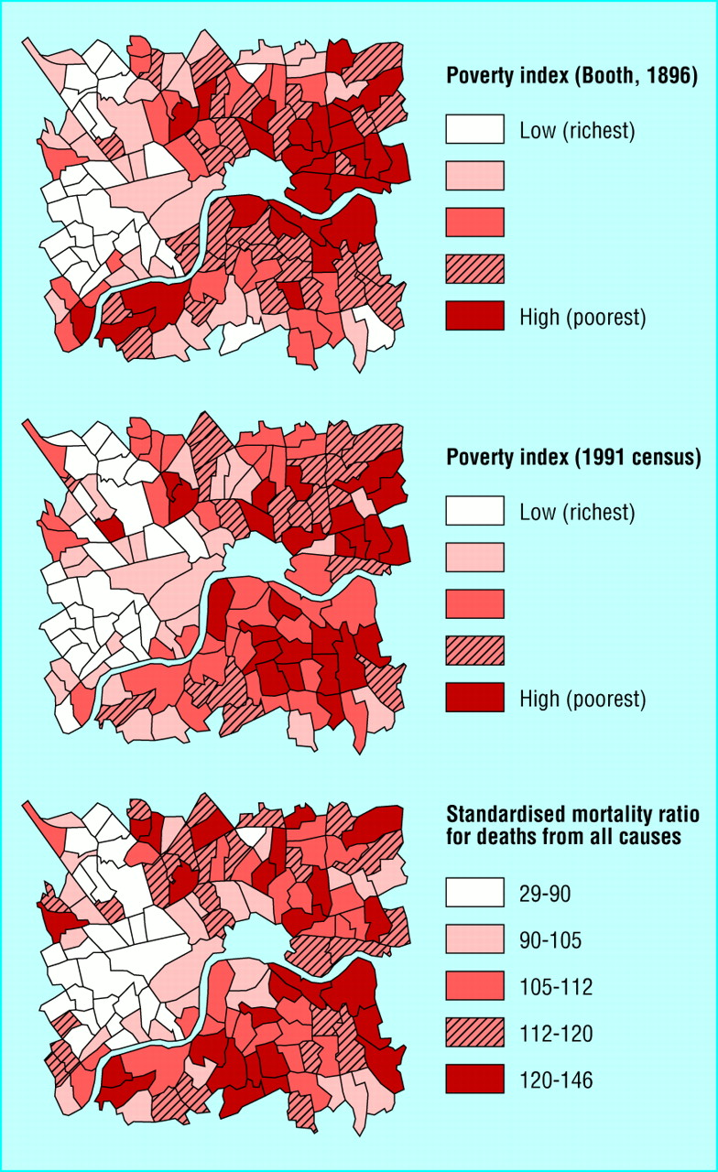

This analysis of the persistence of poverty and poor health provides a reasonable justification for assuming that, in Wales, at Local Health Group Area level, it is probably valid to use 1991 Census data to assess the reliability of the 1998 WHS.

The 1991 Census asked questions about any ‘limiting long-term illness’ (LLTI) suffered by a member of the household. Limiting long-term illness and disability are different concepts but there is a considerable degree of overlap between them (Pearce and Thomas, 1990; Charlton et al, 1994). However, there is evidence that the 1991 Census probably underestimated the prevalence of limiting long-term illness particularly amongst the elderly (Forrest and Gordon, 1993). In Britain, in the Census, 12% of adults were enumerated as having a limiting long-term illness whereas the 1991 Census Validation Survey found a rate of 14% (Heady, Smith and Avery, 1996). Similarly, interviews conducted in the 1989 Post-Enumeration Survey (the Census test) also discovered an adult prevalence rate of 14% (Pearce and Thomas, 1990) and the 1987 Autumn Wording Test of the Census Questions found an adult prevalence rate of 16% (Pearce et al, 1988; Thomas, 1989).

One reason for this underestimate in the Census is that the Limiting Long Term Illness question is known to be context-sensitive. If the question is asked as part of a health survey, along with many other questions of health, then respondents are more likely to claim to have a limiting long term illness compared with respondents to a survey or Census containing just a single question on health.

Nevertheless, useful comparisons can be made between the 1991 Census and 1998 WHS by examining the percentage distribution of LLTI at Local Health Group Area level within Wales as a whole. This comparison should, in part, compensate for the low LLTI prevalence rates in the 1991 Census. Table A5 shows this comparison.

Table A5: Comparison of the distribution of LLTI in Wales in the 1991 Census and 1998 WHS

Local Authority | Percentage distribution of LLTI in Wales  (WHS 1998) | Percentage distribution of LLTI in Wales  (1991 Census)
Isle of Anglesey | 2 | 2
Blaenau Gwent | 3 | 3
Bridgend | 5 | 5
Caerphilly | 7 | 7
Cardiff | 9 | 8
Carmarthenshire | 6 | 7
Ceredigion | 2 | 2
Conwy | 4 | 4
Denbighshire | 3 | 3
Flintshire | 4 | 4
Gwynedd | 4 | 3
Merthyr Tydfil | 2 | 3
Monmouthshire | 3 | 2
Neath Port Talbot | 5 | 6
Newport | 5 | 4
Pembrokeshire | 4 | 3
Powys | 4 | 3
Rhondda, Cynon, Taff | 9 | 11
Swansea | 8 | 8
Torfaen | 3 | 3
The Vale of Glamorgan | 4 | 3
Wrexham | 4 | 4
Total | 100 | 100

In 21 out of 22 Local Health Group Areas, the 1998 WHS results are either identical or differ by 1% or less from the 1991 Census prevalence rates. Only in the Rhondda, Cynon, Taff does the WHS prevalence estimate differ by 2%. This pattern is as expected given the sample size of the WHS and the number of comparisons that are made in Table A5. These results confirm once again a relatively reasonable reliability of the WHS data for measuring health need at Local Health Group Area level.

Conclusion
Fears that the 1998 WHS data may be too invalid and unreliable to provide robust information for health resource allocation appear to be unduly pessimistic. The WHS health condition indicators in aggregate can provide both valid and reasonably reliable measures of health need, partially if they are supplemented with health conditions data from other sources.

References
Anastasi, A. (1988) Psychological testing. New York, NY: Macmillan.
Carmines, E. G. and Zeller, R.A. (1991). Reliability and validity assessment. Newbury Park: Sage Publications.
Charlton, J., Wallace, M. and White, I. (1994) Long-term Illness: results from the 1991 Census, Population Trends, No. 75, Spring: 18-25.
Cronbach, L.J. (1951) Coeffcient Alpha and the Internal Structure of Tests. Psychometrika 16: 297-334.
Cronbach, L.J. (1976) Research on Classrooms and Schools: Formulation of Questions, Design and Analysis. Stanford University Evaluation Consortium, Stanford.
Cronbach, L.J., Gleser, G.C., Nanda, H. and Rajaratnam, N. (1971) The Dependability of Behavioural Measurements. New York: Wiley.
Dorling D., Mitchell, R., Shaw, M., Orford, S. Davey Smith, G. (2000) The Ghost of Christmas Past: health effects of poverty in London in 1896 and 1991 British Medical Journal321: 1547-1551 http://www.bmj.com/cgi/content/full/321/7276/1547)
Fink, A.. (1995) (ed) How to measure survey reliability and validity. Thousand Oaks, CA: Sage.
Forrest, R. and Gordon, D. (1993) People and Places. A 1991 Census Atlas for England. Bristol: SAUS and the Statistical Monitoring Unit.
Heady, P., Smith, S. and Avery, V. (1996) 1991 Census Validation Survey: quality report. London: The Stationery Office.
Kurder, F. (1970) Some Principles of Interest Measurement. Educational and Psychological Measurement 30: 205-226.
Nunnally, J.C. (1981) Psychometric Theory, New Delhi: Tate McGraw-Hill Publishing Company Ltd.
Pearce, D., Clark, A. and Baird, G. (1988) The 1987 Census Test, Population Trends 53: 22-26.
Pearce, D. and Thomas, F. (1990) The 1989 Census Test, Population Trends 61 Autumn: 24-30.
Shaw, M., Dorling, D., Gordon, D. and Davey Smith, G. (2000) ‘The Widening Gap: the social and spatial accumulation of health inequalities’ In Forbes, I (ed) Health Inequalities: Poverty and Policy. London: Academy of Learned Societies for the Social Sciences.
Thomas, R. (1989) Testing questions on disability and long term ill health for the 1991 Census, Survey Methodology Bulletin 24: 56-64.
Appendix 2

Resource allocation calculations (TRF 2 and prescribing)

Summary (1) Medical, Surgical and Other hospital In-patient and Day-patient Allocations excluding paediatrics and psychiatrics – based upon 13 health need indicators

Hospital In-Patient and Day Patient TFR 2 Totals 98-99 for adults (minus Paediatrics & Psychiatric)
A. Medical | £312,319,818
B. Surgical | £329,306,770

E. Other Specialities:
a. General Practice | £34,820,916
b. Radiotherapy | £12,869,868
c. Pathological specialities & Radiology | £83,482
d. Anaesthetics | £1,625,539
Total | £691,026,391

UA Name | Heart Disease | Cancer | Respiratory Disease | Arthritis | Back Pain | Epilepsy | Stroke | Accidents
Isle of Anglesey | £2,419,180 | £2,503,743 | £1,218,694 | £402,677 | £83,965 | £57,728 | £548,977 | £1,184,082
Gwynedd | £3,816,977 | £4,338,233 | £2,073,895 | £748,555 | £142,797 | £33,576 | £638,880 | £2,477,158
Conwy | £4,142,492 | £4,704,264 | £2,007,776 | £769,234 | £151,223 | £89,591 | £638,525 | £2,662,945
Denbighshire | £2,949,993 | £3,807,595 | £1,554,612 | £629,417 | £122,719 | £76,509 | £896,255 | £1,527,195
Flintshire | £4,585,580 | £4,273,257 | £2,371,303 | £892,526 | £191,540 | £101,549 | £541,447 | £3,206,848
Wrexham | £4,117,246 | £4,069,665 | £2,208,743 | £819,297 | £160,384 | £114,788 | £421,180 | £2,409,379
Powys | £4,132,372 | £4,299,247 | £1,972,839 | £701,887 | £163,721 | £109,480 | £702,366 | £1,986,619
Ceredigion | £2,344,693 | £2,544,894 | £1,260,517 | £423,258 | £94,522 | £52,879 | £271,547 | £1,074,676
Pembrokeshire | £4,150,718 | £4,073,997 | £1,904,178 | £736,318 | £145,978 | £56,510 | £595,753 | £2,094,711
Carmarthenshire | £6,558,350 | £6,320,002 | £3,255,639 | £1,210,155 | £233,247 | £95,928 | £1,395,134 | £4,086,174
Swansea | £7,345,055 | £8,455,547 | £4,485,422 | £1,636,558 | £311,355 | £136,384 | £1,302,292 | £4,651,453
Neath Port Talbot | £5,328,206 | £4,860,207 | £3,231,964 | £1,108,105 | £222,978 | £127,463 | £647,167 | £3,050,569
Bridgend | £4,800,296 | £4,173,627 | £2,664,286 | £908,842 | £179,644 | £73,483 | £621,970 | £2,499,882
Vale of Glamorgan | £3,576,750 | £3,660,316 | £1,917,917 | £724,652 | £151,418 | £58,091 | £787,588 | £2,295,585
Cardiff | £9,422,635 | £8,819,413 | £5,805,060 | £1,840,550 | £361,012 | £267,581 | £2,335,496 | £5,876,686
Rhondda, Cynon, Taff | £8,792,618 | £7,736,479 | £5,114,515 | £1,885,408 | £342,317 | £239,434 | £1,736,769 | £5,689,554
Merthyr Tydfil | £2,148,429 | £1,925,456 | £1,363,263 | £496,640 | £83,717 | £56,507 | £496,314 | £1,425,358
Caerphilly | £6,399,547 | £4,938,178 | £3,889,470 | £1,382,304 | £236,481 | £114,045 | £958,213 | £3,727,935
Blaenau Gwent | £2,982,475 | £2,395,450 | £1,679,445 | £606,965 | £114,225 | £96,398 | £542,624 | £1,603,414
Torfaen | £3,384,055 | £2,858,945 | £1,789,048 | £615,002 | £122,380 | £85,284 | £1,012,729 | £2,271,914
Monmouthshire | £2,591,842 | £2,514,572 | £1,397,655 | £488,822 | £102,813 | £64,046 | £290,427 | £1,205,107
Newport | £4,317,037 | £4,249,432 | £2,669,121 | £972,169 | £194,205 | £165,955 | £714,004 | £2,659,826
Wales | £100,306,547 | £97,522,519 | £55,835,362 | £19,999,342 | £3,912,641 | £2,273,209 | £18,095,659 | £59,667,070

Summary (1) Medical, Surgical and Other hospital In-patient and Day-patient Allocations excluding paediatrics and psychiatrics – based upon 13 health need indicators (continued)

UA Name | Diabetes | Varicose Veins | Hearing impairment | Dental health | Food Poisoning | Total Needs Based Allocation for 13 Health Indicators | Total Allocation adjusted to 98-99 control total
Isle of Anglesey | £127,678 | £60,184 | £6,705 | £99,572 | £3,709 | £8,716,894 | £16,166,356
Gwynedd | £301,119 | £115,747 | £10,582 | £152,339 | £6,381 | £14,856,237 | £27,552,387
Conwy | £310,459 | £124,151 | £10,633 | £201,307 | £7,108 | £15,819,708 | £29,339,240
Denbighshire | £208,899 | £86,047 | £8,275 | £153,465 | £5,846 | £12,026,826 | £22,304,960
Flintshire | £314,056 | £128,712 | £11,832 | £210,056 | £7,656 | £16,836,362 | £31,224,727
Wrexham | £269,311 | £112,316 | £15,729 | £203,087 | £6,239 | £14,927,365 | £27,684,300
Powys | £279,132 | £127,262 | £9,994 | £203,541 | £2,492 | £14,690,954 | £27,245,852
Ceredigion | £95,507 | £64,597 | £5,582 | £113,805 | £1,577 | £8,348,054 | £15,482,306
Pembrokeshire | £264,714 | £110,796 | £10,193 | £192,753 | £4,063 | £14,340,682 | £26,596,237
Carmarthenshire | £480,014 | £157,518 | £19,893 | £318,545 | £3,136 | £24,133,733 | £44,758,436
Swansea | £613,027 | £216,107 | £23,945 | £378,295 | £13,013 | £29,568,453 | £54,837,671
Neath Port Talbot | £460,986 | £147,249 | £17,559 | £266,999 | £5,524 | £19,474,977 | £36,118,304
Bridgend | £269,336 | £117,041 | £15,190 | £212,849 | £6,040 | £16,542,487 | £30,679,707
Vale of Glamorgan | £183,301 | £96,972 | £10,765 | £163,255 | £9,349 | £13,635,959 | £25,289,259
Cardiff | £645,716 | £237,203 | £28,776 | £394,184 | £22,085 | £36,056,397 | £66,870,217
Rhondda, Cynon, Taff | £693,727 | £208,495 | £30,118 | £422,784 | £9,201 | £32,901,420 | £61,018,995
Merthyr Tydfil | £159,092 | £55,412 | £8,959 | £105,063 | £2,376 | £8,326,584 | £15,442,488
Caerphilly | £491,932 | £162,532 | £24,760 | £305,851 | £8,860 | £22,640,108 | £41,988,358
Blaenau Gwent | £272,286 | £71,902 | £10,305 | £140,808 | £1,861 | £10,518,157 | £19,506,981
Torfaen | £266,167 | £89,320 | £11,186 | £162,061 | £3,825 | £12,671,916 | £23,501,343
Monmouthshire | £118,886 | £88,605 | £7,945 | £121,483 | £4,159 | £8,996,364 | £16,684,662
Newport | £276,533 | £114,753 | £13,432 | £219,242 | £5,840 | £16,571,550 | £30,733,607
Wales | £7,101,878 | £2,692,921 | £312,357 | £4,741,344 | £140,338 | £372,601,187 | £691,026,391

Summary (2) Children’s Health, Maternity, Psychiatric and A&E Costs

Resource Allocation: Children’s Health Maternity, Psychiatric, A&E and Outpatients

UA Name | A & E Total | Total Children's Health Costs | Total Maternity Costs | Total Psychiatric Allocation | Outpatient Allocations (Medical, Surgical & Other) | Total (Summary 2)
Isle of Anglesey | £899,263 | £1,851,860 | £1,540,466 | £4,016,480 | £3,653,100 | £11,961,169
Gwynedd | £1,881,303 | £3,230,161 | £2,672,548 | £7,937,536 | £6,170,649 | £21,892,197
Conwy | £2,022,401 | £2,794,001 | £2,359,553 | £8,907,990 | £6,750,858 | £22,834,803
Denbighshire | £1,159,843 | £2,433,289 | £2,026,354 | £5,507,337 | £5,184,515 | £16,311,338
Flintshire | £2,435,473 | £4,105,169 | £3,516,807 | £9,444,688 | £7,617,471 | £27,119,608
Wrexham | £1,829,827 | £3,588,472 | £2,949,441 | £8,692,287 | £7,179,159 | £24,239,186
Powys | £1,508,758 | £3,364,234 | £2,633,797 | £8,672,679 | £6,583,008 | £22,762,476
Ceredigion | £816,173 | £1,743,267 | £1,303,319 | £5,493,248 | £3,779,432 | £13,135,439
Pembrokeshire | £1,590,849 | £3,264,535 | £2,567,223 | £8,183,866 | £6,425,558 | £22,032,031
Carmarthenshire | £3,103,286 | £4,531,568 | £3,622,795 | £14,078,371 | £10,478,538 | £35,814,558
Swansea | £3,532,593 | £6,139,865 | £5,067,210 | £18,852,933 | £13,470,832 | £47,063,433
Neath Port Talbot | £2,316,785 | £3,990,951 | £3,059,073 | £12,822,057 | £9,425,663 | £31,614,529
Bridgend | £1,898,561 | £3,783,087 | £3,188,908 | £10,213,377 | £7,833,540 | £26,917,473
Vale of Glamorgan | £1,743,405 | £3,480,800 | £2,885,518 | £6,894,839 | £6,173,336 | £21,177,898
Cardiff | £4,463,108 | £9,351,251 | £8,103,760 | £23,961,358 | £16,362,399 | £62,241,876
Rhondda, Cynon, Taff | £4,320,989 | £6,969,712 | £5,759,774 | £21,978,672 | £15,334,177 | £54,363,324
Merthyr Tydfil | £1,082,502 | £1,833,122 | £1,499,396 | £6,110,761 | £3,905,940 | £14,431,721
Caerphilly | £2,831,218 | £5,387,574 | £4,335,232 | £16,442,359 | £11,178,767 | £40,175,150
Blaenau Gwent | £1,217,729 | £2,339,991 | £1,731,244 | £7,652,914 | £5,117,033 | £18,058,911
Torfaen | £1,725,428 | £2,886,552 | £2,347,630 | £9,227,639 | £5,622,974 | £21,810,223
Monmouthshire | £915,230 | £2,389,145 | £1,797,155 | £4,622,097 | £4,381,527 | £14,105,154
Newport | £2,020,032 | £4,275,488 | £3,605,241 | £10,950,177 | £7,920,396 | £28,771,334
Wales | £45,314,758 | £83,584,614 | £68,572,443 | £230,663,665 | £170,548,870 | £598,684,350

Summary (3) GP, Community Nursing and Chiropody

Resource Allocation: notional GMS, Community Nursing and Chiropody

UA Name | Total GMS allocation | Total Community Nurse Allocation | Total Chiropody Allocation | Total Summary 3
Isle of Anglesey | £3,936,208 | £1,270,306 | £144,623 | £5,351,137
Gwynedd | £6,789,420 | £2,144,708 | £244,700 | £9,178,828
Conwy | £7,414,572 | £2,338,350 | £267,968 | £10,020,890
Denbighshire | £5,575,410 | £1,804,282 | £206,373 | £7,586,065
Flintshire | £8,424,861 | £2,638,630 | £299,876 | £11,363,367
Wrexham | £7,798,858 | £2,496,691 | £282,997 | £10,578,546
Powys | £7,138,658 | £2,286,983 | £262,191 | £9,687,832
Ceredigion | £4,123,668 | £1,309,982 | £148,209 | £5,581,859
Pembrokeshire | £7,009,582 | £2,229,846 | £256,211 | £9,495,639
Carmarthenshire | £11,511,956 | £3,648,557 | £420,851 | £15,581,364
Swansea | £14,749,173 | £4,684,690 | £533,374 | £19,967,237
Neath Port Talbot | £10,284,422 | £3,272,294 | £375,628 | £13,932,344
Bridgend | £8,532,037 | £2,731,317 | £309,320 | £11,572,674
Vale of Glamorgan | £6,695,806 | £2,151,889 | £241,605 | £9,089,300
Cardiff | £18,113,943 | £5,726,169 | £637,082 | £24,477,194
Rhondda, Cynon, Taff | £16,909,468 | £5,343,548 | £610,474 | £22,863,490
Merthyr Tydfil | £4,336,723 | £1,364,154 | £156,379 | £5,857,256
Caerphilly | £12,332,251 | £3,888,593 | £445,234 | £16,666,078
Blaenau Gwent | £5,640,124 | £1,783,596 | £204,614 | £7,628,334
Torfaen | £6,304,093 | £1,973,678 | £224,658 | £8,502,429
Monmouthshire | £4,645,291 | £1,521,798 | £172,339 | £6,339,428
Newport | £8,667,477 | £2,743,105 | £309,908 | £11,720,490
Wales | £186,934,000 | £59,353,168 | £6,754,612 | £253,041,780

1). Hospital In-patient and day-patient cost allocation for Heart & Circulatory Disease

Heart Disease Cost
Disease Area |  | Total Wales (Activity) | Total Wales (Cost) | Outside Wales (Activity) | Outside Wales (Cost) | Total Cost | Average cost per activity (In & Outside Wales)
Heart & Circulatory Disease |  | 76737 | £98,532,532 | 1410 | £1,774,015 | £100,306,547 | £1,284

Heart Disease Resource Allocation
UA Name | Heart Number | Heart rate | % of Welsh Total | Needs Based Cost | Cost adjusted to control total
Isle of Anglesey | 143 | 21 | 2 | £184,101 | £2,419,180
Gwynedd | 226 | 19 | 4 | £290,474 | £3,816,977
Conwy | 246 | 21 | 4 | £315,246 | £4,142,492
Denbighshire | 175 | 19 | 3 | £224,496 | £2,949,993
Flintshire | 272 | 18 | 5 | £348,965 | £4,585,580
Wrexham | 244 | 19 | 4 | £313,325 | £4,117,246
Powys | 245 | 19 | 4 | £314,476 | £4,132,372
Ceredigion | 139 | 18 | 2 | £178,432 | £2,344,693
Pembrokeshire | 246 | 21 | 4 | £315,872 | £4,150,718
Carmarthenshire | 389 | 22 | 7 | £499,094 | £6,558,350
Swansea | 435 | 18 | 7 | £558,963 | £7,345,055
Neath Port Talbot | 316 | 22 | 5 | £405,479 | £5,328,206
Bridgend | 285 | 21 | 5 | £365,305 | £4,800,296
Vale of Glamorgan | 212 | 18 | 4 | £272,193 | £3,576,750
Cardiff | 559 | 17 | 9 | £717,068 | £9,422,635
Rhondda, Cynon, Taff | 521 | 21 | 9 | £669,123 | £8,792,618
Merthyr Tydfil | 127 | 23 | 2 | £163,497 | £2,148,429
Caerphilly | 379 | 23 | 6 | £487,009 | £6,399,547
Blaenau Gwent | 177 | 24 | 3 | £226,968 | £2,982,475
Torfaen | 201 | 22 | 3 | £257,528 | £3,384,055
Monmouthshire | 154 | 17 | 3 | £197,241 | £2,591,842
Newport | 256 | 19 | 4 | £328,529 | £4,317,037
Wales | 5947 | 20 | 100 | £7,633,384 | £100,306,547

2) Hospital In-patient and day-patient cost allocation for Cancer

Cancer costs
Disease Area |  | Total Wales (Activity) | Total Wales (Cost) | Outside Wales (Activity) | Outside Wales (Cost) | Total Cost | Average cost per activity (In & Outside Wales)
2. Cancer Total |  | 96,063 | £96,542,846 | 958 | £979,673 | £97,522,519 | £1,005

Cancer Resource Allocation

UA Name | All Malignancies 95-97 average number | Cancer rate per 1000 | % of Welsh Total | Needs Based Cost | Cost adjusted to control total
Isle of Anglesey | 385 | 6 | 3 | £387,325 | £2,503,743
Gwynedd | 668 | 6 | 4 | £671,118 | £4,338,233
Conwy | 724 | 6 | 5 | £727,742 | £4,704,264
Denbighshire | 586 | 6 | 4 | £589,029 | £3,807,595
Flintshire | 658 | 4 | 4 | £661,066 | £4,273,257
Wrexham | 626 | 5 | 4 | £629,571 | £4,069,665
Powys | 662 | 5 | 4 | £665,087 | £4,299,247
Ceredigion | 392 | 6 | 3 | £393,691 | £2,544,894
Pembrokeshire | 627 | 6 | 4 | £630,241 | £4,073,997
Carmarthenshire | 973 | 6 | 6 | £977,695 | £6,320,002
Swansea | 1301 | 6 | 9 | £1,308,060 | £8,455,547
Neath Port Talbot | 748 | 5 | 5 | £751,867 | £4,860,207
Bridgend | 642 | 5 | 4 | £645,654 | £4,173,627
Vale of Glamorgan | 563 | 5 | 4 | £566,245 | £3,660,316
Cardiff | 1357 | 4 | 9 | £1,364,350 | £8,819,413
Rhondda, Cynon, Taff | 1191 | 5 | 8 | £1,196,821 | £7,736,479
Merthyr Tydfil | 296 | 5 | 2 | £297,865 | £1,925,456
Caerphilly | 760 | 4 | 5 | £763,929 | £4,938,178
Blaenau Gwent | 369 | 5 | 2 | £370,572 | £2,395,450
Torfaen | 440 | 5 | 3 | £442,274 | £2,858,945
Monmouthshire | 387 | 4 | 3 | £389,000 | £2,514,572
Newport | 654 | 5 | 4 | £657,381 | £4,249,432
Wales | 15009 | 5 | 100 | £15,086,584 | £97,522,519

3). Hospital In-patient and day-patient cost allocation for Respiratory Disease

Respiratory Illness Costs

Disease Area |  | Total Wales (Activity) | Total Wales (Cost) | Outside Wales (Activity) | Outside Wales (Cost) | Total Cost | Average cost per activity (In & Outside Wales)
3. Respiratory Illness Total |  | 56,173 | £54,849,642 | 1,010 | £985,720 | £55,835,362 | £976

Respiratory Illness Resource Allocation
UA Name | Respiratory Disease | Respiratory Disease rate | % of Welsh Total | Needs Based Cost | Cost adjusted to control total
Isle of Anglesey | 145 | 21 | 2 | £141,150 | £1,218,694
Gwynedd | 246 | 20 | 4 | £240,199 | £2,073,895
Conwy | 238 | 20 | 4 | £232,541 | £2,007,776
Denbighshire | 184 | 20 | 3 | £180,056 | £1,554,612
Flintshire | 281 | 19 | 4 | £274,645 | £2,371,303
Wrexham | 262 | 21 | 4 | £255,818 | £2,208,743
Powys | 234 | 18 | 4 | £228,495 | £1,972,839
Ceredigion | 150 | 20 | 2 | £145,994 | £1,260,517
Pembrokeshire | 226 | 20 | 3 | £220,543 | £1,904,178
Carmarthenshire | 386 | 22 | 6 | £377,070 | £3,255,639
Swansea | 532 | 22 | 8 | £519,504 | £4,485,422
Neath Port Talbot | 383 | 27 | 6 | £374,327 | £3,231,964
Bridgend | 316 | 24 | 5 | £308,579 | £2,664,286
Vale of Glamorgan | 227 | 19 | 3 | £222,134 | £1,917,917
Cardiff | 689 | 21 | 10 | £672,345 | £5,805,060
Rhondda, Cynon, Taff | 607 | 25 | 9 | £592,365 | £5,114,515
Merthyr Tydfil | 162 | 29 | 2 | £157,894 | £1,363,263
Caerphilly | 461 | 27 | 7 | £450,480 | £3,889,470
Blaenau Gwent | 199 | 27 | 3 | £194,514 | £1,679,445
Torfaen | 212 | 23 | 3 | £207,208 | £1,789,048
Monmouthshire | 166 | 19 | 3 | £161,877 | £1,397,655
Newport | 317 | 23 | 5 | £309,139 | £2,669,121
Wales | 6623 | 22 | 100 | £6,466,876 | £55,835,362

4). Hospital In-patient and day-patient cost allocation for Mental Illness

Mental Illness Costs

Disease Area |  | Total Wales (Activity) | Total Wales (Cost) | Outside Wales (Activity) | Outside Wales (Cost) | Total Cost | Average cost per activity (In & Outside Wales)
4. Mental Illness Total |  | 15,576 | £39,011,868 | 218 | £460,542 | £39,472,410 | £2,499

Mental Illness Resource Allocation
UA Name | Mental Illness  Number | Mental Illness rate | % of Welsh Total | Needs-based cost | Cost adjusted to control total
Isle of Anglesey | 63 | 9 | 2 | £157,052 | £636,554
Gwynedd | 116 | 10 | 3 | £289,382 | £1,172,910
Conwy | 146 | 12 | 4 | £364,478 | £1,477,286
Denbighshire | 105 | 11 | 3 | £262,517 | £1,064,022
Flintshire | 161 | 11 | 4 | £402,788 | £1,632,560
Wrexham | 156 | 12 | 4 | £390,093 | £1,581,106
Powys | 127 | 10 | 3 | £316,675 | £1,283,531
Ceredigion | 89 | 12 | 2 | £223,612 | £906,334
Pembrokeshire | 143 | 12 | 4 | £358,602 | £1,453,470
Carmarthenshire | 229 | 13 | 6 | £572,050 | £2,318,608
Swansea | 303 | 13 | 8 | £757,768 | £3,071,351
Neath Port Talbot | 201 | 14 | 5 | £502,085 | £2,035,026
Bridgend | 166 | 12 | 4 | £414,831 | £1,681,373
Vale of Glamorgan | 120 | 10 | 3 | £299,143 | £1,212,471
Cardiff | 429 | 13 | 11 | £1,073,150 | £4,349,643
Rhondda, Cynon, Taff | 373 | 15 | 10 | £932,524 | £3,779,665
Merthyr Tydfil | 116 | 21 | 3 | £289,510 | £1,173,427
Caerphilly | 302 | 18 | 8 | £754,023 | £3,056,172
Blaenau Gwent | 132 | 18 | 3 | £330,892 | £1,341,157
Torfaen | 161 | 18 | 4 | £403,126 | £1,633,932
Monmouthshire | 70 | 8 | 2 | £175,930 | £713,072
Newport | 187 | 14 | 5 | £468,460 | £1,898,741
Wales | 3897 | 13 | 100 | £9,738,692 | £39,472,410

5) Hospital In-patient and day-patient cost allocation for Arthritis

Arthritis costs
Disease Area |  | Total Wales (Activity) | Total Wales (Cost) | Outside Wales (Activity) | Outside Wales (Cost) | Total Cost | Average cost per activity (In & Outside Wales)
7. Arthritis Total |  | 11,893 | £19,749,412 | 103 | £249,930 | £19,999,342 | £1,667

Arthritis Resource Allocation

UA Name | Arthritis Number | Arthritis rate | % of Welsh Total | Needs Based Cost | Cost adjusted to control total
Isle of Anglesey | 146 | 22 | 2 | £242,899 | £402,677
Gwynedd | 271 | 22 | 4 | £451,536 | £748,555
Conwy | 278 | 24 | 4 | £464,010 | £769,234
Denbighshire | 228 | 24 | 3 | £379,671 | £629,417
Flintshire | 323 | 22 | 4 | £538,381 | £892,526
Wrexham | 296 | 23 | 4 | £494,208 | £819,297
Powys | 254 | 20 | 4 | £423,386 | £701,887
Ceredigion | 153 | 20 | 2 | £255,314 | £423,258
Pembrokeshire | 266 | 23 | 4 | £444,154 | £736,318
Carmarthenshire | 438 | 25 | 6 | £729,978 | £1,210,155
Swansea | 592 | 25 | 8 | £987,189 | £1,636,558
Neath Port Talbot | 401 | 28 | 6 | £668,420 | £1,108,105
Bridgend | 329 | 25 | 5 | £548,223 | £908,842
Vale of Glamorgan | 262 | 22 | 4 | £437,118 | £724,652
Cardiff | 666 | 21 | 9 | £1,110,238 | £1,840,550
Rhondda, Cynon, Taff | 682 | 28 | 9 | £1,137,298 | £1,885,408
Merthyr Tydfil | 180 | 32 | 2 | £299,578 | £496,640
Caerphilly | 500 | 30 | 7 | £833,820 | £1,382,304
Blaenau Gwent | 220 | 30 | 3 | £366,127 | £606,965
Torfaen | 223 | 25 | 3 | £370,976 | £615,002
Monmouthshire | 177 | 20 | 2 | £294,862 | £488,822
Newport | 352 | 26 | 5 | £586,423 | £972,169
Wales | 7236 | 24 | 100 | £12,063,806 | £19,999,342

6). Hospital In-patient and day-patient cost allocation for Diabetes

Diabetes costs
Disease Area |  | Total Wales (Activity) | Total Wales (Cost) | Outside Wales (Activity) | Outside Wales (Cost) | Total Cost | Average cost per activity (In & Outside Wales)
5. Diabetes Total |  | 7,460 | £6,969,481 | 125 | £132,398 | £7,101,878 | £936

Diabetes Resource Allocation

UA Name | Diabetes number | Diabetes rate | % of Welsh Total | Needs Based Cost | Cost adjusted to control total
Isle of Anglesey | 19 | 3 | 2 | £17,782 | £127,678
Gwynedd | 45 | 4 | 4 | £41,937 | £301,119
Conwy | 46 | 4 | 4 | £43,238 | £310,459
Denbighshire | 31 | 3 | 3 | £29,094 | £208,899
Flintshire | 47 | 3 | 4 | £43,739 | £314,056
Wrexham | 40 | 3 | 4 | £37,507 | £269,311
Powys | 42 | 3 | 4 | £38,875 | £279,132
Ceredigion | 14 | 2 | 1 | £13,301 | £95,507
Pembrokeshire | 39 | 3 | 4 | £36,867 | £264,714
Carmarthenshire | 71 | 4 | 7 | £66,852 | £480,014
Swansea | 91 | 4 | 9 | £85,377 | £613,027
Neath Port Talbot | 69 | 5 | 6 | £64,202 | £460,986
Bridgend | 40 | 3 | 4 | £37,511 | £269,336
Vale of Glamorgan | 27 | 2 | 3 | £25,529 | £183,301
Cardiff | 96 | 3 | 9 | £89,930 | £645,716
Rhondda, Cynon, Taff | 103 | 4 | 10 | £96,616 | £693,727
Merthyr Tydfil | 24 | 4 | 2 | £22,157 | £159,092
Caerphilly | 73 | 4 | 7 | £68,512 | £491,932
Blaenau Gwent | 41 | 5 | 4 | £37,922 | £272,286
Torfaen | 40 | 4 | 4 | £37,070 | £266,167
Monmouthshire | 18 | 2 | 2 | £16,557 | £118,886
Newport | 41 | 3 | 4 | £38,513 | £276,533
Wales | 1056 | 4 | 100 | £989,089 | £7,101,878

7) Hospital In-patient and day-patient cost allocation for Back Pain

Back Pain costs
Disease Area |  | Total Wales (Activity) | Total Wales (Cost) | Outside Wales (Activity) | Outside Wales (Cost) | Total Cost | Average cost per activity (In & Outside Wales)
6. Back Pain Total |  | 6,399 | £3,815,240 | 111 | £97,401 | £3,912,641 | £601

Back Pain Resource Allocation

UA Name | Back Pain number | Back pain rate | % of Welsh Total | Needs Based Cost | Cost adjusted to control total
Isle of Anglesey | 189 | 28 | 2 | £113,709 | £83,965
Gwynedd | 322 | 26 | 4 | £193,382 | £142,797
Conwy | 341 | 29 | 4 | £204,793 | £151,223
Denbighshire | 277 | 30 | 3 | £166,192 | £122,719
Flintshire | 432 | 29 | 5 | £259,393 | £191,540
Wrexham | 361 | 28 | 4 | £217,199 | £160,384
Powys | 369 | 28 | 4 | £221,718 | £163,721
Ceredigion | 213 | 28 | 2 | £128,006 | £94,522
Pembrokeshire | 329 | 29 | 4 | £197,690 | £145,978
Carmarthenshire | 526 | 30 | 6 | £315,874 | £233,247
Swansea | 702 | 30 | 8 | £421,652 | £311,355
Neath Port Talbot | 502 | 35 | 6 | £301,968 | £222,978
Bridgend | 405 | 30 | 5 | £243,283 | £179,644
Vale of Glamorgan | 341 | 28 | 4 | £205,058 | £151,418
Cardiff | 813 | 25 | 9 | £488,900 | £361,012
Rhondda, Cynon, Taff | 771 | 32 | 9 | £463,582 | £342,317
Merthyr Tydfil | 189 | 34 | 2 | £113,373 | £83,717
Caerphilly | 533 | 32 | 6 | £320,254 | £236,481
Blaenau Gwent | 257 | 35 | 3 | £154,690 | £114,225
Torfaen | 276 | 30 | 3 | £165,733 | £122,380
Monmouthshire | 232 | 26 | 3 | £139,235 | £102,813
Newport | 438 | 32 | 5 | £263,001 | £194,205
Wales | 8816 | 30 | 100 | £5,298,683 | £3,912,641

8). Hospital In-patient and day-patient cost allocation for Epilepsy

Epilepsy costs
Disease Area |  | Total Wales (Activity) | Total Wales (Cost) | Outside Wales (Activity) | Outside Wales (Cost) | Total Cost | Average cost per activity (In & Outside Wales)
10. Epilepsy Total |  | 3,424 | £2,205,540 | 101 | £67,670 | £2,273,209 | £645

Epilepsy Resource Allocation

UA Name | Epilepsy number | Epilepsy rate | % of Welsh Total | Needs Based Cost | Cost adjusted to control total
Isle of Anglesey | 6 | 1 | 3 | £4,179 | £57,728
Gwynedd | 4 | 0 | 1 | £2,430 | £33,576
Conwy | 10 | 1 | 4 | £6,485 | £89,591
Denbighshire | 9 | 1 | 3 | £5,538 | £76,509
Flintshire | 11 | 1 | 4 | £7,351 | £101,549
Wrexham | 13 | 1 | 5 | £8,309 | £114,788
Powys | 12 | 1 | 5 | £7,925 | £109,480
Ceredigion | 6 | 1 | 2 | £3,828 | £52,879
Pembrokeshire | 6 | 1 | 2 | £4,090 | £56,510
Carmarthenshire | 11 | 1 | 4 | £6,944 | £95,928
Swansea | 15 | 1 | 6 | £9,872 | £136,384
Neath Port Talbot | 14 | 1 | 6 | £9,226 | £127,463
Bridgend | 8 | 1 | 3 | £5,319 | £73,483
Vale of Glamorgan | 7 | 1 | 3 | £4,205 | £58,091
Cardiff | 30 | 1 | 12 | £19,369 | £267,581
Rhondda, Cynon, Taff | 27 | 1 | 11 | £17,331 | £239,434
Merthyr Tydfil | 6 | 1 | 2 | £4,090 | £56,507
Caerphilly | 13 | 1 | 5 | £8,255 | £114,045
Blaenau Gwent | 11 | 1 | 4 | £6,978 | £96,398
Torfaen | 10 | 1 | 4 | £6,173 | £85,284
Monmouthshire | 7 | 1 | 3 | £4,636 | £64,046
Newport | 19 | 1 | 7 | £12,012 | £165,955
Wales | 255 | 1 | 100 | £164,544 | £2,273,209

9). Hospital In-patient and day-patient cost allocation for Stroke

Stroke costs
Disease Area |  | Total Wales (Activity) | Total Wales (Cost) | Outside Wales (Activity) | Outside Wales (Cost) | Total Cost | Average cost per activity (In & Outside Wales)
9. Stroke Total |  | 9,736 | £17,650,813 | 251 | £444,845 | £18,095,659 | £1,812

Stroke Resource Allocation

UA Name | Stroke number | Stroke rate | % of Welsh Total | Needs Based Cost | Cost adjusted to control total
Isle of Anglesey | 11 | 2 | 3 | £19,200 | £548,977
Gwynedd | 12 | 1 | 4 | £22,344 | £638,880
Conwy | 12 | 1 | 4 | £22,332 | £638,525
Denbighshire | 17 | 2 | 5 | £31,345 | £896,255
Flintshire | 10 | 1 | 3 | £18,936 | £541,447
Wrexham | 8 | 1 | 2 | £14,730 | £421,180
Powys | 14 | 1 | 4 | £24,564 | £702,366
Ceredigion | 5 | 1 | 2 | £9,497 | £271,547
Pembrokeshire | 11 | 1 | 3 | £20,836 | £595,753
Carmarthenshire | 27 | 2 | 8 | £48,793 | £1,395,134
Swansea | 25 | 1 | 7 | £45,546 | £1,302,292
Neath Port Talbot | 12 | 1 | 4 | £22,634 | £647,167
Bridgend | 12 | 1 | 3 | £21,753 | £621,970
Vale of Glamorgan | 15 | 1 | 4 | £27,545 | £787,588
Cardiff | 45 | 1 | 13 | £81,681 | £2,335,496
Rhondda, Cynon, Taff | 34 | 1 | 10 | £60,741 | £1,736,769
Merthyr Tydfil | 10 | 2 | 3 | £17,358 | £496,314
Caerphilly | 18 | 1 | 5 | £33,512 | £958,213
Blaenau Gwent | 10 | 1 | 3 | £18,978 | £542,624
Torfaen | 20 | 2 | 6 | £35,419 | £1,012,729
Monmouthshire | 6 | 1 | 2 | £10,157 | £290,427
Newport | 14 | 1 | 4 | £24,971 | £714,004
Wales | 349 | 1 | 100 | £632,875 | £18,095,659

10) Hospital In-patient and day-patient cost allocation for Varicose Veins

Varicose Veins costs
Disease Area |  | Total Wales (Activity) | Total Wales (Cost) | Outside Wales (Activity) | Outside Wales (Cost) | Total Cost | Average cost per activity (In & Outside Wales)
8. Varicose Veins Total |  | 2,576 | £2,670,893 | 26 | £22,028 | £2,692,921 | £1,035

Varicose Veins Resource Allocation

UA Name | Varicose Veins number | Varicose Veins rate | % of Welsh Total | Needs Based Cost | Cost adjusted to control total
Isle of Anglesey | 70 | 10 | 2 | £72,656 | £60,184
Gwynedd | 135 | 11 | 4 | £139,733 | £115,747
Conwy | 145 | 12 | 5 | £149,879 | £124,151
Denbighshire | 100 | 11 | 3 | £103,879 | £86,047
Flintshire | 150 | 10 | 5 | £155,385 | £128,712
Wrexham | 131 | 10 | 4 | £135,592 | £112,316
Powys | 148 | 11 | 5 | £153,635 | £127,262
Ceredigion | 75 | 10 | 2 | £77,984 | £64,597
Pembrokeshire | 129 | 11 | 4 | £133,757 | £110,796
Carmarthenshire | 184 | 10 | 6 | £190,161 | £157,518
Swansea | 252 | 11 | 8 | £260,891 | £216,107
Neath Port Talbot | 172 | 12 | 5 | £177,764 | £147,249
Bridgend | 137 | 10 | 4 | £141,296 | £117,041
Vale of Glamorgan | 113 | 9 | 4 | £117,068 | £96,972
Cardiff | 277 | 9 | 9 | £286,360 | £237,203
Rhondda, Cynon, Taff | 243 | 10 | 8 | £251,703 | £208,495
Merthyr Tydfil | 65 | 12 | 2 | £66,895 | £55,412
Caerphilly | 190 | 11 | 6 | £196,215 | £162,532
Blaenau Gwent | 84 | 11 | 3 | £86,802 | £71,902
Torfaen | 104 | 11 | 3 | £107,830 | £89,320
Monmouthshire | 103 | 12 | 3 | £106,967 | £88,605
Newport | 134 | 10 | 4 | £138,533 | £114,753
Wales | 3141 | 11 | 100 | £3,250,985 | £2,692,921

11). Hospital In-patient, day-patient and outpatient cost allocation for injury in accident

Injury in accident DRG costs
Disease Area |  | Total Wales (Activity) | Total Wales (Cost) | Outside Wales (Activity) | Outside Wales (Cost) | Total Cost | Average cost per activity (In & Outside Wales)
14. Injury in Accidents Total |  | 44,099 | £57,573,947 | 1,557 | £2,093,122 | £59,667,070 | £1,307

TFR 2 1998-99 | In Patient | Out Patient | Total
E. OTHER SPECIALTIES
e. A & E | 1,693,070 | 1,936,983 | 3,630,053
Other Patient Groups
Patients using accident and emergency services |  | 41,684,705 | 41,684,705
Total A & E |  |  | 45,314,758

Accident Resource Allocation

UA Name | Accident number | Accident rate | % of Welsh Total | Needs Based Cost | Cost adjusted to DRG control total | Cost adjusted to TRF2 control total
Isle of Anglesey | 43 | 6 | 2 | £56,712 | £1,184,082 | £899,263
Gwynedd | 91 | 7 | 4 | £118,644 | £2,477,158 | £1,881,303
Conwy | 98 | 8 | 4 | £127,543 | £2,662,945 | £2,022,401
Denbighshire | 56 | 6 | 3 | £73,145 | £1,527,195 | £1,159,843
Flintshire | 118 | 8 | 5 | £153,593 | £3,206,848 | £2,435,473
Wrexham | 88 | 7 | 4 | £115,398 | £2,409,379 | £1,829,827
Powys | 73 | 6 | 3 | £95,150 | £1,986,619 | £1,508,758
Ceredigion | 39 | 5 | 2 | £51,472 | £1,074,676 | £816,173
Pembrokeshire | 77 | 7 | 4 | £100,327 | £2,094,711 | £1,590,849
Carmarthenshire | 150 | 8 | 7 | £195,709 | £4,086,174 | £3,103,286
Swansea | 170 | 7 | 8 | £222,783 | £4,651,453 | £3,532,593
Neath Port Talbot | 112 | 8 | 5 | £146,108 | £3,050,569 | £2,316,785
Bridgend | 92 | 7 | 4 | £119,733 | £2,499,882 | £1,898,561
Vale of Glamorgan | 84 | 7 | 4 | £109,948 | £2,295,585 | £1,743,405
Cardiff | 215 | 7 | 10 | £281,466 | £5,876,686 | £4,463,108
Rhondda, Cynon, Taff | 209 | 9 | 10 | £272,503 | £5,689,554 | £4,320,989
Merthyr Tydfil | 52 | 9 | 2 | £68,268 | £1,425,358 | £1,082,502
Caerphilly | 137 | 8 | 6 | £178,551 | £3,727,935 | £2,831,218
Blaenau Gwent | 59 | 8 | 3 | £76,796 | £1,603,414 | £1,217,729
Torfaen | 83 | 9 | 4 | £108,814 | £2,271,914 | £1,725,428
Monmouthshire | 44 | 5 | 2 | £57,719 | £1,205,107 | £915,230
Newport | 97 | 7 | 4 | £127,393 | £2,659,826 | £2,020,032
Wales | 2187 | 7 | 100 | £2,857,774 | £59,667,070 | £45,314,758

12) Hospital In-patient and day-patient cost allocation for Hearing Impairment

Hearing Impairment costs
Disease Area |  | Total Wales (Activity) | Total Wales (Cost) | Outside Wales (Activity) | Outside Wales (Cost) | Total Cost | Average cost per activity (In & Outside Wales)
17. Hearing Impairment Total |  | 447 | £299,085 | 18 | £13,272 | £312,357 | £672

Hearing Impairment Resource Allocation

UA Name | Hearing impairment number | Hearing impairment rate | % of Welsh Total | Needs Based Cost | Cost adjusted to control total
Isle of Anglesey | 80 | 12 | 2 | £53,506 | £6,705
Gwynedd | 126 | 10 | 3 | £84,442 | £10,582
Conwy | 126 | 11 | 3 | £84,850 | £10,633
Denbighshire | 98 | 11 | 3 | £66,034 | £8,275
Flintshire | 141 | 9 | 4 | £94,420 | £11,832
Wrexham | 187 | 15 | 5 | £125,512 | £15,729
Powys | 119 | 9 | 3 | £79,753 | £9,994
Ceredigion | 66 | 9 | 2 | £44,540 | £5,582
Pembrokeshire | 121 | 11 | 3 | £81,339 | £10,193
Carmarthenshire | 236 | 13 | 6 | £158,740 | £19,893
Swansea | 284 | 12 | 8 | £191,078 | £23,945
Neath Port Talbot | 209 | 15 | 6 | £140,115 | £17,559
Bridgend | 180 | 14 | 5 | £121,215 | £15,190
Vale of Glamorgan | 128 | 11 | 3 | £85,906 | £10,765
Cardiff | 342 | 11 | 9 | £229,629 | £28,776
Rhondda, Cynon, Taff | 358 | 15 | 10 | £240,335 | £30,118
Merthyr Tydfil | 106 | 19 | 3 | £71,492 | £8,959
Caerphilly | 294 | 17 | 8 | £197,579 | £24,760
Blaenau Gwent | 122 | 17 | 3 | £82,230 | £10,305
Torfaen | 133 | 15 | 4 | £89,259 | £11,186
Monmouthshire | 94 | 11 | 3 | £63,399 | £7,945
Newport | 160 | 12 | 4 | £107,185 | £13,432
Wales | 3711 | 12 | 100 | £2,492,558 | £312,357

13) Hospital In-patient and day-patient cost allocation for Dental Health

Dental health costs
Disease Area |  | Total Wales (Activity) | Total Wales (Cost) | Outside Wales (Activity) | Outside Wales (Cost) | Total Cost | Average cost per activity (In & Outside Wales)
15. Dental Health Total |  | 10,473 | £4,671,341 | 157 | £70,002 | £4,741,344 | £446

Dental Health Resource Allocation

UA Name | Dental Health number | Dental Health rate | % of Welsh Total | Needs Based Cost | Cost adjusted to control total
Isle of Anglesey | 185 | 27 | 2 | £82,695 | £99,572
Gwynedd | 284 | 23 | 3 | £126,518 | £152,339
Conwy | 375 | 32 | 4 | £167,185 | £201,307
Denbighshire | 286 | 31 | 3 | £127,453 | £153,465
Flintshire | 391 | 26 | 4 | £174,452 | £210,056
Wrexham | 378 | 30 | 4 | £168,664 | £203,087
Powys | 379 | 29 | 4 | £169,041 | £203,541
Ceredigion | 212 | 28 | 2 | £94,515 | £113,805
Pembrokeshire | 359 | 31 | 4 | £160,081 | £192,753
Carmarthenshire | 593 | 34 | 7 | £264,552 | £318,545
Swansea | 704 | 30 | 8 | £314,175 | £378,295
Neath Port Talbot | 497 | 35 | 6 | £221,743 | £266,999
Bridgend | 396 | 30 | 4 | £176,772 | £212,849
Vale of Glamorgan | 304 | 25 | 3 | £135,583 | £163,255
Cardiff | 734 | 23 | 8 | £327,370 | £394,184
Rhondda, Cynon, Taff | 787 | 32 | 9 | £351,123 | £422,784
Merthyr Tydfil | 196 | 35 | 2 | £87,255 | £105,063
Caerphilly | 569 | 34 | 6 | £254,009 | £305,851
Blaenau Gwent | 262 | 36 | 3 | £116,941 | £140,808
Torfaen | 302 | 33 | 3 | £134,592 | £162,061
Monmouthshire | 226 | 25 | 3 | £100,892 | £121,483
Newport | 408 | 30 | 5 | £182,081 | £219,242
Wales | 8828 | 30 | 100 | £3,937,692 | £4,741,344

14) Hospital In-patient and day-patient cost allocation for Food Poisoning

Food Poisoning costs
Disease Area |  | Total Wales (Activity) | Total Wales (Cost) | Outside Wales (Activity) | Outside Wales (Cost) | Total Cost | Average cost per activity (In & Outside Wales)
13. Food Poisoning Total |  | 176 | £129,375 | 11 | £10,963 | £140,338 | £750

Food Poisoning Resource Allocation

UA Name | Food Poisoning average number 97-2000 | Food Poisoning rate per 1000 | % of Welsh Total | Needs Based Cost | Cost adjusted to control total
Isle of Anglesey | 144 | 2 | 3 | £108,068 | £3,709
Gwynedd | 248 | 8 | 5 | £185,929 | £6,381
Conwy | 276 | 10 | 5 | £207,130 | £7,108
Denbighshire | 227 | 10 | 4 | £170,357 | £5,846
Flintshire | 297 | 8 | 5 | £223,078 | £7,656
Wrexham | 242 | 8 | 4 | £181,802 | £6,239
Powys | 97 | 3 | 2 | £72,608 | £2,492
Ceredigion | 61 | 3 | 1 | £45,966 | £1,577
Pembrokeshire | 158 | 6 | 3 | £118,387 | £4,063
Carmarthenshire | 122 | 3 | 2 | £91,370 | £3,136
Swansea | 505 | 9 | 9 | £379,176 | £13,013
Neath Port Talbot | 215 | 6 | 4 | £160,976 | £5,524
Bridgend | 235 | 7 | 4 | £175,985 | £6,040
Vale of Glamorgan | 363 | 12 | 7 | £272,421 | £9,349
Cardiff | 858 | 11 | 16 | £643,529 | £22,085
Rhondda, Cynon, Taff | 357 | 6 | 7 | £268,106 | £9,201
Merthyr Tydfil | 92 | 6 | 2 | £69,231 | £2,376
Caerphilly | 344 | 8 | 6 | £258,162 | £8,860
Blaenau Gwent | 72 | 4 | 1 | £54,222 | £1,861
Torfaen | 149 | 7 | 3 | £111,445 | £3,825
Monmouthshire | 162 | 7 | 3 | £121,201 | £4,159
Newport | 227 | 7 | 4 | £170,169 | £5,840
Wales | 5449 | 7 | 100 | £4,089,317 | £140,338

15) Hospital In-patient and day-patient additional cost allocation for Low Birth Weight and Normal Birth Weight Babies

Additional birth Costs

Health Condition | Total (Activity) | Total Cost | Average cost per activity
Paediatric cost of Normal Birth weight children | 2,171 | £3,779,948 | £1,791
Paediatric cost of Low Birth weight children | 432 | £3,159,145 | £7,320

Resource Allocation: Additional Birth Costs

UA Name | Average Births 1994-1998 | Births as a % of Welsh Total | Average LBW Number 1994-1998 | Average LBW 1994-1998 as a % of Wales total | Cost adjusted to control total: Normal Birth Weight | Cost adjusted to control total: Low Birth Weight
Isle of Anglesey | 930 | 2 | 50 | 2 | £85,456 | £63,904
Gwynedd | 1614 | 4 | 84 | 3 | £148,583 | £106,598
Conwy | 1425 | 4 | 91 | 4 | £129,538 | £115,629
Denbighshire | 1224 | 3 | 76 | 3 | £111,448 | £96,644
Flintshire | 2124 | 5 | 115 | 5 | £195,087 | £145,944
Wrexham | 1781 | 4 | 100 | 4 | £163,216 | £127,601
Powys | 1590 | 4 | 83 | 3 | £146,441 | £104,888
Ceredigion | 787 | 2 | 40 | 2 | £72,563 | £50,627
Pembrokeshire | 1550 | 4 | 101 | 4 | £140,773 | £127,971
Carmarthenshire | 2188 | 6 | 115 | 5 | £201,298 | £145,999
Swansea | 3060 | 8 | 170 | 7 | £280,638 | £216,229
Neath Port Talbot | 1847 | 5 | 119 | 5 | £167,816 | £151,539
Bridgend | 1926 | 4 | 111 | 4 | £176,201 | £141,450
Vale of Glamorgan | 1742 | 4 | 104 | 4 | £159,163 | £131,582
Cardiff | 4893 | 11 | 325 | 13 | £443,666 | £413,131
Rhondda, Cynon, Taff | 3478 | 8 | 221 | 9 | £316,357 | £280,289
Merthyr Tydfil | 905 | 2 | 58 | 2 | £82,271 | £74,056
Caerphilly | 2618 | 6 | 161 | 6 | £238,597 | £204,647
Blaenau Gwent | 1045 | 2 | 77 | 3 | £94,054 | £97,787
Torfaen | 1418 | 3 | 90 | 4 | £128,927 | £114,464
Monmouthshire | 1085 | 3 | 57 | 2 | £99,894 | £71,956
Newport | 2177 | 5 | 143 | 6 | £197,522 | £181,938
Wales | 41407 | 100 | 2486 | 100 | £3,779,948 | £3,159,145

16) Hospital & Community Maternity cost allocation

Maternity Costs
Source: NHS Trust annual accounts 1998-99
 | In-patients | Out-patients | Total
 | £ | £
C. MATERNITY FUNCTION
 | £ | £
a. Obstetrics | 45,075,060 | 10,932,907 | 56,007,967
b. General practice | 2,507,714 | 90,547 | 2,598,261
Sub-total | 47,582,774 | 11,023,454 | 58,606,228
HEALTH PROGRAMME ANALYSIS
Maternity services |  | 9,966,215 | 9,966,215
Total Maternity |  |  | 68,572,443

Resource Allocation: Maternity Costs

UA Name | Average Births 1994-1998 | Births as a % of Welsh Total | Hospital Maternity Costs | Community Maternity Costs | Total Maternity Costs
Isle of Anglesey | 930 | 2 | £1,316,577 | £223,889 | £1,540,466
Gwynedd | 1614 | 4 | £2,284,124 | £388,424 | £2,672,548
Conwy | 1425 | 3 | £2,016,619 | £342,934 | £2,359,553
Denbighshire | 1224 | 3 | £1,731,847 | £294,507 | £2,026,354
Flintshire | 2124 | 5 | £3,005,680 | £511,127 | £3,516,807
Wrexham | 1781 | 4 | £2,520,774 | £428,667 | £2,949,441
Powys | 1590 | 4 | £2,251,005 | £382,792 | £2,633,797
Ceredigion | 787 | 2 | £1,113,896 | £189,422 | £1,303,319
Pembrokeshire | 1550 | 4 | £2,194,107 | £373,116 | £2,567,223
Carmarthenshire | 2188 | 5 | £3,096,264 | £526,532 | £3,622,795
Swansea | 3060 | 7 | £4,330,749 | £736,461 | £5,067,210
Neath Port Talbot | 1847 | 4 | £2,614,472 | £444,601 | £3,059,073
Bridgend | 1926 | 5 | £2,725,437 | £463,471 | £3,188,908
Vale of Glamorgan | 1742 | 4 | £2,466,141 | £419,377 | £2,885,518
Cardiff | 4893 | 12 | £6,925,972 | £1,177,788 | £8,103,760
Rhondda, Cynon, Taff | 3478 | 8 | £4,922,657 | £837,117 | £5,759,774
Merthyr Tydfil | 905 | 2 | £1,281,476 | £217,920 | £1,499,396
Caerphilly | 2618 | 6 | £3,705,156 | £630,076 | £4,335,232
Blaenau Gwent | 1045 | 3 | £1,479,628 | £251,616 | £1,731,244
Torfaen | 1418 | 3 | £2,006,429 | £341,201 | £2,347,630
Monmouthshire | 1085 | 3 | £1,535,960 | £261,196 | £1,797,155
Newport | 2177 | 5 | £3,081,261 | £523,980 | £3,605,241
Wales | 41407 | 100 | £58,606,228 | £9,966,215 | £68,572,443

17) Psychiatric Hospital & Community cost allocation

Psychiatric costs
Source: NHS Trust annual accounts 1998-99
 | In-patients | Out-patients | Total
D. PSYCHIATRIC SPECIALTIES | £ | £ | £
a. Mental handicap | 37,036,256 | 903,781 | 37,940,037
b. Mental illness | 59,003,877 | 6,193,075 | 65,196,952
c. Child and adolescent psychiatry | 1,310,865 | 3,035,928 | 4,346,793
d. Forensic psychiatry | 6,822,652 | 239,818 | 7,062,470
e. Psychotherapy | - | 255,164 | 255,164
f. Old age psychiatry | 52,745,522 | 1,037,698 | 53,783,221
Sub-total | 156,919,172 | 11,665,464 | 168,584,636
Royal College Specialties and day care functions
Mental handicap |  | 913,882
Mental illness
- Alchoholism |  | 146,072
- General |  | 12,014,289
Child & adolescent psychiatry |  | 1,726,574
Old age psychiatry |  | 8,339,791
Sub-total |  | 23,140,609 | 23,140,609
HEALTH PROGRAMME ANALYSIS
Mental illness |  | 26,331,479
Mental handicap |  | 12,606,941
Sub-total |  | 38,938,420 | 38,938,420
Total Mental Disability |  |  | 51,460,860
Total Children |  |  | 6,073,367
Total Mental Illness & Other |  |  | 173,129,438
Total (all) |  |  | 230,663,665

Resource Allocation: Psychiatric Specialties

UA Name | Learning Disabilities 1999 | Learning Disability rate per 1000 | Learning Disability % of Welsh Total | Total Children with SEN  (Jan 2000) | Children with SEN as a % of Welsh Total | Mental Illness
Isle of Anglesey | 255 | 4 | 2 | 456 | 3 | 63
Gwynedd | 593 | 5 | 5 | 908 | 5 | 116
Conwy | 511 | 5 | 4 | 843 | 5 | 146
Denbighshire | 141 | 2 | 1 | 709 | 4 | 105
Flintshire | 460 | 3 | 4 | 1,033 | 6 | 161
Wrexham | 332 | 3 | 3 | 1,050 | 6 | 156
Powys | 657 | 5 | 5 | 862 | 5 | 127
Ceredigion | 328 | 5 | 3 | 427 | 3 | 89
Pembrokeshire | 380 | 3 | 3 | 635 | 4 | 143
Carmarthenshire | 832 | 5 | 7 | 1,246 | 7 | 229
Swansea | 1207 | 5 | 10 | 1,000 | 6 | 303
Neath Port Talbot | 868 | 6 | 7 | 792 | 5 | 201
Bridgend | 641 | 5 | 5 | 477 | 3 | 166
Vale of Glamorgan | 332 | 3 | 3 | 545 | 3 | 120
Cardiff | 1033 | 3 | 8 | 1,632 | 10 | 429
Rhondda, Cynon, Taff | 1251 | 5 | 10 | 541 | 3 | 373
Merthyr Tydfil | 209 | 4 | 2 | 263 | 2 | 116
Caerphilly | 648 | 4 | 5 | 952 | 6 | 302
Blaenau Gwent | 375 | 5 | 3 | 586 | 3 | 132
Torfaen | 440 | 5 | 4 | 642 | 4 | 161
Monmouthshire | 316 | 4 | 3 | 501 | 3 | 70
Newport | 554 | 4 | 4 | 884 | 5 | 187
Wales | 12363 | 4 | 100 | 16,984 | 100 | 3897

17) Psychiatric Hospital & Community cost allocation

Resource Allocation: Psychiatric

UA Name | Mental Illness rate | % of Welsh Total | Mental Disability allocation | Child and adolescent psychiatry allocation | Mental Illness & Other Psychiatric Allocation | Total Psychiatric Allocation
Isle of Anglesey | 9 | 2 | £1,061,435 | £163,063 | £2,791,982 | £4,016,480
Gwynedd | 10 | 3 | £2,468,356 | £324,695 | £5,144,485 | £7,937,536
Conwy | 12 | 4 | £2,127,032 | £301,451 | £6,479,506 | £8,907,990
Denbighshire | 11 | 3 | £586,911 | £253,534 | £4,666,892 | £5,507,337
Flintshire | 11 | 4 | £1,914,745 | £369,394 | £7,160,549 | £9,444,688
Wrexham | 12 | 4 | £1,381,947 | £375,473 | £6,934,867 | £8,692,287
Powys | 10 | 3 | £2,734,756 | £308,246 | £5,629,678 | £8,672,679
Ceredigion | 12 | 2 | £1,365,297 | £152,692 | £3,975,259 | £5,493,248
Pembrokeshire | 12 | 4 | £1,581,746 | £227,072 | £6,375,048 | £8,183,866
Carmarthenshire | 13 | 6 | £3,463,191 | £445,561 | £10,169,619 | £14,078,371
Swansea | 13 | 8 | £5,024,125 | £357,593 | £13,471,214 | £18,852,933
Neath Port Talbot | 14 | 5 | £3,613,041 | £283,214 | £8,925,802 | £12,822,057
Bridgend | 12 | 4 | £2,668,156 | £170,572 | £7,374,649 | £10,213,377
Vale of Glamorgan | 10 | 3 | £1,381,947 | £194,888 | £5,318,004 | £6,894,839
Cardiff | 13 | 11 | £4,299,852 | £583,592 | £19,077,914 | £23,961,358
Rhondda, Cynon, Taff | 15 | 10 | £5,207,275 | £193,458 | £16,577,939 | £21,978,672
Merthyr Tydfil | 21 | 3 | £869,960 | £94,047 | £5,146,754 | £6,110,761
Caerphilly | 18 | 8 | £2,697,293 | £340,429 | £13,404,637 | £16,442,359
Blaenau Gwent | 18 | 3 | £1,560,934 | £209,550 | £5,882,431 | £7,652,914
Torfaen | 18 | 4 | £1,831,495 | £229,575 | £7,166,568 | £9,227,639
Monmouthshire | 8 | 2 | £1,315,347 | £179,154 | £3,127,596 | £4,622,097
Newport | 14 | 5 | £2,306,019 | £316,113 | £8,328,045 | £10,950,177
Wales | 13 | 100 | £51,460,860 | £6,073,367 | £173,129,438 | £230,663,665

18) Children’s Health Hospital & Community cost allocation

Children’s Health Costs
Source: NHS Trust annual accounts 1998-99
 | In-patients | Out-patients | Total
 | £ | £
A. MEDICAL SPECIALTIES
a. Paediatrics | 44,470,925 | 7,510,039 | 51,980,964
B. SURGICAL SPECIALTIES
k. Paediatric surgery | 3,022,327 | 154,408 | 3,176,735
Royal College Specialties and day care functions
General medicine
- Younger physically disabled |  |  | 7,581
Paediatrics |  |  | 389,545
HEALTH PROGRAMME ANALYSIS
Paediatric community services
- Assessment & development |  |  | 14,658,552
- Vaccination and immunisation |  |  | 2,558,918
- Dental |  |  | 6,970,753
- Other professional advice & support |  |  | 3,841,566
Sub Total minus Dental, Disability & additional Birth costs |  |  | 69,667,187
Total |  |  | 83,584,614

18) Children’s Health Hospital & Community cost allocation (Cont.)

Children’s Health Information

UA Name | Total Population 1998 in Thousands | Children Under 16, 1998 in Thousands | Percentage children with dt > 0 (ie some decayed, missing or filled teeth) 1998-99 | Number of Children with some decayed and missing teeth 1998-99 | Physical and profound multiple disabilities Jan 2000
Isle of Anglesey | 65.4 | 13.4 | 27.1 | 3638 | 70
Gwynedd | 117.5 | 22.9 | 34.4 | 7876 | 77
Conwy | 111.9 | 20.4 | 21.8 | 4449 | 121
Denbighshire | 90.5 | 17.9 | 20.3 | 3626 | 43
Flintshire | 147.0 | 29.9 | 24.2 | 7250 | 57
Wrexham | 125.2 | 25.3 | 35.5 | 8978 | 68
Powys | 126.0 | 24 | 33.9 | 8128 | 84
Ceredigion | 70.7 | 12.3 | 39.0 | 4791 | 35
Pembrokeshire | 113.7 | 23.2 | 32.4 | 7520 | 83
Carmarthenshire | 169.0 | 31.7 | 39.7 | 12570 | 126
Swansea | 229.5 | 44.4 | 27.3 | 12111 | 135
Neath Port Talbot | 138.8 | 27.9 | 38.7 | 10785 | 92
Bridgend | 131.4 | 27 | 30.5 | 8224 | 54
Vale of Glamorgan | 121.3 | 26 | 16.2 | 4200 | 90
Cardiff | 320.9 | 69.4 | 15.4 | 10697 | 199
Rhondda, Cynon, Taff | 240.4 | 50.2 | 26.9 | 13520 | 99
Merthyr Tydfil | 57.0 | 13 | 32.1 | 4167 | 33
Caerphilly | 169.6 | 37.5 | 39.3 | 14736 | 90
Blaenau Gwent | 72.0 | 15.5 | 56.3 | 8730 | 51
Torfaen | 90.2 | 19.6 | 46.9 | 9190 | 57
Monmouthshire | 86.3 | 16.9 | 37.7 | 6365 | 37
Newport | 139.2 | 30.7 | 26.8 | 8228 | 96
Wales | 2,933.3 | 599.1 | 29.4 | 176135 | 1797

18) Children’s Health Hospital & Community cost allocation (Cont.)

Children’s Health Resource Allocation

UA Name | Total Additional Non-maternity Hospital costs related to Birth | Dental cost allocation | Physical disability cost allocation | Other Children's health Costs | Total Children's Health Costs
Isle of Anglesey | £149,360 | £143,967 | £295 | £1,558,238 | £1,851,860
Gwynedd | £255,181 | £311,697 | £325 | £2,662,959 | £3,230,161
Conwy | £245,166 | £176,082 | £510 | £2,372,243 | £2,794,001
Denbighshire | £208,092 | £143,489 | £181 | £2,081,527 | £2,433,289
Flintshire | £341,031 | £286,934 | £240 | £3,476,964 | £4,105,169
Wrexham | £290,817 | £355,322 | £287 | £2,942,046 | £3,588,472
Powys | £251,329 | £321,677 | £354 | £2,790,874 | £3,364,234
Ceredigion | £123,190 | £189,607 | £148 | £1,430,323 | £1,743,267
Pembrokeshire | £268,744 | £297,596 | £350 | £2,697,845 | £3,264,535
Carmarthenshire | £347,297 | £497,460 | £532 | £3,686,279 | £4,531,568
Swansea | £496,867 | £479,312 | £570 | £5,163,116 | £6,139,865
Neath Port Talbot | £319,355 | £426,817 | £388 | £3,244,391 | £3,990,951
Bridgend | £317,651 | £325,474 | £228 | £3,139,733 | £3,783,087
Vale of Glamorgan | £290,745 | £166,229 | £380 | £3,023,447 | £3,480,800
Cardiff | £856,797 | £423,338 | £840 | £8,070,277 | £9,351,251
Rhondda, Cynon, Taff | £596,646 | £535,071 | £418 | £5,837,578 | £6,969,712
Merthyr Tydfil | £156,328 | £164,932 | £139 | £1,511,723 | £1,833,122
Caerphilly | £443,244 | £583,210 | £380 | £4,360,740 | £5,387,574
Blaenau Gwent | £191,842 | £345,495 | £215 | £1,802,439 | £2,339,991
Torfaen | £243,392 | £363,706 | £240 | £2,279,214 | £2,886,552
Monmouthshire | £171,849 | £251,899 | £156 | £1,965,240 | £2,389,145
Newport | £379,460 | £325,630 | £405 | £3,569,993 | £4,275,488
Wales | £6,939,093 | £6,970,753 | £7,581 | £69,667,187 | £83,584,614

19) Outpatient allocations for Medical, Surgical and Other specialities (not including Maternity and Psychiatric) – based on a volume measure from 13 Welsh Health Survey (1998) health conditions

Outpatient costs
A. MEDICAL SPECIALTIES | Out-patients
 | £
b. Geriatrics | 2,111,818
c. Cardiology | 1,171,348
d. Dermatology | 5,593,893
f. Medical oncology | 191,073
g. Neurology | 1,804,555
h. Rheumatology | 3,961,060
i. Gastroenterology | 106,310
j. Haematology | 3,997,443
l. Thoracic medicine | 1,301,003
m. Genito-urinary medicine | 3,098,102
n. Nephrology | 467,310
o. Rehabilitation medicine | 647,519
p. Other medicine | 24,157,468
Sub-total | 48,608,902
B. SURGICAL SPECIALTIES
a. General surgery | 14,222,355
b. Urology | 3,917,337
c. Orthopaedics | 22,107,394
d. ENT | 8,207,704
e. Ophthalmology | 10,559,921
f. Gynaecology | 7,305,187
g. Dental specialities | 7,678,627
h. Neuro-surgery | 886,234
i. Plastic surgery | 981,377
j. Cardiothoracic | 521,473
Sub-total | 76,387,608
E. OTHER SPECIALTIES
a. General Practice | 2,076,192
b. Radiotherapy | 6,530,283
c. Pathological specialities and radiology | 634,909
d. Anaesthetics | 1,082,609
Royal College Specialties and day care functions
General Medicine | 1,419,065
Geriatric | 7,408,662
Other General | 1,968,414

Health Programme Analysis
Services to GPs under open access | 24,432,224
Total | £170,584,870
19) Outpatient allocations for Medical, Surgical and Other specialities (not including Maternity and Psychiatric) – based on a volume measure from 13 Welsh Health Survey (1998) health conditions. (Cont)

Percent of people attending hospital as an Out-patient during the past 12 months by health condition
Health Condition | Outpatients Attendance Rates  (%)
Heart | 42
Cancer | 56
Respiratory | 39
Arthritis | 41
Back pain | 36
Epilepsy | 56
Stroke | 48
Varicose veins | 34
Diabetes | 55
Food Poisoning | 31
Hearing | 39
Seeing | 40
Teeth | 35

Out-patient Resource Allocation
UA Name | Total estimated Out-patient attendances during past 12 months | % of Welsh Total | Total Outpatient Allocation (Not including Maternity and Psychiatric)
Isle of Anglesey | 456 | 2 | £3,653,100
Gwynedd | 771 | 4 | £6,170,649
Conwy | 843 | 4 | £6,750,858
Denbighshire | 648 | 3 | £5,184,515
Flintshire | 952 | 4 | £7,617,471
Wrexham | 897 | 4 | £7,179,159
Powys | 822 | 4 | £6,583,008
Ceredigion | 472 | 2 | £3,779,432
Pembrokeshire | 803 | 4 | £6,425,558
Carmarthenshire | 1309 | 6 | £10,478,538
Swansea | 1683 | 8 | £13,470,832
Neath Port Talbot | 1178 | 6 | £9,425,663
Bridgend | 979 | 5 | £7,833,540
Vale of Glamorgan | 771 | 4 | £6,173,336
Cardiff | 2044 | 10 | £16,362,399
Rhondda, Cynon, Taff | 1916 | 9 | £15,334,177
Merthyr Tydfil | 488 | 2 | £3,905,940
Caerphilly | 1397 | 7 | £11,178,767
Blaenau Gwent | 639 | 3 | £5,117,033
Torfaen | 702 | 3 | £5,622,974
Monmouthshire | 547 | 3 | £4,381,527
Newport | 989 | 5 | £7,920,396
Wales | 21306 | 100 | £170,548,870

20) Community Nursing allocations – based on a volume measure from 13 Welsh Health Survey (1998) health conditions.

Nursing costs
HEALTH PROGRAMME ANALYSIS
General |  | £
- Nursing |  | 59,353,168

Percent of people receiving district nurse or health visitor service during the past 12 months by health condition
Health Condition | District Nurse or Health Visitor Service Rates  (%)
Heart | 15
Cancer | 18
Respiratory | 15
Arthritis | 13
Back pain | 12
Epilepsy | 15
Stroke | 35
Varicose veins | 14
Diabetes | 20
Food Poisoning | 13
Hearing | 15
Seeing | 18
Teeth | 13

Nursing Resource Allocation

UA Name | Total estimated District Nurse or Health Visitor service during past 12 months | % of Welsh Total | Total Community Nurse Allocation
Isle of Anglesey | 168 | 2 | £1,270,306
Gwynedd | 284 | 4 | £2,144,708
Conwy | 309 | 4 | £2,338,350
Denbighshire | 239 | 3 | £1,804,282
Flintshire | 349 | 4 | £2,638,630
Wrexham | 330 | 4 | £2,496,691
Powys | 303 | 4 | £2,286,983
Ceredigion | 173 | 2 | £1,309,982
Pembrokeshire | 295 | 4 | £2,229,846
Carmarthenshire | 483 | 6 | £3,648,557
Swansea | 620 | 8 | £4,684,690
Neath Port Talbot | 433 | 6 | £3,272,294
Bridgend | 361 | 5 | £2,731,317
Vale of Glamorgan | 285 | 4 | £2,151,889
Cardiff | 758 | 10 | £5,726,169
Rhondda, Cynon, Taff | 707 | 9 | £5,343,548
Merthyr Tydfil | 180 | 2 | £1,364,154
Caerphilly | 514 | 7 | £3,888,593
Blaenau Gwent | 236 | 3 | £1,783,596
Torfaen | 261 | 3 | £1,973,678
Monmouthshire | 201 | 3 | £1,521,798
Newport | 363 | 5 | £2,743,105
Wales | 7852 | 100 | £59,353,168

21) Chiropody allocations – based on a volume measure from 13 Welsh Health Survey (1998) health conditions.

Chiropody costs
HEALTH PROGRAMME ANALYSIS
General |  | £
- Chiropody |  | 6,754,612

Percent of people receiving Chiropody service during the past 12 months by health condition

Health Condition | Chiropody Service Rates  (%)
Heart | 23
Cancer | 20
Respiratory | 16
Arthritis | 22
Back pain | 15
Epilepsy | 15
Stroke | 41
Varicose veins | 20
Diabetes | 46
Food Poisoning | 10
Hearing | 21
Seeing | 23
Teeth | 23

Chiropody Resource Allocation

UA Name | Total estimated Chiropody service during past 12 months | % of Welsh Total | Total Chiropody Allocation
Isle of Anglesey | 233 | 2 | £144,623
Gwynedd | 394 | 4 | £244,700
Conwy | 431 | 4 | £267,968
Denbighshire | 332 | 3 | £206,373
Flintshire | 483 | 4 | £299,876
Wrexham | 455 | 4 | £282,997
Powys | 422 | 4 | £262,191
Ceredigion | 239 | 2 | £148,209
Pembrokeshire | 412 | 4 | £256,211
Carmarthenshire | 677 | 6 | £420,851
Swansea | 858 | 8 | £533,374
Neath Port Talbot | 604 | 6 | £375,628
Bridgend | 498 | 5 | £309,320
Vale of Glamorgan | 389 | 4 | £241,605
Cardiff | 1025 | 9 | £637,082
Rhondda, Cynon, Taff | 982 | 9 | £610,474
Merthyr Tydfil | 252 | 2 | £156,379
Caerphilly | 716 | 7 | £445,234
Blaenau Gwent | 329 | 3 | £204,614
Torfaen | 362 | 3 | £224,658
Monmouthshire | 277 | 3 | £172,339
Newport | 499 | 5 | £309,908
Wales | 10870 | 100 | £6,754,612
Unallocated NHS Expenditure from TRF 2

 | In-patients | Out-patients | Total
 | £ | £ | £
F. SUPRA DISTRICT SERVICES
a. Renal dialysis (inc CAPD) | 736,781 | 8,609,961 | 9,346,742
b. Renal transplant | 2,229,276 | - | 2,229,276
c. Open heart surgery | - | - | -
Sub-total | 2,966,057 | 8,609,961 | 11,576,018
G. SUPRA REGIONAL SERVICES
Sub-total | 5,378,319 | 11,854,071 | 17,232,390
Royal College Specialties and day care functions
Other specialities
- Drug abuse |  | 669,897
HEALTH PROGRAMME ANALYSIS
 |  | £
General
- Professional advice & support |  | 2,067,740
- Other paramedical |  | 7,004,743
- Screening |  | 4,594,107
- Home dialysis |  | 1,190,090
- Family planning |  | 2,670,106
Services for local authorities |  | 107,005
Health education and promotion |  | 5,230,008
Occupational therapy |  | 1,478,882
Palliative care |  | 2,477,819
Speech therapy |  | 4,094,167
Other services |  | 31,686,008
Total Unallocated |  | £92,078,980

Final NHS Resource Allocation for 1998-99 (TRF2 return)

UA Name | Adult In-Patient and Day Patient Allocation | A&E Total | Total Children's Health Costs | Total Maternity Costs | Total Psychiatric Allocation | Total Outpaitent Allocation (Not including maternaty and Psychiatric) | Total Community Nurse Allocation | Total Chiropody Allocation | Total TRF2 Allocation
Isle of Anglesey | £16,166,356 | £899,263 | £1,851,860 | £1,540,466 | £4,016,480 | £3,653,100 | £1,270,306 | £144,623 | £29,542,454
Gwynedd | £27,552,387 | £1,881,303 | £3,230,161 | £2,672,548 | £7,937,536 | £6,170,649 | £2,144,708 | £244,700 | £51,833,991
Conwy | £29,339,240 | £2,022,401 | £2,794,001 | £2,359,553 | £8,907,990 | £6,750,858 | £2,338,350 | £267,968 | £54,780,361
Denbighshire | £22,304,960 | £1,159,843 | £2,433,289 | £2,026,354 | £5,507,337 | £5,184,515 | £1,804,282 | £206,373 | £40,626,953
Flintshire | £31,224,727 | £2,435,473 | £4,105,169 | £3,516,807 | £9,444,688 | £7,617,471 | £2,638,630 | £299,876 | £61,282,841
Wrexham | £27,684,300 | £1,829,827 | £3,588,472 | £2,949,441 | £8,692,287 | £7,179,159 | £2,496,691 | £282,997 | £54,703,174
Powys | £27,245,852 | £1,508,758 | £3,364,234 | £2,633,797 | £8,672,679 | £6,583,008 | £2,286,983 | £262,191 | £52,557,501
Ceredigion | £15,482,306 | £816,173 | £1,743,267 | £1,303,319 | £5,493,248 | £3,779,432 | £1,309,982 | £148,209 | £30,075,936
Pembrokeshire | £26,596,237 | £1,590,849 | £3,264,535 | £2,567,223 | £8,183,866 | £6,425,558 | £2,229,846 | £256,211 | £51,114,325
Carmarthenshire | £44,758,436 | £3,103,286 | £4,531,568 | £3,622,795 | £14,078,371 | £10,478,538 | £3,648,557 | £420,851 | £84,642,402
Swansea | £54,837,671 | £3,532,593 | £6,139,865 | £5,067,210 | £18,852,933 | £13,470,832 | £4,684,690 | £533,374 | £107,119,168
Neath Port Talbot | £36,118,304 | £2,316,785 | £3,990,951 | £3,059,073 | £12,822,057 | £9,425,663 | £3,272,294 | £375,628 | £71,380,755
Bridgend | £30,679,707 | £1,898,561 | £3,783,087 | £3,188,908 | £10,213,377 | £7,833,540 | £2,731,317 | £309,320 | £60,637,817
Vale of Glamorgan | £25,289,259 | £1,743,405 | £3,480,800 | £2,885,518 | £6,894,839 | £6,173,336 | £2,151,889 | £241,605 | £48,860,650
Cardiff | £66,870,217 | £4,463,108 | £9,351,251 | £8,103,760 | £23,961,358 | £16,362,399 | £5,726,169 | £637,082 | £135,475,343
Rhondda, Cynon, Taff | £61,018,995 | £4,320,989 | £6,969,712 | £5,759,774 | £21,978,672 | £15,334,177 | £5,343,548 | £610,474 | £121,336,340
Merthyr Tydfil | £15,442,488 | £1,082,502 | £1,833,122 | £1,499,396 | £6,110,761 | £3,905,940 | £1,364,154 | £156,379 | £31,394,743
Caerphilly | £41,988,358 | £2,831,218 | £5,387,574 | £4,335,232 | £16,442,359 | £11,178,767 | £3,888,593 | £445,234 | £86,497,335
Blaenau Gwent | £19,506,981 | £1,217,729 | £2,339,991 | £1,731,244 | £7,652,914 | £5,117,033 | £1,783,596 | £204,614 | £39,554,102
Torfaen | £23,501,343 | £1,725,428 | £2,886,552 | £2,347,630 | £9,227,639 | £5,622,974 | £1,973,678 | £224,658 | £47,509,902
Monmouthshire | £16,684,662 | £915,230 | £2,389,145 | £1,797,155 | £4,622,097 | £4,381,527 | £1,521,798 | £172,339 | £32,483,953
Newport | £30,733,607 | £2,020,032 | £4,275,488 | £3,605,241 | £10,950,177 | £7,920,396 | £2,743,105 | £309,908 | £62,557,954
Wales | £691,026,391 | £45,314,758 | £83,584,614 | £68,572,443 | £230,663,665 | £170,548,870 | £59,353,168 | £6,754,612 | £1,355,818,521

Total allocatable = £1,355,818,521
Total unallocatable = £92,078,980 which is approximately 6.4% of expenditure
Notional Prescription Drugs Allocation

UA Name | 01. Gastro-Intestinal System | 02. Cardiovascular System | 03. Respiratory System | 04. Central Nervous System | 05. Infections | 06. Endocrine System | 07. Obstetrics, Gynae+Urinary Tract Disorders
Isle of Anglesey | £968,505 | £1,579,548 | £952,537 | £1,159,939 | £303,824 | £582,835 | £140,013
Gwynedd | £1,691,407 | £2,688,706 | £1,645,155 | £2,101,264 | £519,748 | £1,051,623 | £247,053
Conwy | £1,813,044 | £2,874,820 | £1,660,113 | £2,248,606 | £520,267 | £1,103,236 | £260,793
Denbighshire | £1,330,433 | £2,099,047 | £1,258,143 | £1,607,481 | £398,328 | £813,307 | £190,245
Flintshire | £2,086,664 | £3,251,942 | £1,938,618 | £2,641,625 | £607,303 | £1,256,204 | £301,397
Wrexham | £1,860,790 | £2,897,961 | £1,782,182 | £2,287,413 | £563,593 | £1,120,888 | £267,133
Powys | £1,703,519 | £2,738,866 | £1,591,322 | £2,032,731 | £504,349 | £1,021,148 | £239,832
Ceredigion | £1,004,589 | £1,579,752 | £995,752 | £1,202,363 | £318,388 | £590,149 | £144,456
Pembrokeshire | £1,701,080 | £2,746,810 | £1,563,877 | £2,027,985 | £492,542 | £1,021,034 | £239,549
Carmarthenshire | £2,817,010 | £4,519,828 | £2,650,591 | £3,487,780 | £835,112 | £1,721,966 | £406,764
Swansea | £3,565,552 | £5,505,380 | £3,561,465 | £4,444,102 | £1,132,023 | £2,228,716 | £524,977
Neath Port Talbot | £2,471,410 | £3,884,077 | £2,529,678 | £3,060,756 | £807,683 | £1,563,105 | £365,214
Bridgend | £2,078,047 | £3,285,146 | £2,084,686 | £2,514,234 | £665,801 | £1,253,167 | £300,498
Vale of Glamorgan | £1,636,720 | £2,534,625 | £1,543,589 | £2,032,674 | £487,076 | £968,582 | £235,782
Cardiff | £4,470,797 | £6,901,654 | £4,578,081 | £5,575,981 | £1,453,583 | £2,743,467 | £665,791
Rhondda, Cynon, Taff | £4,131,579 | £6,456,884 | £4,096,417 | £5,198,706 | £1,295,289 | £2,568,251 | £607,920
Merthyr Tydfil | £1,058,811 | £1,643,380 | £1,090,522 | £1,347,406 | £345,227 | £663,871 | £159,371
Caerphilly | £3,002,196 | £4,704,132 | £3,083,349 | £3,716,277 | £980,672 | £1,885,117 | £445,719
Blaenau Gwent | £1,353,987 | £2,144,809 | £1,347,888 | £1,661,127 | £426,358 | £852,393 | £196,762
Torfaen | £1,540,891 | £2,424,223 | £1,473,315 | £1,938,878 | £461,869 | £938,613 | £225,022
Monmouthshire | £1,101,709 | £1,744,426 | £1,088,534 | £1,311,636 | £348,987 | £656,967 | £158,541
Newport | £2,114,068 | £3,231,802 | £2,120,299 | £2,656,828 | £673,402 | £1,293,086 | £312,092
Wales | £45,502,808 | £71,437,818 | £44,636,113 | £56,255,791 | £14,141,422 | £27,897,725 | £6,634,926

Notional Prescription Drugs Allocation (Cont).

UA Name | 08. Malignant Disease & Immunosuppression | 09. Nutrition and Blood | 10. Musculoskeletal and Joint Disorders | 11. Eye | 12. Ear, Nose and Oropharynx | 13. Skin | Total
Isle of Anglesey | £245,674 | £224,966 | £322,741 | £97,036 | £66,539 | £257,598 | £6,901,757
Gwynedd | £411,633 | £398,879 | £577,873 | £170,093 | £112,877 | £451,422 | £12,067,735
Conwy | £475,272 | £433,281 | £618,332 | £177,198 | £117,369 | £484,826 | £12,787,157
Denbighshire | £344,678 | £314,196 | £483,127 | £131,840 | £89,133 | £355,459 | £9,415,417
Flintshire | £494,251 | £501,863 | £724,844 | £202,995 | £134,983 | £549,204 | £14,691,894
Wrexham | £443,696 | £453,234 | £649,767 | £183,821 | £124,948 | £496,121 | £13,131,548
Powys | £395,188 | £398,246 | £587,164 | £165,001 | £113,504 | £453,988 | £11,944,859
Ceredigion | £238,238 | £238,666 | £354,730 | £100,370 | £69,530 | £271,756 | £7,108,739
Pembrokeshire | £432,664 | £394,591 | £590,462 | £165,738 | £110,562 | £453,073 | £11,939,967
Carmarthenshire | £684,700 | £658,943 | £964,464 | £277,999 | £187,005 | £747,595 | £19,959,755
Swansea | £869,243 | £863,310 | £1,275,577 | £364,398 | £246,906 | £966,623 | £25,548,271
Neath Port Talbot | £581,427 | £579,357 | £878,742 | £255,516 | £175,592 | £672,668 | £17,825,225
Bridgend | £472,824 | £495,365 | £719,936 | £209,581 | £144,049 | £554,788 | £14,778,123
Vale of Glamorgan | £406,129 | £400,960 | £573,274 | £160,045 | £107,489 | £429,060 | £11,516,004
Cardiff | £1,111,631 | £1,121,136 | £1,528,178 | £460,828 | £308,525 | £1,220,823 | £32,140,475
Rhondda, Cynon, Taff | £965,371 | £984,802 | £1,467,377 | £419,387 | £282,401 | £1,110,418 | £29,584,802
Merthyr Tydfil | £250,140 | £248,008 | £387,739 | £110,534 | £74,146 | £293,270 | £7,672,425
Caerphilly | £733,830 | £708,280 | £1,076,252 | £313,070 | £211,058 | £826,991 | £21,686,942
Blaenau Gwent | £309,566 | £317,990 | £483,964 | £137,834 | £92,794 | £367,503 | £9,692,974
Torfaen | £349,875 | £374,905 | £525,319 | £152,609 | £101,626 | £417,898 | £10,925,042
Monmouthshire | £279,647 | £260,022 | £382,950 | £110,370 | £76,775 | £297,443 | £7,818,006
Newport | £519,079 | £513,841 | £768,671 | £215,234 | £146,448 | £570,754 | £15,135,604
Wales | £11,014,756 | £10,884,842 | £15,941,482 | £4,581,497 | £3,094,259 | £12,249,282 | £324,272,720

Allocated prescription drug costs = £324,272,720
Unallocated prescription drug costs = £23,498,814

Number and cost of prescription items for Wales: 1998-99
 | Items |  | Net ingredient |  | Average NIC
 | dispensed |  | cost (NIC) |  | per item (£)
Total | 39,990,208 |  | £347,771,534 |  | 8.70
01. Gastro-Intestinal System | 3,290,637 |  | £45,502,808 |  | 13.83
02. Cardiovascular System | 9,074,212 |  | £71,437,818 |  | 7.87
03. Respiratory System | 3,669,246 |  | £44,636,113 |  | 12.16
04. Central Nervous System | 8,443,433 |  | £56,255,791 |  | 6.66
05. Infections | 2,895,626 |  | £14,141,422 |  | 4.88
06. Endocrine System | 2,537,728 |  | £27,897,725 |  | 10.99
07. Obstetrics, Gynae+Urinary Tract Disorders | 760,722 |  | £6,634,926 |  | 8.72
08. Malignant Disease & Immunosuppression | 225,647 |  | £11,014,756 |  | 48.81
09. Nutrition and Blood | 1,121,205 |  | £10,884,842 |  | 9.71
10. Musculoskeletal and Joint Disorders | 2,048,261 |  | £15,941,482 |  | 7.78
11. Eye | 930,371 |  | £4,581,497 |  | 4.92
12. Ear, Nose and Oropharynx | 611,867 |  | £3,094,259 |  | 5.06
13. Skin | 2,466,527 |  | £12,249,282 |  | 4.97
14. Immunological Products and Vaccines | 598,595 |  | £5,024,890 |  | 8.39
15. Anaesthesia | 51,528 |  | £156,690 |  | 3.04
18. Preparations used in Diagnosis | 21 |  | £912 |  | 43.42
19. Other Drugs and Preparations | 60,706 |  | £412,571 |  | 6.80
20. Dressings | 777,150 |  | £6,630,227 |  | 8.53
21. Appliances | 271,410 |  | £3,047,206 |  | 11.23
22. Incontinence Appliances | 58,232 |  | £1,836,445 |  | 31.54
23. Stoma Appliances | 97,084 |  | £6,389,874 |  | 65.82

Notional General Medical Service (Allocation based on a volume measure from 15 Welsh Health Survey (1998) health conditions.)

GMS Costs
General Medical Services (98-99) | £
(Source: Table 14.6 Health Statistics Wales 1999, p194)
Cash Limited Expenditure
GP Fund holders |  | £20,849,000
GP non-Fund holders |  | £32,552,000
Total Cash Limited |  | £53,401,000
Total Non Cash Limited Expenditure |  | £133,533,000
Total GMS |  | £186,934,000

GP consultation and service receipt rates by health condition from the GPMD and WHS
Attendance rates | Outpatients (%) | Nursing (%) | Chiropody (%) | Speech/OT (%) | WHS GP (% of patients visiting a GP in past year) | GPMD Consultation Rates
Heart | 42 | 15 | 23 | 1 | 92 | 2.3
Cancer | 56 | 18 | 20 | 1 | 88 | 1.4
Respiratory | 39 | 15 | 16 | 2 | 89 | 1.8
arthritis | 41 | 13 | 22 | 1 | 89 | 1.6
Back pain | 36 | 12 | 15 | 1 | 85 | 1.5
epilepsy | 56 | 15 | 15 | 4 | 93 | 1.8
Stroke | 48 | 35 | 41 | 11 | 93 | 1.3
Varicose veins | 34 | 14 | 20 | 1 | 84 | 1.3
Diabetes | 55 | 20 | 46 | 1 | 94 | 3.3
Food Poisoning | 31 | 13 | 10 | 1 | 81 | 1.2
Hearing | 39 | 15 | 21 | 2 | 84 | 1.2
Seeing | 40 | 18 | 23 | 1 | 84 | 1.2
Teeth | 35 | 13 | 23 | 1 | 82 | 1.2
Mental | 42 | 13 | 16 | 2 | 91 | 1.9
Accident | 47 | 15 | 14 | 1 | 85 | 1.4

Estimated Relative number of GP consultations by health condition and LHG area
UA Name | HEART | CANCER | RESPIRE | ARTHRIT | BACK | EPILEPSY | STROKE | VARICOSE
Isle of Anglesey | 324 | 59 | 264 | 231 | 280 | 12 | 14 | 91
Gwynedd | 511 | 86 | 450 | 429 | 476 | 7 | 16 | 175
Conwy | 554 | 117 | 435 | 441 | 504 | 18 | 16 | 187
Denbighshire | 395 | 79 | 337 | 361 | 409 | 16 | 23 | 130
Flintshire | 614 | 95 | 514 | 512 | 638 | 21 | 14 | 194
Wrexham | 551 | 82 | 479 | 470 | 534 | 24 | 11 | 169
Powys | 553 | 76 | 428 | 403 | 545 | 23 | 18 | 192
Ceredigion | 314 | 46 | 273 | 243 | 315 | 11 | 7 | 97
Pembrokeshire | 556 | 100 | 413 | 422 | 486 | 12 | 15 | 167
Carmarthenshire | 878 | 138 | 706 | 694 | 777 | 20 | 36 | 238
Swansea | 983 | 164 | 973 | 938 | 1037 | 28 | 34 | 326
Neath Port Talbot | 713 | 100 | 701 | 635 | 743 | 26 | 17 | 222
Bridgend | 643 | 78 | 578 | 521 | 598 | 15 | 16 | 176
Vale of Glamorgan | 479 | 87 | 416 | 416 | 504 | 12 | 20 | 146
Cardiff | 1261 | 235 | 1259 | 1055 | 1202 | 55 | 60 | 358
Rhondda, Cynon, Taff | 1177 | 158 | 1109 | 1081 | 1140 | 49 | 45 | 314
Merthyr Tydfil | 288 | 37 | 296 | 285 | 279 | 12 | 13 | 84
Caerphilly | 857 | 132 | 843 | 793 | 788 | 23 | 25 | 245
Blaenau Gwent | 399 | 47 | 364 | 348 | 380 | 20 | 14 | 108
Torfaen | 453 | 56 | 388 | 353 | 408 | 18 | 26 | 135
Monmouthshire | 347 | 65 | 303 | 280 | 342 | 13 | 7 | 134
Newport | 578 | 99 | 579 | 557 | 647 | 34 | 18 | 173
Wales | 13427 | 2137 | 12107 | 11469 | 13032 | 468 | 466 | 4061
(Average number of GP consultations per patient per year by health condition from 33 Practices in the General Practice Morbidity Database multiplied through by WHS illness rates at LHG level)

Estimated Relative number of GP consultations by health condition and LHG area (Cont)
UA Name | DIABETES | FOOD | HEARING | SEEING | TEETH | ACCIDENT | MENTAL | Total Number | % of Welsh Total
Isle of Anglesey | 62 | 129 | 97 | 52 | 220 | 84 | 86 | 2004 | 2
Gwynedd | 147 | 246 | 152 | 93 | 336 | 176 | 158 | 3457 | 4
Conwy | 151 | 284 | 153 | 80 | 444 | 189 | 199 | 3775 | 4
Denbighshire | 102 | 205 | 119 | 73 | 339 | 109 | 143 | 2839 | 3
Flintshire | 153 | 342 | 170 | 111 | 464 | 228 | 220 | 4290 | 5
Wrexham | 131 | 344 | 226 | 117 | 448 | 171 | 213 | 3971 | 4
Powys | 136 | 270 | 144 | 84 | 449 | 141 | 173 | 3635 | 4
Ceredigion | 46 | 166 | 80 | 51 | 251 | 76 | 122 | 2100 | 2
Pembrokeshire | 129 | 248 | 147 | 104 | 426 | 149 | 196 | 3569 | 4
Carmarthenshire | 234 | 380 | 286 | 169 | 703 | 291 | 313 | 5862 | 6
Swansea | 298 | 599 | 345 | 205 | 835 | 331 | 414 | 7510 | 8
Neath Port Talbot | 224 | 348 | 253 | 174 | 589 | 217 | 274 | 5237 | 6
Bridgend | 131 | 344 | 219 | 150 | 470 | 178 | 227 | 4344 | 5
Vale of Glamorgan | 89 | 297 | 155 | 101 | 360 | 163 | 163 | 3409 | 4
Cardiff | 314 | 863 | 414 | 271 | 870 | 418 | 586 | 9223 | 10
Rhondda, Cynon, Taff | 338 | 620 | 434 | 298 | 933 | 405 | 509 | 8610 | 9
Merthyr Tydfil | 77 | 131 | 129 | 87 | 232 | 101 | 158 | 2208 | 2
Caerphilly | 239 | 423 | 357 | 202 | 675 | 265 | 412 | 6279 | 7
Blaenau Gwent | 132 | 203 | 148 | 101 | 311 | 114 | 181 | 2872 | 3
Torfaen | 130 | 258 | 161 | 86 | 358 | 162 | 220 | 3210 | 3
Monmouthshire | 58 | 176 | 114 | 75 | 268 | 86 | 96 | 2365 | 2
Newport | 135 | 356 | 193 | 114 | 484 | 189 | 256 | 4413 | 5
Wales | 3456 | 7231 | 4498 | 2800 | 10467 | 4245 | 5320 | 95183 | 100
(Average number of GP consultations per patient per year by health condition from 33 Practices in the General Practice Morbidity Database multiplied through by WHS illness rates at LHG level)

Notional General Medical Service Allocation

UA Name | Total cash limited GMS allocation | Total Non-cash limited GMS allocation | Total GMS allocation
Isle of Anglesey | £1,124,447 | £2,811,760 | £3,936,208
Gwynedd | £1,939,518 | £4,849,902 | £6,789,420
Conwy | £2,118,103 | £5,296,468 | £7,414,572
Denbighshire | £1,592,714 | £3,982,696 | £5,575,410
Flintshire | £2,406,710 | £6,018,151 | £8,424,861
Wrexham | £2,227,882 | £5,570,976 | £7,798,858
Powys | £2,039,284 | £5,099,374 | £7,138,658
Ceredigion | £1,177,999 | £2,945,670 | £4,123,668
Pembrokeshire | £2,002,411 | £5,007,171 | £7,009,582
Carmarthenshire | £3,288,594 | £8,223,363 | £11,511,956
Swansea | £4,213,362 | £10,535,811 | £14,749,173
Neath Port Talbot | £2,937,927 | £7,346,495 | £10,284,422
Bridgend | £2,437,327 | £6,094,710 | £8,532,037
Vale of Glamorgan | £1,912,775 | £4,783,031 | £6,695,806
Cardiff | £5,174,568 | £12,939,375 | £18,113,943
Rhondda, Cynon, Taff | £4,830,488 | £12,078,980 | £16,909,468
Merthyr Tydfil | £1,238,861 | £3,097,861 | £4,336,723
Caerphilly | £3,522,925 | £8,809,325 | £12,332,251
Blaenau Gwent | £1,611,201 | £4,028,923 | £5,640,124
Torfaen | £1,800,875 | £4,503,217 | £6,304,093
Monmouthshire | £1,327,009 | £3,318,281 | £4,645,291
Newport | £2,476,018 | £6,191,459 | £8,667,477
Wales | £53,401,000 | £133,533,000 | £186,934,000

This claim has been made on a numerous occasions by Dom Mintoff (the ex-Prime Minister of Malta) and others.
Question 12 in the Census asked if any member of the household had a 'long-standing illness, health problem or handicap' which limited their work or daily activities.

