Poverty and Neighbourhood Renewal
in
West Cornwall

Final Report

Sarah Cemlyn
Eldin Fahmy
David Gordon

University of Bristol

Simon Bennett

Cornwall Health Research Unit

January 2002 

Contents

Chapter One - Neighbourhood Renewal |  | 1
Introduction |  | 1
Development of the Neighbourhood Renewal Strategy |  | 2
 | The Lessons of the Past | 2
 | The Goals of Neighbourhood Renewal | 3
 | The National Strategy Action Plan (NSAP) | 4
 | Local Neighbourhood Renewal Strategy | 6
Neighbourhood Renewal & Rural Communities |  | 8
Conclusion |  | 11
Chapter Two - Mapping Deprivation |  | 13
Introduction |  | 13
Index of Local Deprivation 2000 |  | 14
Index of Local Deprivation in Cornwall |  | 15
 | Income and Employment | 15
 | Housing, Health and Education | 17
 | Access to Services | 19
 | Child Poverty | 20
 | Multiple deprivation | 20
Crime and Neighbourhood Renewal |  | 22
ILD Deprivation in Kerrier and Penwith |  | 33
Small area measure of deprivation |  | 35
Methodology |  | 35
Findings |  | 37
Identifying Priority Areas |  | 43
Poor Consumers & Social Entrepreneurs |  | 45
 | Methodology | 45
 | Findings | 46
Chapter Three - Consultation With Stakeholders |  | 49
Methodology |  | 49
Research Findings |  | 52
Perspective on identifying deprived neighbourhoods |  | 53
Identification of priority neighbourhoods |  | 53
Problems faced by deprived neighbourhoods |  | 53
Strengths and resources |  | 59
Possible solutions and ways forward |  | 60
Inclusive approach to involving the community |  | 64
Conclusion |  | 66

Chapter Four - Community Audit |  | 69
Introduction |  | 69
Services in Cornwall |  | 72
 | Methodology | 72
 | Key Indicators | 74
 | The 2000 Parish Survey | 79
Regeneration and Community Funding |  | 85
Area based regeneration initiatives |  | 85
Sources of community funding |  | 89
Community Fund spending in the South West |  | 89
Community Organisations |  | 91
Introduction |  | 91
Methodology |  | 92
Findings |  | 93
Chapter Five - Conclusions and Policy Options |  | 95
References |  | 99
Appendix I |  | 105
Remit of the Policy Action Teams |  | 105
Public Service Agreement Targets |  | 106
Appendix II |  | 107
Priority Areas |  | 107
ILD Indicators |  | 108
2000 ILD Deprived Wards in Cornwall by Domain |  | 109
Wards within ILD 2000 most deprived 20% of English wards |  | 110
Wards within ILD 2000 most deprived 10% of English wards |  | 111
Priority Neighbourhoods at 33% Population Threshold, 1991 Census |  | 112
Inverse Distance Weighting |  | 114
GB MOSAIC: Neighbourhood Classifications |  | 115
Appendix III |  | 107
Interview sample |  | 118
Semi-structured interview topic guide |  | 120
Appendix IV: Audit of Local Services |  | 124

ACKNOWLEDGMENTS

A large number of people have given up their valuable time to help the research team. Without their willing and enthusiastic cooperation this research would not have been possible. Although it is invidious to single out individuals when we have been helped by so many, we would like to give special thanks to all the members of the NRF steering group for their help, expertise and constructive criticism.

In particular we wish to thank Matthew Brown, Alan Bruce, Andrea Gilbert, Fergus Murray, Malcolm Brown, Mark Richardson and Anthony Ball. We also received considerable help in our analysis of crime from several members of Devon and Cornwall Constabulary.

We thank Claire McCann of the South West Government Office for her help and advice.

We interviewed 51 people (who are listed in Appendix III) and we would like to thank all of them for their help.

Finally we would also like to thank Helen Anderson for her usual excellent help with editing this report.

We acknowledge crown copyright of much of the data used in this report.

CHAPTER ONE:

NEIGHBOURHOOD RENEWAL

INTRODUCTION

This report is designed to update some of the work in Poverty and Deprivation in West Cornwall in the 1990s which was published by the University of Bristol in 1996. However, this current research is more limited in scope and examines these issues from the somewhat narrow confines of the National Strategy for Neighbourhood Renewal. Readers who are interested in the broader issues of poverty and deprivation should therefore refer also to the 1996 report

In 1997, the Social Exclusion Unit (SEU) was established with a remit to:

“Develop integrated and sustainable approaches to the problems of the worst housing estates, including crime, drugs, unemployment, community breakdown and bad housing.”

In September 1998, as part of this strategy, the SEU published a report recommending the introduction of a National Strategy for Neighbourhood Renewal to address the problems faced by deprived neighbourhoods (SEU, 1998). The report advocated a comprehensive and coordinated response to the complex problems faced by deprived neighbourhoods and recommended setting up 18 Policy Action Teams (PATs) to focus more closely on selected areas. By bringing together Government officials with local residents, local professionals and academics, the SEU sought to combine local expertise with research evidence in addressing difficult problems.

The work of the 18 PATs was directed towards addressing five overarching themes:

- Getting people to work
- Getting the place to work
- Building a future for young people
- Better access to services
- Making Government work better

The remit of each PAT focused upon one of these themes and is summarised in Appendix I.

Drawing upon ongoing work and the initial recommendations of the PATs, the SEU published a proposed framework for the National Strategy for Neighbourhood Renewal (SEU, 2000). This second report outlined the main principles underpinning the Neighbourhood Renewal initiative and is discussed in more detail below.

Following a major consultation based upon this document and ending in June 2000, the Government set out the main elements of its National Strategy Action Plan for Neighbourhood Renewal in January 2001 (SEU, 2001a). Together with the subsequently published PAT Audit (SEU, 2001b), this document outlines the Government’s key commitments and targets for neighbourhood renewal.

For the 88 most deprived Local Authority districts, including Kerrier and Penwith, a £900 million Neighbourhood Renewal Fund will kick-start implementation of this National Strategy. The Fund will be used by Local Strategic Partnerships to tackle deprivation and improve local services.

DEVELOPMENT OF THE NEIGHBOURHOOD RENEWAL STRATEGY

The Lessons of the Past

Since the 1960s, there have been many initiatives aimed at tackling the broader problems of poor neighbourhoods. The first Urban Programme began in 1969 and was followed by Urban Development Corporations, Task Forces, Estates Action, City Challenge, Housing Action Areas, Renewal Areas, Housing Action Trusts and the Single Regeneration Budget (SRB), in subsequent decades. As Figure 1.1 shows, Cornwall has received funding under most regeneration and regional development schemes operating since the Second World War:

Figure 1.1: Regeneration Schemes in South West England since 1945

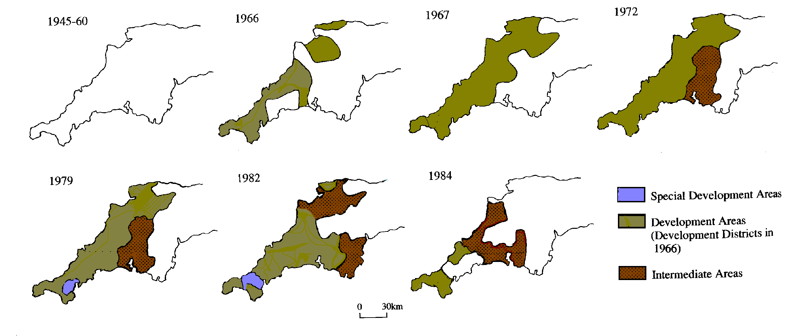
Source: Kain and Ravenhill (1999)

Whilst each approach had some successes, none entirely succeeded in ensuring that all aspects of neighbourhood improvement (eg in jobs, crime, education, health and housing) reinforced each other in a “virtuous circle of regeneration” (SEU, 1998:9). Although systematic evaluation of the effectiveness of regeneration schemes is difficult, official studies are equivocal in their evaluation. Many schemes have had a mixed impact with improvements in housing, employment and crime being patchy and short-lived after the completion of regeneration projects (DoE, 1994; Home Office, 1993).

As a result, the condition of many deprived areas has either not improved or, in some cases, has actually worsened. Despite measurement difficulties, it is clear that the most deprived areas of nearly 20 years ago are still amongst the most deprived areas in the country (Robson et al, 1995; 1998). This is in spite of the fact that most of these areas received various targeted interventions over the years. It is important to stress, however, that this does not mean that targeted policies have not been successful because areas might have been even more deprived without this kind of intervention.

Nonetheless, as the September 1998 report acknowledges, previous schemes have been “thin and ineffective” (SEU, 2000:7) with an over-reliance on small-scale, short-term regeneration projects which lack strategic co-ordination. Although structural, economic changes are partly to blame for the increasing concentration of deprivation in some neighbourhoods, Government regeneration policies appear to have exacerbated these trends. The September 1998 report identifies nine points (SEU, 1998:38-40):

- Mainstream policies not helping, or making it worse. Regeneration spending forms only a very small part of total public spending. Mainstream programmes rarely acknowledge and support the special needs of deprived communities.
- “Initiative-itis”. Regeneration policies themselves have often fragmented into small and confusing initiatives that lead to duplication in applying and running separate schemes.
- Too many rules. Regeneration programmes often have subtly different rules that make little sense to those on the ground.
- Lack of local co-operation. Administrative fragmentation at a local level has meant that routine joint planning, where local services come together to tackle similar problems, is rare.
- Too little investment in people. Regeneration schemes have too often emphasized physical renewal (eg of housing stock) at the expense of creating better opportunities for people (eg in terms of jobs, education, healthcare, etc).
- Strategies not ‘joined up’. Policy has often focused upon ‘turning around’ one neighbourhood in isolation from the surrounding area. However, neighbouring communities depend on each other in many ways.
- Poor links beyond the neighbourhood. Communities thrive when there are well-established links with other areas. Too often in the past, policy has unintentionally worsened the detachment and isolation of poor communities.
- Community commitment not harnessed. There has been a tendency to ‘parachute in’ solutions from outside rather than engaging local communities and building local capacity to act independently.
- ‘What works’ neglected. New initiatives often fail to build upon past successes because lessons from good practice have not been widely circulated.

Above all, as the September 1998 report argued, there has been a failure to address inter-related problems in a “joined up” way. Problems have often “fallen through the cracks” between Whitehall departments or between central and local government. At the neighbourhood level, there has been no one in charge of pulling together all the things that need to go right at the same time (SEU, 1998:9).

The Goals of Neighbourhood Renewal
The shortcomings of previous schemes have also resulted partly from a failure to address the underlying structural causes of neighbourhood decline. Although deprivation is spatially concentrated, the narrow focus upon a minority of Local Authorities arguably deflects attention away from the widespread nature of poverty and inequality which have resulted from mainstream policies and processes of economic ‘restructuring’ in post-1945 Britain.

For example, estimates of the effects of current Government policies on poverty levels over the next five years show that, while the New Deal and the minimum wage will reduce poverty, these effects are far outweighed by the implications of macro-economic policy and the failure to up-rate social benefits in line with rising national output (Piachaud, 1998). Local initiatives alone cannot provide solutions to problems where the causes are national or even international. Governments have often seemed to have learnt little from previous failures and ignored “the strongly held view of those working in regeneration and anti-poverty, that resources should be allocated overwhelmingly according to need and not by competition” (Alcock et al, 1998).

The problem of the relative lack of effectiveness of area-based policies has been known and well-documented for over 25 years (Barnes and Lucas, 1975; Townsend, 1979; Robson et al, 1994; Glennerster et al, 1999). Inequality and deprivation are national problems that require national solutions. Local initiatives must be supported by the right kind of policies at regional and national levels (Kleinman, 1998).

The April 2000 report identified four principle causes of neighbourhood decline:

- Economic ghetto-isation
- The erosion of social capital
- The failure of services
- The absence of a clear strategy of joint action (in partnership with non-governmental agencies)

Of these, the absence of a clear strategy of joint action is viewed by Government as the key to addressing the more basic social and economic causes of neighbourhood deprivation. Few would dispute the importance of strategic co-ordination and joint working in facilitating successful regeneration. However, this emphasis upon technical and administrative solutions can obscure the importance of mainstream policy changes and increased public expenditure in achieving the type of basic structural changes necessary to effective neighbourhood renewal.

The National Strategy Action Plan (NSAP)
The initial consultative framework outlined four key themes in neighbourhood renewal:

- Reviving local economies
- Reviving communities
- Improving local services
- Encouraging leadership and joint working

Within these broad themes, the April 2000 report outlined a range of policy initiatives or ‘key ideas’ emerging from the work of the 18 PATs, as a basis for consultation with interested parties (see Appendix I). This framework and process of consultation informed the development of the National Strategy Action Plan (NSAP) published in January 2001. The NSAP outlines the Government’s strategy for achieving its overall objective that “within 10 to 20 years no-one should be seriously disadvantaged by where they live” (SEU, 2001a:24), although performance targets for this ambitious goal have yet to be established by central Government. This objective is reflected in two long-term goals:

- To have lower worklessness; less crime; better health; better skills and better housing and physical environment in all the poorest neighbourhoods
- To narrow the gap on these measures between the most deprived neighbourhoods and the rest of the country

The NSAP contains three main elements:

- New policies, funding and targets to tackle the problems of deprived neighbourhoods
- Effective ‘drivers of change’ at local and community level
- National leadership and support

Policies, Funding and Targets

Following the 2000 Spending Review and the work of the PATs, every Department with an impact on the key problems of deprived neighbourhoods has new policies, new funding and new targets as a focus for their efforts. These focus primarily upon:

- Employment and economies
- Crime
- Education and skills
- Health
- Poor housing and physical environment (eg air quality, derelict land, etc)

These targets are part of the Public Service Agreements (PSAs) to which central Government Departments are committed (Appendix I). In future, it is anticipated that these Agreements may also be developed at Local Authority level (SEU, 2001a).

Effective Drivers of Change
A central part of the Strategy is the creation of Local Strategic Partnerships (LSPs) which bring together Local Authorities and other public services as well as residents and private, voluntary and community sector organisations. LSPs thus provide a new way for local areas to take ownership of these targets and to set their own ambitious targets for deprived neighbourhoods.

LSPs will be the key to developing and implementing local strategies. They will identify which neighbourhoods should be prioritised, find the root causes of neighbourhood decline, develop ideas on how organisations and individuals can improve things and implement agreed actions. LSPs will also be able to set local targets for improving outcomes in deprived neighbourhoods. They provide a means to allow partners to link existing local partnerships and plans, bringing strategic functions together.

LSPs will need to complement their strategic activity with a focus on specific neighbourhoods. There is no single model for this kind of activity – in many areas, including Kerrier and Penwith, neighbourhood organisations and/or partnerships already exist that can make a contribution to the Local Neighbourhood Renewal Strategy. In other areas, the Government is piloting the idea of Neighbourhood Management.

However, encouraging community and voluntary sector participation in neighbourhood renewal requires additional funding specifically for this purpose. The new Community Empowerment Fund (totalling at least £35 million) will provide around £400,000 over the next three years to each of the 88 NRF areas (including Kerrier and Penwith), to support community and voluntary sector involvement in LSPs. This could fund activities such as resident meetings and surveys to gather views and feed back what happens, outreach to residents to encourage people to express their views and training and support to help residents participate in partnerships.

To support community groups and activities, the Government will also be introducing a fund of £50m, over three years, to set up local ‘Community Chests’ to provide small grants for community organisations in deprived areas.

National Leadership and Support
As noted above, the Government has identified the absence of leadership and poor joint working at national level as a major obstacle to past efforts at regeneration. In September 2000, the Prime Minister announced the setting up of a Neighbourhood Renewal Unit in the DETR to spearhead the follow-up of the National Strategy. This Unit will monitor the implementation and further development of the Strategy and be responsible for a number of the funding streams.

At regional level, the Unit will work closely with Neighbourhood Renewal Teams in Government Offices for the Regions (GOs). These teams will be the main interface with LSPs, as well as ‘joining up’ regional activity, working closely with Regional Development Agencies (RDAs) and other regional players.

Local Neighbourhood Renewal Strategy

The Role of Local Strategic Partnerships (LSPs)

The Government is promoting LSPs as the key local vehicle for implementing and leading neighbourhood renewal. As noted above, the absence of joint working at local level has been one of the key reasons for lack of progress in tackling neighbourhood deprivation. Surprisingly, it has been no-one person’s job at local level to pull together all the different agencies with an impact on deprived neighbourhoods. The trend for greater partnership working, fostered by many Departments, has been an attempt to improve matters but has sometimes resulted in too much time tied up in multiple small-scale partnerships, unconnected by an overarching local strategy.

LSPs aim to bring together public, private, voluntary and community sectors in a single overarching local co-ordination framework which:

- Enables priorities to be set and services to be aligned
- Brings those who deliver or commission different services together with those for whom the services are provided
- Ensures other local partnerships know how they fit into the wider picture, and allows local partners to move to simplify structures where appropriate

The LSPs’ key task is to prepare a Local Neighbourhood Renewal Strategy. This should:

- Outline an agreed vision and plan for positive change in as many neighbourhoods as are in need of renewal
- Have the agreement and commitment of all the key people and institutions who have a stake in the neighbourhood, or an impact on it
- Outline a local strategic level framework for action that responds to neighbourhood needs and puts them in the context of the area as a whole.

LSPs would be expected to set targets for how things should change over time in their most disadvantaged neighbourhoods, especially in terms of the key outcomes of reducing worklessness and crime, and improving skills, health, housing and the physical environment.

Developing a Local Neighbourhood Renewal Strategy
The right approach to drawing up Local Neighbourhood Renewal Strategies differs greatly geographically. However, the Government’s guidance to LSPs identifies five common stages in their development (SEU, 2001a: 47). Figure 1.2 illustrates the key steps.

Figure 1.2: Developing Local Neighbourhood Renewal Strategies

STEP 1: IDENTIFY PRIORITY NEIGHBOURHOODS
Are areas in 10% most deprived wards?
Are areas falling below floor targets?
Are these neighbourhoods areas that should be priorities for other reasons?

STEP 5: IMPLEMENT AND MONITOR AGREED ACTION
Implement agreed changes
Monitor changes in outcomes and ways of working
Adopt strategy in response to risks and opportunities
STEP 2: IDENTIFY PROBLEMS OF DEPRIVED NEIGHBOURHOODS
What are the baseline statistics?
What are the key problems in the areas?
How have they changed over time?
What are the causes?
STEP 3: MAP RESOURCES GOING INTO PRIORITY NEIGHBOURHOODS
How much time and money do organisations (incl. community & voluntary groups) spend in the area?
What other assets exist? (eg. volunteers, buildings, services, networks)
STEP 4: AGREE ON WHAT MORE NEEDS TO BE DONE
Agree goals and make commitments, eg. to:
- Set targets
- Change the way existing services work
- Introduce new services (eg. Neighbourhood Wardens)
- Join up services (eg. co-location)
- Expand existing services
- Try Neighbourhood Management
- Consider the most effective use of assets
- Rationalise activity
- Bid for new money

NEIGHBOURHOOD RENEWAL AND RURAL COMMUNITIES

As noted above, the right approach to developing a Local Neighbourhood Renewal Strategy will differ greatly between places. This is especially pertinent in the context of rural deprivation and regeneration. Historically, regeneration schemes have been a policy response to urban and especially inner city decline and the solutions to problems of community deprivation have thus been informed by this urban focus.

This legacy raises two key issues for rural regeneration partnerships:

- Geographical dispersion. Deprivation in rural areas tends to be ‘hidden’ rather than absent due to the geographical dispersion of rural communities. This makes rural deprivation much more difficult to address through area or regionally-based initiatives.
- Different needs. The key dimensions of deprivation in rural and urban areas may differ. For example, poor access to jobs and services due to isolation, transport costs and inadequate public transport are far bigger issues for rural than urban communities (Countryside Agency, 2000).

Geographical Dispersion
The Government’s 1998 Index of Local Deprivation (ILD) placed five rural districts (including Kerrier and Penwith) amongst the 100 most deprived areas. Using a wider range of measures, the revised 2000 ILD, which takes greater account of rural poverty than its predecessors, identified the 88 most deprived Local Authority Districts (LADs) eligible for NRF support. These 88 LADs account for 82% of the 841 most deprived wards in England. Although most of these wards are in urban areas, at least 16 of the 88 most deprived districts contain substantial rural areas, as Figure 1.3 shows:

Figure 1.3: The 88 Most Deprived LADs in England (2000 ILD)

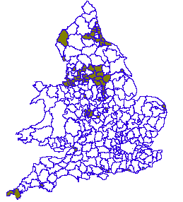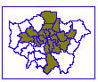

Source: SEU, 2001a: 13-14

Although the 2000 ILD does make greater allowance for the special characteristics of rural areas (DETR, 1998), the problem of spatial scale is especially pertinent in the rural context.

There is no exact definition of what makes a neighbourhood. Local perceptions of neighbourhoods may be defined by natural dividing lines such as roads and rivers, changes in housing design or tenure or the sense of community generated around centres such as schools, shops or transport links.

To get an idea of what is going on at neighbourhood level, statistics from electoral wards are often used as a proxy measure (eg in the ILD statistics). However, in rural communities, ward-level statistics are not precise enough to identify priority neighbourhoods partly because income disparities in rural areas are especially marked, with the very wealthy living ‘alongside’ the very poor (McLaughlin, 1986; Shucksmith, 1996). Measuring rural deprivation therefore requires the development of indicators at a sub-ward level to identify priority areas.

Different Needs
The nature of deprivation in rural areas and small towns often differs from that of industrial conurbations and inner-city communities and this should inform subsequent policy responses. Poor access to jobs and services due to isolation, transport costs and inadequate public transport are far bigger issues for rural than large-scale urban communities. In addition to high levels of long-term registered unemployment, the seasonality of work together with low wages and low rates of economic activity, are also major problems for rural areas and small towns. Figure 1.4 (below) illustrates the seasonal pattern of unemployment in Cornwall for the 1996-1999 period:

Figure 1.4: Seasonal Unemployment in Cornwall, 1996-1999

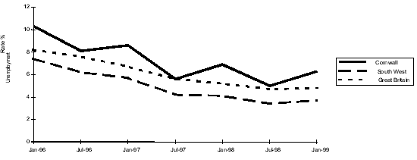

Source: Claimant Count, ONS

In addition, whilst rural areas are generally characterised by lower levels of registered unemployment, there are pockets of high unemployment and other employment disadvantage in rural areas, particularly in isolated locations.

Similarly, housing deprivation in rural areas is often manifested in increasingly unaffordable housing stock and not simply in its physical dilapidation. The demand for owner-occupied housing in rural areas is often very high, partly due to new household formation and the tendency towards smaller households but also as a result of demand from relatively affluent incomers and second-home buyers. However, the supply is often highly constrained and prices tend to be high, generating problems of affordability for those on low or middle incomes. Furthermore, the proportion of social housing to rent is low in rural areas, not only because of right-to-buy sales but also because of historically lower rates of Local Authority and Housing Association provision. This restricts further the choice available to those seeking affordable housing in rural areas.

Clearly, rural areas themselves differ considerably as a result of their unique histories and development. There are marked differences between those living in remote rural areas and those nearer to conurbations. Appendix II illustrates the geographical distribution of deprivation in rural areas, using ward-level ILD statistics for employment, income, education and health (see also Countryside Agency, 2001). These analyses show that, within rural England as a whole, low incomes, educational deprivation, poor health and unemployment are greater in remoter rural areas (and areas that are particularly reliant on agriculture) than in more accessible ‘commuter’ areas. The Southwest region and, especially, Cornwall, performs poorly on all four of these scales.

CONCLUSION

The Neighbourhood Renewal initiative seeks to provide a new means of tackling the complex and inter-related social and economic problems faced by deprived communities. In contrast with past schemes which have frequently been blighted by an absence of overall strategic co-ordination and joint working, Neighbourhood Renewal seeks to provide ‘joined up’ policies and ways of working in order to tackle ‘joined up’ problems. The issues facing deprived communities are complex and raise a number of issues that need to be addressed in order to identify the most appropriate and effective solutions. These include (Glennester et al, 1998):

- How much is the increasing concentration of poverty due to a decline in the fortunes of existing area residents and how much to housing or transport factors which have increasingly driven the poorest people into fewer areas?
- How much is decline due to structural factors such as the loss of traditional industries, how much to market forces such as housing supply and quality and how much to changes in housing policy, or decline in local services or area stigma?
- Why do poor areas matter to the extent that people with choice refuse to live in them or invest in them and how far does this de-selection by people with choice make matters worse?
- How do area concentrations of deprivation in themselves result in a diminution of the life chances of their residents?
- How do housing policy and housing management contribute to educational prospects?
- How much do transport links affect employment chances or the ability of families to provide healthy diets on low incomes?
- How does pre-school provision affect later delinquency or employment prospects in areas where jobs are, in any case, hard to come by?

A strategy of analysis that is sensitive to the unique history and economic and social development of Cornwall (even in comparison with other remote rural areas) is essential to addressing these questions. ‘Off the peg’ solutions to problems of neighbourhood deprivation are thus unlikely to be effective in the Cornish context. Mapping of the key indicators of local deprivation as identified by the SEU (ie employment, housing, health, education and crime) at a very small scale is a first step in exploring the inter-relationships between these different dimensions of social inequality. However, other data sources and local knowledge, together with a detailed audit of community services, facilities and organisation, will be central to the development of an effective regeneration strategy in west Cornwall.

The key steps towards an developing an effective strategy for neighbourhood renewal are:

- Identifying and mapping the priority areas
- Identifying the significant problems and resources within each priority area
- Ensuring that there is full consultation with the local communities
- Locating each area within its context - the most effective renewal strategy may involve targeting resources in adjacent areas rather than into the most deprived area itself (eg job creation, transport links, etc)
- Learning from the mistakes of past efforts in area regeneration

CHAPTER TWO:

MAPPING DEPRIVATION

INTRODUCTION

It is of great importance when developing neighbourhood renewal policies that the meaning of neighbourhood deprivation is clearly understood. Unfortunately, the term area deprivation can have at least three different meanings:

- A compositional meaning, whereby an area is considered to be deprived if it contains a large number of poor people. In this case, the spatial effects are entirely due to the concentration of poor people in a given area – there are no independent area effects.

- A collective meaning, whereby an area is considered to be deprived because if it contains a lot of poor people a ‘social miasma’ may exist. That is, a concentration of poor people will exert a collective influence, above and beyond their individual circumstances, for example, it may be difficult to find a job if you live in a deprived area because employers are prejudice against people from poor areas. Although, this is a commonly held belief there is relatively little (other than anecdotal) evidence to support it.

- A public goods or environmental meaning, whereby an area is considered deprived because it lacks facilities (roads, hospitals, schools, libraries, etc.) or because it suffers from high pollution levels.

These three meanings of area deprivation are separate and distinct, but are often confused. For example the Government’s neighbourhood renewal strategy confuses all these three different meanings of neighbourhood deprivation and the Index of Multiple Deprivation confuses two of them (e.g. poor people and poor services). Unfortunately, the polices necessary to effectively help an area with a lot of ‘poor’ people may be different from the policies needed to help an area with ‘poor’ services. Similarly, a different set of policies may be effective at reducing area ‘stigma’, since not all poor areas are stigmatised and not all stigmatised areas contain a lot of ‘poor’ people.

It is also essential to be clear on the definition of area deprivation that is being used when attempting to develop measures to identify the ‘poorest’ areas, since the three types of area deprivation have different geographies. For example, on the national scale the majority of poor areas which contain ‘poor’ people are found in the major cities (Inner London, Bristol, Plymouth, etc). Whereas the majority of areas with ‘poor’ access to services are often the remoter rural areas where lower proportions of ‘poor’ people live. The inner cities by contrast often have very good levels of public services. It makes little scientific sense to include both measures of ‘poor’ people and ‘poor’ access to services in a single national index as in the IMD 2000 since the higher weighting given to the service domain the more ‘rural’ areas will appear deprived and conversely the higher the weightings given to the domains that measure ‘poor’ people the more the cities will appear deprived.

INDICES OF LOCAL DEPRIVATION (ILD) 2000

The ILD 2000 are measures of deprivation for all 8,414 wards in England. They describe a range of indicators classified in six main ‘domains’ of deprivation:

- Income
- Employment
- Health Deprivation and Disability
- Education, Skills and Training
- Housing
- Geographical Access to Services

In addition to these six domains, the 2000 ILD also contains a supplementary Child Poverty Index. The 2000 Index of Multiple Deprivation (IMD) combines the six main domains within a single deprivation score for each area.

The 2000 IMD uses up-to-date information from 33 indicators to describe deprivation at ward level (a detailed listing of the ILD 2000 indicators is presented in Appendix II). Most of the indicators can be updated regularly and so form the basis for a dynamic index. In addition to the Domain Indices, the overall ward level Index of Multiple Deprivation brings this substantial amount of knowledge and information together for the first time at a small geographical level.

Methodology

For the Income and Employment domains, the scores are presented as a simple rate, as these domains represent the percentage of the population affected by this type of deprivation. This is also the case with the Child Poverty Index.

The Health, Housing, Education and Access domains could not be combined in this way for two reasons:

- The individual indicators may be measured in different ways. For example, in the Health Domain it would not be appropriate to simply add a standardised mortality ratio to a proportion of people receiving Attendance Allowance as these are on different metrics.

- There might be overlap between indicators within a domain. A simple combination of these indicators could result in double counting.

Instead, these four domains were each combined using Factor Analysis (see Noble et al, 2000 for a detailed description of the statistical procedures used to generate the IMD). Factor Analysis is a statistical procedure which attempts to deal with both the problems outlined above.

Once the six separate domains scores for every ward have been calculated, it is then possible to combine these into an overall index. However, as with the indicators, the domains cannot be simply added because they are not all on the same scale. In order to combine the domains, they must first be standardised to a uniform metric by ranking the domain scores. Secondly, it is important to ensure that each domain is transformed to a common distribution. This is necessary because combining domains with different distributions can result in misleading results with some domains having unanticipated disproportionate effects on the overall index score.

From the outset, the DETR proposed that the Income and Employment Domains should carry more weight than the other domains (Noble et al, 2000). It was also proposed that the most robust domains should carry the most weight. This means that the contribution of each domain to the overall Index varies as follows:

- Income | 25%
- Employment | 25%
- Health Deprivation and Disability | 15%
- Education, Skills and Training | 15%
- Geographical Access to Services | 10%
- Housing | 10%

It must be stressed that neither the six domains or their weightings are the result of scientific analysis they are mainly reflections of the Government’s priorities and data availability.

ILD 2000 DEPRIVATION IN CORNWALL

Income and Employment

The scores for the Income and Employment Domains (as well as Child Poverty and Multiple Deprivation) are rates. So, for example, if a ward scores 38.6 in the Income Domain, this means that 38.6% of the ward’s population are Income Deprived. The same applies to the Employment Domain. In the 20% most income deprived Cornish wards at least 28% of the population is income deprived.

It is also instructive to explore how Cornwall compares with the rest of England. The 2000 ILD assigns a rank to each of the eight indices for all 8,414 wards in England. The most deprived ward for each index is given a rank of 1 and the least deprived ward is given a rank of 8,414. Figure 2.1 illustrates the distribution of Income Deprivation in Cornwall by showing the distribution of Cornish wards within the Income Deprivation ranking for English wards.
Figure 2.1: ILD Income Deprivation Rank, 2000 (quintiles)

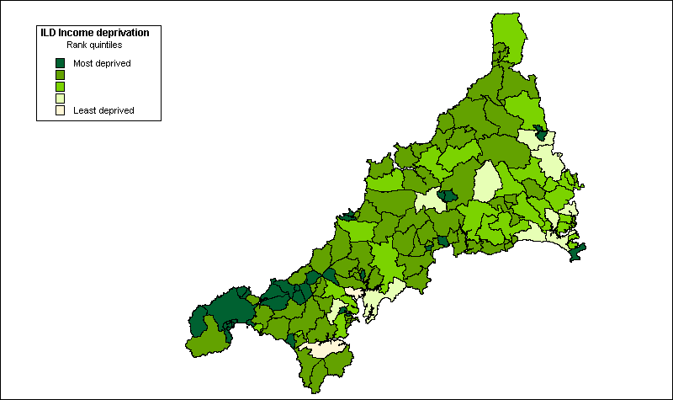

As Figure 2.1 shows, most Cornish wards fall within the most deprived two fifths of the Income Deprivation ranking for England, although deprivation is most concentrated in West Cornwall (Kerrier and Penwith).

Figure 2.2: ILD Employment Deprivation Rank, 2000 (quintiles)

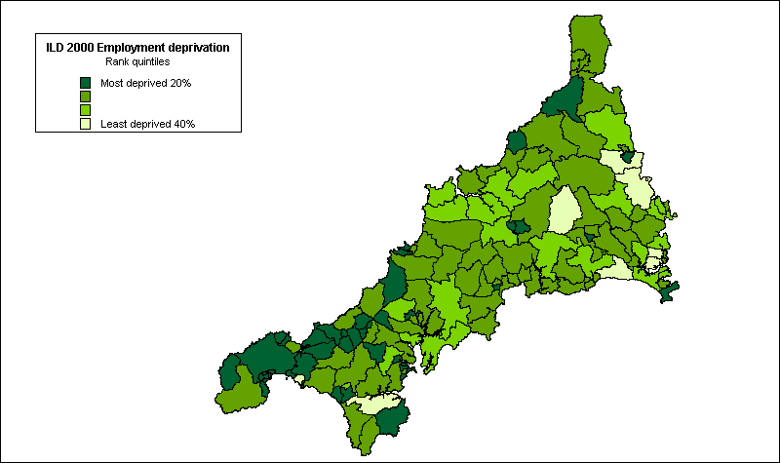

The spatial distribution of Employment Deprivation in Cornwall reveals a similar picture. Overall, in one fifth of wards, at least 15% of the population are classified by the 2000 ILD as employment deprived. Again, high levels of employment deprivation are concentrated in the west of Cornwall, as Figure 2.2 (above) illustrates. As with income, Cornwall fares poorly compared with the rest of England on the Employment Deprivation Index. Indeed, none of the Cornish wards fell within the least deprived fifth of English wards on this measure and only eight within the next fifth of the distribution, as Figure 2.2 (above) shows.

Housing, Health and Education

Deprivation scores for the Housing, Health, Education and Access to Services Domains are not rates. Within each domain, the higher the score, the more deprived the ward. Housing deprivation in Cornwall is concentrated mainly in western Cornwall although the pattern of deprivation is somewhat more dispersed as Figure 2.3 shows:

Figure 2.3: ILD Housing Deprivation Rank, 2000 (quintiles)

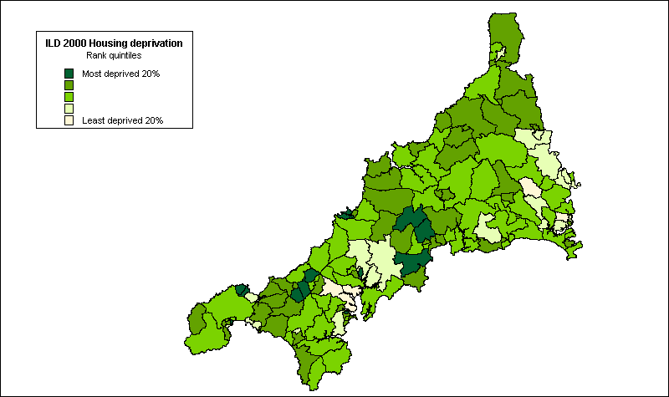

However, as with income and employment deprivation, few wards perform well in comparison with the rest of England, with only four wards falling within the least housing-deprived fifth of English wards.

Comparing health deprivation in Cornwall with the rest of England suggests an even more depressing picture. None of the Cornish wards are ranked within the least health-deprived fifth of English wards and the majority fall within the most deprived two fifths of the distribution. Again, the majority of the most severely health-deprived wards are in Kerrier and Penwith, as Figure 2.4 (overleaf) illustrates.
Figure 2.4: ILD Health Deprivation Rank, 2000 (quintiles)

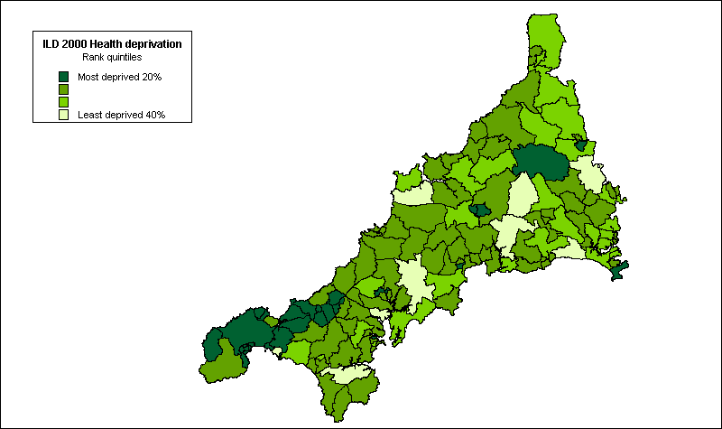

In terms of educational disadvantage, the picture is slightly more encouraging. As Figure 2.5 shows, educational deprivation within Cornwall is less spatially concentrated than for many other domains, although again some of the most deprived wards are in Kerrier:

Figure 2.5: ILD Educational Deprivation Rank, 2000 (quintiles)

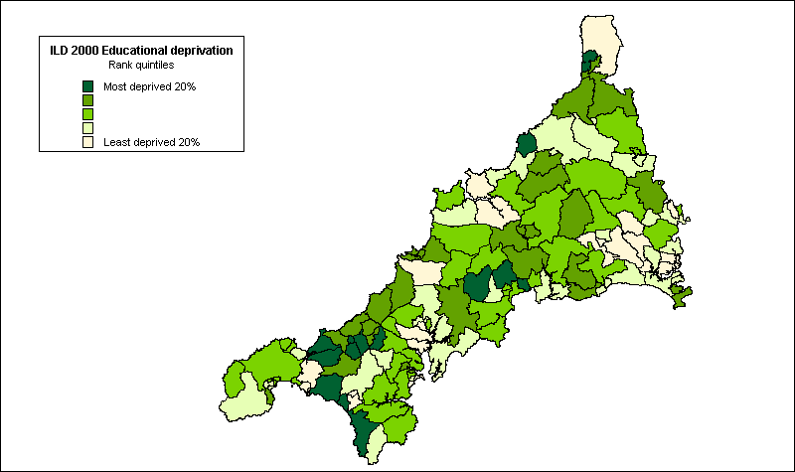

Overall and in comparison with the rest of England, the Cornish wards fare better in terms of educational deprivation than for economic (income, employment) and social (housing, health) deprivation. Fewer Cornish wards fall within the most deprived fifth of the distribution for educational deprivation, although many of these are in Kerrier.

Access to Services

Perhaps unsurprisingly given its remote rural location, Cornwall as a whole fares poorly in terms of the accessibility of local services compared with the rest of England, as Figure 2.6 shows:

Figure 2.6: Access to Services Rank, 2000 (quintiles)

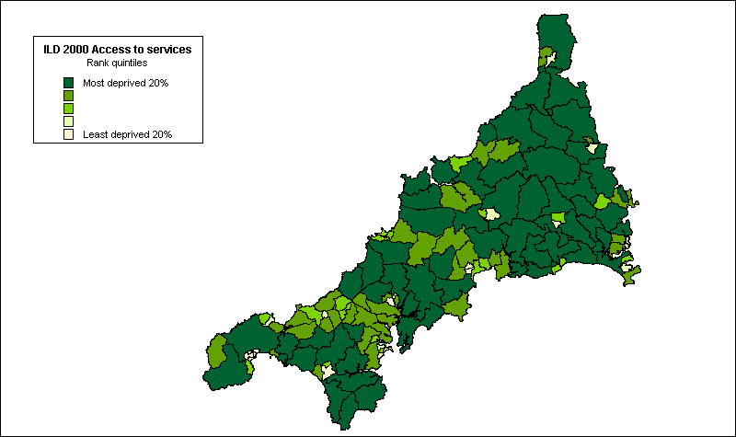

Child Poverty

As with the Income and Employment Indices, the scores for the Child Poverty Index are rates so the deprivation scores represent the percentage of children within each ward currently living in poverty.

Figure 2.7: Child Poverty Rank, 2000 (quintiles)

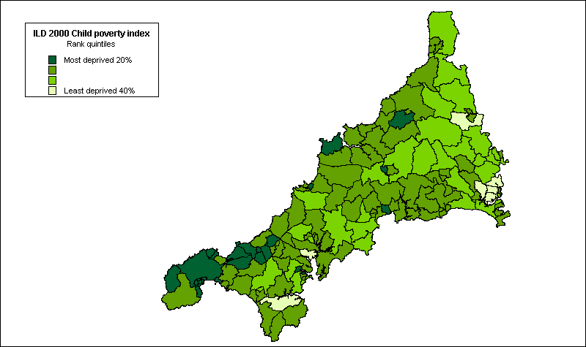

In one fifth of Cornish wards, more than 43% of children are currently living in poverty, according to this measure. As Figure 2.7 shows, the most severe concentrations of child poverty are in Kerrier and Penwith. However, as the figure also illustrates, child poverty is quite widespread throughout Cornwall in comparison with the rest of England. Only seven of the Cornish wards are ranked within the least deprived two fifths of the distribution for this indicator and the majority are within the most deprived two fifths of English wards for child poverty.

Multiple Deprivation

In 80% of Cornish wards, 20% of the population is experiencing multiple deprivation and, in more than one fifth, over a third of the population is experiencing multiple deprivation, according to this measure. Comparing the scores for Cornish wards with the rest of England reveals the extent of multiple deprivation in Cornwall. Only five of the 133 Cornish wards were amongst the least deprived two fifths of English wards and the great majority were amongst the most deprived two fifths for this measure, as Figure 2.8 (overleaf) shows. Within Cornwall multiple deprivation is again spatially concentrated within the districts of Kerrier and Penwith.

Figure 2.8: ILD Index of Multiple Deprivation Rank, 2000 (quintiles)

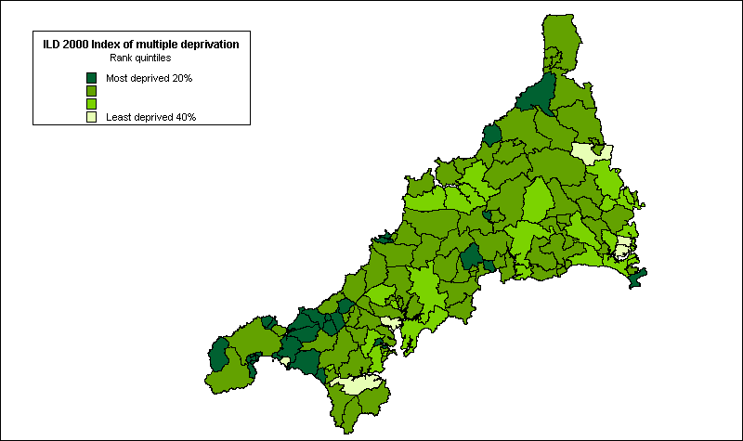

CRIME AND NEIGHBOURHOOD RENEWAL

Introduction

Crime and disorder have been acknowledged by central Government as an important feature of deprivation and a key theme within the context of neighbourhood renewal (SEU, 2001a). However, adequate data on crime was not available during the review of the 2000 ILD and this domain was therefore not included within the final indices (DETR, 2000b).

One of the reasons that a crime domain was not included in the final index of multiple deprivation was because of the detailed comments from Christina Pantazis, at the University of Bristol, who reviewed the problems of measurement of the crime domain proposals. Many commentators assume that all poor areas suffer from high levels of crime. However the relationship between crime, poverty and area is much more complicated than this. This section draws heavily on Christina’s analysis with additional material on the situation in West Cornwall from the research team.

Crime, Poverty and Space

The interest in crime and poor localities has a long history. Henry Mayhew’s (1862) comprehensive survey of Victorian London, provided detail on various ‘rookeries’ (slum criminal quarters); whilst concern with the rise of ‘dangerous poor’ led to a focus on various specific localities (see Morris 1957 for further details). Spatial analyses undertaken in the 1970s and 1980s revealed strong connections between the location of poverty and the occurrence of crime. Baldwin and Bottom (1976), in their classic Sheffield study, found a high concentration of offenders on deprived council estates, whilst Herbert (1977) also found links between poverty, social deprivation, substandard housing and crime. Following the inner-city riots in the 1980s, a number of commentators made links between deprivation and public disorder. Specifically, left realist criminologists such as Kinsey and Young (1986) put forward the theory of relative deprivation to explain rising rates of crime and disorder.

Poverty and Crime: some recent evidence

Recent research into crime and disadvantage in Merseyside, in north west England demonstrated that rates of recorded crime and repeat burglaries were significantly higher in the most disadvantaged areas (Hirshfield and Bowers, 1996). Furthermore, the level of social cohesion was thought to influence the recorded crime rate, so that disadvantaged areas lacking social cohesion experienced far greater levels of crime than similarly disadvantaged areas with higher levels of cohesion.

Home Office research confirms the link between crime and poor areas. Findings from the combined 1984, 1988 and 1992 British Crime Survey demonstrate the link between some poor areas and specific types of crime such as burglary and robbery (Mayhew and Maung 1992). Figure 8 shows the relative crime rates (national average = 100) for burglary and robbery, for residents of different ACORN neighbourhood groups (CACI, 1992). Mixed inner metropolitan areas and less well off and poorest council estates suffer from relatively high crime rates. Mixed inner metropolitan areas have the highest rates of muggings and robbery, whilst the poorest council areas have the highest rates of burglary. These ACORN neighbourhoods are characterised by low-income households. On the other hand, ‘high status, non-family’ areas which are characterised by households with well above average incomes, also suffer from high crime rates, and ‘agricultural’ areas and ‘older terraced housing’, which typically contain many low-income households, have respectively very low and average burglary and robbery rates.

Figure 2.9 Indexed crime rates for combined 1984, 1988, and 1992 British Crime Survey by ACORN

More recent evidence, based on the 1996 and 1998 British Crime Surveys, confirms the link between poor areas and crimes such as burglary, violence and vehicle-related theft (Mirrlees et al. 1998). Figure 2.10 shows the proportion of households and adults who have experienced burglary, vehicle-related theft and violence by ACORN neighbourhood groups (CACI, 1992). Striving areas (neighbourhoods with local authority and multi-ethnic, low-income households) contain the highest proportion of victims in relation to all three types of crime.

Twenty three percent of people in striving areas experienced vehicle-related theft in the previous year. A further 9% and 7% had experienced burglary and violence, respectively. However, rates of victimisation are also high amongst the population in rising areas (neighbourhoods containing affluent urbanites; prosperous professionals in metropolitan areas; and better-off executives, in inner city areas). Thus, the proportions of victims in rising areas were 19%, 8% and 6% for vehicle-related crime, burglary and violence respectively. The lowest rates of crime exist in thriving areas – which typically contain a relatively higher proportion of elderly people.

Figure 2.10 Proportion of households/adults who are victims of burglary, vehicle-related theft and violence by ACORN (1996 & 1998 British Crime Survey)
Much of the Home Office research into poor areas has highlighted the extent of crime in areas containing large council estates (Hope, 1986). Hope and Hough (1988) attempted to tease ‘whether it is tenure itself which is associated with crime, or the ecological distribution of tenure types between different neighbourhoods’ (page 41). Their re-analysis of the 1984 British Crime Survey demonstrated that it is the latter which important: ‘it is the interaction between individual tenure and the predominant tenure of the neighbourhood which is important, especially the concentration of council tenure in small residential areas, that is on ‘estates’ (Hope and Hough 1988: 41). Overall, council tenants had a greater chance of experiencing burglary compared with owner-occupiers. However, council tenants in non-council areas had a risk of burglary around the national average. The greater crime risk faced by council tenants was largely associated with neighbourhoods that were dominated by council housing. Thus, council tenants on estates were particularly vulnerable.

Even between estates which were predominantly council-owned, there was a considerable variation in risks of crime. Council tenants in the poorest council areas have a rate of burglary fives as that of tenants on the better-off estates and those in predominantly non-council areas (Table 2.1). At the same time residents of poor council housing area were twice as likely to be very worried about becoming victims of burglary in the coming year, as those in those better off areas.

Table 2.1 Number of burglaries (including attempts) per 1,000 households by tenure ecology (1984 British Crime Survey)

 | Burglaries per 1,000 households
All owner occupiers | 34
All council tenants | 55
Better-off council tenants | 38
Average council tenants | 66
Poor council tenants | 190
Source: Hope and Hough (1988)

Most studies linking crime with poor areas fail to address whether the main victims of crime are poor people. It is misleading to assume that poor people live in poor areas only, or that only poor people live in poor areas. By avoiding these assumptions we may ask the question who are the main victims of crime in poor areas? It may be, for example, that the victims of crime are disproportionately the ‘better off’ who live in poor areas. In other words, social scientists need to be aware of the pitfalls of the ecological fallacy (Robinson 1950; Baldwin, 1979). This refers to instances in which inappropriate inferences about relationships at the individual level are made on the basis of aggregate data obtained at the area level. In such situations, individuals are assumed to have the same characteristics of the areas in which they live. Many of the early ecology studies of juvenile delinquency fell into the trap of the ecological fallacy (Polk, 1957; Willie, 1967). In Britain, inappropriate conclusions were made about immigrants and their propensity to commit crime based on recorded crime data showing that crime was highest in areas with an immigrant population (Wallis and Maliphant, 1967). While there is limited discussion of the ecological fallacy in the criminological literature, there is a danger that current assumptions about poverty and crime are failing to take into account the full effects of the fallacy.

Poverty and crime: exploring the ecological fallacy

This next section examines the impact of poverty at the area level, and the extent to which there are differences in risks of victimisation between different income households using the 1992 British Crime Survey and the 1991 Census. It confirms the correlation between crime and area poverty, although the relationship between crime and poverty at the individual level is more ambiguous.

The 1991 Census was used to construct a deprivation index known as the Breadline Britain index in order to link it to the 1992 British Crime Survey. Any census based index will comprise variables that are, at best, proxy indicators of deprivation because none of the questions in the 1991 census was specifically designed to measure poverty or deprivation. The Breadline Britain Index is based upon the characteristics of households and individuals found to be living in poverty from the results of the 1990 Breadline Britain survey (Gordon, 1995; Gordon and Forrest 1995).

The findings confirm the importance of area poverty in determining risks of victimisation. Figure 2.11 demonstrates the risks of victimisation according to whether households are in areas of below average poverty or above average poverty (as defined by the Breadline Britain index using the 1991 Census). Forty-five percent of households in areas of above average poverty suffered victimisation in the previous year, compared with only 35% of those households in areas of below average poverty.

Figure 2.11 Percent of households experiencing total crime, household crime, burglary, theft around the dwelling and household vandalism in the previous year

Sources: 1992 British Crime Survey, 1991 Census of Population

Households in poor areas are 1.8 times more likely to experience household crime (which includes burglary, theft around the dwelling, vandalism) compared with households in areas with below average poverty levels. A similar pattern can be observed in relation to the separate components of household property crime. In comparison with households in areas of below average poverty, households in poor areas are 2.5 times more likely to be burgled and 1.5 times more likely to experience theft around the dwelling and vandalism.

Having established the correlation between area poverty and victimisation, Figure 2.12 illustrates the risks of experiencing total crime amongst different income households within poor area and non-poor areas. It shows that regardless of area poverty levels, there is a positive relationship between total victimisation and household income. In areas of below average poverty, the richest households experience the highest levels of victimisation (49%). They are more than twice as likely to experience some type of victimisation than households in the poorest households. There is a similarly positive relationship between household income and victimisation in areas with above average poverty. Sixty four percent of the richest households experience crime, compared with only 35% of the poorest households. Richer households are more likely to experience total victimisation because a large proportion of crime is vehicle-related, and vehicle ownership is higher amongst richer households than in poor households.

Figure 2.12 Percent of households experiencing total crime by gross annual income groups and area poverty (1992 British Crime Survey and 1991 Census).

The next figure (Figure 2.13) examines the relationship between the risk of experiencing household property crime according to household income group and area poverty. Unlike the previous figure the positive relationship between victimisation and income is absent. Instead Figure 2.13 shows that regardless of area poverty levels, there is little difference in victimisation risks amongst the different income groups. In areas of below average poverty, victimisation risks range from 11% to 14%, whereas in areas of above average poverty, the victimisation risks for households are between 19% to 24%.

Figure 2.13 Percent of households experiencing household property crime by gross household income group and area poverty (1992 British Crime Survey and 1991 Census)

The conclusion that can be drawn from these analyses is that it is often ‘richer’ households in poorer areas that are victims of crime. If Neighbourhood Renewal projects in ‘poor’ areas are effective in reducing crime levels this will be of obvious benefit to the community as a whole but it may also be of greater benefit to the ‘richer’ households than the ‘poorer’ households. This should be borne in mind when establishing expenditure priorities.

Criminal Statistics: Notifiable Offences

The Criminal Statistics England and Wales are published annually, together with volumes of supplementary information. The Criminal Statistics provides detail on the number of offences recorded by the police, otherwise known as notifiable offences. This information is routinely available at police force area level and regional level. Information is also contained on offender-based data such as offenders found guilty or cautioned, otherwise known as ‘known offenders’. Statistics on those found guilty and cautioned are presented by offence group and by police force area, with separate tables for indictable and summary offences.

Notifiable offences relate to those offences that the police are required to record. The Criminal Statistics provide information for different offence groupings, but not for other (non-notifiable) offences. This information is available for the 43 police force areas.

The Crime and Disorder Act of 1998 places a new statutory duty on local authorities and the police to produce an audit of crime and disorder, and to develop and implement a crime safety strategy. The result of this is that crime data is now being made available at a more localised level. For example, in Kerrier and Penwith data on notifiable crimes are available for police beat areas and this report has analysed the latest available data.

However there are a number of serious limitations with using the Crime and Disorder Audit data to measure crime at small area level.

Firstly, Police statistics are collected at ‘beat’ level but these areas do not necessarily relate to other administrative boundaries such as parishes or wards. Even higher level police boundaries do not necessarily correspond with district or other administrative boundaries.

There are other concerns relating to the recording and reporting of police data. Offences recorded by the police represent only a subset of total crime committed. According to the British Crime Survey there are four times as many crimes than the police record (Mirrlees-Black et al. 1998). This is mainly because only 44% of crimes are reported to the police. The majority of crimes are therefore not reported to the police. Reporting varies considerably by type of offence. Thefts of cars are most often reported: 97% were in 1997. Burglaries in which something was stolen were also reported (85%). Theft from the person and vandalism were the least likely offences to be reported: 35% and 26% respectively. The most common reason for not reporting crimes is that they are seen as too trivial, or involved too small a loss to warrant police attention. Unreported thefts from vehicles, no loss burglaries and vandalism were particularly likely to be seen as too trivial to report. For violence such as wounding and robbery, the most common reason for not reporting was that the victims felt that the matter was private or had dealt with it themselves.

Furthermore, not all reported crimes are recorded by the police. In 1997 the British Crime Survey estimated that about 54% of all reported crimes were recorded (Mirrlees-Black et al. 1998). Again the recording varies according to offence type. Thefts of cars and burglaries with loss were the most likely offences to be recorded, attempted vehicle related thefts and violence (wounding and robbery) the least likely. There are a number of reasons for this discrepancy, including police discretion. The police may not record a complaint because of their compliance with victims’ wishes not to proceed. Other incidents may be regarded as too trivial to warrant formal action, or the police may feel the report is mistaken or disingenuous, or there is insufficient evidence to suggest a crime has been committed. However, the main reason for non-recording is due to the strict Home Office guidelines that Police Forces must follow. However, from April 2002 new guidelines for “ethical crime recording” should result in crimes being recorded as initially reported, which should lead to some improvements in the statistics.

Finally, considerable fluctuations over time in levels of recorded crime are evident when mapping crime at a very small spatial scale such as the ward or parish. This means that any given spatial distribution of crime levels even on an annual basis will be characterised by substantial ‘random’ changes.

Addressing these issues would ideally involve undertaking a large-scale local victimisation survey similar to the British Crime Survey. However, in the absence of such data all these problems should be acknowledge in interpreting available crime statistics. Therefore the following results on crime in West Cornwall need to be interpreted with caution when drafting neighbourhood renewal policies.

Methodology

In Kerrier, police beat areas are coterminous with parish boundaries. However, there is some divergence between police beats and parish boundaries in Penwith with only approximately two thirds of police beats being coterminous with parish boundaries, effectively constituting sub-divisions within parishes. In these cases and for the whole of Kerrier, it has thus been possible to aggregate total crime statistics to parish level. However, in some areas of Penwith, beat boundaries are unclear and do not correspond with parish boundaries (ie Ludgvan, Madron East, Madron West, Towednack). These areas are therefore excluded in the spatial analyses presented below.

Findings

During 2000-2001, 52,399 incidents were reported to police across Kerrier and Penwith. Of these, only a small proportion (18.3%) were considered by police to be sufficiently serious to be classified as crimes. In addition to these reported crimes, total crime also includes crimes identified through police investigations. Figures 2.14 and 2.15 below illustrate the frequency of total crimes for the period April 1998 to January 2001 for Kerrier and Penwith respectively.

Figure 2.14: Total Crime in Kerrier, 1998 – 2001

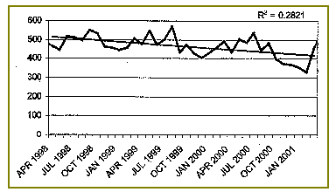
Source: Kerrier Crime and Disorder Audit, 2001

In Kerrier, 5150 crimes were recorded during 2000-01 - or 56 crimes per 1,000 people (based upon CDRP population estimates). Figure 2.9 (above) is suggestive of a long-term decline in levels of total crime – from over 500 in April 1998 to just over 400 in January 2001. However, as noted above, and given the substantial fluctuations evident over this period, this general decline should be treated with caution.
Figure 2.15: Total Crime in Penwith, 1998 – 2001

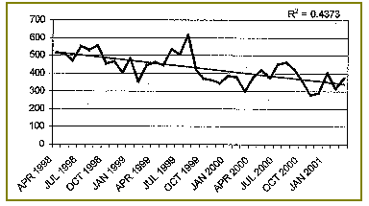
Source: Penwith Crime and Disorder Audit, 2001

In Penwith, 4443 crimes were recorded during 2000-01 - or 74 crimes per 1,000 people (based upon CDRP population estimates). Figure 2.10 (above) is also indicative of a long-term decline in levels of total crime – from over 500 in April 1998 to 350 in January 2001. Again, however, this general decline should be treated with caution given the substantial fluctuations from month to month e.g. recorded crime was over 600 in September 1999 and then halved to 300 in April 2000 before rising again.

In general, the highest levels of recorded crime are concentrated in the more populous areas of West Cornwall (as would be expected). In Penwith, approximately one third of total recorded crime is concentrated in Penzance and Hayle and St Ives each account for around 13% of the recorded total in Penwith. Similarly, in Kerrier most crime occurs in the more densely populated areas, with Cambourne accounting for nearly one third (32%), and Redruth nearly one fifth (18%), of the recorded total for the district.

Controlling for the disparity in population between the more populous large towns in the region and smaller settlements in more remote rural areas has a levelling effect on the spatial distribution across west Cornwall. Figure 2.16 below shows total recorded crime per 1,000 population aggregated to parish level across west Cornwall. On this basis police beats within the larger coastal towns of Penzance, St. Ives and Hayle, and the Camborne, Pool, Redruth area recorded higher numbers of recorded crimes per 1,000 population than rural areas although the disparity between urban and rural areas is considerably reduced. However, it must be noted that some of the victims of crime, (particularly in costal towns) will have been tourists, so the adjustment that has been made for population size will overestimate the ‘true’ crime rates in the tourist areas.
Figure 2.16: Total recorded crime in Kerrier and Penwith by parish per 1,000 population, 2000/01

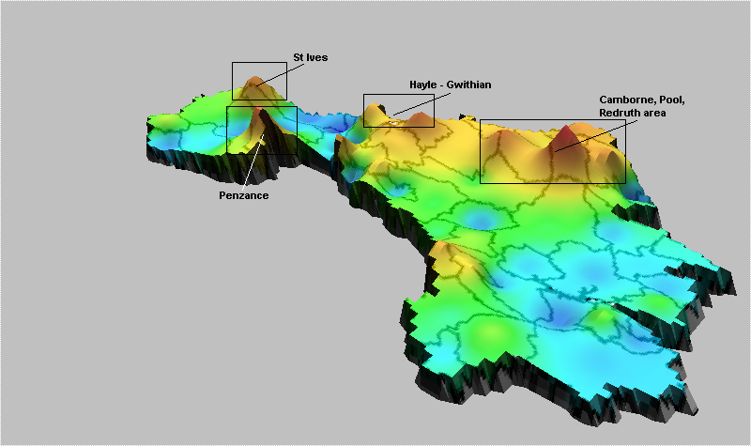
Source: Kerrier and Penwith Crime and Disorder Audits, 2001

In 2000/01 the incidence of reported crime per 1,000 population in the parishes of Penzance (93), Camborne (84), Pool (112), and Hayle (90) was considerably higher than for those rural parishes with the lowest levels of recorded crime per 1,000 population over this period – namely St. Martin (11), Zennor (12), Perranuthnoe (14), Sancreed (15).

However, it must be strongly emphasised that the levels of recorded crime throughout west Cornwall remain considerably lower than in most other areas of England and Wales. Recorded crime statistics provided by the Home Office suggest that the incidence of crime in all the main categories is lower in rural areas than in urban areas. Levels of recorded crime in 2001 in the rural areas of the South West were lower than in urban areas within the region, and levels of crime are generally lower than in other rural areas in England for almost all categories of crime, as Table 2.2, below, shows.

Table 2.2: Recorded Offences per 1,000 population, year to March 2001

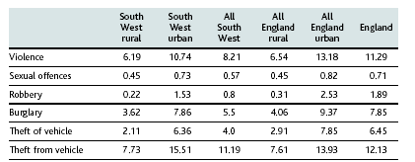
Source: Countryside Agency (2001b) and Home Office, 2001

To conclude, crime in the rural South West in general and in Kerrier and Penwith in particular is much less of a problem than in other parts of England and Wales. Crime rates in west Cornwall are some of the lowest in the UK.

ILD 2000 DEPRIVATION IN KERRIER AND PENWITH

As the 2000 DETR report suggests, deprivation is made up of separate dimensions, (or ‘domains’) of deprivation (DETR, 2000a). The extent and distribution of these different forms of deprivation varies between places at both local and regional levels. Table 2.3 summarises the pattern of deprivation at ward level across the six main domains of the 2000 ILD for West Cornwall.

Table 2.3: ILD Deprived Wards in Kerrier and Penwith, by Deprivation Domain, 2000

 |  |  | Kerrier |  | Penwith
 | English Ward Ranking |  | No | % | No | %
Income |  | Most deprived 10% | 4 | 18 | 5 | 19
 |  | Most deprived 20% | 6 | 27 | 12 | 75
Employment |  | Most deprived 10% | 3 | 14 | 8 | 50
 |  | Most deprived 20% | 10 | 46 | 13 | 81
Housing |  | Most deprived 10% | 2 | 5 | 1 | 6
 |  | Most deprived 20% | 3 | 14 | 3 | 19
Health |  | Most deprived 10% | 3 | 14 | 4 | 25
 |  | Most deprived 20% | 6 | 27 | 13 | 81
Education |  | Most deprived 10% | 5 | 23 | 1 | 6
 |  | Most deprived 20% | 7 | 32 | 2 | 13
Services |  | Most deprived 10% | 3 | 14 | 1 | 6
 |  | Most deprived 20% | 9 | 41 | 4 | 25

As Table 2.3 shows, income and employment deprivation are widespread in West Cornwall, with the great majority of wards in Penwith falling within the most deprived 20% of English wards for both income and employment. Health deprivation is also a significant problem in West Cornwall - especially in Penwith - with four fifths (81%) of the wards within the 20% most health deprived English wards. Comparison with the other four Cornish Local Authorities again reveals the extent of deprivation in West Cornwall (see Appendix II).

Effective targeting of regeneration spending involves first identifying those areas experiencing the worst deprivation. A full listing of all the wards in Kerrier and Penwith experiencing deprivation, as measured by the DETR’s Domains of Deprivation is given in Appendix II. Those wards ranked within the most deprived 20% of English wards on the DETR’s Index of Multiple Deprivation (IMD) are illustrated in Figure 2.17:

Figure 2.17: IMD Deprived Wards in West Cornwall, 2000

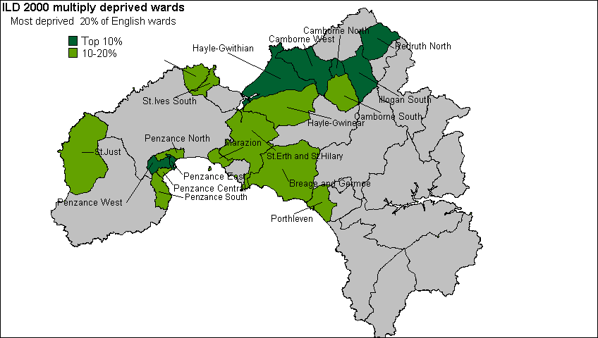

In mid-1998, those wards falling within the 10% most IMD deprived English wards contained a resident population of 40,400 people and those within the most IMD deprived 20% contained 85,500 people. These figures represent 26.9% and 57.0%, respectively, of the resident population of Kerrier and Penwith according to 1998 mid-year population estimates. All seven of the west Cornish wards classified within the 10% most IMD deprived English wards have been identified by central Government as eligible for Neighbourhood Renewal funding.

SMALL AREA MEASURES OF DEPRIVATION

A primary task of this research was to identify the poorest neighbourhoods in West Cornwall at small area level e.g. using areas that are smaller than electoral wards. This required a considerable amount of new research work as no predominantly rural area in the country has yet successfully managed to do this within the neighbourhood renewal framework.

Methodology

The measurement of deprivation at the sub-ward level is constrained both by data limitations and by the appropriateness of deprivation indicators in a rural context. The 1991 Census provides the only reliable data at the sub-ward level for the whole of the UK. One of the main uses of Census statistics is in the construction of deprivation indices, since they form a key element in the allocation of local government and health resources. However, none of the 1991 Census questions was specifically designed to measure deprivation so any Census-based index will be comprised of variables which are at best proxy measures of deprivation (Payne et al, 1996). Moreover, since such indices need to be nationally representative, their construction tends to under-emphasise the distinctive needs of people living in remoter rural areas.

Seven indicators derived from the 1991 Census of Population were finally selected. Their appropriateness in the Cornish context is discussed in more detail below under Findings. These measures approximate to the six ‘domains’ of deprivation (plus the supplementary child poverty index) identified by the DETR and included within the ward level 2000 Index of Local Deprivation:

- Poverty rate (Income)
- Child poverty rate (Supplementary)
- Unemployment rate (Employment)
- Percent of people aged 18 and over with no post school qualifications (Education)
- Limiting Long Term Illness/Disability rate (Health)
- Percent of households with no central heating (Housing)
- Percent of households with no car (Access to services)

Finally, on the basis of these measures, it was possible to construct a scale of multiple deprivation. First, the scores for each Enumeration District were ranked for each measure. Secondly and following the approach adopted by the DETR in the construction of the Index of Multiple Deprivation (IMD) at a ward level, the different ‘domains’ were weighted to broadly reflect the weightings used in the construction of the DETR’s 2000 Index of Multiple Deprivation. This ensured that the final multiple deprivation index was constructed in a similar way to the 2000 IMD used to identify priority districts eligible for Neighbourhood Renewal funding. The following weighting was used:

- Poverty | 20%
- Child poverty | 20%
- Unemployment | 20%
- Standardised Illness Ratio | 12%
- Post-school educational qualifications | 12%
- Central heating | 8%
- Access to a car | 8%

Enumeration Districts were then ranked according to their score on this cumulative index and a cumulative population variable constructed. On this basis, it was possible to identify the most deprived Enumeration Districts for any population threshold (in this case the 33% level). It was decided by the steering committee that the research team should identify the poorest areas in West Cornwall in which a third of the population lived. These would represent the primary target areas for receiving Neighbourhood Renewal funding.

Mapping Deprivation at the Sub-ward Level

For each of the individual indicators described below, an interpolation procedure known as Inverse Distance Weighting (IDW) has been used to map the distribution of deprivation in West Cornwall. There are many advantages to taking spatial data beyond a purely descriptive display method, such as the thematic mapping of points using colours (ie a choropleth map). Deprivation is not constrained by Census boundaries, that is, deprivation usually does not dramatically fall from high levels on one side of an Enumeration District boundary to low levels on the other. IDW interpolation ‘smoothes’ the gradations in levels of deprivation across Enumeration Districts to generate a more realistic model of deprivation. It also enables a spatial analysis of change over time in socio-economic data.

Interpolation is a mathematical process used to estimate values between known point observations. The IDW procedure converts point data into continuous grid layers ( a trend surface) by calculating a value for each grid node by examining surrounding data points lying within a defined search radius. The node value is calculated by averaging the weighted sum of all the points, the weight being a function of inverse distance. Thus, data points that lie progressively farther from the node influence the computed value far less than those lying closer to the node. A technical account of IDW interpolation is given in Appendix II.

(1)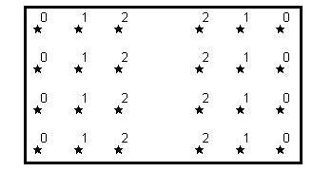(2)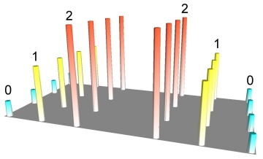(3)
(1)

©Northwood Geoscience

In illustration (1) above, 24 points are arranged regularly with attribute values ranging from 0 to 2. Any numeric attribute can be represented in 3D form, as depicted in the second illustration. This image is actually a rendered grid generated using IDW interpolation by sampling only one data point and using a very small display radius equal to the width of a single column. However, grids are usually used to build a continuous surface that connects data points in space, effectively removing gaps in the representation of data. IDW achieves this by generating a moving average or ‘smoothing’ of the data, as shown in illustration (3).

This kind of trend surface methodology is made necessary because of Spatial Autocorrelation. Areas next to each other are likely to be more similar than areas further away. Spatial autocorrelation can be defined as the clustering pattern in the spatial distribution of a variable which is due to the very fact that the occurrences are physically close together, that is, that they are in geographical proximity. They are not independent of each other, but are linked. The data are spatially dependent.

Spatial autocorrelation is widespread: rich people move to areas where other rich people live; disease can spread from one neighbour to another, etc. If the values in a poverty or health cluster are more alike than would be due to random processes, there exists a positive autocorrelation; if they are less alike than would occur through random processes, there exists a negative autocorrelation.

Findings

Poverty

As the 2000 Indices of Local Deprivation suggest high levels of poverty are endemic across much of west Cornwall. Figure 2.18 (below) shows the distribution of scores for each Enumeration District in west Cornwall for the poverty index. For each Enumeration District the score represents the percentage of households living in poverty as defined by the Breadline Britain in the 1990s Survey (Gordon and Pantazis, 1997) and applied to the 1991 Census data (see Gordon, 1995). The areas highlighted in Figures 2.18 to 2.24 represent the upper quartile of scores for each of the deprivation indicators selected.

As Figure 2.18 shows poverty in west Cornwall is concentrated in much of west Penwith (especially the coastal towns of Penzance and Newlyn, St. Ives, St. Just, and Hayle), as well as in the Camborne, Pool and Redruth area, and the Lizard peninsula.

Figure 2.18: Poverty rate (%) in Kerrier and Penwith by ED (most deprived quartile)

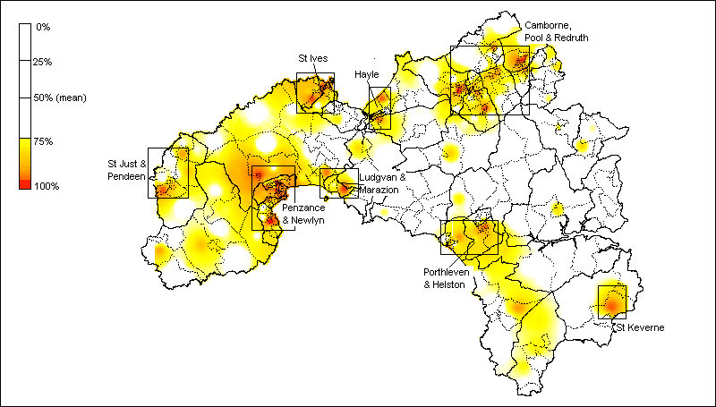
Source: 1991 Census of Population

The child poverty index measures the percentage of poor households with children based on the poverty index derived from the Breadline Britain in the 1990s Survey and applied to the 1991 Census data. As such the pattern is slightly different to the overall poverty index described in Figure 2.18 (above). As Figure 2.19 shows, the distribution of child poverty in west Cornwall is slightly more spatially concentrated than for poverty amongst the adult population, with significant clusters of child poverty in some of the more remote rural settlements such as the St. Buryan area, and in St. Keverne and the Lizard peninsula. However, the larger towns (Penzance and Newlyn, Camborne, Pool and Redruth, Hayle, and St. Just) are also characterised by high rates of child poverty.

Figure 2.19: Child Poverty Rate (%) in Kerrier and Penwith by ED (most deprived quartile)

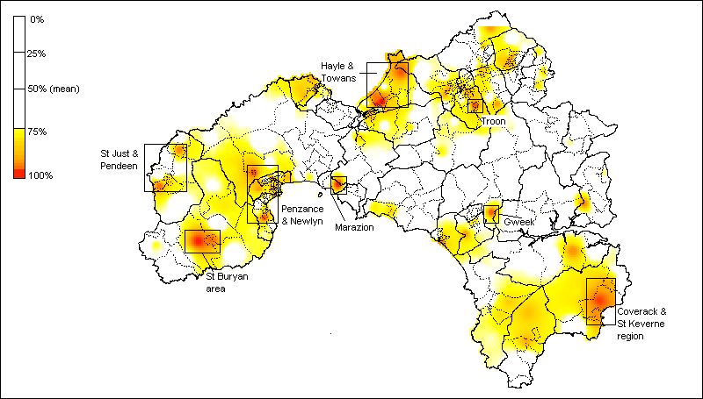
Source: 1991 Census of Population
Health

The Standardised Illness Ratio (SIR) measures the incidence of illness (morbidity) standardised by age and sex, where a score of 100 represents the average health of the population of England and Wales. Thus a score of 167 across an Enumeration District means that residents are 67% more likely to experience a “long term illness, health problem or handicap which limits their daily activities or the work they can do” compared with the average for England & Wales. Conversely, a score of 50 means that residents are less likely to experience illness compared with the average for England & Wales.

As Figure 2.20 (below) shows, ill health in west Cornwall is concentrated mainly in north Kerrier. The Enumeration Districts in west Cornwall with the highest scores (ie. within the upper quartile of the distribution) are predominantly in the Camborne, Pool, Redruth area. Smaller pockets of ill health are also evident in the large coastal towns of Penzance and Newlyn, St. Ives, and Hayle, as well as in the Pendeen area, and the Lizard peninsula.

Figure 2.20: Standardised Illness Ratio in Kerrier and Penwith by ED (most deprived quartile)

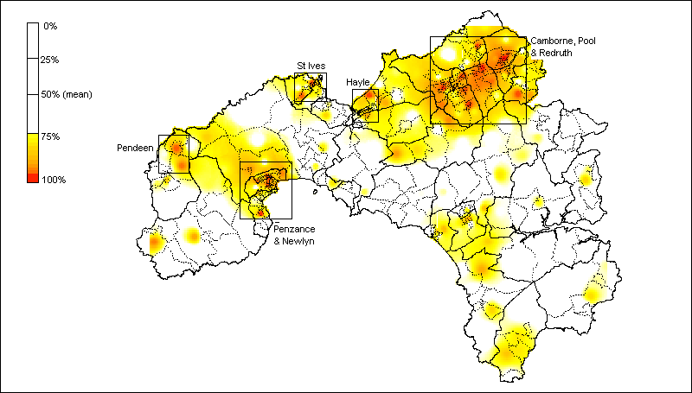
Source: 1991 Census of Population

Unemployment

The Census indicator of unemployment is a more accurate measure of worklessness than Claimant Count estimates since the latter only includes economically active individuals in receipt of unemployment-related benefits. According to this measure the most substantial areas of worklessness are in north Penwith and north Kerrier as a whole, as well as in Penzance and southern Lizard, as Figure 2.21 (below) shows. Unemployment is a particular problem in the larger towns (St. Ives, Hayle, Camborne, Pool and Redruth).

Figure 2.21: Unemployment Rate (%) in Kerrier and Penwith by ED (most deprived quartile)

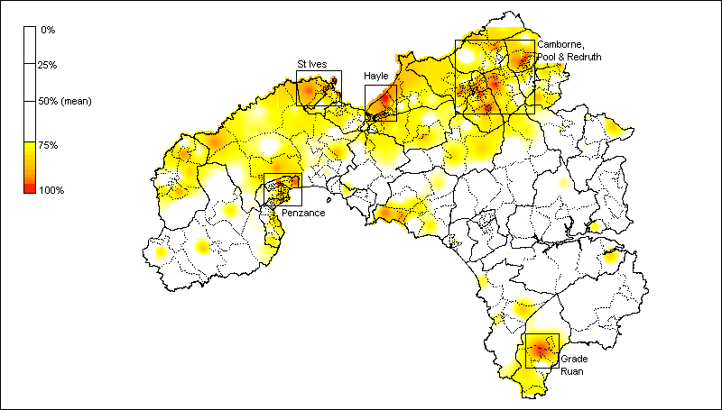
Source: 1991 Census of Population

Education

The distribution of educational disadvantage, as measured by the percentage of individuals without post-school qualifications (degrees, professional and vocational qualifications), is very different than for poverty, child poverty, and unemployment. The distribution of individuals with no post-school educational qualifications is much more dispersed, with significant clusters in many of the smaller and more remote rural settlements across Penwith and especially Kerrier, as Figure 2.22 (below) indicates.

This pattern partly reflects the different age profile of rural areas in comparison with the larger towns. Demographic change means that rural communities are increasingly characterised by greater concentrations of older residents compared with larger towns. Since educational attainment also reflects patterns of generational change it is to be expected that educational attainment would be relatively low in many isolated rural communities with ageing populations. However many of the Enumeration Districts in west Cornwall with the highest scores for educational under-achievement are also concentrated in the larger coastal towns of St. Ives, St. Just, and Hayle, as well as across the Camborne, Pool and Redruth area.

Figure 2.22: Individuals with No Post-School Qualifications (%) in Kerrier and Penwith by ED, (most deprived quartile)

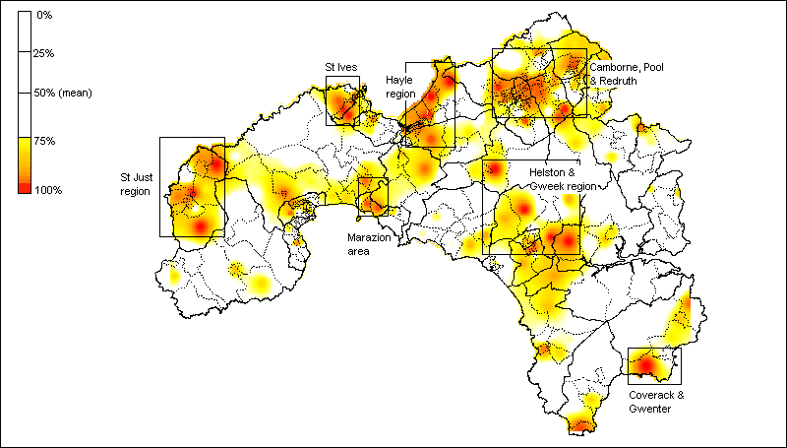
Source: 1991 Census of Population

Housing

The distribution of households lacking central heating in west Cornwall again differs significantly from the key indicators described above - namely poverty, child poverty, and unemployment. The Enumeration Districts with the greatest proportion of households lacking this basic amenity are concentrated predominantly in west Penwith and especially in the Penzance and Newlyn area, as well as in St. Ives, and St.Buryan.

Figure 2.23: Households with No Central Heating (%) in Kerrier and Penwith by ED (most deprived quartile)

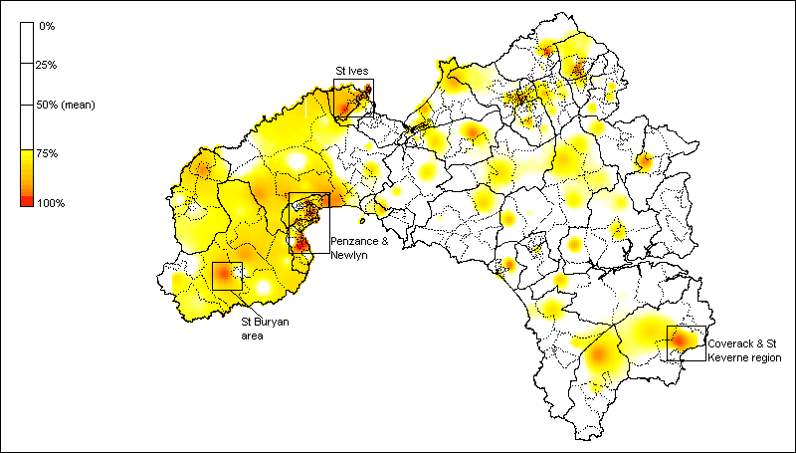
Source: 1991 Census of Population

Access to Services

Access to a car is a key dimension of access to community services in rural areas, especially since historical and new data reveal an overall trend of declining geographical availability for some essential services in many rural areas (Countryside Agency, 2001 – see Chapter 4). Strikingly, the percentage of households in west Cornwall without access to a car closely reflects the distribution of poverty amongst the adult population (see Figure 2.18). As Figure 2.24 (below) shows, levels of access to a car are lowest in the larger towns (St. Ives, St. Just, Penzance and Newlyn, Hayle, and Camborne, Pool, and Redruth). However, there are also substantial rural areas (eg. west Penwith, the Lizard peninsula) where lack of access to a car is also a significant problem, especially given the remote rural location of these settlements.

Figure 2.24: Households with No Access to a Car (%) in Kerrier and Penwith by ED (most deprived quartile)

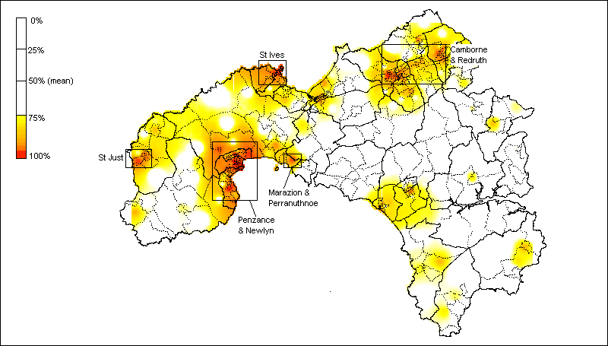
Source: 1991 Census of Population

IDENTIFYING PRIORITY AREAS

Using the methodology described above it was then possible to map deprivation at a small area level using a cumulative index of deprivation which combines the Census indicators described above, as illustrated in Figure 2.25 (below). The most significant concentrations of deprivation produced by this procedure are in the larger settlements – chiefly Camborne, Pool, Redruth, St. Ives, Penzance, and St. Just. However, mapping deprivation at Enumeration District level also reveals smaller pockets of deprivation in rural settlements such as the Lizard area, Pendeen, and the Land’s End area

Figure 2.25: Cumulative index of deprivation in west Cornwall (IDW method), 1991 Census

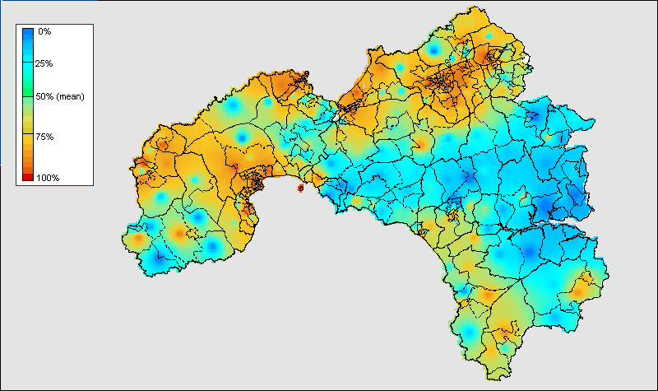
Source: 1991 Census of Population

Ranking Enumeration Districts according to their score on this cumulative index meant it was then possible to identify the most deprived Enumeration Districts for any population threshold (in this case the 33% level as determined by the West Cornwall LSP). The priority areas for NRF funding as determined by this procedure are shown in Figure 2.26, below. A larger scale map of the priority areas with area labels is included in Appendix II. The priority areas are mainly concentrated in the Camborne, Pool, Redruth area, Penzance area, St Ives area, Hayle area, Newlyn area, Helston area, St Just area, Porthleven area, Hayle & Towans, Troon area and Pendeen areas (see Appendix II for details). However, there is also some evidence of priority need in the Lizard area.

Figure 2.26: Priority Areas at 33% Population Threshold, 1991 Census
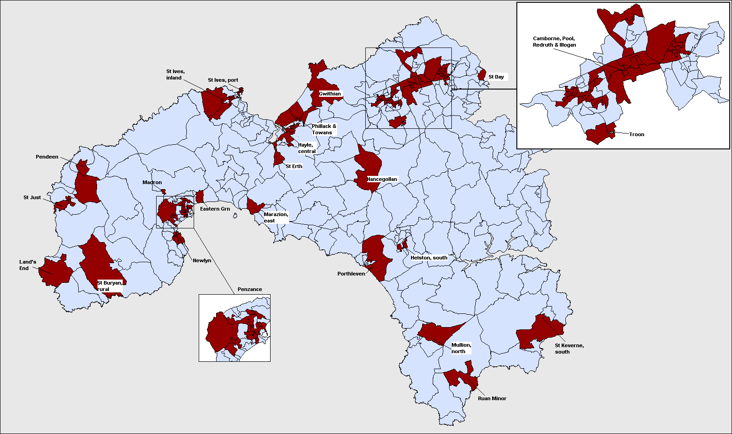
POOR CONSUMERS AND SOCIAL ENTREPRENEURS

Market research companies have created a multi-million (billion?) pound geo-demographics industry in Britain which attempts to classify small areas on the basis of the consumer behaviour of the people who live there. This kind of commercial information can be useful to a scientific study in two respects:
- Geo-demographics data can be used to help validate the measures of deprivation used in this study by examining the ‘fit’ between this index and the market research data.

- Market researchers tend to be much more interested in identifying “rich” and “middle-class” areas than most academics (for the obvious commercial reasons) so these data may be useful in identifying where the highest concentrations of potential “social entrepreneurs” live.

One such data source is the Experian database of household and neighbourhood types developed as part of the Great Britain MOSAIC project. GB MOSAIC classifies all Great Britain households into 52 distinct ‘lifestyle types’ which comprehensively describe their socio-economic and socio-cultural behaviour. A MOSAIC type is assigned to each of the 1.6 million postcodes in Great Britain. The type assigned is the one that most closely describes the characteristics of those households and the individuals living there.

Methodology

A GB MOSAIC type is assigned to each household based upon a large number of statistical measures, originating from different sources and relating either to the individual person, their household, postcode, or other geographic unit such as Census Enumeration Districts or postal sectors. Each year, the data is refreshed (except Census data, which was gathered in 1991) and the GB MOSAIC type assigned to each postcode or household is re-evaluated and, in some instances, changed where the statistical characteristics have altered (for example, due to movements of people or new buildings). A detailed description of the clustering technique used to generate these household types is given in Appendix II.

Using the GB MOSAIC profiles, it was possible to construct variables which broadly correspond to indicators of rural poverty, as well the identification of ‘key stakeholders’ in terms of civic involvement and community regeneration. The following clusters (or household types) were identified as pertinent to the investigation of rural poverty in the West Cornish context:

- Low rise pensioners (D15)
- Low rise subsistence (D16)
- Peripheral poverty (D17)
- Rural disadvantage (K48)

The following clusters (or household types) were identified as pertinent to the identification of potential ‘social entrepreneurs’ in the west Cornish context:

- Clever capitalists (A4)
- Ageing professionals (A5)
- Small town business (A6)
- Chattering classes (H36)
- High spending greys (I48)
Findings

The areas highlighted in Figures 2.26 and 2.27 represent the upper quartile of the distribution measuring the concentration of “social entrepreneurs” and “rural poor” respectively within each postal sector (ie. as a percentage of the total population). As Figure 2.26 shows, households defined as potential “social entrepreneurs” using the GB MOSAIC classification are concentrated in the coastal areas of Kerrier and Penwith – principally around St. Ives, in the south of the Land’s End peninsula, and in the west of the Lizard peninsula. Interestingly, comparing the distribution of these community “animateurs” with the geographical distribution of community organisation (see Figure 4.16) reveals an essentially inverse relationship – namely, those areas characterised by high levels of community organisation contain few households defined here as “social entrepreneurs”.

This pattern may reflect the low population densities of the areas containing high concentrations of “social entrepreneurs”. Community organisation tends to occur in populous areas – chiefly major towns – which act as nodes in the development of community networks due to their accessibility and physical infrastructure such as meeting halls and other venues. It is likely therefore that “social entrepreneurs” live outside these areas in more remote settlements and travel in to the main population centres. Alternatively the real “social entrepreneurs” in west Cornwall may not belong to any of these ‘middle-class’ professional groups, but may be largely composed of ‘poorer’ and/or younger social groups.

Figure 2.26: ‘Social Entrepreneurs’ in West Cornwall by Postcode Sector, 2000

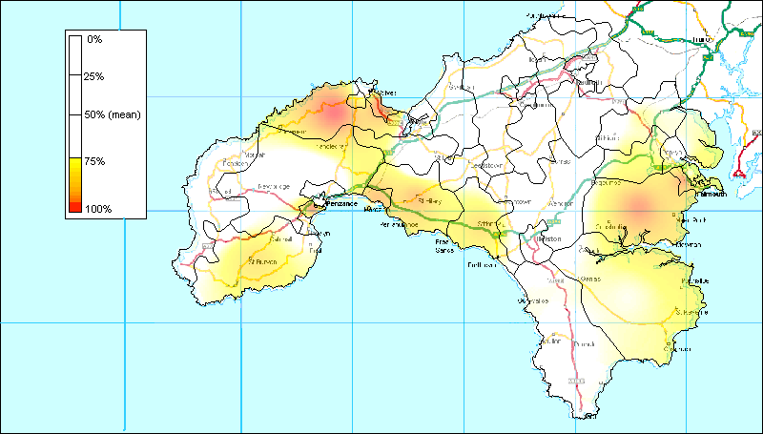
Source: GB MOSAIC © Experian

Households defined as “poor consumers” using the GB MOSAIC classification are concentrated largely in west Penwith (especially in the St. Just area), as well as in north Kerrier (principally in Camborne and Redruth), as Figure 2.27 (below) shows. Comparing the distribution of “poor consumers” with “social entrepreneurs” (Figure 2.26, above) again shows an inverse relationship such that in those areas with high concentrations of poverty as identified by GB MOSAIC “social entrepreneurs” are relatively scarce. This demonstrates the internal consistency of the GB MOSAIC classification.

However comparing the distribution of “poor consumers” with the geographical distribution of poverty using 1991 Census data (Figure 2.18) reveals the limitations of market research approach to social classification. There is some degree of consistency between the two approaches in the areas identified as containing large proportions of “poor” households. As Figure 2.27 reveals, in both approaches west Penwith figures prominently, as well as north Kerrier (especially Camborne and Redruth).

Figure 2.27: ‘Poor Consumers’ in West Cornwall by Postcode Sector, 2000

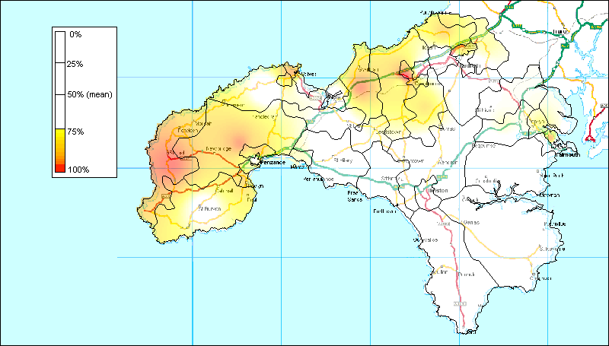
Source: GB MOSAIC © Experian

However, in contrast with the 1999 Census analyses, smaller predominantly rural settlements (eg. in the Lizard peninsula and in the Marazion area) are overlooked using a classification based upon GB MOSAIC. This inconsistency between Census based and GB MOSAIC based approaches is partly a result of the larger spatial scale of UK postal sectors in comparison with Enumeration Districts, which means that smaller pockets of deprivation within otherwise relatively affluent are often missed. However, it also reflects the different priorities of market research, which focus upon predicting consumer behaviour rather than upon the scientific measurement of poverty and social exclusion. These findings emphasise the fact that geo-demographic market researchers are primarily interested in the location of middle income and richer social groups, whereas social scientific research has often concentrated on mapping the distribution of poorer social groups.

CHAPTER THREE:

CONSULTATION WITH STAKEHOLDERS

METHODOLOGY

Scope of the Research
This phase of the research focused on the experience of stakeholders in relation to deprived neighbourhoods. It was intended as a preliminary exercise to explore:

- stakeholders’ perceptions of the location and boundaries of priority neighbourhoods and the extent to which these correlated with statistical mapping
- their view of the issues facing these neighbourhoods and similarities and differences in the issues faced
- their understanding of the causes of the problems
- their perspective on possible solutions

These questions relate to Stage Three of the research specification. However, the data gathered also threw light on some of the questions in Stage Four, particularly the interaction between one neighbourhood and another and the leverage of stakeholders over the challenges faced.

Interview Sample
The primary instrument for the research was semi-structured interviews with a range of stakeholders. Thirty-one face to face interviews, involving 37 people, were conducted by the research team. These interviews took place during three visits by the researchers in October and November. The sample was developed with the aim of including a range of perspectives. The following criteria were important in the selection of research participants:

- A fairly even spread across the two local authority districts of Kerrier and Penwith
- The inclusion of town and rural areas
- Representation from statutory, voluntary and community agencies
- The inclusion of different levels of agency or group, eg overview or umbrella body; area based agency; neighbourhood level agency, worker or activist
- Inclusion of the various levels of local government, ie county, district, town and parish councils
- A reasonable spread of types of organisation in terms of the focus of the agency or group, eg regeneration and community development or a more specialised focus, eg housing, health, employment, crime, education, community arts

Participants were recruited partly by drawing on other information sources and databases to locate particular agencies and partly by the ‘snowball sampling’ technique (Arber, 1996). In this case, ‘snowball sampling’ meant starting with suggestions made by the Research Steering Group and including some members of the Steering Group themselves in the sample. During the first round of interviews, ideas were actively sought from interviewees for extending the sample in particular directions which were not yet well represented.

Of the interviewees, all were white, 18 were women and 19 were men. There was no specific question about Cornish identity but the majority indicated long-standing or lifelong connections with Cornwall. A full list of participating organisations is given in Appendix III.

Community and Voluntary Sector Conference
A significant bonus for this stage of the research was the timing of the community and voluntary sector conference ‘Making it Happen’ on 19 November 2001 to explore the involvement of the sector in neighbourhood renewal and the use of the Community Empowerment Fund and the Community Chest. By the time of the conference, the researchers had had the opportunity to interview most of the key players who had planned the conference and a few of the participants. This had provided them with sufficient understanding of the area and the issues in order to build on this knowledge by attendance at the conference. It was also possible to make connections with other people whom it was hoped to interview and fill some of the gaps in terms of geographical areas and specialist issues.

Interview Instrument
Semi-structured interviews were used in the research to ensure consistency across the topics discussed (which related to the research specification), while allowing flexibility in exploring particular perspectives and issues.

The topic guide was discussed at the Research Steering Group meeting on 10 October and is reproduced in Appendix III. There were two slightly differing versions of the guide, one geared towards development, umbrella or specialist organisations, the other towards neighbourhood groups. The topic guide proved a useful tool in a number of ways. Firstly, it ensured consistency of approach between the two researchers. Consistency was also assisted by sharing some interviews and then reviewing them to identify similar and dissimilar factors of approach and style. Secondly, in the earlier interviews, the flexibility of the topic guide enabled the researchers themselves to gain an understanding of the areas, issues, organisations and structures, as experienced by workers and residents. This was important in identifying emerging themes and clarifying issues in greater depth in subsequent interviews.

The guide covered the various topics comprehensively but also facilitated a focus upon specific questions where appropriate. The later questions had sometimes been covered in earlier answers but the guide could be used to check on any omissions. Some interviewees were more interested in seeing the guide themselves than others. It was always introduced to interviewees and available if they wished but the majority of interviews were conducted flexibly by the interviewer referring as needed to the guide.

Notes were taken during interviews and tape recordings made. Because of the timescale, the notes have been the major source of analysis. An additional source of analysis, reflecting the timescale and logistics of the research, was regular exchange between the researchers about emerging findings which has assisted the identification of common and divergent themes and issues which need further exploration.

Telephone Interviews
The face-to-face interviews were supplemented by 14 telephone interviews between late November 2001 and early January 2002, undertaken by one of the researchers. The topic guide provided a basis for the telephone interviews in most cases and notes were taken. Ten women and four men were interviewed by telephone. This enabled some gaps to be addressed and the range of perspectives to be extended and strengthened, including:

- Additional representation from very local groups in both Penwith and Kerrier
- Disability and access
- Women’s issues especially in relation to domestic abuse
- Health, especially the relationship between health and community development
- Faith groups
- Cornish cultural work
- Trade Unions

Limitations
The research findings are subject to a number of limitations relating primarily to the timescale of the fieldwork. The scope of the consultation was defined in the research specification as “a preliminary exercise to gather data about the identification of issues at local neighbourhood level, and local views about possible causes and solutions”.

The short timescale of the research had implications for the planning and development of the sample. However, despite the time pressures, the cooperation and support which the researchers received from Steering Group members and many other research participants enabled a diverse sample to be put together which included some representation across a number of key dimensions sought. Inevitably, representation of some groups and concerns will be stronger than others.

A related issue was the contemporaneous running of different stages of the research. The statistical mapping of deprivation in order to identify priority neighbourhoods was continuing throughout most of the interview phase and decisions about population thresholds and the most appropriate measurement tools were evolving rather than finalised. This meant that the exploration of research participants’ perceptions of priority neighbourhoods ran in parallel with the quantitative analyses and helped inform the selection of deprivation indicators. On the whole, there has been a very strong connection between the final priority areas as identified by the project Steering Group and the perspectives of respondents.

However, the timescale for the fieldwork did inhibit the inclusion of some individuals in the sample simply because mutual availability could not be arranged in the time. At the interim stage in December 2001, this resulted in some imbalance, for instance, in the representation of regeneration and community development officers in Kerrier and Penwith. Telephone interviewing partially redressed this imbalance. It should also be noted that other interviewees from other levels and types of organisation provided complementary sources of data which also helped to create balance. By the second round of interviews, some consistency was emerging in the data from a range of sources which was reassuring in terms of seeking to include a diversity of perspectives in the research. The attendance of the researchers at the ‘Making it Happen’ conference gave access to a cross section of perspectives across the community and voluntary sector which also helped to place other findings in context. Finally, the telephone interviews were specifically focused towards identified gaps or under-representation as far as possible.

More fundamentally, any project of this speed and scope will tend to gain access to more powerful voices at the expense of less powerful groups and interests. A range of socially marginal groups were referred to by interviewees (eg young people, minority ethnic groups such as Gypsies and Travellers, homeless people, asylum seekers). Some of these groups had strong advocates among interviewees but direct access was not possible given the timescale and nature of the research. Some compensation is sought for this by use of research literature. More generally, the processes of exclusion and division within the most disadvantaged neighbourhoods and communities need to be recognised (Brent, 1997) as a tension within this research and within the process of neighbourhood renewal (JRF, 2000a).

RESEARCH FINDINGS

Perspectives on Identifying Deprived Neighbourhoods
Many respondents were ready to identify particular estates, villages or other local areas where their experience indicated the greatest levels of disadvantage. However, other respondents raised a number of issues about identifying neighbourhoods in this way. These will be discussed as a context for the findings about specific neighbourhoods.

Firstly, some participants were concerned that defining and labelling particular areas as ‘deprived’ feeds into a process of labelling, stigmatisation and lowered expectations which can have a further negative effect on the prospects of an area and undermine other benefits of regeneration (ACU, 1999; JRF, 2000b). In the West Cornish context, this has particular reverberations because of some of the factors underpinning the current levels of economic and social deprivation: the way the industrial history of the area has shaped social and cultural patterns and attitudes; the decline in traditional industries of mining, fishing and agriculture; and geographical peripherality.

Secondly, some participants considered it unhelpful to identify some neighbourhoods rather than others as deprived because they saw the whole area as deprived and in need of renewal.

A third issue raised by some participants was that some areas - which were viewed as experiencing particular problems - were very small and isolated and might not therefore come under the definition of a ‘neighbourhood’.

A related issue, which was raised in one form or another by a majority of respondents, was the proximity of poorer areas to more affluent areas and the consequent masking in statistical terms of these smaller pockets of deprivation.

A fifth issue identified by participants was a difference in perception of size of neighbourhood. This finding is presented tentatively because of the limitations of the research discussed above. Some of the overview bodies and regeneration teams tended to present neighbourhoods in terms of whole estates, wards or villages, while some community volunteers and activists at grassroots level tended to define neighbourhoods more narrowly in terms of a particular estate or part of an estate or a settlement which might be adjacent to another village. The closer to neighbourhood level, the smaller the conception of neighbourhood with which people might identify. This was not a uniform difference between residents’ activists and agency workers. Some of the latter also identified the issue and, indeed, advocated for support to very small and local projects. However, agency workers were likely also to focus on the resource implications of providing multiple local facilities. They tended to seek solutions such as local provision which could nonetheless provide some complementarity between neighbourhoods and to promote means of increasing cooperation between areas.

Identification of Priority Neighbourhoods
This section lists the neighbourhoods identified in North Kerrier, South Kerrier and Penwith. Many of these were referred to by more than one interviewee. The problems and issues which they were considered to face are discussed in subsequent sections. This stage of the research was not designed to produce a profile of each neighbourhood but to explore interviewee perceptions of such neighbourhoods.

North Kerrier
All three wards of Camborne were referred to and the following more specific neighbourhoods: Pengegon; Parc an Tanyses; Trevu; Rectory Road/Crane Road; Troon, especially Grenville Gardens
Beacon; Tolvaddon; East Pool Park; Central Pool; Guinness Trust estate; Illogan, especially the Churchtown area; St Day, Caharrick in Redruth; North Redruth – North Close, Murdoch Close, Montague Avenue; North Country

South Kerrier
St Keverne; Ruan Minor; Helston – Naval estate; St Johns; Bulwark Road; Coronation Park/ Jubilee Terrace; Porthleven; Lizard village; Manaccan; Helford; More tentatively – Mullion; Constantine; St Day; Stithians

Penwith
The East, West and Central wards of Penzance were referred to and the following more specific neighbourhoods: Treneere estate; Lescudjack; Eastern Green; Newlyn – especially Gwavas estate
Pendeen; Areas of St Just; Heamor; Higher Faughan; Marazion; St Ives; Hayle – Queensway area

With a very few exceptions, these neighbourhoods are included in the clusters defined by the mapping exercise and so there is convergence between these stages of the research.

Problems Faced by Deprived Neighbourhoods
This discussion of issues, problems and solutions is primarily illustrative rather than focused on particular neighbourhoods since similarities and differences were found on a wider scale than local neighbourhoods. A majority of these problems are structural in that they stem from the underlying economic problems of the area and its relationship with the wider national and global economy. The specific Cornish manifestations of some of these problems have been linked in wider debates with a specific form of oppression affecting Cornish people in terms of inequalities between Cornwall and the national economy and within Cornwall between Cornish people and in-migrants (Payton, 1992). For example, inequality within Cornwall - related to a Cornish ethnicity - can be seen as particularly manifest in the housing market (Williams, 1993). On the other hand, the relationship between labour market inequalities and in-migration is more ambiguous (Williams and Champion, 1998).

The major common structural problems which were identified by interviewees were as follows:

- Employment and skills
  - Lack of permanent jobs, seasonality and insecurity of employment
  - Low wages
  - Falling real income for the most disadvantage groups
  - Skills mismatch in relation to new jobs emerging such as IT

- Housing and the environment
  - Lack of affordable private housing
  - Impact of incomers and second home owners on house prices
  - Shortage of social housing
  - Adverse impact of tourism on the environment
  - Contamination of some former industrial land

- Education and training
  - Lack of opportunities for higher education and training
  - Lack of opportunities for young people and associated lack of hope
  - An outflow of young people from the area arising from the dearth of jobs and higher education opportunities

- Services and facilities
  - Poor public transport, particularly between rural centres
  - Difficulties of access for disabled people
  - Lack of flexible, accessible transport for disabled people in many areas, and of a central booking system for such transport
  - Lack of available, flexible and affordable childcare, including a shortage of child minders, and a process of small providers being squeezed out of the market
  - Insufficient facilities for play, leisure and cultural activities
  - Shortage of youth workers and youth facilities
  - In-migration, particularly of retired people and resulting pressure on services

- Health
  - Isolation, especially for older widowed and single people and disabled people
  - Mental health issues especially in relation to isolation, to stigmatisation, and to the concentration of mental health resources in Camborne
  - Postnatal depression
  - Long term ill health and shortage of provision for people with long term health problems and impairments
  - Difficulties of access to local primary health services in some areas both rural and urban (eg North Redruth)
  - Difficulties of access to emergency and specialist health services (major hospital in Truro)
  - Drug problems, particularly on some estates in Penwith
  - Alcohol problems
  - Teenage pregnancies
  - Lack of accessible and confidential sexual health services

- Crime and anti-social behaviour
  - Problems of vandalism and anti-social behaviour experienced by older residents on some estates
  - A fear of crime which is not in proportion to the incidence of crime
  - Racism experienced by asylum seekers and by Gypsies and Travellers

Other issues identified by participants, although structural in origin, were also viewed as attitudinal, cultural or behavioural. There is also some overlap with the above list. For instance, drug problems and anti-social behaviour, noted above, have behavioural elements, while most cultural or community issues are strongly related to the socio-economic context. There is also a complex link with issues of Cornish identity, culture and historical experience. Deacon (1993:205) discusses how a declining industrial base and economic insecurity from the late nineteenth century onwards “led to a culture of ‘making-do’ as heroism in the face of grinding day to day hardship became a social virtue”.

The issues most commonly identified relating to community attitudes and behaviour were:

- Low aspirations or ‘poverty of ambition
- Lack of awareness of diverse opportunities including job opportunities and apprenticeships
- Limited horizons and experience in terms of learning from elsewhere within and outside Cornwall
- Pride of place and pride in Cornish identity given little recognition and limited overt expression
- Lack of parenting skills
- Insularity between different villages, estates and neighbourhoods, and lack of willingness to cooperate on larger schemes
- Decline in community networks and support for some residents
- Difficulties of involving a wide range of participants in community activity – most projects and groups are sustained by a small group of activists
- Difficulties recruiting volunteers, exacerbated by the lengthy process of police checks
- Disproportionate middle class involvement in some activities and groups, eg parent-teacher groups, youth forums
- Mistrust of authorities and feelings of abandonment by services in deprived neighbourhoods
- Sense of hopelessness felt by front line agency staff as well as residents
- Limited electoral support for and involvement in town councils

These problems are reflected at an institutional level in the response of agencies and services and in relation to the solution-oriented processes of regeneration and renewal. The West Cornwall area has received funding under a variety of national and European regeneration budgets (see Chapter 1). Clearly this is a major asset, however, this research, which was particularly focused on the renewal of local neighbourhoods, found or confirmed some problems in the way these processes develop and the conditions under which Local Authorities and communities have to respond to them. The issues most commonly identified relating to institutional rules, attitudes and behaviour were:

- The imbalance in the capital as against the revenue budgets
- The focus on large scale projects which can leave the more disadvantaged neighbourhoods and groups even further behind
- Difficulties of obtaining matched funding
- The complexity, bureaucracy, and lack of transparency of the bidding process, which required time and skills often not available in deprived neighbourhoods, and could divert attention from longer term development
- Dangers of fragmentation because of the multiplicity of new initiatives and policies
- Dangers of disillusion and initiative fatigue when consultation and new initiatives do not lead to tangible results for disadvantaged neighbourhoods
- Insufficient proactivity, cooperation and flexibility on the part of statutory agencies in response to community initiatives
- The lack of accessible information about new programmes and projects, especially for people who may not take newspapers or listen to local radio news
- The focus on ‘hard’ targets, for instance national tests and exams in education, compared to softer targets
- The lack of, or withdrawal of, community development work focused on long term support to deprived neighbourhoods
- The lack of focused, sometimes individual support to learn about and access new opportunities
- Very scarce youth work resources to support young people’s personal and social development and their involvement in community activity and decision-making

There was considerable convergence about many of the issues identified by respondents. The great majority of the socio-economic problems listed above were discussed by a majority or all respondents but above all low wages, insecure employment, lack of affordable housing and inadequate transport. There was great consistency in the identification of the structural basis of problems, suggesting a common if often unstated view of the centrality of structural causes related to West Cornwall’s economic trajectory and geographical peripherality.

However, some differences of perspective were evident in relation both to structural issues and institutional responses. Rural areas were identified as particularly disadvantaged in terms of lack of facilities and transport and social isolation. Several respondents also spoke of a divide between North and South Kerrier, with North Kerrier being perceived as having gained the greatest share of resources over recent years. Community activity in South Kerrier, although vibrant and resourceful, was seen as insufficiently supported, both in terms of direct funding resources and in terms of other council decisions such as planning permission.

However, the perceived shortcomings of Local Authority support for neighbourhood groups were also a linking theme between North and South Kerrier and Penwith. For example, a residents’ group on an estate in Penzance had experienced considerable hurdles in its long-running campaign to create a safer and better resourced environment on the estate. A residents’ group in North Redruth was critical of the lack of police response in the area and of the District Council’s expectation that estate residents would feel able to use a community centre in another area of the town.

There was also variation in the experience of transport services within the more urban areas. Although some areas felt well served by buses, eg North Redruth, some anomalies were evident, eg on the Guinness Estate in Pool, the outgoing bus did not return to the estate, causing problems for residents. There also variability in the extent to which buses provided disabled access and there was no unified contact point to book accessible transport.

Other differences emerged in relation to attitudinal, psychological and behavioural factors which reflected different perspectives on neighbourhoods and regeneration. There was a strong consistency from many agency interviewees in identifying low aspirations, limited ambition and, to a lesser extent, lack of parenting skills, as important issues. However, there were also challenges to this dominant view. Thus, some respondents referred to the damaging impact of a culture of blame which implies that local people could have made improvements if they chose. It was argued that the most alienated and marginalised communities may need to be facilitated to express their anger about longstanding experiences of neglect before they can engage more positively with development processes. A more inclusive vision was needed to support development.

Another challenge in this context concerns the very high aspirations which were found among the neighbourhood and residents groups interviewed, who had great ambitions for their neighbourhood in terms of developing community spirit and community facilities. However, these aspirations did not always mesh with the perspectives of agencies and Local Authorities who were encouraging greater networking and cooperation between villages and neighbourhoods. This was partly to widen experience and horizons and partly because of the necessity to rationalise resources and to demonstrate partnership in order to attract further resources.

Similarly, divergences from the prevalent view of low parental aspirations and lack of parenting skills were also evident. The experience of one project coordinator was that ‘hard to reach’ parents were in fact accessing support on a regular basis, interacting well with other parents and participating in the project’s services. The coordinator’s experience of one estate, identified as problematic by many participants, was that residents were well focused on the needs of their children and active in trying to improve the neighbourhood and facilities for children. A major problem for them was the stigmatisation of the area (JRF, 2000b).

The problem of low levels of involvement in community activity was expressed by a number of respondents. The Report of the Policy Action Team on Community Self-Help (ACU, 1999) identified five types of barriers to community and voluntary activity: motivational, organisational, institutional, political and cultural and economic and all of these are relevant in the West Cornish context. For instance, shortages of childcare and the necessity of juggling multiple jobs, were cited as inhibiting voluntary activity. However, the interview findings, particularly from the agencies and associations working most closely with small localities and groups, indicate that ways of overcoming these barriers are being demonstrated. Several participants commented on the increase in involvement once much needed facilities were provided, for instance, play facilities on an estate which provide a focus for parents and children to come together.

Similarly, a number of local projects, particularly in Penwith, had put on Planning for Real events (Neighbourhood Initiatives, 2001) combined with Fun Days to involve the local community and generate participation in planning future changes in the neighbourhood. These events had attracted a good turnout and an enthusiastic response from local people. It should also be noted that other respondents voiced some criticisms of the Planning for Real approach for failing to provide a sufficient context for the exercise, for potentially holding down expectations by not providing broader choices and for insufficiently publicising the policy outcomes of these consultations.

Interviewees suggested that the voluntary and community sectors were insufficiently valued in a number of ways. Some respondents indicated that voluntary services, especially in rural areas, could be relied on inappropriately as substitutes for statutory services. Others considered that the contribution of volunteering to personal and social development, supported by appropriate volunteer training programmes, was not adequately recognised. The value of volunteers’ time, especially in consultation forums, was not always acknowledged and recompensed. It has been argued elsewhere that volunteers need financial support for their involvement (JRF, 2000c). The research provided evidence that some volunteers and community activists were indeed broadening horizons and drawing on ideas from a wide range of sources, such as Planning for Real, earlier cultural traditions, networks inside and outside Cornwall and academic literature to apply to work in local neighbourhoods.

The research did not specifically ask people about their view of Cornish identity and cultural activity and, in many cases, interviewees did not raise these issues spontaneously. This is perhaps not surprising given that the researchers came from outside Cornwall. However, there was some discussion of these issues in face-to-face interviews and the topic was pursued by telephone interview. There was a clear view that Cornish identity is understated and it was suggested that this relates to the historical oppression of the Cornish and continuing disadvantages associated with peripherality, economic decline, inequalities between incomers and local people in the housing market and resultant lowering of self-esteem.

However, organisations involved in promoting social and community development through Cornish cultural activities discussed marked increases in confidence, enthusiasm and commitment of the groups they worked with arising from such activities. These involved reclaiming, regenerating or sustaining different cultural customs associated with Cornish identity, including older Celtic traditions of feast days, music, dancing and language and newer cultural activities of brass bands and rugby football arising from working class industrial traditions (Burton, 1997). Combined with approaches of outreach, oral history, youth and community work and community festivals and events, there was evidence that they have a significant contribution to make to community regeneration, releasing creativity and imagination and enabling expression of pride of place.

More generally, issues of low aspirations and associated lack of skills in communities tended to be discussed in the context of areas which were experiencing considerable problems in terms of lack of jobs and low wages. There are various possible interpretations of these parallel - and sometimes contradictory - perspectives. One is that there may be something of a mismatch between the enthusiasm and expectations of statutory and voluntary agencies and regeneration workers who are aware of the potential growth of opportunities and the difficulties of local people in gaining a clear view of these opportunities. It seemed that low aspirations had probably been a realistic response to the declining opportunities available in recent decades and, for many, may still be a realistic response. A second possibility is that the strengths and enthusiasm of local people are not perceived by agency workers because of differing agendas about where attention should be focused. A third possibility is that the pride, enthusiasm and energy of local people remains untapped because they have not been sufficiently encouraged by authorities and services.

As noted earlier, there were also a number of community views about lack of responsiveness, flexibility and imagination on the part of statutory services. While interviews were held with some mainstream agencies, the research with agencies was primarily focused on development or specialist agencies with a particular interest in neighbourhood renewal. Within these organisations, a number of actual or potential resources for renewal were evident, including community development experience, new approaches to partnership working, action zone initiatives and a commitment to changing conditions for the most deprived communities. These strengths are summarised below.

There was a particular contribution from a health perspective in terms of the potential for health visitors to engage with very alienated communities which have effectively been abandoned by other agencies or are considered to be ‘no-go’ areas. Because of their role with all families, health professionals were seen as having credibility with marginalised and excluded communities where other agencies, including community workers in the first instance, may have difficulties operating. This trust can be used to engage with residents’ feelings of abandonment and anger, promote renewed confidence and mobilise local people to take the lead in working with their own communities. The process also involves raising awareness among other local agencies to develop more productive partnerships on an equal basis with residents. While some of this experience derives from another part of Cornwall (Thomsett, 2001), it has wider implications and reverberates with some of the issues expressed in Kerrier and Penwith. Similar problems were currently seen as operating on a Gypsy site just across the Kerrier border. In this situation, health workers and workers from a children’s charity were still able to access the site and engage effectively with residents.

Strengths and Resources
The previous discussion has highlighted a range of strengths at neighbourhood level which are summarised here. The potential supports available for the regeneration of communities from outside the neighbourhood are also summarised here for ease of reference, although discussion of some of these issues follows in the succeeding section.

Strengths of neighbourhoods and communities:

- Resilience and self-sufficiency
- Established family and community networks
- Pride in very local areas
- High ambitions for local neighbourhoods
- Commitment and vision of core activists
- Potential for personal and social development of volunteering
- Demonstration of potential for wider involvement through Fun Days, response to small neighbourhood improvements, participation in new projects through outreach
- Potential for outreach and capacity building once communities and individuals are engaged at a personal level
- Renewal and development of Cornish cultural activities

Other resources available to neighbourhoods and communities include:

- Developing commitment of local authorities, health trusts and voluntary agencies
- Development of voluntary sector infrastructure through forums, networks and umbrella bodies
- Development of regeneration infrastructure which is beginning to reach out into more deprived neighbourhoods
- Growth of proactive inter-agency working to promote improved services through a variety of nationally sponsored action zone initiatives
- Increase in partnership working across agency and sector boundaries and of associated skills and understanding
- Ongoing improvements in the provision of disabled access to buildings, services, transport and community involvement
- Initiatives to consult and involve young people
- The growth of formal and informal training courses available to local residents to promote skills in community work
- New ideas and perspectives from networking within and outside Cornwall
- Skills, knowledge and time of some incomers, eg retired professional in-migrants

Possible Solutions and Ways Forward
Resources and solutions are linked by a number of issues. One key issue in reducing neighbourhood disadvantage is how poor people and people in poor neighbourhoods can increase their access to resources and generate further resources. A second key issue is how the involvement of communities in neighbourhood renewal can be promoted. This section focuses on these issues and seeks to identify the types and levels of resources available for promoting community involvement in neighbourhood renewal and for assisting community members as key stakeholders to increase their leverage over the challenges they face.

There are a number of theoretical and empirical considerations in relation to community involvement which provide a context for this research. One of these is a range of approaches to understanding the complexity of the term ‘community’ (Mayo, 1994) and the diversity of groups and interests included in any one ‘community’ (Hoggett, 1997). Many writers discuss the tendency for more powerful interests to dominate at neighbourhood level as well as other levels of interaction and for this to be reflected in consultation and participation mechanisms (eg Burns and Taylor, 2000; Chanan et al, 1999). For more disadvantaged people, the obstacles to inclusive participation and involvement are greater (ACU, 1999; Burns and Taylor, 2000).

Chanan et al (1999) identify a variety of roles which are relevant to the community in renewal and regeneration programmes: beneficiaries of programmes and services; consultees and representatives; a source of community activity; deliverers of parts of the programme; and long-term partners. This research has touched on all these roles but the analysis here is primarily of community activity, the community as consultees and representatives and as long-term partners, rather than on the receipt of or provision of services.

There are different levels of organisation and development available to promote community involvement, including involvement in neighbourhood renewal. Firstly, there is the level of coordination, support and advocacy for the sector as a whole. Community groups and small voluntary organisations require the support of a network or of umbrella organisations to promote the exchange of information, provide training and support in relation to funding, facilitate the formation of new links and projects and advocate on behalf of the sector (Burton and Taylor, 1991; Chanan et al, 1999). There were a number of important resources of this type in both Penwith and Kerrier although they were at different stages of development.

In Penwith, Interlink provides many of the liaison, information and support functions for 300 groups. It is not a decision-making group and, therefore, does not seek to represent the sector. However, the Penwith Community Development Trust promotes and supports new developments, for instance, through a new training project Instep and seems to provide informal representation for the sector. The Kerrier Information Exchange which is part of Kerrier Healthy Towns Project fulfils a similar function for North Kerrier. However, this does not currently extend to South Kerrier.

Other bodies are also involved in providing a common forum and a more general voice for the sector. The Cornwall Voluntary Sector Forum (CVSF) was inaugurated in 1993. A wide spectrum of interests is involved, which is a strength as well as creating challenges. It involves 154 groups and has taken an active role in raising awareness and promoting the interests of the sector generally. The Forum has established an accountable and transparent system for selecting representatives of the sector on a variety of partnership bodies.

In terms of development work, the role of Cornwall Neighbourhoods for Change (CNC) is also significant. As a resident-led organisation, building on a community consultation exercise, it has adopted a community development approach in social housing estates across a wide geographical area. CNC has clearly identified the need for increased community development support with and for local residents. It has established a training programme involving an NVQ in Sustainable Communities to assist local residents to expand existing roles or take on new ones.

Probably the most important development - in terms of coordination and representation for the sector - is the consortium which was formed specifically to engage with neighbourhood renewal and promote the involvement of the sector in its decision making mechanisms and processes. The Making it Happen conference in November 2001 was a milestone in this journey. The recommendations from it included:

- Mechanisms for representation on the Local Strategic Partnership which reflected the strength and the diversity of the sector
- The importance of decision-making timescales accommodating the development processes involved in community representation, rather than seeing these as an add-on function
- The need to strengthen and finance existing networks and infrastructures which can support these processes

By the time of the Local Strategic Partnership conference in January 2002, these broad recommendations had been firmed up into concrete proposals building on existing structures.

Interviewees also referred to a range of other networks and forums of a more specialist nature linking interest communities, such as the Cornwall Disability Forum, developing youth forums, the Domestic Violence Forum and Churches Together in Cornwall. It was not possible to explore the work of these groups and their interconnections in depth, however, their existence suggested that if they can be linked in to the overall consultation mechanisms, they would increase the potential to promote more inclusive involvement of minority and marginalised interests.

At an intermediate geographical level, especially in towns, a different set of linking mechanisms have developed, partly around regeneration and Objective 1 programmes. The work of town forums has been considered in this research but not explored in depth. The development of the Community Forum Network, with an advice and support function for groups seeking funding, has potential for meeting some of the problems experienced at local level in relation to the complexity and inaccessibility of funding.

The fieldwork interviews suggested the existence of an active community and voluntary sector across the area but some limits in relation to overall co-ordination. Paradoxically, this also reflects a strength of the sector, namely the independence and resourcefulness of community groups building on a very local sense of neighbourhood. Additionally, there is also an element of competitiveness which can be a motivational strength but may also damage some groups at the expense of others, limit mutual learning from different experiences and make the generation of shared resources more difficult. Addressing perceptions of neglect of the voluntary and community sector by local authorities will be important in demonstrating the value attached to communities’ achievements and in encouraging increased confidence in entering partnerships with other groups and with the authorities. As a result, greater sharing and coordination may become possible. Managing these creative tensions is an important challenge for neighbourhood renewal.

At local level, despite the various problems which have been identified as facing disadvantaged neighbourhoods, there was evidence of considerable community activity. During the (short) period of fieldwork the researchers learnt about a number of very local groups and were able to make contact with some of these. The ‘snowball’ method of making contact and developing a sample was particularly important here, since these are not groups with a high profile or a significant success record in the competition for funds. Some were residents’ groups but there were also cultural groups, health groups, faith based groups and planning groups.

Those groups who were contacted during the research or which were discussed by other respondents, indicated a remarkable level of resourcefulness, resilience and perseverance, sometimes over many years. They may well be an insufficiently tapped resource but one which could be actively promoted in the process of neighbourhood renewal. In order to increase their contribution, they will need increased support in terms of information, access to decision-making and practical acknowledgement of their concerns in the form of shifts in agency policies and practices and funding of local projects and facilities. In turn, they may be able to facilitate a much higher level of involvement in their neighbourhoods and in wider programmes. The process of recognition and provision of support could help to overcome some of the barriers to participation identified in the PAT report on self-help, for instance, the motivational barriers of lack of hope and confidence and the political barrier of adverse labelling of communities (ACU, 1999). In some neighbourhoods, faith-based groups were the foremost community support and the only ones providing facilities but considered the inclusive nature of their work was insufficiently recognised by Local Authorities.

A powerful and consistent case was made by many agencies and groups for community-led development that would respond to community definitions of need, build on and develop residents’ own aspirations, skills and knowledge and provide a channel for local views to make themselves heard at strategic level. Such development was seen as being able to provide the driving force in promoting change and fostering community and inter-agency partnerships. This was a major theme of all of the umbrella and development agencies and of a number of other more specialised statutory and voluntary agencies. The slow pace of such community development in many cases needed to be recognised.

Several respondents identified a decline in community development support in recent years, as regeneration activity was focused away from local development onto funding of large scale, economically orientated projects and wealthier areas. Moreover, both development agencies and more specialised projects all emphasised that community development needed to work with people at a very personal level. This included one-to-one working to engage with people’s own agendas, listen to their concerns, provide support and assist them to access a wider range of opportunities. Leafleting and newspaper and radio advertisements would often not reach people in the most deprived communities, whereas personal contact and word of mouth were more effective. Counteracting decline, neglect and a culture of hopelessness and blame required forms of engagement which could connect with and build on people’s own experiences, needs and strengths.

The development agencies in the community and voluntary sector were also concerned that the understanding of community development needed to be reclaimed. The use of the term was seen as having been distorted, partly by the increasing emphasis on economic regeneration at the cost of social regeneration and partly by the shift of focus away from grass roots groups. Community development workers needed to be supported by an organisation which is able to commit itself to this approach and, in turn, to provide a vehicle for community issues to be expressed and responded to at strategic level. Investment in development work of this nature emerged as a significant area where neighbourhood renewal could both promote a more sustained and community based vision and momentum and help fill in the gaps left by other regeneration programmes at the very local level.

As well as greater support for the least resourced community groups, an increase in community development support at local level was seen as addressing the issue of lack of any organisation in neighbourhoods. Assisting local activists to come together to develop groups and activities on the issues they identify is a key skill in community development (Mayo, 1994; Popple, 1995; Taylor, 1994). Although there are active groups in some neighbourhoods in both Penwith and Kerrier, others currently lack any kind of residents’ association. Also, where there are groups, they are seeking to be more widely supported.

If community involvement is to progress, therefore, resources need to be applied to the various levels of community organisation to assist capacity building. The Community Empowerment Fund will be an important resource to assist representation and involvement by the community and voluntary sector, while the Community Chest will assist some local groups. However, neither of these will obviate the need for more sustained support for development, which facilitates the slow and complex processes involved.

However, it is not just the ‘community’ which needs to change and develop. Statutory partners also need to change attitudes and give up some of their power (Chanan et al, 1999). Different agencies will have different contributions to make depending on the area but all statutory agencies need to embrace change on a par with the change expected in communities. The importance of training for statutory as well as community partners in any process of community or service user involvement has been highlighted in various research studies (JRF, 1999).

The statutory sector does embrace a number of inter-agency mechanisms, such as the Area Child Protection Committee and the Special Needs Accommodation Panel. However, these are not widely inclusive of the voluntary and community sectors. Moreover, the research found that some of the services responding most frequently to disadvantage, such as health and social services, find any diversion of staff resources from front line services towards wider partnership bodies to be almost impossible to manage. One possibility discussed in this connection was a form of outreach - not just to communities but also to these hard pressed services - so that they might at least participate via an intermediary in the development of partnership mechanisms which can more effectively link statutory, voluntary and community effort. However, active involvement in neighbourhood renewal will require management commitment from these services.

A way forward which was discussed by a number of respondents (although disputed by others) was the development of a process of neighbourhood management whereby all services for a particular neighbourhood would be linked and the coordination of change in mainstream services promoted. This was suggested in various forms, from ‘one stop shops’ to outreach services which facilitate a more integrated access. Both Government guidance (DETR, 2000) and research studies (JRF, 2000d) point to a range of possible models which could be adapted to local circumstances.

Inclusive Approaches to Involving the Community
All communities are diverse and all will have complex dynamics (Anastacio et al, 2000; Burns and Taylor, 2000). Some elements of this diversity in West Cornwall have been referred to in this report as the research sought perspectives on issues of inclusion or exclusion at regional and local levels. This section aims to highlight some particular aspects, none of which could be adequately explored during the period of fieldwork but which are offered here as pointers for future planning.
Housing Tenure
Social housing predominates in many deprived areas but some interviewees commented that the residents of privately rented accommodation could be even more disadvantaged for a variety of reasons, including the greater age and poorer repair of the properties and the increased isolation of the tenants. The Kerrier Housing Needs Survey found that, of the accommodation considered ‘unsatisfactory’ by respondents for the needs of everyone living there, 33% in urban sub-areas and 15% in rural sub-areas was privately rented. Figures for ‘unsatisfactory’ owner-occupied property in rural sub-areas were even higher (John Herington Associates, 2001). A number of interviewees and participants in the two conferences attended during the research period, stressed the importance of including both private tenants and owner-occupiers in residents’ associations and other community development activities.

Disability and Access
Disabled people, as elsewhere, face great obstacles to participation, in the form of non-inclusive attitudes, lack of access to buildings, transport and communication within meetings. Some authorities were seen as needing to make considerable improvement in this area and make progress in implementing the Disability Discrimination Act 1995 but others and the community and voluntary sector were seen as making progress on access issues.

Gender
Poor women face multiple disadvantages and women subject to violence are likely to experience further deprivations of income, housing and self-esteem. Refuges and support organisations can provide opportunities to rebuild confidence and skills through mutual support with other women (Hague and Malos, 1993). In turn, this can enable women to become involved in and contribute to their communities. However, such services are under-resourced in Kerrier and Penwith and there is no generally accessible women’s centre.

Cornish Identity
In the view of some interviewees, Cornish people are themselves an oppressed minority ethnic group. This report has considered some of the specifically Cornish dimensions of poverty and deprivation and inequalities experienced by Cornish people. The activities of some community and cultural groups are underpinned by an aim of restoring pride in Cornwall and creatively exploring the various dimensions of Cornish identity and culture. The groups of this kind which were interviewed for this research adopted an inclusive approach to working with the whole community regardless of origin and made an important contribution to renewal.

Minority Ethnic Groups
Other minority ethnic groups within Cornwall also received attention from interviewees. One such group was Gypsies and Travellers, both on site and in housing in estates or villages. In both situations, they experience hostility and discrimination and are often actively excluded from local communities. This reflects their experience throughout the UK (Kenrick and Clark, 1999; Morris and Clements, 1999). Gypsy/Traveller children are settled in various schools in the area, although one such school is under threat of closure. Gypsies who have moved into housing often find that their cultural needs are ignored, as if their ethnicity and culture were only associated with travelling (Cemlyn, 2000; Thomas and Campbell, 1992). Because of the hostility, the Traveller Education Service reported that many Gypsies seek to hide their identity and refrain from any overt activities to celebrate and develop their culture. Contradictions abound in the legal and administrative treatment of Gypsy and Traveller ethnicity, for instance, both Romany Gypsies and Irish Travellers are covered as ethnic groups by the Race Relations (Amendment) Act 2000. However, they are often invisible in ethnic monitoring and in the Census (Morris, 1999) and in studies of minority ethnic groups (eg SEU, 2000).

There was also some discussion of the needs of black, mixed parentage and other minority ethnic children in predominantly white areas and the importance of supportive work to promote inclusion. National research shows that dual heritage children are disproportionately represented amongst vulnerable children and more likely to receive state care than other children, including black children (Boushel, 1996). Children (and adults) need community protection from racism as from other forms of abuse. Self-protection is promoted by the development of a positive identity which, for mixed parentage or dual heritage children, can be complex and is a dynamic and changing process (Katz, 1996). A research study for the Commission for Racial Equality in 1993 found that minority ethnic groups in the South West experienced marked levels of racism and isolation but that their presence and experiences were often ignored by authorities and little support was offered (Jay, 1992). There were also references in the research to asylum seekers who have been dispersed to the South West (Audit Commission, 2000; Garvie, 2001) whose needs may be hidden or ignored.

Incomers
From a different perspective, a community strength which may perhaps be overlooked is the potential contribution of incomers to voluntary and community activity. Overwhelmingly, incomers were presented as part of a problem during this research but it is not a development over which control can easily be exercised and it may be helpful to identify more of the resources which they also represent. One interview clearly demonstrated the skills knowledge and enthusiasm which retired incomers may have to assist the promotion of community groups and developments. Another unexplored area may be the fundraising contribution represented by incomers either through activity or donation.

Young People
The potential contribution of young people also needs to be further considered. This was a section of the population which many respondents referred to as marginalised within communities. In work with young people, despite a generalised lack of youth work resources, there are developing initiatives in Kerrier and Penwith to promote involvement, including the promotion of youth forums, the beginning of work to link community based youth forums and school councils and the planning of a young people’s regeneration conference. A wide range of mechanisms to promote involvement has been found to be valuable elsewhere (JRF, 1998; SEU, 2000).

Other research has found positive benefits in youth forums but also some difficulties and highlighted the need for a clear sense of purpose, engagement with adult decision-makers and wider decision-making structures and the development of democratic structures of accountability (JRF, 1998; Doy et al, 2001). Considerable support is needed to promote youth involvement, which needs greater resources than for equivalent adult processes and structures (JRF, 1998), may take some years to bear results and needs community development as well as youth work input (Doy et al, 2001). The provision of mobile facilities has been found advantageous in rural areas and there may be a need to combine referral with self-referral if ‘harder to reach’ young people are to be included (Doy et al, 2001). Young people from minority ethnic groups are additionally disadvantaged in terms of involvement and further measures are needed (SEU, 2000). Some of the community activities in Kerrier and Penwith, discussed during fieldwork for this research, focused on children’s involvement as well as that of young people and the importance of this area of work is also highlighted in the literature (Henderson, 1995; Speak, 2000).

CONCLUSION

This was a preliminary community consultation. Its speed and scope have limited its extent and depth, however, with the assistance of the Research Steering Group and research participants, it has been possible to include a range of perspectives across various dimensions: geographical; rural - urban; statutory - voluntary and community; neighbourhood, district or county level; and focus of activity or service, eg health, housing, arts, education. The research was contemporaneous with developments within the Local Strategic Partnership and particularly in relation to the participation of the voluntary and community sector, as expressed in the community conference in November 2001 and the LSP conference in January 2002. Findings from interviews about ideas and strategies for development were therefore tested and taken further by developments in practice.

This preliminary consultation found, with one exception, that the neighbourhoods identified by respondents as deprived matched those which the statistical analyses have also identified. In terms of the problems faced by priority neighbourhoods, the research found a significant degree of consensus on major issues relating to the Neighbourhood Renewal themes of employment, housing, health, education and crime, and about their underlying socio-economic causes.

There were divergent views on some other issues arising from different experiences. Some of these were substantive issues, such as greater transport problems and fewer funding resources in rural as against urban areas. Others related to more to perceptual issues and could be broadly divided into views of community attitudes and behaviour and views of authority/agency attitudes and behaviour. Interestingly, some of the negative views of both ‘parties’ were similar, for instance, focusing too narrowly, having low aspirations and insufficient imagination and a lack of willingness to change and experiment with new opportunities and ways of doing things. These negative views were not a uniform picture and there was also plenty of evidence of residents and agency workers reaching out to each other, bridging gaps and being willing to learn and develop in partnership. The research findings themselves have reflected a number of challenges and critiques to any culture of blame, while clearly identifying the need for change. Remedies to the mismatch of expectations between agencies and communities have suggested themselves in the form of enhanced communication with local communities and increased development support.

There were varying views of the advantages and disadvantages of other regeneration programmes. The various initiatives represent both opportunities and potential dangers of further fragmenting and dividing communities. Clearly, the programmes are having a positive impact in many ways but the focus of this research on the most disadvantaged and often very small neighbourhoods highlighted a number of ways in which some programmes can increase inequalities for the most deprived neighbourhoods. These were identified by officials as well as residents and concern the focus on large capital projects involving complex applications and matched funding; the potential for fragmentation because of a multiplicity of initiatives; and possible disillusion if tangible results are not seen following consultations. Anastacio et al (2000:41-42) refer to a form of:

“‘social Darwinism’…as those who are able [to] develop knowledge and skills to negotiate the guidelines and procedures of regeneration funding ‘win out’ over smaller or less experienced groups (particularly unfunded groups with no paid staff or professional support workers)”

Such considerations apply even more to neighbourhoods without any form of organised community group.

There was considerable convergence about ways forward for involving local people in neighbourhood renewal and ensuring that resources are focused on the most deprived neighbourhoods. Enthusiasm, commitment and energy for these tasks were very much in evidence. There was also a rich though patchy foundation in terms of the diversity of community and consultation activities across the area which need to be validated and built upon.

There was a resounding emphasis on the need for more resources to be focused on local and sustained community development, including youth work. These need to be supported by committed organisational structures which recognise the need for a sustained pace and can assist in providing a vehicle for community views to be heard and responded to at strategic level.

The role of health in providing the initial liaison and springboard for development in some of the most disadvantaged communities - because of the trust and access to all families which their role involves - was an important addition to this debate.

In the most disadvantaged communities, a very local and personal level of liaison and communication is also needed. This message from the research applied both to capacity building in communities and to the promotion of access to existing services and employment and training opportunities.

Community development can provide support to neighbourhoods which are currently lacking formal local organisation in order to assist local networks and groups to develop in response to local needs. It can also assist the smallest and least resourced groups to begin to access information, funding and wider networks and opportunities.

As a complement to the larger funding programmes, accessible funding schemes need to be developed which do not require complex procedures and matched funding. This can assist small projects which, in turn, can begin to make tangible improvements in communities and promote further engagement.

Community involvement in neighbourhood renewal needs to aim towards equal partnerships at all levels. Both statutory and community partners need opportunities for training and skill development for this partnership work. High levels of commitment and imagination were being demonstrated in the pursuit of this task during the research period. However, the timescales imposed by Government deadlines may conflict with the requirements for sustained locally-led development and partners will need to be alert to these potential tensions. Research elsewhere has shown that community representatives can become the focus of conflicting pressures “being squeezed between community expectations, on the one hand, and, in practice, not being listened to on the board, on the other” (Anastacio et al, 2000:23). There can be tensions between “a first generation of community leaders, recruited at speed to legitimate a regeneration bid, and a second generation, who emerge as a result of local capacity building” (JRF, 2000c:1). Short cuts to identifying community ‘representatives’ can lead to disregard of a diversity of views and experiences within communities and further stigmatisation of disadvantaged neighbourhoods (Mayo, 1997.) Representation needs to be a dynamic process responsive to changing needs and developments.

Some elements of the diversity present within West Cornish communities have been discussed earlier. Development support and consultation mechanisms will need to pay particular heed to these issues and specific support put in place to promote the involvement of the most marginalised groups. Some attention is already being given to increasing the participation of young people in regeneration but other marginalised or minority groups may become further excluded if the process of neighbourhood renewal does not specifically address their needs. The positive contribution of some groups and agencies may also be overlooked if not specifically included, for example, Cornish cultural groups, faith groups and trades unions.

This stage of the research has not focused in detail on the relationship of mainstream services to neighbourhood renewal but the process will be jeopardised without their active commitment. Some difficulties were found on the part of some key agencies to undertake further involvement in partnerships in the face of pressing day-to-day demands. This will need to be addressed at the highest level in these agencies.

While this research involved a preliminary community consultation, a full community consultation or community profile would involve a very different exercise. Hawtin et al (1994) distinguish between needs assessments, community consultations, social audits and community profiles. They suggest that a community profile involves three elements of being more comprehensive of community life than an agency based needs assessment; of covering needs and resources, being similar in this to a social audit; and of involving the community. They present community consultations as being more usually related to proposals for action which have already been developed. In practice, terminology varies and elements of the different models indicated here are likely to be drawn on in any one exercise.

A model which is helpful in linking community profiling with community development strategies is outlined by Burton (1993) in which a community profile is characterised by being based in the local community and by the active participation of the community in planning and developing the profile, setting aims and objectives for action and evaluating the outcome. It is argued that this approach to community profiling can be geared to identifying needs, allocating resources, encouraging participation, achieving greater collaboration between the community and agencies and promoting personal and professional development. This study showed that a number of approaches to community consultation have been undertaken in Kerrier and Penwith, variously prioritising needs assessment, consultation, community involvement and capacity building. These include the Fun Day approaches to consultation and surveys by Penwith Community Development Trust (2001) and Penwith Housing Association (1999). Any future community-based profiling exercise needs to build on such initiatives.

An overall conclusion from this stage of the research is that neighbourhood renewal could have a key role to play - in the context of other funding programmes and services, in providing development work and promoting linking mechanisms which are based at a very local level. These could build towards strategic perspectives from the bottom up, drawing on the insights of the community and voluntary sector and reaching out to the diversity of communities, to promote sustainable partnerships with the statutory sector.

CHAPTER FOUR:

COMMUNITY AUDIT

INTRODUCTION

Levels of service provision in rural areas vary considerably across England, as indicated by the 2000 ILD (see Figure 2.6). Historical and new data reveal an overall trend of declining geographical availability for some essential services. In some areas, increased mobility and affluence of some rural residents is impacting on local service provision (Countryside Agency, 2001). Those with greater mobility have more choice and are not reliant on most local services. As indicated in Chapter Two, lack of access to a car is an important dimension of deprivation in rural communities (see Figure 2.24).

Increased mobility for some can adversely affect the viability of some local services which, in turn, disadvantages a proportion of the rural elderly, the young and similar groups without transport choice. For those without access to a car, the proximity of essential services is of considerable importance. Despite increasing innovation through ‘outreach’ techniques to deliver services to rural communities, the geographical location of service outlets continues to have a considerable impact on quality of life in rural areas.

Most people regard easy access to essential services as important. The 1999 British Social Attitudes Survey, for example, revealed that a majority of both rural residents and urban dwellers agree that it is important to have a doctor’s surgery within a 15-minute walk of home (Stratford, 2000). Amongst the 6,000 people surveyed, there was also a high level of agreement between urban and rural residents that primary schools and small shops selling basic essentials should be within a 15-minute walk of home.

Similarly, a majority of respondents to the 1999 Poverty and Social Exclusion Survey of Britain considered a wide range of public and private services to be essential (rather than just desirable). Table 4.1 below shows the percentage of people who considered various services to be necessities of life that should be available.

Table 4.1: Percent of the population that think public and private services are essential and should be available in the Poverty and Social Exclusion Survey of Britain (1999)

Essential
%
Doctor | 99
Hospital with an Accident and Emergency Department | 95
Chemists | 94
Dentist | 93
Post Office | 93
Bus services | 93
Facilities for children to play safely nearby | 88
Special transport for those with mobility problems | 87
Optician | 86
Nurseries, playgroups, mother and toddler groups | 86
Public transport to school | 84
Petrol stations | 79
Availability of home help | 77
Access to banks and building societies | 76
Availability of Meals on Wheels | 74
School meals | 72
Libraries | 71
Public sports facilities (e.g. swimming pools) | 68
A train/tube station | 67
A corner shop | 62
Youth clubs | 61
Access to medium to large supermarkets | 61
Public/Community/Village Hall | 59
Evening classes | 51
Places of worship | 46
After School clubs | 44
A pub | 30
Museums and galleries | 28
A cinema or theatre | 21

The importance of equitable geographical access to key local services has been emphasised within the 2000 Rural White Paper, Our Countryside: The future. Widening access to key services in rural areas (food shops, Post Offices, cash points, children’s nurseries, primary schools and GP’s surgeries) is defined within the Rural White Paper as a key policy goal (Objective 1A) (DETR, 2000). Similarly, access to services has been identified by the DETR as a key dimension of deprivation in the development of the 2000 Index of Local Deprivation (see Chapter Two). Access to a Post Office, a large food store, a GP’s surgery and a primary school are all included within the Access to Services domain.

Services and Poverty
The idea of the Welfare State is one of the greatest British Social Policy inventions of the 20th Century. It has been exported around the world and has arguably done more to alleviate human suffering and improve health than any other single invention, including that of antibiotics. The services provided through local government are a keystone of the Welfare State in the UK. They not only provide efficient and effective social care and public protection for the whole population but also provides a major contribution of income ‘in kind’ to the poorest groups in society.

Most ‘economic’ studies of income and wealth tend to ignore the importance of services in raising the standard of living of households. This failure often makes international comparisons, based on cash incomes alone, of only limited value. The services (in-kind benefits) provided by the Welfare State eg NHS, education and other local government services, have a greater effect on increasing the standard of living of the lowest income households than do the combined values of wages and salaries, Income Support and retirement pensions available to these households. Table 4.2 shows the contribution that earnings, cash benefits and in-kind services had on the poorest and richest 10% of all UK households in 1996-97.

Table 4.2: Income, taxes and benefit contribution to the average incomes of the poorest and richest 10% of households in the UK in 1996-97 (£)

Income | Poorest 10% of Households  (N=2,245,000) | Richest 10% of Households  (N=2,245,000)
Wages and Salaries | 1,026 | 36,599
Other Income | 822 | 18,762
Total Income | 1,848 | 55,361
Retirement Pension | 1,227 | 506
Income Support | 1,205 | 6
Child Benefit | 434 | 141
Housing Benefit | 536 | 8
Other Cash Benefits | 766 | 245
Total Cash Benefits | 4,168 | 906
Direct Taxes (Income, Council, etc) | 719 | 13,166
Total Disposable Income | 5,297 | 43,101
Indirect Taxes (VAT, etc) | 1,926 | 5,916
Post Tax Income | 3,371 | 37,184
Benefits in Kind
National Health Service | 1,894 | 1,240
Education | 1,959 | 385
Other Benefits in Kind | 210 | 165
Total Benefits in Kind | 4,063 | 1,790
Final Income | 7,433 | 38,974
Source: recalculated from data in Economic Trends and Social Trends (see Gordon and Townsend, 2000)

Table 4.2 shows that the richest 10% of households in the UK have an average final income of £38,974 (after accounting for the contribution of benefits and the effects of taxation). This is more than five times larger than the average final income of the poorest 10% of households (ie £7,433). It also illustrates the huge importance of services to the poorest households. Over half of the income (£4,063) that the poorest 10% of households receive is in the form of ‘benefits-in-kind’. For example, the poorest households received £1,894 worth of services from the NHS, representing over a quarter of their final income. If the NHS was not a free service, the poorest households would be 25% poorer. The contribution of NHS services to the final income of the poorest 10% of retired households (629,000 households) is even greater. They received £2,639 worth of NHS services in 1996-97, representing almost half of their final incomes of £5,475 per year.

Table 4.2 (above) illustrates the effectiveness of the Welfare State system in alleviating poverty. Cash and in-kind benefits raise the incomes of the poorest households from £1,848 to a final income of £7,433 - a four-fold increase. This was not, however, sufficient to raise the poorest 10% of households out of poverty, which would have required (approximately) a five to six-fold increase in original income in 1996-97. However, the Welfare State prevented the poorest households from sinking into a state of absolute destitution.

SERVICES IN CORNWALL

In their 1991 Survey of Rural Services, Lievesley and Maynard (1992) concluded that Cornwall was among the better served counties, with a better than average distribution and range of services. The Cornwall and Isles of Scilly Rural Strategy Document (Cornwall County Council, 1988) mapped a healthy scattering of village halls and primary schools at that time but there were few areas where the bus service was described as frequent. In terms of training and job centres, the people in sparsely populated North Cornwall are rather less well-served than those in the West Cornwall Districts.

The 1994 Survey of Rural Services also showed Cornwall as being relatively well-served across a range of services (Rural Development Commission, 1995). However, the 1994 Rural Facilities Survey, carried out jointly by Cornwall County Planning (CCP) and the Cornwall Rural Community Council (CRCC), was a more detailed study than the national one of which it was a part. The CCP and CRCC chose, in the case of almost all services covered by the survey, to study provision in settlements (excluding major towns and parishes located adjacent to them) rather than parishes because “the fact that one settlement has a full range of facilities may be of little relevance to other settlements in the parish” (CCP/CRCC, 1995). Whilst warning of the problems associated with looking at Cornwall’s facilities on a parish basis, the 1994 Survey concluded that:

“even when looked at on a settlement basis there is a good distribution of facilities. Although here has been widespread historical decline in shops and churches, the trends of decline seem to be slowing.”

The Rural Services Survey for 2000 has recently been released and again confirms the relatively high levels of service provision that exist in Cornwall compared with many other rural areas of England. However, as Chapter Three illustrated, whilst Cornwall performs well in comparison with other rural areas, this does not imply that the quality of local services is always adequate in meeting local needs. Significant gaps remain in access to local services for rural residents, and the serviceability of many community facilities is also open to question.

Methodology
The 2000 Rural Services Survey (RSS), commissioned by the Countryside Commission, provides up-to-date and robust data on the pattern of rural services across England. The 2000 RSS incorporates extensive information from postcoded data, allowing almost 100% accurate data coverage for the following services:

- Cash points
- Banks and building societies
- Post offices
- Primary schools
- Secondary schools

Where such data are available, the analyses presented below illustrate the geographic availability of services to households using sets of distance bandings. These household data are on a postcoded basis and are thus based on detailed information at a very local level. Distances are calculated as straight lines. Whilst these cannot reflect real road or footpath distances, they are a relatively consistent indication of service availability in relation to where people live. The application of GIS technology to these data provides an assessment of the geographic availability of services to individual settlements and households.

This approach represents a major step forward from simply reporting on the presence of services within administrative units such as parishes or wards where boundaries owe more to tradition than the needs of local communities. Consider the illustration below.

Illustration (1) illustrates the location of a local service (denoted by the red cross) on a ward map together with a radius of access at a specified distance (eg 4km). In this case, although people living in adjacent wards are clearly very close to the service, they will not figure in any map computed on the basis of ward boundaries. In Illustration (2) however, where mapping is computed on the basis of an access radius, it is possible to compute and map the proportion of ward populations within any predefined radius of a local service. This approach is applied to the analysis of key local services as described above, and the results are presented below.

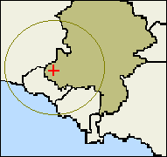(1)
(1)
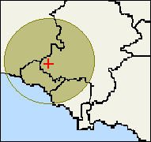(2)

Key Indicators

Cash Points

Over 65% of rural households in the South West live within 4km of a cash point (compared with 72% in Kerrier and Penwith and 79.3% nationally). The distribution of cash points is closely related to the distribution of banks and building societies. However, there is some evidence that the spread of cash points into alternative premises is beginning to benefit rural households. In virtually all regions, the proportion of households within 2km of a service is slightly higher for cash points than for banks and building societies, implying a broader dispersion across the rural parts of each region. Cash is also increasingly available through ‘cashback’ facilities in local food stores and similar outlets.

Figure 4.1 : Percent of Households more than 4km from a Cash Point, 2000

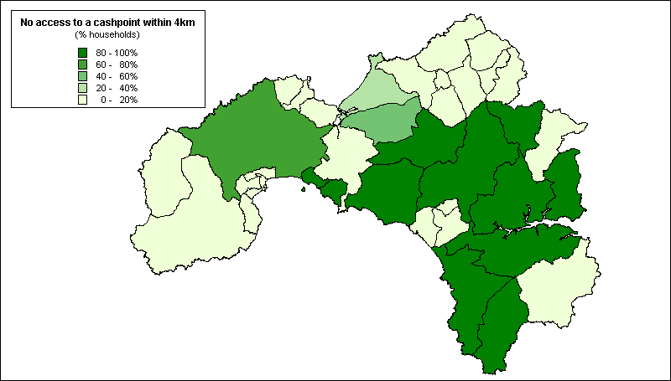
Source: 2000 Rural Services Survey

Banks and Building Societies
Over 81% of rural households in the South West live within 4km of a bank or building society, compared with 82.4% in Kerrier and Penwith. Banks and building societies are strongly concentrated in market towns within rural areas and very few parishes with small populations contain any of these facilities. It is only in the largest parishes, with populations above 3,000, that a significant proportion contain any banks or building society branches (Countryside Agency, 2001).

Figure 4.2: Percent of Households more than 4km from a Bank or Building Society, 2000

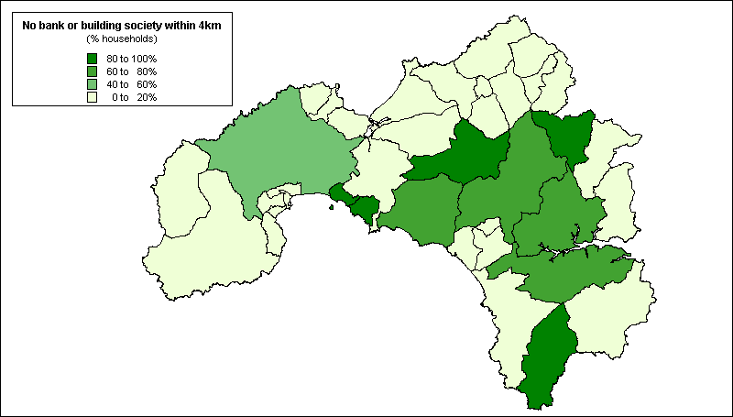
Source: 2000 Rural Services Survey

Many poorer households have restricted access to these and similar financial services, including some of the most basic financial services such as a current bank account and home contents insurance. Analysis of the 1995/6 Family Resources Survey shows that around 20% of UK households do not have a current bank or building society account (Kempson, 1994), and a similar proportion do not have home contents insurance (Whyley et al, 1998). Around three out of 10 UK households have no savings at all (Kempson and Whyley, 1999).

Unfortunately, since such questions are not contained within the Census, there is no nationwide evidence based upon 100% population coverage. However, the consequences of exclusion from financial services for households’ day-to-day money management, for example, in relation to bill payment, are more amenable to analysis. Payment of household bills now relies heavily upon access to a bank or building society account. People without these facilities settle bills in cash at Post Offices and time-consuming, pay-as-you-go methods such as pre-payment meters – in the process incurring higher fuel tariffs and additional transaction charges (Whyley and Kempson, 1998).

Figure 4.3 (below) illustrates the ward-level distribution of households with pre-payment electricity meters in west Cornwall. As this map shows, pre-payment customers are mainly concentrated in the Camborne, Pool and Redruth area, as well as around Penzance. North Kerrier as a whole and the St Just area also contain above average concentrations of pre-payment customers. Comparing this distribution with the cumulative index of deprivation derived from the 1991 Census (Figure 2.25), shows a reasonably close ‘fit’ with the pattern of deprivation in West Cornwall - again confirming that most pre-payment customers pay bills in this way due to lack of money rather than through choice.

Figure 4.3: Households in Kerrier and Penwith with Pre-payment
Electricity Meters (%), 1998

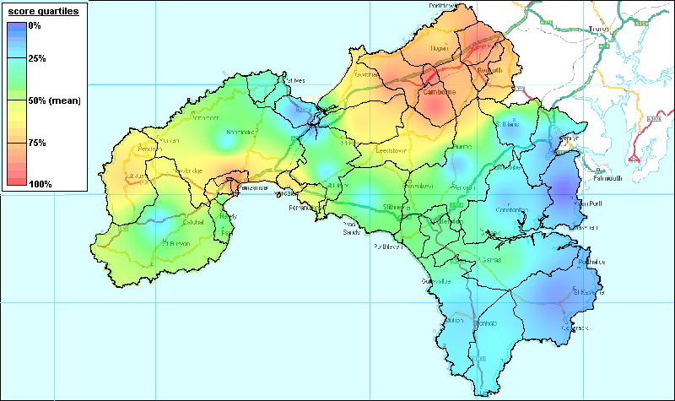

Post Offices
Nearly 94% of rural households in the South West live within 2km of a Post Office compared with 96.4% in Kerrier and Penwith as a whole. Nationally, numbers of these outlets in rural areas continue to decline - 58% of parishes had a Post Office in 1991 compared to 54% in 2000 (Countryside Agency, 2001). In Kerrier and Penwith, 83.8% of rural parishes had a Post Office in 2000.

Figure 4.3: Percent of Households more than 2km from a Post Office, 2000

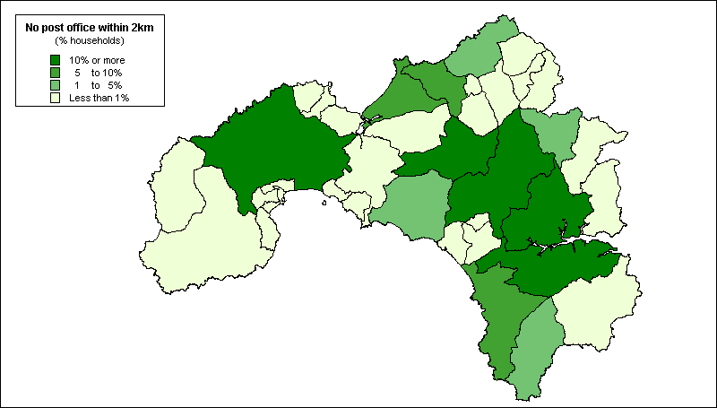
Source: 2000 Rural Services Survey

Primary Schools
Over 91% of rural households in the South West live within 2km of a primary school compared with 95.4% in Kerrier and Penwith as a whole. Although some schools in remoter areas have closed, the total number of schools shows a slight increase for 2000. Nationally, 52% of parishes have a primary school in 2001 (compared with 47% in 1991) and, in Kerrier in Penwith, 78.4% of rural parishes had a primary school in 2000. This is probably the result of more comprehensive data sourced from DfEE (Countryside Agency, 2001).

Figure 4.4: Percent of Households more than 2km from a Primary School, 2000

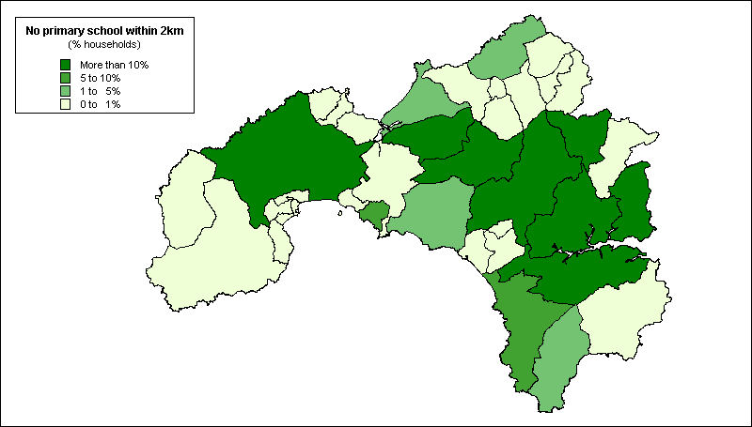
Source: 2000 Rural Services Survey

Secondary Schools
In the South West, 78.2% of households live within 4km of a secondary school compared with 77.8% in Kerrier and Penwith as a whole. Secondary schools are a strategic service and are centrally sited in relation to the catchment area at the time they were built. Of the rural parishes in Kerrier and Penwith, 16.2% had a secondary school in 2000.

Figure 4.5: Percent of Households more than 4km from a Secondary School, 2000

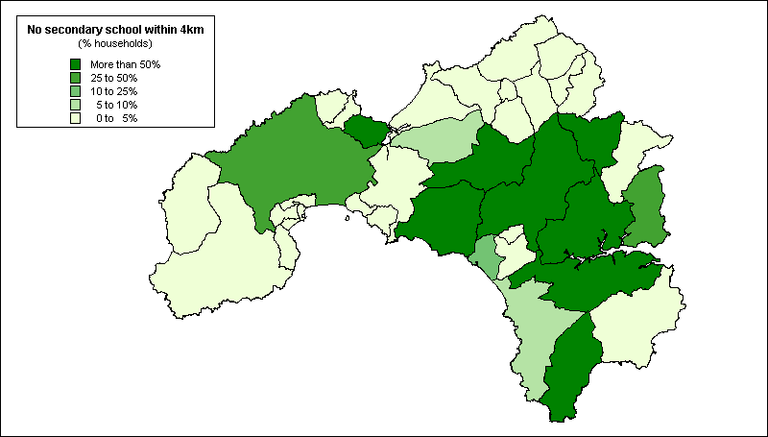
Source: 2000 Rural Services Survey

GP’s Surgeries
In the South West, 67.5% of households lived within 2km of a GP’s surgery in 2001 compared with 88.9% in Kerrier and Penwith as a whole. Doctors’ branch surgeries were held in 37.8% of the rural parishes in Kerrier and Penwith. As Figure 4.6 shows, most residents in rural areas depend on primary health care located in predominantly urban service centres and very few settlements with less than 1,000 residents contain branch surgeries.

Figure 4.6: Percent of Households more than 2km from a GP’s Surgery, 2000

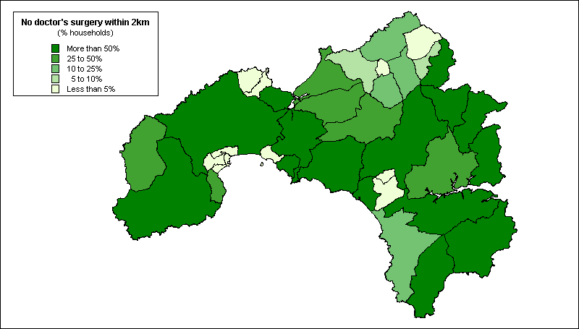
Source: 2000 Rural Services Survey

The 2000 Parish Survey

Introduction

The 2000 RSS also used a rural parish questionnaire to record data on services where information is not currently available on a postcoded basis. This helped us to establish broad trends but the degree of error from this process must be acknowledged. For a variety of reasons, the response rate in the 2000 RSS (67%) was less than ideal and varied considerably by region with a response rate of 75% in Cornwall as a whole. Moreover, since these data are not based upon distance bandings in some areas of a parish access may remain a problem even where community services and facilites exist.

Using this approach, it was possible to map the provision of the following services at a parish level in Kerrier and Penwith:

- General stores
- Petrol filling stations
- Public houses
- Public transport provision
- Village halls and community centres
- Community internet
- Youth clubs

The results of these analyses are presented below. Appendix IV outlines the key services that people need to access regularly for each of the Priority Areas within Kerrier and Penwith (see Chapter Two).

Figure 4.7 illustrates the broad distribution of a range of other community services across the rural parishes of Kerrier and Penwith. A majority of rural parishes in the region responding to the Parish Survey contained at least one pub (92%), Post Office (84%), village hall (76%) and general store (59%). Daily bus services operated in most (70%) of the rural parishes of Kerrier and Penwith responding to the Parish Survey and, in most of the others, services ran Monday to Saturday.

Figure 4.7: Absence of Local Services in Kerrier and Penwith
by Parish, 2000 (%)

Source: 2000 Parish Survey (2000 RSS)

However, as Figure 4.7 shows, in only about half (51%) of parishes responding to the Parish Survey was a community transport scheme available (including dial-a-ride, a community minibus or taxi, or other community transport facility). Similarly, less than half the rural parishes in Kerrier and Penwith responding to the Parish Survey had a village shop (46%) or doctor’s surgery (38%). Less than a quarter (24%) had any kind of community Internet facility.

General Stores

Nationally, 71% of rural parishes have no village shop compared with 54% of the rural parishes responding to the Parish Survey in Kerrier and Penwith. Figure 4.8 illustrates their distribution across the region.

Figure 4.8: Number of General Stores in Kerrier and Penwith by Parish,
2000 (excluding village shops)

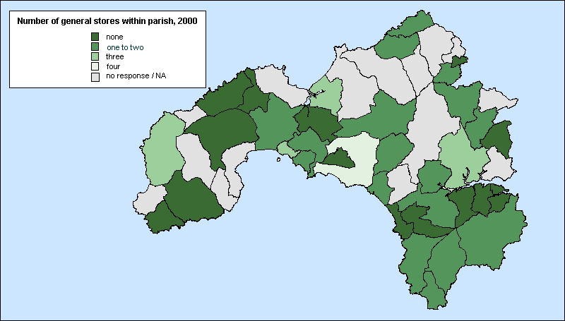
Source: 2000 Parish Survey (2000 RSS)

Petrol Filling Stations

In the South West as a whole, 71.2% of rural households live within 2km of a petrol station and 89.3% within 4km. However, petrol stations are not only a local service so location on main transport routes or the proximity of larger population bases is generally more important than proximity to smaller rural settlements or parishes. Nationally, 81% of rural parishes have no filling stations and, in Kerrier and Penwith, 67% of rural parishes, especially the less populous ones, have no filling station.

Public Houses

For many small rural communities, pubs often provide an important place to meet, especially where there is no village hall. Nationally, 75% of rural parishes responding to the Parish Survey have at least one pub, compared with 92% in Kerrier and Penwith. Their distribution within the region is illustrated in Figure 4.9.

The difference between West Cornwall and national estimates may partly be explained by the income generated by tourism for pubs and inns in Cornwall. However, most Rural Community Councils report a continuing decline in numbers of rural pubs. Smaller villages and more remote or isolated settlements are reported as more likely to experience pub closures than those attractive to tourists, larger village centres and pubs on main roads (Moseley and Chater, 2000).

Figure 4.9: Number of Public Houses in Kerrier and Penwith by Parish, 2000

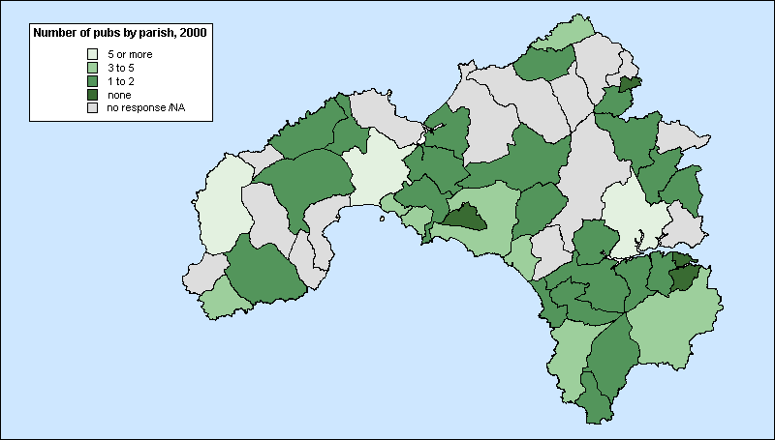
Source: 2000 Parish Survey (2000 RSS)

Public Transport Provision

Both public and ‘community’ transport services are important for increasing people’s mobility to access services and facilities in other locations. Nationally, only 35% of rural parishes responding to the Parish Survey reported the existence of a daily bus service (including Sundays) compared with 70% in Kerrier and Penwith. The distribution of public bus services is illustrated below.

Figure 4.10: Frequency of Public Bus Services in Kerrier and Penwith
by Parish, 2000

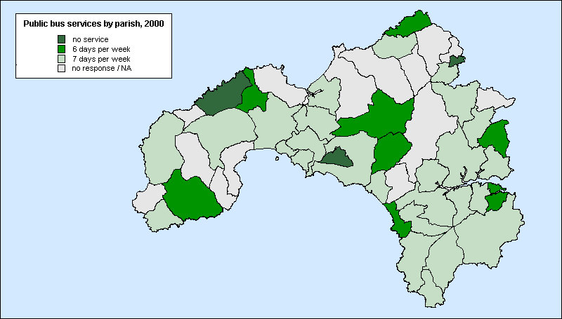
Source: 2000 Parish Survey (2000 RSS)

In addition to scheduled bus routes, community-level provision is now a key contributor to people’s mobility for residents in Kerrier and Penwith. Over half (51%) the rural parishes in the region responding to the Parish Survey benefit from access to a community-run vehicle for a wide range of journey purposes – an almost identical figure to national estimates (48%) (Countryside Agency, 2001).

Village Halls and Community Centres

A key part of the infrastructure for much local voluntary activity is an adequate community centre – both as a place for meeting and to host activities. Rural communities will generally not have the access to the range of public buildings which voluntary groups in some urban areas have but depend rather upon the existence of a village or church hall or other community centre.

There has been an increase in the availability of village halls since 1991 when only 70% of rural parishes nationally had one, partly as a result of Millennium funding. In Kerrier and Penwith, 76% of rural parishes responding to the Parish Survey have a village hall compared with 85% nationally. Their distribution is illustrated below.

Figure 4.11: Number of Village Halls in Kerrier and Penwith by Parish, 2000

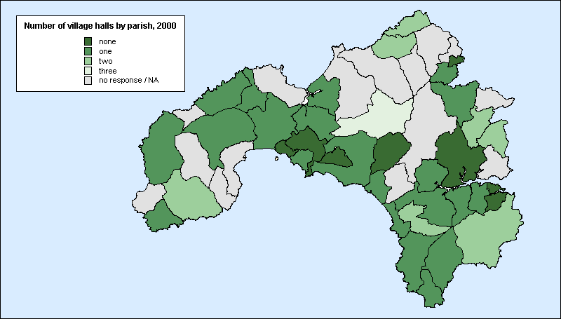
Source: 2000 Parish Survey (2000 RSS)

Community Internet

In Kerrier and Penwith, 24% of rural parishes responding to the Parish Survey had a community Internet facility in 2000 compared with just 9% of rural parishes nationally, as Figure 4.12, below, shows.

Figure 4.12: Community Internet Facilities in Kerrier and Penwith by Parish, 2000

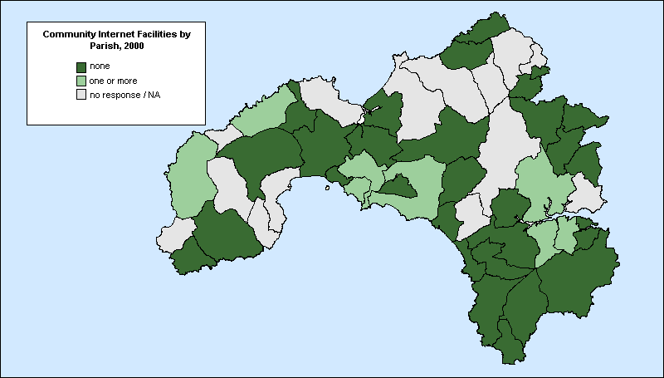
Source: 2000 Parish Survey (2000 RSS)

Youth Clubs

Twenty-four percent of rural parishes in Kerrier and Penwith responding to the Parish Survey had no youth clubs in 2000 compared with 49% nationally, as Figure 4.13, below, shows.

Figure 4.13: Number of Youth Clubs in Kerrier and Penwith by Parish, 2000

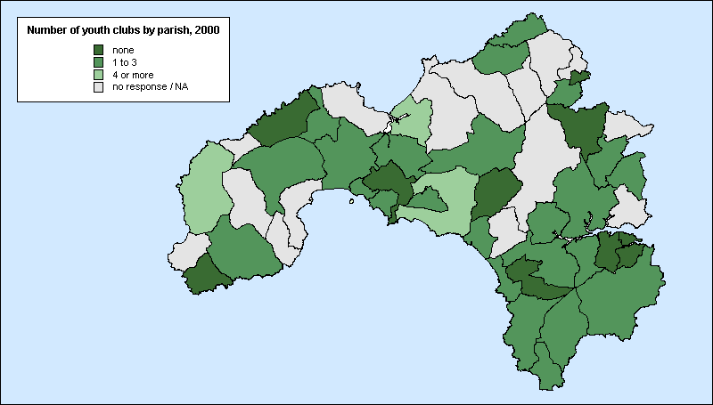
Source: 2000 Parish Survey (2000 RSS)

Conclusion

It must be acknowledged that, whilst Cornwall performs well in comparison with other rural areas, this does not imply that the quality of local services is always adequate in meeting local needs. The consultation exercise outlined above (Chapter Three) identified significant gaps in local service provision (eg in relation to local public transport provision), as well as a need for the modernisation of many community facilities (eg village and community halls). Moreover, not only is the provision of local services in West Cornwall insufficient in meeting the perceived needs of local people - and especially of disadvantaged groups - but the accessibility of services is an especially salient issue for those without access to a car – especially when compared to urban areas. The analyses presented above illustrate patterns of access at a specified radius (usually 2 or 4km). Whilst the presence of local services within these radii is often adequate for many people in urban areas (though not for the most income deprived) due to the availability of public transport, in more remote areas even at such distances access remains problematic for many people (eg. children, older people, disabled people).

REGENERATION AND COMMUNITY FUNDING

In addition to surveying the level and distribution of community services in West Cornwall it is also important to consider the flow of grant aid in West Cornwall since these constitute a key resource for local communities and a significant lever in neighbourhood regeneration. The following section outlines the various area based regeneration initiatives and other sources of community funding currently available in the UK, and their allocation in West Cornwall.

Area-Based Regeneration Initiatives
Objective One
Objective One is one of three programmes set up to help reduce differences in social and economic conditions within the European Union. Objective One is the highest priority designation for European aid and is targeted at areas where prosperity, as measured by GDP per capita, is 75% or less than the European average. In July 1999, Cornwall and Scilly were designated as an Objective One area under the new Structural Fund Regulations covering the period 2000-2006. In total, £314m will be available between the years 2000 and 2006 from all four structural funds (ERDF, EAGGF, ESF and FIFG).

http://www.objectiveone.com

Objective Two
Objective Two is an EU-funded support measure under the European Regional Development Fund and the European Social Fund. The new Objective Two combines the previous Two and Five(b) programmes and is designed for areas of urban, industrial, fishing and rural decline. Because the Objective Two area now includes much of the previous rural Objective Five(b) areas, there is scope for rural (not agricultural) projects to receive funding from Objective Two. Plymouth, South Hams, West Devon, Torridge, North Devon, West Somerset, part of Torbay and part of Bristol have been successful in obtaining Objective Two status. A population coverage of 585,000 has been achieved with £108m being available over the programme period. Transitional funding will also be available for those areas previously in receipt of structural funds but outside the new programme. Parts of Plymouth, Torbay, West Somerset and Mid-Devon - a population of 130,000 - will qualify and £10m will be available in these areas. Monies for Objective Two and Transitional areas will be available from ERDF and ESF.

LEADER+
LEADER+ is a six year European Community initiative for assisting rural communities in improving the quality of life and economic prosperity in their local area. Partnerships of local organisations and people receive funds to identify development needs within their rural communities which they set out in a development plan and to develop and test small-scale, innovative pilot projects to meet these development needs in a sustainable way.

http://www.defra.gov.uk/erdp/leader/leaderhome.htm

INTERREG III
INTERREG III is a Community Initiative designed to promote trans-national co-operation in spatial planning, in order to create balanced development and integration of the European territory, focusing especially on border areas within Europe. The South West falls within the Atlantic Arc and North West Metropolitan areas. There is the potential for significant complementarity between the schemes in terms of networking and information dissemination, with INTERREG bringing forward potential projects which could be pursued with LEADER+ funding.

EQUAL
EQUAL is a European Social Fund initiative that aims to combat all forms of discrimination and inequality in the labour market. The aims of EQUAL are complementary to LEADER+, particularly in promoting access to opportunities for the regional target groups of women, young people and the older working population.

England Rural Development Plan
The England Rural Development Plan encompasses schemes funded under the Common Agricultural Policy. It aims to refocus agricultural support to wider rural development. Several of the measures are extensions of existing funding programmes such as Countryside Stewardship, Environmentally Sensitive Areas, Organic Farming Scheme, Woodland Grant Schemes, Farm Woodland Premium Scheme and Hill Farm Allowance Scheme. The Plan also includes project-based rural development measures including the Rural Enterprise Scheme, Processing and Marketing Grant Scheme and Vocational Training Scheme.

http://www.defra.gov.uk/erdp/docs/erdpdocsindex.htm

County Rural Development Programme
County Rural Development Programmes are integrated programmes of social and economic projects developed by local cross sector partnerships to address the priorities identified in the Rural Development Programme Strategies. There is a partnership in each of the six Shire Counties in the South West region with strategic direction given to the process by elected member-led committees.

http://www.cornwallenterprise.co.uk/

Single Regeneration Budget
The Single Regeneration Budget aims to support area-based regeneration initiatives driven by local partnerships. Throughout the South West Region, £31 million has been won from the Government’s Single Regeneration Budget. This aims to safeguard or create 2000 jobs and provide training and development opportunities for 37,000 people. A Single Regeneration Budget round six has been announced for the coming year. However, it is likely that this will be the last round of funding.

Coastal and Market Towns Initiative
This is a new joint initiative launched by the Countryside Agency and South West Regional Development Agency to provide funding to aid capacity building in and around market and coastal towns in the South West region. The scheme is currently under discussion and is being developed. A national pilot has been undertaken in another region of the UK and nine towns in the South West, including Helston, are currently participating in the scheme. In Helston, a Community Strategic Plan is being developed to include the list of priority projects highlighted at the Community Event held at RNAS Culdrose in summer 2001. A proposal bid totalling £200,000 over 3 years is currently under consideration.

http://www.southwestrda.org.uk/development/market_towns.shtml

Countryside Agency’s Land Management Initiative
This initiative aims to demonstrate how managing land to achieve a healthy and attractive economy can be achieved, while maintaining or improving the viability of farming businesses and enhancing the economic and social prospects of rural areas through practical solutions to local issues. Potentially, the South West has two of the initial 12 schemes; the South West Forest on the Cornwall/Devon border, and the Severn Vale on the Gloucestershire/Herefordshire/Worcestershire border (shared with Government Office for the West Midlands). The South West Forest is already operating, however, the Severn Vale has yet to start.

Existing funding streams are used to implement ideas where they exist, including Structural Funds and project-based schemes under England Rural Development Plan, Regional Development Agency funding streams, etc. Countryside Agency experimental funding will be required for novel, untested solutions. LEADER+ could therefore complement by concentrating on rural development which is not land-based within Land Management Initiative’s remit or by supporting solutions beyond the funding capacity of the Land Management Initiative.

Health Action Zones
Health Action Zones (HAZs) are a new way of tackling health inequalities which link health with regeneration, employment, education, housing and anti-poverty initiatives in order to respond to the needs of vulnerable groups and deprived communities. The HAZ initiative brings together organisations within and beyond the NHS (eg Local Authorities, the voluntary and private sectors, local communities) to develop and implement locally agreed strategies for improving the health of local people. A central aim for HAZs is integrating the services and approaches they are developing into mainstream activity.

Altogether, more than £274 million has been made available to assist HAZs in the three years from April 1999. The 26 HAZs are located in some of the most deprived areas in England, including inner cities, rural areas and ex-coalfield communities. Cornwall and the Isles of Scilly were awarded HAZ status in May 1999. The HAZ has set out a seven year programme of change with funding totalling £3.6 million. This enables services to be reshaped in order to better address the problems caused by rural deprivation and isolation.

http://www.doh.gov.uk/pricare/haz.htm

Employment Action Zones
Employment Action Zones are designed to help long term unemployed in areas of concentrated or multiple deprivation to improve their employability with a view to obtaining sustained employment or self employment and began operating from April 2000.

Education Action Zones
Education Action Zones (EAZs) allow local partnerships to develop new and imaginative approaches to raising standards in disadvantaged urban and rural areas. Each EAZ includes a cluster of two to three secondary schools with their supporting primaries and special schools working in partnership with LEAs, parents, business and other representatives from the local community. There are now 73 large EAZs throughout the country. Each EAZ receives up to £750,000 funding per year from the DfES and in return they are required to raise £250,000 per year from the private sector.

The Cornwall EAZ, CPR Success Zone, was established in May 2000 and covers three secondary schools and 27 primary schools in the North Kerrier area. CPR Success Zone receives £500,000 per annum for the next three years with an additional £250,000 per annum dependant upon private sector support.

http://www.standards.dfee.gov.uk/eaz/

Sports Action Zones
Sport Action Zones, initiated under the direction of Sports England, aim at encouraging co-operation between schools, sports clubs and other voluntary groups in deprived areas in order to improve sporting and recreational opportunities. Funding is mainly revenue-based, focusing around sports and community development officers, coaches and sports leaders and other outreach workers. Cornwall was among the first 12 Sports Action Zones to be announced.

http://www.sportactionzone.org.uk/
Sources of Community Funding

The Community Fund
Since its launch in 1995, the National Lottery (now The Community Fund) has become a principal focus for community grant support to charitable, benevolent and philanthropic organisations in England and Wales, granting more than £1.5 billion to over 30,000 groups (NLCB Annual Report, 1999-2000). Community groups in Kerrier and Penwith have received more than £8.6 million in National Lottery funding between 1995 and 2001. During this period, 82,400 funding applications were received by the NLCB, of which 30,023 (ie 36%) were successful. More than 650 applications for National Lottery funding have been submitted by local groups in Kerrier and Penwith alone - with a success rate of 39%.

http://www.community-fund.org.uk

New Opportunities Fund
The New Opportunities Fund is National Lottery funding awarding grants to health, education and environment projects throughout the UK. Grant programmes focus particularly on the most disadvantaged sections of society. In total, the constituencies of St Ives and Camborne and Falmouth received over £3 million from the New Opportunities Fund to January 2002.

http://www.nof.org.uk

Sport England
Provides financial support to local sporting organisations through Lottery-funded programmes, primarily for capital schemes over £5,000. There are additional Lottery funding streams due to come on line during 2001 which will include funding for green spaces, informal recreation areas and school playgrounds. In the 1999-2000 funding round, Cornwall secured £3.5 million from Sports England, of which Kerrier and Penwith received over £2.9 million (ie 83% of Cornwall’s grant allocation).

Since 1995, ‘Priority Areas’ have increase the level of Sports Lottery funding going to rural and inner city areas. Over 180 Local Authorities are defined as Priority Areas, along with all authorities in Rural Development Areas (including Kerrier and Penwith). Applicants from these areas benefit as they can apply for up to 90% of the total capital cost of any project. As a result, while 25% of the population live in Sport England’s ‘Priority Areas’, both urban and rural, they have received 57% by value of the local grants (National Lottery Yearbook, 1999).

http://www.nof.org.uk

Community Fund Spending in the South West

In the past, a range of problems have frustrated attempts to reliably map funding flows at a Local Authority level - not least an absence of consistent and standardised information from Local Authorities and, to a lesser extent, central Government. The most recent study by Coombes et al (2000), commissioned by The Community Fund, investigates the spatial distribution of funding directed at combating deprivation from the available, nationally comparable sources. In these terms, the South West as a whole is the third best funded region (per claimant) as Table 4.3 (below) shows:

Table 4.3: Community Funding in the UK by Region, 1998

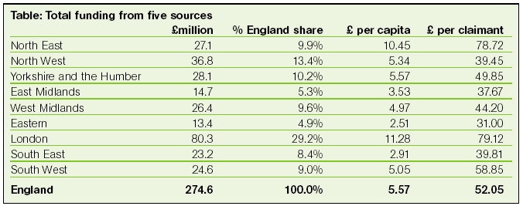
Source: Coombes et al (2000)

However, whilst there is some relationship between per capita funding and regions’ relative level of need at more local levels, the link between the degree of need and of funding is much less evident, as Figure 4.14 (below) shows.

Figure 4.14: Community Funding from Different Sources in the Southwest by County, 1998

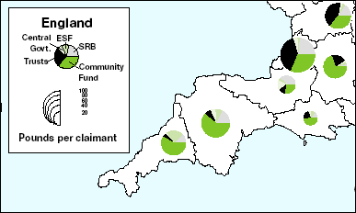
Source: Coombes et al., 2000

Many areas of high deprivation are especially dependent upon public sector funding. However, as Coombes et al (2000) reveals, this is less likely to be the case in rural areas. Nationally, the funding source whose distribution most closely matches the pattern of need (as measured by the Claimant Count) is The Community Fund.

One consequence is thus that The Community Fund is the most important source for parts of the country which tend to be over-looked by other funders, especially rural areas and the more southern regions including West Cornwall, as Figure 4.14 (above shows). Coombes et al (2000) shows that over half (55%) of all Community Fund spending was directed at combating deprivation in 1998 and this represented over one third (36%) of all funding for voluntary groups across England.

Community Fund grants are particularly important to rural areas, not least because other funders tend to focus on cities. The distribution of Community Fund spending in West Cornwall is illustrated in Figure 4.15 which shows that Community Fund spending is concentrated in the Penzance area, around Camborne and Pool and in the Lizard peninsula.

Figure 4.15: Community Fund spending in West Cornwall since 1995 by postal area

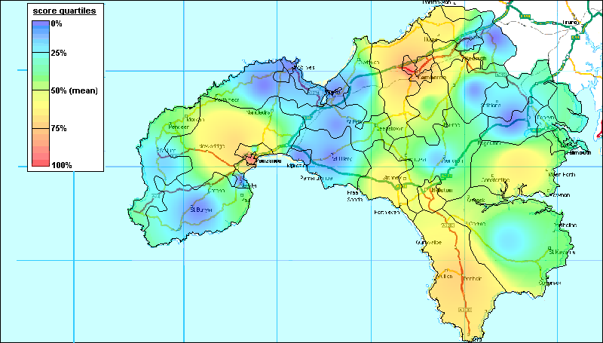
Source: The Community Fund

However, given the Community Fund’s stated focus on grant support to deprived areas, the ‘fit’ between Community Fund spending and deprivation in West Cornwall is not close. Many of the most deprived areas as identified at a sub-ward level using 1991 Census data (see Figure 2.25) have not benefited substantially from Community Fund spending. These areas include Redruth, Hayle and St Ives, St Just and Pendeen, Newlyn, Marazion, and parts of Helston.

COMMUNITY ORGANISATION

Introduction

Increasing participation in volunteering and community activity in poor neighbourhoods has been acknowledged as a key policy objective within the Government’s Active Communities Unit. Their report outlines a range of targets both for fostering community development generally and specifically in relation to widening community involvement in the voluntary and community sectors (ACU, 1999).

Encouraging the development of more active rural communities is also central to rural strategy envisioned within the Government’s rural white paper, Our Countryside: The future (DETR, 2000). Our Countryside emphasises the importance of sustained support for community initiatives in terms of community infrastructure (eg village halls), project funding and community development work. Underlying all these initiatives is an increased emphasis upon the vitality and cohesiveness of rural communities. One important indicator of community vibrancy in each of these policy documents is the extent of community involvement in voluntary sector organisations. The remainder of this chapter explores the level and distribution of voluntary sector organisation in Kerrier and Penwith.

Methodology

The relatively transient and unstructured nature of much voluntary community action poses a range of methodological challenges. Local groups frequently lie dormant, disestablish or change their form over time, in the process undermining the reliability of estimates of local community activity. Moreover, differences in the geographical coverage of voluntary groups make direct comparisons difficult – some groups cover vary small areas whilst others operate at a larger spatial scales such as Local Authorities or even counties.

For the above reasons, no listing of voluntary organisations will ever be entirely reliable. The findings presented in the following sections should therefore be treated as illustrative rather than presenting a definitive guide to voluntary organisation in West Cornwall and the conclusions presented here are therefore tentative.

Cornwall County Council’s CWIC database has been used as the main source of data on community organisation. All the records contained in the CWIC database are no more than 14 months out of date at the time of writing. There is no scientific way of reliably establishing the coverage of the CWIC database, although it is anticipated that this source will be validated by cross-reference to other existing sources of information.

In collaboration with colleagues at Camborne College, the research team classified all references in the database for Kerrier and Penwith Local Authority areas within the following typology of community organisation:
- Hobbies and crafts
- Environment and rural issues
- Sports and leisure
- Education, employment and skills
- Health and para-health
- Community advice and empowerment
- Youth, the aged, and ‘minority’ groups
- Faith-based organisations
- Other

In total, the CWIC database listed 1,185 voluntary and community organisations in Kerrier and Penwith – 562 in Kerrier and 623 in Penwith. Of these, 1,056 (89%) contained a postcode reference. It was thus possible to map the distribution of these community organisations in west Cornwall against postcode boundaries. Detailed below are the frequency and distribution of voluntary organisations in West Cornwall – as derived from this database.

Findings
Figure 4.16 below illustrates the distribution of voluntary organisations in West Cornwall across the categories listed above. Within this categorisation ‘Youth, the aged and other ‘minority’ groups’ accounts for the greatest proportion (19.5%) of total levels of voluntary organisation – though not necessarily the greatest total membership. This is a very diverse category including youth groups, mother and toddler groups, The Women’s Institute, British Legion groups and a host of other ‘demographically-based’ interest groups. ‘Hobby and craft’ pursuits are the second largest category, accounting for 17.6% of organisations within the sector.

Figure 4.16: Distribution of Voluntary and Community Organisations in Kerrier and Penwith, 2001 (%)
Source: Cornwall County Council CWIC database

In the absence of external validation and given the scale of measurement (postcode district) dictated by the data source, any conclusions about the geographical pattern of voluntary activity are necessarily tentative. However, overall, the spatial distribution of voluntary organisation in West Cornwall broadly reflects patterns of settlement, with voluntary groups being concentrated in the more populous areas, as Figure 4.17 below shows:

Figure 4.17: Voluntary and Community Organisations in Kerrier and Penwith, by Postcode Area, 2000

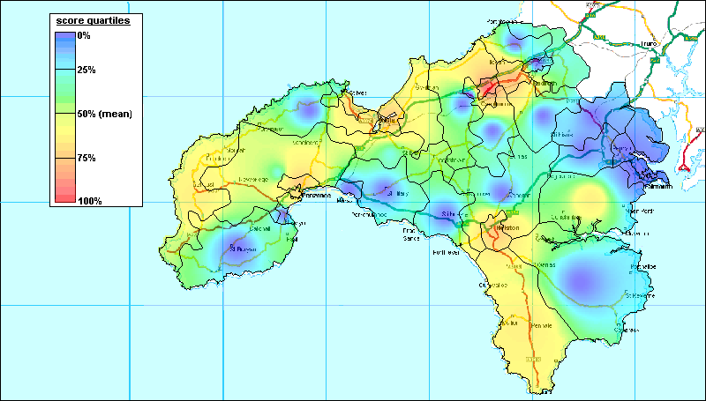
Source: Cornwall County Council CWIC database

Nonetheless, there are some interesting variations from this general pattern. In particular, the Lizard area appears to support a higher level of voluntary and community organisation than might be expected given its very low population density. Conversely, both St Ives and especially Newlyn show lower levels of community organisation than might be expected given their population densities. However, as was noted above, the geographical coverage of sampled organisations varies so low levels of community organisation in these areas are not necessarily indicative of low levels of community participation since residents may simply be travelling to surrounding neighbourhoods.

CHAPTER FIVE:

CONCLUSIONS AND POLICY OPTIONS

The purpose of this section is to illustrate some of the major conclusions and potential broad policy options that the LSP may wish to consider. This report is designed to help the LSP develop an evidence based strategy for neighbourhood renewal, within the framework prescribed by the Government. It is not appropriate to provide detailed anti-poverty advice in this report, however readers with an interest in these matters should refer to the University of Bristol’s previous report on Poverty and Deprivation in West Cornwall in the 1990s which contains extensive anti-poverty advice specific to the west Cornwall context (Payne et al, 1996).

The primary purpose of this report is to provide the Local Strategic Partnership (LSP) with the best scientific advice on the location of the poorest areas in west Cornwall at small area level e.g. using areas that are smaller than electoral wards. This required a considerable amount of new research work as no predominantly rural area in the country had previously successfully managed to do this within the neighbourhood renewal framework. Chapter two describes the statistical and geographical Information System (GIS) methods used to achieve the identification of priority areas and chapter three provides details of the consultations undertaken by the research team to validate and expand on the statistical analyses. An index of multiple deprivation was constructed at 1991 Census Enumeration District level using 7 indicators which both reflect the Government’s priorities for neighbourhood renewal and the situation in west Cornwall. The indicators used were;

- Poverty rate (Income)
- Child poverty rate (Supplementary)
- Unemployment rate (Employment)
- Percent of people aged 18 and over with no post school qualifications (Education)
- Limiting Long Term Illness/Disability rate (Health)
- Percent of households with no central heating (Housing)
- Percent of households with no car (Access to services)

A statistical GIS technique (Inverse Distance Weighting) was then applied to these data to identify priority areas with high concentrations of need. These priority areas are mainly concentrated in the Camborne, Pool, Redruth area, Penzance area, St Ives area, Hayle area, Newlyn area, Helston area, St Just area, Porthleven area, Hayle & Towans, Troon area and Pendeen areas (see Appendix II for details). However, there is also some evidence of priority need in the Lizard area

The stakeholder consultation found, with the exception of the Lizard area, that the neighbourhoods identified by respondents as deprived matched those which the statistical analyses also identified.

There was widespread agreement on the need to involving local people in neighbourhood renewal and ensuring that resources are focused on the most deprived neighbourhoods. Enthusiasm, commitment and energy for these tasks were very much in evidence. There was a resounding emphasis on the need for more resources to be focused on local and sustained community development, including youth work. Which should be supported by committed organisational structures which recognise the need for continued work over a period of years and can help the local community get its views heard and responded to at strategic level.

Chapter three and four also looked at the important issue of access to services particularly in the more rural areas. Although Cornwall has slightly greater service provision than other rural areas in England, this does not imply that the quality of local services is always adequate to meet local needs. The consultation exercise (Chapter Three) identified significant gaps in local service provision (eg in relation to local public transport provision), as well as a need for the modernisation of many community facilities (eg village and community halls).

Policy Options
Strong local communities have long been recognised as pivotal in defending the population against the effects of poverty. In the 1930s, Winifred Holtby identified local government as “in essence the first line of defense thrown up by the community against our common enemies - poverty, sickness, ignorance, isolation, mental derangement and social maladjustment.” It is a fundamental duty of policy makers, according to Professor Julian Le Grand, to “be more aware of the distributional consequences of all forms of public policy”.

The primary challenge for the LSP is to integrate the neighbourhood renewal strategy into a broader-based West Cornish anti-poverty strategy otherwise all that will be achieved is a disjointed set of specific initiatives. The Local Government Anti Poverty Unit argued in the 1990s that:

“The real challenge is to look at, and change as necessary, the whole of local authority activity, in direct relation to the needs of the community it is there to serve. With a focus on the community - both the individual and collective needs - it is logical to respond in an integrated (corporate) way and even more logical to, draw up strategies for action rather than responding in a piecemeal way.”

In 21st Century jargon, what is needed is a ‘joined-up’ strategy not ‘initative-itis’.

In order to have long term success, neighbourhood renewal must result in an improvement and increase in mainstream services to the priority areas. The NRF strategy must tackle the difficult problem of refocusing and changing mainstream services which are currently being delivered by a wide range of organisations. Neighbourhood renewal action should be integral to mainstream programmes. Many initiatives have been marginalised in the past and have therefore had only a limited success. Although this research did not focused in detail on the relationship of mainstream services to neighbourhood renewal, the consultation identified some difficulties on the part of some key mainstream services to undertake further involvement in partnerships in the face of pressing day-to-day demands. These will need to be addressed at the highest level in these agencies.

Two fundamentals are necessary as foundations for a successful strategy. Firstly, the budget process must be comprehensible to all stakeholders and the general public, to the extent that LSP members are able to evaluate actual and projected spending against community needs. Funding mechanisms need to be understandable if they are to be accessible. Secondly, sound research is essential to inform the targeting and resourcing process, starting with a deprivation profile of the local authority areas (Wheeler 1995). This report and the Poverty and Deprivation in West Cornwall in the 1990s (Payne et al, 1996) provide the LSP with the necessary deprivation profile of priority areas.

One option the LSP may wish to consider is to use NRF monies to mainly fund revenue expenditure in deprived neighbourhoods. Many of the other area-based anti-poverty funds available in West Cornwall are often mainly for capital projects. However, the effectiveness of a capital project can often be limited if revenue monies are not also available. It might be possible to produce an integrated anti-poverty neighbourhood strategy if NRF funds are spent primarily on people not buildings and money from other sources is used to fund necessary infrastructure work.

In the past, a lot of neighbourhood funding has been concentrated on large scale projects to the detriment of some of the most disadvantaged neighbourhoods which lacked strong community leadership. The LSP may wish to consider using some NRF funds specifically for smaller scale projects – not all communities want to try to manage a £250,000 project in the first instance.

The key challenge for the LSP is how to provide support for local people and groups so that they can become fully involved in neighbourhood renewal. In particular the neighbourhood renewal strategy will need to address how to support priority neighbourhoods which lack organised groups, how to support small neighbourhood groups and how to promote the involvement of the most marginalised and discriminated groups within communities. Community involvement in neighbourhood renewal needs to aim towards equal partnerships at all levels.

REFERENCES

Active Community Unit (1999) Report of the Policy Action Team on Community Self-Help. London: Social Exclusion Unit.
Alcock, P., Craig, C., Lawless, P., Pearson, S. and Robinson, D. (1998) Inclusive Regeneration: Local Authorities Corporate Strategies for Tackling Disadvantage. Sheffield Hallam University: CRESR.
Anastacio, J., Gidely, B., Hart, L., Keith, M., Mayo, M. and Kowarzik, U. (2000) Reflecting realities. Participants’ perspectives on integrated communities and sustainable development. Bristol: The Policy Press.
Arber, S. (1996) ‘Designing samples’ In: N. Gilbert (Ed) Researching Social Life. London: Sage Publications.
Audit Commission (2000) Another Country. Implementing dispersal under the Immigration and Asylum Act 1999. Abingdon: Audit Commission.
Baldwin, J. (1979) ‘Ecological and Areal Studies in Great Britain and the United States’ In: N. Morris and M. Tonry (Eds) Crime and Justice: An Annual Review of Research. Vol 1, Chicago: University of Chicago Press.
Baldwin, J. and Bottoms, A. (1976) The urban criminal : a study in Sheffield. London: Tavistock.
Barnes, J. and Lucas, H. (1975) Educational Priority. London: HMSO.
Bottoms, S. (1994) ‘Environmental Criminology’ In: M. Maguire, R. Morgan and R. Reiner (Eds) The Oxford Handbook of Criminology. London: Clarendon Press.
Boushel, M. (1996) Vulnerable Multiracial Families and Early Years Services: Concerns, Challenges and Opportunties, Children and Society 10: 305-316.
Boushel, M. (2000) What Kind of People are WE? ‘Race’, Anti-Racism and Social Welfare Research, British Journal of Social Work 30(1): 71-89.
Brent, J. (1997) ‘Community Without Unity’ In: P. Hoggett (Ed) Contested Communities. Experiences, struggles and policies. Bristol: The Policy Press.
Bruce, A., Gordon, D. and Kessell, J. (1995) Analysing Rural Poverty, Local Government Policy Making 22(1): 16-23.
Burns, D. and Taylor, M. (2000) Auditing Community Participation. Bristol: The Policy Press.
Burrows, R. and Rhodes, D. (1998) Unpopular places? Area disadvantage and the geography of misery in England. Bristol: The Policy Press.
Burton, P. (1993) Community Profiling. A guide to identifying local needs. Bristol: SAUS Publications.
Burton, P. and Taylor, M. (1991) The role and scope of the voluntary sector in Avon. Bristol: SAUS Publications.
Burton, R. (1997) ‘A passion to exist: cultural hegemony and the roots of Cornish identity’ In: P. Payton (Ed) Cornish Studies 5. Exeter: University of Exeter Press.
Cemlyn, S. (2000) Assimilation, control, mediation or advocacy? Social work dilemmas in providing anti-oppressive services for Traveller children and families, Child and Family Social Work 5: 327-341.
Chanan, G., Gilchrist, A. and West, A. (1999) Involving the Community. Single Regeneration Budget. London: Community Development Foundation.
Chandola, T., Lloyd, M., Noble, M., Wright, G. and Wigglesworth, R. (2000) Rural Deprivation: An analysis of the indices of deprivation 2000 for rural areas. Report to the Countryside Agency. Oxford: University of Oxford.
Coombes, M., Raybould, S. and Wong, C. (1992) Developing indicators to assess the potential for urban regeneration. London: HMSO.
Coombes, M., Alderman, N. and Raybould, S. (2000) Mapping Grants to Deprived Areas in England. Unpublished report for The Community Fund (University of Newcastle, Centre for Urban and Regional Studies).
Cornwall County Council & Cornwall Rural Community Council (1995) Rural Facilities Survey. CCP/CRCC: Truro.
Countryside Agency (2000a) The State of the Countryside, 2000. Wetherby: Countryside Agency.
Countryside Agency (2000b) The State of the Countryside, 2000 – Southwest Region. Wetherby: Countryside Agency.
Deacon, B. (1993) ‘And shall Trelawney die? The Cornish identity’ In: P. Payton (Ed) Cornwall Since The War. Redruth: Institute of Cornish Studies.
DETR (1998) Guidance on the Methodology for Multi-Modal Studies. London: DETR.
DETR (2000a) Indices of Deprivation 2000: Regeneration Research Summary 31. London: DETR.
DETR (2000b) National Strategy for Neighbourhood Renewal. Report of Policy Action Team 4: Neighbourhood Management London: The Stationery Office.
DoE (1994) Assessing the Impact of Urban Policy. Inner Cities Research Programme. London: HMSO.
Doy, E., Gilbert, D. and Maitland, L. (2001) Empowering young people in rural Suffolk. Home Office Findings 156. www.homeoffice.gov.uk/rds/pdfs/r156.pdf
Everitt, B. (1980) Cluster Analysis. London: Gower.
Ford, R., Mernagh, M. and Adamau, M. (1995) 1994 Survey of Rural Services. Salisbury: Rural Development Commission.
Garvie, D. (2001) Far from home. The housing of asylum seekers in private rented accommodation. London: Shelter.
Glennester, H., Lupton, R., Noden, P. and Power, A. (1999) Poverty, Social Exclusion and Neighbourhood: Studying the area bases of social exclusion. Centre for Analysis of Social Exclusion Occasional Paper 22, London: LSE.
Gordon, D. (1995) Census Based Deprivation Indices: Their Weighting and Validation, Journal of Epidemiology and Community Health 49 (Suppl 2): 39-44.
Gordon, D. and Forrest, R. (1995) People and Places Volume II: Social and Economic Distinctions in England - A 1991 Census Atlas. Bristol: SAUS and the Statistical Monitoring Unit.
Gordon, D. and Loughran, F. (1997) Child Poverty and Needs Based Budget Allocation, Research, Policy and Planning 15(3): 28-38.
Hague, G. and Malos, E. (1993) Domestic Violence. Action for Change. Cheltenham: New Clarion Press.
Henderson, P. (1995) Children and Communities. London: Pluto.
Hirshfield, A. and Bowers, K. (1996) The Geography of Crime and Disadvantage: An English Case Study, Paper presented at the 5th International Seminar on Environmental Criminology and Crime Analysis, Tokyo, Japan, 1st-3rd July.
Hoggett, P. (Ed) (1997) Contested communities. Experiences, struggles, policies. Bristol: The Policy Press.
Home Office (1994) Housing, Community and Crime: The impact of the priority estates project. Home Office Research Study 131.
Home Office (2000) Recorded Crime Statistics: England and Wales. London: Home Office.
Hope, T. (1986) Council Tenants and Crime. Home Office Research Bulletin (21): 46-51.
Hope, T. and Hough, M. (1998) ‘Area, crime and incivility: a profile from the British Crime Survey’ In: T. Hope and M. Shaw (Eds) Communities and Crime Reduction, Home Office Research and Planning Unit, London: The Stationery Office.
Hough, M. and Mayhew, P. (1983) The British Crime Survey, First Report, London: Home Office Research and Planning Unit.
Jay, E. (1992) ‘Keep them in Birmingham’. Challenging racism in south-west England. London: Commission for Racial Equality.
John Herington Associates (2001) Kerrier District Council Housing Needs Survey Final Report. Loughborough: John Herington Associates.
JRF (1998) Including young people in urban renegeration. JRF: York (www.jrf.orf.uk/knowledge/findings/housing/hr918.asp)
Joseph Rowntree Foundation (1999) Evaluation of the National User Involvement Project. JRF: York (www.jrf.org.uk/knowledge/findings/socialcare/scr129.htm)
JRF (Joseph Rowntree Foundation) (2000a) Community participants’ perspectives on involvement in area regeneration programmes. JRF: York (www.jrf.orf.uk/knowledge/findings/housing/770.asp)
JRF (2000b) Challenging images: housing estates, stigma and regeneration. JRF: York (www.jrf.orf.uk/knowledge/findings/housing/020.asp)
JRF (2000c) Strengthening community leaders in area regeneration. JRF: York (www.jrf.orf.uk/knowledge/findings/housing/720.asp)
JRF (2000d) Tackling social exclusion at local level. JRF: York (www.jrf.orf.uk/knowledge/findings/foundations/310.asp)
Kain, R. and Ravenhill, W. (Eds) (1999) A Historical Atlas of South-west England. Exeter: University of Exeter Press.
Katz, I. (1996) The Construction of Racial Identity in Children of Mixed Parentage. Mixed Metaphors. London: Jessica Kingsley Publishers.
Kempson, E. (1994) Outside the Banking System: A review of households without a current account. London: HMSO.
Kempson, E., and Whyley, C. (1999) The Extent and Nature of Financial Exclusion. Working Paper 1, Bristol: Personal Finance Research Centre, University of Bristol.
Kenrick, D. and Clark, C. (1999) Moving On. The Gypsies and Travellers of Britain. Hatfield: University of Hertfordshire Press.
Kinsey, R. and Young Lea (1986) Losing the fight against crime. Oxford: Blackwell.
Kleinman, M. (1998) Include Me Out? The New Politics of Poverty and Place. Centre for Analysis of Social Exclusion Occasional Paper 11. London: LSE.
Lee, P., Murie, A. and Gordon, D. (1995) Area Measures of Deprivation. A study of Current Methods and Best Practices in Identification of Poor Areas in Great Britain. University of Birmingham: Birmingham.
Lievesley, R. and Maynard (1992) Survey of Rural Services, Rural Development Commission, London.
Mayhew, P. and Maung, N. (1992) Surveying Crime: Findings from the 1992 British Crime Survey, Home Office Research and Statistics Department, Research Findings No.2. London: HMSO.
Mayo, M. (1994) Communities and Caring: the mixed economy of welfare. Basingstoke: Macmillan.
Mayo, M. (1994) ‘Community Work’ In: C. Hanvey and T. Philpot (Eds) Practising Social Work. London: Routledge.
Mayo, M. (1997) Partnerships for regeneration and community development, Critical Social Policy 17(3): 3-26.
McLaughlin, B. (1986) The Rhetoric and the Reality of Rural Disadvantage. Journal of Rural Studies 2: 291-307.
Mirrlees-Black, C., Budd, T., Partridge, S. and Mayhew, P. (1998) The 1998 British Crime Survey, Issue 21/98, London: Home Office Research, Development and Statistics Directorate.
Morris, R. (1999) The invisibility of Gypsies and other Travellers, Journal of Social Welfare and Family Law 21(4): 397-404.
Morris, R. and Clements, L.(Eds) (1999) Gaining Ground: Law Reform for Gypsies and Travellers. Hatfield: University of Hertfordshire Press.
Morris, T (1958) The criminal area : a study in social ecology. London : Routledge and Kegan Paul.
Moseley, M. and Chater, C. (2000) Rural services and social housing 1999-2000: The evidence of the Rural Community Councils. London: Countryside Agency.
Neighbourhood Initiatives (2001) Practical tools for community action (www.nif.co.uk)
Payton, P. (1993) ‘Contemporary Cornwall: A Suitable Case for Treatment?’ In: P. Payton (Ed) Cornwall Since The War. Redruth: Institute of Cornish Studies.
Penwith Community Development Trust (2001) Research Project for the Disadvantaged Groups within the Penwith Community. Penzanze: Penwith Community Development Trust.
Penwith Housing Association (1999) ESF Capacity Building Project.Action Research Phase. Research Report. September 1999. Torquay: New Directions.
Piachaud, D. (1998) The Prospects for Poverty. New Economy, March 1998.
Pantazis, C. and Gordon, D. (1997) ‘Poverty and Crime’ In: D. Gordon and C. Pantazis (Eds) Breadline Britain in the 1990s. Aldershot: Ashgate.
Payne, S., Henson, B., Gordon, D. and Forrest, R. (1996) Poverty and Deprivation in West Cornwall in the 1990s. A Report to the West Cornwall Initiative. Bristol: Statistical Monitoring Unit.
Polk, K. (1957) Juvenile Delinquency and Social Areas, Social Problems 5: 214-17.
Popple, K. (1995) Analysing Community Work: its theory and practice. Buckingham: Open University Press.
Robinson, W. (1950) Ecological Correlations and the Behaviour of Individuals, American Sociological Review 15: 351-7.
Robson, B., Bradford, M. and Tye, R. (1995) 1991 Deprivation Index: A review of approaches and a matrix of results. London: HMSO.
Robson, B., Bradford, M. and Tomlinson, R. (1998) Updating and Revising the Index of Local Deprivation. DETR Regeneration Research Series. London: HMSO.
Saunders, J. (1998) Weighted Census-based deprivation indices: their use in small areas. Journal of Public Health Medicine 20(3): 253-260.
SEU (1998) Bringing Britain Together: A national strategy for neighbourhood renewal. London: The Stationery Office.
SEU (2000a) National Strategy for Neighbourhood Renewal: A framework for Consultation. London: The Stationery Office.
SEU (2000b) Report of Policy Action Team 12: Young People London: The Stationery Office (www.cabinet-office.gov.uk/seu/2000/pat12/contents.htm)
SEU (2000c) Minority Ethnic Issues in Neighbourhood Renewal London: Social Exclusion Unit.
SEU (2001a) A New Commitment to Neighbourhood Renewal. London: The Stationery Office.
SEU (2001b) National Strategy for Neighbourhood Renewal: Policy Action Team audit. London: The Stationery Office.
Shucksmith, M., Roberts, D., Scott, D., Chapman, P. and Conway, E. (1996) Disadvantage in Rural Areas. Research Report 29. London: RDC.
Simpson, L. (1995) The Department of the Environment’s Index of Local Conditions: Don’t Touch It. Radical Statistics 61: 13-25.
Simpson, L. (1996) Resource Allocation Using Measures of Relative Social Need in Geographic Areas: The Relevance of the Signed Chi-Squared, the Percentage, and the Raw Counts. Environment and Planning A, 29.
Speak, S. (2000) Children in urban regeneration: foundations for sustainable participation. Community Development Journal 35(1): 31-40.
Taylor, M. (1994) Signposts to Community Development. London: Community Development Foundation.
Thompsett, C. (2001) The Rebirth of a Community. Unpublished research report available via email from: hazel.stuteley@cornwall.nhs.uk
Thomas, P. and Campbell, S. (1992) Housing Gypsies. Cardiff: University of Wales.
Townsend, P. (1979) Poverty in the United Kingdom. London: Penguin.
Wallis, C, and Maliphant, R. (1967), Delinquent Areas in the County of London: Ecological Factors, British Journal of Criminology 7: 250-284.
Wheeler, R. (1995) Implementing Local Government Strategies, LGAPU, London.
Whyley, C. and Kempson, E. (1998) Frequent Payers and Pre-payment Meter Customers in a Competitive Gas Market. London: Gas Consumers Council.
Whyley, C., McCormick, J. and Kempson, E. (1998) Paying for Peace of Mind: Access to home contents insurance for low-income households. London: Policy Studies Institute.
Williams, M. (1993) ‘Housing the Cornish’ In: P. Payton (Ed) Cornwall Since The War. Redruth: Institute of Cornish Studies, 157-180.
Williams, M. and Champion, T. (1998) ‘Cornwall, poverty and in-migration’ In: P. Payton (Ed) Cornish Studies 6. Exeter: University of Exeter Press, 118-126.
Willie, C.V. (1967) The Relative Contribution of Family Status and Economic Status to Juvenile Delinquency, Social Problems 14: 326-35.

APPENDICES

APPENDIX I

I.1: THE REMIT OF THE POLICY ACTION TEAMS

Theme | Policy Action Team | Lead Dept.
GETTING PEOPLE TO WORK | 1: Jobs | DfEE
GETTING PEOPLE TO WORK | 2: Skills | DfEE
GETTING PEOPLE TO WORK | 3: Business | HMT
GETTING THE PLACE TO WORK | 4: Neighbourhood Management | SEU
GETTING THE PLACE TO WORK | 5: Housing Management | DETR
GETTING THE PLACE TO WORK | 6: Neighbourhood Wardens | HO
GETTING THE PLACE TO WORK | 7: Unpopular Housing | SEU
GETTING THE PLACE TO WORK | 8: Anti-social Behaviour | HO
GETTING THE PLACE TO WORK | 9: Community Self-help | HO
GETTING THE PLACE TO WORK | 10: Arts and Sports | DCMS
A FUTURE FOR YOUNG PEOPLE | 11: Schools Plus | DfEE
A FUTURE FOR YOUNG PEOPLE | 12: Young People | SEU
ACCESS TO SERVICES | 13: Shops | DH
ACCESS TO SERVICES | 14: Financial Services | HMT
ACCESS TO SERVICES | 15: Information Technology | DTI
MAKING GOVERNMENT WORK BETTER | 16: Learning Lessons | SEU
MAKING GOVERNMENT WORK BETTER | 17: Joining It Up Locally | DETR
MAKING GOVERNMENT WORK BETTER | 18: Better Information | SEU
Source: SEU, 1998: 58-59

I.2: PUBLIC SERVICE AGREEMENT TARGETS

Issue | Govt. lead | Local lead | Target
JOBS | DfEE/DSS | Employment Service, New Deal Partnership, Action Teams for jobs | Increase the employment rates of disabled people, lone parents, ethnic minorities and over-55s, and narrow the gap between these rates and the overall rate
JOBS | DTI | Small Business Service | More sustainable enterprise in disadvantaged communities
JOBS | DfEE/DSS | Employment Service, New Deal Partnership, Action Teams for jobs | Increase the employment rates of disabled people, lone parents, ethnic minorities and over-55s, and narrow the gap between these rates and the overall rate
JOBS | DTI/DETR | Regional Development Agencies | Improve the economic performance of all regions, measured by the trend growth in each region’s GDP per capita
CRIME | Home Office | Crime and Disorder Reduction Partnerships | Reduce domestic burglary by 25 per cent, with no Local Authority district having a rate more than three times the national average (by 2005)
EDUCATION | DfEE | Schools and Local Education Authorities (LEAs) | Reduce to zero the number of LEAs where fewer than x per cent of pupils achieve the expected standards of literacy and numeracy (x to be set in 2001)
EDUCATION | DfEE | Schools and Local Education Authorities | Increase the percentage of pupils obtaining five or more GCSEs at A*–C, with at least 38 per cent to achieve this standard in every LEA, and at least 25 per cent in every school
HEALTH | DH | Health Authorities, Primary Care Trusts, Primary Care Groups | To develop targets in 2001 to narrow the health gap in childhood and throughout life between socio-economic groups and between the most deprived areas and the rest of the country. Targets will be developed in consultation with external stakeholders and experts early in 2001
HOUSING | DETR | Local Authorities and Registered Social Landlords | Reduce by 33% the number of households living in non-decent social housing, with most improvement in the most deprived local authority areas, as part of a comprehensive regeneration strategy, by 2004
ENVIRONMENT | DETR | Local Authorities | Improve air quality in the most deprived areas so that it meets the objectives and targets prescribed in the Government’s Air Quality Strategy in line with the dates set out in the Strategy
ENVIRONMENT | DETR | Local Authorities | Increase by 2003 the recycling and composting of household waste as set out in the Government’s Waste Strategy
Source: SEU, 2001a: 30

APPENDIX II

II.1: PRIORITY AREAS

Priority Area | Pov | Cpov | Unemp | Ed | Ltil | Ch | Car | Pop | Hse
 | (%) |  |  |  |  |  |  | No
Madron | 33.2 | 63.3 | 15.1 | 97.2 | 17.8 | 48.4 | 47.8 | 460 | 186
Marazion east | 33.0 | 70.9 | 13.6 | 97.5 | 16.9 | 46.2 | 48.4 | 516 | 221
St Keverne south | 29.1 | 60.7 | 6.9 | 90.9 | 14.1 | 60.0 | 27.6 | 284 | 105
Newlyn | 29.1 | 46.8 | 6.0 | 92.7 | 14.6 | 64.8 | 46.8 | 1580 | 647
Helston south area | 28.7 | 30.9 | 3.7 | 91.8 | 16.5 | 38.6 | 41.2 | 1421 | 609
Penzance area | 28.6 | 39.5 | 6.6 | 92.7 | 18.0 | 52.7 | 51.1 | 9152 | 4082
St Ives area | 28.1 | 44.5 | 7.5 | 92.6 | 17.2 | 53.5 | 46.2 | 3616 | 1517
Troon area | 26.8 | 76.7 | 8.3 | 94.0 | 13.6 | 27.6 | 35.7 | 1056 | 304
Porthleven area | 26.3 | 40.2 | 7.3 | 92.7 | 19.2 | 33.3 | 30.8 | 1178 | 501
Camborne/Redruth | 25.9 | 39.9 | 4.4 | 92.5 | 17.9 | 42.4 | 41.4 | 17361 | 7334
Eastern Green | 24.5 | 40.4 | 22.3 | 90.0 | 20.6 | 56.2 | 51.3 | 442 | 226
St Just area | 24.3 | 46.3 | 4.4 | 92.3 | 16.7 | 32.8 | 45.4 | 1368 | 613
Mullion north | 24.3 | 33.5 | 14.7 | 88.5 | 14.2 | 37.0 | 33.3 | 365 | 162
Land's End | 23.7 | 24.4 | 12.8 | 91.7 | 17.1 | 39.3 | 34.0 | 346 | 150
Pendeen area | 23.1 | 55.9 | 5.8 | 93.1 | 15.7 | 44.9 | 29.8 | 1023 | 403
Hayle area | 22.3 | 54.4 | 7.4 | 92.6 | 12.9 | 37.3 | 32.2 | 3621 | 1426
Phillack & Towans | 21.8 | 52.3 | 7.3 | 92.7 | 19.2 | 33.3 | 30.8 | 1175 | 504
St Buryan, rural | 21.6 | 68.0 | 14.4 | 83.3 | 15.7 | 58.2 | 17.3 | 248 | 98
Nancegollan | 20.9 | 24.9 | 13.4 | 100.0 | 13.1 | 39.7 | 18.1 | 327 | 116
Ruan Minor | 18.6 | 39.1 | 22.3 | 85.2 | 17.4 | 35.1 | 22.7 | 334 | 154
Gwithian | 17.2 | 56.0 | 14.6 | 100.0 | 14.1 | 46.4 | 13.4 | 205 | 97

Pov - Poverty rate (Income)
Cpov - Child poverty rate (Supplementary)
Unemp - Unemployment rate (Employment)
Ed - Percent of people 18 and over with no post school qualifications (Education)
Ltil - Limiting Long Term Illness/Disability rate (Health)
Ch - Percent of households with no central heating (Housing)
Car - Percent of households with no car (Access to services)
Pop - Population resident in households
Hse - Number of households

 | Pov | Cpov | Unemp | Ed | Ltil | Ch | Car
Camborne, Pool, Redruth area | 1901 | 758 | 1309 | 1284 | 3099 | 3108 | 3035
Penzance area | 1166 | 461 | 600 | 667 | 1648 | 2150 | 2087
St Ives area | 427 | 190 | 273 | 266 | 622 | 812 | 701
Hayle area | 318 | 173 | 269 | 269 | 466 | 532 | 459
Newlyn area | 188 | 88 | 95 | 115 | 231 | 419 | 303
Helston area | 175 | 54 | 53 | 117 | 243 | 235 | 251
St Just area | 149 | 69 | 60 | 106 | 228 | 201 | 278
Porthleven area | 132 | 53 | 62 | 93 | 225 | 243 | 190
Hayle & Towans | 110 | 58 | 86 | 89 | 226 | 168 | 155
Troon area | 103 | 79 | 88 | 64 | 144 | 106 | 137
Pendeen area | 93 | 52 | 71 | 72 | 161 | 181 | 120

II.2: ILD INDICATORS

2000 ILD INDICATORS
INCOME | Adults in Income Support households (DSS) for 1998
INCOME | Children in Income Support households (DSS) for 1998
INCOME | Adults in Income Based Job Seekers Allowance households (DSS) for 1998
INCOME | Children in Income Based Job Seekers Allowance households (DSS) for 1998
INCOME | Adults in Family Credit households (DSS) for 1999
INCOME | Children in Family Credit households (DSS) for 1999
INCOME | Adults in Disability Working Allowance households (DSS) for 1999
INCOME | Children in Disability Working Allowance households (DSS) for 1999
INCOME | Non-earning, non-IS pensioner and disabled Council Tax Benefit recipients (DSS) for 1998 apportioned to wards
EMPLOYMENT | Average unemployment claimant counts (JUVOS, ONS) May 1998 to February 1999
EMPLOYMENT | People out of work but in TEC delivered Government supported training (DfEE)
EMPLOYMENT | People aged 18-24 on New Deal options (ES)
EMPLOYMENT | Incapacity Benefit recipients aged 16-59 (DSS) for 1998
EMPLOYMENT | Severe Disablement Allowance claimants aged 16-59 (DSS) for 1999
HEALTH DEPRIVATION AND DISABILITY | Comparative Mortality Ratios for men and women at ages under 65. District level figures for 1997 and 1998 applied to constituent wards (ONS)
HEALTH DEPRIVATION AND DISABILITY | People receiving Attendance Allowance or Disability Living Allowance (DSS) in 1998 as a proportion of all people
HEALTH DEPRIVATION AND DISABILITY | Proportion of people of working age (16-59) receiving Incapacity Benefit or Severe Disablement Allowance (DSS) for 1998 and 1999 respectively
HEALTH DEPRIVATION AND DISABILITY | Age and sex standardized ratio of limiting long-term illness (1991 Census)
HEALTH DEPRIVATION AND DISABILITY | Proportion of births of low birth weight (<2,500g) for 1993-97 (ONS)
EDUCATION, SKILLS AND TRAINING | Working age adults with no qualifications (3 years aggregated LFS data at district level, modelled to ward level) for 1995-1998
EDUCATION, SKILLS AND TRAINING | Children aged 16+ not in full-time education (Child Benefit data – DSS) for 1999
EDUCATION, SKILLS AND TRAINING | Proportions of 17-19 year old population who have not successfully applied for HE (UCAS data) for 1997 and 1998
EDUCATION, SKILLS AND TRAINING | KS2 primary school performance data (ward level estimates) for 1998
EDUCATION, SKILLS AND TRAINING | Primary school children with English as an additional language (DfEE) for 1998
EDUCATION, SKILLS AND TRAINING | Absenteeism at primary level (all absences, not just unauthorised) (DfEE) for 1998
HOUSING | Homeless households in temporary accommodation (Local Authority HIP Returns) for 1997-
HOUSING | Household overcrowding (1991 Census)
HOUSING | Poor private sector housing (modelled from 1996 EHCS and RESIDATA)
GEOGRAPHICAL ACCESS TO SERVICES | Post Office (General Post Office Counters) for April 1998
GEOGRAPHICAL ACCESS TO SERVICES | Food shops (Data Consultancy) 1998
GEOGRAPHICAL ACCESS TO SERVICES | GP (NHS, BMA, Scottish Health Service) for October 1997
GEOGRAPHICAL ACCESS TO SERVICES | Primary School (DfEE) for 1999

II.3: 2000 ILD DEPRIVED WARDS IN CORNWALL, BY DOMAIN
Percentage of wards within most deprived 10% and 20% of English Ranking
 |  | Caradon | Carrick | Kerrier | N. Cornwall | Penwith | Restormel | England
INCOME | Most deprived 10% | 0 | 5 | 18 | 0 | 19 | 0 | 10
INCOME | Most deprived 20% | 3 | 20 | 27 | 15 | 75 | 17 | 20
EMPLOYMENT | Most deprived 10% | 0 | 5 | 14 | 0 | 50 | 0 | 10
EMPLOYMENT | Most deprived 20% | 7 | 40 | 46 | 19 | 81 | 11 | 20
HOUSING | Most deprived 10% | 0 | 0 | 5 | 0 | 6 | 0 | 10
HOUSING | Most deprived 20% | 0 | 10 | 14 | 0 | 19 | 22 | 20
HEALTH | Most deprived 10% | 0 | 5 | 14 | 0 | 25 | 0 | 10
HEALTH | Most deprived 20% | 3 | 15 | 27 | 15 | 81 | 6 | 20
EDUCATION | Most deprived 10% | 0 | 0 | 23 | 0 | 6 | 0 | 10
EDUCATION | Most deprived 20% | 0 | 0 | 32 | 7 | 13 | 17 | 20
ACCESS TO SERVICES | Most deprived 10% | 33 | 5 | 14 | 52 | 6 | 6 | 10
ACCESS TO SERVICES | Most deprived 20% | 57 | 35 | 41 | 63 | 25 | 22 | 20
CHILD POVERTY | Most deprived 10% | 0 | 5 | 9 | 0 | 38 | 0 | 10
CHILD POVERTY | Most deprived 20% | 0 | 10 | 23 | 11 | 75 | 11 | 20
IMD | Most deprived 10% | 0 | 5 | 18 | 0 | 19 | 0 | 10
IMD | Most deprived 20% | 3 | 10 | 32 | 11 | 75 | 17 | 20

II.4: WARDS IN KERRIER AND PENWITH WITHIN ILD 2000 MOST DEPRIVED 20% OF ENGLISH WARDS, BY DOMAIN

Income | Employment | Housing | Health | Education | Access to services
Camborne North | Camborne North | Camborne South | Camborne North | Breage and Germoe | Breage and Germoe
Camborne South | Camborne South | Illogan South | Camborne South | Camborne North | Constantine and Gweek
Camborne West | Camborne West | Penzance East | Camborne West | Camborne South | Crowan
Hayle-Gwinear | Hayle-Gwinear | Redruth North | Hayle-Gwinear | Hayle-Gwinear | Grade-Ruan and Landewednack
Hayle-Gwithian | Hayle-Gwithian | St Ives North | Hayle-Gwithian | Hayle-Gwithian | Ludgvan
Illogan South | Helston South | St Ives South | Illogan South | Illogan South | Meneage
Ludgvan | Illogan South |  | Ludgvan | Mullion | Mullion
Marazion | Ludgvan |  | Marazion | Porthleven | Perranuthnoe
Penzance Central | Marazion |  | Penzance Central | St Day and Lanner | St Buryan
Penzance East | Penzance Central |  | Penzance East |  | St Erth and St Hilary
Penzance North | Penzance East |  | Penzance North |  | St Keverne
Penzance South | Penzance North |  | Penzance South |  | Stithians
Penzance West | Penzance South |  | Penzance West |  | Wendron and Sithney
Porthleven | Penzance West |  | Redruth North
Redruth North | Porthleven |  | Redruth South
St Ives North | Redruth North |  | St Erth and St Hilary
St Ives South | Redruth South |  | St Ives North
St Just | St Erth and St Hilary |  | St Ives South
 | St Ives North |  | St Just
 | St Ives South
 | St Just
 | St Keverne
 | Stithians

II.5: WARDS IN KERRIER AND PENWITH WITHIN ILD 2000 MOST DEPRIVED 10% OF ENGLISH WARDS, BY DOMAIN

Income |  | Employment |  | Housing | Health |  | Education | Access to service
Camborne North | Camborne North |  | Camborne South |  |  | Camborne North | Breage and Germoe | Breage and Germoe
Camborne West | Camborne West |  | Illogan South |  |  | Camborne West | Camborne North | Meneage
Illogan South | Hayle-Gwithian |  | Penzance East |  |  | Marazion | Camborne South | St Buryan
Marazion | Illogan South |  |  |  |  | Penzance Central | Hayle-Gwithian | Wendron and Sithney
Penzance East | Marazion |  |  |  |  | Penzance East | Illogan South
Penzance West | Penzance Central |  |  |  |  | Penzance West | Porthleven
Redruth North | Penzance East |  |  |  |  | Redruth North
St Ives North | Penzance West
St Just | St Erth and St Hilary
 | St Ives South
 | St Just

Figure A1: Priority Neighbourhoods at 33% Population Threshold, 1991 Census

II.6: INVERSE DISTANCE WEIGHTING (IDW)

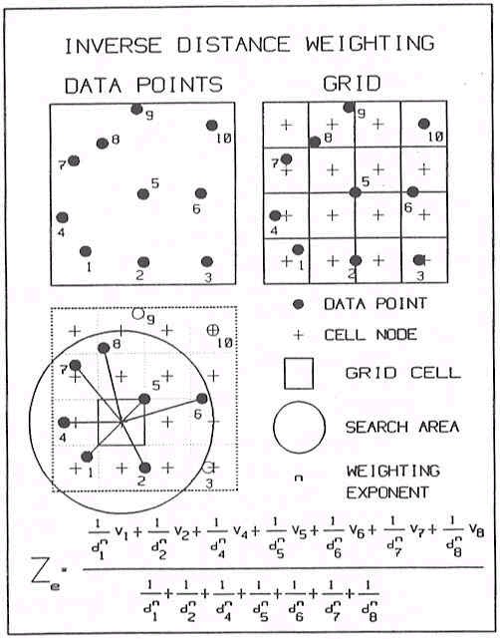

II.7: GB MOSAIC: NEIGHBOURHOOD CLASSIFICATIONS

Methodology

The cluster algorithm used to build GB MOSAIC is known as ‘iterative relocation’ and is based on ‘minimum sum of squares’ as a similarity measure. Prior to clustering, the variables used to build GB MOSAIC are standardised based on (population-weighted) means and standard deviations. Based on random start points (proportional to population), the algorithm assigns each household to the best-fit cluster. It recalculates the average score of each cluster on each input variable and reassigns postcodes to new clusters whenever better fit could, consequently, be achieved. When complete, the solution produces a set of clusters which are as different from each other as possible across the input variables and, within each cluster, sets of households which are as similar as possible across the input variables.

This class of cluster analysis techniques are known as K-means clustering. Academic research has shown that they can produce robust results however, it has also shown that sub-optimal results can occur with K-means clustering if random start points are used (as was done with GB MOSAIC). Better results are often achieved if start points are first generated using a hierarchical clustering algorithm, such as Ward’s method (Everitt, 1980)

The characteristics of the area types used in this analyses are listed below:

Type A1 - Clever Capitalists
Clever Capitalists describes neighbourhoods of extremely expensive housing where people in the upper ranks of business and government live and media celebrities can be found. Many of the people in this type are involved in high finance, particularly in the setting up and financial management of companies, in broking and commercial trading.

Type A4 - Ageing Professionals
Ageing Professionals is a type of area with large inter-war and early post-war houses, typically with large mature gardens in the more desirable suburbs of the larger regional centres. Hospital Consultants, senior academics, top civil servants and senior managers in local government have now paid off their mortgages on houses, which were absurdly cheap - by today's prices - when they were first bought.

Type A5 - Small Town Business
Small Town Business are neighbourhoods of well built detached houses, often with extensive gardens, forming the better residential areas of small country towns. People who choose to live in these areas include local business proprietors and professional people, shop owners, bank managers, estate agents, accountants and solicitors. By contrast with upmarket areas in bigger cities, here you will find many more residents who have achieved success without the benefit of higher education, formal professional qualifications or company directorships. Many more people are self-employed and many fewer will be working for large corporations.

Small Town Business tend to place more emphasis on local and provincial loyalties than national or an international outlook. This is a world of relatively self-reliant, practical and financially astute small-town-business people, often approaching retirement, operating in a conservative but community-oriented culture.

Type H36 - Chattering Classes
Chattering Classes is conspicuous for its outstandingly high proportion of graduates, most of whom work in highly paid service jobs associated with the media, the arts, politics or education. These are neighbourhoods of highly articulate but sceptical influencers and opinion formers who direct the cultural and political agenda of the nation.

Type I38 - High Spending Greys
High Spending Greys are the neighbourhoods to which senior civil servants, successful business people and the upper echelons of the armed forces typically retire. By contrast to the 1960s and 1970s, when large south coast resorts were the typical destinations for the still active and continuingly high income retired, the 1980s saw retired people switch to less urbanised and often more environmentally attractive coastal areas.

Type D15 - Low Rise Pensioners
Low Rise Pensioners neighbourhoods are characterised by public housing for the elderly, typically taking the form of bungalows, sheltered accommodation and small terraced houses often provided by both Local Authorities and Housing Associations. Low Rise Pensioners occurs throughout Great Britain mostly in small pockets rather than in the form of large scale developments of similar housing.

Type D16 - Low Rise Subsistence
Low Rise Subsistence consists of council estates of low rise semi-detached and terraced housing suffering very high levels of sickness and unemployment. Typically built during the 1930s and 1950s, these estates are often located in towns with limited employment opportunities and low wage rates. These neighbourhoods are characterised by a quiet apathy; they lack the aggressive vitality of the inner city melting pot, the economic optimism of better off council housing and the naked aggression of the inner and outer city ghettos. Low incomes and opportunities of Low Rise Subsistence have created a passive lifestyle of low expectations and limited ambitions, significantly dependent on the welfare state for income support, social services and public transport.

Type D17 - Peripheral Poverty
Peripheral Poverty neighbourhoods comprise low density, mostly two-storey council housing where low incomes, unemployment, sickness and the difficulties of bringing up children within one parent families are common social problems. Whereas other deprived areas occur in older inner areas of large cities, where there are now comparatively few children, Peripheral Poverty is typically located on the outskirts of larger towns. The families, many of whom were homeless, have been re-housed in large, modern estates, often with poor access to shops, jobs and social facilities.

Unless carefully managed, these can become ‘sink’ estates where people live out of necessity rather than choice and where they no longer feel in control of their destinies. Debt and petty crime are persistent problems, many local shops lie vacant and, where they are in use, they are boarded up at night. With low car ownership and high reliance on limited public transport, residents feel isolated from the benefits of the consumer society they witness on the television for so many hours a day.

Type K48 - Rural Disadvantage
Rural Disadvantage, by contrast with our idyllic picture of Merrie England, is not an area of large estates, of wealthy landowners or of pretty cottages set in attractive gardens. It is a rural existence found beyond the commuting distance of large cities where poverty, isolation and hardship persist.

In Wales and the South West in particular, wage levels in such villages are especially low, there are few jobs for women and the small upland farmers can seldom afford to hire paid labour. The low incomes of Rural Disadvantage are further compounded by the deteriorating provision of local services. Buses no longer provide access to local market towns, further increasing the necessity to buy and run a car. Village Post Offices, butchers and bakers are no longer economically viable and the quality, range and value for money associated with urban supermarkets contrasts with the high prices and limited variety of the remaining local shops.

APPENDIX III

III.1 INTERVIEW SAMPLE

III.1a Face to face interviews

- The social inclusion officer and lead officer for Neighbourhood Renewal for Penwith
- The lead officer for Neighbourhood Renewal and housing manager for Kerrier
- The community economic development manager for North Kerrier
- The Integrated Area Plan coordinator for South Kerrier
- 3 members of the North Kerrier regeneration team
- The research officer for the North Kerrier regeneration team
- Clerks of three town councils, one in North Kerrier (Camborne), one in South Kerrier (Helston) and one in Penwith (Penzance)
- The chairperson of one parish council in South Kerrier (St Keverne)
- The director of Penwith Community Development Trust
- The development officer of Kerrier Healthy Towns Project
- The development officer of the Cornwall Voluntary Sector Forum
- The coordinator of Pendeen Community Project
- The coordinator of Cornwall Community Volunteer Service
- Two development workers at Cornwall Neighbourhoods for Change
- The chairperson of Cornwall Neighbourhoods for Change, chairperson of Penwith
Tenants Association, and founder member of Treneere Residents Association
- The chairperson of the Cornwall Forum Network and deputy chairperson of Crofty Town Forum
- The facilitator of Engage West Cornwall
- Social Services General Manager for Adult Care in Kerrier
- A member of the Employment Service Action Team in South Kerrier
- The director of the North Kerrier Education Action Zone
- The chairperson of Lescudjack Sure Start and founder member of Treneere Residents Association
- The director of Trevu Sure Start
- Two police crime prevention officers in Camborne
- The coordinator of CHILD in South Kerrier
- A development worker for the Guinness Trust and former housing officer for the Guiness Trust and senior housing needs officer for Kerrier
- The chairperson of Helping Hands, a residents association in the Close Hill estate, Redruth
- The coordinator of Kerrier Youth Service
- The director and two other workers from Galowan, a community arts and development organisation in West Cornwall, working primarily in Penzance and Newlyn
- The coordinator of the Drug and Alcohol Reference Group based in Truro and working across Penwith and Kerrier

III.1b Telephone interviews

- Community Development Adviser, Department of Health
- The projects and partnerships Manager for Employment Service in Cornwall
- A support teacher at Cornwall Traveler Education Service
- The project leader of West Cornwall Children’s Project, Children’s Society
- The manager of Penzance Women’s Aid
- The chairperson of PANIC –Proper Access Now in Cornwall
- The minister of religion, Elim Pentecostal Church, Pengegon and chair of Crossover Community Project Evaluation Committee
- The community worker, Crossover Community Project, Pengegon
- The Methodist minister on the Gwavas Estate in Newlyn
- The chairperson of St Ives Town Regeneration Forum and vice-chair of St Ives District Community Association
- A resident of Hayle, involved in various voluntary and community projects
- The secretary of Wheal Rose and Matela Close Residents Association, Porthleven and member of Planning for Porthleven
- A worker with Cumpas, an organisation promoting Cornish cultural activities and events
- Representatives of the South West Trades Union Congress and of TUC Learning Services in Cornwall

III.2 SEMI-STRUCTURED INTERVIEW TOPIC GUIDE

The topic guides were discussed at the Research Steering Group meeting on 10th October, and are reproduced below

III.2a Interview topic guide for umbrella organisations

- What is your organisation’s main focus of work?

- Which neighbourhoods do you think are the most deprived?

- What do you see as their similarities and differences?

- What role does your organisation have in the identified neighbourhood(s)?

- What do you see as the main resources and strengths of this neighbourhood?

- If not already covered, and as relevant to each organisation:
What do you see as the main resources in terms of:
- People
- Groups
- Networks
- Culture/way of life
- Agencies and organisations
- Political processes
- Services
- Environment

- What do you see as the main problems of this neighbourhood?

- If not already covered: What do you see as the problems in terms of:
- Income
- Employment
- Education
- Health
- Housing
- Physical Environment
- Play and leisure facilities
- Childcare
- Transport
- Crime
- Community involvement
- Conflicts of interest

- What general improvements do you think are most needed in the neighbourhood(s)?

- If not already covered: What do you think might most improve the situation for poorer people in the neighbourhood(s)?

- Do you think there are other people/ groups whose needs might be overlooked?

- If not already covered by the answers to previous questions: How do you think the problems you have discussed can best be addressed?
(Consider the problem areas holistically or in turn as appropriate)

- What support/resources could assist the neighbourhood to address these problems?

- How do you think local involvement in neighbourhood renewal can best be encouraged?

- What needs to change outside the neighbourhood to assist neighbourhood renewal?

- What do you see as the role of your organisation in bringing about change at neighbourhood level?

- What other organisations do you think should be involved?

- What do you see as the benefits of existing liaison/networking/partnership mechanisms?

- How do you think these should these be developed to facilitate change and promote local involvement?

- Do you have suggestions as to contacts it would be useful to interview?

- Are there any other ideas or issues you would like to share?

III.2b Interview Topic Guide for neighbourhood residents only

- What area do you see as your/the group’s/agency’s neighbourhood?

- If not already covered: What helps you to define this neighbourhood?

- What do you like most about this neighbourhood? What do you see as its main resources and strengths?

- If not already covered: What do you see as the main resources in terms of:
  - People
  - Groups
  - Networks
  - Culture/way of life
  - Agencies and organisations
  - Political processes
  - Services
  - Environment

- What do you see as the main problems of this neighbourhood?

- If not already covered: What do you see as the problems in terms of:
  - Income
  - Employment
  - Education
  - Health
  - Housing
  - Physical Environment
  - Play and leisure facilities
  - Childcare
  - Transport
  - Crime
  - Community involvement
  - Conflicts of interest

- What improvements would you like to see in the neighbourhood?

- What do you think might most improve the situation for poorer people in the neighbourhood?

- Do you think there are other people/ groups whose needs might be overlooked?

- If not already covered by the answer to the previous question: How do you think the problems you have discussed can best be addressed?
(Consider the problem areas holistically or in turn as appropriate)

- What support/resources could assist the neighbourhood to address these problems?

- What needs to change outside the neighbourhood to assist this process?

- What involvement would you like to have in a renewal strategy for this neighbourhood?

- Who else/ which other organisations do you think could be involved?

- What training or other support could assist you or others to be more actively involved?

- Is there anyone else whose views you think we should seek?

- Are there any other ideas or issues you would like to share?

APPENDIX IV

AUDIT OF LOCAL SERVICES

Lands End Peninsula
Bus Regular daily services to Penzance & St Ives. Community Bus (Lands End)
Rail Penzance Station, main line (6 miles)
Jobs PTT (Training), Unit 5b, Old Dairy Business Park, Sancreed, Newbridge
Benefits Branwell House, Clarence St., Penzance, TR18 2NP (6 miles)
Hospitals Royal Cornwall Hospitals Trust, Treliske Hospital, Truro (30 miles)
West Cornwall Hospital, St. Clare St., Penzance (6 miles)
GPs/Clinics The Health Centre, St Just
Dentists J D Hargreaves, 4 Bank Square, St Just
Social Services Penzance Social Services, Roscadgill Parc, Heamoor, Penzance (6 miles)
Post Offices Pendeen P O, 11 The Square, Pendeen
St Buryan Sub P O, St Buryan
St Ives Sub P O, Market St, St Just
Sennen P O, Sennen
Banks
/Building Societies Lloyds TSB Bank PLC, 1 Bank Square, St Just
Credit Union Penwith Credit Union Ltd., St. Johns Hall, Alverton St., Penzance,
TR18 2QR (6 miles)
Library St Just Library, Market Street, St Just. Mobile facilities

Penzance
Bus Regular daily services to St Ives, Hayle, Helston & West Penwith.
Voluntary Car Scheme
Rail Penzance Station, main line
Jobs Grafters employment agency, 28 Polweath Rd., Penzance
Breadline Employment Training, Breadline Centre, Bread St., Penzance
Rose English Consultancy (Training), Ayr Cottage, Ayr, Penzance
Ultra Training Ltd., Champions Yard, Causewayhead, Penzance
Benefits Branwell House, Clarence St., Penzance, TR18 2NP
Hospitals Bolitho House, Laregan Hill, Penzance
Poltair Hospital, Madron, Penzance
Royal Cornwall Hospitals Trust, Treliske Hospital, Truro (25 miles)
West Cornwall Hospital, St. Clare St., Penzance
GPs/Clinics Sunnyside Surgery, Hawkins Road, Penzance TR18 4LT
The Surgery, The Old Bridge, Newlyn, Penzance
Morrab Surgery, 2 Morrab Road, Penzance TR18 4EL
The Surgery, 7 Alverton Terrace, Penzance
The Surgery, 9 Fore St, Penzance
Penalverne Surgery, Bosowan, Penalverne Drive, Penzance
Dentist M G Harper, 5 Alverton Terrace, Penzance
Hobson & Hirst Dental Surgery, 45 Morrab Rd., Penzance
Julian A Keen, 60 Morrab Rd., Penzance
Dr L B Lewis, 12 Alverton Terrace, Penzance
M Nellist, 3 Morrab Rd., Penzance
R Thomas, 18 Morrab Rd., Penzance
W G Upton, 11 Chapel St., Penzance
C P G Ziar & Associates, 67 Chapel St., Penzance
Social Services John Daniel Centre, Penzance
Richmond House Day Centre, Penzance
St Mary’s Day Centre, Penzance
Penwith Respite Care Hostel, Penzance
Penzance Social Services, Roscadgill Parc, Heamoor, Penzance
Post Offices Alverton P.O. 5 Lansdowne Place, Alverton
Godolphin P O & Stores, Godolphin Cross, Penzance
Gulval P O, 4 Trevarrack Noweth, Gulval, Penzance
Heamoor P O, Heamoor, Penzance
Long Rock P O, 4a Godolphin Rd., Long Rock, Penzance
The Madron P O Stores, Church Rd., Madron
Newlyn P O, The Strand, Newlyn
St Clare St P O, St Clare St., Penzance
Banks/
Building Societies Abbey National PLC, 37 Market Place, Penzance, TR18
Alliance & Leicester PLC, 111 Market Jew St., Penzance
Barclays Bank PLC, 8-9 Market Jew St., Penzance
Bristol & West PLC, 30 Market Place, Penzance
Halifax PLC, 13 Market Jew St., Penzance, TR18
HSBC Bank PLC, 1 Green Market, Penzance
Lloyds TSB Bank PLC, Market House, Market Place, Penzance
Lloyds TSB Bank PLC, 23-24 Market Place, Penzance
NatWest Bank, Penzance
Credit Union Penwith Credit Union Ltd., St. Johns Hall, Alverton St., Penzance,
TR18 2QR
Library Morrab Library, Morrab Gardens, Penzance
Penzance Public Library, 62 Morrab Rd., Penzance

Marazion
Bus Regular daily services to Penzance & Helston
Rail Penzance Station, main line
Jobs See Penzance (3 miles)
Benefits Branwell House, Clarence St., Penzance, TR18 2NP (3 miles)
Hospitals Royal Cornwall Hospitals Trust, Treliske Hospital, Truro (23 miles)
West Cornwall Hospital, St. Clare St., Penzance (3 miles)
GPs/Clinics Marazion Health Centre, Gwallon Lane, Marazion TR17 0HW
Dentist See Penzance (3 miles)
Social Services Penzance Social Services, Roscadgill Parc, Heamoor, Penzance (3 miles)
Post Offices Goldsithney P O, 1 Primrose Hill, Goldsithney
Marazion P O, Market Place, Marazion
Banks/Building
Societies See Penzance (3 miles)
Credit Union Penwith Credit Union Ltd., St. Johns Hall, Alverton St., Penzance,
TR18 2QR (3 miles)
Library Mobile facilities

St Ives
Bus Regular daily services to Hayle, Penzance & West Penwith
Rail Carbis Bay and St Ives Stations, branch line from St Erth (main line)
Jobs See Hayle (3 miles)
Benefits Branwell House, Clarence St., Penzance, TR18 2NP (7 miles)
Hospitals Royal Cornwall Hospitals Trust, Treliske Hospital, Truro (20 miles)
West Cornwall Hospital, St. Clare St., Penzance (7 miles)
GPs/Clinics Stennack Surgery, Stennack, St Ives, TR26 1RU
Dentist Burgess, Adams & Priest, St Ives Rd., Carbis Bay
Poznansky & Franklin, Tregenna Hill Surgery, St Ives
Social Services Penzance Social Services, Roscadgill Parc, Heamoor, Penzance (7 miles)
Post Offices Carbis Bay P O, St Ives Rd., Carbis Bay
Halsetown P O, Halsetown, St Ives
St Ives P O, Tregenna Place, St Ives
Wharf P O, 4 Chy An Chy, St Ives
Banks/
Building Societies HSBC Bank PLC, 5 High St., St Ives
HSBC Bank PLC, Longstone Cross, Carbis Bay, St Ives
Lloyds TSB Bank PLC, 13 High St., St. Ives
NatWest Bank, St Ives
Credit Union Penwith Credit Union Ltd., St Johns Hall, Alverton St., Penzance,
TR18 2QR (7 miles)
Library St Ives Library, Gabriel Street, St Ives

Hayle
Bus Regular daily services to St Ives, Penzance & Camborne,
Voluntary Car Scheme
Rail Hayle Station, main line, St Erth Station, main line
Jobs Workmates, construction labour specialist, 12d Chappel Terrace, Foundry
Hill, Hayle, Cornwall, TR27 4H
Benefits Branwell House, Clarence St., Penzance, TR18 2NP (8 miles)
Hospitals Royal Cornwall Hospitals Trust, Treliske Hospital, Truro (18 miles)
St Michaels Hospital, Trelissick Rd., Hayle
West Cornwall Hospital, St Clare St, Penzance (8 miles)
GPs/Clinics Bodriggy Health Centre, Bodriggy, Hayle TR27 4NB
Dentist Budden & Geffrey, 66 Hayle Terrace, Hayle
Copperhouse Dental Surgery, 29 Fore St., Copperhouse, Hayle
Social Services Frank Johns Care Centre, Hayle
Post Offices Copperhouse P O, 45 Fore St., Hayle
Hayle Sub P O, 13 Penpol Terrace, Hayle
St Erth P O, 1 School Lane, St Erth
Banks/Building
Societies Barclays Bank PLC, 23 Foundry Square, Hayle
Lloyds TSB Bank PLC, 3 Foundry Square, Hayle
Credit Union Penwith Credit Union Ltd., St. Johns Hall, Alverton St., Penzance,
TR18 2QR (8 miles)
Library Hayle Library, Commercial Rd., Hayle

Helston
Bus Regular daily services to Redruth, Camborne, Falmouth, Truro &
Lizard Peninsula
Rail Redruth & Camborne Station, main line (8 miles)
Jobs Cornwall & Devon Careers Service, Helston School, Church Hill
Helston Jobclub, Coinagehall St., Helston
Benefits Branwell House, Clarence St., Penzance, TR18 2NP (12 miles)
Hospitals Royal Cornwall Hospitals Trust, Treliske Hospital, Truro (13 miles)
GPs/Clinics Meneage Street Surgery, 100 Meneage St., Helston, TR13 8RF
Helston Medical Centre, Trengrouse Way, Helston TR13 8AE
Dentist Anderson, Cope & Holloway, 2 Meneage St, Helston
Bradburn Carrie, also Dr P Hodgkinson, 41A Meneage St,
Helston, TR13 8RB
Social Services Camborne Social Services, The White House, 24 Bassett Rd.,
Camborne (7 miles)
Post Offices Helston P O, 28 Coinagehall St., Helston
Nancegollan P O, Nancegollan
Banks/Building
Societies Abbey National PLC, 11 Meneage St., Helston, TR13
Bristol & West PLC, 5 Meneage St, Helston
HSBC Bank PLC, 2 Coinagehall St., Helston
Lloyds TSB Bank PLC, 1 Market Place, Helston
Lloyds TSB Bank PLC, 28 Meneage St., Helston
NatWest Bank, Helston
Credit Union Kerrier/Fal Credit Union (proposed) c/o Link into Learning,
23 Broad Street, Penryn TR10 8JL
Library Helston Library, Trengrouse Way, Helston

Lizard Peninsula
Bus A choice of 4-6 buses daily to Helston or Falmouth depending on
school term, etc. Community Buses & Voluntary Car Schemes
Rail Redruth or Camborne Stations, main line (15 miles)
Jobs See Helston (8 miles)
Benefits Branwell House, Clarence St., Penzance, TR18 2NP (18 miles)
Hospitals Royal Cornwall Hospitals Trust, Treliske Hospital, Truro (18 miles)
GPs/Clinics The Health Centre, St Keverne, Helston TR12 (8 miles)
Mullion Health Centre, Nansmellyon Rd., Mullion
Dentists See Helston (8 miles)
Post Offices Mullion PO, Nansmellyon Rd., Mullion
Ruan Minor PO, Ruan Minor
St Keverne PO, The Square, St Keverne
Banks/Building
Societies See Helston (8 miles)
Credit Union Kerrier/Falmouth Credit Union (proposed) c/o Link into Learning,
23 Broad Street, Penryn TR10 8JL
Library Mobile Facilities

Camborne & Troon
Bus Regular daily services to Hayle, Redruth & Helston.
Voluntary Car Schemes
Rail Camborne Station, main line
Jobs DMT Business Services Ltd., 28 Commercial St., Camborne
The Camborne Centre, 1 Wesley St., Camborne
Benefits Lemon Quay House, Lemon Quay, Truro, TR1 2PU (10 miles)
Hospitals Camborne Redruth Community Hospital, Barncoose, Redruth (3 miles)
Royal Cornwall Hospitals Trust, Treliske Hospital, Truro (10 miles)
GPs/Clinics Veor Surgery, South Terrace, Camborne TR14 8SS
Andrew House Surgery, 2 South Terrace, Camborne, TR14 8ST
Trevithick Surgery, Basset Road, Camborne TR14 8SG
Dentists C Ettling, 22 Chapel St., Camborne TR14 8ED
Green & Plaice, 5 Chapel St., Camborne
Killivose Dental Practice, The Barns, Killivose, Camborne
S D Smith, 15 Commercial St., Camborne
Social Services Boundervean Day Centre, Camborne
Kehelland Day Centre, Camborne
Camborne Resource Centre
Penelvan Residential Centre, 22 Roskear, Camborne
Camborne Social Services, The White House, 24 Bassett Rd., Camborne
Post Offices Beacon P O, 2 Pendarves St., Beacon
Tehidy Road P O, Tehidy Rd., Camborne
Troon P O, 3 New Rd., Troon, Camborne
Tuckingmill P O, 44 Pendarves St., Tuckingmill, Camborne
Banks/Building
Societies Abbey National PLC, 6 Trelowarren St., Camborne, TR14
Barclays Bank PLC, 28 Chapel St., Camborne
Halifax PLC, 31 Trelowarren St., Camborne, TR14
HSBC Bank PLC, 45 Commercial St., Camborne
Lloyds TSB Bank PLC, Commercial St., Camborne
Woolwich PLC, 42-44 Commercial St, Camborne
Credit Union Kerrier/Fal Credit Union (proposed) c/o Link into Learning,
23 Broad Street, Penryn TR10 8JL
Library Camborne Library, The Cross, Camborne

Pool & Illogan
Bus Regular daily services to Redruth & Camborne. Services to and from
Cornwall College in termtime. Voluntary Car Schemes
Rail Redruth or Camborne Stations, main line (2 miles)
Jobs Cornwall & Devon Careers Ltd., Wilson Way Pool
College Training, Cornwall College, Trevenson Rd., Pool, TR15 3 RD
Joblink Training, Trevenson Rd., Pool
Benefits Lemon Quay House, Lemon Quay, Truro, TR1 2PU (10 miles)
Hospitals Camborne Redruth Community Hospital, Barncoose, Redruth (2 miles)
Royal Cornwall Hospitals Trust, Treliske Hospital, Truro (10 miles)
GPs/Clinics Harris Memorial Surgery, Illogan, Redruth, TR16 4RX
Homecroft Surgery, Voguebeloth, Illogan
Pool Health Centre, Station Rd., Pool
Dentists Dr G L Parle, Mayfield Dental Practice, 117 Agar Rd.,
Illogan Highway, Redruth
Social Services Camborne Social Services, The White House, 24 Bassett Rd.,
Camborne (2 miles)
Post Offices Illogan Highway P O, Chariot Way, Illogan Highway, Redruth
Paynters Lane End P O, Robartes Terrace, Illogan
Pool P O, 42 Fore St., Pool
Banks/Building
Societies Barclays Bank PLC, Agar Rd., Illogan Highway
Lloyds TSB Bank PLC, 126-128 Agar Rd., Illogan Highway
Lloyds TSB Bank PLC, 5 Fore St., Pool
Credit Union Kerrier/Fal Credit Union (proposed) c/o Link into Learning,
23 Broad Street, Penryn TR10 8JL
Library Camborne Library, The Cross, Camborne (2 miles)

Redruth
Bus Regular daily services to Camborne & Truro
Rail Redruth Station, main line
Jobs Cornwall & Devon Careers Ltd., 2 Alverton St., Reduth
Royal Navy & Royal Marines Career Office, Oak House, Chapel St,
Redruth
Ultra Recruitment Agency, 57a Fore St., Redruth
Access Training (South West) Ltd, Trevenner House, Nettles Hill, Redruth
Cornwall Training Centres, 15-16 Cardrew Way, Cardrew Ind. Estate,
Redruth
Media Action for Training and Employment, Unit 12a, West Cornwall
Enterprise Centre, Cardrew Ind Est, Redruth
Rite Associates (Training), Highburrow, Wilson Way, Redruth
DGSA/TFTL/ADR – Training for Transport, Redruth
Benefits Lemon Quay House, Lemon Quay, Truro, TR1 2PU (8 miles)
Hospitals Camborne Redruth Community Hospital, Barncoose, Redruth
Cornwall Healthcare Trust, Charles Andrew Clinic, West End, Redruth
Lower Cardrew House, North St, Redruth
Royal Cornwall Hospitals Trust, Treliske Hospital, Truro (8 miles)
Trenqweath, Penryn St, Redruth
GPs/Clinics Lanner Moor Surgery, Lanner Moor, Redruth, TR16 6HZ
Manor Surgery, Forthnoweth, Chapel St., Redruth, TR15 2BY
The Surgery, 19 Clinton Rd., Redruth
Dentists Bateson & French, 28 Green Lane, Redruth
J.C. Duncan, 1 Trewirgie Rd, Redruth
Dr J Pearson, 24 Clinton Rd., Redruth
M G Sheppard., 24 Clinton Rd., Redruth
Social Services Murdoch & Trevithick Centre, Redruth
St Christopher’s Hostel, Redruth
Thornton House Residential Centre, Redruth
Post Offices Carnkie P O, Carnkie
Close Hill P O, Close Hill, Redruth
Mount Ambrose P O, 101 Mount Ambrose, Redruth
Banks/Building
Societies Barclays Bank PLC, Penryn St, Redruth
Halifax PLC, 20 Fore St., Redruth, TR15
HSBC Bank PLC, 81 Fore St., Redruth
Lloyds TSB Bank PLC, 27 Fore St., Redruth
Lloyds TSB Bank PLC, Market Square, Redruth
NatWest Bank, Redruth
Credit Union Kerrier/Fal Credit Union (proposed) c/o Link into Learning,
23 Broad Street, Penryn TR10 8JL
Library Cornish Studies Library, Clinton Rd., Redruth
Redruth Library, Clinton Rd., Redruth

Porthleven
Bus Regular daily services to Helston and Penzance
Rail Redruth or Camborne Stations, main line (8 miles)
Jobs See Helston (2 miles)
Benefits Branwell House, Clarence St., Penzance, TR18 2NP (9 miles)
Hospitals Royal Cornwall Hospitals Trust, Treliske Hospital, Truro (15 miles)
GPs/Clinics The Surgery, Sunset Gardens, Porthleven, Helston TR13 9BT
Dentist See Helston (2 miles)
Social Services Camborne Social Services, The White House, 24 Bassett Rd.,
Camborne (8 miles)
Post Office Porthleven Post Office & Stores, Chapel View, Fore St., Porthleven,
TR13 9HQ
Banks/
Building Societies Lloyds Bank PLC, Commercial Rd, Inner Harbour, Porthleven
Credit Union Kerrier/Fal Credit Union (proposed) c/o Link into Learning,
23 Broad Street, Penryn TR10 8JL
Library Mobile facilities

At the local level, 20 Local Authorities (although not Kerrier or Penwith), will pilot the idea of local PSAs in 2001–02. If successful, authorities in the most deprived areas will – in order to receive further NRF support – need to demonstrate that local PSAs include a focus on tackling deprivation and contribute to delivering national targets (SEU, 2001a:84).
This involves devolving power down to a single person or neighbourhood institution and involves making service level agreements, running local services and managing a devolved budget (SEU, 2001a).
Figure 1.4 is based on Claimant Count data, however Labour Force Survey (LFS) data on unemployment in Cornwall also shows a similar seasonal; pattern.
Factor analysis attempts to identify underlying variables, or factors, that explain the pattern of correlations within a set of observed variables. Factor analysis is often used in data reduction to identify a small number of factors that explain most of the variance observed in a much larger number of manifest variables.
However, the factor scores should not be compared between domains as they have different minimum and maximum values and ranges. To compare between domains, the ranks should be used.
Those offences tried by judge and jury at the Crown Court.
Those offences tried at Magistrates’ Courts.
The population weighting used here is based upon Office for National Statistics 1998 mid year population estimates.
Excluding the following police beat areas: Ludgvan, Madron East, Madron West, Towednack beats.
Data is collected for Crime Reduction Partnership areas which are generally linked to Local Authority areas, although some may be larger and some smaller. The data cannot be compared directly to data from previous years which used Basic Command Units (BCU) to report since BCU boundaries do not all coincide with Local Authority ones.
The poverty and child poverty measures are derived from the 1990 Breadline Britain survey (Gordon and Pantazis, 1997) and applied to 1991 Census data (Gordon, 1995; Gordon and Loughran, 1997). These measures are considered to be amongst the most accurate available by many authors (eg Lee et al, 1995; Burrows and Rhodes, 1998; Saunders, 1998).
In the Breadline Britain in the 1990s survey poverty was defined scientifically using the consensual method e.g. in order to be poor a household had to have both a low income and a standard of living that was below the minimum acceptable to the majority of the British population.
It should be noted that the Lizard area may well contain a greater numbers of areas of need than these statistics reveal. The highly seasonal nature of work on the Lizard (particularly flower picking and tourism) combined with the influence of the nearby large RAF base and the high number of second homes may obscure the ‘true’ extent of need in statistical analysis.
This claim has been made on a numerous occasions by Dom Mintoff (the ex-Prime Minister of Malta) and others.
Rural parishes are defined by the Countryside Agency as parishes with populations of less than 10,000. On the basis of 1991 Census population estimates, the parishes of Carn Braa, Penzance, Helston, Camborne and Redruth are thus excluded from the 2000 RSS parish data set.
This includes Beavers, Cubs, Scouts, Rainbows, Brownies, Girl Guides, Youth Social Clubs, Youth Parish Councils and Young Farmers as well as statutory provision.
These were: charitable trusts and foundations; the European Social Fund; the Single Regeneration Budget; selected central government schemes and the Community Fund.

