CHAPTER FOUR:

COMMUNITY AUDIT

INTRODUCTION

Levels of service provision in rural areas vary considerably across England, as indicated by the 2000 ILD (see Figure 2.6). Historical and new data reveal an overall trend of declining geographical availability for some essential services. In some areas, increased mobility and affluence of some rural residents is impacting on local service provision (Countryside Agency, 2001). Those with greater mobility have more choice and are not reliant on most local services. As indicated in Chapter Two, lack of access to a car is an important dimension of deprivation in rural communities (see Figure 2.24).

Increased mobility for some can adversely affect the viability of some local services which, in turn, disadvantages a proportion of the rural elderly, the young and similar groups without transport choice. For those without access to a car, the proximity of essential services is of considerable importance. Despite increasing innovation through ‘outreach’ techniques to deliver services to rural communities, the geographical location of service outlets continues to have a considerable impact on quality of life in rural areas.

Most people regard easy access to essential services as important. The 1999 British Social Attitudes Survey, for example, revealed that a majority of both rural residents and urban dwellers agree that it is important to have a doctor’s surgery within a 15-minute walk of home (Stratford, 2000). Amongst the 6,000 people surveyed, there was also a high level of agreement between urban and rural residents that primary schools and small shops selling basic essentials should be within a 15-minute walk of home.

Similarly, a majority of respondents to the 1999 Poverty and Social Exclusion Survey of Britain considered a wide range of public and private services to be essential (rather than just desirable). Table 4.1 below shows the percentage of people who considered various services to be necessities of life that should be available.

Table 4.1: Percent of the population that think public and private services are essential and should be available in the Poverty and Social Exclusion Survey of Britain (1999)

Essential
%
Doctor | 99
Hospital with an Accident and Emergency Department | 95
Chemists | 94
Dentist | 93
Post Office | 93
Bus services | 93
Facilities for children to play safely nearby | 88
Special transport for those with mobility problems | 87
Optician | 86
Nurseries, playgroups, mother and toddler groups | 86
Public transport to school | 84
Petrol stations | 79
Availability of home help | 77
Access to banks and building societies | 76
Availability of Meals on Wheels | 74
School meals | 72
Libraries | 71
Public sports facilities (e.g. swimming pools) | 68
A train/tube station | 67
A corner shop | 62
Youth clubs | 61
Access to medium to large supermarkets | 61
Public/Community/Village Hall | 59
Evening classes | 51
Places of worship | 46
After School clubs | 44
A pub | 30
Museums and galleries | 28
A cinema or theatre | 21

The importance of equitable geographical access to key local services has been emphasised within the 2000 Rural White Paper, Our Countryside: The future. Widening access to key services in rural areas (food shops, Post Offices, cash points, children’s nurseries, primary schools and GP’s surgeries) is defined within the Rural White Paper as a key policy goal (Objective 1A) (DETR, 2000). Similarly, access to services has been identified by the DETR as a key dimension of deprivation in the development of the 2000 Index of Local Deprivation (see Chapter Two). Access to a Post Office, a large food store, a GP’s surgery and a primary school are all included within the Access to Services domain.

Services and Poverty
The idea of the Welfare State is one of the greatest British Social Policy inventions of the 20th Century. It has been exported around the world and has arguably done more to alleviate human suffering and improve health than any other single invention, including that of antibiotics. The services provided through local government are a keystone of the Welfare State in the UK. They not only provide efficient and effective social care and public protection for the whole population but also provides a major contribution of income ‘in kind’ to the poorest groups in society.

Most ‘economic’ studies of income and wealth tend to ignore the importance of services in raising the standard of living of households. This failure often makes international comparisons, based on cash incomes alone, of only limited value. The services (in-kind benefits) provided by the Welfare State eg NHS, education and other local government services, have a greater effect on increasing the standard of living of the lowest income households than do the combined values of wages and salaries, Income Support and retirement pensions available to these households. Table 4.2 shows the contribution that earnings, cash benefits and in-kind services had on the poorest and richest 10% of all UK households in 1996-97.

Table 4.2: Income, taxes and benefit contribution to the average incomes of the poorest and richest 10% of households in the UK in 1996-97 (£)

Income | Poorest 10% of Households  (N=2,245,000) | Richest 10% of Households  (N=2,245,000)
Wages and Salaries | 1,026 | 36,599
Other Income | 822 | 18,762
Total Income | 1,848 | 55,361
Retirement Pension | 1,227 | 506
Income Support | 1,205 | 6
Child Benefit | 434 | 141
Housing Benefit | 536 | 8
Other Cash Benefits | 766 | 245
Total Cash Benefits | 4,168 | 906
Direct Taxes (Income, Council, etc) | 719 | 13,166
Total Disposable Income | 5,297 | 43,101
Indirect Taxes (VAT, etc) | 1,926 | 5,916
Post Tax Income | 3,371 | 37,184
Benefits in Kind
National Health Service | 1,894 | 1,240
Education | 1,959 | 385
Other Benefits in Kind | 210 | 165
Total Benefits in Kind | 4,063 | 1,790
Final Income | 7,433 | 38,974
Source: recalculated from data in Economic Trends and Social Trends (see Gordon and Townsend, 2000)

Table 4.2 shows that the richest 10% of households in the UK have an average final income of £38,974 (after accounting for the contribution of benefits and the effects of taxation). This is more than five times larger than the average final income of the poorest 10% of households (ie £7,433). It also illustrates the huge importance of services to the poorest households. Over half of the income (£4,063) that the poorest 10% of households receive is in the form of ‘benefits-in-kind’. For example, the poorest households received £1,894 worth of services from the NHS, representing over a quarter of their final income. If the NHS was not a free service, the poorest households would be 25% poorer. The contribution of NHS services to the final income of the poorest 10% of retired households (629,000 households) is even greater. They received £2,639 worth of NHS services in 1996-97, representing almost half of their final incomes of £5,475 per year.

Table 4.2 (above) illustrates the effectiveness of the Welfare State system in alleviating poverty. Cash and in-kind benefits raise the incomes of the poorest households from £1,848 to a final income of £7,433 - a four-fold increase. This was not, however, sufficient to raise the poorest 10% of households out of poverty, which would have required (approximately) a five to six-fold increase in original income in 1996-97. However, the Welfare State prevented the poorest households from sinking into a state of absolute destitution.

SERVICES IN CORNWALL

In their 1991 Survey of Rural Services, Lievesley and Maynard (1992) concluded that Cornwall was among the better served counties, with a better than average distribution and range of services. The Cornwall and Isles of Scilly Rural Strategy Document (Cornwall County Council, 1988) mapped a healthy scattering of village halls and primary schools at that time but there were few areas where the bus service was described as frequent. In terms of training and job centres, the people in sparsely populated North Cornwall are rather less well-served than those in the West Cornwall Districts.

The 1994 Survey of Rural Services also showed Cornwall as being relatively well-served across a range of services (Rural Development Commission, 1995). However, the 1994 Rural Facilities Survey, carried out jointly by Cornwall County Planning (CCP) and the Cornwall Rural Community Council (CRCC), was a more detailed study than the national one of which it was a part. The CCP and CRCC chose, in the case of almost all services covered by the survey, to study provision in settlements (excluding major towns and parishes located adjacent to them) rather than parishes because “the fact that one settlement has a full range of facilities may be of little relevance to other settlements in the parish” (CCP/CRCC, 1995). Whilst warning of the problems associated with looking at Cornwall’s facilities on a parish basis, the 1994 Survey concluded that:

“even when looked at on a settlement basis there is a good distribution of facilities. Although here has been widespread historical decline in shops and churches, the trends of decline seem to be slowing.”

The Rural Services Survey for 2000 has recently been released and again confirms the relatively high levels of service provision that exist in Cornwall compared with many other rural areas of England. However, as Chapter Three illustrated, whilst Cornwall performs well in comparison with other rural areas, this does not imply that the quality of local services is always adequate in meeting local needs. Significant gaps remain in access to local services for rural residents, and the serviceability of many community facilities is also open to question.

Methodology
The 2000 Rural Services Survey (RSS), commissioned by the Countryside Commission, provides up-to-date and robust data on the pattern of rural services across England. The 2000 RSS incorporates extensive information from postcoded data, allowing almost 100% accurate data coverage for the following services:

- Cash points
- Banks and building societies
- Post offices
- Primary schools
- Secondary schools

Where such data are available, the analyses presented below illustrate the geographic availability of services to households using sets of distance bandings. These household data are on a postcoded basis and are thus based on detailed information at a very local level. Distances are calculated as straight lines. Whilst these cannot reflect real road or footpath distances, they are a relatively consistent indication of service availability in relation to where people live. The application of GIS technology to these data provides an assessment of the geographic availability of services to individual settlements and households.

This approach represents a major step forward from simply reporting on the presence of services within administrative units such as parishes or wards where boundaries owe more to tradition than the needs of local communities. Consider the illustration below.

Illustration (1) illustrates the location of a local service (denoted by the red cross) on a ward map together with a radius of access at a specified distance (eg 4km). In this case, although people living in adjacent wards are clearly very close to the service, they will not figure in any map computed on the basis of ward boundaries. In Illustration (2) however, where mapping is computed on the basis of an access radius, it is possible to compute and map the proportion of ward populations within any predefined radius of a local service. This approach is applied to the analysis of key local services as described above, and the results are presented below.

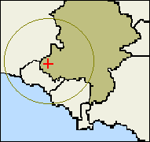(1)
(1)
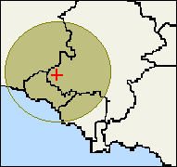(2)

Key Indicators

Cash Points

Over 65% of rural households in the South West live within 4km of a cash point (compared with 72% in Kerrier and Penwith and 79.3% nationally). The distribution of cash points is closely related to the distribution of banks and building societies. However, there is some evidence that the spread of cash points into alternative premises is beginning to benefit rural households. In virtually all regions, the proportion of households within 2km of a service is slightly higher for cash points than for banks and building societies, implying a broader dispersion across the rural parts of each region. Cash is also increasingly available through ‘cashback’ facilities in local food stores and similar outlets.

Figure 4.1 : Percent of Households more than 4km from a Cash Point, 2000

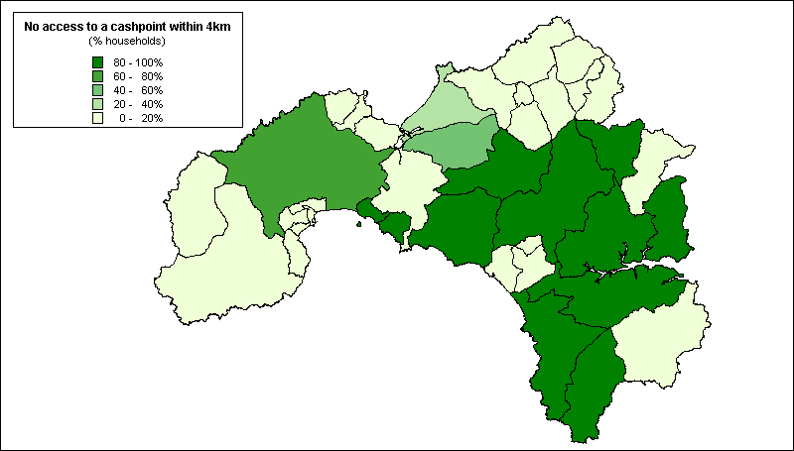
Source: 2000 Rural Services Survey

Banks and Building Societies
Over 81% of rural households in the South West live within 4km of a bank or building society, compared with 82.4% in Kerrier and Penwith. Banks and building societies are strongly concentrated in market towns within rural areas and very few parishes with small populations contain any of these facilities. It is only in the largest parishes, with populations above 3,000, that a significant proportion contain any banks or building society branches (Countryside Agency, 2001).

Figure 4.2: Percent of Households more than 4km from a Bank or Building Society, 2000

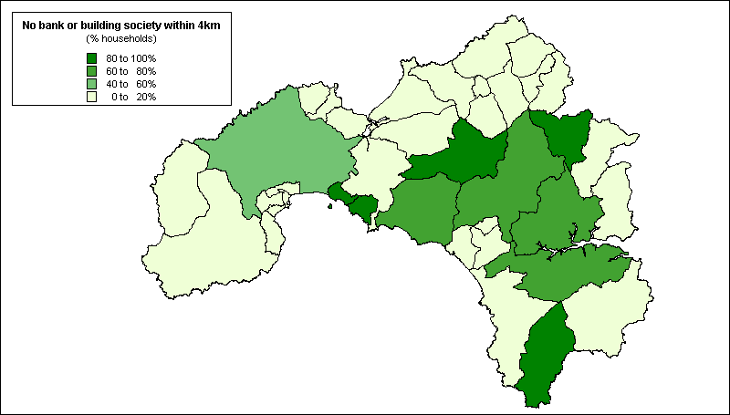
Source: 2000 Rural Services Survey

Many poorer households have restricted access to these and similar financial services, including some of the most basic financial services such as a current bank account and home contents insurance. Analysis of the 1995/6 Family Resources Survey shows that around 20% of UK households do not have a current bank or building society account (Kempson, 1994), and a similar proportion do not have home contents insurance (Whyley et al, 1998). Around three out of 10 UK households have no savings at all (Kempson and Whyley, 1999).

Unfortunately, since such questions are not contained within the Census, there is no nationwide evidence based upon 100% population coverage. However, the consequences of exclusion from financial services for households’ day-to-day money management, for example, in relation to bill payment, are more amenable to analysis. Payment of household bills now relies heavily upon access to a bank or building society account. People without these facilities settle bills in cash at Post Offices and time-consuming, pay-as-you-go methods such as pre-payment meters – in the process incurring higher fuel tariffs and additional transaction charges (Whyley and Kempson, 1998).

Figure 4.3 (below) illustrates the ward-level distribution of households with pre-payment electricity meters in west Cornwall. As this map shows, pre-payment customers are mainly concentrated in the Camborne, Pool and Redruth area, as well as around Penzance. North Kerrier as a whole and the St Just area also contain above average concentrations of pre-payment customers. Comparing this distribution with the cumulative index of deprivation derived from the 1991 Census (Figure 2.25), shows a reasonably close ‘fit’ with the pattern of deprivation in West Cornwall - again confirming that most pre-payment customers pay bills in this way due to lack of money rather than through choice.

Figure 4.3: Households in Kerrier and Penwith with Pre-payment
Electricity Meters (%), 1998

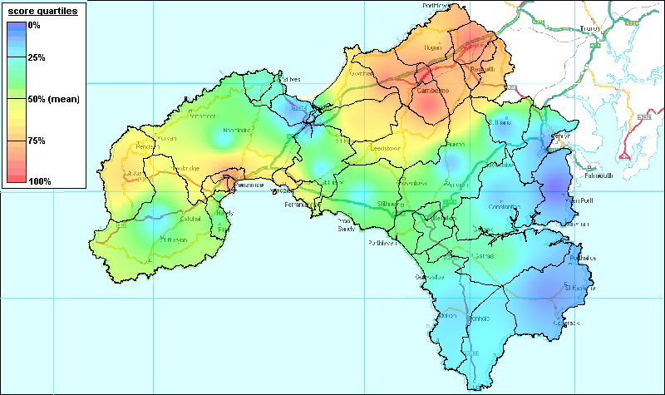

Post Offices
Nearly 94% of rural households in the South West live within 2km of a Post Office compared with 96.4% in Kerrier and Penwith as a whole. Nationally, numbers of these outlets in rural areas continue to decline - 58% of parishes had a Post Office in 1991 compared to 54% in 2000 (Countryside Agency, 2001). In Kerrier and Penwith, 83.8% of rural parishes had a Post Office in 2000.

Figure 4.3: Percent of Households more than 2km from a Post Office, 2000

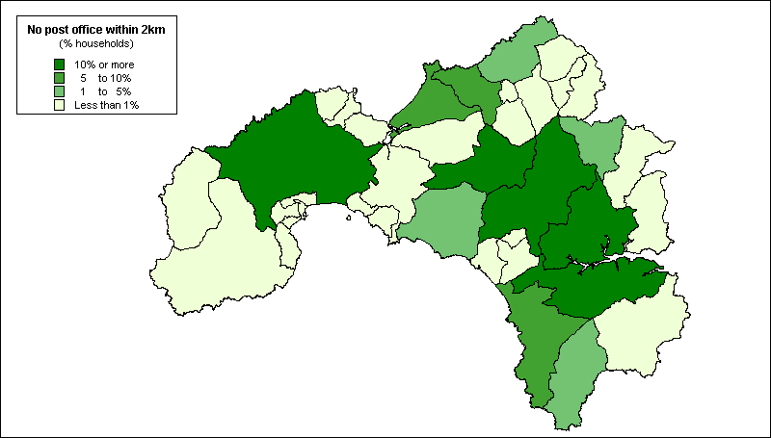
Source: 2000 Rural Services Survey

Primary Schools
Over 91% of rural households in the South West live within 2km of a primary school compared with 95.4% in Kerrier and Penwith as a whole. Although some schools in remoter areas have closed, the total number of schools shows a slight increase for 2000. Nationally, 52% of parishes have a primary school in 2001 (compared with 47% in 1991) and, in Kerrier in Penwith, 78.4% of rural parishes had a primary school in 2000. This is probably the result of more comprehensive data sourced from DfEE (Countryside Agency, 2001).

Figure 4.4: Percent of Households more than 2km from a Primary School, 2000

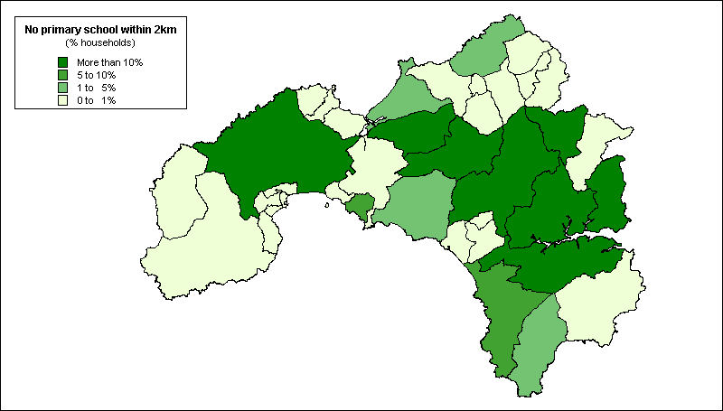
Source: 2000 Rural Services Survey

Secondary Schools
In the South West, 78.2% of households live within 4km of a secondary school compared with 77.8% in Kerrier and Penwith as a whole. Secondary schools are a strategic service and are centrally sited in relation to the catchment area at the time they were built. Of the rural parishes in Kerrier and Penwith, 16.2% had a secondary school in 2000.

Figure 4.5: Percent of Households more than 4km from a Secondary School, 2000

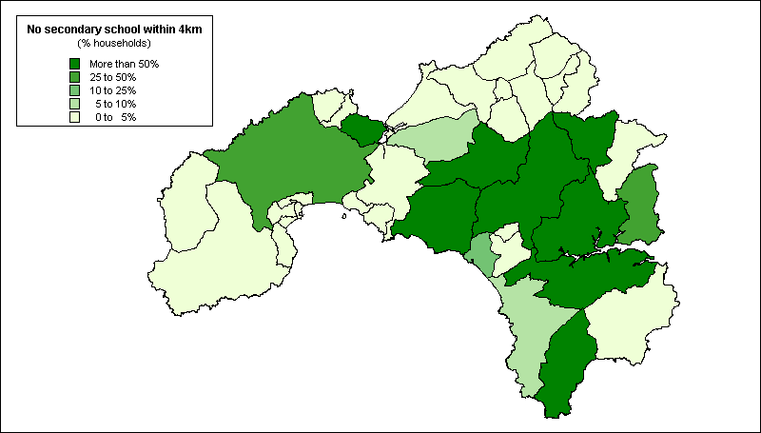
Source: 2000 Rural Services Survey

GP’s Surgeries
In the South West, 67.5% of households lived within 2km of a GP’s surgery in 2001 compared with 88.9% in Kerrier and Penwith as a whole. Doctors’ branch surgeries were held in 37.8% of the rural parishes in Kerrier and Penwith. As Figure 4.6 shows, most residents in rural areas depend on primary health care located in predominantly urban service centres and very few settlements with less than 1,000 residents contain branch surgeries.

Figure 4.6: Percent of Households more than 2km from a GP’s Surgery, 2000

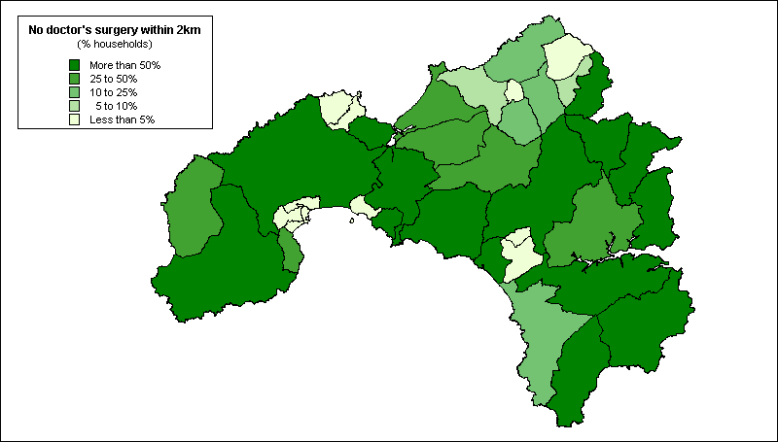
Source: 2000 Rural Services Survey

The 2000 Parish Survey

Introduction

The 2000 RSS also used a rural parish questionnaire to record data on services where information is not currently available on a postcoded basis. This helped us to establish broad trends but the degree of error from this process must be acknowledged. For a variety of reasons, the response rate in the 2000 RSS (67%) was less than ideal and varied considerably by region with a response rate of 75% in Cornwall as a whole. Moreover, since these data are not based upon distance bandings in some areas of a parish access may remain a problem even where community services and facilites exist.

Using this approach, it was possible to map the provision of the following services at a parish level in Kerrier and Penwith:

- General stores
- Petrol filling stations
- Public houses
- Public transport provision
- Village halls and community centres
- Community internet
- Youth clubs

The results of these analyses are presented below. Appendix IV outlines the key services that people need to access regularly for each of the Priority Areas within Kerrier and Penwith (see Chapter Two).

Figure 4.7 illustrates the broad distribution of a range of other community services across the rural parishes of Kerrier and Penwith. A majority of rural parishes in the region responding to the Parish Survey contained at least one pub (92%), Post Office (84%), village hall (76%) and general store (59%). Daily bus services operated in most (70%) of the rural parishes of Kerrier and Penwith responding to the Parish Survey and, in most of the others, services ran Monday to Saturday.

Figure 4.7: Absence of Local Services in Kerrier and Penwith
by Parish, 2000 (%)

Source: 2000 Parish Survey (2000 RSS)

However, as Figure 4.7 shows, in only about half (51%) of parishes responding to the Parish Survey was a community transport scheme available (including dial-a-ride, a community minibus or taxi, or other community transport facility). Similarly, less than half the rural parishes in Kerrier and Penwith responding to the Parish Survey had a village shop (46%) or doctor’s surgery (38%). Less than a quarter (24%) had any kind of community Internet facility.

General Stores

Nationally, 71% of rural parishes have no village shop compared with 54% of the rural parishes responding to the Parish Survey in Kerrier and Penwith. Figure 4.8 illustrates their distribution across the region.

Figure 4.8: Number of General Stores in Kerrier and Penwith by Parish,
2000 (excluding village shops)

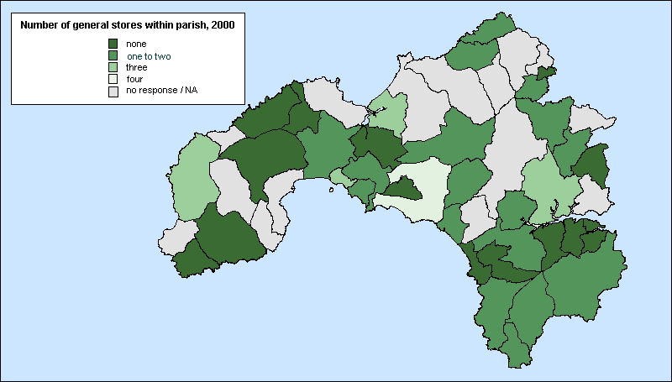
Source: 2000 Parish Survey (2000 RSS)

Petrol Filling Stations

In the South West as a whole, 71.2% of rural households live within 2km of a petrol station and 89.3% within 4km. However, petrol stations are not only a local service so location on main transport routes or the proximity of larger population bases is generally more important than proximity to smaller rural settlements or parishes. Nationally, 81% of rural parishes have no filling stations and, in Kerrier and Penwith, 67% of rural parishes, especially the less populous ones, have no filling station.

Public Houses

For many small rural communities, pubs often provide an important place to meet, especially where there is no village hall. Nationally, 75% of rural parishes responding to the Parish Survey have at least one pub, compared with 92% in Kerrier and Penwith. Their distribution within the region is illustrated in Figure 4.9.

The difference between West Cornwall and national estimates may partly be explained by the income generated by tourism for pubs and inns in Cornwall. However, most Rural Community Councils report a continuing decline in numbers of rural pubs. Smaller villages and more remote or isolated settlements are reported as more likely to experience pub closures than those attractive to tourists, larger village centres and pubs on main roads (Moseley and Chater, 2000).

Figure 4.9: Number of Public Houses in Kerrier and Penwith by Parish, 2000

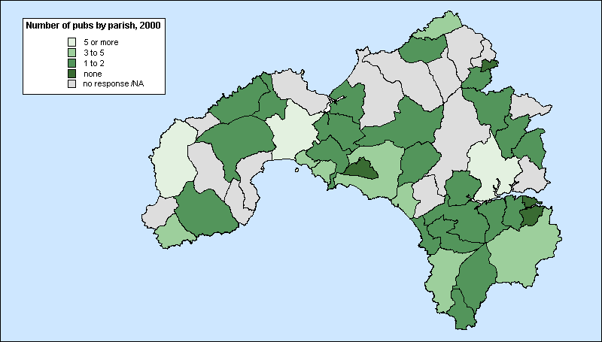
Source: 2000 Parish Survey (2000 RSS)

Public Transport Provision

Both public and ‘community’ transport services are important for increasing people’s mobility to access services and facilities in other locations. Nationally, only 35% of rural parishes responding to the Parish Survey reported the existence of a daily bus service (including Sundays) compared with 70% in Kerrier and Penwith. The distribution of public bus services is illustrated below.

Figure 4.10: Frequency of Public Bus Services in Kerrier and Penwith
by Parish, 2000

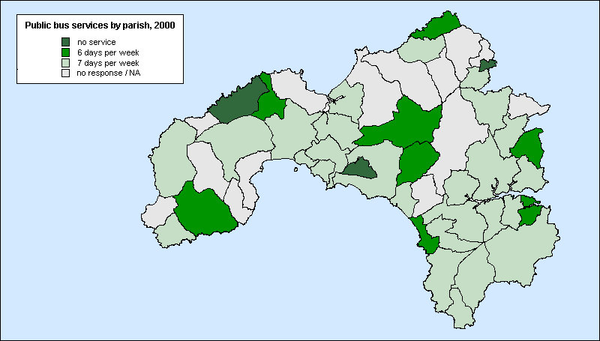
Source: 2000 Parish Survey (2000 RSS)

In addition to scheduled bus routes, community-level provision is now a key contributor to people’s mobility for residents in Kerrier and Penwith. Over half (51%) the rural parishes in the region responding to the Parish Survey benefit from access to a community-run vehicle for a wide range of journey purposes – an almost identical figure to national estimates (48%) (Countryside Agency, 2001).

Village Halls and Community Centres

A key part of the infrastructure for much local voluntary activity is an adequate community centre – both as a place for meeting and to host activities. Rural communities will generally not have the access to the range of public buildings which voluntary groups in some urban areas have but depend rather upon the existence of a village or church hall or other community centre.

There has been an increase in the availability of village halls since 1991 when only 70% of rural parishes nationally had one, partly as a result of Millennium funding. In Kerrier and Penwith, 76% of rural parishes responding to the Parish Survey have a village hall compared with 85% nationally. Their distribution is illustrated below.

Figure 4.11: Number of Village Halls in Kerrier and Penwith by Parish, 2000

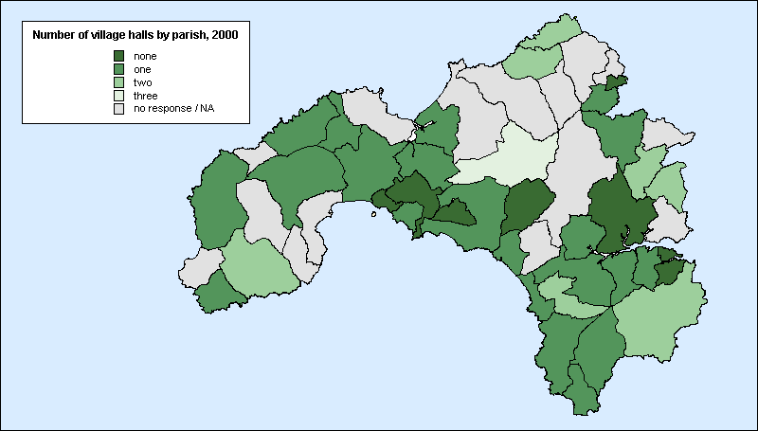
Source: 2000 Parish Survey (2000 RSS)

Community Internet

In Kerrier and Penwith, 24% of rural parishes responding to the Parish Survey had a community Internet facility in 2000 compared with just 9% of rural parishes nationally, as Figure 4.12, below, shows.

Figure 4.12: Community Internet Facilities in Kerrier and Penwith by Parish, 2000

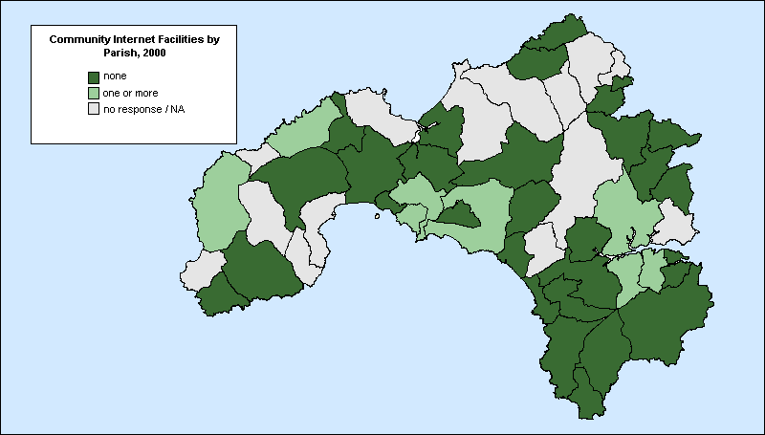
Source: 2000 Parish Survey (2000 RSS)

Youth Clubs

Twenty-four percent of rural parishes in Kerrier and Penwith responding to the Parish Survey had no youth clubs in 2000 compared with 49% nationally, as Figure 4.13, below, shows.

Figure 4.13: Number of Youth Clubs in Kerrier and Penwith by Parish, 2000

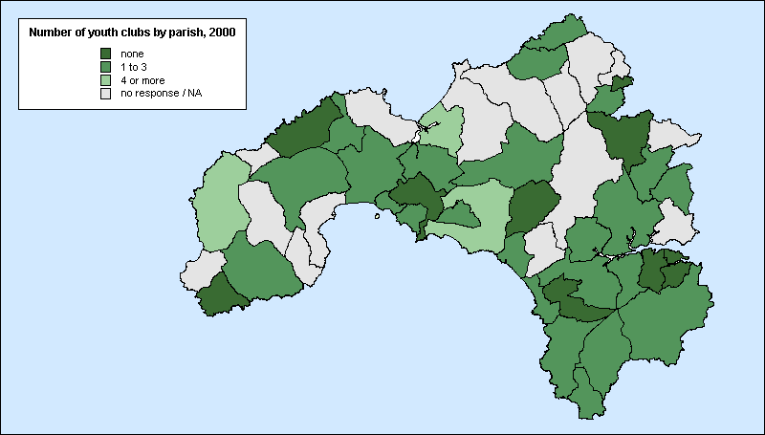
Source: 2000 Parish Survey (2000 RSS)

Conclusion

It must be acknowledged that, whilst Cornwall performs well in comparison with other rural areas, this does not imply that the quality of local services is always adequate in meeting local needs. The consultation exercise outlined above (Chapter Three) identified significant gaps in local service provision (eg in relation to local public transport provision), as well as a need for the modernisation of many community facilities (eg village and community halls). Moreover, not only is the provision of local services in West Cornwall insufficient in meeting the perceived needs of local people - and especially of disadvantaged groups - but the accessibility of services is an especially salient issue for those without access to a car – especially when compared to urban areas. The analyses presented above illustrate patterns of access at a specified radius (usually 2 or 4km). Whilst the presence of local services within these radii is often adequate for many people in urban areas (though not for the most income deprived) due to the availability of public transport, in more remote areas even at such distances access remains problematic for many people (eg. children, older people, disabled people).

REGENERATION AND COMMUNITY FUNDING

In addition to surveying the level and distribution of community services in West Cornwall it is also important to consider the flow of grant aid in West Cornwall since these constitute a key resource for local communities and a significant lever in neighbourhood regeneration. The following section outlines the various area based regeneration initiatives and other sources of community funding currently available in the UK, and their allocation in West Cornwall.

Area-Based Regeneration Initiatives
Objective One
Objective One is one of three programmes set up to help reduce differences in social and economic conditions within the European Union. Objective One is the highest priority designation for European aid and is targeted at areas where prosperity, as measured by GDP per capita, is 75% or less than the European average. In July 1999, Cornwall and Scilly were designated as an Objective One area under the new Structural Fund Regulations covering the period 2000-2006. In total, £314m will be available between the years 2000 and 2006 from all four structural funds (ERDF, EAGGF, ESF and FIFG).

http://www.objectiveone.com

Objective Two
Objective Two is an EU-funded support measure under the European Regional Development Fund and the European Social Fund. The new Objective Two combines the previous Two and Five(b) programmes and is designed for areas of urban, industrial, fishing and rural decline. Because the Objective Two area now includes much of the previous rural Objective Five(b) areas, there is scope for rural (not agricultural) projects to receive funding from Objective Two. Plymouth, South Hams, West Devon, Torridge, North Devon, West Somerset, part of Torbay and part of Bristol have been successful in obtaining Objective Two status. A population coverage of 585,000 has been achieved with £108m being available over the programme period. Transitional funding will also be available for those areas previously in receipt of structural funds but outside the new programme. Parts of Plymouth, Torbay, West Somerset and Mid-Devon - a population of 130,000 - will qualify and £10m will be available in these areas. Monies for Objective Two and Transitional areas will be available from ERDF and ESF.

LEADER+
LEADER+ is a six year European Community initiative for assisting rural communities in improving the quality of life and economic prosperity in their local area. Partnerships of local organisations and people receive funds to identify development needs within their rural communities which they set out in a development plan and to develop and test small-scale, innovative pilot projects to meet these development needs in a sustainable way.

http://www.defra.gov.uk/erdp/leader/leaderhome.htm

INTERREG III
INTERREG III is a Community Initiative designed to promote trans-national co-operation in spatial planning, in order to create balanced development and integration of the European territory, focusing especially on border areas within Europe. The South West falls within the Atlantic Arc and North West Metropolitan areas. There is the potential for significant complementarity between the schemes in terms of networking and information dissemination, with INTERREG bringing forward potential projects which could be pursued with LEADER+ funding.

EQUAL
EQUAL is a European Social Fund initiative that aims to combat all forms of discrimination and inequality in the labour market. The aims of EQUAL are complementary to LEADER+, particularly in promoting access to opportunities for the regional target groups of women, young people and the older working population.

England Rural Development Plan
The England Rural Development Plan encompasses schemes funded under the Common Agricultural Policy. It aims to refocus agricultural support to wider rural development. Several of the measures are extensions of existing funding programmes such as Countryside Stewardship, Environmentally Sensitive Areas, Organic Farming Scheme, Woodland Grant Schemes, Farm Woodland Premium Scheme and Hill Farm Allowance Scheme. The Plan also includes project-based rural development measures including the Rural Enterprise Scheme, Processing and Marketing Grant Scheme and Vocational Training Scheme.

http://www.defra.gov.uk/erdp/docs/erdpdocsindex.htm

County Rural Development Programme
County Rural Development Programmes are integrated programmes of social and economic projects developed by local cross sector partnerships to address the priorities identified in the Rural Development Programme Strategies. There is a partnership in each of the six Shire Counties in the South West region with strategic direction given to the process by elected member-led committees.

http://www.cornwallenterprise.co.uk/

Single Regeneration Budget
The Single Regeneration Budget aims to support area-based regeneration initiatives driven by local partnerships. Throughout the South West Region, £31 million has been won from the Government’s Single Regeneration Budget. This aims to safeguard or create 2000 jobs and provide training and development opportunities for 37,000 people. A Single Regeneration Budget round six has been announced for the coming year. However, it is likely that this will be the last round of funding.

Coastal and Market Towns Initiative
This is a new joint initiative launched by the Countryside Agency and South West Regional Development Agency to provide funding to aid capacity building in and around market and coastal towns in the South West region. The scheme is currently under discussion and is being developed. A national pilot has been undertaken in another region of the UK and nine towns in the South West, including Helston, are currently participating in the scheme. In Helston, a Community Strategic Plan is being developed to include the list of priority projects highlighted at the Community Event held at RNAS Culdrose in summer 2001. A proposal bid totalling £200,000 over 3 years is currently under consideration.

http://www.southwestrda.org.uk/development/market_towns.shtml

Countryside Agency’s Land Management Initiative
This initiative aims to demonstrate how managing land to achieve a healthy and attractive economy can be achieved, while maintaining or improving the viability of farming businesses and enhancing the economic and social prospects of rural areas through practical solutions to local issues. Potentially, the South West has two of the initial 12 schemes; the South West Forest on the Cornwall/Devon border, and the Severn Vale on the Gloucestershire/Herefordshire/Worcestershire border (shared with Government Office for the West Midlands). The South West Forest is already operating, however, the Severn Vale has yet to start.

Existing funding streams are used to implement ideas where they exist, including Structural Funds and project-based schemes under England Rural Development Plan, Regional Development Agency funding streams, etc. Countryside Agency experimental funding will be required for novel, untested solutions. LEADER+ could therefore complement by concentrating on rural development which is not land-based within Land Management Initiative’s remit or by supporting solutions beyond the funding capacity of the Land Management Initiative.

Health Action Zones
Health Action Zones (HAZs) are a new way of tackling health inequalities which link health with regeneration, employment, education, housing and anti-poverty initiatives in order to respond to the needs of vulnerable groups and deprived communities. The HAZ initiative brings together organisations within and beyond the NHS (eg Local Authorities, the voluntary and private sectors, local communities) to develop and implement locally agreed strategies for improving the health of local people. A central aim for HAZs is integrating the services and approaches they are developing into mainstream activity.

Altogether, more than £274 million has been made available to assist HAZs in the three years from April 1999. The 26 HAZs are located in some of the most deprived areas in England, including inner cities, rural areas and ex-coalfield communities. Cornwall and the Isles of Scilly were awarded HAZ status in May 1999. The HAZ has set out a seven year programme of change with funding totalling £3.6 million. This enables services to be reshaped in order to better address the problems caused by rural deprivation and isolation.

http://www.doh.gov.uk/pricare/haz.htm

Employment Action Zones
Employment Action Zones are designed to help long term unemployed in areas of concentrated or multiple deprivation to improve their employability with a view to obtaining sustained employment or self employment and began operating from April 2000.

Education Action Zones
Education Action Zones (EAZs) allow local partnerships to develop new and imaginative approaches to raising standards in disadvantaged urban and rural areas. Each EAZ includes a cluster of two to three secondary schools with their supporting primaries and special schools working in partnership with LEAs, parents, business and other representatives from the local community. There are now 73 large EAZs throughout the country. Each EAZ receives up to £750,000 funding per year from the DfES and in return they are required to raise £250,000 per year from the private sector.

The Cornwall EAZ, CPR Success Zone, was established in May 2000 and covers three secondary schools and 27 primary schools in the North Kerrier area. CPR Success Zone receives £500,000 per annum for the next three years with an additional £250,000 per annum dependant upon private sector support.

http://www.standards.dfee.gov.uk/eaz/

Sports Action Zones
Sport Action Zones, initiated under the direction of Sports England, aim at encouraging co-operation between schools, sports clubs and other voluntary groups in deprived areas in order to improve sporting and recreational opportunities. Funding is mainly revenue-based, focusing around sports and community development officers, coaches and sports leaders and other outreach workers. Cornwall was among the first 12 Sports Action Zones to be announced.

http://www.sportactionzone.org.uk/
Sources of Community Funding

The Community Fund
Since its launch in 1995, the National Lottery (now The Community Fund) has become a principal focus for community grant support to charitable, benevolent and philanthropic organisations in England and Wales, granting more than £1.5 billion to over 30,000 groups (NLCB Annual Report, 1999-2000). Community groups in Kerrier and Penwith have received more than £8.6 million in National Lottery funding between 1995 and 2001. During this period, 82,400 funding applications were received by the NLCB, of which 30,023 (ie 36%) were successful. More than 650 applications for National Lottery funding have been submitted by local groups in Kerrier and Penwith alone - with a success rate of 39%.

http://www.community-fund.org.uk

New Opportunities Fund
The New Opportunities Fund is National Lottery funding awarding grants to health, education and environment projects throughout the UK. Grant programmes focus particularly on the most disadvantaged sections of society. In total, the constituencies of St Ives and Camborne and Falmouth received over £3 million from the New Opportunities Fund to January 2002.

http://www.nof.org.uk

Sport England
Provides financial support to local sporting organisations through Lottery-funded programmes, primarily for capital schemes over £5,000. There are additional Lottery funding streams due to come on line during 2001 which will include funding for green spaces, informal recreation areas and school playgrounds. In the 1999-2000 funding round, Cornwall secured £3.5 million from Sports England, of which Kerrier and Penwith received over £2.9 million (ie 83% of Cornwall’s grant allocation).

Since 1995, ‘Priority Areas’ have increase the level of Sports Lottery funding going to rural and inner city areas. Over 180 Local Authorities are defined as Priority Areas, along with all authorities in Rural Development Areas (including Kerrier and Penwith). Applicants from these areas benefit as they can apply for up to 90% of the total capital cost of any project. As a result, while 25% of the population live in Sport England’s ‘Priority Areas’, both urban and rural, they have received 57% by value of the local grants (National Lottery Yearbook, 1999).

http://www.nof.org.uk

Community Fund Spending in the South West

In the past, a range of problems have frustrated attempts to reliably map funding flows at a Local Authority level - not least an absence of consistent and standardised information from Local Authorities and, to a lesser extent, central Government. The most recent study by Coombes et al (2000), commissioned by The Community Fund, investigates the spatial distribution of funding directed at combating deprivation from the available, nationally comparable sources. In these terms, the South West as a whole is the third best funded region (per claimant) as Table 4.3 (below) shows:

Table 4.3: Community Funding in the UK by Region, 1998

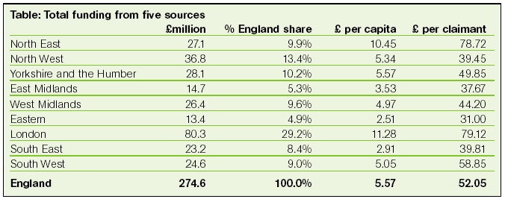
Source: Coombes et al (2000)

However, whilst there is some relationship between per capita funding and regions’ relative level of need at more local levels, the link between the degree of need and of funding is much less evident, as Figure 4.14 (below) shows.

Figure 4.14: Community Funding from Different Sources in the Southwest by County, 1998

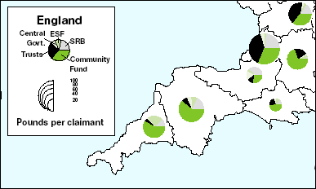
Source: Coombes et al., 2000

Many areas of high deprivation are especially dependent upon public sector funding. However, as Coombes et al (2000) reveals, this is less likely to be the case in rural areas. Nationally, the funding source whose distribution most closely matches the pattern of need (as measured by the Claimant Count) is The Community Fund.

One consequence is thus that The Community Fund is the most important source for parts of the country which tend to be over-looked by other funders, especially rural areas and the more southern regions including West Cornwall, as Figure 4.14 (above shows). Coombes et al (2000) shows that over half (55%) of all Community Fund spending was directed at combating deprivation in 1998 and this represented over one third (36%) of all funding for voluntary groups across England.

Community Fund grants are particularly important to rural areas, not least because other funders tend to focus on cities. The distribution of Community Fund spending in West Cornwall is illustrated in Figure 4.15 which shows that Community Fund spending is concentrated in the Penzance area, around Camborne and Pool and in the Lizard peninsula.

Figure 4.15: Community Fund spending in West Cornwall since 1995 by postal area

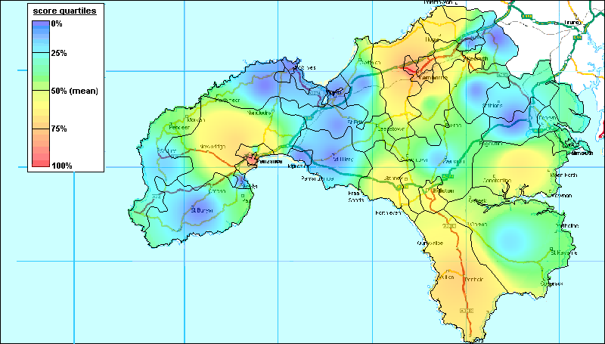
Source: The Community Fund

However, given the Community Fund’s stated focus on grant support to deprived areas, the ‘fit’ between Community Fund spending and deprivation in West Cornwall is not close. Many of the most deprived areas as identified at a sub-ward level using 1991 Census data (see Figure 2.25) have not benefited substantially from Community Fund spending. These areas include Redruth, Hayle and St Ives, St Just and Pendeen, Newlyn, Marazion, and parts of Helston.

COMMUNITY ORGANISATION

Introduction

Increasing participation in volunteering and community activity in poor neighbourhoods has been acknowledged as a key policy objective within the Government’s Active Communities Unit. Their report outlines a range of targets both for fostering community development generally and specifically in relation to widening community involvement in the voluntary and community sectors (ACU, 1999).

Encouraging the development of more active rural communities is also central to rural strategy envisioned within the Government’s rural white paper, Our Countryside: The future (DETR, 2000). Our Countryside emphasises the importance of sustained support for community initiatives in terms of community infrastructure (eg village halls), project funding and community development work. Underlying all these initiatives is an increased emphasis upon the vitality and cohesiveness of rural communities. One important indicator of community vibrancy in each of these policy documents is the extent of community involvement in voluntary sector organisations. The remainder of this chapter explores the level and distribution of voluntary sector organisation in Kerrier and Penwith.

Methodology

The relatively transient and unstructured nature of much voluntary community action poses a range of methodological challenges. Local groups frequently lie dormant, disestablish or change their form over time, in the process undermining the reliability of estimates of local community activity. Moreover, differences in the geographical coverage of voluntary groups make direct comparisons difficult – some groups cover vary small areas whilst others operate at a larger spatial scales such as Local Authorities or even counties.

For the above reasons, no listing of voluntary organisations will ever be entirely reliable. The findings presented in the following sections should therefore be treated as illustrative rather than presenting a definitive guide to voluntary organisation in West Cornwall and the conclusions presented here are therefore tentative.

Cornwall County Council’s CWIC database has been used as the main source of data on community organisation. All the records contained in the CWIC database are no more than 14 months out of date at the time of writing. There is no scientific way of reliably establishing the coverage of the CWIC database, although it is anticipated that this source will be validated by cross-reference to other existing sources of information.

In collaboration with colleagues at Camborne College, the research team classified all references in the database for Kerrier and Penwith Local Authority areas within the following typology of community organisation:
- Hobbies and crafts
- Environment and rural issues
- Sports and leisure
- Education, employment and skills
- Health and para-health
- Community advice and empowerment
- Youth, the aged, and ‘minority’ groups
- Faith-based organisations
- Other

In total, the CWIC database listed 1,185 voluntary and community organisations in Kerrier and Penwith – 562 in Kerrier and 623 in Penwith. Of these, 1,056 (89%) contained a postcode reference. It was thus possible to map the distribution of these community organisations in west Cornwall against postcode boundaries. Detailed below are the frequency and distribution of voluntary organisations in West Cornwall – as derived from this database.

Findings
Figure 4.16 below illustrates the distribution of voluntary organisations in West Cornwall across the categories listed above. Within this categorisation ‘Youth, the aged and other ‘minority’ groups’ accounts for the greatest proportion (19.5%) of total levels of voluntary organisation – though not necessarily the greatest total membership. This is a very diverse category including youth groups, mother and toddler groups, The Women’s Institute, British Legion groups and a host of other ‘demographically-based’ interest groups. ‘Hobby and craft’ pursuits are the second largest category, accounting for 17.6% of organisations within the sector.

Figure 4.16: Distribution of Voluntary and Community Organisations in Kerrier and Penwith, 2001 (%)
Source: Cornwall County Council CWIC database

In the absence of external validation and given the scale of measurement (postcode district) dictated by the data source, any conclusions about the geographical pattern of voluntary activity are necessarily tentative. However, overall, the spatial distribution of voluntary organisation in West Cornwall broadly reflects patterns of settlement, with voluntary groups being concentrated in the more populous areas, as Figure 4.17 below shows:

Figure 4.17: Voluntary and Community Organisations in Kerrier and Penwith, by Postcode Area, 2000

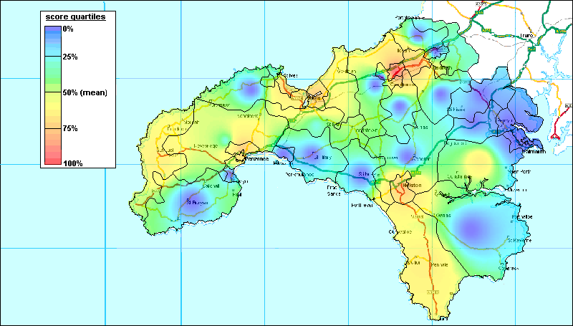
Source: Cornwall County Council CWIC database

Nonetheless, there are some interesting variations from this general pattern. In particular, the Lizard area appears to support a higher level of voluntary and community organisation than might be expected given its very low population density. Conversely, both St Ives and especially Newlyn show lower levels of community organisation than might be expected given their population densities. However, as was noted above, the geographical coverage of sampled organisations varies so low levels of community organisation in these areas are not necessarily indicative of low levels of community participation since residents may simply be travelling to surrounding neighbourhoods.

This claim has been made on a numerous occasions by Dom Mintoff (the ex-Prime Minister of Malta) and others.
Rural parishes are defined by the Countryside Agency as parishes with populations of less than 10,000. On the basis of 1991 Census population estimates, the parishes of Carn Braa, Penzance, Helston, Camborne and Redruth are thus excluded from the 2000 RSS parish data set.
This includes Beavers, Cubs, Scouts, Rainbows, Brownies, Girl Guides, Youth Social Clubs, Youth Parish Councils and Young Farmers as well as statutory provision.
These were: charitable trusts and foundations; the European Social Fund; the Single Regeneration Budget; selected central government schemes and the Community Fund.

