Documenting Performative Practice — tracing

© Elena Cologni, 2003, Research Centre, Central Saint Martins College of Art & Design, The London Institute, Southampton Row, London, elenacologni@hotmail.com
(video live installation-paper 45 minutes)

My presentation will attempt to respond to the following question:

‘Must practice as research include some form of disseminable reflection or is the practice in performance/screening contexts sufficient to stand as research outputs? 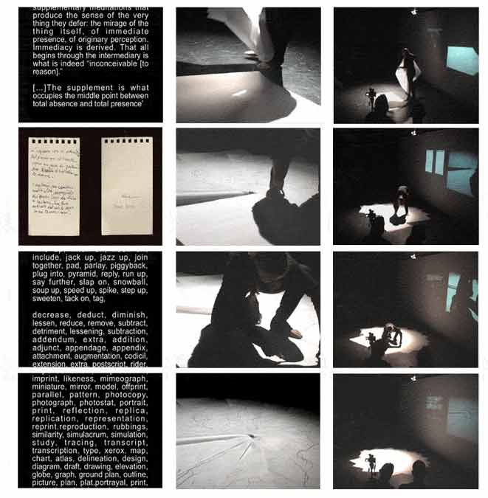

‘What might be the role of documentation?’

This is structured in two parts: the first posing an hypothesis and the second a thesis, hoping to discuss together at a later stage what the synthesis might be. Initially, by means of a brief introduction to my research background, I will present a case study — my own research experience — to illustrate how the documentation of performance art pieces, in order to collect research outcomes, was subsequently incorporated into the performance format itself. This process, supported by, while generating, its theoretical critical contextualisation, thus became evidence of its status of research. The ‘video-live-installation’ presentation was since adopted as a format of artistic expression that incorporates research strategies of audience involvement in the art-making process.

Subsequently, by performing the piece tracing I will both present and represent my performative self simultaneously, thus opening up questions within a debate regarding issues of presence/representation, the live spectacle and its simultaneous documentation as perceived by you audience. This process of the construction and recording of the documentation as supplement (part) of the live event results in the paradox of its status as documentation, or does it? With the infinite possibilities offered by digital media, and in the derridean logic of différance, this stage may not be the closure point, but it may instead generate new discourses, thus acquiring an ontological prerequisite of aperture.

------------------------------------------------------

The beginning of my research study coincided with the focus of my Art practice on interactivity, which was subsequently addressed as the interchange based on Amelia Jones’s concept as described in Body Art, Performing the Subject. By adopting an empirical methodology in developing my study, the research was led by Art practice opening up new hypothesis to be tested both in the theoretical and in the artistic context. In this process the Lacan’s concepts of Mirror Stage and Gaze, and Merleau-Ponty’s Chiasm or Intertwining were particularly suitable for a visual and spatial reading thus bridging the theory and the practice.

I developed a method for involvement of the other — my own image, the audience, the environment — in order for the input to become part of the work itself.

As my understanding of the anti-ocularcentric philosophical ground for my practice developed, I became more aware of the significance of dynamics of perceptual involvement, often based on synaesthetic relations, where vision had lost its primacy over the other senses. It is in this context that my performative practice based on the interchange and chiasm became the ground for my present investigation.

Jones states that Body Art tells us that the self is inexorably embodied, and yet she argues that the works suggest that this does not mean that the performed body/self is ever completely legible or fixed in its effects. ‘Body Art, through its very performativity and its unveiling of the body of the artist, surfaces the insufficiency and incoherence of the body/self (or the body-as-subject) and its inability to deliver itself fully (whether to the subject-in-performance herself or himself or to the one who engages with this body).’

The unique body of the artist in the Body Art work has meaning by virtue of its contextualization within the codes of identity that accrue to the name/body. Thus, this body is not self-contained in its meaningfulness; it is a body/self, relying not only on an authorial context of ‘signature’ but also on a receptive context in which the interpreter or viewer may interact with it. This context is precisely the point at which the body becomes a ‘subject’. Documents of the body-in-performance are just as easily contingent in that the meaning that accrues to the image of the body is open-ended and dependent on the ways in which the image is contextualised and interpreted. Seemingly ‘acting as a “supplement” to the “actual” body of the artist in performance, the photograph of the Body Art event or performance could in fact, be said to expose the body itself as supplementary, as both the visible proof of the self and its endless deferral.’

Jones argues that the sequence of supplements initiated by the Body Art project — the body ‘itself’, the spoken narrative, video, and other visuals within the piece, the video, film, photograph, and text documenting it for posterity — announces the necessity of ‘an infinite chain, ineluctably multiplying the supplementary mediations that produce the sense of the very thing they defer: the mirage of the thing itself, of immediate presence, or originary perception.’ Derrida notes that ‘the indefinite process of supplementarity has always already infiltrated presence, always already inscribed there the space of repetition and the splitting of the self’.

The relationship between presence and representation through documentation is imbedded in my own production methodology, particularly, the synchronic way of working in different media (photographic, video, live) has led me to conceive a form of presentation of my work, which contains them all simultaneously. The type of format of work that I define as video live installation includes the elements of: performativity (that because of its nature gives the character of unique and temporary to the event); the involvement of the audience because their perception of the piece complete its meaning; the question of the relation between presentation and representation in the present time of the piece’s apprehension and delivery. The most significant point is that the documentation of the event is both produced and perceived during the event itself and this process is therefore witnessed by the audience.

The multiplied represented image of myself thus created in the video live installation format, as well as the production of the subsequent resulting artistic outcomes (video documentation, video stills, voice or text), are all based on conceptual compositions of the ontology of the mirrored image, which is projected, infinitely repeated and rebound echoing back that image. In this sense the enactment of the self in my work generating the supplementary representations of the self and encompassing time and movement, not only contributes to, but also reinforces the questioning of the ocularcentric discourse posed by the mirrored self in self-portraiture in my previous research.

The video live installations allow me to understand the relationships between my public and private personas, and between presentation and representation in the live spectacle and its simultaneous documentation. This is considered as a form of ‘present memory’ of the event and relate to the audience’s perception of it; also, from this, discourses of live and mass media culture (Philip Auslander’s on live/mediatized) emerge. Furthermore, in referring to Derrida’s concept of deferral, by creating a ‘live time distancing’ from the event as part of its delivery in the present time of its perception, a mirror parallel between the production of the performance’s ‘supplements’ and methods of memory archiving becomes possible.

In this context the documentation for research may stand for proof for the live event, but it also becomes something else from it and thus never fully document it; the nature of live Art is in the liveness of both its delivery and fruition, but also of the continuously shifting contextualisation of its produced supplements.

Bibliography

Anderson, Laurie , ‘What is body Art?’ from Confessions of a Street Talker, 1975, in Laurie Anderson, Stories from the Nerve Bible: a retrospective 1972-1992, New York, Harper Collins, 1994

Derrida, J., Of Grammatology, tr Gayatri Spivak, Baltimore: John Hopkins University Press, 1978.

Derrida, J., Memoirs of the Blind, The Self-Portrait and other Ruins, Chicago and London, The University of Chicago Press, 1990.

Derrida, J., That Dangerous Supplement, in Of Grammatology, tr Gayatri Spivak,
John Hopkins University Press, Baltimore, 1978.

Gasche, R., The Tain of the Mirror, Derrida and the Philosophy of Reflection, Harvard University Press 1986, 1997 5th printing.

Jay, M., Downcast Eyes, the Denigration of Vision in Twentieth-Century French Thought, University of California Press, 1994.

Jones, A., Body Art, Performing the Subject, University of Minnesota Press, 1998.

Maurice Merleau-Ponty, The Visible and the Invisible, trans. Alphonso Lingis, Evanston, Northwestern University Press, 1968.

Merleau-Ponty, M., The Visible and the Invisible, trans. Lingis, A., Evanston, Northwestern University Press, 1968.

Nemser, Cindy, ‘Subject-object Body Art’, Arts Magazine 46, n.1, Sept-Oct 1971.

Schmidt, J., Maurice Merleau-Ponty, Between phenomenology and structuralism, Theoretical Traditions in the Social Sciences, MacMillan Publishers London, 1985.

Vergine, L., Il corpo come linguaggio ( la ‘Body-art’ e storie simili), Giampaolo Prearo Editore, Milano, 1974.

