Adult ADHD Screening and Assessment

Patient Information Pack

Why have I been referred?
Your GP has referred you to the Adult ADHD Screening Service because you have reported symptoms that may be consistent with Attention Deficit Hyperactivity Disorder (ADHD).
Being referred does not mean that you have ADHD. The screening process is the first step in helping determine whether a full ADHD assessment would be appropriate and beneficial for you.
In our BNSSG area, everyone referred for possible ADHD follows the same screening pathway. This helps ensure that each person receives the most appropriate and timely care based on their individual needs. If screening indicates that a specialist ADHD assessment is the right next step, you can then discuss your Right to Choose options for the provider who will carry out that assessment once it has been determined that you need it.

What happens next?
Your GP practice will send a referral to the Avon and Wiltshire Mental Health Partnership (AWP) Adult ADHD Screening Team.
The screening team will then contact you and invite you to complete a series of questionnaires through a secure online system called ATMOS. These include:
- A patient information form
- Questionnaires about ADHD symptoms
- Questions about how these symptoms affect your daily life
Once you have completed the questionnaires, the screening team will review your responses and prepare an outcome report, which will be shared with both you and your GP.

Completing your questionnaires
Please complete the questionnaires within three weeks of receiving them.
If you think you may have difficulty completing the questionnaires, please seek support as soon as possible. Reasonable adjustments can be made where needed. Please contact us at:
awp.adhdtool@nhs.net
We will do our best to accommodate your needs.

Your ADHD Screening Timeline
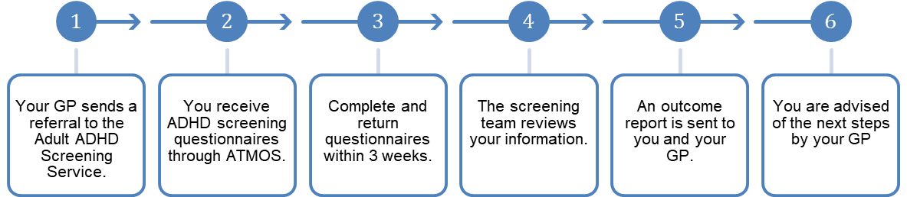

Possible outcomes of screening

Outcome 1: ADHD is not indicated

Following a careful review of the information provided, the screening team may decide that a full ADHD assessment is not the most appropriate next step at this time.

This does not mean that your symptoms are not real or that the difficulties you are experiencing are not having an impact on your daily life. Rather, the information available suggests that ADHD may not be the most likely explanation for your experiences.

If this is the outcome, you will receive a letter explaining the reasons for the decision and outlining any alternative factors or conditions that may better account for your symptoms. Your GP can discuss these findings with you, answer any questions you may have, and help you explore other forms of support, assessment, or treatment that may be beneficial.

Outcome 2: Further ADHD assessment recommended
If the screening suggests that a full ADHD assessment would be helpful, you will be asked to contact your GP practice to discuss referral options.
If you meet the criteria for priority assessment, you will automatically be placed on the priority waiting list for the AWP Adult ADHD Service. This may be particularly beneficial if you have complex needs that are best supported within a specialist NHS ADHD service. If you prefer, you can choose to opt out of this arrangement.
Your GP will discuss the available assessment options with you, which may include:
- AWP Adult ADHD Service (NHS)
- Clinical Partners (Right to Choose)
- Another Right to Choose provider
Some GP practices now have clinicians trained to undertake ADHD assessments within the practice. If this is available to you, your GP practice will let you know.

Important information
Not all Right to Choose providers offer:
- Medication titration (adjustment of medication doses)
- Ongoing medication reviews
- Long-term follow-up care
These factors should be considered carefully when choosing a provider as it may affect the acceptance of your ongoing care back into your GP surgery.

How long will onward referral take?
Waiting times vary depending on the provider you choose. Once you have been referred for assessment, your chosen provider will give you information about their current waiting times.
The screening stage is generally completed much more quickly than a full ADHD assessment.

What can I do while I am waiting?
Many people find it helpful to learn more about attention difficulties and develop self-management strategies while waiting for an assessment.
You may find the following helpful:
- Establishing daily routines
- Using reminders, calendars and planners
- Breaking larger tasks into smaller, manageable steps
- Improving sleep habits
- Engaging in regular physical activity and exercise
- Eating a healthy diet
- Addressing specific mental health needs such as anxiety and mood related difficulties
- Seeking support from family, friends or peer support groups

