How can (name of child) be looked after and kept safe?
(Name of social worker) and his/her manager are worried that you may not always be able to keep (name of child) safe.

(put your photo here)

We have talked about this in the Danger Statement poster.

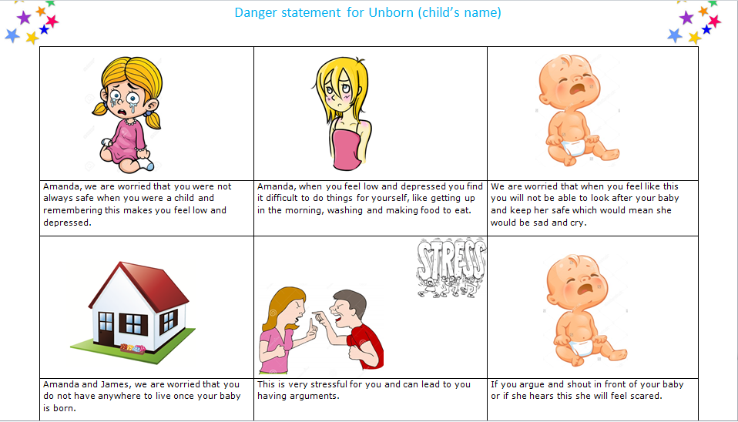

(Brief explanation of the worries/why it is not safe at home) (Name of parent), (for example:) sometimes when you feel very low you struggle to find the energy to look after yourself properly. We are worried because if you struggle to look after yourself we just do not know how you will manage to look after (name of child).

(Simplified Re BS) We do not think it would be safe for (name of child) live with (name of alternate family member) because (brief reason)

We just do not know how you will be able to look after (name of child) once she is born.
(Simplified care plan example) We would like you to go to a parent and child foster placement with (name of child) so the carers can help you to learn how to look after (name of child) and support you to make sure she is safe all of the time.
You would be responsible for looking after (name of child), doing things like changing her nappy, cuddling her and giving her bottles. The foster carers’ job would be to help you remember to do all of these things so (name of child) can be happy and feel safe.

(Consideration of father) (Name of father) has said that he does not want to look after (name of child) at the moment because he would like you to do this/(name of social worker) does not think that it would be safe for (name of father) to look after (name of child) because (reason).
(Contact) (Name of mother if care plan is not for p&c) would like to see (name of child) and we think that (frequency) for (time) would be the right amount of time for her to have with (name of child). This would be somewhere safe like (venue) and would be (level of supervision).
(Name of father) would like to see (name of child) and we think that (frequency) for (time) would be the right amount of time for him to have with (name of child). This would be somewhere safe like (venue) and would be (level of supervision).

(brief rationale for order being sought, for example:) When you are in the foster placement with (name of child) sometimes you might feel lonely, stressed or low and want to go back to live with (name of partner/family member). We are worried that if you change your mind this would not be safe for (name of child, so (name of social worker) would like to ask the judge for an Interim Care Order so (name of child) can stay in the foster placement, even if you change your mind.

(put your photo here)
We will go to court and talk to the judge about how to keep (name of child) safe once she has been born. After this we will need to go back to court twice more and tell the judge how things are going. This will all take about 26 weeks, which is six months. This will give us time to work together and think about how you can keep (name of child) safe both now and in the future.

(calendar to show end of proceedings’ date)

