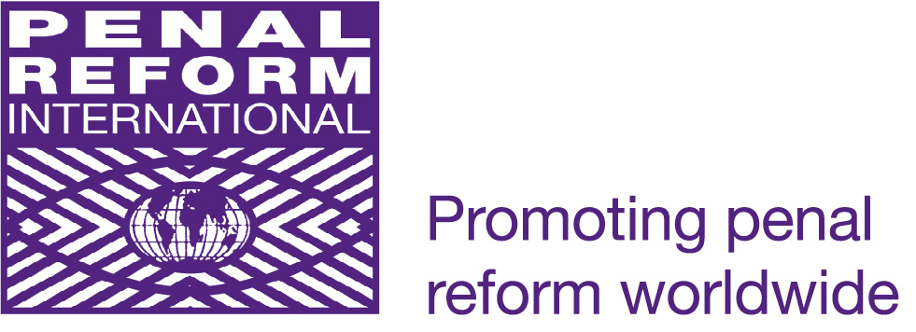

Human Rights Implementation Centre
OSCE Review Conference, Warsaw Part
Tuesday, 5 October 2010
13:00 – 15:00, Meeting Room 3

Side Event: ‘Why are we still talking about torture? The need for preventive strategies.’

Background paper
For decades there have been various initiatives at international, regional and national levels to combat the occurrence of torture. At the international level, in 1984, the UN adopted the Convention against Torture and Other Cruel, Inhuman or Degrading Treatment or Punishment (UNCAT), which came into force some three years later. This instrument was aimed at criminalisation of torture and eradication of impunity for the crime of torture. Pursuant to the provisions of the UNCAT, a Committee against Torture (CAT) was established, charged with oversight of the implementation of the UNCAT by its states parties.
In 1985, the efforts to combat torture were further strengthened at the international level by the creation of the post of Special Rapporteur on torture and other cruel, inhuman or degrading treatment or punishment at the UN with the core elements of mandate being visits to states and tailored advice on how to eradicate torture and ill-treatment.
These special measures at the UN level were of course complementary to existing measures, such as the prohibition of torture and other ill-treatment contained in the International Covenant on Civil and Political rights.
At the regional level, the prohibition of torture and ill-treatment followed a similar pattern. The European Convention on Human Rights, adopted in 1950, contained a non-derogable prohibition of torture in its Article 3. Then, in 1987 a new instrument was drafted, the European Convention for the Prevention of Torture and Inhuman or Degrading Treatment or Punishment (ECPT). The main contribution of this instrument was the establishment of the Committee on Prevention of Torture (CPT) with a mandate to visit states parties to the ECPT and their places of deprivation of liberty with the aim of providing tailored advice on how to eliminate torture. On the American continent, the American Convention on Human Rights was adopted in 1969 and the Inter-American Convention to Prevent and Punish Torture in 1985.
These universal and regional instruments are continuously updated by corresponding monitoring mechanisms through contemporary interpretation of their provisions and advancement of relevant jurisprudence and standards. In particular, the European Court of Human Rights with its legally binding judgements as well as UN Human Rights Committee and the UN Committee against Torture contribute to the further elaboration of standards through their decisions on individual cases relating to torture and ill-treatment.
The OSCE also has numerous commitments in place which clearly state the commitment of the participating States to the absolute nature of the prohibition against torture. States have taken upon themselves, as a political obligation, the eradication of torture and other cruel, inhumane or degrading treatment or punishment in the OSCE area.
In addition, an array of non-treaty instruments (declarations, recommendations, bodies of principles, codes of conduct and guidelines) have emerged that provide practical guidance on implementation, for example, the UN Standard Minimum Rules for the Treatment of Prisoners (1955), UN Basic Principles on the Role of Lawyers (1990), and the Role of Prosecutors (1990), Principles and Best Practices on the Protection of Persons Deprived of Liberty in the Americas (2008), European Prison Rules (2006).
The standard setting and monitoring efforts at international and regional level have not been in vain. Changes have been made in the domestic legislation of many countries in the OSCE area, and policies and working plans have been developed to assist with implementation. In many cases torture has been publicly condemned, adequately defined and criminalised, adequate penalties have been provided for, and standards and norms have even found their reflection in regulation. International organizations, international non-governmental actors and local NGOs have tirelessly engaged in providing training on torture and ill-treatment to various parts of society, including law enforcement agencies, judges and prosecutors, lawyers and human rights defenders.
However, the practice of torture and other forms of ill-treatment persists in countries of the OSCE region.
The aim of this side event is discuss the factors that make it possible for torture to recur. The speakers will approach the subject of torture from the perspective of prevention, rather than response to what has already occurred. This requires a holistic examination of existing state systems (in particular the criminal justice system), and analysis of the extent to which systemic elements contribute to the persistence of torture. It will be argued that only such an approach can lead to success in any torture prevention exercise, and that this approach lies at the heart of implementation of the Optional Protocol to the UNCAT.

Speakers:
- Zbiegniew Lasocik, member of the UN Sub-Committee Against Torture and Law Professor
- Eric Svanidze, former member of the CPT, expert on torture and detention monitoring
- Saule Mektepbayeva/Mary Murphy, Penal Reform International
- Elina Steinerte, Bristol University, Human Rights Implementation Centre
Moderator:
Liane Adler, OSCE Office for Democratic Institutions and Human Rights

The event will take place in English and Russian language. Refreshments will be served.

