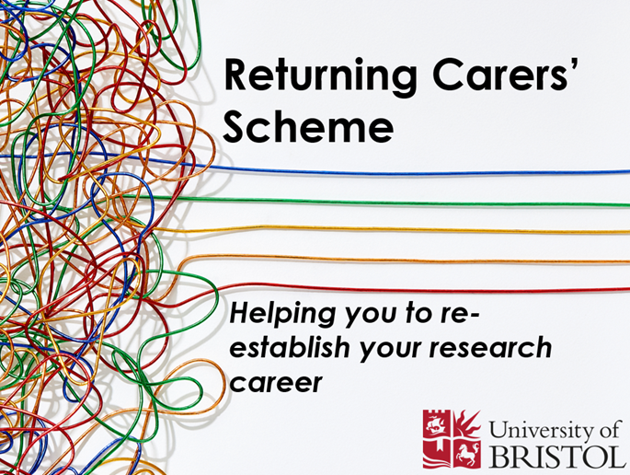

Returning Carers’ Scheme (RCS)

APPLICATION FORM

SECTION A: PERSONAL DETAILS – To be completed by employee

Name:

Job title:

Gender:
Pathway and level:

School / Department:

Faculty:

Date of application:

EQUALITY DATA MONITORING- PLEASE CHECK THIS BOX IF YOU GIVE YOUR PERMISSION FOR THE EDI TEAM TO OBTAIN YOUR DEMOGRAPHIC DATA FROM MyERP ☐
It is voluntary to disclose the following information but doing so will enable us to better understand the experience of staff from different groups and to examine whether or not we are meeting everyone's needs.

All responses are anonymous, the information disclosed will be treated in the strictest confidence, and all data stewardship will comply with GDPR regulations.

SECTION B: DETAILS OF LEAVE TAKEN – To be completed by employee
This can include, but is not restricted to:
- Adoption leave
- Career breaks for family reasons
- Leave to care for a dependant
- Maternity leave
- Parental leave
- Paternity leave

This leave must be a continuous period of 16 weeks
Reason for leave taken:
Start date of leave:

End date of leave:

Any additional information you wish to provide:
SECTION C: REQUEST FOR SUPPORT – To be completed by employee (total text for Section C not to exceed two sides of A4). Please liaise with your Head of School, HRBP and Faculty Finance contact. Requests for funds should not normally exceed £10,000 in total. Applicants are advised to ensure their application covers the following points to demonstrate to the panel how their application meets the remit of the fund:
- Outline the impact taking the leave has had on your career trajectory in the short or long term
- Outline any barriers you have faced as you returned to work, or longer-term impact
- Detail how the funded activity you are asking for will help you overcome these barriers and difficulties
- It is helpful to include information on why this activity is or cannot be funded by your current source of funds
- Briefly outline your plans for the coming few years, and how this activity will support your career development
- Be as specific as you can about outcomes from this award (publications, future grant applications, a unique skillset etc.) and how they will support your career plans.
Please note: this scheme is not a bridging fund between funding contracts.

Impact of leave taken on research activity/outputs:
Level and nature of funding requested: | Please provide total sum plus an itemised list of precise costs and nature of the support that this funding will cover, including the financial year/s during which the expenditure will fall.
Reason(s) for funding request: | Please set out how the funding requested will mitigate the impact that the time out of the workplace has had on your research activity and support the further development of your career as a researcher. Please include details of the research outputs/activity that will result from this funding.

SECTION D: STATEMENT OF SUPPORT – To be completed by the Head of School

Please provide confirmation that the proposal fits with Faculty/University research priorities and that the funding will result in a positive contribution towards the research portfolio of the School, as well as any other information that you deem relevant to this application. Please also consult with HRBPs and Finance Business Partners before confirming the endorsement.
Name of Head of School:
Signed: |  | Date:
Checking this box will be accepted instead of a signature if you are submitting this form via email

SECTION E: CONFIRMATION – To be filled in by the Faculty HR Business Partner

Please provide confirmation that that all dates, costs, salary, and financial year information is provided and commensurate with the details of the proposal (via liaison with Finance and Payroll as required) and that all sections of the form have been completed and are accurate (including the details of leave taken). Please include any amendments that need to be made prior to the proposal being given final consideration.
Name of Faculty HR Business Partner:

Signed: |  | Date:
Checking this box will be accepted instead of a signature if you are submitting this form via email
Please tick this box to confirm the application meets the criteria of the scheme

HRBP to send completed form to Shaun Yardy (ve18861@bristol.ac.uk) to obtain a charge code

RETURNING CARERS SCHEME APPLICATION DECISION
Charge Code:

Once completed, HRBP to inform applicant of outcome and send them the completed form, copying in edi-team@bristol.ac.uk and the Finance BP

If successful, you will be required to produce a one-page report on your use of the funds to edi-team@bristol.ac.uk within 12 months of receipt of the funds. This will detail:
- Any research outputs, as evidenced by publications, presentation of papers, development of collaborations or submission of grant proposals.
- Any career development, as evidenced by attendance at conferences or participation in training or development.
- Any other identified benefits to your career


Please note that the University financial year begins on 1st August.

