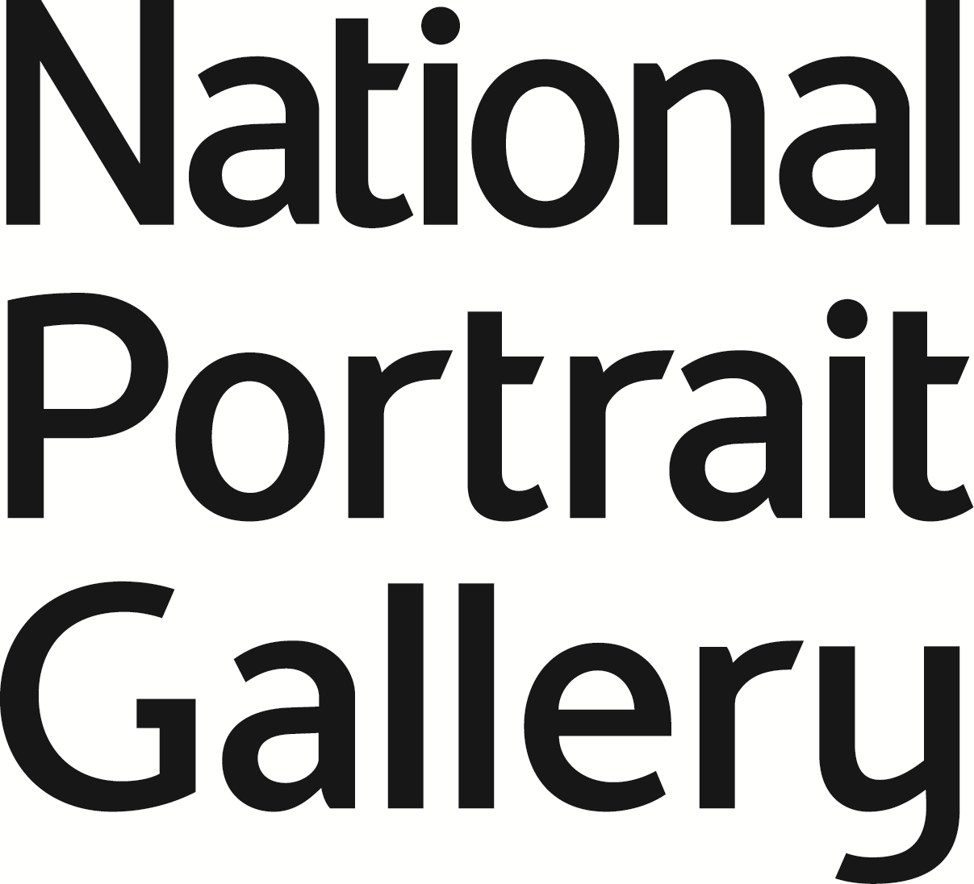

The Bristol/NPG AHRC Studentship
Collaborative Doctoral Award Application Form 2014

Please note this application form is for students wishing to be considered for the AHRC-funded Collaborative Doctoral Studentship with the University of Bristol and the National Portrait Gallery, London: ‘The production, transmission and reception of engraved and photographic theatrical portraits in the mid-19th century and their contribution to the promotion of celebrity’.

Applicant Details:

Surname or Family Name:

Other Names in full:

Date of Birth:

Address for correspondence:

Telephone Number:

Email address:

Residency status:

Nationality:

Please state the country in which you are normally resident:

On what date did you take up residence there?

How long have you resided there?

Qualifications:

Qualification Type and Subject:
(e.g. BA History of Art)

Awarding Institution:

Year awarded:

Class:

Brief Description:
(maximum of 1,000 characters including spaces)

Other or expected qualifications:
Qualification Type and Subject:
(e.g. MA History, Drama, Theatre Studies, English, History of Art)

Awarding Institution:

Year awarded or end date:

Class:

Brief description:
(maximum of 4,000 characters including spaces)

Relevant experience or employment:
Programme of Study:
Please state whether you are applying for a FULL or PART time award:
Previous AHRC awards or applications:
Please provide the reference number(s) of any previous AHRC awards or applications

Case for Support
Please write in no more than 4,000 characters, in Arial with a font size of no more than 11, your reasons for the interest in this project and how you can apply your knowledge and research experience into developing and shaping the key research questions as described in the project overview. Please also state your interest in undertaking a Collaborative Doctoral Award and what you hope to gain from a project of this type.

Please send this form to Dr Ruth Brimacombe rbrimacombe@npg.org.uk by 5pm, 28 March 2014

References:
Please provide the contact details of two academic references from people who are able to comment on your recent academic performance. You should contact these referees and ask them to submit a reference answering the following questions:

Please comment as fully as possible (in 300 – 400 words) on the candidate’s suitability for an award. Please include comments on the following:

1. Your views on the candidate’s suitability for postgraduate training in general and for the particular research he/she proposes to undertake.

2. Information on how, and to what extent, the candidate has shown academic ability in terms of:

a) ability to grasp concepts and reason analytically;
b) motivation and perseverance in achieving objectives; and,
c) capacity for original thought.

3. An assessment of the candidate's particular strengths and weaknesses, and of possible further training the candidate will require to complete successfully their research.

Referee One:
Name and Title:
Institutional Address:
Position:
Telephone:
Email:

Referee Two:
Name and Title:
Institutional Address:
Position:
Telephone:
Email:

Both references should be submitted to:
Dr Ruth Brimacombe via rbrimacombe@npg.org.uk

Deadline: 5pm 28 March 2014

