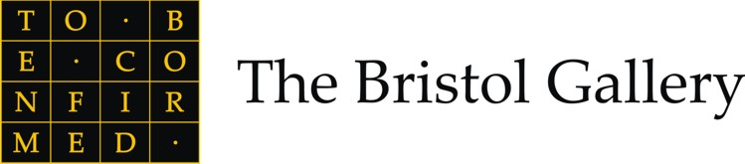
FOR IMMEDIATE RELEASE
New Exhibition

New Contemporaries I

Having opened its doors to critical acclaim with their inaugural exhibition, Myth and History in September 2009, The Bristol Gallery is now pleased to present New Contemporaries I co-curated by University of Bristol student Holly Lopez, a recent first class graduate from the History of Art department and currently undertaking the department’s MA Art, Histories and Interpretations. The Bristol Gallery's latest exhibition features the best and the brightest emerging contemporary artists, brought together for the first time at the gallery on Bristol's prestigious Harbourside development. The show explores new parameters and directions in contemporary art, bringing together a diverse range of talent and experience to new audiences in the region. The exhibition offers the viewer unusual and exciting discoveries, promoting and creating access to vibrant contemporary visual art with a lively assembly of artists working in a range of media including photography, textiles, abstract work, video, installation and sculpture.

The Bristol Gallery is proud to present works by Arno, Jan Lewin-Cadogan, Rakhee, Nicola Dale, Cordelia Spalding, Katharine Barker, Paul Wright, Arabella Nock, Fran Richardson, Alison Black, Susan Bowman, Peter Walker, Michelle Lord and Helen Grundy

The exhibition runs from Saturday 7th November 2009 – Thursday 7th January 2010.

Curated by Andrew Price and Holly Lopez.

Press /Private View
Thursday 05 November 2009, 5pm – 7pm
For more information or to arrange a gallery visit please contact Holly Lopez at holly@thebristolgallery.com

Further details

Autumn/Winter at The Bristol Gallery:
Saturday 7 November – Thursday 7 January 2010 New Contemporaries I

Spring Season forthcoming highlights include:
Saturday 16th January – Thursday 25th February To Be Confirmed
Saturday 6 March – Thursday 15 April 2010 Concilium Plebis
Saturday 24 April – Sunday 23 May 2010 Peter Blake: Alphabet

Gallery Opening Hours:
Monday – Friday: 9am – 6pm
Saturday: 10am – 5pm
Sunday: 11am – 4 pm
Late night opening: Thursday until 8pm

Further Information:
The Bristol Gallery
Building 8, Unit 2
Millennium Promenade
Harbourside
Bristol BS1 5TY

Tel: 0117 930 0005
Fax: 0117 930 0017
Email: knowledge@thebristolgallery.com
Website: www.thebristolgallery.com

For more information or to arrange a gallery visit please contact Holly Lopez at holly@thebristolgallery.com

