STAGE 1 26 mins

START: 725 690
TC1: 681½ 782

Go via ∙233 then:

WNW WSW NNW W

YYYY YYY YYY YYY YYY YYY YYYY

YYY YYY YRR RYR RYR RRRY

Then cross:

68 74 75 69 76 69 77 78

TO TC1…
STAGE 2 46 mins

TC1: 681½ 782
TC2: 789 874

!!EXTREME CAUTION OVER BRIDGE AT 736 828!!

18:12 8:10 9:05 19:12 8:58 18:14 11:13

9:10 8:31 13:20 10:00 16:59 8:21

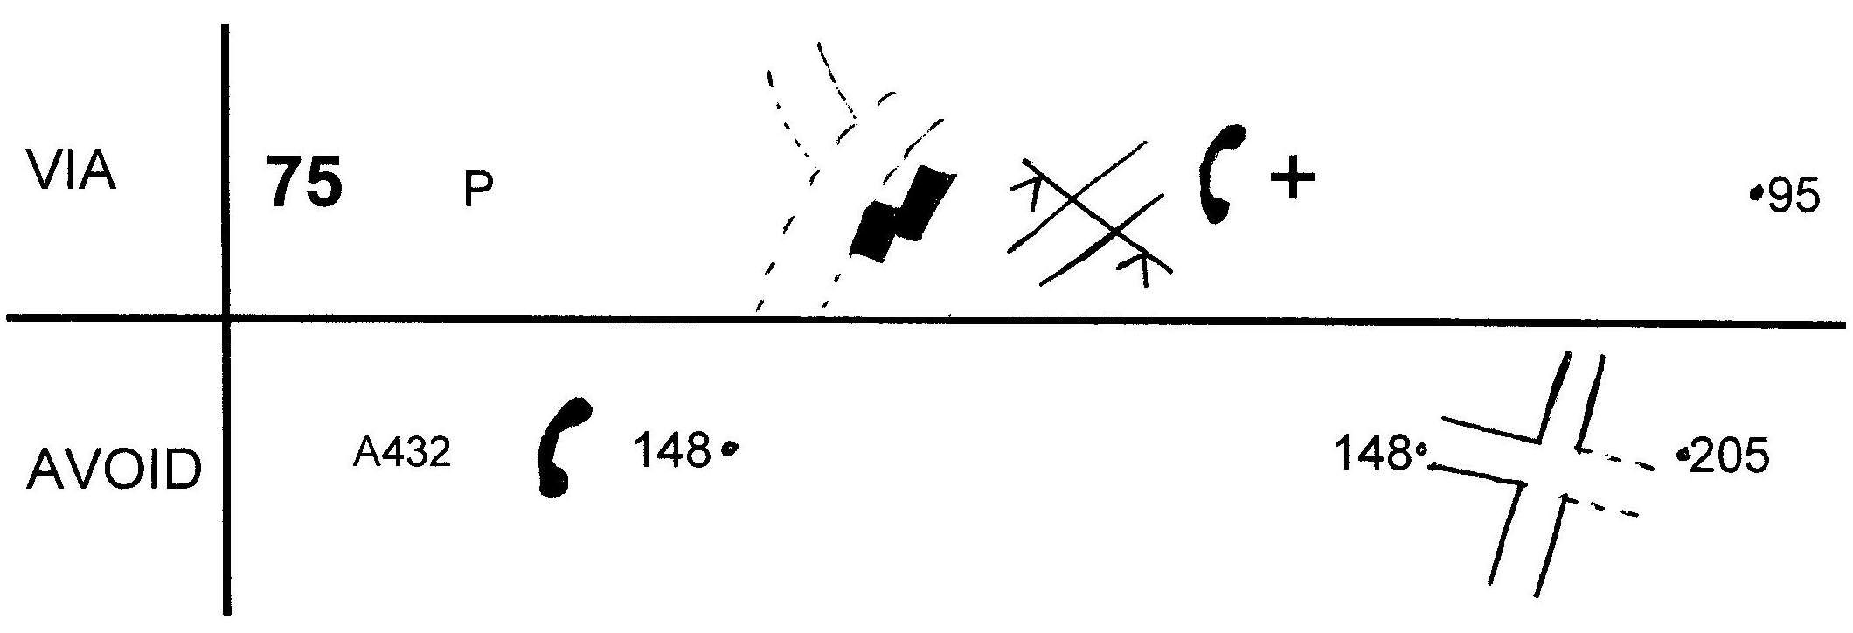

TO TC2…
STAGE 3 54 mins!

TC2: 789 874
TC3: 664 904

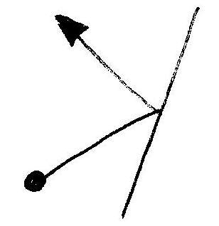 | 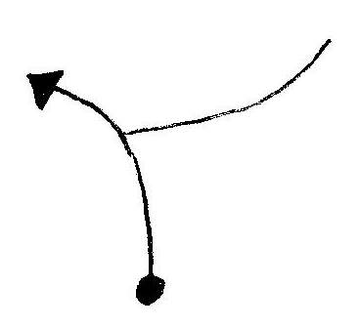 | 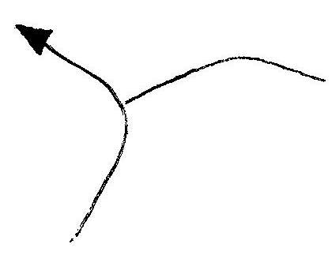
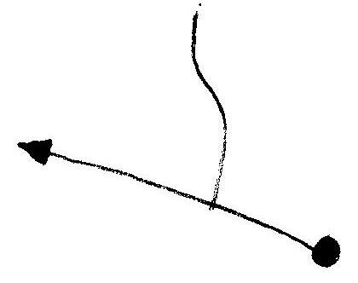 | 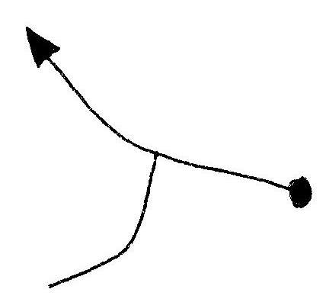 | 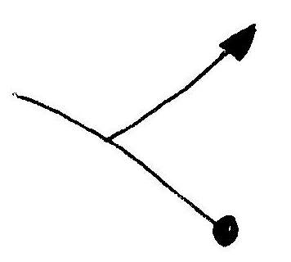

91 92 76 92 77 78

92 79 93 79 78 77

SOX TR TL TL TL

TL TL TL TR TR

PTO…

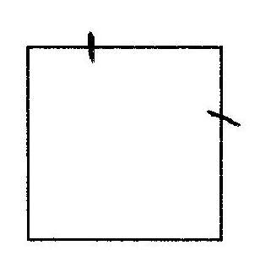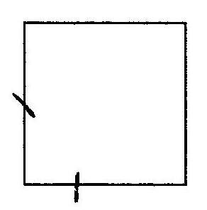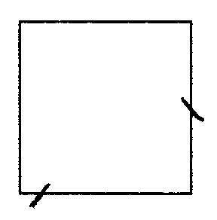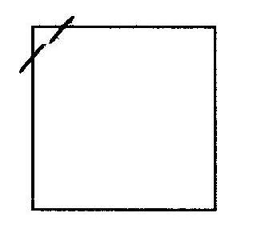

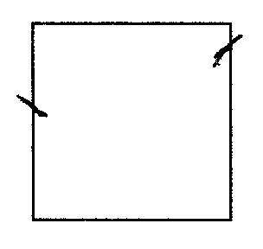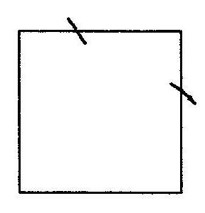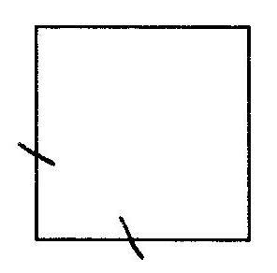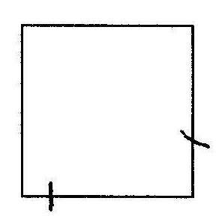

Exit junctions:

NW S SW E E WSW SW

Exit grid squares travelling:

SW SSE WSW NNE SW SW

WNW W

TO FINISH

