STAGE 1 28 mins

START: 734 728
TC1: 681½ 782

TR out of car park then:

YRRRRYYYYYYYYYYYYYYYYYYYYY

YYYYYYYYYYYRRRYYRRRYYYY

Hint: Jcns 3, 4, 10, 13 are crossroads

37 47 27 57 37 67 37

Then exit junctions:

A=26

13 4 4 4 84 4 134 134 84 4134

TO TC1…
STAGE 2 46 mins

TC1: 681½ 782
TC2: 789 874

!!EXTREME CAUTION OVER BRIDGE AT 736 828!!

My watch is 1:20 slow

19:32 9:30 10:25 20:32 10:18 19:34
12:33 10:30 9:51 14:40 11:20 18:19 9:41

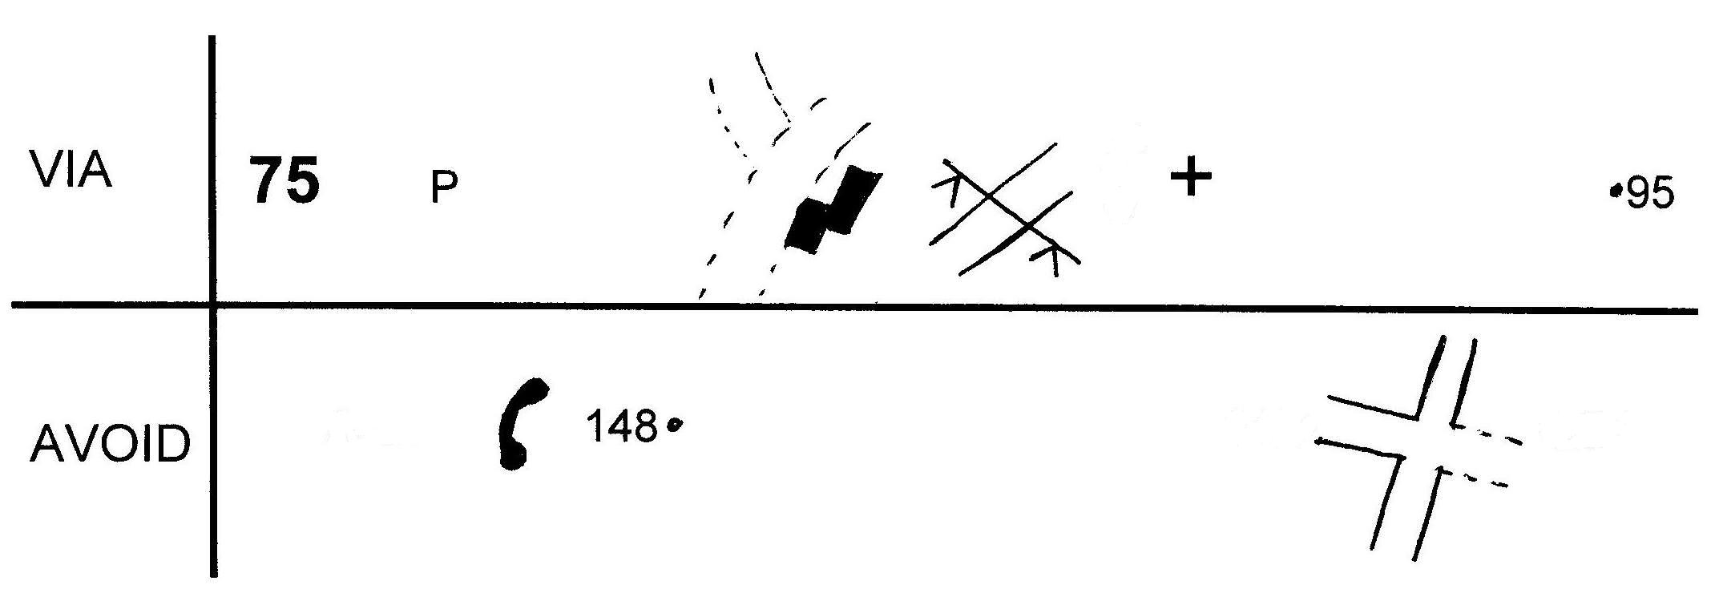
TO TC2…

STAGE 3 54 mins!

TC2: 789 874
TC3: 664 904

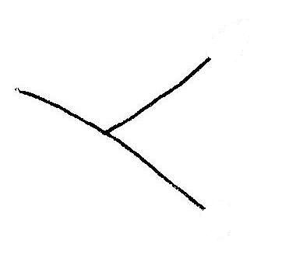 |  | 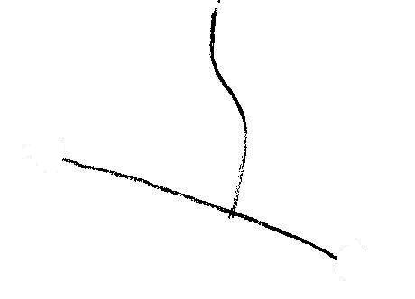
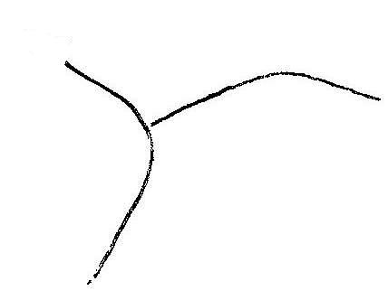 | 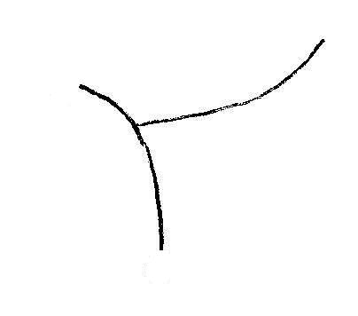 | 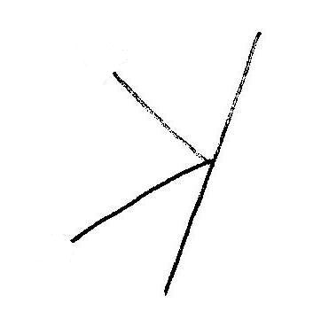

919276927778927993797877

Using the same code as before:

8123797157157157157157157979

PTO…

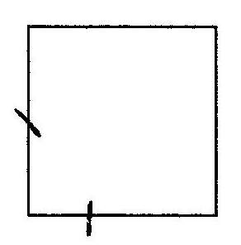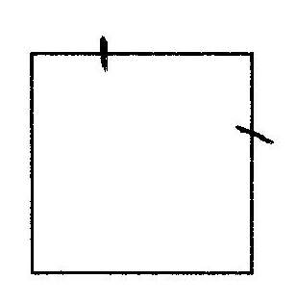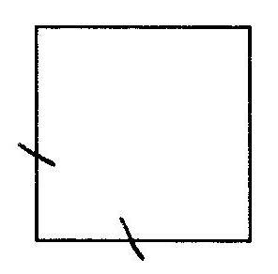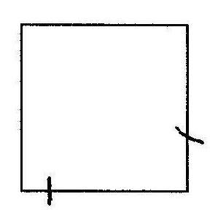

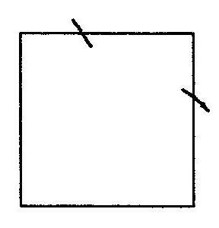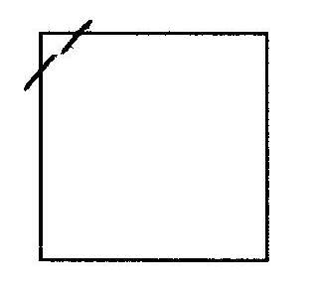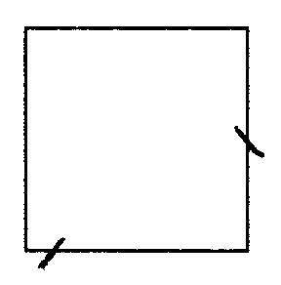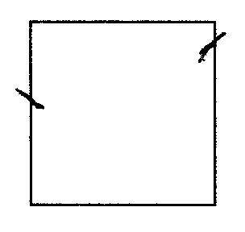

Exit junctions:

315° 180° 225° 90° 90° 247.5° 225°

Exit grid squares travelling:

NE NNW ENE SSW NE NE

ESE E

Hint: I have turned my compass through 180º

TO FINISH

