Medication Matters

Making decisions about taking medications


Medications are tablets, medicines or
injections.

Most of us take medications at some time in
our lives.

Often this is because a doctor has said they
will help us to feel better.


One type of medication that we might be
offered is psychotropic medication.

Lots of people with learning difficulties take
psychotropic medications.

Psychotropic medications are given to help
people with their thoughts, moods or
feelings.

Sometimes they are given to help
people with their behaviour. We don’t know
for sure if psychotropic medications can help with this.



The Medication Matters project wanted to
find out more about what is was like for
people with learning difficulties taking
psychotropic medications.

They found:

People with learning difficulties might not know much about their psychotropic medications.

People thought their carers would know about their medications. But carers did not always know very much either.

People with learning difficulties might not have a free choice about whether they take their psychotropic medications.

People with learning difficulties can be more involved in making decisions about taking psychotropic medications.

Knowing about psychotropic medications

We have a right to know about our medications.

But people with learning difficulties might not have been told much about theirs.

Or they might not remember what they were told.

They might not know why they are taking it.

Medications can help you feel better.

But sometimes they can give you problems as well. This could be things like making you feel dizzy or sick or very sleepy.

These are called side effects. People with learning difficulties might not know what side effects to look out for. They might not know what to do if they have side effects.

Having a choice about taking psychotropic medications

We have the right to choose whether or not we take medications.
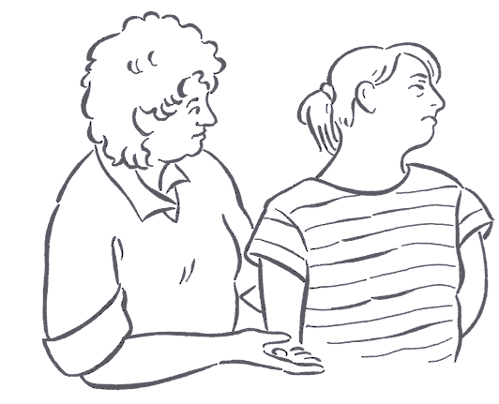

But the Medication Matters project found that people with learning difficulties might not feel they have a choice about taking their medications.

They might not have been involved in the decision to take it. One person said:

‘I’ve been told I must, I’m forced to take it’.

But some people know they can make the decision themselves. One person said:

‘It is just permission by myself. It is OK. It is my choice. It is up to me and it is my choice’.

Getting involved in decisions about psychotropic medications

You can be more involved in the decision about taking psychotropic medications.

You can ask for time to make your decision.

You can ask someone you trust to help you understand the information and make your decision.

You can find out as much as you can about the medications before you decide.

On the next page are some questions that you can ask the doctor.
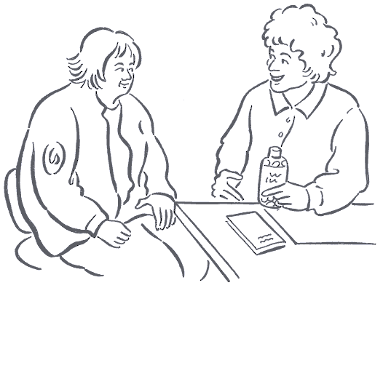

You can ask them when a medication is first suggested.

Or you can ask them when your medication is reviewed. A review is a chance to talk to your doctor about how you are feeling with the medication. And to check that your medication is working as well as it can for you.

Everyone who takes medication should have it reviewed regularly.

Questions you can ask about psychotropic medications

- What does this medication do?

- How can it help me?
- Are there other things I could try? (Like talking to someone, or going to relaxation classes)
- What risks and side effects might there be?
- What should I do if I think I have side effects?
- What should I do if I forget to take the medication?
- What would happen if I suddenly stop taking it?
- How much do I need to take? When do I take it?

- How should I take it? (Like with water or before meals)

Things you can do

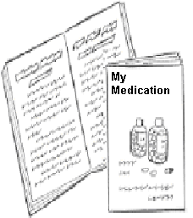

You can find out more about your
medication with the help of someone you
trust. There is a booklet that can help you
do this. It is called ‘My Medication’.

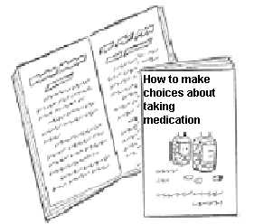

You can think through the decision about
taking psychotropic medication with the
help of someone you trust. There is a
booklet to help you do this. It is called
‘How to make choices about taking
medication’.



There is a booklet that gives information on how to find out more about different medications. It is called ‘Health and Medicines information’



You can find out how to get these booklets by getting in touch with us at the Norah Fry Research Centre.

How we did the research

People with learning difficulties and researchers at the Norah Fry Research Centre worked together to do this research.

They asked people taking psychotropic medication what they knew about their medications and what they thought they should be told.

They also talked to carers and doctors about what information people need to make choices about taking medication.

Service User Advisory Group


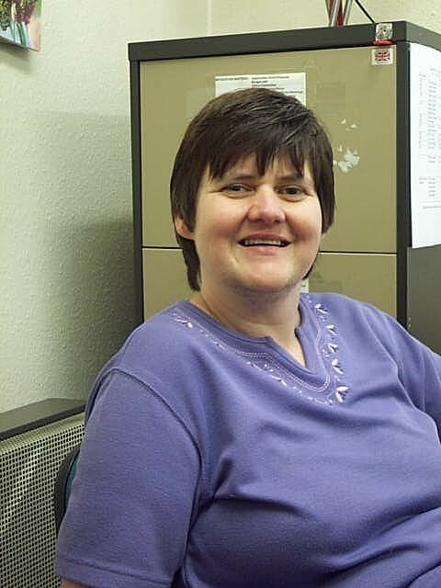



For further information, please contact:

The Medication Matters Team
Norah Fry Research Centre
3 Priory Road
BRISTOL BS8 1 TX

 Tel: 0117 923 8137
Website: www.bris.ac.uk/Depts/NorahFry/




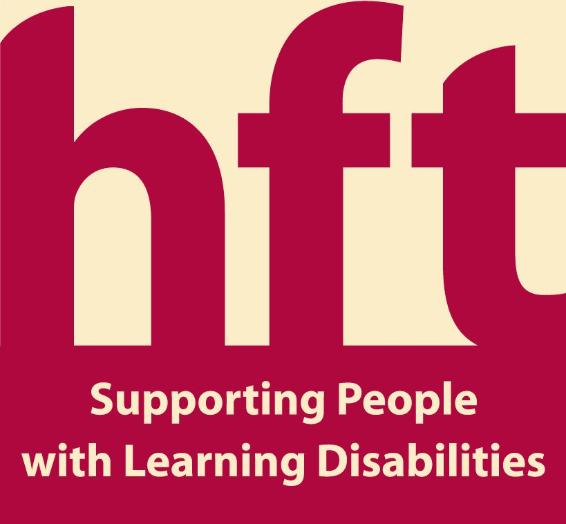


This is an easier summary of the findings of the Medication Matters project. The summary is also available on CD.
You can photocopy and share this summary.
Pictures by Vali Herzer. Design and layout by Maggi Walton

