The Bilingual Environment

Some Comments on Developing Bilingualism for Deaf People

This paper appears in Spanish/Portuguese in Skliar C (ed) Actualidad de la Educacion Builingue para sordos, Porto Alegre, Brazil: Editora Mediacao

Jim Kyle

Centre for Deaf Studies
University of Bristol
8 Woodland Rd
Bristol BS8 1TN

Fax: +44 117 954 6921

Not to be quoted without permission: jim.kyle@bris.ac.uk

November 1998

Outline:
Although
• there has been a major change in the approach to deaf children's education in the last ten years or so; although
• this change has used the facts of spoken language bilingualism to support the development; and although
• it is vital and obvious that a deaf child should master a language as early and as easily as possible,
• there have been unsupported claims on the role of schools, the participation of teachers and parents and even of deaf people;
• there are unsupported claims about the nature of bilingualism and
• there are issues to be addressed if we are ever to provide a sensible framework for deaf children's growth.
Johnson (1998) in a conference in Lisbon, set out a series of hard facts about the failure of deaf children and the need for a sensible language approach. Kyle (1998) in the same conference offered examples of successful sign language acquisition by a two-year-old deaf child from a hearing family. We know the goal for deaf children and we know where we are now.
This paper is about how we might reach this goal and some of the progressive problems, which have been and will be encountered along the way.

Thanks are due to a number of people who have contributed indirectly to this paper through their interesting discussion and insights: Flo Canavan, Paddy Ladd, Mary Griggs and Alys Young were particularly helpful.
It is relatively obvious that deaf children should be bilingual. They have a natural language of vision and space that they will acquire if they are brought together in groups such as in schools. They live in a society that is dominated by spoken and written language - if they are to reach the potential which is apparent in their cognitive functioning, then they need access to the language of the majority. Most minority groups have come to the same conclusion.
For over 200 years in Europe, educators have resisted the obvious.
There are many reasons for this. Perhaps the most important has been that the educators have almost all come from the majority community and have drawn on a medical/religious model of deafness - not only is it their job to educate but it is also to remediate and to save. The job is successful when there is no deafness, when deaf children do not stand out and when the deaf child is functionally integrated into the majority.
This is a typical medical/religious view on the task. It has been validated by majority societies for a very long time. In the case of deaf children it carries overtones of colonialism in denigrating the natural language of the minority and the suppression of the culture.
Skuttnab-Kangas (1981) calls it submersion.
In minority groups, it has limited success unless there is natural language access to the majority culture and in time, to the majority sources of power. In deafness, this is rarely the case. Submersion does not lead to majority language acquisition. Deaf people do not progress to positions of power in society. This has been known as early as 1910 when Alfred Binet published a study of deaf people in Paris. For most of the 200 years since then, educators in deafness have searched for the Holy Grail - the magic method to overcome this obstacle.
Methods and Madness
The oral method has been the dominant approach for educators for the last hundred years. It is promoted as most natural to hearing people and since teachers are usually hearing, it requires the least adjustment to their natural communication. It is also less time consuming (in terms of the period to acquire it) and less demanding (in terms of the need to maintain contact with a community and culture to ensure that the language is updated). Hearing teachers use speech in the class, do not know and do not acknowledge the language competence of their children in sign language and do not enter the community of their former pupils, except in exceptional circumstances . Given these circumstances, it is also easier in theory to demand that the deaf pupils deny their own language and attempt to remove it from the school environment. Classroom control is much easier if the pupils are not allowed to use a language that the teacher cannot understand.
Most deaf people over the age of thirty years in Europe will recount many incidences of awful punishment for the simple expression of their natural communication. In the UK, this will involve locking in cellars and cupboards, physical punishment and public ridicule.
However, the problems are much more severe than the reported limitations of educational achievement and the abuse received in school.
Young (1996) has discussed the adjustment made by parents to deafness in their child, showing that aspirations remain high but communication is a major source of frustration. Griggs (1998) shows that deaf people view their estrangement from their "blood" family as an inevitable consequence of their parents and siblings lack of communication.
Griggs (1998) has also gone on to show how the language deprivation in childhood has led to seriously high levels of mental ill-health in deaf people by their mid-thirties. Kyle (1998) also highlighted this aspect.
The issue of language method is for deaf children, not just about school and learning; it is about life and survival.
Kyle and Allsop (1997) in a survey of 17 countries in Europe have shown the different perceptions of deaf people and hearing people about the language. Hearing people see sign language as part of a service which they can and may provide to deaf people; deaf people see sign language as their language - a community language.
This discrepancy in view has affected the way in which we have thought about bilingualism for deaf people. So far, we have not developed a coherent view about deaf people's language and the proposed and discussed Bi-Bi methods are not yet within the correct framework to understand the questions, which will need to be dealt with.
The debate on deaf children's language and the progress which has been made since Tervoort (1983) surveyed deaf education in Europe, has been considerable and most countries have now some experimentation with sign language in education. The apparent progress seems to be from speech only, to some form of visual speech system, to a formalised (methodised sign - something which was apparent and widely used in the 19th century and has only been re-discovered) to a bilingual approach. The debate about this bilingual approach has been extensive - but not yet extensive enough. There are problems that have only been thought of in a superficial way.
The Language Environment and the language partners who inhabit it
More significant in our examination of bilingual deaf children has to be the bigger picture - the circumstance in which the language is used and where it is learned. Language exists in its interaction.
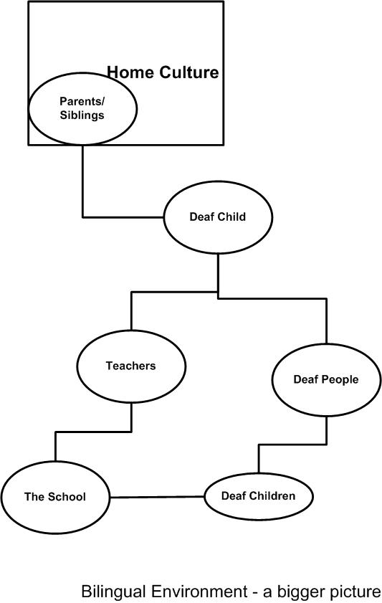
The School
In the last few years, the discussion of method has simply been transferred from oralism through Total Communication to the recognition of sign language. The issues, which are debated by the schools, are to do with policy and practice and are not really about the adoption of language. So when the school changes policy to a bilingual approach, it does not necessarily mean that there is a real acceptance of the use of language and the context in which language occurs. It does not imply that the language is used throughout the school.
Much of the pressure on the school comes from the educational system as a whole. The funding for the school usually comes from external sources - most commonly government or local government. Parents and other benefactors may contribute. The school will usually have a board of governors. Rarely, if ever, is there a majority of deaf people in the decision-making process.
The priorities are to deliver a curriculum that defines itself in terms of content and method. Since the educational system is the majority one, this curriculum is likely to be hearing-centric that is, it draws on a hearing perspective on the world.
Moving from one policy to another is usually a case of translating part of the curriculum into signed form. This is often done by hearing people. There is no guarantee of the integrity of the signed version and no assessment of how it works in linguistic terms - that is, we do not know if sign language is used within the school.
The Teachers
Responsibility for delivering the curriculum rests with the teachers. They vary in their knowledge of and commitment to the deaf community and to deaf perspectives. Rarely will they have been prepared for the deaf community by their training. The training, which they have received commonly, is based on hearing views and relates to the delivery of curriculum. It forms part of the medico-educational circle.
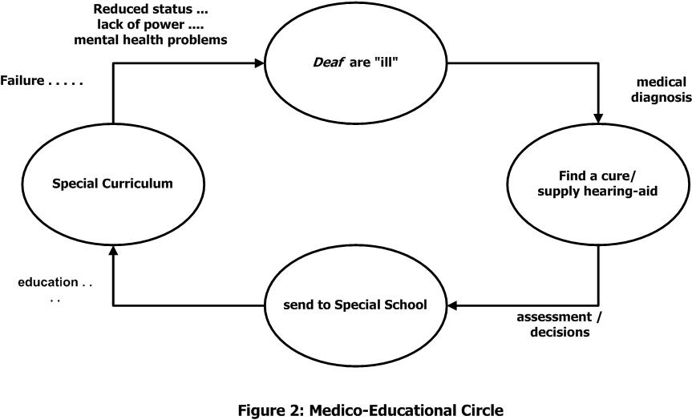Although individual teachers vary in their degree of contact with the deaf community, in any one school, there are likely to be teachers of different age and different extent of training and ability. These differences do not immediately disappear as soon as a policy decision is made to introduce sign language. In fact, they become resistances to change.
One of the major focal points of change in a proposed bilingual system is the learning of sign language. Hearing people have difficulty in learning sign language (Kyle and Woll, 1985). A range of social, psychological, linguistics and educational factors tend to limit their language learning. Put very simply, teachers are rarely taught sign language at a high enough level for educational (teaching) purposes, have to overcome attitudinal hurdles which suggest that a minority language is less important and do not have sufficient grammatical knowledge of sign language to support their learning. Even more significant is the mixed signal provided by the school system. Seldom does the head teacher or other management of the school see it as a priority to acquire sign language. Teachers see the request to learn sign language as coming from those who are not prepared to learn themselves. Teachers may be expected to learn to sign in their own free time - out of school hours. Usually they will be expected to learn to sign as individuals in situations which are divorced from the school and/or classroom. Most significantly, it is highly unlikely that there will be sign teaching in a context which understands the school itself as a language community. There are rarely classes, for learning sign language which involve all the staff at the same time and which work within the school's daily routine, but work within sign language.
One guiding feature of the teacher's life is the curriculum. Issues in the curriculum are generally expressed as translation issues - how can certain elements be presented in the language of the minority. There has never been an examination of the needs and skills of the minority as a basis for the definition of the curriculum. It is likely that deaf children will continue to fail in this curriculum - even if sign language is used.
Deaf Teachers
This situation is both helped and hindered by the presence or absence of deaf teaching staff. In many countries deaf people are disallowed from becoming teachers by law or by the system of training which is offered. Many systems insist that deaf staff in school use their voice at all times. Deaf people who are able to work through the obstacles of the education system are often those who have succeeded in an oral system and may have had to deny their own language. This can work both for bilingualism (in a determinism to ensure that other deaf children do not endure the oppression) or work against bilingualism (if the deaf person feels that all children can be successes like themselves).
The alternative scenario is the introduction of deaf people without qualifications as helpers or part-time workers. These arrive because hearing people have shown sufficient insight to see the need for language models. However, their status is questionable because of the control retained by hearing teachers. The bilingual model which results means that sign language is associated with the lower status deaf helper and the spoken/written language is linked with the power of the hearing person.
The Deaf Community
Schools are usually rooted in the community's aspirations. Schools are controlled by the community which they serve - except in the case of minority groups where they may have practices enforced by the minority and they may often collude with this ("our children have to live in a majority culture and so the only means to gain power and success is to follow the majority principles").
In very few countries in the world, do deaf people have any real control over deaf schools. Not surprisingly the deaf community's attitude is mixed. On the one hand, deaf people may recall their school days as a happy time when they first used sign language freely; on the other hand, it is a place populated by teachers who used speech only and who punished them for use of the language which they found so effective. Deaf people seeing hearing people now embracing the language of the community are understandably sceptical. Deaf people returning to school in the role of helper are also somewhat suspicious of the school which formerly denied them the language.
The situation of the deaf community in a bilingual environment is difficult to place and there are concerns as can be seen in the section on evolution of this environment.
The Family
Young (1996) in a perceptive research analysis has indicated that families create their structures and beliefs before they have deaf children. The family often has hearing children before it has deaf children. The expectancies and skills of parenting are often already in place prior to the birth of the deaf child. This has important implications for the type of change that is requested by professionals and by deaf people.
The birth of a deaf child is likely to create stress for the family but not necessarily the grief and sense of loss that is often attributed to it by hearing professionals. Parents seek information and re-assurance. This may lead them to medical models and medical intervention as well as towards denial of deafness. It may also lead them to deaf people and to the deaf community. In a family intervention programme (Deaf children at School, Sutherland and Kyle, 1993) deaf people visited the home in order to support the families. The response was wholly positive and provided a re-appraisal of the deaf child in a more positive light. Since the intervention began from the point of diagnosis, this was a major effect on the child's language growth. Sign language was used at home and the child was more likely to arrive at school with a functioning language.
Families exist before, during and after bilingual schools. In fact the family is the true host of bilingualism.
The Child
As far as we can determine, deaf children like hearing children learn language most successfully in the first three years of life. Work by McEntee, Kyle and Ackerman (1996) has confirmed the natural language development of deaf children in deaf families and the acquisition of the major functions of language in the period up to three years. Kyle (1998) has shown examples of similar development in deaf children from hearing families. Hearing loss is not in itself a blockage to language development - however, the methods which have been applied and the advice which has been given have become obstacles to the child's language growth.
The realisation that language development occurs most appropriately before school has been highlighted in the above section. However, the issue for most programmes has been when and how to introduce the different languages. When we move from speech-first, to sign-first, the questions remains the same. So do the answers. It is not possible to programme the acquisition of first and second languages. It is sufficient to say that the signed language requires an effort on the part of the hearing people and the spoken language requires a major effort on the part of the deaf child. If the deaf child does not have sufficient hearing to allow motor feedback to be linked to auditory feedback, then speech development will be slow and frustrating. In this case, the bilingual framework is probably in written language and signed language. In this case, it will not be introduced effectively until 6 or 7 years of age, although this might be altered by parents using reading materials and books.
What is apparent is that the deaf child needs language access from the earliest possible age. In bilingual programmes proposed by deaf people, the access should be to sign language. In most realistic models of bilingualism, language should certainly be experienced and acquired long before arrival at school. This indicates that bilingual programmes where language is introduced for the first time, in school are too late in their intervention.
Evolution
In an ideal world, deaf infants embark on a bilingual journey. The language which they experience from a few months of age includes sign language. Ninety-five percent of deaf children are born in hearing families and so to achieve this goal a great deal of language teaching is required as soon as the child is known to be deaf. Since often this fact is not confirmed until one year old, a great deal of time is lost in early interaction. Gestural input and simple sign language often describes the first 18 months of life as the parents strive to find a means of conducting family life.
This leads to a second stage where sign language is learned effectively by at least one of the parents. The family situation begins to look more like a minority bilingual family where one parent communicates in the minority language. The only major difference is that the child does not have full access to the second language which is used at home or by playmates in the community. In this situation, parents often seek out deaf adults and the deaf club to try to bring in more resource. Professionals may or may not be supportive. In some parts of Europe the professionals have been obstructive, threatening to withdraw services if families choose to associate with deaf people. The families may experience a stigma which is designed to isolate them from other parents and which is base affirmation of majority values.
This leads to a further stage of siege when the family holds out for the child's well-being in sign language and attempts to adapt. At this time, there may be supporting deaf people who extend the signing of the parents, take an interest in the child and act as an entrance to the deaf community. Parents may track down other parents who have similar feelings. In some countries, such as Denmark the whole of the parents' organisations has formed up in the sign language approach and so contact with other parents may be easier.
This leads to a further stage of dissonance since the parents discover that the child is "normal" in the sign language environment. This contradicts the views of neighbours and even close relatives who still believe in the loss of the normal child. Parents experience a further stigma since they seem to have adopted an untenable position in the eyes of the community of hearing speakers.
At this time the parents have greatest need for the support of the deaf community and this may be forthcoming. However, it is not certain. Deaf people having experienced their own difficulties in childhood may not be able to or may not be interested in dealing with the issues which hearing parents face. In fact they may not be able to answer the questions which they are asked:
• "how does a deaf person put a deaf child to bed?" - most deaf parents do not have deaf children
• "what resource material can I use to encourage my child to learn about the world?" - deaf adults when they were children did not experience satisfactory parenting and may not have recollection of early childhood
• "how much signing should be used at different times of the day and in different circumstances?" - the pattern of life in deaf homes with hearing children, may be quite different. Deaf parents may not sign to their hearing children.
• "what is the normal development pattern for sign language?" - relatively few people, deaf or hearing, can answer this adequately
The language environment of signing at home mixed with exposure to spoken/written language continues, but the family feels the deaf community has less knowledge than they had expected.
As the bilingual family progresses, further stages can be seen. In spoken language bilinguals, there is often a language divide - one parent uses one language and the other uses the other. Or there are periods of language use - the child uses one language during the day at school or in majority situations and then the minority language at home. Sometimes, the minority language becomes a majority when the family returns "home" to meet the grandparents and other relatives.
Deaf children inhabit a different sort of bilingual environment. First of all, the people they meet who use the minority language are usually majority group members. They (the parents, relatives, teachers, professionals) are using sign language as second language users. In contrast, most hearing-speaking bilinguals are meeting first language users of both of the languages which they use. This has implications for the levels of fluency and commitment and the duration of the signed input. Hearing signers often speak when other hearing speakers are present, even when the child is watching.
The deaf child at this age is growing rapidly in sign competence and is ready for school (for learning) and for the deaf community (for sign language enrichment). In both cases, there may be problems. School is populated by second language users of sign language and often there are deaf children who have not yet acquired a language. The deaf child's sign competence may be ahead of the teacher's.
Opportunities for access to the deaf community may be limited. There are few deaf associations which offer facilities to signing parents and to deaf children, either formally or informally. Deaf clubs tend to be for adults.
At this point, the parents may begin to realise that their own home culture is more vital than the presumed support from professionals or other deaf people. The bilingual environment at home becomes the most important aspect of the child's development. In some ways this is the most significant point, when we see the confirmation of family confidence in its own capacity to meet the needs of the child and to provide the family environment which the child can use.

Bilingual education at school follows in the developmental pattern of the child in ways described by others contributing to this collection. In the framework offered here, the school developments will be only effective if they take on the issues of language acceptance and realise that the school exists as a consistent language community where sign can be interchanged with spoken/written language.
The whole of this development can only be adequately realised if the family is recognised as the primary bilingual unit. Without the family's involvement in the process, the bilingual development will be limited.
Deaf children ought to be bilingual - it is vital for their well-being and their progress in the world. We can create the basis for this most effectively and appropriately by attention to he needs of the family and developments in the pre-school period.

References

Griggs M (1998) Deafness and Mental Health: Perceptions of metnal health in the deaf community, PhD Dissertation, Universityof Bristol
Johnson R (1998) Issues in Bilingual Education, paper presented at the Ibero-Latin American Congress on Bilingual Education, Lisbon, July 1998
Kyle JG (1998) Beginning Bilingualism, paper presented at the Ibero-Latin American Congress on Bilingual Education, Lisbon, July 1998
Kyle JG and Allsop L (1997) Sign on Europe, Bristol:CDS and Brussels: EUD
Kyle JG and Woll B (1985) Sign Language, Cambridge: Cambridge University Press
McEntee L, Kyle JG and Ackerman J (196) Deaf Children Developing Sign, Final Report to Leverhulme, Bristol:CDS
Skuttnabb-Kangas T (1981) Bilingualism or Not, Clevedon, UK: Multilingual Matters
Sutherland H and Kyle JG (1983) Deaf Children at Home, Bristol: CDS
Tervoort B (1983) Survey of sign language in the education of deaf children, in JG Kyle and B Woll (ed) Language in Sign, London: Croom Helm
Young A (1996) Bilingual Principles in Families of Deaf Children, PhD Dissertation, University of Bristol

