**My visit to the Children’s Burns Unit at Frenchay Hospital**

In the Easter holiday I was invited by Dr Amber Young to visit and gain an understanding of the Paediatric Burns Unit, as I was very interested about their work.

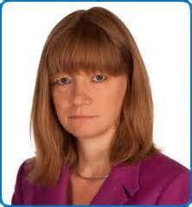

Children are brought in by their parents in the car, ambulance and helicopter. More than 700 children from the South West are admitted each year for treatment of burns and scalds.

The child must be assessed within 24 hours to ensure the best healing outcome.

The team approach is very important and is key to looking after a very badly burnt child who needs a lot of attention and specialist care. The people who are involved with the child and his/her healing journey are:

Doctors

Nurse Practitioners

Physiotherapists

Psychotherapists

Dieticians

Teachers

Volunteers

Receptionists

Dr Amber Young is a consultant paediatric anaesthetist and leads the team in the specialist paediatric burns unit at Frenchay Hospital.

One of the things I found out was that the most common causes of child burns are:

Hot drinks

Hot food

Hot bath water

Ovens

And log/coal burners.

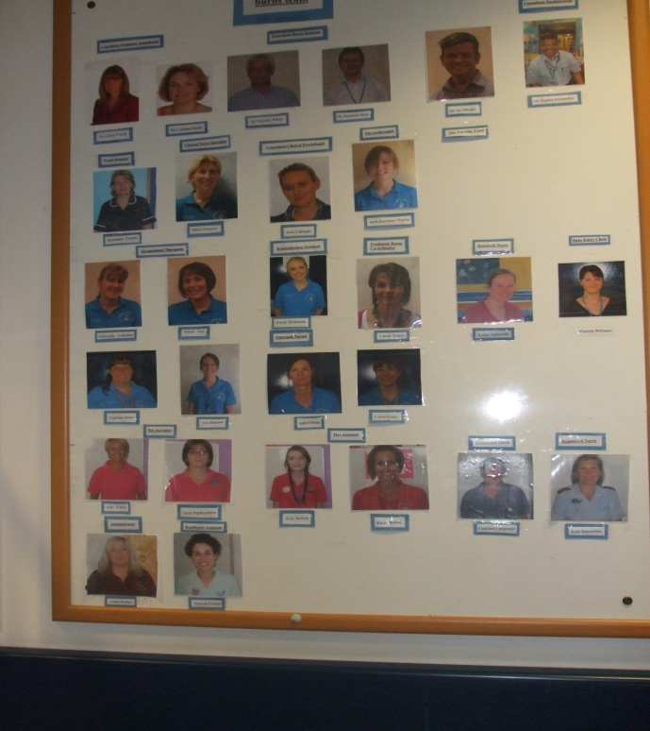

**The unit**

The unit has various sections, each having a dedicated function.

*The Receiving room*: this is where the children are admitted and assessed.

*Isolation room*: this room is used for the children that have been badly burned and are very susceptible to infection.

*Quiet room*: It is important to have a private area where the staff can discuss serious news with the child or parents.

*Patient rooms*: this is where the children stay for in patient and long term care. There are also fold up beds in the rooms so that the parent can stay next to their child. All the rooms have only 1 patient in them to help prevent infection.

*Parent rooms:* parents can stay in the hospital if their child is staying for a period of time.

*School room:* Children that are staying for a longer term are educated by the hospital’s own teachers.

*Physiotherapy room*: Physiotherapists help the child to exercise the effected limbs through play activities.

*Out Reach rooms*: once the child is discharged they are monitored either in the hospital or at home this assess their healing process.

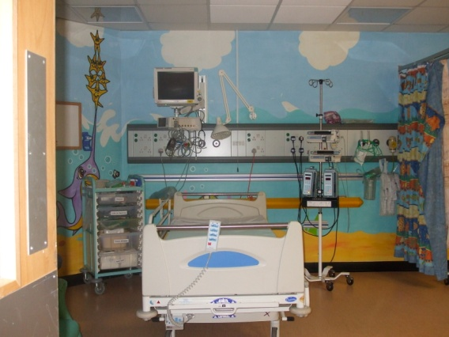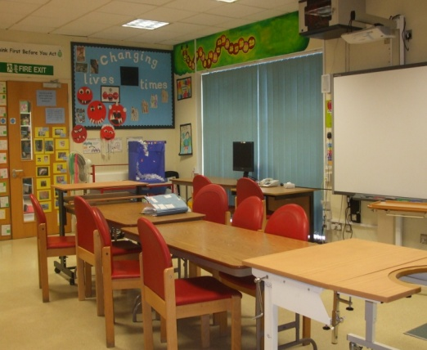

**The problems that have to be managed;**

*Pain* is managed very carefully to reduce the effect on the child both emotionally and physically.

*Infection* is a very serious problem for a child with burns. It causes poor healing, major scarring and even organ failure. Healthy skin defends our body against infection, if it is damaged it can’t do this!

*Fluid and temperature control.* These are difficult to manage. Body fluid is lost with blistering and the damaged skin cannot function in regulating the body’s temperature.

*Scar management* if the wound is not managed effectively or is deep then this may lead to long term scarring which has a negative impact physically and emotionally on the child.

**FAB. Frenchay After Burns Club.**

This is a Charity funded club that covers the South West which helps children who have had a burn injury and their families.

It runs fun activities which allow children and their parents to meet new friends and share their experiences. Through this they can support each other.

It is run by ward staff and volunteers.

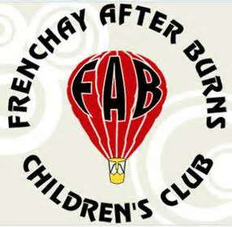

I think what this unit does is very inspiring to the children and the adults. They do so much research to learn how to treat these unfortunate accidents focussing on how to manage and reduce infection and the long impact of scarring.

**Stewart Cooper 8P.**