MAPPING DEPRIVATION IN THE SOUTH WEST

Eldin Fahmy and David Gordon

University of Bristol



November 2002
TABLE OF CONTENTS

1. | Introduction | 3
2. | Mapping Deprivation In The Southwest | 4
3. | How Much Is Enough? | 7
4. | Determining Poverty Thresholds | 9
5. | The Geography Of Deprivation In The Southwest | 17
6. | Conclusion | 23
 | References | 25
 | Appendices | 28

1. INTRODUCTION

The primary purpose of this report is to produce an area based ‘deprivation’ index that can be used to reliably inform the geographical analysis of morbidity and mortality in the South West region. There is now overwhelming evidence available from Britain and other industrialised countries that demonstrate that poverty is a significant causal factor of increased mortality and morbidity rates at area level. However, although poor people and households suffer from greater levels of ill health, it is also clear that those with incomes and standards of living just above the poverty threshold also have worse health than their more wealthy peers (for example see Townsend and Davidson, 1982; Acheson, 1988: Gordon et al, 1999; Shaw et al, 1999; Davey Smith et al., 2001). The command of resources over time needed to live healthily are greater than the resources needed to just avoid poverty (Bradshaw, 1993; Bhatia and Katz, 2002).

Therefore two different 1991 census based indices are developed in this report;

1) An index of the Low Cost but Acceptable (LCA) budget standard e.g. just above the poverty threshold (Parker, 1988; 2000).

2) An index of the Minimum Income for Healthy Living (MIHL) budget standard e.g. the costs of healthy living. (Morris et al, 2000).

The results for the South West region from these two new indices are compared with those from more ‘traditional’ national representative poverty and deprivation indices such as the Index of Local Deprivation (ILD) and the Breadline Britain index.

A significant problem when developing health related deprivation indices for the South West region is that a greater proportion of the population live in rural and semi-rural areas than in UK as a whole. Deprivation indices that are nationally representative are known to underestimate the extent of ‘rural’ poverty and overestimate the extent of ‘urban’ poverty, particularly where no allowance is made for the usual additional costs of living in a rural area (Bruce et al, 1995; Payne et al, 1996; Shucksmith et al, 1996; Bramley et al, 2000; Martin et al, 2000). This problem is often compounded when complex weighting procedures are used in the construction of the deprivation index (Senior, Williams & Higgs, 2000). In this analysis we have allowed for the unavoidable additional costs of rural and semi-rural living and the complex relationship between socio-economic factors and geographical location and the chances of living on a low income.
2. MAPPING DEPRIVATION IN THE SOUTHWEST

At the end of the twentieth century poverty remains a major and deep-rooted problem both in the UK and across the western industrialised nations. Academic research within the UK reveals growing levels of poverty and inequality since the 1970s (eg. Mack and Lansley, 1985; Gordon and Pantazis, 1997, Gordon et al., 2001). Alongside this increasing social polarisation, the spatial concentration of poverty in particular neighbourhoods and on certain estates has also increased, despite a raft of national initiatives aimed at combating poverty since the 1960s. Although such initiatives have generally been targeted at inner city areas and industrial, urban communities, growing levels of poverty can be found in all localities - including rural communities and traditionally ‘affluent’ areas (see eg. Chandola et al., 2000; Chapman et al., 1998).

However, increasing evidence of poverty and deprivation in rural areas raises a range of challenges for the identification and spatial mapping of poverty. According to most accounts the Southwest is a predominantly ‘rural’ region. However, there is no unambiguous definition of rurality, nor is there any universally accepted approach to its measurement. A range of measures are available (eg. settlement size, population density, land-use, and accessibility of services, multivariate classification), and the categorisation of urban and rural areas in large measure reflects the approach adopted. Figure 1 (below) shows the settlement profile of the Southwest region based on the 1991 Office for National Statistics’ (ONS) classification of urban areas. As Figure 1 illustrates, although the geography of the Southwest is overwhelmingly rural, the majority of the region’s population live within ‘urban’ areas. The definition of ‘urban’ settlements used by the ONS is for many purposes restricted to settlements of more than 10,000 inhabitants. Using this narrower definition, a majority (65%) of the Southwest’s population live in urban areas, nevertheless a considerably smaller proportion than for England and Wales as a whole (79%) (ODPM, 2002: 29).

Figure 1: Urban Areas in the Southwest, 2002

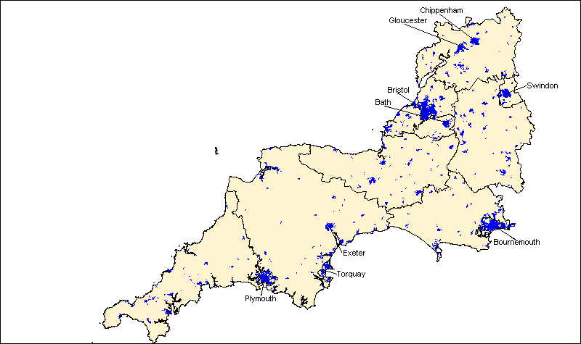

Source: ONS1991 Urban Settlement Boundaries [computer file] ©Crown copyright

However, in terms of its administrative geography the Southwest is classified as a predominantly rural region according to most classifications. Figure 2 (below) illustrates the geographic predominance of rural areas when based upon 1991 ward boundaries and an urban/rural classification developed by the Office for National Statistics (see ONS, 1999; Wallace and Denham, 1996 for further details). However, together the ‘rural’ authorities (ie. mixed, predominantly, or wholly rural) account for less than one fifth (17%) of the region’s population according to 1991 Census of Population data. A rather different picture emerges when using alternative methodologies and larger spatial scales (eg. at county or district level). For a fuller treatment of these measurement issues see ODPM (2002) and Martin et al. (2000).

Figure 2: ONS Urban and Rural Wards in the Southwest, 1991

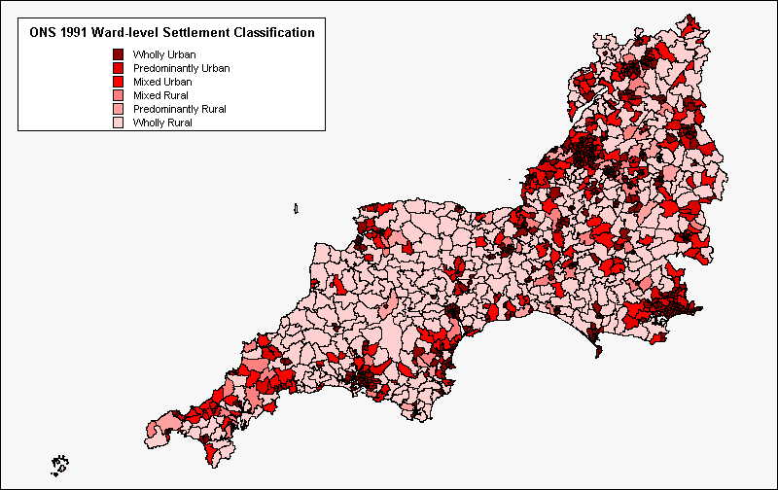

Notwithstanding the difficulties involved in defining rural and urban areas it is clear that developing indicators of disadvantage for the Southwest involves taking account of the distinctive dynamics of poverty in both urban and rural areas, and the distinctive needs of residents in urban and rural communities. This has important implications both for the measurement of poverty and social exclusion at an individual level using survey techniques, and in terms of the selection of area-based indicators of deprivation which draw upon existing administrative data.

When people experience persistent low incomes they are forced to make increasingly difficult choices about which areas of expenditure to cut back on. People restrict expenditure on some areas of their lifestyle more than others, and the choices people make when restricting expenditure are influenced by a wide range of factors such as age, sex, social class, family circumstances, education, culture, etc. However, these choices are also influenced by the person’s geographical location. Recent research suggests that rural residents often have somewhat different priorities to urban dwellers (see eg. Payne et al., 1996). It thus follows that poverty in rural areas is also distinct from poverty in urban areas. On this basis the definition and measurement of poverty should take account of individual level differences in expenditure patterns between urban and rural areas.

However, a much larger body of literature has focused upon the appropriateness of conventional area-based indicators of poverty and disadvantage in rural contexts in view of persistent concerns over the ‘urban bias’ of standard measures (eg. Dunn et al., 1998; Shucksmith et al., 1996). Payne et al.’s 1996 study of Cornwall, for example, puts a strong case for developing rural deprivation indices since multivariate (regression) analysis shows that the chances that different types of household will be poor varies between urban and rural areas (see Section 4, below). The United Kingdom is an overwhelmingly urban society, and this has understandably influenced the selection, standardisation procedures and weightings used in the development of deprivation indices (see eg. Martin et al., 2000).

The challenges involved in the measurement of rural poverty, and the ‘urban bias’ of official deprivation indices such as the DETR’s Indices of Local Deprivation (DETR, 2000b) and the Jarman Index (1984) have been well documented (eg. Martin et al., 2000; Hodge et al., 2000; Shucksmith et al., 1996). In particular, there are two main types of concern. Firstly, it is argued that the nature of rural deprivation is not reflected adequately in the standard indices. Poor access to jobs and services due to isolation, transport costs and inadequate public transport are far bigger issues for rural than large-scale urban communities. Whilst rural areas are generally characterised by lower levels of registered unemployment, the seasonality of work together with low wages and low rates of economic activity are major problems for many rural areas which are frequently overlooked. Secondly, it is argued that the dispersed nature of rural deprivation means that poverty in rural areas often remains hidden. In remote rural areas ward-level statistics are inappropriate in locating very small clusters of often acute deprivation. This observation emphasises the importance of developing sub-ward level statistics of deprivation in the Southwest (see eg. Gordon, Fahmy and Cemlyn, 2002).

The analyses contained in this report seek to advance understanding of poverty and deprivation in ways which are sensitive to the unique circumstances of the Southwest. In doing so they therefore seek to reflect the distinctive dynamics of poverty in urban and rural communities within the Southwest. As noted above, the probability of poverty for different household types varies between urban and rural areas. Moreover the cost of living in remote rural areas is typically higher than urban areas (ref). These considerations are reflected in the methodology used in this report (Section 5). However, before considering these issues in further detail it is important to first consider: (a) what is meant by ‘poverty’ and how should it be measured? (Section 3), and; (b) what income is necessary in order to avoid poverty and live healthily for different households in 2002? (Section 4).

3. HOW MUCH IS ENOUGH?

This report uses a budget standards methodology to determine the level of income needed by different households to avoid poverty and to live healthily. The budget standards approach brings together social science, statistical and physiological data on society’s standards and patterns of behaviour and combines them to produce a detailed costing of a minimum adequate level of living (eg. Bradshaw et al., 1993; Parker et al., 1998, 2000). Budget standards methodology was originally pioneered by Seebohm Rowntree to explore whether poverty was caused by financial mismanagement or by low incomes (Rowntree, 1901). In order to address this question Rowntree distinguished between (a) ‘primary’ poverty – families whose income was insufficient for the maintenance even of ‘physical efficiency’, and; (b) ‘secondary’ poverty – families whose income would have been sufficient for the maintenance of physical efficiency were it not that some portion of it was absorbed by other expenditure.

To measure primary poverty Rowntree carried out preliminary research into the amounts and types of foods, the levels of rents, cost of heating and lighting, etc. deemed necessary to maintain physical efficiency. Rowntree’s estimates of the income needed to avoid poverty were set deliberately low in order to test whether there was any level of income at which people could not maintain a non-poor lifestyle no matter how hard they tried (Veit Wilson, 1986). Rowntree’s primary poverty line thus implied a very harsh definition of poverty:

And let us clearly understand what a merely physical efficiency means. A family living upon the scale allowed for must never spend a penny on railway fare or omnibus. They must never go into the country unless they walk. They must never purchase a half penny newspaper or spend a penny to buy a ticket for a popular concert. They must write no letters to absent children, for they cannot afford to pay the postage. They must never contribute anything to their church or chapel, or give any help to a neighbour which costs them money. They cannot save nor can they join a sick club or trade union, because they cannot pay the necessary subscriptions. The children must have no pocket money for dolls, marbles or sweets. The father must smoke no tobacco and drink no beer. The mother must never buy any pretty clothes for herself or her children, the character of the family wardrobe as for the family diet being governed by the regulation 'nothing must be bought but that which is absolutely necessary for the maintenance of physical health and what is bought must be of the plainest and most economical description'.

In 1992 Stitt and Grant (1993) updated Rowntree’s approach and methodology in order to draw a similar poverty line for the UK, and thus to address the question of how much poverty is caused by inadequate incomes in the UK in the 1990s. On this basis a couple with two children would need an income of at least £129.31 per week in 1992 in order to avoid primary poverty as originally defined by Rowntree (Stitt and Grant, 1993: 100). In both cases, this conception of poverty is used as a heuristic device – even the most vehement critics of poverty research would be hard pressed to argue that this approach exaggerated the extent of poverty.

However, since the 1960’s a more expansive, ‘relative’ approach to the definition and measurement of poverty has taken hold, partly as a result of the groundbreaking work of Peter Townsend (eg. 1979, 1993). In this view poverty describes an inability to obtain the ‘conditions of life’ which allow individuals to participate in the customary roles and norms of behaviour of a society (Townsend, 1979). Similarly, Gordon et al. (2001: 9) refer to poverty in terms of ‘the enforced lack of socially perceived necessities’. Although budget standards approaches are generally not based upon a consensual view of what constitutes minimum necessities of life in modern Britain (see however Middleton et al., 2000; Middleton et al., 1994) a broader understanding of poverty is also reflected in recent budget standards studies. Bradshaw et al. (1993), for example, developed a ‘Modest but Adequate’ budget modelled upon an approach first used in 1948 by the US Bureau of Labour Statistics to describe a level of income sufficient to ‘satisfy prevailing standards of what is necessary for health, efficiency, the nurture of children and for participation in community activities’ (Wynn, 1970: 36 [emphasis added).

More recently Hermione Parker and colleagues have up-dated the work of Bradshaw et al. (1993) in order to develop ‘Low Cost but Acceptable’ (LCA) budgets for UK households (Parker et al.: 1998, 2000). In common with the approach developed by Bradshaw et al. (1993) the LCA budget is based upon a much broader conception of poverty than that used by Rowntree to construct a primary poverty line. The LCA poverty threshold is defined as:
A living standard which takes account of psychological and social as well as physical needs. Warmth, shelter and a healthy, palatable diet are necessary but, on their own, insufficient. Social integration is also necessary (such things as being able to buy presents for children and grandchildren, have birthday and Christmas outings, go to clubs or pubs, share a drink with friends). So too is the avoidance of chronic stress.

(Parker at al., 2000: xx)

The LCA budgets thus cover a wide range of expenditures (from food, housing, fuel and clothing to holidays, arts, entertainments and leisure goods) for a range of household types. The budgets were calculated using pricing data derived from national retail outlets (including mail order) and, where necessary, local shops and services. Low-income focus groups were then used to validate this process by gaining information on the shopping patterns, diets, etc. of low-income households. Using this approach a couple with one full-time earner and with two children would need an income of at least £223.35 per week in 1998 in order to avoid poverty as defined above (Parker et al., 1998: 80). Similarly, a pensioner couple living in local authority accommodation and with a car would need £159.12 in order to avoid poverty as defined above (Parker et al., 2000: 85).

A similarly multi-dimensional understanding of poverty and well-being is used by Morris and colleagues in order to determine a minimum income for healthy living for single young men (aged 18-30) (Morris et al., 2000). Original survey data, as well as data derived from the 1994-96 Family Expenditure Surveys (FES) and other, ad hoc sources were used to price a budget covering not only basic physiological needs for healthy living such as good nutrition, decent housing but also such items as exercise, recreation and social integration and support networks. On this basis a single, healthy man in employment aged 18-30 would need an income of at least £131.86 in 1999 in order to live healthily (Morris et al., 2000: 885).

4. DETERMINING POVERTY THRESHOLDS

Using the income thresholds calculated on the basis of the above approaches it is thus possible to estimate poverty thresholds for a range of different household types using the budgets developed by Stitt and Grant (1993), Parker et al. (1998, 2000) and Morris et al. (2000). The income needed by households to avoid poverty and to live healthily depends upon the composition of households and their different circumstances. However, measuring the real ‘spending power’ of households of different sizes and compositions is a major problem when determining poverty thresholds. It is evident that economies of scale exist within households so that it does not cost a family of four twice as much as a family of two to maintain the same standard of living. However, how much extra larger households need to have the same standard of living as smaller households is less clear.

Conventionally equivalency scales are often used in order to adjust income thresholds to real need for different household types. One of the purposes of budget standards is to derive equivalence scales independently of expenditure data (Bradshaw et al., 1993). In this research, income thresholds from the most extensive and up-to-date source - the LCA budget standard (Parker et al.: 1998, 2000) - are used to adjust household income to real need, supplemented where necessary by other sources. This equivalisation scale has then been applied to the MIHL and Rowntree budget standards. A more detailed description of the equivalisation procedure is given in Appendix 1.

Whilst many of the same social and demographic factors are important predictors of poverty and deprivation in both rural and urban areas their relative significance often differs. Table 1 (below) illustrates the variation in the relative odds that households will fall within the bottom twenty per cent of disposable household income according to various established predictors of poverty and deprivation. Thus, for example, the odds of lone parents having low actual incomes are significantly higher in rural areas (1:6.3) than in urban communities (1:4.7). This may reflect the scarcity of well-paid employment and affordable childcare in remoter rural areas.

Table 1: Odds of being in the bottom 20% disposable household income, 1991 FES – Multivariate Analysis

 | UK Population  (Actual Income) | Rural/Semi-Rural Population  (Actual Income) |  | UK Population  (Income per person)  N=7,056 |  | Rural & Semi-Rural Population  (Income per person)
Lone Parent | 4.7 |  | 6.3 |  | 10.0 | 15.0
Rented Tenure | 10.8 | 8.3 |  | 12.4 |  | 9.9
Head of Household Unemployed | 3.0 | 2.8 |  | 6.6 |  | 3.5
No Access to a Car | 18.3 | 17.7 |  | 5.9 |  | 5.8
Single Pensioners | 13.8 | 14.9 |  | 1.4 |  | 1.7
Low Social Class | 1.4 | 1.7 |  | 2.5 |  | 2.1
No Central Heating | 2.4 | 1.9 |  | 2.3 |  | 1.7
Source: Payne et al. (1996: 76)

However income inequality is only one, rather crude measure of poverty and deprivation. In contrast with income inequality approaches which identify an essentially arbitrary ‘poverty’ threshold (eg. 50% of average household income), the budget standards approach identifies empirically based income thresholds below which it is not possible to avoid poverty and to live healthily in the long term. By applying the Rowntree, LCA and MIHL budget thresholds to Family Expenditure Survey (FES) data it is therefore possible to develop a predictive model of the social and demographic determinants of poverty and deprivation which can then be mapped using 1991 Census of Population data. The following established predictors of poverty and deprivation are used in both the Family Expenditure Survey series and in the 1991 Census of Population:

FES / Census Deprivation Indicators

- No access to a car
- Live in rented accommodation (LA/HA/private)
- Lone parent
- More than four children in household
- Social class IV or V
- No central heating
- Property not self-contained
- No wage earner in household

Using data from the 1991-2 Family Expenditure Survey (FES) in order to ensure comparability with 1991 Census data, it was therefore possible to weight the census data for the south west using logistic regression analysis for the above predictor variables. A weighting which reflects the contrasting dynamics of rural and urban deprivation in the south west region was used. In order to reflect the distinctive profile of poverty in rural areas it is necessary to perform separate analyses for urban, accessible rural and remoter rural areas. The 1991-2 FES data have therefore been analysed using population density at the local authority district level as a proxy indicator of rurality to partition the data. In addition, account has also been taken of the additional costs for rural households in the setting of income thresholds. This reflects the higher cost of rural essentials as a result of higher transport costs and especially the constraints upon consumer choice in remoter rural areas.

The 1991-2 FES classification thus divides the southwest into three categories on the basis of population density (people per square hectare) as depicted in Figure 3 (below).

Figure 3: 1991-2 FES Local Authority District Population Bands

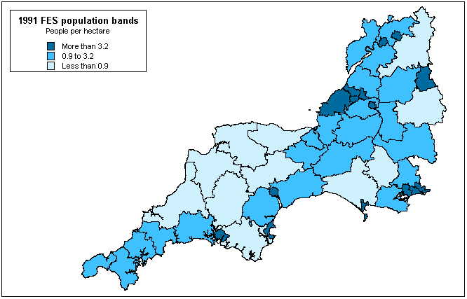
Source: Family Expenditure Survey, 1991-92

Table 2 (below) shows the results of logistic regression analysis using the 1991-2 Family Expenditure Survey data.

Table 2: Variables Associated with the Odds of Poverty by Population Density

 | Rural |  | Semi-Rural |  | Urban
 | LCA | MIHL | LCA | MIHL | LCA | MIHL
Lone Parent | 8.5 | 8.3 | 8.9 | 8.5 | 7.9 | 13.6
No Earner | 11.6 | 8.9 | 9.7 | 8.5 | 9.0 | 7.9
Overcrowding | 6.4 | - | - | - | - | 3.3
Not Owner-Occupier | 8.6 | 7.3 | 15.4 | 8.5 | 15.1 | 10.3
More Than Three Children | - | - | 5.6 | 7.7 | 5.6 | 4.7
No Car | 1.8 | 2.6 | 1.9 | 2.4 | 3.5 | 3.1
Semi/Unskilled Manual Worker | 2.5 | 1.7 | - | - | 2.3 | -
No Central Heating | 1.7 | 1.6 | 2.5 | 2.5 | - | 1.7

Source: 1991-2 Family Expenditure Survey

The initial weightings are developed using 1991 Census district level data for England and Wales in order to ensure the wider applicability of the procedure, partitioning the data and analysis on the basis of population density as detailed above. However, in order to reflect the distinctive dynamics of deprivation in the Southwest region this initial weighting is then re-weighted to ward level 1991 Census data for the southwest. The final weightings which have been applied in the development of these deprivation indices are given in Table 3 (below).

Table 3: Weightings for LCA and MIHL Poverty by Population Density, 1991 FES (percentages)

 | Rural |  | Semi-Rural |  | Urban
 | LCA | MIHL | LCA | MIHL | LCA | MIHL
Lone Parent | 24 | 31 | 23 | 32 | 19 | 34
No Earner | 27 | 32 | 24 | 32 | 20 | 27
Overcrowding | 17 | - | - | - | - | 16
Not Owner-Occupier | 24 | 28 | 29 | 32 | 24 | 30
More Than Three Children | - | - | 18 | 31 | 15 | 20
No Car | 6 | 13 | 7 | 13 | 11 | 15
Semi/Unskilled Manual Worker | 10 | 9 | - | - | 7 | -
No Central Heating | 6 | 7 | 9 | 13 | - | 7

As an example, using these weightings means that for households living in ‘rural’ districts in the Southwest, the total number of households classified as poor applying the LCA budget standards methodology developed by Parker et al. (1998, 2000) is:

24% of lone parent households +
27% of households with no earners +
17% of overcrowded households +
24% of renting households +
6% of households without a car +
10% of low social class households +
6% of households without central heating.

Similarly, for households living in ‘urban’ districts in the Southwest, the total number of households classified as poor applying the MIHL budget standards methodology developed by Morris et al. (2000) is:

34% of lone parent households +
27% of households with no earners +
16% of overcrowded households +
30% of renting households +
15% of households without a car +
7% of households without central heating
20% of households with more than three children.

Overall using this methodology 365,250 (19.6%) households in the Southwest are classified as LCA poor, and 487,176 (26.2%) households are classified as MIHL poor.

If these different approaches are truly measuring the same phenomenon there should be a close relationship between the two measures. As Figure 4 (below) shows there is indeed a very close relationship between the LCA and the MIHL measures. Each point on the scatterplot below represents an individual urban (blue), semi-rural (green), or rural (red) ward. The values for each point on the x and y axes represent the percentage of households classified as poor on the LCA and MIHL scales respectively. If there is a close convergence between the scales the points would be expected to be clustered together. If there is little convergence between these scales the points will be widely scattered. Figure 4 (below) thus shows a very strong linear relationship between the LCA and MIHL scales for urban, semi-rural and rural districts.

Figure 4: Percentage of Poor Households by Ward – LCA and MIHL Budgets, 1991 Census
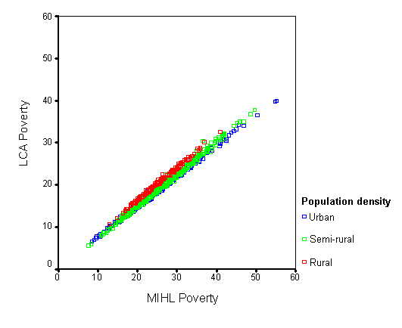
The ‘shape’ of the linear relationship (ie. the slope of the line) describes the nature of the relationship between the LCA and MIHL scales. For example, a 45˚ slope would indicate parity between the two scales, that is, that the scores for each individual ward are identical on both scales. Since the slope of the line in Figure 4 (above) is less than 45˚ this means that the scores for each ward on the MIHL scale are higher than those given by the LCA scale – the MIHL scale gives higher estimates of poverty compared with the LCA scale.

‘Triangulating’ methods by using a combination of approaches to the measurement of poverty also improves confidence in the resulting findings and the reliability of estimates derived using the budget standards approach (Veit Wilson, 1998). Comparing the scores for individual wards produced using the LCA and MIHL budgets with other established indices of deprivation such as the Breadline Britain index offers one means of validating the data in this way. In contrast with budget standards methods, the Breadline Britain index uses a consensual approach to the measurement of poverty. The consensual approach uses survey methods to establish what people view as the minimum necessities of life in modern Britain and then to ascertain the level of income at which people suffer an enforced lack of these socially defined necessities (see eg. Mack and Lansley, 1985; Gordon and Pantazis, 1997; Gordon et al., 2000). Using multivariate techniques analogous to those described above these findings are then applied to Census data to produce an weighted deprivation score for each ward (see Gordon, 1995).

As Figure 5 shows, a close relationship exists between the LCA and the Breadline Britain indices for urban, semi-rural and rural wards. An almost perfect correlation between the indices for urban wards is evident – for each urban ward the percentage classified by the LCA and Breadline Britain indices is almost identical. The relationship between the two indices for rural and semi-rural wards is less close since the ‘observations’ (rural and semi-rural wards) are less tightly clustered. Moreover, the scores for each rural and semi-rural ward are higher on the LCA index than on Breadline Britain, indicating that a greater percentage of rural and semi-rural households are classified as poor by the LCA index than by the Breadline Britain index. This is to be expected since the Breadline Britain index is optimised for the population of Britain (which is predominantly urban) rather than for the Southwest which is more mixed. On this basis, the LCA index appears to approximate more closely to the dynamics of rural deprivation in the Southwest than the Breadline Britain index.

Figure 5: Percentage of Breadline Index Poor Households Compared with the Percentage of LCA Poor Households by Ward, 1991 Census
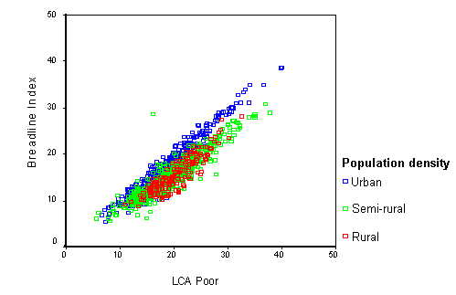

A similar pattern is evident when the MIHL index is compared with the Breadline Britain index, as Figure 6 (below) shows. Again, the closest relationship between the two scales is displayed by the urban wards, and considerably more variability is evident in relation to the poverty scores for rural and semi-rural wards. However, and in contrast with Figure 5 (above), even in the urban wards the MIHL index gives higher estimates of poverty compared with the Breadline Britain index. This is to be expected if it is assumed that the income needed to live healthily (as defined by the MIHL budgets) is likely to be greater than that needed solely to avoid poverty, the focus of the Breadline Britain index.

Figure 6: Percentage of Breadline Index Poor Households Compared with the Percentage of MIHL Poor Households by Ward, 1991 Census
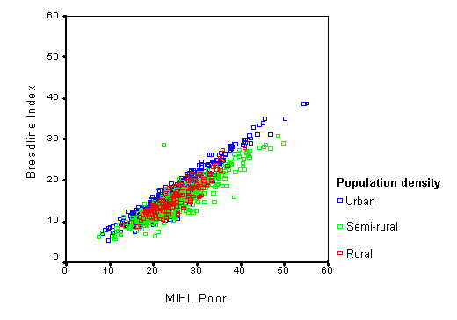
Table 4 (below) summarises the relationship between the LCA and MIHL scores and the Breadline Britain index. This shows the adjusted R squared values derived by linear regression analysis where a score of 1 indicates a perfect correlation between the Breadline Britain index and the LCA and MIHL indices respectively, and a score of 0 indicates no correlation. As Table 4 shows, the relationship between both of these scales and the Breadline Britain index is moderately good even in remoter rural areas, with adjusted R² scores of .796 and .793 for the LCA and MIHL scales respectively. However, the relationship is especially strong for urban wards, with adjusted R² scores of .929 and .927 for the LCA and MIHL scales respectively. As noted above this is to be expected given that the Breadline Britain index is optimised for the British population which is largely urban.

Table 4: Breadline Britain Compared with LCA and MIHL Indices by Population Density, Adjusted R²
 | LCA | MIHL
Rural | .796 | .793
Suburban | .853 | .845
Urban | .929 | .927

5. THE GEOGRAPHY OF DEPRIVATION IN THE SOUTHWEST

Overall, 365,250 (19.6%) households in the Southwest are classified as LCA poor, and 487,176 (26.2%) households are classified as MIHL poor. However, there are marked regional variations. In terms of the spatial distribution of deprivation in the southwest, applying the above weightings to 1991 Census data at ward level gives the following results (Figures 7 to 10, overleaf). In all cases ‘LCA Deprived’ refers to the percentage of households within a ward classified as poor using the approach pioneered by Parker et al. (1998, 2000) and applied to the Southwest 1991 ward level Census data using the weightings described above. Similarly ‘MIHL Deprived’ refers to the percentage of households within a ward classified as poor using the approach pioneered by Morris et al. (2000) and applied to the Southwest 1991 ward level Census data using the weightings described above.

Currently, there is no commonly agreed optimal strategy for the display of spatially aggregated chloroplethic data. A range of innovative classification strategies are available for the presentation of ‘traditional’, chloroplethic spatial data (see eg. Cromley, 1996). However, the intuitive appeal of quartile, quintile and decile distributions explains their continued widespread usage. Figures 7 and 8 (below) illustrate the decile distribution of LCA and MIHL ward-level deprivation scores respectively. In each ward the classification reflects the percentage of households within each ward classified as ‘LCA poor’ (Figure 7) and ‘MIHL poor’ (Figure 8).

These maps reveal the substantial continuities in the areas identified as poor using the methodology described above (see Section 4). Overall, these data suggest that poverty is concentrated in the larger urban settlements in the region, as well as in many of the more remote rural areas (eg. west Cornwall, Exmoor, the Dorset coast and rural Wiltshire). By contrast ‘accessible rural’ areas are often characterised by higher than average incomes relative to need, (eg. in former Avon authority area and in Gloucestershire.

Figure 7: LCA Deprived Wards by decile, 1991 Census

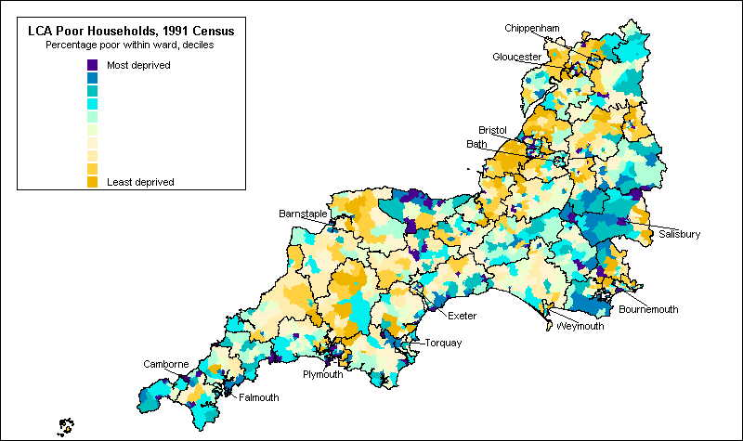

Figure 8: MIHL Deprived Wards by decile, 1991 Census

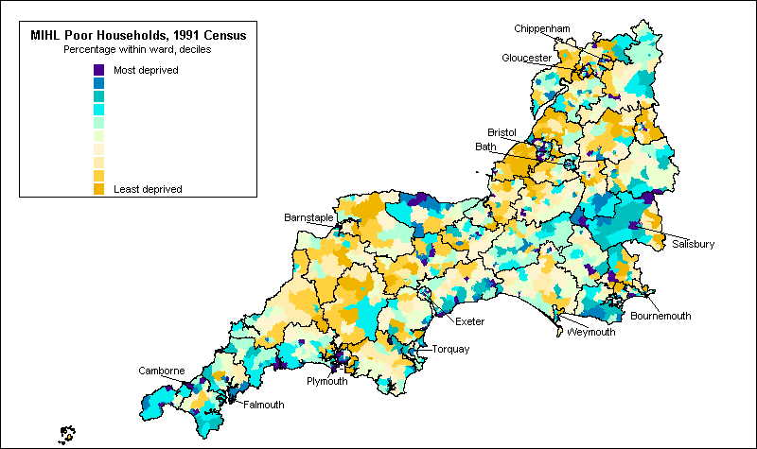

For additional clarity an interpolation procedure known as ‘Inverse Distance Weighting’ (IDW) has been used to map the distribution of poverty in the Southwest. There are many advantages to taking spatial data beyond the purely descriptive method illustrated above (Figures 7 & 8). Deprivation is not constrained by Census boundaries - deprivation usually does not dramatically fall from high levels on one side of a (ward) boundary to low levels on the other. IDW interpolation ‘smoothes’ the gradations in levels of deprivation across wards to generate a more realistic model of deprivation. (A detailed description of the IDW interpolation procedure is given in the Appendix 3). The results of applying this procedure to the LCA and MIHL poverty indices is shown in Figures 9 and 10 (below) respectively. These maps clarify but do not fundamentally alter the basic pattern displayed in the chloropleth maps above (Figures 7 & 8). Again, deprivation is concentrated in the major urban areas and the most remote rural areas of the Southwest (eg. west Cornwall, Exmoor), with significant concentrations of affluent households in more accessible rural areas (eg. North Somerset, South Gloucestershire).

Figure 9: LCA Deprived Wards, 1991 Census – IDW Method

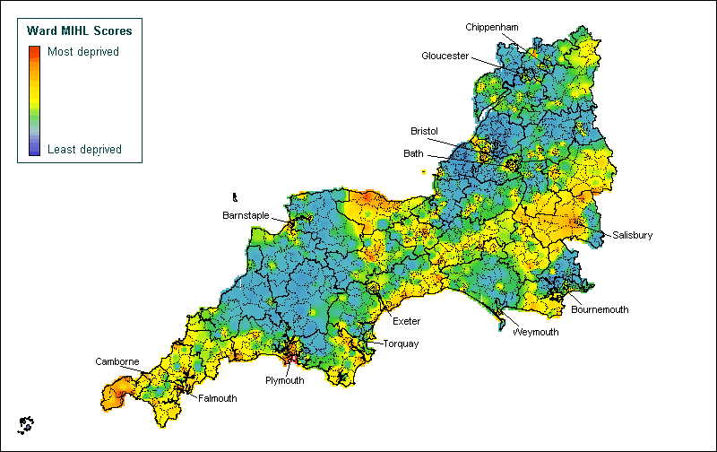

Figure 10: MIHL Deprived Wards, 1991 Census – IDW Method

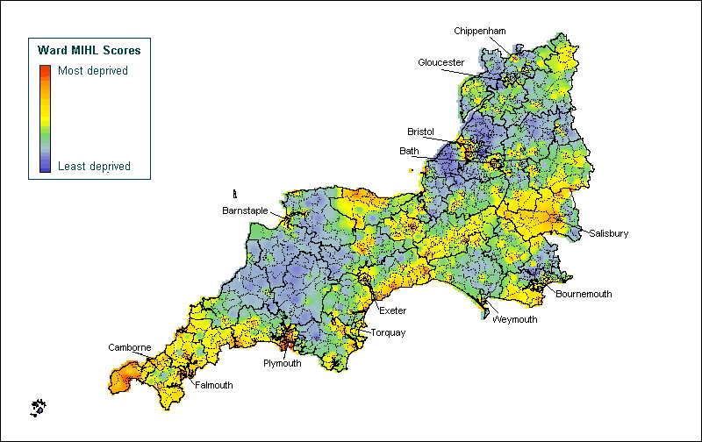

However, it must be acknowledged that the dispersed nature of rural settlements means that ward-level estimates of poverty and deprivation are likely to mask significant concentrations of poverty at a very small areal scale. In sparsely populated areas such as north Devon, for example, ward-level measures are likely to mask the existence of small pockets of sometimes intense deprivation due to the ‘averaging’ effect arising from their proximity to more affluent areas. In these circumstances it would ideally be desirable to map deprivation at a sub-ward level (see Gordon, Fahmy and Cemlyn [2002] for an example of this approach in the west Cornish context). It has long been recognized that the use of Enumeration Districts as a unit of statistical analysis is problematic as any analysis is undermined by the artificiality of ED boundaries which often carry little meaning in terms of the data - the ‘modifiable areal unit effect’ (Openshaw, 1984). The mapping of deprivation at a very small spatial scale using meaningful areal units will in future be facilitated through the anticipated release 2001 Census of Population sub-ward ‘Output Area’ data in 2003.

It is also instructive to compare these findings with other established indices of deprivation such as the Breadline Britain Index and the 2000 Index of Deprivation. Contemporary policy makers are now confronted with a plethora of different national indices of deprivation, and the use of one measure over another can produce very different results depending upon the construction of the index. However whilst a range of indices are available, the Breadline Britain Index has been demonstrated to be amongst the most reliable measure of relative deprivation available (see Lee et al., 1995; Burrows and Rhodes, 1998; Saunders, 1998). Figure 11 (below) illustrates the spatial distribution of ward-level Breadline Britain deprivation scores for the Southwest region only. (For further details about the methodology used in the development of the Breadline Britain Index see Gordon (1995)). As has already been noted (see Section 4), there is a close correlation between the Breadline Britain Index and the LCA and MIHL indices, and this is reflected in the spatial mapping. Overall there is thus a close correspondence between the areas identified as containing significant concentrations of poverty. However, since the Breadline Britain Index is optimised for the predominantly urban population of Britain it records somewhat lower levels of poverty in many of the more remote rural areas and coastal regions (eg. the Devon coastline, Exmoor, southern Wiltshire, west Cornwall).

Figure 11: Breadline Britain Index by decile, 1991 Census

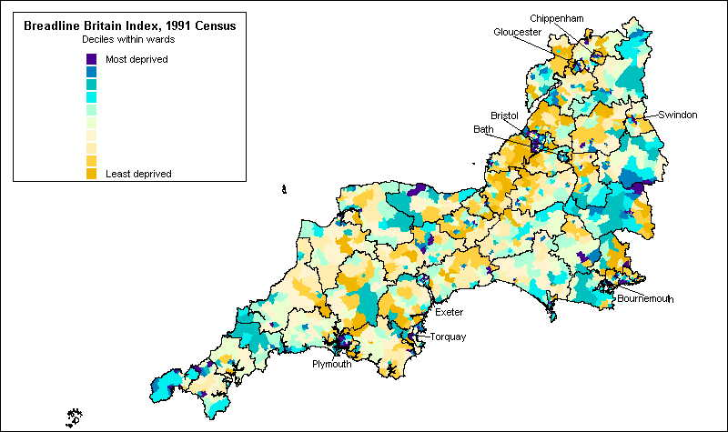

An increasing acknowledgement of the problems faced by rural communities, and of the growth in rural poverty in recent years, is reflected in changes to the DETR’s Indices of Local Deprivation (ILD). The 2000 ILD accords greater emphasis to access to services and, since many rural residents have poor access to essential services, to ‘deprivation’ in remote rural areas (DETR; 1998, 2000b). As a result of transformations applied to the data which constitute the overall Index of Multiple Deprivation (IMD), areas with very poor access to services figure very prominently in the 10% most IMD-deprived wards (see DETR, 2000 for further details of the methodology used in the construction of the 2000 ILD). This is reflected in the spatial distribution of Multiple Deprivation as illustrated in Figure 12 (below). Thus, overall Multiple Deprivation is most prevalent in the geographically peripheral western areas of the region (eg. Devon and Cornwall), as well as in the main urban areas.

Figure 12: DETR Index of Multiple Deprivation, 2000

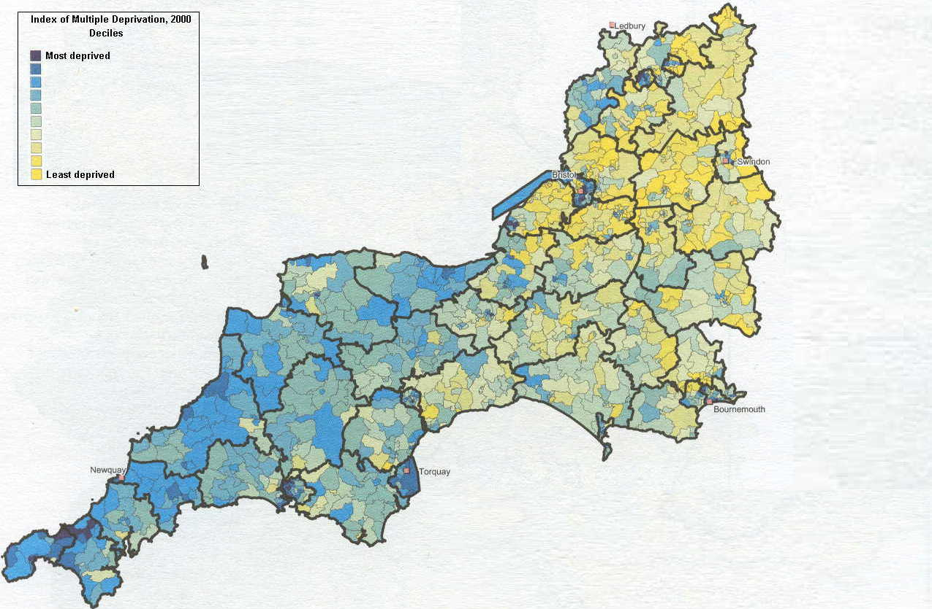

Source: DETR (2000: 81) [©Crown Copyright]

Unfortunately this approach conflates two distinct understandings of poor areas. ‘Poor areas’ can mean either areas containing a large number (or proportion) of poor people, or, alternatively, areas which lack facilities such as public and private services. Areas with poor access to public and private services, often remote rural areas rather than major urban and metropolitan regions, do not necessarily contain large proportions of ‘poor’ people, as measured on the basis of, for example, income, employment, or health. Indeed, measures such as employment or income deprivation are often inversely correlated with access to services – in other words the components are not additive. The inclusion of both types of measures within an overall national index, such as the 2000 Index of Multiple Deprivation, is thus highly problematic. The lack of consistency between the 2000 ILD and the indices reviewed above (Figures 7 to 11) in the identification of poverty in rural areas such as Devon, north Cornwall and west Somerset is largely explained by the inclusion of access to services within the DETR’s 2000 Index of Deprivation.

A central concern of this report has been the development of indicators of poverty and deprivation which are sensitive to the distinctive dynamics of poverty in urban and rural areas in the Southwest. Table 5 (below) shows the mean deprivation scores for wards of different settlement type (ranging from ‘wholly urban’ to ‘wholly rural’) for the LCA and MIHL indices, as well as for the Breadline Britain Index for comparison. For each index the mean score in Table 5 refers to the percentage of households classified as ‘poor’.

Table 5 Ward-level poverty rates (%) by 1991 ONS Urban/Rural Classification - Breadline, LCA and MIHL Poverty Indices

 | Breadline | LCA | MIHL
Wholly Urban | 17.8 | 20.4 | 27.4
Predominantly Urban | 16.3 | 19.7 | 26.0
Mixed Urban | 14.9 | 18.6 | 24.5
Mixed Rural | 14.0 | 17.4 | 22.8
Predominantly Rural | 13.3 | 17.5 | 22.5
Wholly Rural | 13.9 | 17.7 | 22.7
ALL | 16.4 | 19.6 | 26.2

As Table 5 illustrates, overall poverty rates tend to be highest in the most urbanised wards, ranging from 17.8% of households (Breadline) to 27.4% of households (MIHL). In comparison rates of poverty in rural and predominantly rural wards are significantly lower. Thus, in ‘wholly rural’ wards poverty rates range from 13.9% (Breadline) to 22.7% (MIHL).

7. CONCLUSION

This report has focused upon mapping the extent and distribution of poverty and deprivation in the Southwest of England using a budget standards methodology to determine the level of income needed by different household types to avoid poverty and to live healthily. These measures are derived from original research conducted by Parker and colleagues (1998, 2000) to determine ‘Low Cost but Acceptable’ (LCA) budget standards, and by Morris and colleagues (2000) in order to establish a ‘Minimum Income for Healthy Living’ (MIHL) (see Section 4). The link between poverty and ill health is well established (see eg. Shaw et al., 1999). Determining the extent and spatial distribution of poverty is therefore essential in developing effective health policies directed at reducing and eliminating social inequalities in health. Whilst there is no universal agreement as to the best way to define and measure poverty, budget standards approaches are both widely used and intuitively appealing (see Section 3). The LCA budget standard adopted here also accords well with other established indices of deprivation derived using a different, consensual survey methodology, for example the Breadline Britain index (see Section 4).

However, the LCA budget standard produces rather lower estimates of the income needed to avoid poverty for different household types than those estimates derived using the MIHL approach. This is to be expected since these two standards are conceptually distinct. The LCA budgets estimate the income necessary to meet the basic physical, social and psychological needs of individuals and households living in the UK at the end of the twentieth century. This approach does not always make allowance for the patterns of consumption (eg. sporting and leisure activities, nutrition, etc.) necessary for sustained healthy living. However, these types of expenditure are explicitly included within the budgets derived from the MIHL methodology developed by Morris and colleagues. This approach seeks to estimate the income needed by different household types in order to live healthily, and not simply to avoid poverty. Since the overall goal of this report is to inform the development of health policies directed at alleviating and eliminating social inequalities in health, the MIHL index is thus a more appropriate basis upon which to frame public health policies in the Southwest.

A recurrent theme in this report has been the difficulties involved in measuring and mapping deprivation in ways which are sensitive to the distinctive dynamics of poverty in urban and rural areas (see Section 2). In particular, the ‘invisibility’ of poverty in rural areas, where poverty is both widely dispersed and different in form to urban poverty, is especially pertinent to the Southwest since the region is significantly more rural than the UK as a whole. The methodology used in this report goes some way towards addressing the measurement problems arising from the distinctiveness of rural poverty and differences in the composition of the urban and rural poor (see Section 4). However, as with poverty there is no unambiguous definition of ‘rurality’. The weightings used in census-based deprivation indices such as these partly depend upon the approach adopted in measuring rurality. This obviously has implications for the final area deprivation scores generated using these weightings.

The dispersed nature of rural poverty also raises a range of other challenges in terms of the spatial mapping of poverty and deprivation in the Southwest. To some extent these can be addressed through the use of GIS techniques such as Inverse Distance Weighting to ‘smooth’ variations in levels of deprivation across essentially arbitrary administrative boundaries such as electoral wards (see Section 5). However, the dispersed nature of rural settlement means that ward-level estimates are likely to mask significant concentrations of poverty at a very small areal scale. In these circumstances it would ideally be desirable to map deprivation at a sub-ward level. It has long been recognized that the use of Enumeration Districts (ED) as a unit of statistical analysis is problematic as any analysis is undermined by the artificiality of ED boundaries which often carry little meaning in terms of the data. The mapping of deprivation at a very small spatial scale using meaningful areal units will in future be facilitated through the anticipated release of 2001 Census of Population sub-ward ‘Output Area’ data in 2003. It will be interesting to see how the data presented here compare with up-to-date sub-ward level estimates generated using an analogous methodology.

REFERENCES

Acheson Report (1998) Independent Inquiry into Inequalities in Health, Report of the Scientific Advisory Group, Chairman, Sir Donald Acheson, London: The Stationery Office.

Bhatia, R and Katz, M. (2002) Estimation of Health Benefits From a Local Living Wage Ordinance. American Journal of Public Health, 91, 9, 1398-1402

Bradshaw, J. (1993) (Ed.) Budget Standards for the United Kingdom Aldershot: Avebury

Bramley, G., Gordon, D. and Lancaster, S. (2000) Benefit Take-up and the Geography of Poverty in Scotland. Regional Studies, 34, 6, 507-519.

Bruce, A., Gordon, D. and Kessell, J. (1995) Analysing Rural Poverty. Local Government Policy Making. 22, 1, 16-23.

Burrows, R., and Rhodes, D. (1998) Unpopular Places? Area disadvantage and the geography of misery in England. Bristol, Policy Press.

Chandola, T., Lloyd, M., Noble, M., Wright, G., & Wigglesworth, R. (2000). Rural Deprivation: An analysis of the indices of deprivation 2000 for rural areas. Report to the Countryside Agency. Oxford: University of Oxford.

Chapman, P., Phimister, E., Shucksmith, M., Upward, R., & Vera-Toscano, E. (1998). Poverty and Exclusion in Rural Britain: The dynamics of low income and employment. York: Joseph Rowntree Foundation.

Cromley, R. G. (1996). A Comparison of Optimal Classification Strategies for Chloroplethic Displays of Spatially Aggregated Data. International Journal of Geographical Information Systems, 10, 405-424.

Davey Smith, G., Dorling, D. and Shaw, M. (2001). Poverty, Inequality and Health, 1800-2000: A reader. Bristol: The Policy Press.

DETR (Department of the Environment, Transport and the Regions). (1998). Guidance on the Methodology for Multi-Modal Studies. London: DETR.

DETR (Department of the Environment, Transport and the Regions). (2000a). Indices of Deprivation 2000: Regeneration Research Summary 31. London: DETR.

DETR (Department of the Environment Transport and the Regions) (2000b). Measuring Multiple Deprivation at the Small Area Level: The Indices of Deprivation, 2000. London: DETR.

Dunn, J., Hodge, I., Monk, S., & Kiddle, C. (1998). Developing Indicators of Rural Disadvantage. Salisbury: Rural Development Commission.

Gordon, D. (1995). Census Based Deprivation Indices: Their Weighting and Validation. Journal of Epidemiology and Community Health, 49, 39-44.

Gordon, D., Fahmy, E., & Cemlyn, S. (2002). Poverty and Neighbourhood Renewal in West Cornwall. West Cornwall Local Strategic Partnership / University of Bristol. [Available at: www.bris.ac.uk/poverty/region.htm]

Gordon, D., Adelman, L., Ashworth, K., Bradshaw, J., Levitas, R., Middleton, S., Pantazis, C., Patsios, D., Payne, S., Townsend, P. and Williams, J. (2000) Poverty and Social Exclusion in Britain York: Joseph Rowntree Foundation

Gordon, D., & Pantazis, C. (Eds.) (1997). Breadline Britain in the 1990s. Aldershot: Ashgate.

Hodge, I., Dunn, J., Monk, S., & Kiddle, C. (2000). An Exploration of 'Bundles' as Indicators of Disadvantage. Environment and Planning A, 32, 1869-1887.

Jarman, B. (1984). Underprivileged Areas: Validation and distribution of scores. British Medical Journal, 289, 1587-1592.

Lee, P., Murie, A., & Gordon, D. (1995). Area Measures of Deprivation. A study of Current Methods and Best Practices in Identification of Poor Areas in Great Britain. Birmingham: University of Birmingham.

Mackay, G.A. and Macleod, Y. (1996) Rural Scotland Price Survey: Summer 1996 Report. Highlands and Islands Enterprises and Mackay Consultants, Inverness.

McCusker, J.(2001) "Comparing the Purchasing Power of Money in Great Britain from 1264 to Any Other Year Including the Present" Economic History Services, [Available at: www.eh.net/hmit/ppowerbp/]

Mack, J., & Lansley, S. (1985). Poor Britain. London: Allen and Unwin.

Martin, D., Brigham, P., Roderick, P., Barnett, S., & Diamond, I. (2000). The (Mis)representation of Rural Deprivation. Environment and Planning A, 32, 735-751.

Middleton, S., Ashworth, K. & Walker, R. (1994). Family Fortunes: Pressures on parents and children in the 1990s . London: CPAG.

Middleton, S. (2000) “Agreeing Poverty Lines: The development of consensual budget standards methodology” in Bradshaw, J. and Sainsbury, R. (Eds.) Researching Poverty Aldershot: Ashgate

Morris, J.N., Donkin, A.J.M., Wonderling, D., Wilkinson, P. and Dowler, E.A. (2000) “A Minimum Income for Healthy Living” Journal of Epidemiology and Community Health 54(12): 885-889

ODPM (Office of the Deputy Prime Minister). (2002). Urban and Rural Area Definitions: A user guide. London: ODPM

ONS (Office for National Statistics) (1999). The ONS Classification of Local and Health Authoroties of Great Britain. London: Government Statistical Service.

Openshaw, S. (1983). The Modifiable Areal Unit Problem. Norwich: Geo Books.

Parker, H. (Ed.) (2000) Low Cost but Acceptable: Incomes for older people Bristol: The Policy Press

Parker, H. (Ed.) (1998) Low Cost but Acceptable. A minimum income standard for the UK: Families with children. Bristol: The Policy Press

Payne, S., Henson, B., Gordon, D., & Forrest, R. (1996). Poverty and Deprivation in West Cornwall in the 1990s. A Report to the West Cornwall Initiative. Bristol: Statistical Monitoring Unit. [Available at: www.bris.ac.uk/poverty/region.htm]

Rowntree, B.S. (1901). Poverty: A Study of Town Life. London: Macmillan.

Saunders, J. (1998) Weighted Census-based deprivation indices: their use in small areas. Journal of Public Health Medicine, 20, 3, 253-260.

Senior, M., Williams, H. and Higgs, G. (2000) Urban-rural mortality differentials: controlling for material deprivation. Social Science & Medicine 51, 289-305.

Shucksmith, M., Roberts, D., Scott, D., Chapman, P., & Conway, E. (1996). Disadvantage in Rural Areas. London: Rural Development Commission.

Stitt, S., & Grant, D. (1993). Poverty: Rowntree Revisited. Aldershot: Avebury.

Townsend, P. (1993). The International Analysis of Poverty. Hemel Hempstead: Harvester Wheatsheaf.

Townsend, P. (1979). Poverty in the United Kingdom. London: Penguin.

Townsend, P. (1970) “Measures of Income and Expenditure” in Townsend, P. (Ed) The Concept of Poverty (1970) London: Heinemann

Townsend, P. and Davidson, N. (1982) The Black Report, London: Penguin Books.

Veit-Wilson, J. (1998) Preface to Parker, H. (Ed.) Low Cost but Acceptable Bristol: The Policy Press

Wallace, M., & Denham, C. (1996). The ONS Classification of Local and Health Authorities of Great Britain. London: HMSO.

Wyn, M. (1970). Family Policy. London: Michael Joseph.

APPENDIX

A1. The LCA and MIHL Budget Standards

The equivalency scale used in this research is shown in Table A1 (below). The values for each household member were added together to give the total income equivalence value for that household. This number was then divided into the gross income for that household. For example, the equivalence value for a lone-parent household with two children is 1.53 + 0.23 = 1.76. If the household’s net annual income is £10,000, its equivalised income is £5,682 (=£10,000/1.76).

Table A1: Equivalised income scale

Type of household | Equivalence value
Single person household | 0.71
Couple | 1.00
Couple with one child | 1.25
Lone parent in employment with one child | 1.53
Single pensioner | 0.80
Pensioner couple | 1.18
Add for each additional adult | 0.45
Add for each additional child | 0.23

However, the probability of having an adequate income and avoiding poverty is also dependent upon housing costs as well as the cost of employment (eg. the cost of transport, the cost of childcare for single parents) which are especially significant factors in rural areas (Payne et al., 1996). Since the above equivalency scale is developed from budget standards data it thus reflects assumptions about the lifestyles and expenditure patterns of different household types. For example, it is assumed that at least one adult is in full-time work in households containing adults of working age. Lone parent households in full-time employment will, on average, need a greater income to avoid poverty and to live healthily compared with similar households types in order to cover the costs of childcare, travelling to work and so on.

Figure A1 (below) compares the income thresholds necessary to avoid poverty and to live healthily derived from these different budget standards methodologies for different household types and adjusted for the effects of inflation to October 2001 prices. As Figure A1 shows, there is considerable divergence between the different income thresholds as determined by these methods with the Rowntree standard producing the lowest standards and MIHL the highest standards. This is to be expected since the desired outcomes are conceptually distinct. As already noted, the definition of poverty used in the Rowntree budgets is much more restrictive than that used in the LCA budgets so it is unsurprising that the income thresholds specified are considerably lower. Similarly, it is not unreasonable to suppose that the income needed to live healthily (the MIHL budgets) is likely to be greater than that needed solely to avoid poverty (the LCA and Rowntree budgets).

Figure A1: Comparison of Budget Standards by Household Type: Rowntree, LCA and MIHL (£ per week, 1991 prices)

A2. The Family Expenditure Survey, 1991

Subject Categories

Family Expenditure Survey - Major studies
Consumer behaviour – Economics
Family life and marriage - Social issues, attitudes and behaviour
Depositor(s): Central Statistical Office
Principal Investigator(s): Central Statistical Office
Data Collector(s): Office of Population Censuses and Surveys. Social Survey Division

Abstract

The UK Family Expenditure Survey (FES) is a continuous survey with an annual sample of around 10,000 households (about 1 in 2000 of all United Kingdom households) about 60% of which co-operate by providing the interviewers with information about the household, household and personal incomes, certain payments that recur regularly (eg rent, gas and electricity bills, telephone accounts, insurances, season tickets and hire purchase payments) and in maintaining a detailed expenditure record for 14 consecutive days.

The original purpose of the survey was to provide information on spending patterns for the United Kingdom Retail Price Index (RPI). The survey is a cost efficient way of collecting a variety of related data that the government departments require to correlate with income and expenditure at the household, tax unit and person levels. The annual survey has been in existence since 1957 (with an earlier large scale survey in 1953/54) and was one of the first Department of Employment (DE) systems to be computerised in the early 1960s.

Main Topics

1. Household Schedule

This schedule is taken at the main interview. Information for most of the questions is obtained from the head of household or housewife, but certain questions of a more individual character are put to every spender aged 15 or over (or 16 or over from 1973 onwards). Until the introduction of the community charge, information on rateable value and rate poundage was obtained from the appropriate local authority, as was information on whether the address was within a smokeless zone. Information was collected about the household, the sex and age of each member, and also details about the type and size of the household accommodation. The main part of the questionnaire relates to expenditure both of a household and individual nature, but the questions are mainly confined to expenses of a recurring nature, e.g.:

i) Household
Housing costs, payment to Gas and Electricity Boards or companies, telephone charges, licences and television rental.

ii) Individual
Motor vehicles, season tickets for transport, life and accident insurances, payments through a bank, instalments, refund of expenses by employer, expenditure claimed by self-employed persons as business expenses for tax purposes, welfare foods, education grants and fees.

2. Income Schedule

Data are collected for each household spender. The schedule is concerned with income, national insurance contributions and income tax. Income of a child not classed as a spender is obtained from one or other of his parents and entered on the parent's questionnaire. Information collected includes:- employment status and recent absences from work, earnings of an employee, self-employed earnings, National Insurance contributions, pensions and other regular allowances, occasional benefits - social security benefits and other types, investment income, miscellaneous earnings of a 'once-only' character, tax paid directly to Inland Revenue or refunded, income of a child.

3. Diary Records

The diary covers fourteen days. Each household member aged 15 or over (or 16 or over from 1973 onwards) is asked to record all expenditure made during the 14 days. Children aged between 7 and 15 have also now been asked to complete simplified diaries of their daily expenditure. Data from the children's diaries has been included in the survey results for the first time in 1998-99.

Coverage

Dates of Fieldwork: 1991
Country: United Kingdom national
Spatial Units: Standard Regions
Observation Units: Families/households

A3. Inverse Distance Weighting (IDW)

Interpolation is a mathematical process used to estimate values between known point observations. The IDW procedure converts point data into continuous grid layers ( a trend surface) by calculating a value for each grid node by examining surrounding data points lying within a defined search radius. The node value is calculated by averaging the weighted sum of all the points, the weight being a function of inverse distance. Thus, data points that lie progressively farther from the node influence the computed value far less than those lying closer to the node.

(1)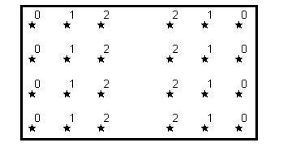(2)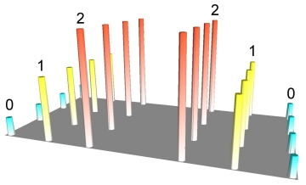(3)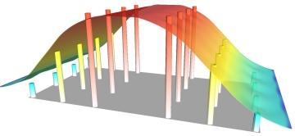
(1)

©Northwood Geoscience

In illustration (1) above, 24 points are arranged regularly with attribute values ranging from 0 to 2. Any numeric attribute can be represented in 3D form, as depicted in the second illustration. This image is actually a rendered grid generated using IDW interpolation by sampling only one data point and using a very small display radius equal to the width of a single column. However, grids are usually used to build a continuous surface that connects data points in space, effectively removing gaps in the representation of data. IDW achieves this by generating a moving average or ‘smoothing’ of the data, as shown in illustration (3). A technical account of IDW interpolation is in Figure A1 (below).

Figure A2: The IDW Interpolation Procedure

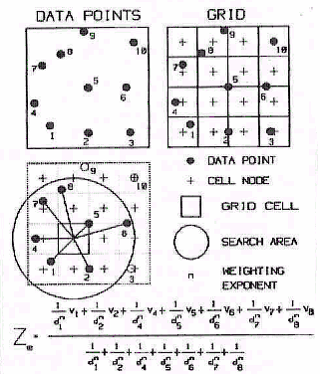

Urban areas are defined by ONS as built-up settlements with 1,000 or more inhabitants and a minimum land area of 20 hectares. However, in practice a population threshold of 10,000 residents is assumed for most purposes (ODPM, 2002). The 1991 Urban Areas Classification is currently being revised - the 2001 Classification is expected to be released in the summer of 2003.
A detailed description of the 1991 Family Expenditure Survey is given in Appendix 2.
Subsequent analyses of the 1991-2 FES data reflect the following classification of population density (people per hectare [pph]): “rural” = Less than 0.9pph; “semi-rural” = 0.9 to 3.2pph; “urban” = More than 3.2pph.
It is assumed that rural areas have a 2.6% greater cost of living compared with urban and semi-rural areas. The figure is taken from Scottish Highlands Development Board data on living costs in urban and rural Scotland (Mackay and Macleod, 1996; Bramley et al, 2000) we have assumed that the same urban-rural cost relationships also occur in the South West region.

