Poverty and Neighbourhood Renewal
in
West Cornwall

summary REPORT

Sarah Cemlyn
Eldin Fahmy
David Gordon
University of Bristol

Simon Bennett
Cornwall Health Research Unit



January 2002

Preamble
This report contains a brief summary of some of the key findings of the research team. The full report will be submitted at the end of January.

1. Neighbourhood renewal
1.1 In 1997, the Social Exclusion Unit (SEU) was established with a responsibility for developing integrated and sustainable solutions to the problems faced by Britain’s most deprived communities. In September 1998, as part of this strategy, the SEU recommended the introduction of a national strategy for Neighbourhood Renewal.

1.2 Drawing upon extensive research and consultation, the Government set out the main elements of its National Strategy Action Plan for Neighbourhood Renewal (NSAP) in January 2001. For the 88 most deprived Local Authority districts identified by central Government, including Kerrier and Penwith, a £900 million Neighbourhood Renewal Fund (NRF) will kick-start implementation of this National Strategy.

1.3 The NSAP outlines the Government’s strategy for achieving its overall objective that “within 10 to 20 years no-one should be seriously disadvantaged by where they live”. This ambitious objective is reflected in two long-term goals:

- To have lower worklessness; less crime; better health; better skills and better housing and physical environment in all the poorest neighbourhoods
- To narrow the gap on these measures between the most deprived neighbourhoods and the rest of the country
More detailed national targets have subsequently been established relating to the five core themes of Neighbourhood Renewal: employment; education; crime; health, and housing and the physical environment.

1.4 A central part of the Strategy is the creation of Local Strategic Partnerships (LSPs) which bring together Local Authorities and other public services as well as residents and private, voluntary and community sector organisations. The West Cornwall LSP (WCLSP) will be responsible for developing and implementing a Local Neighbourhood Renewal Strategy. They will:
- Identify priority neighbourhoods
- Identify problems of deprived neighbourhoods
- Map resources going into priority neighbourhoods
- Agree on what more needs to be done
- Implement and monitor agreed action

1.5 Encouraging community and voluntary sector participation in neighbourhood renewal is also vital. The new Community Empowerment Fund will provide around £400,000 over the next three years to each of the 88 NRF areas (including Kerrier and Penwith) to support community and voluntary sector involvement in LSPs. To support community groups and activities, the Government will also be funding the introduction of local Community Chests to provide small grants for community organisations in deprived areas.

2. mapping deprivation
2.1 The DETR’s 2000 Index of Multiple Deprivation (2000 IMD) (which measures deprivation at a ward level) was used by central Government to identify NRF priority areas. This index describes a range of measures classified in the following six main ‘domains’:
- Income
- Employment
- Health
- Education
- Housing
- Access to services
The 2000 IMD combines these domains within a single deprivation score for each of the 8,414 English wards.

2.2 Those wards in Kerrier and Penwith within the 10% most IMD-deprived wards in England were identified as NRF priority areas and are shown below:

Figure 1: IMD-Deprived Wards in West Cornwall, 2000
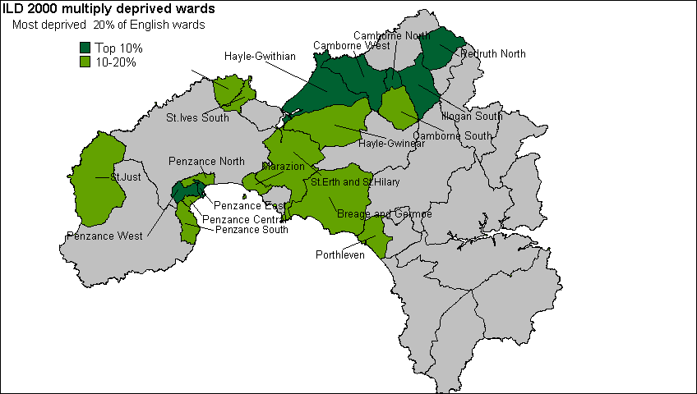

2.3 A key task of this research was to identify the poorest neighbourhoods in West Cornwall at very small area level (ie sub-ward level). The DETR’s 2000 IMD (used to identify the 88 priority areas for NRF funding) is less appropriate in the West Cornish context since electoral wards cover relatively large spatial areas with diverse populations. Targeting NRF funding on this basis would result in significant pockets of poverty being overlooked, as well as the targeting of other areas which are not obviously ‘deprived’.

2.4 The 1991 Census provides the only reliable data at the sub-ward level for the whole of the UK. Seven indicators derived from the 1991 Census were finally selected for analysis at the Enumeration District level (approximately 200-400 individuals). These measures approximate to the six ‘domains’ of deprivation (plus the supplementary child poverty index) identified by the DETR and included within the 2000 IMD:
- Poverty rate (Income)
- Child poverty rate (Supplementary)
- Unemployment rate (Employment)
- Percent of people aged 18+ with no post school qualifications (Education)
- Standardised Illness Ratio (Health)
- Percent of households with no central heating (Housing)
- Percent of households with no car (Access to services)

2.5 On the basis of these measures, it was possible to construct a scale of multiple deprivation using an approach analogous to that used in the development of the 2000 IMD, ensuring that the final deprivation index was constructed in a similar way to that used to identify priority districts eligible for NRF funding. Enumeration Districts (EDs) were then ranked according to their score on this cumulative index. It was possible to identify the most deprived EDs for any population threshold (in this case, the 33% level, as decided by the LSP Research Steering Group), as illustrated in Figures 2 and 3. Figure 2 identifies the neighbourhoods with the highest levels of deprivation, using a statistical technique called Inverse Distance Weighting.

Figure 2: Small Neighbourhood Concentrations of Deprivation in West Cornwall Identified by Inverse Distance Weighting
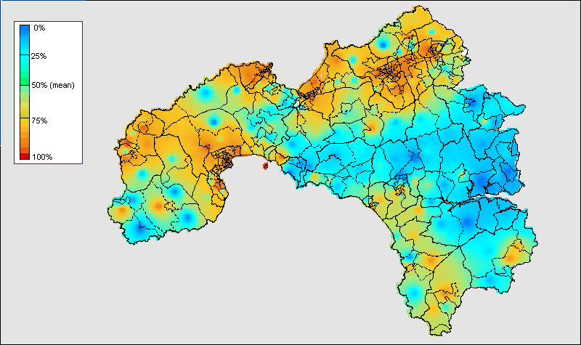

2.6 The Priority Areas for NRF funding identified by this process are shown in Figure 3, mapped at 1991 Census Enumeration District level.
Figure 3: Priority Areas at Enumeration District Level, 33% Population Threshold
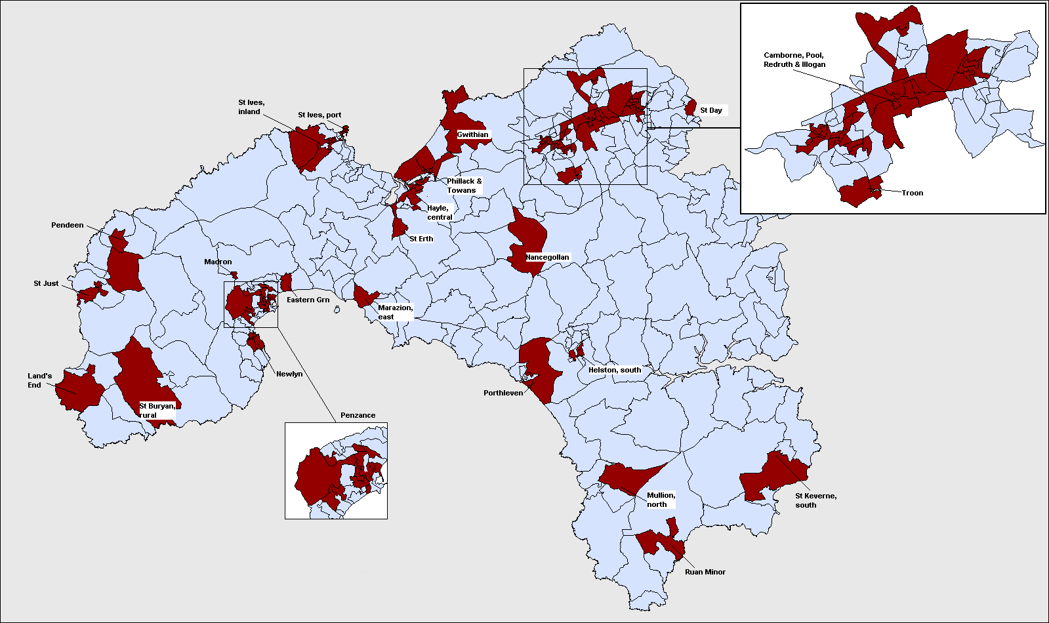

3. CONSULTATION WITH STAKEHOLDERS
3.1 This phase of the research focused on the experience of “key stakeholders” in relation to deprived neighbourhoods. Thirty-one face-to-face interviews, involving 37 people from diverse organisations and areas and 14 telephone interviews, were undertaken. This was a preliminary exercise and not a full community consultation.

3.2 Many respondents were ready to identify particular estates or villages where their experience indicated the greatest levels of disadvantage. With very few exceptions, these neighbourhoods are all included in the clusters defined by statistical analyses as deprived.

3.3 There were also concerns that defining particular areas as ‘deprived’ feeds into a process of stigmatisation and lowered expectations; that the whole geographical area was deprived; that some deprived areas were very small and that the proximity of poor and affluent areas could result in the former being overlooked statistically.

3.4 The major social problems identified were:
- Employment: seasonality and insecurity; low wages; declining real income for disadvantaged groups; skills mismatch in relation to emerging industries
- Housing and environment: Lack of affordable private housing; impact of incomers and second homes on house prices; shortage of social housing; adverse impact of tourism on the environment; contamination of former industrial land
- Education and training: Lack of opportunities for higher education; loss of apprenticeship system; lack of opportunities generally for young people and associated lack of hope; resulting outflow of young people from the area
- Services and facilities: Poor public transport; lack of available, flexible and affordable childcare; difficulties of access for disabled people; insufficient play, leisure and cultural facilities; shortage of youth workers; in-migration pressures
- Health: Isolation, especially for older, single, and disabled people; mental health issues including postnatal depression; long term ill health and shortage of relevant provision; difficulties of access to primary health services, and emergency and specialist services; drug and alcohol problems; teenage pregnancies; shortage of accessible and confidential sexual health services
- Crime and anti-social behaviour: Problems of vandalism and anti-social behaviour experienced by older residents on some estates; fear of crime disproportionate to the incidence of crime; racism experienced by asylum seekers and minority ethnic groups including Gypsies and Travellers

3.5 Other issues, although structural in origin, were viewed as attitudinal:
- Low aspirations; lack of parenting skills; decline in community support; difficulties of involving a wide range of participants in community activities; mistrust of agencies; hopelessness felt by front line agency staff and residents
- Limited horizons and experience in terms of learning from elsewhere within and outside Cornwall and taking up opportunities; insularity between different villages, estates and neighbourhoods; pride of place and Cornish identity given little recognition and overt expression

3.6 Whilst funding under a variety of national and European regeneration budgets is clearly a major asset for regeneration, this research identified some problems in the way these processes have developed and the conditions under which Local Authorities and communities have to respond to them. Some of these are:
- An imbalance in the capital as against the revenue budgets and a focus on large-scale projects which can further marginalise disadvantaged areas and groups; difficulties of obtaining matched funding; the complexity, bureaucracy, and lack of transparency of the bidding process
- Fragmentation arising from the multiplicity of new initiatives and policies; dangers of disillusion when consultation and new initiatives do not lead to tangible results for disadvantaged neighbourhoods
- Insufficient proactivity, cooperation and flexibility within statutory agencies; a lack of accessible information about new programmes; a focus on ‘hard’ targets rather than long-term community development work providing sustained support

3.7 There was considerable convergence about many issues and their structural basis in West Cornwall, especially relating to wages, employment, housing, and transport. In other respects relating to institutional and community responses, there were differences. Rural areas were seen as especially disadvantaged. Access to transport was spread unevenly in urban and rural areas. Attitudinal factors were diversely perceived. Many agency interviewees identified low aspirations and limited parenting skills. A culture of blame was seen as damaging with anger needing to be tapped.

3.8 Among residents’ groups, the research team found very high aspirations for local neighbourhoods. Some projects referred to good parenting skills. Pride in Cornish identity is more often unspoken than overt, but Cornish cultural activities were promoted. Ways of overcoming barriers to involvement were actively demonstrated. Evidence was offered of the potential of Health Visitors to engage with the most alienated communities.

3.9 There are three possible approaches to these diverging perspectives. Firstly, there is a possible mismatch between agency expectations and local people’s hitherto realistic self-sufficiency. Secondly, divergent agendas may inhibit agency understanding of local residents’ strengths. Thirdly, there is a possible masking of this strength and energy with disadvantaged people feeling insufficiently encouraged and listened to.

3.10 Different levels of organisation promote community development and participation. Firstly, in relation to umbrella bodies providing coordination, support and advocacy for the sector as whole, important resources were available though at different stages of development. There were also forums linking interest communities. At an intermediate level, other linking mechanisms have developed around regeneration. However, there are constraints upon coordination with the independence and resilience of local groups sometimes limiting mutual learning and sharing through competition for resources and status. At a local level, there was considerable activity in residents, planning, faith-based, cultural and health groups, but these needed increased access to support, information and funding.

3.11 A powerful case was made for community-led development building on residents’ own aspirations, skills and knowledge to provide a channel to express views at strategic level. Increased community development support was needed not only for the least resourced groups but also for neighbourhoods lacking organisation. Development agencies argued that the understanding of community development, which was focused on economic regeneration, needed to be reclaimed for social and community regeneration. Community development work needed appropriate organisational and strategic support.

3.12 Statutory partners also needed to change attitudes, give up some of their power, develop skills in partnership working and move to more equal partnership approaches. A process of neighbourhood management was advocated by some to coordinate all services and promote change in a neighbourhood, however there was no consensus on this.

3.13 Social housing predominates in many disadvantaged areas but residents of privately rented housing and owner occupiers also need to be included. Disabled people face obstacles to participation. Poor women face multiple disadvantages and women subject to violence are likely to experience further deprivations of income, housing, self-esteem. Incomers to Cornwall, often presented as a problem, also have a potential community contribution to make.

3.14 Some see Cornish people themselves as an oppressed minority ethnic group. Other minority ethnic groups also received attention. Gypsies and Travellers, on sites and in housing, experience hostility and discrimination. Black, mixed parentage and other minority ethnic children in predominantly white areas have particular support needs. The needs of asylum seekers may be hidden or ignored.

3.15 This report has identified consensus about major problems in priority neighbourhoods and underlying causes; divergences about the attitudes and responsibility of local residents in promoting change; ways forward to bridging these gaps of perception and expectation; and very significant agreement about the need for more resources for local and sustained community-led development.

4. community audit
4.1 Most ‘economic’ studies of income and wealth tend to ignore the importance of services in raising the standard of living of households. Public health, education and other services have a greater effect on increasing the standard of living of the lowest income households than have income sources (wages and salaries, Income Support, pensions) available to these households. However, historical and new data reveal an overall trend of declining geographical availability for some essential services in many rural areas (Countryside Agency, 2001).

4.2 Access to a car is an increasingly important key determinant of access to services in rural communities – hence its inclusion within the deprivation index (see Section 2). However, increased mobility for some can adversely affect the viability of local services which, in turn, disadvantages groups without transport choice. For those without access to a car, the proximity of essential services is of considerable importance and continues to have a considerable impact on quality of life in rural areas.

4.3 Most people regard easy access to essential services as important. The 1999 British Social Attitudes Survey, for example, reveals that a majority of both rural residents and urban dwellers agree that it is important to have a doctor’s surgery within a 15-minute walk of home and there was also a high level of agreement that primary schools and local shops should be within a 15-minute walk of home.

4.4 The importance of equitable geographical access to key local services is also emphasised within the 2000 Rural White Paper, Our Countryside: The future. Widening access to key services in rural areas (food shops, post offices, cash points, children’s nurseries, primary schools and GP’s surgeries) is identified within the Rural White Paper as a key policy goal.

4.5 The 2000 Rural Services Survey (2000 RSS), commissioned by the Countryside Agency, provides up-to-date, robust data on the pattern of rural services across England. It incorporates extensive information from post-coded data, allowing almost 100% accurate data coverage for the following services: cash points; banks and building societies; post offices and primary schools and secondary schools.

4.6 These analyses illustrate the geographic availability of services to households using sets of distance bandings. These household data are on a post-coded basis and are thus based on detailed information at a very local level. This approach represents a major step forward from simply reporting on the presence of services within administrative units (eg parishes or wards). Illustration (1) shows the location of a service (labelled ‘+’) on a ward map. In this case, although people living in adjacent wards are clearly very close to the service, they do not figure in any map computed on the basis of ward boundaries. In Illustration (2), where mapping is computed using an access radius, the proportion of households within a defined radius can be calculated.

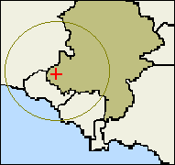(1)
(1)
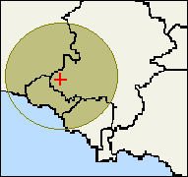(2)

4.7 This approach is used in the analysis of the key local services described above. The Rural Services Survey series reveals Cornwall to be among the better served counties, with a higher than average distribution and range of services. The 2000 RSS again confirms the relatively high levels of service provision that exist in Cornwall compared with many other rural areas of England.

4.8 The 2000 RSS yields the following information:
- Cash Points: Over 72% of rural households in Kerrier and Penwith live within 4km of a cash point (compared with 65% in the South West and 79.3% nationally).
- Banks and Building Societies: In Kerrier and Penwith 82% of rural households live within 4km of a bank/building society, compared with 81% in the South West.
- Primary Schools: Over 95% of rural households in Kerrier and Penwith live within 2km of a primary school compared with 91% in the South West as a whole
- Secondary Schools: In Kerrier and Penwith 78% of households live within 4km of a secondary school compared with an identical figure in the South West as a whole.
- GP’s Surgeries: In Kerrier and Penwith 89% of households live within 2km of a GP’s surgery in 2001 compared with 68% in the South West as a whole.
- Post Offices: Over 96% of rural households in Kerrier and Penwith live within 2km of a Post Office compared with 94% in the South West as a whole, as Figure 4 shows:
Figure 4: Percentage of Households more than 2km from a Post Office, 2000
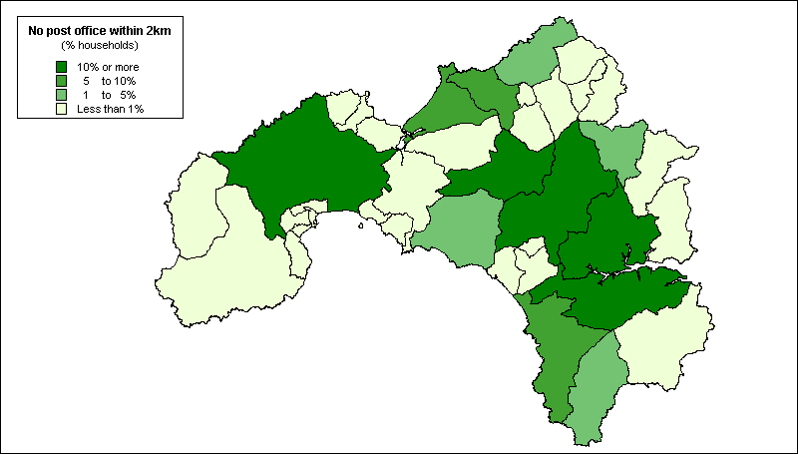

4.9 However it must be acknowledged that whilst Cornwall performs well in comparison with other rural areas, this does not imply that the quality of local services is always adequate in meeting local needs. The consultation exercise outlined above (Section 3) identified significant gaps in local service provision (eg. in relation to local public transport provision), as well as a need for the modernisation of many community facilities (eg. village and community halls).

4.10 As in previous years, the 2000 Rural Services Survey also used a rural parish questionnaire to record data on services where information is not currently available on a post coded basis. This helped us to establish broad trends but the degree of error from this process must be acknowledged. For a variety of reasons, the response rate in the 2000 RSS (67%) was less than ideal and varied considerably by region.

4.11 On the basis of these parish returns, we found that a majority of rural parishes in the region contained at least one pub (92%), Post Office (84%), village hall (76%) and general store (59%). Daily bus services operated in most (70%) of the rural parishes of Kerrier and Penwith, including on Sundays. However, in only about half (51%) of parishes was a community transport scheme available (eg dial-a-ride, community minibus or taxi, etc). Similarly, less than half the rural parishes in Kerrier and Penwith had a village shop (46%) or doctor’s surgery (38%).

4.12 Increasing participation in volunteering and community activity in poor neighbourhoods is a key policy theme within the Neighbourhood Renewal framework. It is also central to the development of the Government’s rural strategy as detailed within the 2000 White Paper - Our Countryside: The future. Underlying these initiatives is an emphasis upon the vitality and cohesiveness of rural communities and the extent of community involvement in voluntary sector organisation is an important indicator of community vibrancy in each of these policy documents.

4.13 Due to difficulties in accurately measuring community organisation, no listing of voluntary organisations will ever be entirely reliable. The findings presented in the following sections should therefore be treated as illustrative rather than presenting a definitive guide to voluntary organisation in West Cornwall.

4.13 Cornwall County Council’s CWIC database has been used as the main source of data on community organisation. All references in the database for Kerrier and Penwith were categorised within the following typology of community organisation: hobbies and crafts; environment and rural issues; sports and leisure; education, employment and skills; health and para-health; community advice and empowerment; youth, the aged, and ‘minority’ groups; faith based organisations; other.

4.14 In total, the CWIC database listed 1,185 voluntary and community organisations in Kerrier and Penwith – 562 in Kerrier and 623 in Penwith. Of these, 89% contained a postcode reference. It was thus possible to map the distribution of these community organisations in west Cornwall against postcode boundaries. Overall, the spatial distribution of voluntary organisation in West Cornwall broadly reflects patterns of settlement, with voluntary groups being concentrated in the more populous areas, as Figure 5 (overleaf) shows:
Figure 5: Voluntary and Community Organisations by Postcode Area, 2000
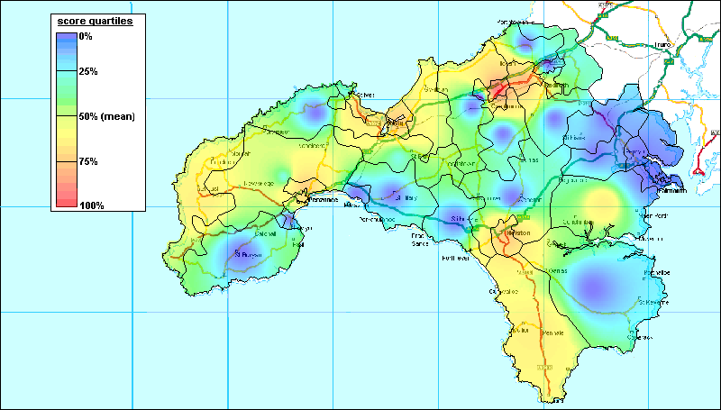

4.15 There are some interesting variations from this general pattern. For example, the Lizard area appears to support higher levels of community organisation than might be expected given its very low population density. Conversely, St Ives and especially Newlyn show lower levels of community organisation than might be expected given their population densities. However, the spatial coverage of sampled organisations varies so low levels of community organisation are not necessarily indicative of low levels of community participation since residents may simply be travelling to surrounding neighbourhoods.

5 Conclusions: Policy Illustrations
5.1 The purpose of this section is to illustrate some of the potential broad policy options that the LSP may wish to consider. No specific policy conclusions will be drawn by the research team until all the analyses have been completed.

5.2 Strong local communities have long been recognised as pivotal in defending the population against the effects of poverty. In the 1930s, Winifred Holtby identified local government as “in essence the first line of defense thrown up by the community against our common enemies - poverty, sickness, ignorance, isolation, mental derangement and social maladjustment.” It is a fundamental duty of policy makers, according to Professor Julian Le Grand, to “be more aware of the distributional consequences of all forms of public policy”.

5.3 The primary challenge for the LSP is to integrate the neighbourhood renewal strategy into a broader-based West Cornish anti-poverty strategy otherwise all that will be achieved is a disjointed set of specific initiatives. The Local Government Anti Poverty Unit argued in the 1990s that:

“The real challenge is to look at, and change as necessary, the whole of local authority activity, in direct relation to the needs of the community it is there to serve. With a focus on the community - both the individual and collective needs - it is logical to respond in an integrated (corporate) way and even more logical to, draw up strategies for action rather than responding in a piecemeal way.”

In 21st Century jargon, what is needed is a ‘joined-up’ strategy not ‘initative-itis’.

5.4 One option the LSP may wish to consider is to use NRF monies to mainly fund revenue expenditure in deprived neighbourhoods. Many of the other area-based anti-poverty funds available in West Cornwall are often mainly for capital projects. However, the effectiveness of a capital project can often be limited if revenue monies are not also available. It might be possible to produce an integrated anti-poverty neighbourhood strategy if NRF funds are spent primarily on people not buildings and money from other sources is used to fund necessary infrastructure work.

5.5 In the past, a lot of neighbourhood funding has been concentrated on large scale projects to the detriment of some of the most disadvantaged neighbourhoods which lacked strong community leadership. The LSP may wish to consider using some NRF funds specifically for smaller scale projects – not all communities want to try to manage a £250,000 project in the first instance.

5.6 The key challenge for the LSP is how to provide support for local people and groups so that they can become fully involved in neighbourhood renewal.

