The Distribution of Child Poverty
in the
Developing World

Report to UNICEF

By

David Gordon
Shailen Nandy
Christina Pantazis
Simon Pemberton
Peter Townsend

Funding for this publication was provided by the United Nations Children's Fund ( UNICEF)

Centre for International Poverty Research
University of Bristol
8 Priory Road
Bristol BS8 1TZ
United Kingdom

July 2003
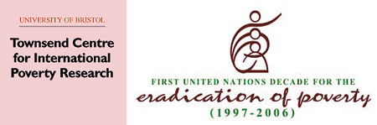

Contents

Acknowledgements ii

Chapters

- Child Rights and Child Poverty in Developing Countries 1

- Relationship between Child Poverty and Child Rights 11

- Measurement of Child Poverty and Standard of Living 23

- Severe Deprivation amongst Children in the Developing World 47

- Nature and Severity of Deprivation and Poverty amongst
Households with Children 77

- Conclusions and Policy Implications 81

Bibliography 89

Appendices

- Human Rights Provisions Relating to Poverty 101

- International Agreements on Poverty and Human Rights 107

- Constructing a Combined Index of Anthropometric Failure 115

- Severe Deprivation and Absolute Poverty of Children: Country Data 122

Acknowledgements

The authors wish to express their thanks to UNICEF for providing a grant which funded two stages of research developed from the year 2000 which involved collaborative work between the University of Bristol and the London School of Economics. In a succession of meetings with UNICEF staff and, in particular, with Alberto Minujin, at meetings in London, Rio de Janeiro and New York, the plan described in these pages evolved and was agreed. The idea for the work sprang from the new focus on children themselves rather than on families and communities in general that was reflected in UNICEF's programme during the 1990s.

The first priority was to review direct and indirect information about children and find the strengths and weaknesses of existing data about children's conditions and needs. While a great deal of national and international research on Articles in the Convention on the Rights of the Child has been completed, the relationship between child poverty and child rights had not been fully explored. Thanks are due to Jo Beall, Jonathan Bradshaw, Meghnad Desai and David Piachaud, John Micklewright, Giovanni Andrea Cornia and Jane Falkingham for the ideas being developed and especially the comparative studies on the Transition Countries of Eastern Europe published by the Innocenti Research Centre in Florence. The valuable assistance, in the early weeks, of Ceema Namazie in reviewing child data in Kyrgyz is gratefully acknowledged. We would also like to thank Enrique Delamonica and Bill O'Neil for their very helpful comments on the first draft. Jan Vandemoortele also provided us with considerable help, support and encouragement.

Several classes of postgraduate students at both the University of Bristol and at Birmingham University have generated a stimulating debate on the measurement of child poverty in developing countries.

The dependable advice and support of Jean Corston and Helen Gordon throughout this project is also warmly acknowledged. Helen Gordon also put considerable effort into formatting and editing this report.

The views expressed in this document do not necessarily represent the views of UNICEF or its Division of Policy and Planning.

Chapter 1

Child Rights and Child Poverty in Developing Countries

Introduction
This research report presents the first ever scientific measurement of the extent and depth of child poverty in all the developing regions of the world. This measurement of child poverty is based upon internationally agreed definitions arising from the international framework of child rights. In successive annual reports, UNICEF has argued that poverty is one of the greatest obstacles to the survival and development of children. The near-consensus reached by all national governments in framing the 1989 Convention on the Rights of the Child gave momentum to serious and effective work to reduce violations of a number of rights relevant to the reduction of child poverty in different countries.

Poverty denies children their fundamental human rights. Severe or extreme poverty can cause children permanent damage physically and mentally, stunt and distort their development and destroy opportunities of fulfilment, including the roles they are expected to play successively as they get older in family, community and society. Both research and administrative data show that investment in basic social services for children is a key element to ensure success in alleviating their poverty. It also shows that a minimal level of family resources to enable parents to meet the needs of their children are required - even when families are prepared to put their own needs or the needs of work and other social claims upon them second. If there are insufficient resources to satisfy children's needs - however hard parents can be shown to try - then this can cause other obligations and relationships to crumble. This is why UNICEF insists that "poverty reduction begins with children".

The World Declaration and Plan of Action adopted by the World Summit for Children in 1990 set forth a vision of a ‘first call’ for children by establishing seven major and 20 supporting goals that were quantifiable and considered achievable by the year 2000.

UNICEF has reported on progress towards these goals. In 2000, it was found that some of the trends in the 1980s and 1990s had deepened rather than lifted public concern. Since 1987, the number of people in developing countries, other than in East Asia and the Pacific, with less than $1 a day, had increased by 12 million a year. In many countries, the extreme poor had been “left further behind.” And “the evidence is compelling that the 1990s saw a widening in the gap between rich and poor countries as well as between rich and poor people within countries, both in terms of incomes and social outcomes.” (UNICEF, 2000a, pp9, 17 and 45).

In a statement prepared for the end-of-the-decade review, planned for September 2001 but postponed until May 2002, the Executive Director of UNICEF, Carol Bellamy, was obliged to call attention to the "mixture of conspicuous achievement and dispiriting failure" for children. Most governments had not lived up to the promises made at the 1990 World Summit for Children. Despite some progress, stronger leadership and more sustained policies were required (UNICEF, 2002a).

At the United Nations General Assembly's Special Session on Children in September 2002, the latest information was debated. The ten years since the 1990 World Summit for Children were found to have yielded mixed results. Three million fewer children under five now died each year, due in large part to immunization programmes and the dedicated efforts of families and communities. In developing countries, 28 million fewer children under five suffered the debilitating effects of malnutrition. More than 175 countries were polio-free and 104 had eliminated neonatal tetanus. Yet, despite these gains, more than 10 million children still died each year from mostly preventable diseases, 150 million were estimated to be malnourished, some 600 million children still lived in poverty and more than 100 million - the majority of them girls - were not in school. The number of children orphaned by AIDS had grown from 1.2 million to 10.4 million and under five mortality from AIDS was expected to double by the year 2010 (UN, 2002 and see also UNICEF, 2002b).

UNICEF has strengthened its work on poverty. It has actively participated in international conferences and government exchanges and published documents and promoted policies - many aimed to reduce child poverty. Its report Poverty Reduction Begins with Children was of prime concern at the special session of the UN General Assembly in Geneva in June 2000. The reports from the UNICEF Innocenti Research Centre cover a wide range of research into child rights and development in both rich and poor countries, especially that affecting child poverty, including, for example, A League Table of Child Poverty in Rich Nations (UNICEF Innocenti Research Centre, 2000) and extensive work on poverty in the transition economies and on the problems of child labour in India, Sub-Saharan Africa and Latin America, and the ramifying problems of children caught up in armed conflict.

The authors of this report seek to contribute to the consolidation and extension of this work to include all the developing regions of the world.

The special objective: reviewing the concept and measurement of child poverty
What are the lessons that may be learned from both the evolution of UNICEF's programme and the 'End-of-Decade' reviews? The authors of the present report have a special objective but, in reaching it, a general objective must be pursued as well. These two will be explained in turn.

The special objective of this report is to provide a firm conceptual foundation for defining and measuring child poverty and its dimensions in developing regions of the world. There are currently no consistent estimates of the extent or severity of child poverty in developing countries. Many countries have detailed anti-poverty strategies and statistics on child poverty but the figures are usually rough estimates derived from different sources about the distribution and trends in total of household income. These estimates tend to use different methods and definitions of poverty that makes the necessary task of comparing countries extremely difficult.

Should child poverty be defined independently or should it be defined in relation to adults? During the last 50 years, the choice of the former method has attracted a growing number of adherents. Theoretically, a more independent definition of poverty means treating children as objects of knowledge in a number of key respects independently of adults, including their parents. Technically, this means finding criteria of measurement of child poverty that are direct rather than indirect, that is, statistical indicators of the conditions and experiences of children, not of the families or households in which they happen to live. The Universal Declaration of Human Rights represented a major international step after the 1939-45 war in agreeing measures for human development but, as the title shows, it was addressed to humankind as a whole rather than to particular categories of population (United Nations General Assembly, 1948). Gradually, people came to believe that the needs and rights of children had to be separately distinguished if progress in acting upon and meeting human rights as well as human needs was to be achieved.

In 1989, four decades after the Universal Declaration of Human Rights, the Convention on the Rights of the Child (CRC) was adopted by governments across the world. The CRC has been quickly ratified by more nations than has any other charter or convention. The process of distinguishing children routinely from adults in recommending international action on rights has still to be matched in the treatment of the concepts of poverty and development.

Child-centred or family-centred?
The model of the Convention on the Rights of the Child suggests that the question of whether the corresponding conceptualisation of child poverty should be child - or family - centred must be decided in favour of the former. Children’s needs are different in degree and kind from those of adults. Their experience of violations of normative behaviour can be distinct from the experience of their parents and other adults. They may not get an equal share of consideration or resources within household and family. What applies to adult members of household or family cannot be assumed automatically to apply to them. It is evident from individual illustrations that children are sometimes in poverty when their parents are not and vice versa.

This argument, of course, accepts that there are areas of ‘overlap’ between children and parents in unravelling the particular conditions and experiences of each. Inevitably, many questions will be posed about procedure in developing separate detailed definitions and measures for child and adult. This applies to each of the key related concepts of rights, development, poverty, deprivation and social exclusion. It is sometimes difficult (if not impossible) to separate children’s conditions and experiences from those of adults in the same family or household. Sharing a group of rooms is an example. However, even in such an instance, accommodation can be used differently by adult and child, with prohibitions about, or freedom of access to, different spaces and facilities.

There is no dispute that the CRC gives children the rights to survive, develop, participate and be protected – and that the international problem is how to put such ideals or aspirations into practice. The concept of child poverty could be defined in relation to specified rights to “freedom from material and social deprivation” – premature death, hunger, malnutrition, and lack of access to clean water, sanitation, education, health care and information. It could also be defined in relation to specified rights to “freedom from insufficient resources” – namely access to an “adequate standard of living” and the right to “social security.” Certain articles in the CRC can be usefully grouped together. Representative information about their fulfilment is available and information about the fulfilment of one article can sometimes be properly combined with information about another. Thus, measures of multiple deprivation can provide even sharper evidence about progress in fulfilling child rights than separate measures of deprivation treated separately or singly.

Should the criterion for child poverty be ‘insufficient resources’ or ‘multi-dimensional deprivation’?
In the present circumstances, there is confusion about what is the appropriate conceptualisation of poverty for scientists and agencies to use and develop. There is no doubt that there can be alternative choices of the ‘core’ of meaning that may be turned into good operational science and practical construction of policy. So far as possible, the choice has to follow criteria of scientific coherence, reproducibility and validity but also be distinguishable from other closely related concepts – in this case, material and/or social deprivation, social exclusion and, more restrictedly, malnutrition. Establishing a ‘core’ of meaning in one case carries the implication of establishing such a core for other related and even overlapping concepts. In separating the meaning of the different key terms, the likelihood of using one term to mean another is thereby reduced and one source of confusion eliminated.

The recent history of the debate shows that any success in achieving the millennium goal of halving extreme poverty in the world by the year 2015 will depend, at least in part, upon achieving scientific and political consensus about meaning. The arguments and the possible conclusion around which consensus might be built, are set out in two reports (Gordon and Townsend, 2000, especially Chapters 4, 5 and 18; Townsend and Gordon, 2002, especially Chapters 3 and 14). The conclusion of these reports is that the core of meaning must be ‘insufficient resources’ but its acceptance must also depend on two associated conclusions:

- that the right threshold of sufficiency must be demonstrated in relation to all forms of resources and not just income, and

- that the level at which resources can be demonstrated to become insufficient must depend on evidence about the links between resources and external criteria, such as type and degree of material and social deprivation, or low standard of living - to avoid circularity of reasoning, i.e. the resources must be insufficient to achieve an adequate standard of living.

The reasons for reaching this conclusion may be illustrated from history of World Bank practice since the 1939-45 war. The basis of the Bank’s use of a “dollar-a-day per person” as the poverty line has not been securely established, even in the Bank’s own terms. For example, the annual reports in both 1990 and 2000 were taken up with poverty eradication issues and have been very influential. The Bank sought to develop a poverty line that permits “cross-country comparison and aggregation" (World Bank, 1990, p27). Poverty is defined as "the inability to attain a minimal standard of living" (ibid, p26). Despite the difficulties of counting the contribution to living standards of public goods and common-property resources in fixing a poverty line, the World Bank chose a 'consumption-based' standard that was supposed to comprise:

"two elements: the expenditure necessary to buy a minimum standard of nutrition and other basic necessities and a further amount that varies from country to country, reflecting the cost of participating in the everyday life of society." (World Bank, 1990, p26).

The first of these elements was believed to be "relatively straightforward" because it could be calculated by "looking at the prices of the foods that make up the diets of the poor" (ibid, p26-27). But the second element was "far more subjective; in some countries indoor plumbing is a luxury, but in others it is a 'necessity'" (ibid, p27). The second element was set aside and not considered at any length (although it should be pointed out that the example of plumbing is not only open to question as a ‘luxury’ in some countries but as a ‘material’ instead of ‘social’ illustration of "the cost of participating in the everyday life of society"). The conceptual and operational possibilities of constructing the second element of the Bank's poverty line have not since been seriously discussed. The case for including this element could be said to be stronger now than it was said to be originally by the Bank. Without that element, the Bank’s poverty line lacks scientific justification and popular credibility. In particular, this formulation of the poverty line is not one that is applicable cross-nationally – with relevance to rich and poor countries – like other thresholds of risk, for example, environmental pollution, radiation and malnutrition. Moreover, if the poverty line excludes one of the two elements supposed to make it viable, the result must be to underestimate the level of income and other resources required to escape poverty.

The answer given to the question raised in this section of the report paves the way for a more exact appraisal of child poverty. For example, children’s share of overall resources needs to be established – rather than assumed to be ‘equal per capita’ in the World Bank’s poverty formulation. Similarly, children's direct rather than indirect experience of different forms of deprivation has to be calculated in scale and severity to help to establish an appropriate poverty line for households including children. It is also of crucial importance to know the extent and nature of children’s deprivation in order to target anti-poverty policies effectively.

Income- or expenditure-based measure of child poverty?
There is a continuing debate between advocates of income and advocates of expenditure as the basis for measuring poverty. The debate has existed for many years (Townsend, 1970a). The reason for concern in making the right choice is that the measures of poverty on one basis rather than the other produces much larger differences for developing than for industrialised countries. The issue is two-fold. Applying one measure rather than the other may greatly change the numbers found to be in poverty in rich compared with poor countries. Equally, it may greatly change the numbers found to be in poverty in rural compared with urban areas.

Recently, Hussain concluded, for urban China, that poverty was much greater when measured by expenditure than it was when measured by income (see Hussain, in Townsend and Gordon, 2002, pp300-302). He believed that much of the difference was due to incomes being in part committed to saving rather than to expenditure. The problem is different for predominantly rural regions and countries. Unless income is broadly defined to include income in kind from growth of food for family consumption and exchange of produce or barter, resources can be seriously under-estimated. There are other equally important issues. In rich countries, free or subsidised public services enhance real income or standard of living and can be a form of “income in kind” as substantial as is the value of home-produced crops in rural countries and regions. Much special research indicates that the concepts of income and expenditure are not easy to operationalise in practice or reconcile. However, a more comprehensive definition of income, combined with care over time (at least several weeks) in arriving at reliable data about ‘real’ expenditure, seems to bring some degree of convergence in the calculations by statisticians of total income and total expenditure and of the respective distribution of the two.

For children, their share of income can be estimated by finding:

- what cash income they receive, plus
- what share of income is spent solely on their behalf, plus
- what ‘income’ in kind they receive privately and from public services and facilities, plus
- what share they can be presumed to have of the remaining household resources that are spent for the joint benefit of all members of the household.

The UN has recently produced detailed guidance on the measurement of the components of total household income (Canberra Group, 2001). However, this guidance relates to the household as a whole or the adults within households. There has, unfortunately, been little scientific work on how the total incomes or consumption of children should be measured.

Continuing attempts to get closer to reliable data for children will help to refine the crude attempts to apportion income rights ‘per capita’ or by means of other procedures of ‘equivalisation’. ‘Equivalisation’ is not a necessary part of poverty measurement - as is often supposed. If external criteria have to be invoked to decide the poverty line of income or resources generally for households, then those criteria apply to different types of household, including the number and characteristics of children within them.

It is not currently known how to measure either child income or child expenditure on a global scale. The question has not attracted searching and sustained examination. We hope that new work can be undertaken. In the meantime, we are presenting an alternative (or complementary) approach. The remaining chapters of this report demonstrate that different forms of child deprivation can be measured consistently in combination to show the extent of multiple and severe deprivation. In future, these data may be correlated with present information about the distribution of income and expenditure (see Chapter 6).

Linking child rights to the measurement of child deprivation
As discussed previously, an objective of this report is to distinguish child poverty from adult poverty and to formulate a more accurate measurement of child poverty in the developing regions of the world. This has been argued in general terms and will be set out technically and empirically in this report. It is suggested that the core of the meaning of poverty must be “insufficient resources”. This research represents a significant advance in identifying and measuring the material and social deprivation of children. However, child income and expenditure and the resources in kind that they receive and use also need sustained attention. This research has successfully measured some of the resources available to children (using direct measures) but has not been able to express these resources in monetary terms.

By contrast, with the lack of information on children’s total incomes, there exists a large body of data for different countries on child deprivation. Many of the data have been brought into being as a result of the introduction of the CRC. Therefore, a rights-based formulation of children’s multiple deprivation becomes a distinct scientific possibility and has attracted enthusiasm elsewhere. Our belief is that the data can be used to develop a coherent body of indicators of multiple child deprivation that, in itself, offers objective and acceptable criteria for the determination of poverty lines. This will allow trends in child poverty and severe or extreme poverty to be tracked more accurately - and more convincingly - among developing countries.

Pressure for this to be done comes from growing public concern not just about the huge extent of persisting child poverty but about non-fulfilment of the rights of the child. The international history of both problems is more closely linked than often supposed.

Does the fulfilment of child rights include children’s development?
By any intellectual standards, the stream of work on human rights embodies concepts of poverty eradication and human development despite the fact that each of the three concepts has been examined and elaborated separately in a large number of studies and by different organisations. It may be time to recognise that the three areas of work have been kept artificially distinct and should be brought closer together, with human rights providing the distinctive umbrella. The three concepts need to be linked more explicitly than has so far been attempted. Separate exposition and analysis implies differently prioritised programmes of action, however, in meaning and, it must be added, operational specification, they are found to overlap. Clarifications of that belief and of questions of focus and emphasis, urgently require resolution.

At the turn of the century, attempts were made to clarify the relationship between rights and development – for example, in the work of UNICEF and UNDP. The encouragement of human development and fulfilment of human rights represents a common commitment to promote the freedom, well-being, dignity and quality of life of individuals in all societies. The two can be said to be compatible but also sufficiently distinct for each to offer something substantial to the other.

“If human development focuses on the enhancement and the capabilities and freedoms that the members of a community enjoy, human rights represent the claims that individuals have on the conduct of individual and collective agents and on the design of social arrangements to facilitate or secure these capabilities and freedoms.” (UNDP, 2000, p20)

In the Human Development Report for 2000, which takes human rights as its theme, the two concepts of human rights and human development are distinguished and are said to enrich each other. However, the argument is muted and is not perhaps appreciative of the gathering force and sheer range of the concept of human rights. Thus, UNDP acknowledges that “to have a particular right is to have a claim on other people or institutions that they should help or collaborate in ensuring access to some freedom. This insistence on a claim on others takes us beyond the idea of human development." (ibid, p21). However, elaboration of what sorts of duties or responsibilities are placed on ‘other people or institutions’ (especially the latter) and how this might redress the unnecessarily dominant individualism of the human development approach, as well as its ducking of ‘cause’ and of complementary information about ‘mal-development’, is not explored. Although some linkage between the two concepts is accepted, the true potentialities of that linkage are not seized. All that is conceded is that the human rights approach "may offer an additional and very useful perspective for the analysis of human development." (Our emphasis, ibid, p21.)

This seems to claim too much for the concept of human development or at least its conventional interpretation. ‘Human development’ is a term that implies progress and represents necessary or actual evolution. In the way that it is used, the term tends to be short on history and on cause. In predominant measure, it tends to be interpreted as a process of building on present conditions (and therefore inequalities) without appraisal of lessons learned from retrospective analysis of how the distribution of world conditions came about. ‘Rights’ can only be taken seriously in a world where there are manifest wrongs. By contrast, ‘development’ does not carry the same connotations of remedying negative outcomes and forces. For example, the invention of the concept of ‘underdevelopment’ was motivated deliberately in the 1970s to call attention to the one-sided meaning that had come to be attached conventionally to ‘development’. Another historical - as well as contemporary - example of the exclusion of negatives from the usage of the term is in the linkages made with economic ‘growth’. Development and growth have been assumed to be bed-fellows and one is generally supposed not to take place without the other.

Again, in the international work going on into human development, measures of economic growth and poverty do not take sufficient account of the ravages of war and the costs of deforestation, global warming and pollution. Nor is unpaid work, production or care, especially by women, built quantitatively into the equation. The causes of poverty and material and social deprivation are not sought in the collection of cumulative evidence of the initiation and sustainability of violence. Neither is the ‘universality’ of rights reflected in the choice of social and economic indicators – particularly of poverty. These ideas lie behind the research reported here. They help to explain why human development might be treated largely as an element lying within the wider human rights framework rather than as a separate or more compelling strategic objective. They also help to explain why the investigation and resolution of child poverty has been cast in these pages within the framework of the CRC.

If ‘human development’ implies progress and necessary or actual evolution then ‘human rights’ implies a set of ideals or end results and therefore highlights the huge strides that have to be taken to surmount or improve contemporary conditions. ‘Human rights’ incorporates a set of standards of human behaviour that are expressed authoritatively rather than left implicit – even if their exact meaning in relation to events in different countries remains to be clarified. This difference in the treatment of the concepts is not highlighted, for example, in the UNDP’s Human Development Report for 2000. Compared with ‘human development,’ ‘human rights’ tends to be treated as a more extensive multi-disciplinary concept – within which important elements of meaning, like social inclusion and personal freedom as well as human development may largely, if not comprehensively, be located. It is also the case that instruments of ‘human rights’ have been endorsed formally by nearly all governments.

There are many ways in which a scientific approach that integrates the two concepts of human development and human rights might be specified and made practical. Both streams of work would gain. For example, one of the problems for the relationship between child rights and development is the need to strike a better balance in both between civil and political rights on the one hand and social and economic rights on the other. “While the discussion on rights has tended to emphasise civil and political rights that on human development has tended to portray economic and social conditions - for example in the application of the human development index.” (ibid, p20). This may explain the existence of separate sets of ‘practitioners’ for each of the two concepts, rather than those whose job it is to represent the overlapping percentage of work and the extent to which co-ordination is needed to improve assessments of outcome. Human rights plainly include economic and social rights as well as civil and political rights.

Does the instrument of child rights provide a legal framework for poverty reduction?
Some human rights specialists go a lot further than even imaginative international agencies like UNDP in showing the anti-poverty potentialities of the gathering momentum of world-wide interest in human rights. One authority in international law writes: "International human rights instruments provide a legal framework for poverty reduction strategies…. The language of human rights covers some of the multidimensional experiences of poverty, for example the loss of personal space and security, and erosion of individual freedoms of movement and of expression…[Poverty] is the very antithesis of the human right to development…. Denial of human rights is both a cause and a consequence of poverty. Poverty constitutes in itself a denial of fundamental human rights and a barrier to the enjoyment of all other human rights. A human rights shortfall is an obstacle to the eradication of poverty" (Chinkin, 2002).

Chinkin argues that, by means of international law, the framework for entitlements, the language for the presentation of claims and national and international machinery for their determination should be integrated into the various strategies of poverty eradication. Examples of these strategies would include "the transfer of resources, access to non-exploitative micro-credit, and the reduction of military expenditures" (ibid, p587). The great virtue of this argument for an enlarged role for international law is that ‘resources’ (including income) are re-affirmed as comprising the core of the definition and measurement of child poverty and, therefore, as the element that has to be properly institutionalised in every strategy concerned with defeating poverty. Whilst there is deepening concern across the world about the growing inequality of resources, substantial redistribution of these resources has not become a feature of current international strategy. Yet there are compelling arguments for stronger international taxation and international company law, as well as for fairer world trade, all of which can only be developed within a stronger ‘rule of law’ consensus if there is to be the smallest chance of fulfilling the UN's millennium goal of halving world poverty by 2015.

How can non-fulfilment of child rights and the persistence and growth of child poverty be linked?
Since 1989, UNICEF has steered the consideration and development of indicators of child rights (for example, see UNICEF, 1998a; 2002c). The need for accurate and reliable global monitoring is a high priority. The value of clarifying the links between child poverty and child rights can be illustrated by the current range of indicators monitoring progress. How might indicators of child poverty and trends in poverty be developed in relation to Article 27 of the UN Convention on the Rights of the Child: "States Parties recognise the right of every child to a standard of living adequate for the child's physical, mental, spiritual, moral and social development?" Article 26 provides a complementary fundamental right of the child to social security and other articles refer to related rights to material facilities and basic social services.

The CRC gives children the rights to survive, develop, participate and be protected. As cited above, there are Articles in the Convention and in the Universal Declaration that specify access to an adequate standard of living and to social security as fundamental rights. Other Articles cover freedom from different aspects of material and social deprivation. ‘Survival’, ‘development’, ‘participation’ and ‘protection’ themselves imply minimal standards of food, safe drinking water and other goods and facilities, like health and education that are basic to both physical and social growth.

The concept of poverty must necessarily embody lack of access to such rights and can be defined usefully, we argue, in relation to these rights, so that estimates of child poverty may be constructed on the basis of access to a number of specific economic and social rights. Thus, direct and indirect indicators like per cent of population below the national and international poverty lines, GDP per capita of the poorest 20%, infant and child mortality rates, low birth-weight rate, per cent of one-year-olds fully immunised, per cent of children not reaching Grade 5, daily per capita rate of calories intake, per cent access to safe drinking water and sanitation and ante-natal care received provide illustrations of the data that were examined in preparing this report.

A number of the Articles of the CRC express fundamental rights to freedom from deprivation. Survey data - especially the Demographic and Health Surveys (DHS) and Multiple Indicator Cluster Surveys (MICS) - can be used to show how many children have - and do not have - these rights fulfilled. This provides the basis for the remainder of this report and will be explained step by step.

However, the CRC also lists the fundamental rights to an ‘adequate’ standard of living and to ‘social security’. Operational definitions of these rights need to be developed urgently for children. This means seeking ‘direct’ indicators or measures of child poverty, in the sense that they apply to the children in families and households to which they belong, rather than seeking ‘indirect’ measures that apply to the adults in those families and households, on the unexamined assumption that children have an equal share of total household income or living standards or have a share proportionate to their needs. While many children do indeed experience conditions that reflect the conditions of their families as a whole, there are some who get distinctly less, or more, than a ‘fair’ share. By recommending more direct assessment of child living conditions and their income and expenditure, the possibilities of defining what may be for them “an adequate income” or a right to “social security” can be linked with direct measures for their assistance. Although strong arguments can be put forward for the collection of better information about children’s standard of living and income this information, alas, is not currently available.

However, reliable information is available on children’s standard of living which has been used in this report to develop a measure of severe deprivation of basic human need for children, in order to directly measure the extent of child poverty in developing countries. We show that a sufficient indicator, or combination of indicators, can be assigned for each of seven separate criteria of deprivation of basic human need and these can be validly and reliably combined into a single index. Data are available, thanks especially to the DHS, for a large number of countries. We believe this is an important step in clarifying the extent and severity of child poverty in developing countries.

Chapter 2

Relationship between Child Poverty and Child Rights

“I am often asked what is the most serious form of human rights violation in the world today and my reply is consistent: extreme poverty.”
(Mary Robinson, UN High Commissioner for Human Rights, 2002)

Introduction
This chapter explains how the child rights framework might be used to measure child poverty. It is followed by Chapter 3 which describes the operational measure used to construct cross-national evidence of the distribution of poverty and the results of applying that measure.

In preparing a reliable but also widely acceptable measure of poverty in relation to the framework of child rights, two problems have to be understood. The first is that, although the Convention on the Rights of the Child lays down aims that have attracted near-universal support, each one of them is expressed in terms that in practice need to be clarified for purposes of interpretation and action. The second is that the aims are expressed in a large number of Articles in the Convention and need to be grouped or clustered for purposes, whether scientific or political, of concerting strategy, deciding priorities and therefore policies and organising ways of monitoring progress. These two problems will be illustrated below. Later in the chapter the principles of the methods used to develop a set of indicators will be discussed.

Using rights to measure child poverty (1) the problem of clarifying specific rights
Following the adoption of the Universal Charter of Human Rights and of other instruments of human rights by the international community, the decision to agree a complementary instrument in the interests of children in 1989 represented an historical turning point. The comprehensive range of aims adopted and the near-unanimity of agreement among nation states is impressive and lends authority to all subsequent work. Differences of interpretation between governments and reservations attached were of course left at the time for later clarification and action on detail by combinations of international and national political representatives.

Like the other instruments of human rights, the CRC imposes moral imperatives that can help to overcome particular disagreements about necessary action by governments and other institutions. For example, the social theorist Zygmunt Bauman insists that there is a moral imperative laid upon everyone to engage with the tools for achieving human justice that fortuitously have become available. Via the 1989 Convention, governments and others are presented with a list of duties that they are expected to honour. This has led some to distinguish ‘perfect’ from ‘imperfect’ duties (UNDP, 2000). The formulation of rights in different Charters and Conventions does not address the issues of how duties are to be discharged or the extent to which those duties can be discharged. The formulation conveys an ‘all-or-nothing’ command. Either the duties are honoured or they are not. There is no in-between. The continuum of satisfaction of the different rights that exist in reality is sometimes ignored when governments and international bodies who are culpable for denying rights are expected to fulfil their duty. As Bauman succinctly writes:

“In a world of global dependencies with no corresponding global polity and few tools of global justice, the rich of the world are free to pursue their own interests while paying no attention to the rest…the issue of a universal right to a secure and dignified life, and so to universal (truly cosmopolitan) standards of justice, must be confronted point blank before the subtleties of cultural choices may come into their own.” (Bauman, 2001)

Bauman’s objective is to secure the most basic human needs by calculated and persistent use of the ‘few tools of global justice’ available to governments and international bodies as well as to imaginative social scientists and lawyers - human rights conventions. The fulfilment of rights necessarily depends on calculations of the human needs that have to be met. However, while the formulation of rights carries with it a near-consensus about duty and mission – little short of the authority of international law - there remains the element of ambiguity about the precise detail of each right that is to be observed. Satisfaction of rights depends on full discussion and resolution of specific meaning as well as on appropriate policies and action.

The distinction between perfect and imperfect duties helps to turn attention from an unquestionable or absolute division between right and wrong to the finely graded conditions or situations that exist in everyday life – and hence the relative or proportionate fulfilment of duty. In accepting that children have a number of rights, attention can be called to the actual conditions they experience and therefore what need they have to secure those rights.

As discussed in Chapter 1, the needs of children have to be distinguished from those of adults. For example, Lansdown (1998) identifies the following needs:

- children are people who have to be accorded equal status to adults;
- children’s healthy development and civil participation are integral to the creation of successful countries;
- children are particularly vulnerable as a consequence of their development and dependence;
- children are disproportionately affected by the activities and omissions of government, due to their reliance upon public services;
- and children are universally excluded from participation in political processes.

The relevance of perfect and imperfect duties in simultaneously satisfying children’s needs and rights can be illustrated by different Articles of the Convention. Thus, Article 28(1)(a) of the CRC is clear that states should “make primary education compulsory and available free to all”. Hence, to measure the provision of free primary educational attendance is, in principle, a relatively simple exercise, providing a clear deprivation indicator to demonstrate a state’s infringement of the Convention. Such an indicator would be the percentage of the relevant age groups not in primary education. However, some hard questions remain. As Casas (1997, p288) notes, the social scientist must be cautious when creating lists of indicators to consider the “different practical interpretations, depending on historical, cultural, and conceptual contextualisations”. Hence, there are degrees among countries in the satisfaction of ‘compulsion’ – by age, gender, ethnicity and area – and in the degrees of ‘primary education’ provided. However, this example of access to primary education suggests that some rights lend themselves better than others to measurement and implementation.

Rights that appear to be more ambiguously expressed encourage signatories of the CRC to plead ‘imperfect’ duties and absolve themselves of the responsibility of honouring the clear intentions of the Convention. For example, Article 26(1) of the Convention states that:

“State Parties shall recognise for every child the right to benefit from social security, including social insurance, and shall take the necessary measures to achieve the full realisation of this right in accordance with their national law.”

Whilst the Convention clearly seeks to promote the notion that a state should provide a social security safety net for children, it does not provide detail on the form of systems a state should seek to comply with. However, other instruments of human rights can be quoted in support. The International Labour Convention No 102, the Social Security (Minimum Standards) Convention (SSC) contains a very detailed vision of the requirements for welfare. Although only 40 states have ratified the SSC, it was adopted by the Council of Europe in Article 12 of the European Social Charter and, whilst it does not have the near universal ratification of the CRC, the SSC has signatories from all continents and is one of the tenets of the European Union. In the context of this chapter, the SSC makes provision for family benefit (Articles 39-44) for the ‘maintenance of children’, a maternity benefit (Articles 46-52) and a survivors’ benefit (Articles 59-64). The Convention is quite specific on issues of rates of qualification and eligibility which should be achieved by each state and the rates for each benefit. For instance, for Family Benefit, the SSC stipulates that the total value of the benefits granted should be:

“(a) 3 per cent of the wage of an ordinary adult male labourer, as determined in accordance with the rules laid down in article 66, multiplied by the total number of children of persons protected; or (b) 1.5 percent of the said wage, multiplied by the total number of children of all residents.”

Whilst the adequacy of these provisions may be debated, this should not obscure the fact that such supplementary instruments are important tools not just for the clarification - but also the implementation - of rights. This is an example of the ways of clarifying particular Articles of the Convention of greatest relevance to the eradication of child poverty.

For developing countries, it is difficult to reconcile the fundamental right to social security, expressed in Article 26, and the right to a adequate standard of living, expressed in Article 27, with many of the measures introduced in the 1980s and 1990s under the rubric of ‘Structural Adjustment Programmes’. Access to public social services like health and social insurance was often restricted and expenditure cut, on the pretext that private provision would be an effective substitute.

The examples given show that rights in the CRC require extensive elaboration of precise meaning but also usually involve identification of a threshold drawn at some point on a continuum from extreme non-fulfilment to more than generous fulfilment. Another example of this process is Article 12 on the right to health of the International Covenant on Economic, Social and Cultural Rights (ICESCR) - especially General Comment 14, specifying states’ obligations and the development of performance indicators. Under paragraphs 43 and 44 of Comment 14, the ICESCR lists core obligations to satisfy minimal enjoyment of the right to health. These include: ‘to ensure the right of access to health facilities, goods and services on a non-discriminatory basis, especially for vulnerable or marginalized groups’; ‘to ensure access to the minimum essential food which is nutritionally adequate and safe, to ensure freedom from hunger to everyone’; and ‘to ensure access to basic shelter, housing and sanitation, and an adequate supply of safe and potable water’. This elaboration of meaning illustrates the range of factors that have to be investigated and satisfied in guaranteeing a particular right but also opens up further ambiguities that invite clarification. Thus, access to facilities, for example, could be measured in distance, in time, or in economic terms and the nature of what health facilities are acceptable remains to be specified. However, accepting that different criteria of health can properly be applied, it is evident that fulfilment or violation of health, when assessed and ‘measured’, is likely to lie on a continuum between two extremes – for individuals, populations and countries.

If absolute poverty is to be measured, then threshold measures of severe deprivation of basic human needs can be developed. In Chapter 3, threshold measures for the severe deprivation of the following basic human needs: food, safe drinking water, sanitation facilities, access to information, education, health and shelter will be defined. These needs are reflected successively in CRC Articles 13, 17, 24, 27 and 28, although the Convention does not specify in each case what constitutes mild, moderate, severe or extreme deprivation.

An example of such an operationalisation can be found in the goals announced at the World Summit for Children 1990, which sought to implement the aspirations contained in the CRC. As a consequence of this agreement, UNICEF undertook the task of assisting countries with appropriate surveys. These Multiple Indicator Cluster Surveys (MICS) conducted by each country have allowed a comprehensive list of indicators to be developed to monitor progress in relation to these goals. These surveys and the indicators they deploy are located within a global consensus upon the manner in which the aspirations of the CRC should be achieved.

Using rights to measure child poverty (2) the problem of clustering rights
Arranging some of the Articles of the Convention into groups or clusters can be justified on various grounds: for example, seeking causal links to maximise strategies to reduce violations; exploring the extent to which action in relation to one Article in the Convention necessarily assists the realisation of other Articles; ordering the different Articles to allow related issues to be examined; or developing programmes of action to be introduced by stages. The idea of the ‘clusters’ may also be useful in advocating broadly based but targeted strategies to bring about a reduction in the severity or number of violations more quickly than would otherwise be the case.

The particular value of organising CRC Articles into clusters is to explore, or confirm, the extent to which success in reducing one unsatisfied human right spills over into success in reducing other unsatisfied rights. The authors of the present report have adopted this approach. Rights can be examined separately in turn, as discussed above. This has all the professed advantages of selective action: concentrating energies and assembling information on one problem and ignoring the ramifications that affect other problems for the sake of speed and the justifiable use of limited resources. However, facing up to multiple and interconnected problems is the reality that has to be understood. It could be seriously disadvantageous to deny information on the likely knock-on consequences for other rights. A sense of proportion and the identification of priorities can only proceed in the context of demonstrating interrelationships between certain rights and categorising those that are closely linked. Any programme of investigation or action would be necessarily larger and more complicated, as well as more costly, and perhaps controversial, than the ‘particularistic’ alternative. Problems in widening the strategy must of course be anticipated but we consider that this ‘grouping’ is the right methodological or scientific course to take.

It will never be easy to obtain agreement on the grouping or categorisation of some rights in distinction from others but there are precedents in the steps that different international bodies – for example, UNICEF itself (in its work on indicators, and the Committee on the International Covenant, in its organisation of commentaries) - have taken. It is better to proceed with the task of seeking to reconcile scientific and democratic support so that realistic conclusions may be drawn about both specific rights and sets of rights that are related.

A precedent for organising rights into appropriate clusters is provided by the work of the Committee on the Rights of Child, which symbolises the diverse nature of the Convention and the safeguards it provides. All signatory states, under Article 44(1) of the CRC, are obliged to report to the Committee within two years of signing the Convention and thereafter every five years. These reports help to show both the progress made in the implementation of the Convention and the difficulties as well as transgressions that are arising in the process. They provide a substantial audit of the rights of children that mirrors the intentions of the Convention. Countries are required to provide wide-ranging information upon: implementation, the definition of the child and the application of general principles.

Of particular interest to the approach we are taking in this report, is the Committee’s clustering of the remaining rights in the Convention into specific thematic categories. Hence, countries are required to collect information on the following categories: civil rights and freedoms; family environment and alternative care; basic health and welfare; education, leisure and cultural activities; and special protection measures. It cannot be disputed that these reports offer a vital source for the development of general indicators of rights and this can be seen in their application to our categories in Table 2.1. However, they are problematic once attention is paid to the measure of child poverty. The Committee’s clusters do not correspond with those required to relate to a multiple deprivation or poverty index. However, scrutiny of the Articles in the Convention demonstrates the fact that a number of them deal with different elements of material and social deprivation and two of them deal with very low income. In relation to the millennium goals now expressed by the UN (and the anti-poverty goals expressed separately by a number of international agencies and governments) we would therefore recommend that, in its future work, the Committee will find it possible to extend its analysis of clustered rights accordingly.

Planning by stages: 1) The use of existing indicators
In applying the child rights framework, we decided on two stages of work – first, to review what could be done with existing statistical indicators already available, and second, to build new indicators from survey data recently becoming available from country-wide studies sponsored by international agencies such as UNICEF. As a first step, therefore, indicators that were patently related to child rights - derived from existing sources (especially the statistical handbooks of the World Bank, the UN, UNDP, WHO and other international agencies) - were organised into clusters according to common criteria (see also Gordon et al, 2001).

Rights from the CRC were grouped together to produce a list of direct or indirect indicators whereby the fulfilment/non fulfilment of rights could be determined. This is set out in Table 2.1.

Table 2.1: How rights from Articles in the Convention on the Rights of the Child can be clustered, with possible indicators

Rights Cluster | Examples of Possible Indicators
Rights of freedom of expression and thought and to exchange information and ideas [Articles 13 and 14]
Right of access to information in the media ad books to promote social and mental well-being [Articles 13 and 17] | Percentage of children and mothers with access to or possession of information mediums.  Source: Demographic and Health Surveys (DHS).
Right to protective measures against violence, maltreatment, injury, exploitation, abuse, including sexual abuse, illicit drugs and deprivation [Articles 19, 20, 32, 33, 34 and 37] | Number of children economically active. Source: International Labour Office.
Rights in disablement of assistance for special needs and actively participate in community life [Article 23]
Right to highest attainable standard of health and access to adequate nutritious foods, clean drinking water, pollution free environment and preventive and curative health care services [Article 24] | Percentage of children immunised; Percentage of untreated incidents of diarrhoea and the form of treatment received; Percentage of malnourished children. Sources: DHS and MICS
Right to benefit from social security, incl. Social insurance [Article 26] | Percentage of population protected by family benefits. Sources: ILO
Right to standard of living adequate for physical, mental, spiritual, moral and social development and material assistance and support programmes – particularly for nutrition, clothing and housing [Article 27]
Right to free primary education and where appropriate free secondary education to enlarge access to education [Article 28] | Number of children between 7-18 years who have not received any primary or secondary education. Source: DHS  Proportion of children aged 10-12 years reaching a specific level of learning achievement in literacy numeracy and life skills. Source: MICS
Right to recreational activities and full participation [Article 31]
Right to measures promoting recovery and social integration following neglect, abuse, exploitation, suffering in armed conflict, torture or other degrading treatment. [Article 39] | Percentage of under eighteens in armed force. Source: Save the children database

At the first stage of the work, using only existing cross-national statistical data published by the leading international agencies, we constructed an index of 10 (later amalgamated to seven) indicators of child rights. Table 2.1 illustrates the nature of ‘clustering’. It also illustrates those articles having common relevance to deprivation and poverty. As an increasing number of operational indicators for articles of human rights are introduced in future years, it will become possible to draw a clearer picture between universal and anti-poverty rights. This must be an international objective – combining theoretical and empirical needs. For the present, it is easier to justify (which we do) the construction of an index of ‘child poverty’ than one of ‘child rights’.

One problem with many existing indicators is that they are too often indirect, in the sense that they apply to households or families as a whole, and not directly to children. Such data as are available for children are often extremely limited and unrepresentative. The MICS offers a more direct and representative set of data, though this approach to comparative measurement will need to be checked and examined by other scientists and, in time, improvements both in the surveys and the analysis will be necessary.

Planning by stages: 2) The use of existing indicators to measure child rights and child poverty
This UNICEF research project offers a new analysis of the DHS data, on the basis of the agreed rights of the child, to shed light on the comparative extent and severity of child poverty. The analysis, examining 46 national data sets, was necessarily a lengthy process. Table 2.2 summarises the approach adopted in this report to cluster CRC rights related to severe deprivation among children – with their relevant indicators. In doing this, it was found that a distinction could be made more sharply between child deprivation and the non-fulfilment of child rights generally and that the measurement of deprivation (by means both of existing but also new indicators) offered a breakthrough in establishing an acceptable and coherent means of identifying and measuring child poverty. At this stage, it was less easy to prioritise child rights generally or to construct a representative index – because of ambiguities of meaning, fragmentary information from unrepresentative or highly restricted indicators and serious problems of comparability of data and of the conception of certain rights.

Table 2.2 concentrates on those child rights most relevant to the elimination of severe child deprivation. The deprivation index used in this study has been drawn from information about unfulfilled rights in the CRC. There is of course the conceptual problem that, in Human Rights Charters and Conventions, rights either exist or not – graduation between extremes is not considered. However, it was considered that agreement could be reached about a threshold of ‘severe’ forms of deprivation – that can be reflected in the choice and combination of indicators (illustrated in Gordon, 2002, p70). In choosing this threshold, it was felt that this indisputably represented the level of unfulfilled needs which the signatories to the CRC would have envisaged the Convention to serve against. The needs contained in the deprivation index are the most basic human needs for survival and autonomy and, consequently, overcome severe deprivation. The identification of severe deprivation seemed the suitable starting point.

Table 2.2: Categorisation of child rights relevant to the eradication of child poverty and/or multiple deprivation

Form of Deprivation | Severe  Deprivation  (criteria selected) | Indicators | CRC Article/  Right  Infringed | Rights/  Indicators | NIGERIA  % of children deprived/ (total number of children) | INDIA  % of children deprived/ (total number of children)
Food | Malnutrition | Severe Anthropometric Failure in children under 5 (stunting, underweight, and wasting at <-3 standard deviations from reference population median) | 24 (2) (c)  HEALTH | ‘imperfect/  indirect’ | 15.8%  (2.5m) | 26.2%  (27.6m)
Safe drinking water | Long Walk to water (more than 200 meters) which is occasionally polluted | Over 15 min to water or surface water | 24 (2) (e)  HEALTH | ‘imperfect/  indirect’ | 44.2%  (23.8m) | 19.3%  (76.4m)
Sanitation Facilities | No sanitation facilities in or near dwelling | No sanitation facility  (no toilet, pit latrine etc) | 24 (2) (c)  HEALTH | ‘median’ | 25.9%  (13.9m) | 68.1%  (269.5m)
Health | Health facilities more than 1 hours travel away. No immunisation against diseases. | No immunisation or untreated diarrhoea | 24 (1)/(2)(c)  HEALTH | ‘imperfect/  indirect’ | 39.3%  (21.1m) | 21.5%  (85.1m)
Shelter | No facilities, non perm. Bldg, no privacy, no flooring, one or two rooms. 5+ per room | Mud flooring or over five people per room | 27 (3)  STANDARD OF LIVING | ‘imperfect/  indirect’ | 46.5%  (25.0m) | 42.4%  (167.8m)
Education | Unable to attend primary or secondary education | Child between 7-18 years and not currently in school or not received any education | 28 (1) (a)/(b)  EDUCATION | ‘perfect/  direct’ | 22.1%  (6.7m) | 15.6%  (37.5m)
Information | No access to radio, television or books or newspapers. | Combination of (i) Information access – If mother listened to radio in last week or read newspaper or watched TV. (ii) Information possession – of a TV or radio | 13/17  INFORMATION | ‘perfect/  direct’ | 25.2%  (13.6m) | 39.7%  (157.1m)

Table 2.2 also shows that indicators of rights may represent perfect or imperfect duties - as well as apply directly or indirectly to children - affecting the use that can be made of them. Some rights are more prescriptive than others, containing ‘perfect/imperfect’ duties, hence some rights and their corresponding indicators represent a better match than others. The indicators can be ranged from those gathered at the ‘perfect/direct’ point through to those at the ‘imperfect/indirect’ point. The ‘perfect/direct’ point is characterised by a right which has a prescriptive quality and an indicator which is capable of quantifying the essence of the duty. This category requires a minimal level of interpretation.

An example of a rights/indicator closest to the ‘perfect/direct’ point is that of education. Article 28 establishes “the right of the child to education” and progresses to specify “primary education compulsory and available free to all” and “the development of different forms of secondary education, make them available and accessible to every child…”. As a theoretical measure of this right, the severe deprivation indicator ‘unable to attend primary or secondary education’ provides a close measure of the prescribed components of the Article. Consequently, the indicators used in the study to determine severe deprivation of education of non-attendance and non-receipt of education offer a close estimate of the levels of the fulfilment of the right.

Indicators could also be derived from the UNICEF MICS surveys. In the case of education, in the MICS2 surveys, UNICEF developed the ‘Learning achievement’ and ‘Literacy rate’ indicators, which serve to address the question of the quality of education children are receiving (UNICEF, 2002a, Annex 1). Only through a cluster of indicators such as these, can the social scientist begin to suggest successful policy strategies. However, one of the limitations of this approach is the restricted nature of the data collected under MICS in terms of the scope of child rights. An example of this and relevant to this point of the continuum, is the absence of MICS indicators (and, consequently, data) on information provision (unrelated to health).

Table 2.2 also illustrates possible use of a ‘median’ point on the rights/indicator continuum. Article 24 contains “the right of the child to the enjoyment of the highest attainable standard of health”. It is proposed in accordance with this right that states should “combat disease and malnutrition…the application of readily available technology”. Whilst there is no direct reference to the provision of sanitation facilities, it is indisputable that poor sanitation is linked to the spread of disease and this should be inferred to be one of the strategies/technologies the Article believes would serve to combat disease. In this situation, support for an interpretation should be sought from supporting authorities. Such an example exists in the UNICEF publication, Sanitation and Hygiene: A Right for Every Child (UNICEF, 1998b). Once this is established, then the indicator used in the case of severe deprivation of ‘no sanitation facilities in or near the dwelling’ would appear to contravene the infrastructure with which the CRC envisages to promote rights of the child to health.

The distinction which will be drawn between median and ‘imperfect/indirect’ is that, whilst the Article contains few descriptive elements, the indicator in the median cluster remains direct in nature. With direct indicators, it would appear to be a safe assumption that, if a child does not have access to proper sanitation facilities in or near their dwelling, this is an appropriate measure of non-fulfilment of this right. This approach is supported by a similar indicator which has been used by UNICEF to measure the goal set at the World Summit for universal access to sanitary means of excreta disposal. It has sought to measure the proportion of the population who have, within their dwelling or compound, a flush toilet, pit latrine or toilet connected to a sewage system (UNICEF, 2002a).

Table 2.2 also illustrates the ‘imperfect/indirect’ point of the continuum. It is of little surprise that, in the more ambiguous articles of the Convention, the indicators become increasingly indirect. Article 24 (as outlined above) cites that states employ a number of measures, including 2(c) “to combat disease and malnutrition…through the provision of adequate nutritious foods”. This clearly identifies malnutrition as an infringement of the “right of the child to the enjoyment of the highest attainable standard of health”, yet what constitutes malnutrition which is not specified in the Article and is contested (clearly more contested than the quantification of a child’s attendance at primary school). Malnutrition is discussed in greater detail in Chapter 3 and Appendix III.

The more general component of Article 24 seeks to secure the child’s right to health through the development of the necessary services and treatment. Using the DHS data, the “routine expanded program of immunisation”, alongside the treatment of diarrhoea, was taken as an indicator of the protection of children against disease and illness. These indicators were chosen as an operationalisation of the category of severe deprivation. However, the ‘imperfect/indirect’ nature of this particular ‘right/indicator’ makes the data difficult to interpret. For instance, Article 24(1) talks of securing the right through facilities “for the treatment of illness and rehabilitation of health” and, similarly, 2(c) describes the need to “combat disease and malnutrition…within the framework of healthcare, through…the application of readily available technology”.

Without prescribed standards, indicators of these rights have to come with caveats attached to the question of their accuracy. This is symptomatic of this point upon the rights/indicator continuum. One way of addressing this issue is to seek the use of indicators from other survey data. Again, the MICS indicators are an example of data which may be used to develop a cluster of indicators which, in turn, may help us to construct a more complex picture of right fulfilment and the direction potential strategies might take.

Similarly, the MICS indicators can broaden clusters. In the case of health, this could encompass “the number of under five deaths from acute respiratory infections”. However, as is often the case with MICS, these data are only for estimation at global and regional level and are restricted to the age group of under fives.

The larger framework of child rights
Using a normative framework, such as the CRC, as an instrument to gain political accountability for poverty, is also important. Opportunities are offered in the various instruments of human rights to develop comprehensive anti-poverty strategies. This has a number of advantages. It helps to focus attention on those Articles of the CRC that are evidently at issue in achieving the millennium goal of halving world poverty. It helps to call attention to Articles that at first sight appear to have nothing to do with poverty but in practice turn out to be heavily implicated. It also helps to encourage repetition of the exercise of grouping different Articles of the Convention for other objectives than those of tracking and eradicating poverty. What we have done is by no means definitive but it illustrates the potentialities of such an approach for research and action.

Mary Robinson, the former United Nations High Commissioner for Human Rights, in an address to the World Summit in Johannesburg in 2002, placed poverty eradication as a central factor in the achievement of human rights generally. Concluding with the words of Klaus Topfer, she summarised this position:

“Certainly, the full potential of human rights cannot be realised when an increasing portion of the world’s inhabitants find their human potential constrained by a polluted and degraded environment and are relegated to hopelessness in extreme poverty.” (Robinson, 29/8/02)

These sentiments are reflected in the stated objectives of this UNICEF report. There is one caveat. The CRC provides a diverse range of rights to protect children from a variety of exploitative and oppressive situations - as illustrated in Table 2.1. Thus, Article 38 provides rights to prevent the use of child soldiers, whilst Article 34 seeks to protect children from sexual exploitation. These are not foremost in protecting children from poverty though they may be found to be indirectly relevant in different ways. However, these examples illustrate the fact that the rights listed in the CRC range much wider and are more comprehensive than the rights that may be generally considered to be most pertinent to the problem of resolving poverty. We wish to avoid analytical ‘essentialism’ or ‘reductionism’. Whilst we intend to identify the children who suffer multiple deprivation and poverty, we do not intend to marginalise other critical issues. Some problems may be smaller in scale but are compelling in their intensity or immediacy. These sometimes deserve to command attention – ahead of other priorities. Hence, our analysis is not intended to collapse issues of gender, race, religion and disability into the category of poverty; we recognise the specificity of these variables alongside their interrelationships with poverty.

Even if the eradication of child poverty is given pride of place in the framework of child rights, a balance has to be struck with other priorities. Because many ‘developing’ countries are found to have higher levels of child poverty and, as a consequence, more breaches of the CRC in respect of deprivation than countries of the ‘developed world’, this must not lead to blanket conclusions being drawn about these countries. The eradication of poverty fulfils a number of child rights but certainly not all. There are, of course, respects in which poor countries compare favourably as well as unfavourably with rich countries. For example, while there are countries in our study, such as Mozambique and Namibia, in which far more children than in the US, for example, are found to be denied the rights to be free from poverty, the comparison cannot be allowed to stop there. Article 37(a) stipulates that:

‘…Neither capital punishment nor life imprisonment without the possibility of release shall be imposed for offences committed by persons below eighteen years of age’,

In the context of the death penalty, countries of the industrialised world are by no means immune from criticism on some aspects of human rights – including Article 37(a). Neither Mozambique nor Namibia contravenes this Article, as they do not have a death penalty. By contrast, since 1990, the US has been one of only seven countries to execute prisoners for offences committed when under the age of eighteen. It also tops the list of these seven for having executed a total of 17 children since 1990 (Amnesty International, 2002). Because of such evidence, it would be incorrect to draw the conclusion that ‘developing countries’ are the only or worst offenders against child rights, because of their worse record on child poverty. Rather, child rights are wide in scope and extend beyond the remit of child poverty in this report. Moreover, as an increasing number of social scientists argue, the apparent failure of a ‘developing country’ to fulfil its obligations has to be analysed afresh in the context of globalisation, global social policy and the structures of international capital – as argued earlier. In 2003, accountability has to be extended beyond national governance or sovereignty.

Conclusion
This chapter has discussed the ways in which the Convention on the Rights of the Child may be operationalised to assist the collection of evidence about violations and at the same time allow better specification of the principal objectives of international policy. We started by reviewing the recent work of UNICEF and other bodies - which has favoured assembling child rights into clusters from which lists of indicators may be generated. However, we found that this use of child rights remains at an early stage of development and, moreover, had not yet been linked clearly – for example, even by the Committee on Child Rights - to the problem of resolving child poverty. We have therefore provided examples of grouping different Articles in the Convention for purposes of analysing progress and constructing policy priorities. We went on to specify those rights which allow construction of an index of multiple deprivation. Given the range of information becoming available, we found this was the most realistic and reliable measure of child poverty.

In this chapter, our aim has therefore been to conceptualise the links between child rights and child poverty and to single out those elements that justify the construction of a set of indicators of severe deprivation among children. Our conclusions are:

- the information presently available from international agencies in the form of statistical indicators – as in their annual reports - cannot be adapted satisfactorily for the purposes of providing a measure of child poverty that is directly relevant to children themselves and reliably comparative across countries;

- There are a large number of Articles of the CRC that deal with different aspects of the material and social deprivation of children and for which information is now being collected in country surveys (especially the Demographic and Health Surveys (DHS), and the Multiple Indicator Cluster Surveys (MICS). This information can be used to construct a sound and reasonably broad-ranging measure of child poverty;

- The Committee on the Rights of the Child should recommend governments to give prior attention to the cluster of multiple deprivation rights when they report progress on the fulfilment of the Convention; and

- The potentialities for reliable measurement of this cluster of rights to freedom from multiple deprivation can be confirmed after specific examination of the survey information about children that has become available in the last few years.

Chapter 3

Measurement of Child Poverty and Standard of Living

Introduction
This chapter will present a brief summary of recent research on the international comparative measurement of children’s well-being and then discuss, in greater detail, the measurement of child poverty.

The 21st Century world is one in which a vast quantity of information on all aspects of human existence is easily available, often via the Internet. The 1990s witnessed a revolution in the collection of high quality statistical information about the world’s children and their families. A range of harmonised survey instruments, such as the Living Standards and Measurement Surveys (LSMS), the Demographic and Health Surveys (DHS) and the Multiple Indicator Cluster Surveys (MICs) have been used successfully in a large number of countries (see Gordon et al, 2001, for discussion). However, despite these advances and increasing concern about the issue of child poverty, there are still few analyses of the standard of living and well-being of children in developing countries. In fact, there is a surprising lack of direct information on children per se. With the notable exception of basic health and education statistics, much of the statistical information on ‘children’ is derived from measures of the situation of the child’s family or main carer. Children are routinely considered as a property of their household and are assumed to share equally in its fortunes (or misfortunes).

The international monitoring of children’s well-being
In Japan, the government routinely publishes reports on children’s situation and well-being on or close to May 5th, or Children’s Day, which is a national public holiday. Japan has been producing these reports on children since the 19th Century (Barnes, 2001). Unfortunately, Japan is the exception, not the rule and most countries still do not routinely produce detailed national reports on children’s circumstances.

In 1979, UNICEF pioneered the way for the international monitoring of children’s well-being when it collected and published a range of indicators about the welfare of the world’s children in the first report on the state of the world’s children (Black, 1996). The State of the World’s Children reports have been published annually since and have proved an invaluable source of internationally comparative information on children and their families. UNICEF also sponsored a range of comparative studies in the 1990s to monitor children’s welfare in industrialised countries, which produced both comparative reports (Cornia and Danziger, 1996) and specific country studies (for example, see Bradshaw, 1990; Kumar, 1995). However, despite UNICEF’s efforts, attempts to collect comparable international data on children in industrialised countries led to the common conclusion that they were invisible in most countries’ systems of social accounts (Ben-Arieh, 1994; 1996). In the early 1990s, an attempt to compare children in 16 industrialised countries, led Jensen and Saporiti (1992) to conclude that: “there was a dearth with respect to statistical data about children”.

The 1989 United Nations Convention on the Rights of the Child (CRC) marked a watershed not only for the promotion of children’s rights but also for the collection and production of indicators on children’s well-being. It is impossible to monitor the implementation of children’s rights without statistical indicators on children (Ennew and Miljeteig, 1996) and the reporting requirements in the CRC have resulted in a continued growth in the amount of information about children’s lives.

During the 1990s, the CRC has inspired a number of substantial international studies of children. For example, in 1995, Childwatch International began a major development project on indicators on the rights of the child with case studies in Senegal, Vietnam and Nicaragua (Ennew and Miljeteig, 1996; Casas, 1997). Similarly, both the European Observatory on National Family Policies and European Centre for Social Welfare Policy and Research have produced a series of major comparative international studies on monitoring the social situation of children in industrialised countries in the 1990s (Ditch et al, 1998; Qvortrup, 1993; Moore, 1995; Ben-Arieh and Wintersberger, 1997).

Results from this international research were a documentation of the change in the nature of the indictors used to monitor children’s situation in industrialised countries. A shift was noted, from indicators measuring ‘survival’ to indicators of ‘well-being’ and also a shift from ‘negative’ indicators to ‘positive’ indicators (Ben-Arieh, 2000).

Another result from this research was the development of ideal criteria for sets of social indicators of child well-being (Moore, 1995; Barnes, 2001):

- Indicators should assess well-being across a broad array of outcomes behaviours and processes.
- Age-appropriate indicators are needed from birth through adolescence and covering the transition into adulthood.
- Indicators are needed that assess dispersion across a given measures of well-being, the duration that children spend in a given status and which assess cumulative risk factors experienced by children.
- Indicators should be easily and readily understood by the public
- Indicators should assess both positive and negative aspects of well-being.
- Indicators should have the same meaning in varied societal groups, within and across nations.
- Indicators should have the same meaning over time.
- Indicators should be collected now that anticipate the future and provide baseline data for subsequent trends.
- Coverage of the population or event being monitored should be complete or very high: data collection procedures should be rigorous and should not vary over time.
- Indicators should help track progress in meeting social goals for child well-being at the national, state and local levels.
- Indicators should be available for relevant population sub-groups.

A range of composite indices of children’s well-being have been produced which can be used to compare countries and regions, for example, the NIQOL 92 index of Jordan (1993) and the Kids Count Index in the USA (Ann E Casey Foundation, 1999). These indices combine and rank a range of indicators but they have not, as yet, found widespread acceptance. UNICEF has also developed an Index of Social Health for use in industrialised countries which includes infant mortality, public expenditure on education, teenage suicides and income distribution. This index is designed to measure change over time of children’s situation in a country, rather than compare countries (Miringoff and Opdyke, 1993). A more complex version of this index (the Index of Social Health of Children and Youth), comprising eight variables, has also been used within the USA (Mirinigoff, 1990).

Income and child poverty
One of the most commonly used international indicators of ‘poverty’ for both adults and children is the per capita Gross Domestic Product (GDP) - or Gross National Product (GNP) - of a country. Numerous studies use these kinds of economic activity indicators as a crude proxy for poverty (for example, Sachs et al, 2001). Although it can be expected that the distribution of child poverty would broadly conform with the global distribution of GDP per head, this is a very crude way in which to measure and map child poverty. These kinds of economic statistics, derived from national accounts data, are very crude proxy measures of the social situation and living conditions within a country. It was inherent inadequacies of these kinds of analysis that led to the growth of the social indicators movement in the 1960s (Bauer, 1966). There are large disparities in both income and living conditions within most countries as well as between countries.

The revolution in volume, coverage and quality of household survey data that occurred in the 1990s has recently allowed the analysis of income data on a global scale based upon the directly measured income of households, rather than on their inferred incomes from national accounts (Milanovic, 2002). Analyses are so far available for both 1988 and 1993 and data for later years are currently being assembled. It would be possible to use the global household level income data from social surveys collected by Milanovic and his co-workers to produce a low income ‘poverty’ analysis for households with children for the regions of the world. For example, a similar type of analysis to the World Bank’s $1 per day poverty line could be used, based upon income rather than expenditure/consumption. There are, however, a number of reasons why this kind of approach to measuring child poverty in developing countries is far from ideal (see Gordon et al, 2001, for discussion).

- Little is known about the income/expenditure/consumption needs of children in most developing countries and how these needs may vary by age, gender and location. Therefore, any income or expenditure/consumption poverty threshold for children would have to be set at an essentially arbitrary level given the current lack of knowledge about children’s needs. In particular, the World Bank’s (1990) consumption-based poverty definition in terms of the expenditure necessary to buy a minimum standard of nutrition is inappropriate for measuring child poverty, particularly for young children who have low food requirements but numerous additional basic needs that require expenditure. Many academic commentators have severely criticised the World Bank’s $1 per day poverty threshold for not being an adequate definition of adult’s needs in developing countries (for example, Comparative Research Programme on Poverty, 2001). Therefore, setting an arbitrary child poverty income threshold is unjustifiable and would likely lead to incorrect policy conclusions.

- Household based income and expenditure/consumption ‘poverty’ analyses usually assume an equal sharing of resources within a household. This assumption is unlikely to be correct for many ‘poor’ and ‘rich’ households with children. In ‘poor’ families across the world, parents often sacrifice their own needs in order to ensure that their children can have some of the things they need (e.g. children are often allocated a disproportionate share of household resources). Conversely, in ‘rich’ households parents may spend less than expected on young children so as not to ‘spoil’ them.

- There are many technical problems involved in using either an income or expenditure/consumption approach to measuring child poverty in developing countries, for example, calculating equivalent spending power of national currencies using purchasing power parity, equivalisation by household type, controlling for infrequent, irregular or seasonal purchases, under-reporting bias and other measurement errors, data discontinuities, quantifying the benefits from ‘home’ production and the use of durables, etc. (see Atkinson, 1990; Goodman and Webb, 1995; Reddy and Pogge, 2002, for discussion of these issues).

- The extent of child poverty is not just dependent on family income but also on the availability of infrastructure and services, such as health, education and water supply.

- Internationally agreed definitions of poverty are all concerned with outcomes (e.g. the effects of the of lack of command over resources over time).

International definitions of poverty
Poverty, like evolution or health, is both a scientific and a moral concept. Many of the problems of measuring poverty arise because the moral and scientific concepts are often confused. In scientific terms, a child or their household is ‘poor’ when they have both a low standard of living and a lack of resources over time (often measured in terms of low income). In many circumstances, a child or their household would not be considered to be ‘poor’ if they had a low income and a reasonable standard of living (although they are likely to be at risk of becoming ‘poor’).

A low standard of living is often measured by using a deprivation indicators (high deprivation equals a low standard of living) or by consumption expenditure (low consumption expenditure equals a low standard of living). Of these two methods, deprivation indices are more accurate since consumption expenditure is often only measured over a brief period and is obviously not independent of income currently available. Deprivation indices are broader measures because they reflect different aspects of living standards, including personal, physical and mental conditions, local and environmental facilities, social activities and customs.

Figure 3.1 below illustrates these concepts and illustrates the ‘objective’ poverty line/threshold. This can be defined as the point that maximises the differences between the two groups (‘poor’ and ‘not poor’) and minimises the differences within the two groups (‘poor’ and ‘not poor’). For scientific purposes, broad measures of both income and standard of living are desirable. When the definition of income is extended operationally to include the value of assets and receipt of goods and services in kind, the correlation between the two become greater (see Chapter 1 and Townsend, 1979, p1176). Standards of living includes varied elements, including both the material and social conditions in which children and their families live and their participation in the social, cultural, economic and political life of their country.

Figure 3.1: Definition of poverty

A wide range of different methods have been used by governments and academic researchers to measure poverty and the merits and problems of each method have been classified and discussed by the Comparative Research Programme on Poverty (CROP) of the International Social Science Council (Øyen et al, 1996) and, more recently, by Boltvinik (1999) on behalf of UNDP.

Social science research has shown that all cultures have a concept and definition of poverty although these definitions often vary (Gordon and Spicker, 1998). A major problem with many previous attempts to measure poverty on a global scale is that there was no agreed definition of poverty. This situation changed at the World Summit on Social Development in Copenhagen (United Nations, 1995). Among the innovations agreed in the 1995 Copenhagen Declaration and Programme of Action was the preparation of national anti-poverty plans based on measures in all countries of ‘absolute’ and ‘overall’ poverty. The aim was to link - if not reconcile - the difference between industrialised and developing world conceptions, allow more reliable comparisons to be made between countries and regions and make easier the identification of acceptable priorities for action. In developing anti-poverty strategies, the international agreement at Copenhagen was a breakthrough and the governments of 117 countries agreed to these definitions of absolute and overall poverty.

Absolute poverty is defined as "a condition characterised by severe deprivation of basic human needs, including food, safe drinking water, sanitation facilities, health, shelter, education and information. It depends not only on income but also on access to social services."

Overall poverty takes various forms, including "lack of income and productive resources to ensure sustainable livelihoods; hunger and malnutrition; ill health; limited or lack of access to education and other basic services; increased morbidity and mortality from illness; homelessness and inadequate housing; unsafe environments and social discrimination and exclusion. It is also characterised by lack of participation in decision-making and in civil, social and cultural life. It occurs in all countries: as mass poverty in many developing countries, pockets of poverty amid wealth in developed countries, loss of livelihoods as a result of economic recession, sudden poverty as a result of disaster or conflict, the poverty of low-wage workers, and the utter destitution of people who fall outside family support systems, social institutions and safety nets.

Women bear a disproportionate burden of poverty and children growing up in poverty are often permanently disadvantaged. Older people, people with disabilities, indigenous people, refugees and internally displaced persons are also particularly vulnerable to poverty. Furthermore, poverty in its various forms represents a barrier to communication and access to services, as well as a major health risk, and people living in poverty are particularly vulnerable to the consequences of disasters and conflicts.

After the Copenhagen summit, the UN established four task forces to prepare co-ordinated action on the major commitments from all the global summits, including children, women, population, habitat and social development. The conclusion of this work was a statement of commitment to action to eradicate poverty issued in June 1998 by the executive heads of all UN agencies (Langmore, 2000). Poverty eradication “is the key international commitment and a central objective of the United Nations system”.

Poverty was described as:

“Fundamentally, poverty is a denial of choices and opportunities, a violation of human dignity. It means lack of basic capacity to participate effectively in society. It means not having enough to feed and cloth a family, not having a school or clinic to go to, not having the land on which to grow one’s food or a job to earn one’s living, not having access to credit. It means insecurity, powerlessness and exclusion of individuals, households and communities. It means susceptibility to violence, and it often implies living on marginal or fragile environments, without access to clean water or sanitation” (UN Statement)

Income is important but access to public goods – safe water supply, roads, healthcare, education – is of equal or greater importance, particularly in developing countries. These are the views of both the governments of the world and the institutions of the United Nations and poverty measurement clearly needs to respond to these views.

There is a need to look beyond income and consumption expenditure poverty measures and at both the effects of low family income on children and the effects of inadequate service provision for children (Vandemoortele, 2000; Mehrotra et al, 2000). It is a lack of investment in good quality education, health and other public services in many parts of the world that is as significant a cause of child poverty as low family incomes. Nobel Laureate, Amartya Sen, has argued that, in developing countries, poverty is best measured directly using indicators of standard of living rather than indirectly using income or consumption measures.

“In an obvious sense the direct method is superior to the income method … it could be argued that only in the absence of direct information regarding the satisfaction of the specified needs can there be a case for bringing in the intermediary of income, so that the income method is at most a second best” (Sen, 1981).

Furthermore, Atkinson (1990) has argued that:

“The definition of the poverty indicator, of the poverty level, and of the unit of analysis are not purely technical matters. They involve judgements about the objectives of policy. Any cross-country comparison of poverty has therefore to consider the purposes of this analysis and the relationship between these objectives and those pursued within the countries studied.”

Measuring child poverty in industrialised countries
For convenience, organisations such as Eurostat (the European Union statistical office) and the OECD have, in recent years, compared the extent of child poverty in industrialised countries by using a relative standard of income, such as half the average or median household income. Considerable research efforts have resulted in a number of comparative studies of child poverty/low family income in industrialised countries; using Luxembourg Income Study (LIS), European Community Household Panel Survey (ECHP) and other similar data (for example, see Cornia and Danziger, 1996; Bradbury and Jantti, 1999; Bradshaw, 1999; 2000; Mejer and Siermann, 2000; UNICEF, 2000a; Bradbury et al, 2001; Vleminckx and Smeeding, 2001). However, the European Union plans in future to use a much wider range of social indicators to measure poverty and social inclusion than just relative low income thresholds (Atkinson et al, 2002).

The UNICEF Innocenti Research Centre in Florence built upon the work of Bradbury and Jannti (1999) to produce an influential analysis on the distribution of child poverty in OECD countries. A child was deemed to be poor if they lived in a family whose equivalised income was less than 50% of the median in the country in which they lived. Figure 3.2 shows the child poverty (low family income) rates in industrialised countries (UNICEF Innocenti Research Centre, 2000).

The lowest child poverty rates are found in the Nordic countries - which have comprehensive welfare states - whereas the highest rates are found in Mexico and the USA which have much less comprehensive welfare states and less effective social safety nets.

Figure 3.2: UNICEF child poverty league table
(% of children living in households with income below 50% of the national median)

Measuring child poverty in developing countries
The purpose of this research is to produce the first accurate and reliable measure of the extent and severity of child poverty in the developing world using internationally agreed definitions of poverty. In particular, the primary objective is to produce an operational measure of absolute poverty for children as defined agreed at the World Summit for Social Development.

The governments of 117 countries agreed that absolute poverty is “a condition characterised by severe deprivation of basic human needs” (United Nations, 1995). Brown and Madge (1982), in their major review of over 100 years of literature on deprivation, argued that:

“Deprivations are loosely regarded as unsatisfactory and undesirable circumstances, whether material, emotional, physical or behavioural, as recognised by a fair degree of societal consensus. Deprivations involve a lack of something generally held to be desirable - an adequate income, good health, etc - a lack which is associated to a greater or lesser extent with some degree of suffering.”

Similarly, Townsend (1987) has argued that:

“Deprivation may be defined as a state of observable and demonstrable disadvantage relative to the local community or the wider society or nation to which an individual, family or group belongs. The idea has come to be applied to conditions (that is, physical, emotional or social states or circumstances) rather than resources and to specific and not only general circumstances, and therefore can be distinguished from the concept of poverty.”

The two concepts of poverty and deprivation are tightly linked but there is general agreement that the concept of deprivation covers the various conditions, independent of income, experienced by people who are poor, while the concept of poverty refers to the lack of income and other resources which makes those conditions inescapable or at least highly likely.

Deprivation can be conceptualised as a continuum which ranges from no deprivation, through mild, moderate and severe deprivation to extreme deprivation at the end of the scale (Gordon, 2002). Figure 3.3 illustrates this concept.

Figure 3.3: Continuum of deprivation

In order to measure absolute poverty amongst children, it is necessary to define the threshold measures of severe deprivation of basic human need for:

- food
- safe drinking water
- sanitation facilities
- health
- shelter
- education
- information
- access to services

A taxonomy of severe deprivation is required, since a reliable taxonomy is a prerequisite for any scientific measurement. In this research, the threshold measures for severe deprivation, as far as is practicable, conform to internationally agreed standards and conventions. Theoretically, we have defined ‘severe deprivation of basic human need’ as those circumstances that are highly likely to have serious adverse consequences for the health, well-being and development of children. Severe deprivations are causally related to ‘poor’ developmental outcomes both long and short term. Table 3.1 shows the idealised operational definitions of deprivation for the eight criteria in the World Summit definition of absolute poverty (from Gordon et al, 2001).

Table 3.1: Operational definitions of deprivation for children

Deprivation | Mild | Moderate | Severe | Extreme
Food | Bland diet of poor nutritional value | Going hungry on occasion | Malnutrition | Starvation
Safe drinking water | Not having enough water on occasion due to lack of sufficient money | No access to water in dwelling but communal piped water available within 200 meters of dwelling or less than 15 minutes walk away | Long walk to water source (more than 200 meters or longer than 15 minutes). Unsafe drinking water (e.g. open water) | No access to water
Sanitation facilities | Having to share facilities with another household | Sanitation facilities outside dwelling | No sanitation facilities in or near dwelling | No access to sanitation facilities
Health | Occasional lack of access to medical care due to insufficient money | Inadequate medical care | No immunisation against diseases. Only limited non-professional medical care available when sick | No medical care
Shelter | Dwelling in poor repair. More than 1 person per room | Few facilities in dwelling, lack of heating, structural problems. More than 3 people per room | No facilities in house, non-permanent structure, no privacy, no flooring, just one or two rooms.  More than 5 persons per room | Roofless – no shelter
Education | Inadequate teaching due to lack of resources | Unable to attend secondary but can attend primary education | Child is 7 or older and has received no primary or secondary education | Prevented from learning due to persecution and prejudice
Information | Can’t afford newspapers or books | No television but can afford a radio | No access to radio, television or books or newspapers | Prevented from gaining access to information by government, etc.
Basic Social Services | Health and education facilities available but occasionally of low standard | Inadequate Health and education facilities near by (e.g. less than 1 hour travel) | Limited health and education facilities a days travel away | No access to health or education facilities

Operational measures of absolute poverty for children
The most appropriate available data which could be used to operationalise the measurement of child poverty in developing countries were the DHS and, for China, the China Health and Nutrition Surveys. High quality household and individual survey data were available from 46 countries, collected within the last 10 years (and, for most countries, much more recently – see Gordon et al, 2001). Detailed face-to-face interview data were available for almost 500,000 households, of which over 380,000 were households with children (Table 3.2). The total number of children in this aggregated sample was nearly 1.2 million (approximately one in every 1,500 children in the developing world) and the information about the children’s lives was reported by their mothers or main carers. This is probably the largest and most accurate survey sample of children ever assembled. It is a particularly good sample of African children (with interview data on one child in every 650) although the number of children in the East Asian and Pacific sample (123,400) represents a lower sampling fraction (one child in every 4,500).

Table 3.2: Summary sample size details, by region

Region | Sample size (All HH) | Number of HH with children | Number of children in sample | Number of children under 18  (UN figures, 2000)
Latin America & Caribbean | 95,963 | 71,863 | 189,709 | 193,482,000
Middle East North Africa | 34,980 | 28,432 | 106,280 | 154,037,000
South Asia | 116,443 | 95,960 | 276,609 | 559,615,000
East Asia & Pacific | 62,773 | 49,858 | 123,400 | 603,761,000
Sub-Saharan Africa | 178,056 | 142,494 | 487,885 | 317,860,000
World total | 488,215 | 388,607 | 1,183,883 | 1,828,755,000

It was not possible to use the survey data to operationalise the idealised definitions of severe deprivation of basic human need that we had established prior to the data analysis phase of this research (see Table 3.1 above). Some compromise always has to be made when dealing with real survey data. However, the severe deprivation measures that were available are conceptually very close to our idealised measures. The measures used were:

- Severe Food Deprivation– children whose heights and weights for their age were more than -3 standard deviations below the median of the international reference population e.g. severe anthropometric failure.

- Severe Water Deprivation - children who only had access to surface water (e.g. rivers) for drinking or who lived in households where the nearest source of water was more than 15 minutes away (e.g. indicators of severe deprivation of water quality or quantity).

- Severe Deprivation of Sanitation Facilities – children who had no access to a toilet of any kind in the vicinity of their dwelling, e.g. no private or communal toilets or latrines.

- Severe Health Deprivation – children who had not been immunised against any diseases or young children who had a recent illness involving diarrhoea and had not received any medical advice or treatment.

- Severe Shelter Deprivation – children in dwellings with more than five people per room (severe overcrowding) or with no flooring material (e.g. a mud floor).

- Severe Education Deprivation – children aged between 7 and 18 who had never been to school and were not currently attending school (e.g. no professional education of any kind).

- Severe Information Deprivation – children aged between 3 and 18 with no access to, radio, television, telephone or newspapers at home.

- Severe Deprivation of Access to Basic Services – children living 20 kilometres or more from any type of school or 50 kilometres or more from any medical facility with doctors. Unfortunately, this kind of information was only available for a few countries so it has not been possible to construct accurate regional estimates of severe deprivation of access to basic services.

Children who suffer from these levels of severe deprivation are very likely to be living in absolute poverty. However, while the cause of severe deprivation of basic human need is invariably a result of lack of resources/income, there will also be some children in this situation due to discrimination (e.g. girls suffering severe education deprivation) or due to disease (severe malnutrition can be caused by some diseases). For this reason, we have assumed that a child is living in absolute poverty if he or she suffers from two or more severe deprivations of basic human need as defined above. Similarly, a household with children is defined as living in absolute poverty if the children in that household suffer from two or more severe deprivations of basic human need.

The main practical criteria used to select these measures of severe deprivations were:

- data availability for a large number of children
- the definitions must be consistent with international norms and agreements

The purpose of this study was to measure children’s living conditions that were so severely deprived that they were indicative of absolute poverty. Thus, the measures used are typically indicative of much more severe deprivation than the indicators frequently published by international organisations. For example, ‘no schooling’ instead of ‘non-completion of primary school’, ‘no sanitations facilities’ instead of ‘unimproved sanitations facilities’, ‘no immunisations of any kind’ instead of ‘incomplete immunisation against common diseases’, ‘malnutrition measured as anthropometric failure below -3 standard deviations from the reference population median’ instead of ‘below -2 standard deviations from the reference median’, etc. We have, in the tradition of Rowntree (1901), tried to err on the side of caution in defining these indicators of absolute poverty in such severe terms that few would question that these living conditions were unacceptable. Details of how each severe deprivation was measured are discussed below.

Severe food deprivation amongst children
Children suffering from severe food deprivation are those children who are severely stunted, wasted or underweight (more than -3 standard deviations below the reference population median).

Food deprivation exists where households are unable to obtain sufficient food to meet the needs of all members but also arises where there is intra-household and social discrimination (where some members may be considered 'worth' more or less than others and so not have equal access to food). Uvin (1994) has argued that “Food deprivation refers to inadequate individual consumption of food or specific nutrients, also known as undernutrition”. A child will suffer from food deprivation if she has an insufficient quantity and/or quality of food. Food can be of insufficient quality if it lacks micronutrients and/or if it is contaminated with harmful pathogens.

Severe anthropometric failure is often used as an indicator of food deprivation. It is a major determinant of child survival since it determines the physical and cognitive development of children and affects morbidity by reducing immunocompetence (Osmani, 1992; Waterlow, 1989). Severely malnourished children have been shown to have higher rates of mortality (Chen et al, 1980) and over half the 12.2 million deaths of children under five years of age in developing countries are associated with malnutrition (Bailey et al, 1998; Pelletier et al, 1993). The link with poverty is well documented, in both developing and developed countries (Dreze et al, 1995; Osmani, 1992; Miller and Korenman, 1994) and the main causes of malnutrition are food deprivation and/or exposure to infection.

Estimates of anthropometric failure in children tend to be based on children under five years old. The World Health Organisation's Global Database on Child Growth and Malnutrition contains data on children up to age 11 years of age but no older age groups. There have been several surveys conducted on malnutrition in adolescents but they are rarely comparable since they often use different indicators, cut-off points and reference populations.

Any estimate of anthropometric failure depends on the measure being used. Three of the main anthropometric measures often used as indicators of the prevalence of malnutrition in young children are:

- Stunting (low height for age)
- Wasting (low weight for height)
- Underweight (low weight for age)

Stunting reflects chronic (long-term) under-nutrition. It is associated with long-term deprivation of food or exposure to infection and, in children over two, its effects are believed to be irreversible. In children under three, stunting implies a current failure to grow as a result of under-nutrition. In older children, low height for age reflects a previous failure to grow and results in them being stunted. The stunting measure does not reflect short-term changes in nutritional status (Cogill, 2001).

Wasting is an indicator of body mass and is used to assess acute (current) under-nutrition or recent weight loss, which can result either from low food intake and/or repeated infection. The prevalence of wasting may be affected by the season of measurement (food availability at harvest time for example) and is appropriate for assessing nutritional status in emergency situations.

Underweight is used as a composite measure of wasting and stunting and is associated both with a lack of food and infection (e.g. weight loss from repeated bouts of diarrhoea). It reflects both chronic and acute under-nutrition for a given age but cannot distinguish between the two - i.e. an 'underweight' child could be tall and thin (wasted) or short and fat (stunted) but will be necessarily malnourished. It is the measure currently used by WHO and UNICEF to estimate the prevalence of child malnutrition in developing countries.

Children whose measurements are more than -2 standard deviations below a reference population median are classified as ‘mild to moderate’ stunted, wasted or underweight. Children whose measurements are more than -3 standard deviations below the reference population median are considered ‘severely’ stunted, wasted or underweight (WHO, 1995a).

In this study, we have used a composite measure of anthropometric failure which includes all children who are more than -3 standard deviations from the reference median in terms of being wasted, stunted and underweight and all possible combinations of these failures (e.g. severely underweight and severely stunted). Further details can be found in the technical appendix (Appendix III).

Severe water deprivation amongst children
Households and children in households who were using surface water or had more than a 15 minute walk to their water source were considered severely water deprived.

The relationship between clean water, health and poverty has known for a long time. Victorian campaigners like Edwin Chadwick and William Farr appreciated the link between water, sanitation, health and poverty and their work culminated in the world’s first Public Health Act in the UK in 1848. In the years following the Act, mortality from diseases like cholera and typhoid declined significantly, with a concurrent increase in life expectancy. The impact of a lack of access to water is manifold. Children without sufficient drinking water or water for hygiene are susceptible to a range of diseases (including diarrhoea and malnutrition) resulting in illness and death that could otherwise have been prevented. In many developing countries, health services are unable to meet the basic needs of the population and diseases resulting from a lack of water contribute to the overburdening of the system. Sick children are unable to attend school, so affecting their education and further limiting what opportunities they have.

The 2000 Global Water Supply and Sanitation Assessment (GWSSA) estimated that, at the start of the year 2000, 1.1 billion people were without access to ‘improved water supplies’. ‘Improved water supplies’ include piped water to dwellings, water from public standpipes, boreholes, protected wells and springs and rainwater. Sources of water not considered ‘improved’ were unprotected wells and springs, water from tanker trucks, private vendors and bottled water (due to quantity not quality considerations). Water deprivation is not just an issue of water quality it is also an issue of the quantity and in particular the distance people must travel to obtain water. Distance to a water source is a major factor in determining the quantity of water used and what it is used for. The 2000 GWSSA makes clear that “the quantity of water people use depends on their ease of access to it…If water is available through a house or yard connection, people will use large quantities for hygiene, but consumption drops when water must be carried for more than a few minutes from a source to the household” (WHO, UNICEF and WSSCC, 2000)

Where people are water deprived, the burden of collecting and transporting water often falls on women and children and fetching water is a activity that takes up valuable time which could be spent at school or working. International organisations like the World Health Organisation (WHO) and UNICEF have defined ‘reasonable access’ to mean the availability of at least 20 litres per person per day from a source within one kilometre of the dwelling. In urban areas, reasonable access has been elsewhere defined as piped water or a public standpipe within 200 metres of the dwelling (UNDP, UNEP, World Bank and World Resources Institute, 2000) but, for rural areas, the issue of distance is less clear, with reasonable access meaning that a family member should not spend a ‘disproportionate part of the day’ obtaining water for the family. A Department for International Development (DFID) manual on water and sanitation programs showed that water consumption fell significantly from around 50 litres per person per day (lcd) if the water source was in or within five minutes of the dwelling, to around 10 litres per person per day if the source was more than five minutes away (DFID, 1998).

Minimum quantities of water needed
Having established a universal need for water from safe/improved/accessible supplies, the issue then arises of how much water people need to survive/live normal, healthy lives. There have been recommendations for a basic water requirement (BWR) – the amount of water a person would need to fulfil their basic drinking, cooking, bathing and sanitation needs – from the WHO, World Bank and USAID, which ranges from 20 to 50 lcd. A 1996 article in Water International attempted to set targets for water use by looking at the basic needs uses of water. Gleick (1996) estimated that, to meet peoples’ basic needs, a standard of 5 lcd be set for drinking, 10 lcd for cooking and food preparation, 15 lcd for bathing and 20 lcd for sanitation and hygiene.

A USAID policy paper from 1982 states that 10 lcd is the minimum requirement for drinking, cooking and food preparation and that “second in priority is sufficient water for bathing, personal hygiene and washing utensils, for which 10 – 15 lcd is the minimum….where these minimum standards…cannot be assured, investments in water supply are not likely to achieve their desired health impact” (USAID, 1982).

In this study, we have erred on the side of caution by defining severe deprivation of water need as children whose households were using surface water or had more than a 15 minute walk to their water source. The rational for this composite measure is that surface water can occasionally become polluted and dangerous (unsafe) and a 15 minute walk to a water source (30 minute round trip) means that it is highly likely that the child will only have access to a severely limited quantity of water at home.

Severe sanitation deprivation amongst children
Severe sanitation deprivation is defined in this study as children who do not have access to any sanitation facilities whatsoever in or near their homes.

The importance of sanitation (and water) to children’s lives was well understood in the 19th Century where, in UK cities like Liverpool and London, the life expectancy of the poor was less than it is in developing countries today. People in large numbers suffered with and died from dysentery, cholera and diarrhoea, just as they do today in developing countries. Public health and sanitation reforms of Edwin Chadwick and others led to a rapid decline in the high mortality and morbidity rates and life expectancy rose dramatically in the following years. European countries like Britain were able to invest considerable resources in the construction of sewer systems, which allowed for the safe removal of waste from already over crowded cities (Szreter, 1988).

Access to sanitation facilities has been shown to be the critical factor in improving child health in developing countries. Its importance to primary health care strategies was propounded at the 1978 Alma Ata conference, where the goal of Health for All by the Year 2000 was set.

Esrey and Habicht (1986) surveyed the epidemiological evidence of health benefits from improved water and sanitation. They found that child health was affected by the quality of drinking water used, the quantity of water used and the provision of sanitation facilities for safe disposal of human waste. Studies, which examined the health impact of both water and sanitation, showed a reduction in diarrhoea was associated with improved water and sanitation conditions. They also showed lower rates of malnourished children in families whose toilets were connected to the sewage system than families with no latrines.

Studies that looked at the health impact of improved sanitation “consistently reported an association between improved health and sanitation” (ibid). Those that compared the relative importance of water and sanitation found that the latter was a more important determinant of child health. The level of sanitation was found to determine the size of the impact on health, with flush toilets producing larger health impacts than pit latrines. The impact of sanitation on child health will also be affected by a range of other factors, such as the extent of breastfeeding, the mother’s level of education, household income and socio-economic status.

Lowering mortality and morbidity through the provision and use of clean water and effective sanitation can reduce the number of days children miss school. Sanitation in schools is a particularly important issue and studies have shown that the participation of girls increases if the school has some form of sanitation facility. However, many schools in developing countries lack proper toilets, which means children are exposed to infection and ill health.

Measuring severe deprivation of sanitation needs
The DHS data provides details of the toilet facilities used by children and their household and show what proportion of households had flush toilets within the home or compound, what proportion used pit latrines or public toilets and what proportion had no access to any facilities. It should be noted that no indication of the quality of facilities was available and, in some instances, the conditions of ‘communal’ facilities might make the use of a field a more attractive option. In many countries, safety is an important issue. If communities have to rely on public toilets which they consider unsafe (especially at night), then they are unlikely to use them. However, in some states where private ownership of toilets is low (such as China), the use of well-maintained public toilets means people at least have access to a safe means of excreta disposal, which is the important point.

An example of good practice is the Sulabh Sanitation Movement, which began in India during the 1970s and which provides community toilets. Toilet blocks are linked to bio-gas plants, which recycle human waste into a range of useful by-products, such as fertiliser and bio-gas. Users are charged a nominal fee, which is put towards the maintenance and up keep of the facility and to education and awareness raising programmes (on issues such as AIDS and family planning methods) (UN-HABITAT and UNEP, 2002).

Previous global estimates of access to sanitation have had to deal with differing national definitions of what constitutes ‘convenient access’ to sanitation. While some countries consider pit latrines to be sanitary, others might not. For example, Uganda considers pit latrines as sanitary and the DHS data show that over 80% of households therefore have access to sanitation. However, if one takes a more stringent approach and considers pit latrines unsanitary (as Brazil does), then the proportion of households with children with access drops to 3% (UNICEF, 1997).

The list below shows what are considered to be 'improved' and 'not improved' sanitation facilities by international agencies like the WHO and UNICEF.

Technologies considered ‘improved’ sanitation
Connection to a public sewer
Connection to a septic system
Pour-flush latrine
Simple pit latrine
Ventilated improved pit latrine
Technologies considered ‘not improved’ sanitation
Service or bucket latrines (where excreta are removed manually)
Public latrines
Open latrine
Source: GWSSA (2000)

For the purposes of this report, the same definition of severe sanitation deprivation was applied to all states for which data were available. Thus, the data shown refer to those households with children who had no access to any sanitation facilities whatsoever.

Severe health deprivation amongst children
The World Health Organisation (1995c) considers that “The world's biggest killer and the greatest cause of ill health and suffering across the globe is listed almost at the end of the International Classification of Diseases. It is given code Z59.5 -- extreme poverty. Seven out of 10 childhood deaths in developing countries can be attributed to just five main causes, or a combination of them: pneumonia, diarrhoea, measles, malaria and malnutrition. Around the world, three out of four children seen by health services are suffering from at least one of these conditions (WHO, 1996; 1998).

The measure used to indicate severe deprivation of children’s health needs is a composite one which includes children (under 18 years) who have not received any of the eight EPI immunisations or who have had untreated diarrhoea in the two weeks prior to the survey for which no medical advice was obtained.

Immunisation and child health
Immunisation against childhood diseases such as diphtheria, pertussis (whooping cough) and tetanus (DTP), polio, tuberculosis (BCG) and measles has contributed to significant reductions in morbidity and mortality. For example, the annual global reported incidence of measles declined by two-thirds between 1990 and 1999 as a result of the increase in immunisation coverage.

Immunisation data can be used as an indicator of a country's health system's capacity to provide essential services. Achieving high levels of coverage is, by itself, not a sufficient indicator of the effectiveness of a health care system, since deficiencies in other areas may be considerable. A lack of progress in achieving high levels of coverage is considered a strong indicator of failure to provide essential services to the most vulnerable – children and pregnant women.

The incidence of vaccine-preventable disease varies between countries and use of coverage measures should take this into consideration. Thus, in most developed countries, where the incidence of measles is low, children are given the vaccination at a later age (12-15 months) than in a developing country, where prevalence is greater and chances of infection much higher. Children in these countries need to be fully immunised by one year of age.

State level data can conceal significant differences between socio-economic groups. An upward trend in overall immunisation could result from increased coverage among groups who already have medium to high levels of coverage, while coverage among the poorest remains low or even declines. DHS data have been used to show the difference in coverage rates between socio-economic groups, with children from poorer groups less likely to be immunised (Gwatkin et al, 2000).

Immunisation against the main childhood diseases is a universally recommended and cost-effective public health priority, for which internationally agreed targets exist. The 1990 World Summit for Children set a goal of achieving 90% coverage by the year 2000. In 2002, at the UN Special Summit for Children, the Secretary General's report confirmed that, while the 90% goal had not been met, significant progress had been made, with a 73% coverage achieved. However, progress was not uniform, with coverage in Sub-Saharan Africa declining during the 1990s, from around 60% in 1990, to 47% in 1999. The main reason for this decline was "the fall in commitments made by donors, especially in training, surveillance and logistics, which was not fully compensated by national budget increases" (United Nations General Assembly, 2002).

In 1995, WHO reported that 80% of the three million deaths from diarrhoeal disease were among children under five. About half of these deaths were due to acute watery diarrhoea, 35% to persistent diarrhoea and 15% to dysentery. Food and water contaminated by pathogens (particularly, E. Coli) were the main cause of diarrhoeal disease, with food contamination being the most important cause in most countries. Many of the child deaths resulting from diarrhoeal are thought to be preventable if medical advice and treatment (such as ORT) are available (WHO, 1995c).

The measure of severe deprivation of children’s basic health needs used in this report is composed of two elements – immunisation status and the treatment of diarrhoea. DHS data were collected on children aged between 0 and 2 and 0 and 5, depending on the country. Ideally, a measure of child health would be one derived from and applicable to children of all ages, however, it is younger children who are likely to suffer the most severe consequences from untreated diarrhoeal disease and who have the least developed immune systems.

The measure used to indicate severe deprivation of children’s health needs is a composite one, which includes children who have not received ANY of the eight EPI immunisations or who have had untreated diarrhoea in the two weeks prior to the survey for which no medical advice was obtained. Since immunisations start soon after birth, all children were eligible. Fully immunised status was not used since this would exclude a large proportion of the children, since no six month old is fully immunised, due to the recommended vaccination schedule. The numbers of children who had not received any immunisations was far greater than the number with untreated diarrhoea in the two weeks prior to the survey.

Severe shelter deprivation amongst children
Severe deprivation has been operationalised in terms of whether the dwelling has either mud flooring or has more than five occupants per room.

The relevance of shelter deprivation for health has been recognised in the scientific literature for over 150 years, since Chadwick (1842) estimated that the average life expectancy of people in Liverpool, England, in the worst housing (cellars), to be only 15 years. The literature on housing and its relationship to health demonstrates that current housing conditions - as well as past housing conditions - can have significant impacts upon both physical and mental health. The aspects of poor housing which impact upon health vary, to some extent, with stages of the life cycle. Particular types of housing disadvantage have a greater effect upon children and child development than upon adult health, while some represent problems particularly for older people.

Children in developing countries and living in overcrowded and poor quality housing, with a lack of basic services, are exposed to diseases such as diarrhoea, respiratory infections, measles, malaria, cholera and dengue fever. Urban children, in particular, are also exposed to diseases of pollution and are exposed to a higher risk of accidents. Campbell et al (1989) and Ezzati and Kamen (2001) found that exposure to pollutants from domestic biomass fuels such as wood, charcoal, agricultural residues and dung is causally linked with acute respiratory infections in children. Bruce et al (2000) also found that indoor air pollution increases the risk of chronic obstructive pulmonary disease in childhood and is the most important cause of death among children under five years of age in developing countries. Estimates suggest that indoor cooking fumes are killing half a million women and children in India each year (New Scientist, 2002b). Although the proportion of global energy derived from biomass fuels fell from 50% in 1900 to around 13% in 2000, their use may be increasing among poor people who are unable to switch to cleaner fuels (Bruce et al, 2000).

There are a variety of indicators which can be used to measure shelter deprivation. In examining the relationship between housing deprivation and social change in the UK, between 1970 and 1990, Dale et al (1996) described housing deprivation in terms of overcrowding (defined as less than one room per person), lacking amenities (defined as sharing or lacking either an inside toilet or bath/shower) and sharing accommodation. Marsh and his colleagues’ (1999) longitudinal analysis of the impact of poor housing on health went beyond the physical characteristics of the dwelling to define housing deprivation as including subjective assessments such as satisfaction with accommodation and neighbourhood. Both studies, however, acknowledged that what constitutes housing deprivation changes over time: “minimum standards of what is acceptable housing must be revised with economic progress and social aspirations” (Dale et al, 1996, p8).

Historically, most definitions of housing deprivation have been concerned with aspects of housing from a public health dimension, at least in the European context (Murie, 1983). Housing deprivation was seen as issue of public health and therefore concern focused on the physical characteristics on the dwelling. However, the focus on the physical aspects of dwellings is regarded as inadequate as considerations have given way to the manner in which “the accommodation is occupied, where it is located and the social and economic characteristics of the occupants.” (ibid)

In the developing world context, shelter deprivation is still principally seen in terms of the physical aspects of the dwelling. The most common indicators refer to dwelling complying with building regulations and whether the dwelling is a permanent structure. Other indicators used are floor area per person and number of people per room which both measure over-crowding. Homelessness is also used as a measure of deprivation but its definition and measurement is controversial (as it also is in the industrialised world) (see, for example, Tipple and Speak, 2000).

In this study, we have used a composite indicator of severe shelter deprivation - more than five occupants per room - which is a robust indicator of overcrowding - and the presence of a mud floor - which is a robust indicator of the dwelling not complying with local building regulations. Children living in households with more than five people per room or in a house with a mud floor are highly likely to have an increased risk of infection. There educational development is also likely to be effected as it is very hard to study in such dwelling conditions.

Severe education deprivation amongst children
Severe education deprivation is suffered by those children who are aged between seven and eighteen who have received no primary or secondary education, i.e. no professional education at all.

All governments in the world believe that children should attend school by the age of seven. Whilst, in most countries, children start primary school by six years of age, in some they start at seven which is the reason why the definition of severe education deprivation includes children from seven years and upwards to 18. A child who has had no basic formal education is highly likely to be illiterate and have his or her development impaired by modern standards. This belief is historically relatively recent, 150 years ago virtually no government would have considered that all children should attend school or need to be taught by qualified professionals (Hendrick, 1994; 2003).

The value of education in the alleviation of poverty is today universally acknowledged, as recent reports from the Department for International Development make clear: “elimination of poverty and progress towards sustainable development cannot take place without increased and improved levels of education” (DFID, 2001c) whilst “the countries which have made the greatest progress in reducing poverty in recent decades are those which have combined effective and equitable investment in education.” (DFID, 2001b, p10)

There is also a large body of research which supports the view that education can have significant benefits with respect to the wider goals of development. This is particularly the case when the education of women is improved. The mother’s role in relation to her children is significant because it is she who will be responsible for making sure that they have been fed, attended school or are taken to the health services in times of illness. For example, Filmer (1999) found that the education of women has a significant impact on the enrolment of children in all countries considered. Bicego and Ahmad (1998) found that improving the mother’s education is linked to reductions in child mortality and, whilst it is difficult to disentangle the effects of education on child mortality from other factors such as income poverty, there is evidence that education is independently associated with improved health rates (Government of Pakistan, cited in Watkins, 2000).

The benefits of girls’ education are summarised at the End of Decade Review of the World Summit for Children in the box below (see Box 3.1).

Box 3.1: The benefits of girls’ education

- A right is fulfilled
- Prospects for increased family income
- Later marriage and reduced fertility rates
- Reduced infant mortality
- Reduced maternal mortality
- Better nourished and healthier children and families
- Greater opportunities and life choices for women (including protection against HIV/AIDS)
- Greater participation of women in development and in political and economic decision-making.

Source: UNICEF (2001b)

Measuring severe education deprivation among children
Education deprivation can be measured in a variety of ways although, in the developing world, this has traditionally been fraught with difficulties because of poor quality data. In the UK, educational achievement in terms of national qualifications is used as the basis of comparing educational inequalities among children (Quilgars, 2001). However, the most common measure used in the context of the developing world has been gross primary enrolment rate. One of the main weaknesses of school enrolment is that it is only a proxy for actual school attendance (World Bank, 2000). Additionally, the gross enrolment rate represents the proportion of children enrolled regardless of age. This has led to some countries having gross enrolment rates of more than 100%. Instead, the net primary enrolment rate, which corresponds to the number of children of the official primary school-age enrolled in primary education expressed as a percentage of the corresponding population, is preferred - as is evident in the Education For All 2000 Assessment (World Education Forum, 2000).

Many studies focusing on educational attainment use the adult and not the child population. Barro and Lee (1993), for example, used proportions of the population with primary, secondary and higher education among individuals aged 25 and above in order to gauge educational attainment. Others, like Nehru et al (1993), constructed estimates based on mean schooling (years) at primary, secondary, and tertiary levels for the working age population and did not disaggregate their information by sex.

This study uses individual level survey microdata on receipt of formal education by children which is likely to be more accurate than administrative statistics on enrolment.

Severe deprivation of access to information amongst children
This study defines children as severe information deprived if they are aged three or more and have no radio, telephone, television and newspapers at home. Very young children (under three years old) are unlikely to be considered to be information deprived if they lack access to these media.

A lack of access to information is considered by the world’s governments to be a characteristic of absolute poverty. This form of deprivation, like education deprivation, is a relatively recent historical phenomenon. In the 21st Century children’s access to information is seen as both a basic human right and an important requirement for children’s development. Modern societies require a well educated and informed population in order to prosper and eradicate poverty. Children need access to information in order to know and understand about the world outside their own community.

Since the 1950s has been a profound expansion in the use of domestic Information and Communication Technologies (ICTs) such as telephones, radios and televisions, whilst the development of the Internet, since the early 1980s, has also had a big impact. However, there is international concern that there is a growing global information divide between the rich and the poor: as the developed world moves rapidly into the Information Age, children in developing countries lag behind those in the developed world.

Nelson Mandela, for example, stated at TELECOM 95, the 7th World Telecommunications Conference and Exhibition, that: “One gulf will not be easily bridged - that is the division between the information rich and the information poor. Justice and equity demand that we find ways of overcoming it. If more than half the world is denied access to the means of communication, the people of developing countries will not be fully part of the modern world. For, in the 21st century, the capacity to communicate will almost certainly be a key human right”.

Despite the enshrinement of access to information in various declarations and covenants: “The free and fair flow of information in poor countries is the exception rather than the rule and poverty places further restrictions on access to information. Governments may be poorly placed to systematically disseminate information to the public or may not be inclined towards such transparency because of high levels of corruption. Poor countries are also prone to conflict and such environments are not conducive to free flows of information and rights to access information” (Skuse, 2001, p3)

Poor infrastructure is one of the central problems facing poor countries in the developing world, i.e. low levels of rural electrification and telephone connections, low quality radio and television transmitters and poor press circulation. For example, although there has been a growth in telephone connections among the developing countries, the gap has widened between them and the emerging nations. In 1991, total telephone penetration (fixed-line/mobile phones) stood at 49% in developed countries, 3% in emerging nations and just 0.3% in the developing countries. By 2001, the corresponding levels were 121%, 19%, and just over 1%. (ITU, 2002). It is shocking that the whole of Africa has only 14 million telephone lines, fewer than New York or Tokyo (UNCHS, 2001).

However, in many developing countries, investing in improving communications infrastructure may not have such a big impact. This is primarily because people’s incomes are often insufficient to cover the costs of purchasing radios, televisions, newspapers, computers, etc and are also insufficient to cover the relatively high costs of energy, e.g. batteries, electricity, or fuel for generators and insufficient to pay for the relatively expensive charges associated with accessing the Internet - telephone and server charges. (Box 3.2).

Box 3.2: Information and poverty in Rwanda

Although radio sets and batteries are widely available for sale in Rwanda, they are difficult to afford for rural people. A small portable FM/SW receiver currently costs about 3,000 FR (about £5.45) and the accompanying batteries to run it cost 200 FR (£0.36). Owning and listening to radio is a luxury when one considers that the daily wage for an adult male labourer on a rural building site is 300 FR per day, or that a female tea-picker can expect to earn only 100 FR (£0.18 per day). Because of this, radio listeners in poor countries such as Rwanda tend to ration their daily listening to key broadcasts such as the national news and international news.
Source: Skuse (2001, p6)

Amongst the most important sources of information for children in developing countries are access to radios, televisions, telephones and newspapers. In this study, we have measured severe information deprivation for children as those who live in households where no adult has access to these information sources. The adults include the children’s mother (or mothers if there are several women with children in the household) and the ‘head of household’, who is often a man. Data on access to information sources is reported separately in the DHS by the head of household in the household interview and by eligible women who answered the ‘women’s questionnaire’. We have assumed that, if the adults in the household do not have access to information sources, then neither will the children in the household.

Measuring absolute poverty
Absolute poverty in this study is defined as children or households with children who suffer from two or more different types of severe deprivation of basic human need e.g. severe water and sanitation deprivation, or severe education, information and shelter deprivation, etc. The reason for using a multiple deprivation threshold to measure absolute poverty, rather than equating absolute poverty with a single deprivation, is that in rare cases single severe deprivations can result from causes other than a lack of command of sufficient resources over time e.g. severe anthropometric failure can result from ill health rather than from lack of income. Similarly, severe education deprivation could result from discrimination (particularly against girls) rather than from the lack of a teacher or a school in the village. However, it is very unlikely that two or more different severe deprivations would be caused by any reason other than a lack of sufficient resources.

Ideally in order to accurately measure poverty it is necessary to have both resource/income information and standard of living/deprivation data collected in the same survey. If this is not possible then deprivation data is preferable to income or expenditure data as it is both easier to measure and does not change as rapidly over time – deprivations can be more reliably measured than income. Many scientific studies on poverty have demonstrated that multiple deprivation is a robust indicator of poverty (for example, Townsend, 1979) and, similarly, severe multiple deprivation should be a good indicator of absolute poverty as defined at the World Summit on Social Development.

Chapter 4

Severe Deprivation amongst Children in the Developing World

Introduction
This chapter describes the distribution of severe deprivation of basic human need amongst children in the developing world. It begins by summarising the main results of the study and is followed by three sections which each consider the data in more detail. The first of these sections compares the extent of severe deprivation in developing world regions with regards to each of the seven indicators, i.e. food, water, sanitation, health, shelter, education and access to information. Differences within regions are also examined in terms of gender and locality. The second section examines the distribution of severe deprivation, defined in terms children experiencing one or more severe deprivations. The third and final section compares absolute poverty rates between and within regions – where absolute poverty is defined as the condition of those children who suffer from multiple severe deprivations - two or more different types of severe deprivation of basic human need (see Chapter 3 for discussion).

Summary of main results
This study found shockingly high rates of severe deprivation amongst children. It reveals that severe shelter and severe sanitation deprivation are the largest problems affecting children in the developing world, with 34% of children suffering from severe shelter deprivation and 31% of children suffering from severe sanitation deprivation (Figure 4.1).

Figure 4.1: Percent of children who are severely deprived of basic human needs

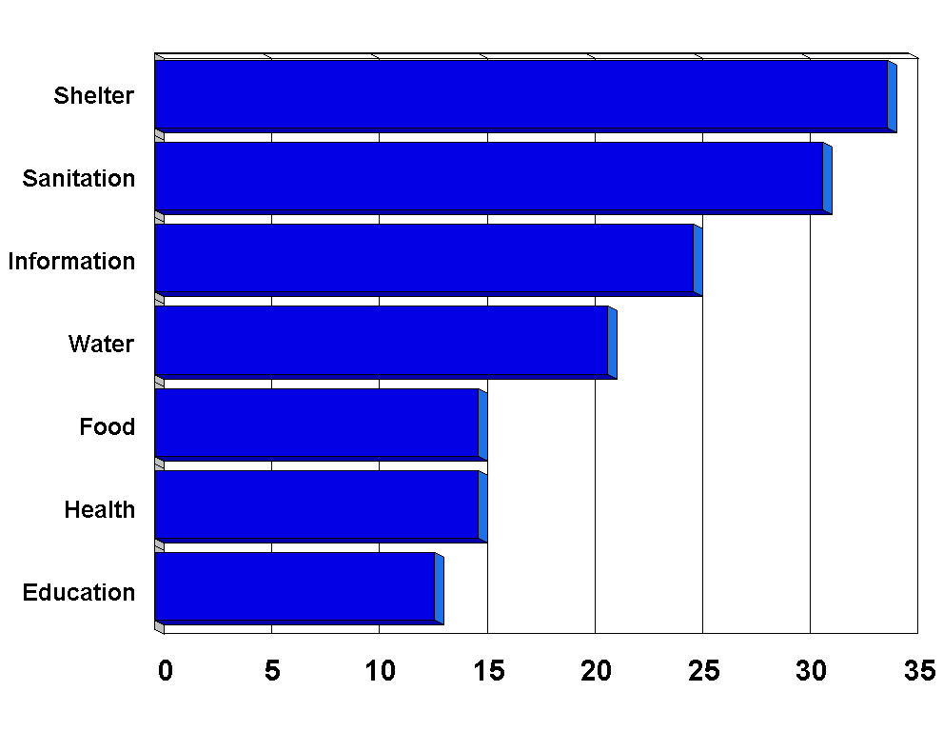
These deprivations are discussed in order of decreasing severity.

Shelter deprivation
Over a third of the developing world’s children have to live in dwellings with more than five people per room or which have mud flooring. Some regions have exceptionally high rates of shelter deprivation. Sub-Saharan Africa, for example, has 62% of its children suffering from shelter deprivation and this rises to 73% in rural areas.

Sanitation deprivation
Over half a billion children (31%) in the developing world have no toilet facilities whatsoever. Most of these children live in South Asia, where this condition applies to over 61% of children (nearly 344 million children). Urban-rural differences are considerable, with rural areas having much higher rates of severe sanitation deprivation (41% compared to 8%).

Information deprivation
Almost half a billion children (a quarter of the children in the developing world) lack access to either radio, television, telephone or newspapers at home. South Asia and Sub-Saharan Africa have 40% of their children experiencing severe information deprivation. Rural children are significantly much more likely that their urban counterparts to suffer from information deprivation, being three times as likely to lack access to information (31% compared to 11%).

Water deprivation
Over 20% of children (nearly 375 million children) in the developing world have a more than 15-minute walk to water or are using unsafe water sources. Sub-Saharan Africa has over 50% of its children (167 million children) severely water deprived and the continent accounts for nearly half of all cases of water deprivation in the developing world. Differences between urban and rural areas were considerable, with 7% of children in urban areas and 27% of rural areas severely water deprived. Over 60% of rural children in Sub-Saharan Africa are severely water deprived.

Food deprivation
Over 15% of children under five years in the developing world (91 million children) are severely food deprived, over half of whom were in South Asia. Rates of food deprivation are twice as high in rural areas than in urban areas. At the global level, there appears to be little difference between the extent of food deprivation of girls and boys, although this varies between regions and countries.

Health deprivation
Nearly 15% of children in the developing world (265 million children) had not been immunised against any diseases or had a recent illness involving diarrhoea and had not received any medical advice or treatment. There is considerable regional variation, with Sub-Saharan Africa having over a quarter of its children severely health deprived. A much larger proportion of rural children (21%) are severely health deprived than urban children (8%). Gender differences at the global level were less clear, with 14% of boys and 15% of girls severely health deprived, although there are more visible differences within regions, with the South Asia and Middle East and North Africa regions having a slight female disadvantage.

Education deprivation
Throughout the developing world, there are approximately 135 million children aged between 7 and 18 who are severely educationally deprived in terms of lacking any school education (no primary or secondary education). Children in Sub-Saharan Africa are more likely to be affected by educational deprivation, with one in three lacking any formal education. Rural areas are also more likely to be educationally disadvantaged, with more than three times as many rural children lacking education than their urban counterparts. Gender disparities are particularly evident in some regions. In the Middle East and North Africa, for example, there are three times as many girls who are severely educationally deprived than boys.

Results by region
Sub-Saharan Africa has the highest rates of severe deprivation with respect to four of the seven indicators (Figure 4.2). More than half of this region’s children are severely shelter deprived (198 million), as well as water deprived (167 million). The region also suffers from the highest rates of deprivation with respect to health (27%) and education (30%).

Figure 4.2: Percent of children who are severely deprived by region

However, South Asia has the highest percentages of children experiencing sanitation, information and food deprivation, 61%, 40% and 27%, respectively. Over half of the world’s severely food deprived children live in South Asia (53 million).

Children in East Asia are the least likely to be severely deprived with respect to five of the seven indicators. This region has the lowest rates of severe sanitation deprivation. China has a rate of less than 2% which contributes to the low regional average of 5%.

The study also revealed that there may be significant differences in rates of severe deprivation amongst children within regions. For example, in sub-Saharan Africa, only 19% of Mali children live in severely water deprived conditions, compared to 90% of Rwandan children (see Appendix IV for other examples).

Results by urban-rural locality
Rural children are more likely to be deprived than urban children with respect to all seven areas of deprivation of basic human need (Figure 4.3).

Figure 4.3: Percent of urban and rural children severely deprived

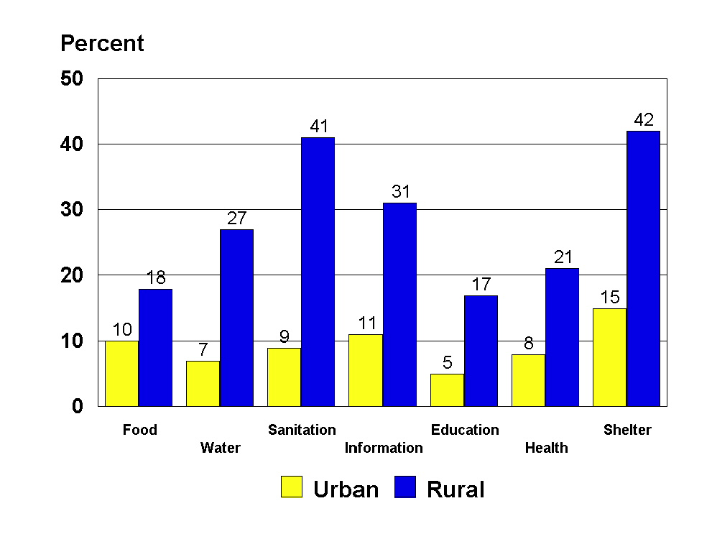

The greatest difference between urban and rural children is in severe sanitation deprivation (41% in rural areas compared with 9% in urban areas). Rural children are also almost three times more likely than their urban counterparts to live in over-crowded conditions or in accommodation with only mud flooring. This pattern of higher levels of severe deprivation amongst rural children is repeated in nearly all regions.

Results by gender
Globally, girls are significantly educationally disadvantaged (Figure 4.4). They are at least 60% more likely than boys to be severely educationally deprived (16% compared to 10%). They suffer particularly high rates of disadvantage in the Middle East and North Africa, where they are three times more likely than boys to be without primary or secondary school education.

On the other hand, girls and boys are roughly equally disadvantaged with respect to severe food deprivation (15% and 16%, respectively) and health deprivation (14% and 15%, respectively). Boys are more likely to be severely food deprived in all regions except in East Asia and South Asia where severe food deprivation is more prevalent in girls. With respect to severe health deprivation, there is a slight female disadvantage in South Asia and the Middle East and the North Africa regions. The sub-Saharan African region has a mixed pattern of gender inequalities in health. While, at the overall level, a slightly higher proportion of boys were severely health deprived compared to girls, more than a dozen countries have a slight female disadvantage.

Figure 4.4: Percent of girls and boys severely deprived

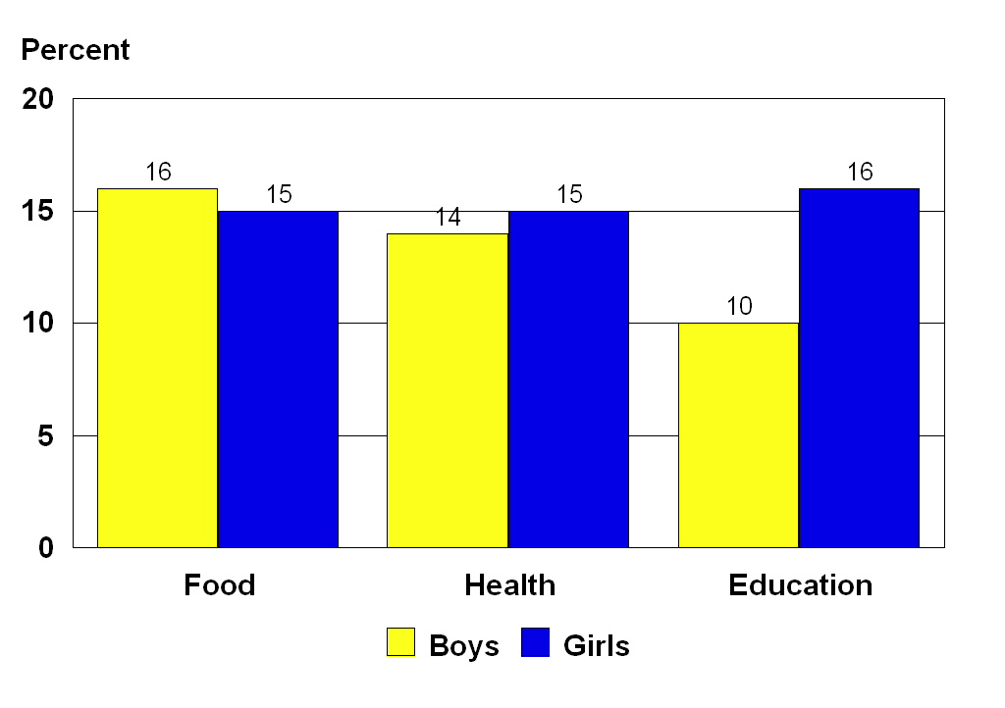
Results of severe deprivation
Over half of the world’s children in developing countries - just over one billion children – are severely deprived, defined as children suffering from one or more forms of severe deprivation of basic human need. Two regions, South Asia and sub-Saharan Africa have severe deprivation rates of more than 80%. Rural children experience much higher levels of severe deprivation than urban children. For example, more than 90% of rural children in South Asia and sub-Saharan Africa live in conditions of severe deprivation. Rural children in the Middle East and North Africa follow closely behind at 89%.

Results of absolute poverty
Children experiencing two or more forms of severe deprivation are considered to be living in absolute poverty. Over a third of all children (37% or 675 million) suffer from two or more different types of severe deprivation, with considerable regional variation. Rates of absolute poverty are highest in Sub-Saharan Africa and South Asia, 65% (207 million) and 59% (330 million), respectively. They are lowest in Latin America and the Caribbean and East Asia and the Pacific regions, 17% and 7%, respectively. Rural children face significantly higher levels of poverty than urban children, with rates for absolute poverty rising to more than 70% in both rural sub-Saharan Africa and rural South Asia.

Section One: Extent of severe deprivation

Food deprivation
Severe food deprivation is measured using data on severe anthropometric failure (i.e. a failure to grow at normal rates to 'normal' weights and heights) in children under five. Since anthropometric data are rarely collected on or available for children over five years of age, the data presented in this report only refer to children under five in developing countries (see Chapter 3 for further discussion).

At an overall level, it is estimated that 15% of children under five years old (representing 91 million children) in developing countries are severely food deprived (Figure 4.5 and Table 4.1). The lowest rate is in the East Asia and Pacific region, at 5% (nearly 8 million children). South Asia has the highest overall rate at 27% (54 million children).

Table 4.1: Children (under five years) suffering severe food deprivation

Region | % | Number ('000s)
Latin America & Caribbean | 5 | 2,885
South Asia | 27 | 53,714
Middle East & North Africa | 12 | 6,483
Sub-Saharan Africa | 19 | 20,286
East Asia & Pacific | 5 | 7,960
Developing world | 15 | 91,328

Figure 4.5: Percent of children (under five years) suffering severe food deprivation

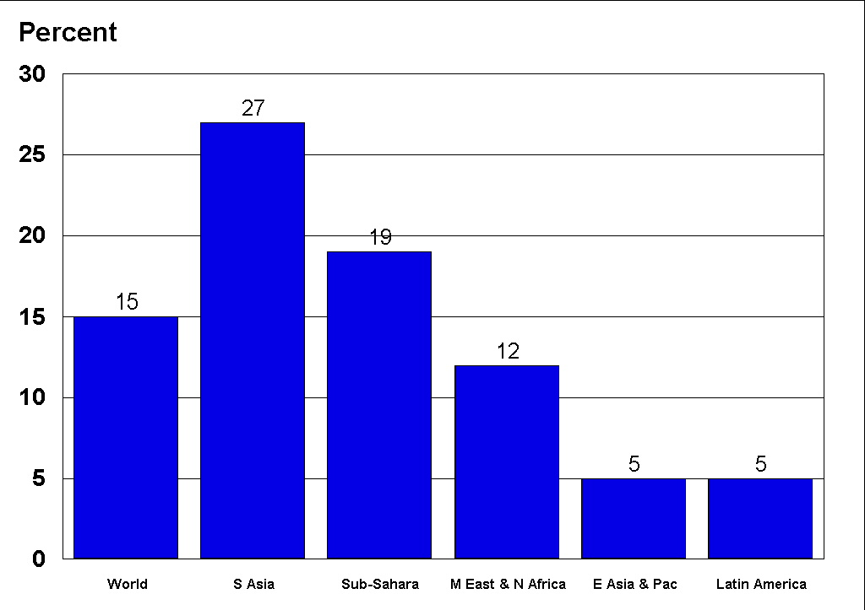

Differences in severe food deprivation are very pronounced between urban and rural areas. At the global level, 10% of urban children under five (nearly 17 million children) and 18% of rural children under five (74 million children) are severely food deprived (Figure 4.6 and Table 4.2).

Table 4.2: Urban and rural children (under five years) suffering severe food deprivation

Region | Urban children |  | Rural children
 | % | Number ('000s) | % | Number ('000s)
Latin America & Caribbean | 3 | 965 | 10 | 1,926
South Asia | 19 | 8,067 | 29 | 45,698
Middle East & North Africa | 8 | 1,571 | 13 | 4,955
Sub-Saharan Africa | 12 | 2,998 | 20 | 17,102
East Asia & Pacific | 6 | 3,352 | 4 | 4,640
Developing world | 10 | 16,953 | 18 | 74,321

Figure 4.6: Percent of rural and urban children (under five years) suffering severe food deprivation

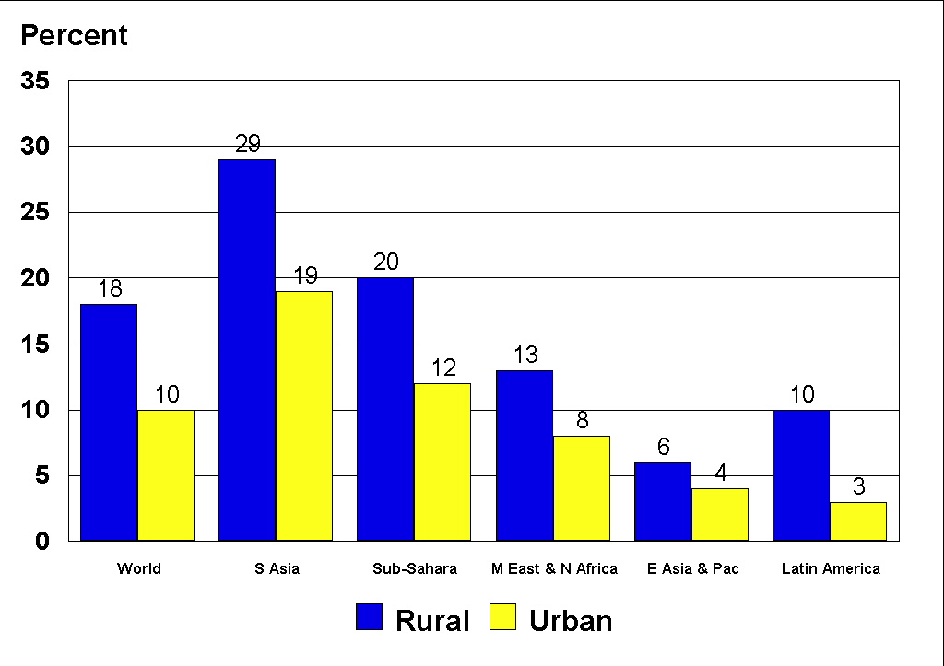

In urban areas, the lowest rate of food deprivation is in the Latin America and Caribbean region, at 3% (965,000 children) and highest in South Asia, at 19% (8 million children). In rural areas, the lowest rate is in the East Asia and Pacific region, at 4% (under 5 million children) and highest in South Asia at 29% (nearly 46 million children).

Gender differences in severe food deprivation appear to be relatively unimportant amongst children under five years (Figure 4.7 and Table 4.3). At the overall level, it is estimated that 16% of boys under five (48 million boys) and 15% of girls under five (44 million girls) are severely food deprived.

Table 4.3: Boys and girls (under five years) suffering severe food deprivation

Region | Boys |  | Girls
 | % | Number ('000s) | % | Number ('000s)
Latin America & Caribbean | 6 | 1,557 | 5 | 1,332
South Asia | 26 | 26,504 | 28 | 27,257
Middle East & North Africa | 12 | 3,494 | 11 | 3,025
Sub-Saharan Africa | 19 | 10,501 | 18 | 9,790
East Asia & Pacific | 6 | 5,947 | 3 | 2,323
Developing world | 16 | 48,003 | 15 | 43,727

Figure 4.7: Percent of girls and boys (under five years) suffering severe food deprivation

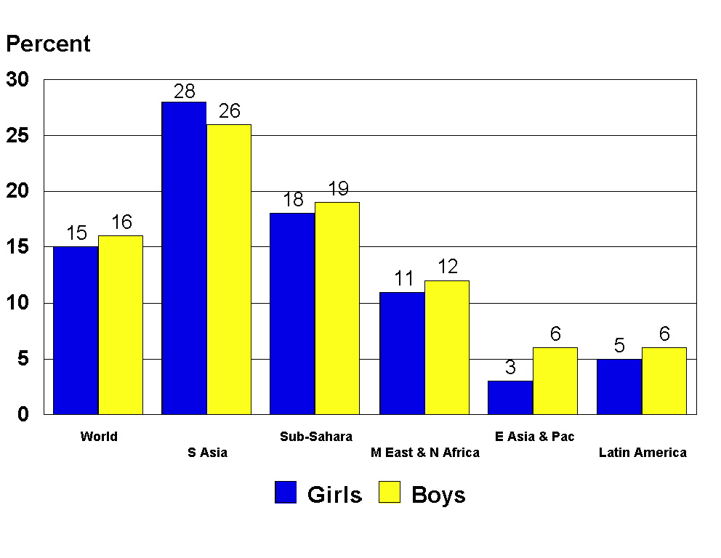

The Latin America and Caribbean region has the lowest rates of food deprivation for boys at 6% (1.5 million boys). East Asia has the lowest rate for girls at 2.9% (2.3 million girls). South Asia has the highest rates of food deprivation for both boys and girls, at 26% (26.5 million boys) and 28% (27 million girls). While, at the overall level, gender differences in severe food deprivation are not clear, it is apparent that slight differences do occur within regions, as Table 4.3 shows.

Water deprivation
At the overall level, it is estimated that 21% of children (nearly 376 million children) are severely water deprived (Figure 4.8 and Table 4.4). This means over a third of a billion children have more than a 15 minute walk to their source of water (thus limiting the quantity they use), or are using unsafe sources of water (i.e. surface water). Of the five regions, the lowest rate is in the Latin America and Caribbean region, where 7% (14 million children) are severely water deprived. Sub-Saharan Africa has by far the highest rate, at 53% (167 million children). The East Asia and Pacific region has a relatively low rate of severe water deprivation, at 10% (58.5 million children).

Table 4.4: Children suffering severe water deprivation

Region | % | Number ('000s)
Latin America & Caribbean | 7 | 14,318
South Asia | 18 | 99,611
Middle East & North Africa | 24 | 36,199
Sub-Saharan Africa | 53 | 166,877
East Asia & Pacific | 10 | 58,565
Developing world | 21 | 375,569

Figure 4.8: Percent of children suffering severe water deprivation

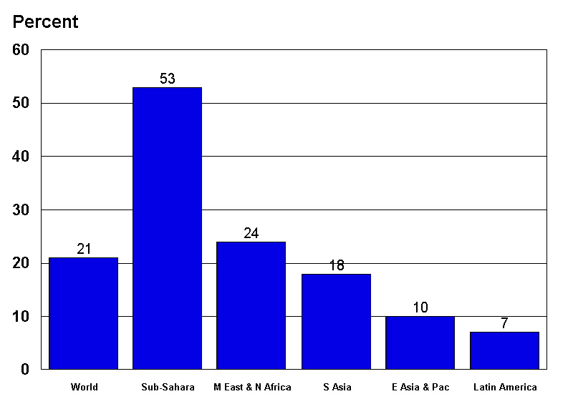

There are considerable differences in severe water deprivation between urban and rural areas in each of the five regions (Figure 4.9 and Table 4.5). At the overall level, 7% of urban areas (nearly 41 million children) are severely water deprived. The rate in rural areas is over three times higher, at 27% (335 million children).

Table 4.5: Urban and rural children suffering severe water deprivation

Region | Urban children |  | Rural children
 | % | Number ('000s) | % | Number ('000s)
Latin America & Caribbean | 1 | 1,434 | 20 | 12,885
South Asia | 9 | 11,192 | 21 | 88,649
Middle East & North Africa | 5 | 2,626 | 34 | 33,674
Sub-Saharan Africa | 19 | 14,685 | 63 | 152,039
East Asia & Pacific | 6 | 10,943 | 11 | 47,737
Developing world | 7 | 40,880 | 27 | 334,983

Figure 4.9: Percent of rural and urban children suffering severe water deprivation
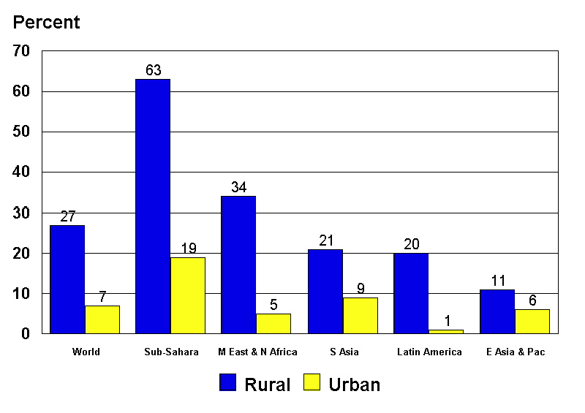
In urban areas, the lowest rate of severe water deprivation is in the Latin America and Caribbean region at 1% (1.4 million children) and the highest urban rate is in Sub-Saharan Africa at 19% (15 million children). The other regions all have urban rates of water deprivation below 10%.

Rates of severe water deprivation in rural areas are considerably higher. The East Asia and Pacific region has the lowest rural rate by far, at 11% (nearly 48 million children). All other regions have rural rates over 20%, with the highest in Sub-Saharan Africa at 63% (152 million children). The Middle East and North Africa region has the second highest rural rate of 34% (34 million children) although the geographic features of the region (i.e. desert and semi-desert regions) limit the availability of water. The South Asia and Latin America and Caribbean regions have similar rural rates of 21% (89 million children) and 20% (13 million children) respectively.

Sanitation deprivation
For this report, severe sanitation deprivation is defined as a child having NO access to ANY sanitation facilities of any description. Thus, children with sanitation facilities which are considered not improved (e.g. public or shared latrines, open pit latrines and bucket latrines) by the Joint Monitoring Programme are not counted as severely deprived in this report, although it is acknowledged that the use of a bucket or open pit latrine is a far from appropriate or adequate method of waste disposal.

At the overall level, it is estimated that 31% of children (nearly 567 million children) in developing countries are severely sanitation deprived, lacking ANY form of sanitation facility, improved or otherwise (Figure 4.10 and Table 4.6). The lowest rate is in the East Asia and Pacific region, at 5% (30 million children) and the highest in South Asia, at 61% (344 million children). Sub-Saharan Africa also has a relatively high rate at 38% (120 million children).

Table 4.6: Children suffering severe sanitation deprivation

Region | % | Number ('000s)
Latin America & Caribbean | 17 | 33,472
South Asia | 61 | 343,604
Middle East & North Africa | 26 | 39,742
Sub-Saharan Africa | 38 | 119,833
East Asia & Pacific | 5 | 30,188
Developing world | 31 | 566,839

Figure 4.10: Percent of children suffering severe sanitation deprivation

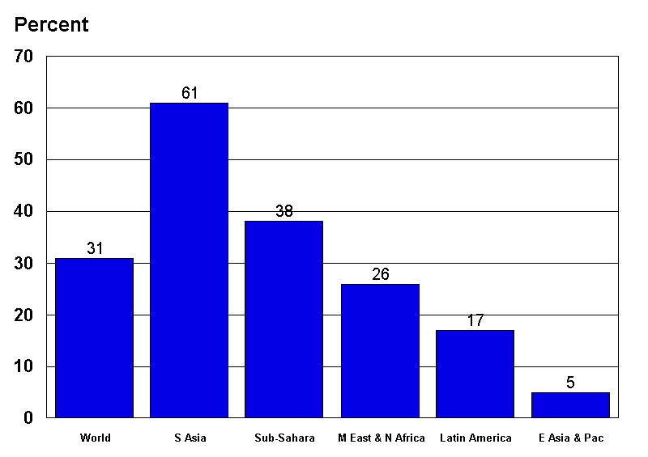

Differences between urban and rural areas are considerable, confirming the findings of the GWSSA results (WHO, UNICEF, WSSCC, 2000). At the overall level, the urban rate of severe sanitation deprivation is 9% (51 million children) (Figure 4.11 and Table 4.7). The rural rate is nearly five times higher, at 41% (516 million children). Over half a billion children in rural areas lack access to any form of sanitation facility.

Table 4.7: Urban and rural children suffering severe sanitation deprivation

Region | Urban children |  | Rural children
 | % | Number ('000s) | % | Number ('000s)
Latin America & Caribbean | 6 | 7,950 | 41 | 25,580
South Asia | 19 | 24,292 | 74 | 319,135
Middle East & North Africa | 5 | 2,462 | 38 | 37,250
Sub-Saharan Africa | 12 | 8,966 | 46 | 110,902
East Asia & Pacific | 4 | 6,948 | 5 | 23,223
Developing world | 9 | 50,617 | 41 | 516,089

Figure 4.11: Percent of rural and urban children suffering severe sanitation deprivation

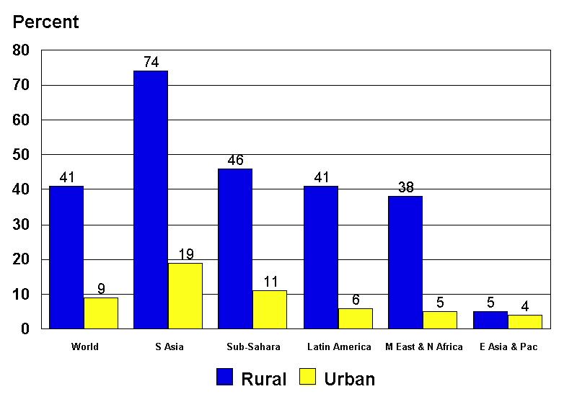

With regard to sanitation deprivation in urban areas, the East Asia and Pacific and Middle East and North Africa regions both have relatively low rates, at 4% (less than 7 million children) and 5% (just over 2 million children), respectively. The highest urban rate is in South Asia, at 19% (24 million children). In rural areas, the lowest rate is in the East Asia and Pacific region, at 5% (23 million children), considerably lower than all other regions – although this could be explained by the high use of public sanitation facilities in China. Each of the other regions has rural sanitation deprivation rates above 35%, with South Asia having the highest rate of 74% (319 million children). The sub-Saharan Africa and Latin America and Caribbean regions both have rural rates over 40%.

Health deprivation
A range of factors determines the health of children and no single indicator can sufficiently reflect the burden of disease or complete extent of morbidity. For the purposes of this report, a child was considered severely health deprived if they had not received ANY of the eight immunisations recommended by the WHO’s expanded programme of immunisation (EPI) or if they had had untreated diarrhoea in the two weeks prior to the DHS survey interview (see Chapter 3 for further discussion).

It is estimated that, at the overall level, 15% of children in developing countries (265 million children) are severely health deprived (Figures 4.12 and Table 4.8). The lowest rate is in East Asia and the Pacific at 3% (18 million children) and the highest rates are in South Asia and Sub-Saharan Africa, with 23% (128 million children) and 27% (84 million children), respectively.

Table 4.8: Children suffering severe health deprivation

Region | % | Number ('000s)
Latin America & Caribbean | 7 | 12,770
South Asia | 23 | 128,711
Middle East & North Africa | 14 | 20,949
Sub-Saharan Africa | 27 | 84,233
East Asia & Pacific | 3 | 18,113
Developing world | 15 | 264,776

Figure 4.12: Percent of children suffering severe health deprivation

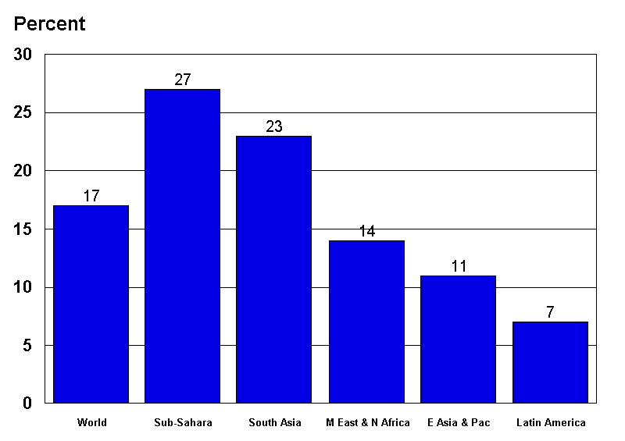

As with the other measures of severe deprivation, there are considerable differences between urban and rural areas (Figure 4.13 and Table 4.9). At the overall level, 8% of urban children (47 million children) and 21% of rural children (263 million children) are severely health deprived.

Table 4.9: Urban and rural children suffering severe health deprivation

Region | Urban children |  | Rural children
 | % | Number ('000s) | % | Number ('000s)
Latin America & Caribbean | 4 | 5,734 | 11 | 6,821
South Asia | 14 | 17,169 | 26 | 110,703
Middle East & North Africa | 6 | 3,392 | 18 | 17,482
Sub-Saharan Africa | 13 | 9,971 | 30 | 72,652
East Asia & Pacific | 6 | 10,769 | 13 | 55,478
Developing world | 8 | 47,035 | 21 | 263,136

Figure 4.13: Percent of rural and urban children suffering severe health deprivation

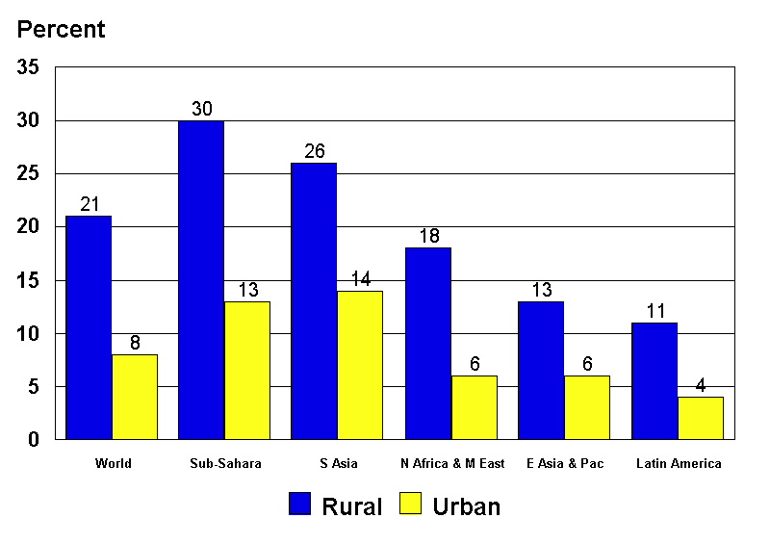

The lowest urban rate is in the Latin America and Caribbean region, at 4% (nearly 6 million children), although the Middle East and North Africa and East Asia and Pacific regions both have low rates, 4% and 6% respectively. The highest urban rates are in Sub-Saharan Africa (13%, nearly 10 million children) and South Asia (13%, nearly 11 million children). In rural areas, the lowest rate of severe health deprivation is in the Latin America and Caribbean region, at 11% (6 million children); and the highest rate is in Sub-Saharan Africa, at 30% (73 million children).

Figure 4.14 and Table 4.10 presents the data on severe health deprivation by gender. At the overall level, the rate of severe health deprivation in boys is slightly less than it is for girls, 14% (133 million boys) compared to 15% (132 million girls). At the regional level, the lowest rate of severe health deprivation for boys is in East Asia and the Pacific 3% (10 million boys). The highest rate for boys is in Sub-Saharan Africa, at 26% (43 million boys). The East Asia and Pacific region also has the lowest rate for girls, at 3% (under 9 million girls) and Sub-Saharan Africa again has the highest rate, at 26% (41 million girls).

Table 4.10: Boys and girls suffering severe health deprivation

Region | Boys |  | Girls
 | % | Number ('000s) | % | Number ('000s)
Latin America & Caribbean | 7 | 6,366 | 7 | 6,497
South Asia | 22 | 63,555 | 24 | 65,245
Middle East & North Africa | 13 | 9,864 | 15 | 11,118
Sub-Saharan Africa | 27 | 43,436 | 26 | 40,661
East Asia & Pacific | 3 | 10,124 | 3 | 8,622
Developing world | 14 | 133,345 | 15 | 132,144

Figure 4.14: Percent of girls and boys suffering severe health deprivation
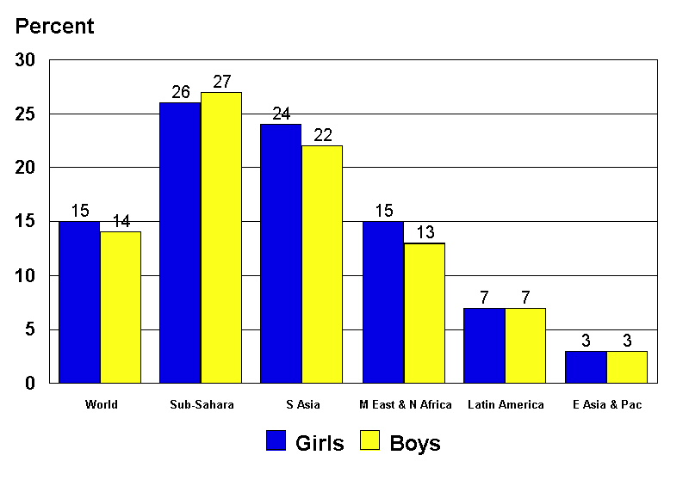

It should be noted that diseases such as HIV/AIDS, Malaria and Tuberculosis, which account for a large proportion of child deaths and ill health in the developing world, are not measured by these data. It is likely that the burden of ill health is actually far greater than is implied by the measures of severe health deprivation used in this report. What is certain is that the decline of public health systems and services means that appropriate care is rarely available, affordable or provided, and so increasing numbers of children will continue to suffer and die from a range of causes, a large number of which (such as diarrhoea and the EPI six targeted diseases) are preventable.

Shelter deprivation
More than one in three of all children experience shelter deprivation, defined in terms of living in accommodation with more than five people per room or which has mud flooring (Figure 4.15). This represents more than 614 million of the developing world’s children (Table 4.11).

The prevalence risks for shelter deprivation vary enormously between regions. Sub-Saharan Africa has a prevalence rate which is double the world’s average, at 62%, whereas South Asia and North Africa and the Middle East have prevalence risks, of 45% each. By contrast, only 8% of children living in East Asia and the Pacific are severely shelter deprived.

Table 4.11: Children suffering severe shelter deprivation

Region | % | Number (‘000s)
Latin America & Caribbean | 23 | 43,727
South Asia | 45 | 253,506
Middle East & North Africa | 45 | 69,471
Sub-Saharan Africa | 62 | 198,027
East Asia & Pacific | 8 | 49,508
Developing world | 34 | 614,238

Figure 4.15: Percent of children suffering severe shelter deprivation

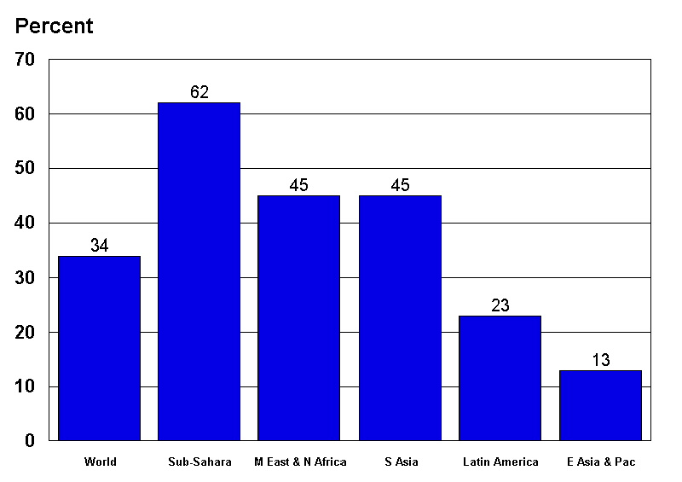

Rural children are significantly more likely than their urban counterparts to be living in circumstances of severe shelter deprivation (42% compared to 15%) (Figure 4.16 and Table 4.12). Whereas more than 530 million of the developing world’s rural children are severely shelter deprived, only 83 million urban children are affected by the same conditions. However, a note of caution is required in the interpretation of these findings as the indicator of severe shelter deprivation used in this study may under-estimate the dwelling related problems experienced by children living in urban areas, e.g. violence, homelessness (see Chapter 3 for further discussion).

Notwithstanding this, there are important discrepancies between regions with regards to prevalence rates amongst rural children. Rates of severe shelter deprivation are highest for rural children in sub-Saharan Africa (73%, representing 176 million children), and lowest for urban children in East Asia and the Pacific (5%, representing 8 million). Sub-Sahara Africa, as well as having the highest rates of rural children living in shelter deprivation, also has the highest proportions of urban children living in those same conditions (28%, representing 21 million children).

However, inequalities amongst children within regions is greatest in North Africa and the Middle East, where rural children are more than four times as likely as urban children in the same region to be severely shelter deprived (62% compared to 15%).

Table 4.12: Urban and rural children suffering severe shelter deprivation

Region | Urban children |  | Rural children
 | % | Number (‘000s) | % | Number (‘000s)
Latin America & Caribbean | 12 | 14,987 | 46 | 28,738
South Asia | 24 | 30,142 | 52 | 223,135
Middle East & North Africa | 15 | 8,041 | 62 | 61,288
Sub-Saharan Africa | 28 | 21,487 | 73 | 176,336
East Asia & Pacific | 5 | 8,511 | 10 | 41,286
Developing world | 15 | 83,169 | 42 | 530,783

Figure 4.16: Percent of rural and urban children suffering severe shelter deprivation

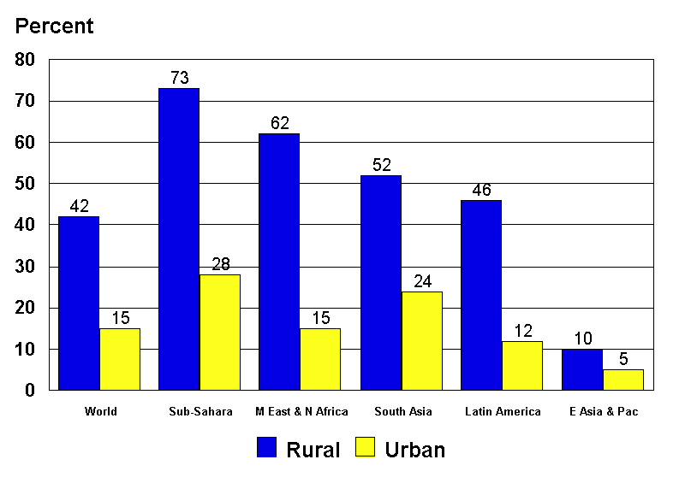

Education deprivation
Throughout the developing world, 13% of all children (134 million) aged between 7 and 18 are educationally deprived, defined in terms of lacking either a primary or secondary school education (Figure 4.17 and Table 4.13). Sub-Saharan Africa has an above-average prevalence rate of 30% (50 million children), as does the Middle East and North Africa at 23% (19 million children) and South Asia at 19% (57 million children), whereas Latin America and the Caribbean and East Asia have relatively small rates, at 3% and 1%, respectively.

Table 4.13: Children (aged 7-18) suffering severe educational deprivation

Region | % | Number (‘000s)
Latin America & Caribbean | 3 | 4,028
South Asia | 19 | 57,134
Middle East & North Africa | 23 | 18,608
Sub-Saharan Africa | 30 | 50,274
East Asia & Pacific | 1 | 4,139
Developing world | 13 | 134,183

Figure 4.17: Percent of children (aged 7-18) suffering severe educational deprivation

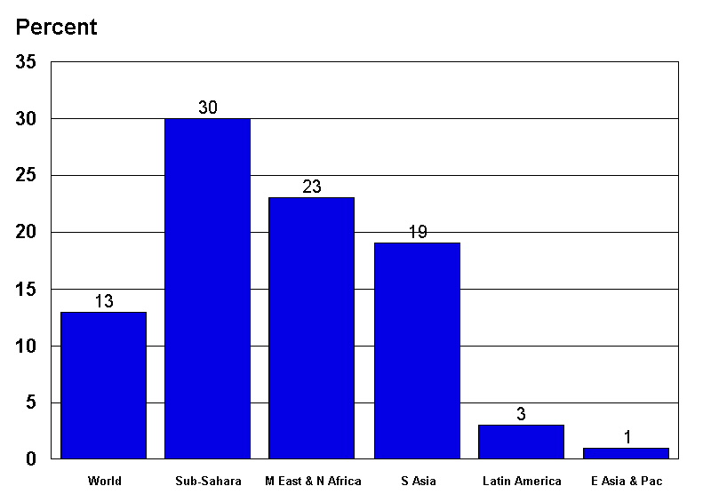

There are significant urban-rural discrepancies in lack of access to education. Seventeen percent of all rural children aged between 7 and 18 experience severe education deprivation, compared to only 5% of all urban children (Figure 4.18 and Table 4.14). Prevalence rates of severe education deprivation are higher amongst rural children in every single region of the developing world. Overall rural children are at least three times more likely than urban children to be severely educationally deprived (17% compared to only 5%). However, the Middle East and North Africa and Sub-Saharan Africa regions have well above-average prevalence rates of severe education deprivation amongst rural children, at 33% and 35%, respectively.

With regards to urban children, higher than average prevalence rates of educational deprivation exist in the Sub-Saharan Africa and South Asia regions, 13% and 10%, respectively. Some regions exhibit large inequalities between urban and rural children. For example, rural children in the Middle East and North Africa are at least five times more likely than their urban counterparts to be severely educationally deprived (33% compared to only 6%).

Table 4.14: Urban and rural children suffering severe educational deprivation

Region | Urban children |  | Rural children
 | % | Number (‘000s) | % | Number (‘000s)
Latin America & Caribbean | 2 | 1,541 | 7 | 2,428
South Asia | 10 | 6,892 | 22 | 50,055
Middle East & North Africa | 6 | 1,768 | 33 | 16,877
Sub-Saharan Africa | 13 | 5,556 | 35 | 44,700
East Asia & Pacific | 1 | 623 | 1 | 3,542
Developing world | 5 | 16,380 | 17 | 117,602

Figure 4.18: Percent of rural and urban children (aged 7-18) suffering severe educational deprivation

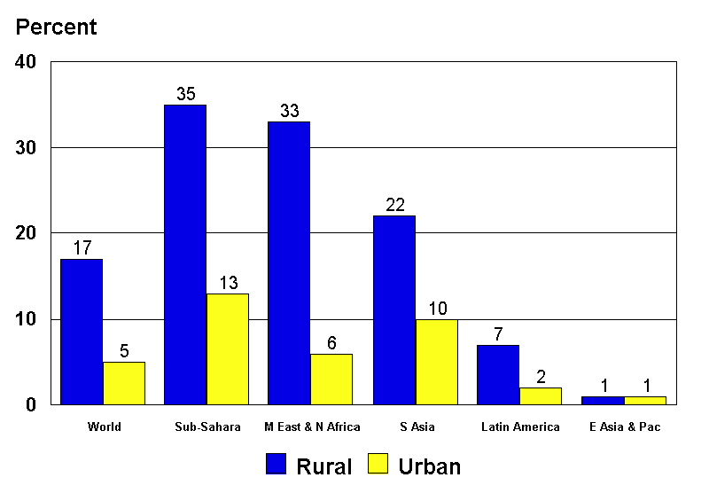

Girls are much more likely than boys to be at risk of being educational deprived. Globally, they are over one and a half times more likely than boys to suffer severe education deprivation (16% compared to 10%) (Figure 4.19 and Table 4.15). There are also many more girls than boys throughout the world who are educationally deprived. It is estimated that there are over 80 million girls who have received neither a primary nor secondary school education, compared with 54 million boys.

This study also reveals significant gender discrepancies in access to education both between regions and within them. The regions of the Middle East and North Africa and Sub-Saharan Africa have above-average deprivation prevalence rates amongst girls, at 34% and 32%, respectively. However, the greatest gender inequalities within regions exist in the Middle East and North Africa region where girls who suffer severe education deprivation outnumber boys by almost three to one. The East Asia and the Pacific region has the greatest gender equality with respect to access to education, whereas Latin America and the Caribbean reveals a very small gender bias against boys rather than girls.

Table 4.15: Boys and girls (aged 7-18) suffering severe educational deprivation

Region | Boys |  | Girls
 | % | Number (‘000s) | % | Number (‘000s)
Latin America & the Caribbean | 4 | 2,148 | 3 | 1,822
South Asia | 14 | 21,015 | 25 | 35,983
Middle East & North Africa | 12 | 5,100 | 34 | 13,491
Sub-Saharan Africa | 27 | 23,293 | 32 | 27,056
East Asia & Pacific | 1 | 2,123 | 1 | 1,946
Developing world | 10 | 53,679 | 16 | 80,299

Figure 4.19: Percent of girls and boys (aged 7-18) suffering severe educational deprivation

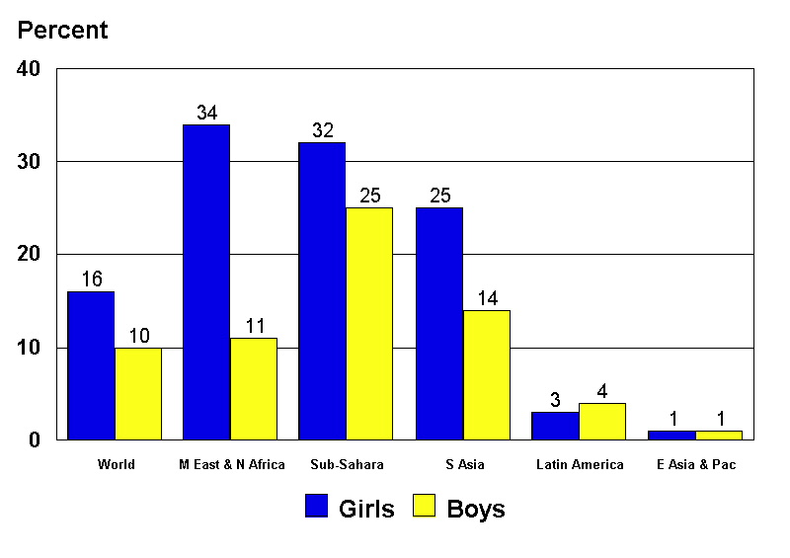

Information deprivation
Globally, it is estimated that 25% of all children aged three years and above are severely information deprived, representing almost 448 million children (Figure 4.20 and Table 4.16). This means that one in four children in developing countries lack access to TV, radio, telephone or newspapers. Nevertheless, these global figures disguise the real magnitude of information deprivation in some regions. Analysis by region reveals that 40% of South Asian and 39% of Sub-Saharan African children suffer from severe information deprivation (226 and 124 million children, respectively). On the other hand, lower than average prevalence rates were found in the regions of Latin America and the Caribbean (10%) and East Asia and the Pacific (7%).

Table 4.16: Children (three years and above) suffering severe information deprivation

Region | % | Number (‘000s)
Latin America & Caribbean | 10 | 18,381
South Asia | 40 | 225,525
Middle East & North Africa | 23 | 34,966
Sub-Saharan Africa | 39 | 124,283
East Asia & Pacific | 7 | 44,678
Developing world | 25 | 447,834

Figure 4.20: Percent of children (three years and above) suffering severe information deprivation
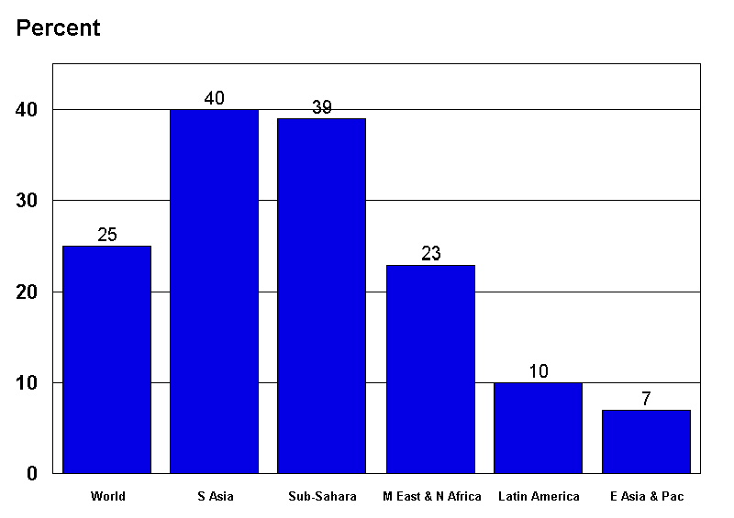

Severe information deprivation amongst children is far more extensive in rural areas than in urban areas: 31% (388 million children) compared to 11% (60 million children) (Figure 4.21 and Table 4.17). The highest prevalence rates amongst rural children are in South Asia at 47% (202 million children) and Sub-Saharan Africa at 45% (109 million children), whilst the lowest rates affect children in East Asia and the Pacific at 9% (37 million children). Amongst urban children, the regions with highest prevalence rates are again Sub-Saharan Africa (20%) and South Asia (19%). On the other hand, the greatest inequalities in access to information are amongst children living in Latin America and the Caribbean, where there are almost four rural children who are deprived for every one urban child (19% compared to only 5%).

Table 4.17: Urban and rural children (3 years and older) suffering severe information deprivation

Region | Urban Children |  | Rural Children
 | % | Number (‘000s) | % | Number (‘000s)
Latin America & Caribbean | 5 | 6,646 | 19 | 11,748
South Asia | 19 | 23,656 | 47 | 201,946
Middle East & North Africa | 14 | 7,440 | 28 | 27,515
Sub-Saharan Africa | 20 | 15,227 | 45 | 108,977
East Asia & Pacific | 4 | 7,122 | 9 | 37,415
Developing world | 11 | 60,090 | 31 | 387,601

Figure 4.21: Percent of rural and urban children (3 years and older) suffering severe information deprivation
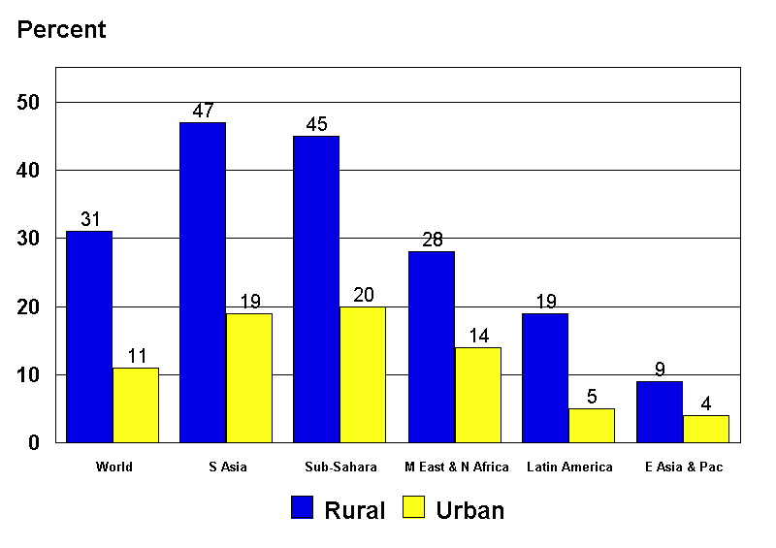
Section Two: Distribution of severe deprivation

This next section compares the extent of severe deprivation among the regions of the developing world. For the purposes of this study, severe deprivation has been defined as children experiencing one or more severe deprivations of basic human need. Table 4.18 and Figure 4.22 show the number and proportion of children in the five UNICEF regions suffering one or more severe deprivation.

Table 4.18: Children suffering severe deprivation

Region | % | Number ('000s)
Latin America & Caribbean | 35 | 68,493
South Asia | 82 | 459,444
Middle East & North Africa | 65 | 99,354
Sub-Saharan Africa | 83 | 264,460
East Asia & Pacific | 23 | 137,054
Developing world | 56 | 1,028,804

Figure 4.22: Percent of children suffering severe deprivation

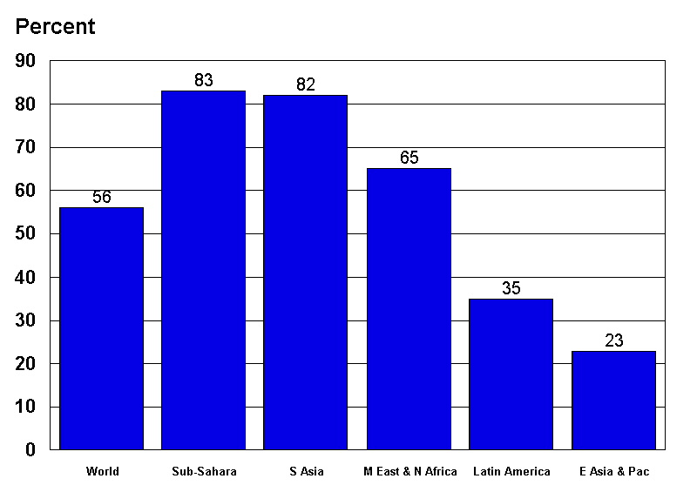

At the global level, 56% of children in the developing world (more than 1 billion children) are severely deprived of basic human needs. The lowest rate is in the East Asia and Pacific region (23%), while rates are highest in South Asia (82%) and Sub-Saharan Africa (83%). All but two of the regions have severe deprivation rates above 50%.

Urban-rural differences are apparent, with 31% of children (over 175 million children) in urban areas and 67% of children (853 million children) in rural areas being severely deprived in at least one way (Figure 4.23 and Table 4.19).

Table 4.19: Urban and rural children suffering severe deprivation

Region | Urban children |  | Rural children
 | % | Number ('000s) | % | Number ('000s)
Latin America & Caribbean | 20 | 25,934 | 67 | 42,570
South Asia | 48 | 61,174 | 92 | 398,270
Middle East & North Africa | 32 | 17,669 | 82 | 81,651
Sub-Saharan Africa | 53 | 40,578 | 93 | 223,969
East Asia & Pacific | 17 | 30,050 | 25 | 106,656
Developing world | 31 | 175,405 | 67 | 853,115

Figure 4.23: Percent of rural and urban children suffering severe deprivation
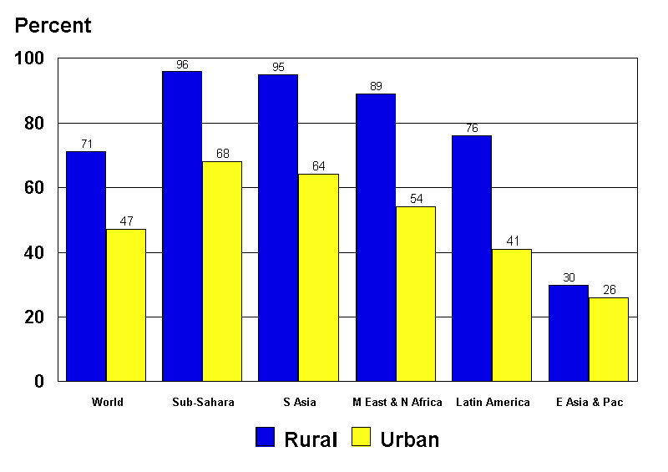

The East Asia and Pacific region has the lowest rates for both urban and rural areas, at 17% and 25%, while Sub-Saharan Africa has the highest rates for both urban and rural areas - 53% and 93%, respectively. South Asia also has high rates in both urban and rural areas, at 48% (61 million children) and 92% (398 million children).

Section Three: Distribution of absolute poverty
The final section of this chapter compares the extent of absolute poverty among the different regions in the developing world. For the purposes of this report, absolute poverty is defined as multiple severe deprivation of basic human need - i.e. children who suffer from two or more different severe deprivations.

Table 4.20: Children suffering from absolute poverty

Region | % | Number ('000s)
Latin America & Caribbean | 17 | 33,085
South Asia | 59 | 329,613
Middle East & North Africa | 40 | 61,153
Sub-Saharan Africa | 65 | 206,927
East Asia & Pacific | 7 | 43,471
Developing world | 37 | 674,249

Figure 4.24: Percent of children in absolute poverty

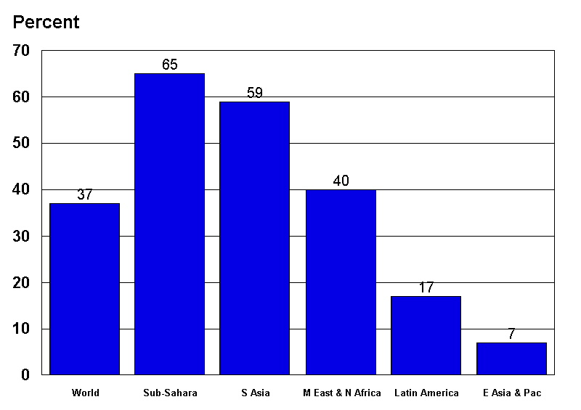

At the global level, it is estimated that 37% of children in the developing world (over 674 million children) are living in absolute poverty. The lowest rate is found in the East Asia and Pacific region, at 7% (43 million children) and the highest rate is in Sub-Saharan Africa, at 65% (nearly 207 million children). South Asia also has a high rate of absolute poverty, with 59% (320 million children) of children suffering two or more forms of severe deprivation.

Most children living in absolute poverty live in rural areas, although rates in the urban areas of some regions are high (Figure 4.25 and Table 4.21). At the overall level, the urban rate of absolute poverty is 12% (65 million children), while the rural rate is much higher at 48% (610 million children).

Table 4.21: Urban and rural children in absolute poverty

Region | Urban children |  | Rural children
 | % | Number ('000s) | % | Number ('000s)
Latin America & Caribbean | 6 | 7,168 | 41 | 25,769
South Asia | 22 | 28,234 | 70 | 301,838
Middle East & North Africa | 9 | 4,978 | 57 | 56,222
Sub-Saharan Africa | 25 | 19,014 | 78 | 188,124
East Asia & Pacific | 3 | 5,385 | 9 | 38,276
Developing world | 12 | 64,778 | 48 | 610,229

Figure 4.25: Percent of rural and urban children in absolute poverty
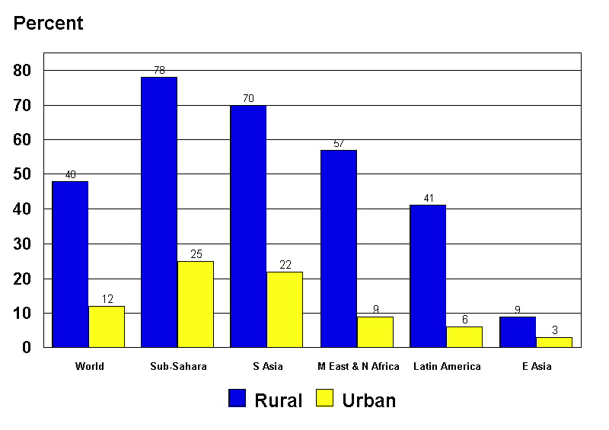

The lowest urban and rural rates are found in the East Asia and Pacific region, at 3% (just over 5 million children) and 9% (38 million children), respectively. The highest urban rates of absolute poverty are in Sub-Saharan Africa and South Asia; with Sub-Saharan Africa's urban absolute poverty rate at 25% (19 million children) compared to South Asia's 22% (28 million children). Absolute poverty rates in rural areas are above 50% in all regions (except Latin America and the Caribbean East Asia and Pacific), with rates in both South Asia and Sub-Saharan Africa at 70%-plus.

Chapter 5

Nature and Severity of Deprivation and Poverty amongst Households with Children

Introduction
The purpose of this chapter is to examine both the distribution and the nature of absolute poverty in the developing world at household level. The previous chapters have been concerned with severe deprivation and absolute poverty measured at the level of the individual child. However, policy interventions to combat poverty and deprivation are more often targeted at the family or household. It is therefore of considerable policy importance to understand both the extent and distribution of absolute poverty at household level. It is also important to understand which are the most frequently occurring combinations of severe deprivation that result in absolute poverty.

Deprivation and poverty amongst households with children
Chapter 4 described the regional distribution of severe deprivation and absolute poverty of children in the developing world. Tables 5.1 and 5.2 compare the results discussed in Chapter 4 with the distribution of severe deprivation and absolute poverty measured at the level of households with children. It should be noted that households with children may contain some children who are severely deprived and others who suffer from no deprivations (e.g. the girls may be educationally deprived but not the boys). However, this situation is comparatively rare. Similarly, a household with children may be defined as absolutely poor (e.g. suffering from two or more different types of severe deprivation) without any of the individual children in the household experiencing two deprivations (e.g. a young child may have not been immunised and an older child may never have attended school).

Table 5.1: Distribution of severe deprivation at individual and household level

Region | Children |  | Households with children
 | % | Number (000s) | % | Number (000s)
Sub-Saharan Africa | 83 | 264,460 | 84 | 82,336
South Asia | 82 | 459,444 | 81 | 157,077
Middle East & North Africa | 65 | 99,354 | 62 | 27,898
Latin America & Caribbean | 35 | 68,493 | 30 | 24,277
East Asia & Pacific | 23 | 137,054 | 20 | 65,518
Developing World | 56 | 1,028,804 | 48 | 357,107

Table 5.1 shows that, while over half (56%) of the developing world’s children suffer from severe deprivation, just under half (48%) of households with children are in a similar situation. This is because, in most regions, the risk of severe deprivation increases with household size. Households with more children are often more likely to be deprived than households with fewer children.

Table 5.2: Distribution of absolute poverty at individual and household level

Region | Children |  | Households with children
 | % | Number (000s) | % | Number (000s)
Sub Saharan Africa | 65 | 206,927 | 68 | 67,041
South Asia | 59 | 329,613 | 63 | 122,320
Middle East & North Africa | 40 | 61,153 | 41 | 18,169
Latin America & Caribbean | 17 | 33,085 | 14 | 11,623
East Asia & Pacific | 7 | 43,471 | 6 | 18,055
Developing World | 37 | 674,249 | 32 | 237,207

Table 5.2 shows that, in the developing world as a whole, 37% of children are living in absolute poverty compared with 32% of households with children. However, in both Sub-Saharan Africa and South Asia, there are slightly higher rates of poverty amongst households with children than amongst individual children. It should be noted that household sizes are significantly larger on average in these two regions than in the rest of the developing world.

Intensity of poverty and deprivation
The most common measure of poverty is the proportion of individuals, households or families that fall beneath the poverty line. If q is the number of people identified as poor and n the total number of people in the community, then the head count ratio measure H is q/n. The head count ratio ranges from 0 (nobody is poor) to 1 (everybody is poor).

This simple indicator provides useful information on the incidence of poverty among the population. However, the head count ratio does not provide information on the distribution of poverty amongst the poor nor does it capture the intensity of poverty, i.e. how far the poor fall below a given poverty line (Sen, 1981; Hagenaars, 1986).

The use of the head count ratio has been under severe attack for 30 years (Atkinson, 1979). In 1968, Watts (1968, p326) noted that it had "Little but its simplicity to recommend it" and Sen (1979, p295) has remarked that, considering its inadequacies, the degree of support commanded by this measure is "quite astonishing".

The head count ratio can even be dangerous for monitoring the effectiveness of pro-poor policies. Successful policies aimed at raising the well-being of the poorest of the poor will not affect the head count ratio if their new living standard is still below the poverty line. On the other hand, successful pro-poor policies aimed at persons just below the poverty line will reduce the head count ratio. Therefore, for anti-poverty policy purposes, it is of crucial importance that the intensity/severity of poverty is measured along with the extent of poverty (Gordon and Spicker, 1998). Table 5.3 provides some information on the intensity of severe deprivation and absolute poverty amongst households with children by region.

Table 5.3: Severity of deprivation for households with children (%)

Number of deprivations | Developing world | Sub-Saharan Africa | South Asia | Middle East &North Africa | Latin America & Caribbean | East Asia & Pacific
0 | 52 | 16 | 19 | 40 | 70 | 80
1 | 16 | 16 | 18 | 22 | 15 | 14
2 | 12 | 19 | 23 | 16 | 8 | 4
3 | 10 | 19 | 21 | 12 | 4 | 1
4 | 6 | 16 | 13 | 8 | 2 | 1
5 | 3 | 10 | 5 | 3 | 1 | -
6 | 1 | 4 | 1 | 1 | - | -
7 | - | 1 | - | - | - | -
Total | 100 | 100 | 100 | 100 | 100 | 100

Table 5.3 shows that, of the 32% of households with children in the developing world that are living in absolute poverty (suffering two or more different types of severe deprivation), 12% suffer from two deprivations, 10% from three and 10% from four or more. There is considerable regional variation, with the regions with the highest absolute child poverty head counts also having the severest poverty. In Sub-Saharan Africa, almost a third (31%) of households with children suffer from four or more different severe deprivations of basic human need. In South Asia, almost one in five (19%) of households with children are similarly affected whereas both the Latin America & Caribbean and the East Asia & Pacific region have comparatively few households with children that suffer from these high levels of multiple deprivation.

Combinations of severe deprivations
Information about the intensity of poverty is important for accurate monitoring of the effectiveness of anti-poverty policies. However, in order to develop reliable anti-poverty policies, it is necessary to know both the distribution and frequency with which combinations of severe deprivations occur. This way, policies can be targeted to tackle the most important child deprivation problems in a region or country. Table 5.4 shows the ten most frequently occurring combinations of deprivations which affect 5% or more of the households with children in the developing world.

In Table 5.4, the combination of deprivations that occurs with the greatest frequency in a region is highlighted in bold. Globally, shelter and sanitation deprivation are the most frequently occurring combination of severe deprivations in the developing world, affecting 15% of households with children. Information deprivation - in combination with either shelter deprivation or sanitation deprivation - affects 28% of households with children. However, there are considerable regional variations. In Sub-Saharan Africa, the most prevalent combination of deprivations is severe shelter and water deprivation, which is suffered by two out of five (39%) households with children. In South Asia, severe sanitation and information deprivation is the largest problem and, in the Middle East and North Africa, severe education and shelter deprivation occur more frequently than any other combination of deprivations.

Table 5.4: Combinations of deprivations suffered by children in households in the developing world (%)

Deprivation Combination | World | Sub-Saharan Africa | South Asia | Middle East & North Africa | Latin America | East Asia
Shelter & Sanitation | 15 | 30 | 32 | 15 | 8 | 1
Shelter & Information | 14 | 34 | 29 | 15 | 4 | 2
Sanitation & Information | 14 | 23 | 36 | 7 | 4 | 1
Shelter & Water | 9 | 39 | 9 | 14 | 4 | 1
Sanitation & Water | 9 | 25 | 14 | 12 | 3 | 1
Shelter & Education | 8 | 26 | 13 | 17 | 2 | -
Sanitation & Education | 8 | 18 | 16 | 12 | 2 | -
Water & Information | 8 | 28 | 11 | 7 | 2 | 2
Education & Information | 7 | 21 | 14 | 9 | 1 | -
Water & Education | 5 | 19 | 5 | 11 | 1 | -
Absolute Poverty | 32 | 68 | 63 | 41 | 14 | 6
Note: Only deprivation combinations that affect 5% or more of the developing world’s households with children are shown. The table does not sum as households with children can suffer from combinations of more than two different deprivations (e.g. 3 deprivations, 4 deprivations, see Table 5.3).

It is very clear, even from this preliminary examination of combinations of severe deprivations, that, in order to eradicate absolute child poverty in the developing world, different polices will be required in different regions and countries. A global, ‘one size fits all’ anti-poverty policy is unlikely to work effectively or efficiently. If the commitment of the governments of the world to halve absolute poverty amongst children by 2015 is to be achieved, then priorities will need to be set that are region and country specific and based upon the best available scientific evidence. In particular, the problems of severe shelter and sanitation deprivation will need to be tackled.

Chapter 6

Conclusions and Policy Implications

Introduction
This research has produced the first scientific estimates of absolute child poverty in the developing world. Over a third of children (37%) live in absolute poverty and over half (56%) suffer from severe deprivation of basic human need. This means that, in the developing world, over 1 billion children are severely deprived and 675 million are absolutely poor. This is shocking given that severe deprivations of basic human need are those circumstances that are highly likely to have serious adverse consequences for the health, well-being and development of children. Severe deprivations harm children in both the short term and the long term. Many of the absolutely poor children surveyed in this research will have died or had their health profoundly damaged by the time this report is published, as a direct consequence of their appalling living conditions.

Absolute poverty has been measured within the internationally agreed framework of children’s rights, using a definition of absolute poverty that has been agreed to by 117 Governments as: "a condition characterised by severe deprivation of basic human needs, including food, safe drinking water, sanitation facilities, health, shelter, education and information. It depends not only on income but also on access to social services." The definitions used in this study to identify severe deprivation of children’s basic human needs represent much worse living conditions than are usually reported by UN agencies. They measure absolute poverty in such severe terms that any reasonable person would consider that these living conditions were unacceptable and damaging. No government or parent wants children to have to live like this. Therefore, this final chapter looks at what lessons can be learnt from this research and what could be done to help eradicate absolute child poverty during the 21st Century.

The causes of absolute poverty
This research has shown that the severe deprivations which affect the greatest number of children are shelter, sanitation, information and water deprivation. Fewer children suffer from severe deprivation of food, health and education. This, in part, demonstrates the success of international agencies and donors that have focused on improving children’s access to health and education services and preventing malnutrition. However, lessons can be drawn from the experiences of industrialised countries in combating poverty and improving children’s health. During the 19th and first half of the 20th Centuries, the major improvements in standard of living and life expectancy of children in industrialised countries was as a result of significant public investment in housing, sewerage and water systems. Safe water, housing and sanitation facilities are a prerequisite for good health and education. If children are made chronically sick as a result of unsafe water supplies or inadequate sanitation or overcrowded housing conditions, then they cannot go to school even if free high quality education is available. Similarly, good health facilities can help alleviate the symptoms of chronic sickness but they cannot tackle the causes. Food aid will not be effective at reducing malnutrition if children suffer from chronic diarrhoea as a result of a lack of sanitation facilities and/or unsafe water.

This evidence points to the conclusion that UNICEF and other international agencies, governments and donors may need to give a higher priority to tackling the problems of severe shelter, sanitation and water deprivation than is presently the case.

There has been some recent debate within the international community about the need to tackle the problems of housing, water and sanitation deprivation. However, much of this debate has focused on facilitating the private sector to provide additional investment and infrastructure in urban areas. This research shows that far more children in rural areas suffer from severe deprivation than their urban peers. Since the prime motivation of the private sector is the need to optimise profits, it is extremely unlikely that it will be able to provide water and sewerage infrastructure in all poor rural areas as this would not be profitable. The only way to provide all absolutely poor rural children with adequate housing, sanitation and water facilities is by public investment to pay for these infrastructure facilities. International agencies could be more active in campaigning for greater shelter, sanitation and water infrastructure investment in rural areas of the developing world. Improvements to this rural infrastructure would be the most effective method of reducing absolute child poverty.

Sanitation
Children are particularly affected by poor sanitation, since it is directly linked to the most serious of childhood illnesses – diarrhoea and malnutrition. Sanitation facilities provided for communities may often be unsuitable for children. If facilities are constructed for adults, they may be too large for young children and present obvious dangers (such as falling in); facilities lacking adequate lighting may intimidate young children wanting to use them at night; children wanting to use public facilities may be made to wait while adults use them first, etc. The needs of adolescent girls and young women for sanitation and privacy also need to be a priority.

Sanitation facilities require effective drainage systems, which carry sewage away from communities. Children use fields and open spaces to play, areas that are commonly used for defecation in the absence of public or private facilities. UNICEF is already committed to improving children’s access to sanitation and should support organisations which try to establish and maintain public sanitation facilities. Such organisations have started to provide child-friendly facilities, which children can use in safety, without fear or intimidation. The provision of sanitation facilities in schools is also important and should be supported.

There has been some reluctance in the past to highlight the need to improve sanitation facilities as many people do not like to talk about human excreta disposal and donors have gained greater positive publicity for helping improve children’s health and education facilities than for funding latrines. UNICEF could play a lead role in both raising funds and highlighting the crucial importance of eradicating severe sanitation deprivation as a method of helping eradicate absolute child poverty. Toilet facilities are a priority for children.

Water
Severe water deprivation is an issue of both quality and quantity. Improving water quality is clearly important for the health of children. Children should not have to use unsafe (or unimproved) sources of water, such as lakes, ponds or streams, as these may become contaminated and dangerous. Communities need to have access to safe water (piped water, stand-pumps, covered wells etc.), through services that they can afford, run and maintain themselves. Such facilities will need to be located and provided near to where people live, to cut journey times for collection. Distance to the water source is of special significance to children since they are often help collect and carry the water. Carrying water over a long distance can result in injuries, especially to necks and backs, and the time spent collecting water can impact on school attendance.

The distance children need to go in order to get to their water supply is arguably of greater importance than water quality (Esrey, 1996). Water quantity is directly linked to distance to water supply, with less water used the further away the water source. The measure of severe water deprivation used in the report takes into account the issue of distance to water source, something the Joint Monitoring Programme (JMP) of UNICEF and WHO does not currently measure (i.e. it focused on water quality issues only). It is important that UNICEF and other international organisations, governments and donors take steps to help increase both the quality and quantity of water available to poor children if absolute poverty is to be eradicated.

Shelter
Overcrowded dwellings facilitate the transmission of disease (e.g. respiratory infections, Measles). It can also result in increased stress and mental health problems for both adults and children and lead to accidents and injuries. Poor quality shelter, constructed from inferior materials, does not protect against the elements. Successive UN conferences and conventions have sought to address the issue of poor housing and shelter deprivation in both developed and developing countries but progress on meeting children’s basic shelter needs is slow. Considerable international attention has focused on improving the housing conditions in urban slums, shanty towns and favelas. However, this research has shown that severe shelter deprivation blights the lives of 42% of rural children in developing countries compared with 15% of children in urban areas. Improving the housing conditions of families with children in rural areas needs to be given a higher priority.

Food
This research used severe anthropometric failure, i.e. children more than minus 3 standard deviations below the international reference population median, as a measure of severe food deprivation. However, data on children’s height and weights are only usually collected for children up to 5 years old. There is good scientific evidence that older children (particularly during puberty) may also be at risk of suffering from malnutrition. Anthropometric data need to be collected on older children, so that more accurate estimates of child malnutrition in the developing world can be made.

A technical innovation of this research has been the development and use of a composite index of anthropometric failure (CIAF), based on the work of Peter Svedberg (2000). It provides a more comprehensive indicator of malnutrition than existing measures, and thus may be more appropriate for use in target setting and resource allocation. UNICEF may want to consider development of this indicator and its potential use to monitor the international commitments to reduce child malnutrition by half by 2015.

Child and family benefit
Another lesson that can be drawn from the experiences of industrialised countries in reducing child poverty is that, after public infrastructure investment, the most effective anti-poverty policy for children is the establishment of a child or family social security benefit.

It has been argued elsewhere (Townsend and Gordon, 2002) that an international children's investment fund should be established under the auspices of the UN. Half its annual resources should be devoted to countries with extensive child poverty, where schemes of child benefit in cash or kind exist or are introduced. All countries with large numbers of children who are below an internationally recognised poverty line and also with comparatively low GDP should be entitled to participate. Such participation would require dependable information that the benefits are reaching children for whom they are intended. The remaining annual resources of the fund would be made available to countries for investment in housing, sanitation and water infrastructure, education, health and other schemes of direct benefit to children.

Programmes to gradually increase public expenditure so that categories of the extreme poor start to benefit offer a realistic, affordable and successful method for poverty alleviation. For example, in Brazil, the Zero Hunger Programme intends to provide quantity, quality and regularity of food to all Brazilians in conjunction with accelerated Social Security reform. The first includes food banks, popular restaurants, food cards, distribution of emergency food baskets, strengthening of family agriculture and a variety of other measures to fight malnutrition. The Social Security reform programme includes social assistance for low-income 15-17 year-olds, assistance for 7-14 year-olds who are enabled to go to school and avoid the exacting toll of the worst conditions of child labour, minimum income and food scholarships for pregnant and nursing mothers with incomes less than half the minimum wage or who are HIV positive, benefits for elderly disabled with special needs and a range of other transfer programmes for the elderly, widowed, sick and industrially injured and unemployed that are being enlarged year by year (Suplicy, 2003).

The social security systems of developing countries present a diverse picture. Partial systems were introduced by colonial authorities in most of Asia, Africa and the Caribbean. They were extended in the first instance to civil servants and employees of large enterprises. There were benefits for relatively small groups that included health care, maternity leave, disability allowances and pensions (Midgeley, 1984; Ahmad et al, 1991). In India, there are differences among major states as well as a range of schemes for smallish categories of population (Ghai, 2001;. Prabhu, 2001). In Latin America, some countries introduced schemes before the 1939-45 war and others followed suit after that war. Benefits tended to be limited in range and coverage. There were different systems for particular occupations and categories of workers and a multiplicity of institutions. Between 20% and 60% of the workforce were covered, compared with between 5 and 10% for most of Sub-Saharan Africa and 10 to 30% for most of Asia. “The greatest challenge facing the developing countries is to extend the benefits of social security to the excluded majority to enable them to cope with indigence and social contingencies.”(Huber, 1996)

These recommendations are the key to a far better future for hundreds of millions of children. But how might social security systems now evolve to provide universal beneficial effects of more substantial redistribution? Human rights now play a central part in discussions of international social policy. This applies to civil and political rights, less so to social and economic rights. Articles 22 and 25 in the Declaration of Human Rights - dealing with the rights to an ‘adequate’ standard of living and social security – have been often been overlooked in General Assembly and other reports from the UN. The fundamental right to social security is also spelt out in Article 26 of the CRC and the related rights to an adequate standard of living in Article 27 (see Chapters 1 and 2 and Appendix I).

UNICEF and other international organisations (such as the ILO) should campaign for a legal right to child benefit under Articles 25 and 27 of the Convention on the Rights of the Child.

The needs of children in the 21st Century
The needs of children in the 21st Century are different from those of children in 19th and 20th Centuries and new policies will be required to meet these needs.. For example, in the 21st Century, severe information deprivation is an important constraint on the development of both individual children and societies as a whole – many consider that ‘knowledge is power’. This study provides the first estimates of the extent of severe information deprivation amongst children. A quarter of children in the developing world are severely information deprived with approximately 390 million living in rural areas and 60 million living in urban areas.

Reducing information deprivation will require action at a number of different levels, including getting children into school and increasing literacy rates for both children and adults. Without this, the provision of newspapers and other media would have little effect.

The most cost-effective intervention is through improvements to radio access. Radio is one of the main channels of information in developing countries. They are a cheap, effective means through which communities can be informed about the importance of education and health initiatives (e.g. immunisation for young children, the benefits of hand-washing, effective and cheap ways to treat diarrhoea, availability of food supplements for malnourished children, etc.). All countries have the means to make radio broadcasts. Governments could improve public information services and regularly broadcast programmes that inform communities about simple but effective changes they can make to their lives – e.g. making simple water filters using locally available materials, constructing basic sanitation facilities at low cost, etc. The development of cheap clockwork radios has meant the technology can be made available to all, at an affordable price.

There are many examples of community radio networks which have an important role in the provision of public information (e.g. the Developing Countries Farm Radio Network, the World Community Radio Movement, Community Radios Worldwide). Community organisations have campaigned for the installation of small, local transmitters which can provide information to local communities. They have also argued for the granting of broadcast licences to women’s groups, local colleges and universities, cooperatives, etc. However, commercialisation of the airwaves and the imposition of license fees have begun to affect community radio stations, as they are pushed aside by commercial broadcasters.

Governments might consider allocating resources to the development of community media funds which would provide information over the airwaves on important issues such as health and education. UN Organisations like the FAO and UNESCO have been committed to community media and radio networks for a number of years and support initiatives providing information to rural areas (Hughes, 2001; Ilboudo (2001). As one UNESCO report stated:

Community radio is low-cost, easy to operate reaches all segments of the community through local languages and can offer information, education, entertainment, as well as a platform for debate and cultural expression. As a grass-roots channel of communication, it maximises the potential for development to be drawn from sharing the information, knowledge and skills already existing within the community. It can therefore act as a catalyst for community and individual empowerment (Hughes, 2001).

UNICEF could help inform both governments and the public on the importance of information access for children and thereby raise the profile of this issue.

The poverty of girls
This study found that gender differences at the global level were greatest for severe education deprivation, with girls 60% more likely to be deprived. Significant regional and country disparities were revealed in the study, with girls in the Middle East and North Africa region three times more likely to be severely education deprived.

The reasons why children (and particularly girls) do not go to school vary and policies need to be targeted at the causes of non-attendance if they are to be effective. For example, children may not attend school because there is no school close enough or because it is too expensive or because the quality of the education is not good enough or because there is discrimination against girls.

Abolishing primary school fees may encourage and enable poor parents to send their children - and particularly their daughters - to school. In some countries, there needs to be a concurrent effort made to change social attitudes about the value of education for girls. This applies to all levels of society including parents, politicians, and schoolteachers. There are other practical interventions that can be pursued including the provision of incentives such as bursaries, free school meals and books, improved sanitation facilities and security. As part of the global Education For All campaign, UNESCO recently recommended a number of activities that governments should undertake to meet the goals of eliminating gender disparities in education by 2005 and achieving gender equality by 2015. These are summarised below:

- Prove that they are serious about educating girls by implementing free and compulsory education;
- Set concrete targets and fund them adequately;
- Educate mothers - the most crucial measure for the sustained education of girls;
- Support gender-responsive schools and allow pregnant girls and teenage mothers to continue their education;
- Promote research into the root causes of gender discrimination in education and base policies on the research findings;
- Make educational content relevant to local cultural and economic contexts so that parents see that educating girls improves their quality of life;
- Build bridges between the formal and non-formal education systems so that girls can return to school after early marriages and pregnancy;
- Educate women as well as girls. Women are empowered through education and literate mothers are more likely to send their daughters to school;
- Give families incentives to send girls to school, such as school meals;
- School feeding programs create a demand for education and enhance learning;
- Provide gender-sensitive curricula and textbooks;
- Train more female teachers and make teacher training gender responsive;
- Eliminate child labour. According to a recent ILO report, 352 million children between the ages of 5 and 17 are engaged in economic activities of which 168 million are girls.
- Include HIV/AIDS prevention in the curriculum;
- Education is a powerful ‘social vaccine’ against the pandemic. Learning methods should address the fact that girls are heading households, caring for siblings and being forced to generate income;
- Build schools closer to girls’ homes to increase access, particularly for rural children;
- Make schools safe for girls and equip them with separate toilets.

Regional and country-specific anti-poverty policies
This research has found that the major causes of absolute child poverty vary both between and within regions of the developing world. For the world as a whole, shelter combined with sanitation deprivation affects the greatest number of children. Whereas shelter combined with water deprivation is the biggest problem in Sub-Saharan Africa, in South Asia, almost 36% of households with children suffer from shelter and information deprivation. By contrast, in the Middle East & North African region, shelter combined with education deprivation affects the greatest number of poor children. It is clear that, in order to eradicate absolute poverty amongst children, policies will need to be targeted at the various problems they face. A single set of anti-poverty policies for the planet is not the most effective or efficient way to eradicate child poverty. Aid donors and international agencies need to be aware - and make the public aware - of the need for tailored anti-poverty strategies which deal with the ‘real’ problems faced by children in different countries. Investment in eradicating severe educational deprivation may be a very effective means of reducing absolute child poverty in some countries in North Africa and the Middle East but it would be much less effective in Latin America or South Asia where ending other severe child deprivations should be prioritised.

Further research
A more sophisticated analysis of the needs of poor children would be useful to UNICEF and other international agencies, governments and aid donors. This research could be extended in future in a number of ways, including:

Country level and sub-region analysis
This research used data from the 46 countries where most of the world’s children live and this was aggregated up to regional level. An analysis of the extent and nature of absolute poverty at country level or sub-country level for the larger states like India or China would help identify priorities for anti-poverty policies. The number of countries could also be increased.

A study of trends in child poverty
High quality survey data are available from the late 1980s and many countries have data available from two or more points in time. An analysis of changes in the extent and nature of absolute poverty of children would help identify both the successes and failures of anti-poverty policies.

Severe deprivation and mortality
Mortality data are available for each child born to women interviewed in the surveys. There is considerable scientific evidence that absolute poverty can result in ill health and the death of children. Some severe deprivations or combinations of deprivations may be more likely to kill than others, e.g. water and food deprivation may have fatal consequences whereas education and information deprivation may not. A study could include an analysis of gender disparities and urban/rural differences.

The relationship between absolute poverty, income and standard of living
This research could be extended and validated by comparing the results from the Demographic and Health Surveys (DHS) with those available from the World Bank’s LSMS Surveys and UNICEF’s MICS Surveys. This would allow the relationship between absolute child poverty and consumption to be established in a number of countries (i.e. how much household income or expenditure is required for children to avoid absolute poverty). Similarly, the relationship between absolute child poverty and a household’s standard of living (as measured by an asset index) could be identified. Other causal factors related to child poverty could also be examined on a global scale, such as family structure, employment, land ownership, etc.

Bibliography

ACC/SCN (1999) The Substance and Politics of a Human Rights Approach to Food and Nutrition - Policies and Programmes, ACC/SCN News Volume 18. WHO: Geneva.
ACC/SCN (2000) Fourth Report on the World Nutrition Situation. ACC/SCN in collaboration with IFPRI: Geneva.
ACC/SCN (2002) Ending Malnutrition by 2020: An Agenda for Change in the Millennium, Commission on the Nutrition Challenges of the 21st Century, ACC/SCN: Geneva.
Ahmad, E., Dreze, J., Hills, J. and Sen, A. (1991), Social Security in Developing Countries, Clarendon Press: Oxford.
Aldrich, B. and Sandhu, R. (1995) Housing and the Urban Poor: policy and practice in developing countries, Zed books: London.
Ali, M. and Shah, I. (2000) Sanctions and childhood mortality in Iraq, The Lancet 355: 1851-7.
Amnesty International (2002) Facts and Figures on the Death Penalty. http://web.amnesty.org/rmp/dplibrary.nsf/ff6dd728f6268d0480256aab003d14a8/46e4de9db9087e35802568810050f05f!OpenDocument
Ann E Casey Foundation (1999) Kids Count Data Book. Ann E Casey Foundation: Baltimore. (published annually and available free at http://www.aecf.org)
Atkinson, A.B. (1979) Poverty and Social Security, Harvester Wheatsheaf: New York.
Atkinson, A.B. (1990) Comparing poverty rates internationally: Lessons from recent studies in OECD countries, London School of Economics Welfare State Programme/53: London.
Atkinson, A.B. (2002) ‘Is rising income inequality inevitable? A critique of the ‘Transatlantic Consensus’’ in P. Townsend and D. Gordon (Eds) World Poverty: New policies to defeat and old enemy. The Policy Press: Bristol, pp25-52.
Atkinson, A.B., Cantillon, B., Marlier, E. and Nolan, B. (2002) Social Indicators - The EU and Social Inclusion. OUP: Oxford.
Bailey, K., De Onis, M. and Blossner, M. (1998) ‘Protein-Energy Malnutrition’ in C.J.L. Murray and A.D. Lopez (Eds) Malnutrition and the Burden of Disease: The Global Epidemiology of Protein-Energy Malnutrition, Anaemia and Vitamin Deficiencies, VIII. The Global Burden of Disease and Injury Series, 1998, Harvard University Press: Boston.
Barnes, H. (2001) ‘How other countries monitor the well-being of their children’ in J. Bradshaw (Ed.) Poverty: the outcomes for children. Family Policy Studies Centre: London, pp215-236.
Barro, R and Lee, J. (1993) International Comparison of Educational Attainment, Quarterly Journal of Economics 106(2): 407-443.
Bauer, R.A. (1966) Social Indicators. MIT Press: Cambridge, MA.
Baumann, Z. (29/12/01) Quality and Inequality, The Guardian Newspaper.
Beard, J. (1998) Safe to drink - For a Few Pence a year, a Life can be Saved, New Scientist 157(2127): 10.
Ben-Arieh, A. (2000) Beyond Welfare: Measuring and Monitoring the State of Children – New Trends and Domains. Social Indicators Research 52: 235-257.
Ben-Arieh, A. and Wintersberger, H. (Eds) (1997) Monitoring and Measuring the State of Children - Beyond Survival. Eurosocial Report No. 62, European Centre: Vienna.
Bicego, G. and Boerma, J. (1993) Maternal education and child survival: a comparative study of survey data from 17 countries, Social Science and Medicine 36(9): 1207-1227.
Black, M. (1996) Children First: The Story of UNICEF, Past and Present. Oxford University Press: Oxford.
Boerma, J.T. (1996) Child Survival in Developing Countries: Can Demographic and Health Surveys help to understand the determinants? Royal Tropical Institute: Amsterdam (Published PhD Thesis).
Boltvinik, J. (1999) Poverty Measurement Methods: An Overview. UNDP Social Development and Poverty Elimination Division Poverty Reduction Series. (Available from http://www.undp.org/poverty/publications/pov_red/Poverty_Measurement_Methods.pdf )
Bos, E. and Batson, A. (2000) Using Immunisation Coverage Rates for Monitoring Health Sector Performance: Measurement and Interpretation Issues, World Bank: Washington DC.
Bosch, C., Hommann, K., Rubio, G., Sadoff, C. and Travers, L. (2001) ‘Water, Sanitation and Poverty’, Poverty Reduction Strategy Sourcebook: Water and Sanitation. World Bank: Washington DC.
Bradbury, B. and Jantti, M. (1999) Child Poverty Across Industrialised Countries, Innocenti Occasional Paper, Economic and Social Policy Series, No 71, UNICEF International Child Development Centre: Florence.
Bradbury, B., Jenkins, S.P. and Micklewright, J. (Eds) (2001) The Dynamics of Child Poverty in Industrialised Countries. Cambridge University Press: Cambridge.
Bradshaw, J. (1990) Child Poverty and Deprivation in the UK. National Children’s Bureau: London.
Bradshaw, J. (1999) Child poverty in comparative perspective, Journal of European Social Security 1/4, 383-404.
Bradshaw, J. (2000) ‘Child poverty in comparative perspective’ in D. Gordon and P. Townsend (Eds) Breadline Europe: The measurement of poverty. The Policy Press: Bristol, pp223-250.
Bradshaw, J. (Ed.) (2001) Poverty: the outcomes for children. Family Policy Studies Centre: London.
British Geological Survey (2001) Phase 2 Ground Water Studies of Arsenic Contamination in Bangladesh, British Geological Survey: Nottingham. www.bgs.ac.uk/arsenic
Brown, M. & Madge, N. (1982) Despite the Welfare State: A Report on the SSRC/DHSS Programme of Research into Transmitted Deprivation, SSRC/DHSS Studies in Deprivation and Disadvantage, Heinemann Educational Books, London.
Bruce, N., Perez-Padilla, R. and Albalak, R. (2000) Indoor air pollution in developing countries: a major environmental and public health challenge, Special Theme – Environment and Health, World Health Organisation.
Bryceson, D.F. (1989) Nutrition and the Commoditization of Food in Sub Saharan Africa, Social Science and Medicine 28(5):425-440.
Calaguas, B.U. (1999) The Right to Water, Sanitation and Hygiene and the Human Rights-Based Approach to Development, Water Aid Briefing Paper.
Campbell, H., Armstrong, J. and Byass, P. (1989) Indoor air pollution in developing countries and acute respiratory infection in children, Lancet 1:1012.
Canberra Group (2001) Expert Group on Household Income Statistics: Final Report and Recommendations. Canberra Group, Ottawa.
Casas, F. (1997) Children’s Rights and Children’s Quality of Life: Conceptual and Practical Issues, Social Indicators Research 42: 283-298.
Castells, M. (2000) ‘The Rise of the Fourth World’. in D. Held and H. Grew (Eds) The Global Transformations Reader, Blackwell: London.
Chadwick, E. (1842) Report on the sanitary conditions of the labouring population of Great Britain, HMSO: London.
Chen, L., Chowdhury, A.K.M. and Hauffman, S.L. (1980) Anthropometric Assessment of Energy-Protein Malnutrition and Subsequent Risk of Mortality Among Pre-School Children, American Journal of Clinical Nutrition 33: 1836-1845.
Chevassus-Agnes, S. (1999) Anthropometric, Health and Demographic Indicators in Assessing Nutritional Status and Food Consumption, Food and Agriculture Organisation of the United Nations: Rome. (www.fao.org/sd/wpdirect/Wpre0125.htm).
Chinkin, C. (2002) The United Nations Decade for the Elimination of Poverty: What Role for International Law? Current Legal Problems 2001, Oxford University Press: Oxford, pp552-557.
Cogill, B. (2001) Anthropometric Indicators Measurement Guide, Food and Nutrition Technical Assistance Project, Academy for Educational Development: Washington DC.
Comparative Research Programme on Poverty (2001) A Critical Review Of The World Bank Report: World Development Report 2000/2001. Attacking Poverty. CROP: Bergen, Norway (available at http://www.crop.org/publications/files/report/Comments_to_WDR2001_2002_ny.pdf)
Cornia, G. and Danziger, S. (Eds) (1996) Child Poverty and Deprivation in Industrialised Countries 1994-1995. Clarendon Press: Oxford.
Dale, A., Williams, M. and Dodgeon, B. (1996) Housing Deprivation and Social Change, HMSO: London.
Dasgupta and Hauspie (Eds) (2001) Perspectives in Human Growth, Development and Maturation, Kluwer Academic Publishers: Dordrecht.
De Onis, M. and Garza, C. (1997) Time for a New Growth Reference, Pediatrics 100(5).
De Onis, M. and Habicht, J.P. (1996) Anthropometric Reference Data for International Use: Recommendations from a World Health Organisation Expert Committee, American Journal of Clinical Nutrition 64: 650-658.
De Onis, M., Monteiro, C., Akre, J. and Glugston, G. (1993) The world-wide magnitude of protein-energy malnutrition: an overview from the WHO Global Database on Child Growth, Bulletin of the World Health Organisation 71(6): 703-12.
De Onis, M., Frongillo, E.A. and Blösner, M. (2000) Is Malnutrition Declining? An Analysis of Changes in Levels of Child Malnutrition Since 1980, Bulletin of the World Health Organisation 78(10): 1222-1232.
De Onis, M., Victoria, C.G., Garza, C., Frongillo, E.A. and Cole, J.R. (2001) ‘A New International Growth Reference for Young Children’ in Dasgupta and Hauspie (Eds) Perspectives in Human Growth, Development and Maturation, Kluwer Academic Publishers: Dordrecht.
De Rose, L., Messer, E. and Millman, S. (1998) Who's Hungry and How Do We Know? Food Shortage, Poverty and Deprivation, United Nations University Press: Tokyo.
Department for International Development (DFID) (1998) Guidance Manual on Water and Sanitation Programmes, DFID: London.
Department for International Development (DFID) (1999) Better Health for Poor People. DFID: London.
Department for International Development (DFID) (2001a) Children Out of School, DFID: London.
Department for International Development (DFID) (2001b) The Challenge of universal primary education, DFID: London.
Department for International Development (DFID) (2001c) Summary: The Challenge of universal primary education, DFID: London.
Department for International Development (DFID) (2001d) Meeting the Challenge of Urban Poverty: Strategies for achieving the international development targets, DFID: London.
Department for International Development (DFID) (2001e) Addressing the Water Crisis: Healthier and More Productive Lives for Poor People, DFID: London.
Department for International Development DFID (2001f) Assessing the Health of the Poor: Towards a Pro-Poor Measurement Strategy DFID Health Systems Resource Centre: London.
Department for International Development (DFID) (2002) Breaking the Cycle of Child Poverty. DFID: London.
Ditch, J., Barnes, H. and Bradshaw, J. (Eds) (1998) Developments in National Family Policies in 1996. Commission of the European Communities: Brussels.
Doyal, L. and Gough, I. (1984) A Theory of Human Need, Critical Social Theory 4(1): no.10.
Doyal, L. and Gough, I. (1991) A Theory of Human Need, Macmillan: London.
Dreze, J., Sen, A. and Hussain, A. (1995) The Political Economy of Hunger - Selected Essays, Clarendon Press: Oxford.
ECOSOC (1999) Preliminary report of the Special Rapporteur on the right to education, E/CN.4/1999/49, United Nations Economic and Social Council: New York.
ECOSOC (2001) Report of the Special Rapporteur on adequate housing as a component to the right to an adequate living, E/CN.4/2001.51, UN: New York.
ECOSOC (2002) Annual Report of the Special Rapporteur on the right to education, E/CN.4/2002/60, United Nations Economic and Social Council: New York.
Ellwood, W. (1990) Pinstripes and Poverty: Inside the World Bank, The New Internationalist. Issue 214. http://www.newint.org/issue214/keynote/htm
Ennew, J. and Miljeteig, P. (1996) Indicators for children’s rights: progress report on a project, International Journal of Children’s Rights 4: 213-236.
Esrey, S.A. (1996) No half measures – sustaining health from water and sanitation systems, Waterlines, 14(3): 24-27.
Esrey, S.A. and Habicht, J.P. (1986) Epidemiologic Evidence for Health Benefits From Improved Water and Sanitation in Developing Countries, Epidemiologic Reviews 8: 117-128.
Esrey, S.A., Habicht, J.P., Latham, M.C., Sisler, D.G. and Casella, G. (1988) Drinking Water Source, Diarrhoeal Morbidity, and Child Growth in Villages with Both Traditional and Improved Water Supplies in Rural Lesotho, American Journal of Public Health 78(11): 1451-1455.
Esrey, S.A., Potash, J.B., Roberts, L. and Shiff, C. (1990) Health Benefits from Improvements in Water Supply and Sanitation, USAID: Washington DC.
Eveleth, P.B. and Tanner, J.M. (1990) Worldwide Variations in Human Growth, Second Edition, Cambridge University Press: Cambridge.
Feacham, R. et al (Eds.) (1977) Water Wastes and Health in Hot Climates, John Wiley & Sons: Chichester.
Feacham, R. et al (1978) Water, Health and Development.
Filmer, D. (1999) The Structure of Social Disparities in Education: Gender and Wealth, First Draft, World Bank: New York (see http://www.worldbank.org/gender/prr/workingp.htm)
Filmer, D. and Pritchett, L. (1999) The Effect of Household Wealth on Educational Attainment Around the World: Demographic and Health Survey Evidence, World Bank: New York.
Foege, W. (2000) ‘The Power of Immunization’ in The Progress of Nations 2000. UNICEF: New York.
Food and Agriculture Organisation (FAO) (2000a) A Millennium Free from Hunger. FAO: Rome.
Food and Agriculture Organisation (FAO) (2000b) The State of Food Insecurity in the World, FAO: Rome.
Food and Agriculture Organisation (FAO) (2002) Mobilising the Political Will and Resources to Banish World Hunger, FAO technical background document. FAO: Rome
Garza, C. and De Onis, M. (1999) A New International Growth Reference for Young Children, American Journal of Clinical Nutrition 70(supplement): 169S-172S.
George, S. (1999) A Short History of Neo-Liberalism: Twenty years of elite economics and emerging opportunities for structural change. http://www.zmag.org/CrisesCurEvts/Globalism/george
Ghai, D. (2001) ‘Social Security for All’, Technical Commissions, Leo Wildmann Symposium, Stockholm, September, International Social Security Association: Geneva.
Gleick, P. (1996) Basic Water Requirements For Human Activities: Meeting Basic Needs, Water International 21: 83-92.
Gleick, P. (1998) The Human Right to Water, Water Policy 1: 487-503.
Golding, P. (2000) Forthcoming Features: Information and Communications Technologies and the Sociology of the Future, Sociology 34(1): 165-184.
Goodman, A. and Webb, S. (1995) The Distribution of UK Household Expenditure, 1979-92. IFS Commentary No 49. IFS: London.
Gordon, D. (2000) ‘Inequalities in income, wealth and standard of living’ in C. Pantazis and D. Gordon (Eds) Tackling inequalities: Where are we now and what can be done? The Policy Press: Bristol, pp25-58.
Gordon, D. (2002) ‘The international measurement of poverty and anti-poverty policies’ in P. Townsend and D. Gordon (Eds) World Poverty: New policies to defeat an old enemy. The Policy Press: Bristol.
Gordon, D. and Spicker, P. (Eds) (1998) The International Glossary on Poverty, Zed Books: London.
Gordon, D. and Townsend, P. (Eds) (2000) Breadline Europe: The Measurement of Poverty, The Policy Press: Bristol.
Gordon, D., Pantazis, C. and Townsend, P. (with Namazie, C. and Nandy, S.) (2001) Child Rights and Child Poverty in Developing Countries, University of Bristol: Bristol.
Gruskin, S. and Tarantola, D. (2000) ‘Health and Human Rights’ in Detels, McEwan, Beaglehole and Tanaka (Eds) The Oxford Textbook of Public Health. OUP: Oxford.
Gwatkin, D. (2001) Health Inequalities and the Health of the Poor: What do we know? What Can We Do? Bulletin of the WHO 78(1): 3-17.
Gwatkin, D.R., Rutstein, S., Johnson, K. and Pande, R.P. (2000) Socio-economic Differences in Health, Nutrition and Population, Health, Nutrition and Population Series, World Bank: Washington DC.
Hagenaars, A.J.M. (1986) The perceptions of poverty. Elsevier Science Publishers B.V, Amsterdam.
Hall, S. (1998) The Great Moving Nowhere Show, Marxism Today. Nov/Dec: 9 -14.
Hanlon, J. (1999) A Pound of Flesh. The New Internationalist. Issue 310. http://www.newint.org/issue310/flesh.htm
Hardon, A. and le Grand, A. (1993) Pharmaceuticals in Communities: Practices, Public Health Consequences and Intervention Strategies, Royal Tropical Institute: Amsterdam.
Harper, C., Marcus, R. and Moore, K. (2003) Enduring poverty and the conditions of childhood: life course and intergenerational poverty transmissions, World Development (forthcoming).
Harpham, T. and Tanner, M. (Eds) (1995) Urban Health in Developing Countries, Earthscan Publications: London.
Henderson, R. (1998) ‘Immunization: Going the Extra Mile’ in The Progress of Nations 1998, UNICEF: New York.
Hendrick, H. (1994) Child welfare :England, 1872-1989. Routledge: London
Hendrick, H. (2003) Child welfare :historical dimensions, contemporary debates. The Policy Press: Bristol.
Hertz, N. (2001) The Silent Takeover: Global Capitalism and the Death of Democracy, William Heinemann: London.
Huber, E. (1996) ‘Options for Social Policy in Latin America: Neo-liberal versus Democratic Models’ in G. Esping-Andersen (Ed.) Welfare States in Transition, UNRISD and Sage Publications: Geneva and London.
Hughes, S. (2001) Community Multimedia Centres: Integrating Modern and Traditional Information and Communication Technologies for Community Development - A Programme addressing the digital divide in some of the poorest communities of the developing world, UNESCO: Paris. http://www.fao.org/docrep/003/x6721e/x6721e17.htm
Hunt P., Nowak M. and Osmani S. (2002) Draft Guidelines on A Human Rights Approach to Poverty Reduction Strategies, Geneva, UN Office of the High Commissioner for Human Rights.
Hunter, S. and Williamson, J. (2000) Children on the Brink 2000, USAID: Washington DC.
Hussain, A., Kermat, Ali S.M. and Kvale, G. (1999) Determinants of Mortality Among Children in the Urban Slums of Dhaka City, Bangladesh, Tropical Medicine and International Health 4(11): 758-764.
Hutton, S. and Redmond, G. (2000) Poverty in Transition Economies, Routledge: London.
Hyde, K. and Miske, S. (2000) Education for All 2000 Assessment, Thematic Study: Girl’s Education, Draft, UNICEF: New York.
Ilboudo, J.P. (2001) FAO's Experience in the Area of Rural Radio, Including Information and Communication Technologies Servicing Rural Radio: New Contents, New Partnerships, FAO: Rome. http://www.fao.org/docrep/003/x6721e/x6721e38.htm#P5_1
IFAD (2001) Rural Poverty Report 2001: The Challenge of Ending Rural Poverty, OUP: Oxford.
Imam, A. (1994) SAP is really sapping us. The New Internationalist. Issue 257. http://www.newint.org/issue310/flesh.htm
International Consultative Forum on Education for All (2000) Education for All 2000 Assessment: Statistical Document, UNESCO: Paris.
International Food Policy Research Institute (2000) Nutrition and Development, IFPRI: Washington DC.
International Food Policy Research Institute (2001) Global Food Projections to 2020 - Emerging Trends and Alternative Futures, IFPRI report: Washington DC.
International Institute for Population Sciences (IIPS) and ORC Macro (2000), National Family Health Survey (NFHS-2), 1998-1999, IIPS: India, Mumbai.
ITU (2002) World Telecommunication Development Report, Reinventing Telecoms, International Telecommunication Union.
ITU (2002) Internet for a mobile generation, International Telecommunication Union.
Jensen, A.M. and Saporiti, A. (1992) Do Children Count? Childhood as a Social Phenomenon. A Statistical Compendium. Eurosocial Report 36, European Centre: Vienna.
Jochnick, C. (2001) ‘The Human Rights Challenge to Global Poverty’ in W. Van Genugten and C. Perez-Bustillo (Eds) The Poverty of Rights: Human Rights and the Eradication of Poverty, Zed Books: London.
Jordan, T.E. (1993) Estimating the quality of life for children around the world: NICQL ‘92’. Social Indicators Research 30: 17-38.
Kammen, D. and Ezzati, M. (2001) Indoor air pollution from biomass combustion and acute respiratory infections in Kenya: an exposure-response study, The Lancet 358, August 25th, 619-624.
Kothari (2002) Statement of the Special Rapporteur on adequate housing as a component of the right to an adequate standard of living, Special Session of the General Assembly on Children, 8-10 May: New York.
Kumar, V. (1995) Poverty and Inequality in the UK: the effects on children. National Children’s Bureau: London.
Kurz, K.M. and Johnson-Welch, C. (1994) The Nutrition and Lives of Adolescents in Developing Countries: Findings from the Nutrition of Adolescent Girls, ICRW: Washington DC.
Langmore, J. (2000) ‘Reducing poverty: the implications of the 1995 Copenhagen Agreement for research on poverty’ in D. Gordon and P. Townsend (Eds) Breadline Europe: The measurement of poverty. The Policy Press: Bristol, pp35-47.
Lansdown, G. (1998) ‘The Convention: history and impact’ in L. Carlson, M. Mackeson-Sandbach and T. Allen (Eds) Children in Extreme Situations. Working Paper Series, LSE Development Studies Institute: London. http://www.lse.ac.uk/depts/destin/workingpapers/alistair1998.pdf
Leary, V. (1994) The Right to Health in International Human Rights Law, Health and Human Rights 1(1): 24-56.
Leckie, S. (1999) UNDP Human Development Report, Housing Rights, UNDP.
Leon, D. and Walt, G. (Eds) (2001) Poverty, Inequality and Health: An International Perspective, OUP: Oxford.
Lynas, M. (14/2/00) Letter from Zambia. The Nation. http://past.thenation.com/cgibin/framizer.cgi?url=http://past.thenation.com/issue/000214/0214lynas.shtml
MacDonald, R. (2001) Providing Clean Water: Lessons from Bangladesh, British Medical Journal 322: 626-627.
Mann, J., Gostin, L., Gruskin, S., Brennan, T., Lazzarini, Z. and Feinberg, H. (1994) Health and Human Rights, Health and Human Rights 1(1): 6-23.
Marsh, A., Gordon, D., Pantazis, C. and Heslop, P. (1999) Home Sweet Home? The impact of poor housing on health, The Policy Press: Bristol.
Martin, F. and Feldman, E. (1998) Access to Information in Developing Countries, Transparency International. http://www.transparency.org/
Martorell, R. and Habicht, J.P. (1986) ‘Growth in Early Childhood in Developing Countries’ in F. Falkner and J.M. Tanner (Eds) Human Growth: A Comprehensive Treatise, Volume 3. Plenum Press: New York.
McMurray, C. (1996) Cross-sectional Anthropometry: what can it tell us about the health of young children?, Health Transition Review 6: 147-168.
Mehrotra, S., Vandemoortele, J.and Delamonica, E. (2000) Basic Services for All? Public Spending and the Social Dimensions of Poverty. UNICEF Innocenti Research Centre Florence, Italy. (Available from http://www.unicef-icdc.org/publications/pdf/basice.pdf)
Mejer, L. and Siermann, C. (2000) Income Poverty in the European Union: Children, Gender and Poverty Gaps. Statistics in Focus, Population and Social Conditions. Theme 3 – 12/2000. Eurostat: Luxembourg.
Midgeley J. (1984), Social Security, Inequality and the Third World. Wiley, New York.
Milanovic, B. (2002) True World Income Distribution, 1988 and 1993: First Calculations Based on Household Surveys Alone, The Economic Journal 112: 51-92.
Miljeteig, P. (1997) ‘The international effort to monitor children's rights’ in A. Ben-Arieh and H. Wintersberger (Eds) Monitoring and measuring the state of children - beyond survival, Eurosocial Report 63, European Centre: Vienna, pp55-62.
Miller, J.E. and Korenman, S. (1994) Poverty and Children's Nutritional Status in the United States, American Journal of Epidemiology 140(3): 233-243.
Miringoff, M. (1990) The Index of Social Health 1990. The Fordham Institute for Innovation in Social Policy: Tarrytown, New York.
Miringoff, M. and Opdyke, S. (1993) The Index of Social Health: monitoring the well-being of children in industrialised countries. UNICEF: New York.
Moore, K.A. (Ed.) (1995) New Social Indicators of Child Well-being. Eurosocial Report 56, European Centre: Vienna.
Murie, A. (1983) Housing Inequality and Deprivation, Studies in Deprivation and Disadvantage 7, Heinemann Educational Books: London.
Nduati, R., John, G., Mbori-Ngacha, D., Richardson, B., Overbaugh, J., Mwatha, A. et al (2000) Effect of breast feeding and formula feeding on transmission of HIV-I: a randomised control trial, Journal of the American Medical Association 283: 1167-74.
Nehru, V., Swanson, E. and Dubey, A. (1993) A New Database on Human Capital Stock: Sources, Methodology and Results, Policy Research Working Paper, 1124, World Bank: New York.
New Internationalist (2001) The World Guide: An alternative reference to the countries of our planet, New Internationalist Publications Ltd: Oxford.
New Scientist (2002a) Time to Rethink Everything: Saving the World on a Dollar a Day - Part 2: Clever Ways to Build a Better Life, New Scientist, 4 May.
New Scientist (2002b) Don’t let Asia’s brown haze conceal the real killers in the atmosphere, New Scientist 175, 2356, 17th August, page 5.
Nicol, A. (1999) A Poverty Reduction Approach to Water, Sanitation and Hygiene Programmes, WaterAid Briefing Paper, Water Aid: London.
Nigam, A. and Rasheed, S. (1998) Financing of Fresh Water for All: A Rights Based Approach, UNICEF Staff Working Papers, Evaluation, Policy and Planning Series, UNICEF: New York.
Osmani, S.R. (1992) Nutrition and Poverty, Clarendon Press: Oxford.
Øyen, E., Miller, S. M.and Samad, S.A. (1996) Poverty: A Global Review. Handbook on International Poverty Research. Scandinavian University Press.
Pacey, A. (Ed.)(1978) Sanitation in Developing Countries, John Wiley & Sons: New York.
Pahl, J. (1989) Money and marriage, Macmillan Education Ltd: London.
Pantazis, C. and Gordon, D. (Eds) (2000) Tackling inequalities: Where are we now and what can be done? The Policy Press: Bristol.
Partnership for Child Development (1998) The Anthropometric Status of School Age Children in five countries in the Partnership for Child Development, Proceedings of the Nutrition Society 57: 149-158.
Pearce, D.W. and Warford, J.J. (1993) World Without End: Economics, Environment and Sustainable Development, OUP: Oxford.
Pearce, F. (2002) Divided we fall. New Scientist 173(2328): 5.
Pearce, F. (1995) Death and the Devil's Water. New Scientist 147(1995): 14.
Pearce, F. and Tombs, S. (1998) Toxic capitalism: Corporate Crime and the Chemical Industry. Ashgate Dartmouth: Aldershot.
Pelletier, D.L., Frongillo, E.A. and Habicht, J.P. (1993) Epidemiological Evidence for a Potentiating Effect of Malnutrition on Child Mortality, American Journal of Public Health 83(8): 1130-1133.
Pescod, M. (1978) ‘Excreta Disposal in Relation to Water Supply’ in A. Pacey (Ed.) Sanitation in Developing Countries, John Wiley & Sons: New York.
Phillips, D.R. and Verhasselt, Y. (Eds) (1994) Health and Development, Routledge: London.
Prabhu, K.S. (2001) Socio-Economic Security in the Context of Pervasive Poverty,: A Case Study of India, SES papers, ILO: Geneva.
Quilgars, D (2001) ‘Educational attainment’ in J. Bradshaw (Ed.) Poverty: the outcomes for children, Family Policy Studies Centre/Family Policy Studies Centre: London.
Qvortrup, J. (Ed.) (1993) Childhood as a Social Phenomenon: Lessons from an International Project. Eurosocial Report 47. Billund, Denmark.
Ramalingaswami, V. (1996) 'The Asian Enigma' in The Progress of Nations, UNICEF: New York.
Reading, R. (1997) Social Disadvantage and Infection in Childhood, Sociology of Health and Illness 19(4): 395-414.
Reddy, S.G. and Pogge, T.W. (2002) How Not to Count the Poor. Columbia University (available from http://www.socialanalysis.org)
Robinson, M. (29/8/02) Statement at the World Summit on Sustainable Development Plenary Session. Johannesburg, South Africa. http://www.un.org/events/wssd/events/statementsunhchrE.htm
Rowntree, B.S. (1901) Poverty. A Study of Town Life. Macmillan: London. Recently re-published in 2000 by The Policy Press (see http://www.bris.ac.uk/Publications/TPP/pages/at036.htm)
Sachs, J.D., Mellinger, A.D. and Gallup, J.L. (2001) The Geography of Poverty and Wealth. Scientific American (March 2001) 284(3): 70-75. (details available at http://www.cid.harvard.edu/cidinthenews/articles/Sciam_0301.html)
Saloojee, H. and Violari, A. (2001) HIV Infection in Children, British Medical Journal 323:670-674.
Sellen, D.W. (2000) Age, Sex and Anthropometric Status of Children in an African Pastoral Community, Annals of Human Biology 4: 345-365.
Sen, A. (1979) Issues in the Measurement of Poverty, Scandinavian Journal of Economics, 81, 285-307.
Sen, A. (1981) Poverty and Famines: An Essay on Entitlement and Deprivation. Clarendon Press, Oxford.
Skuse, A. (2001) Negotiated outcomes: an ethnography of the production and consumption of a BBC World Service Radio Soap Opera for Afghanistan, University College London. Ph.D. thesis.
Skuse, A. (2001) Information communication, technologies, poverty and empowerment, Social Development Department, Dissemination Note No.8, DFID: London.
Smith, L.C. and Haddad, L. (2000) Overcoming Child Malnutrition in Developing Countries: Past Achievements and Future Choices, 2020 Vision Discussion Paper 20. IFPRI: Washington DC.
Spencer, N. (2000) Poverty and Child Health, Second Edition, Radcliffe Medical Press: Oxford.
Suplicy, E.M. (2003), President Lula’s Zero Hunger Programme and the Trend Toward a Citizen’s Basic Income in Brazil, LSE: London (in press).
Svedberg, P. (1990) Undernutrition in Sub-Saharan Africa: Is there a Gender Bias? Journal of Development Studies 26.
Svedberg, P. (1999) 841 Million Undernourished? World Development 27(12): 2081-2098.
Svedberg, P. (2000) Poverty and Undernutrition: Theory, Measurement and Policy, Oxford University Press: New Delhi.
Szreter, S. (1988) The Importance of Social Intervention in Britain's Mortality Decline c.1850-1914: a Reinterpretation of the Role of Public Health, Social History of Medicine 1: 113-148.
Tipple, G. and Speak, S. (2000) Definitions of homelessness in developing countries, Newcastle Upon Tyne.
Tomkins, A. and Watson, F. (1993) Malnutrition and Infection - A Review, ACC/SCN State-of-the-Art Series Nutrition Policy Discussion Paper No. 5, WHO: Geneva.
Townsend, P. (1970a) ‘Measures of Income and Expenditure as Criteria of poverty’ in P. Townsend (Ed.) The Concept of Poverty, Heinemann: London.
Townsend, P.(Ed.) (1970b) The Concept of Poverty, Heinemann: London.
Townsend, P. (1979) Poverty in the United Kingdom. Allen Lane and Penguin Books: London.
Townsend, P. (1987) Deprivation, Journal of Social Policy 16(2) 125-146.
Townsend, P. (2002) ‘Poverty, social exclusion and social polarisation: the need to construct an international welfare state’ in P. Townsend and D. Gordon (Eds) World Poverty: New policies to defeat an old enemy. The Policy Press: Bristol.
Townsend, P. and Gordon, D. (Eds) (2002) World Poverty: New policies to defeat an old enemy. The Policy Press: Bristol.
UNAIDS (2000) Report on the Global HIV/AIDS Epidemic, World Health Organization: Geneva.
UNCHS (1995) Monitoring Human Settlements. Abridged Survey, Nairobi.
UNCHS (1996) An Urbanising World: Global Report on human settlements, Oxford University Press: Oxford.
UNCHS (Habitat) (1998) Global Strategy for Shelter to the Year 2000, UNCHS: Nairobi.
UNCHS (Habitat) (1999) Basic facts on Urbanisation, UNCHS: Nairobi.
UNCHS (Habitat) (2001) State of the World’s Cities 2001, UNCHS: Nairobi.
UNCHS (2001) Cities in a Globalizing World :Global Report on Human Settlements 2001, Earthscan: London.
UNCHS/OHCHR (2002) Housing rights legislation: Review of the international and national instruments, United Nations Housing Rights Programme, Report No.1, UNCHS: Nairobi.
UNCTAD (2002a) The Least Developed Countries Report 2002. United Nations: Geneva.
UNCTAD (2002b) Press Release. http://www.unctad.org/en/pub/ps1ldc02.en.htm
UNDP (1994) Human Development Report 1994, Oxford University Press: Oxford.
UNDP (1997) Human Development Report 1997, Oxford University Press: Oxford.
UNDP (1999) Human Development Report 1999, UNDP: New York.
UNDP (2000) Human Development Report 2000, Oxford University Press: Oxford.
UNDP (2001) ‘Making technologies work for human development’ in Human Development Report 2001, Oxford University Press: Oxford.
UNDP, UNEP, World Bank and the World Resources Institute (2000) World Resources 2000-2001- People and Ecosystems: The Fraying Web of Life, UNDP: Washington DC.
UNFPA (1999) State of the World’s Population 1999. UNFPA: New York.
UN-HABITAT and UNEP (2002) Sulabh Sanitation Movement Restoring Dignity to 'Scavengers', Water for Cities Newsletter, Issue 10.
UNICEF (1995) Strategies in Water and Environmental Sanitation, UNICEF: New York.
UNICEF (1996) The Progress of Nations. UNICEF: New York.
UNICEF (1997) The Progress of Nations 1997. UNICEF: New York.
UNICEF (1998a) Indicators for global monitoring of child rights. Summary Report, International Meeting, 9-12 February, Division of Evaluation, Policy and Planning, UNICEF: New York.
UNICEF (1998b) Sanitation and Hygiene: A right for every child. UNICEF: New York.
UNICEF (1998c) The Progress of Nations 1998. UNICEF: New York.
UNICEF (1999a) Children Orphaned By AIDS: Front-line Responses from Eastern and Southern Africa, UNICEF: New York.
UNICEF (1999b) State of the World’s Children 1999, UNICEF: New York.
UNICEF (2000a) Poverty Reduction Begins with Children. UNICEF: New York.
UNICEF (2000b) The Progress of Nations 2000, UNICEF: New York.
UNICEF (2000c) Sanitation for All, UNICEF: New York.
UNICEF (2001a) Progress since the World Summit for Children: a statistical review. UNICEF: New York.
UNICEF (2001b) We the Children: meeting the promises of the World Summit for Children. UNICEF: New York.
UNICEF (2002a) The State of the World’s Children 2002, UNICEF: New York (also Official Summary at http://www.unicef.org/sowc02summary/)
UNICEF (2002b) End Decade Assessment – MICS 2. http://www.childinfo.org/MICS2/Gj99306m.htm
UNICEF (2002c) Progress since the World Summit for Children: A Statistical Review, UNICEF: New York.
UNICEF Innocenti Research Centre (2000) Innocenti Report Card No.1, A league table of child poverty in rich nations. The United Nations Children’s Fund: Florence, Italy. (Download free http://www.unicef-icdc.org/cgi-bin/unicef/Lunga.sql?ProductID=226)
United Nations (1977) Report of the United Nations Water Conference, Mar del Plata. March 14-25,1977. United Nations Department of Publications: New York.
United Nations (1989) Convention on the Rights of the Child, United Nations Department of Publications: New York.
United Nations (1995) The Copenhagen Declaration and Programme of Action: World Summit for Social Development 6-12 March 1995, United Nations Department of Publications: New York.
United Nations (1996) Habitat Agenda and Istanbul Declaration, Second United Nations Conference on Human Settlements, Istanbul, Turkey, 3-14 June 1996, United Nations Department of Publications: New York.
United Nations (2000)The Right to the Highest Attainable Standard of Health: 11/8/00 E/C12/2000/4, CESCR General Comment 14.
(http://www.unhchr.ch/tbs/doc.nsf/(symbol)/E.C.12.2000.4,+CESCR+General+comment+14.En?OpenDocument)
United Nations Economic and Social Council (2001) Economic, Social and Cultural Rights, Report of the Special Rapporteur on adequate housing as a component of the right to an adequate standard of living, Mr. Miloon Kothari, submitted pursuant to Commission resolution 2000/9, E/CN.4/2001/51.
United Nations General Assembly (1948) Universal Declaration of Human Rights.
United Nations General Assembly (UN) (2002) We the Children: End-decade review of the follow-up to the World Summit for Children, Report of the Secretary-General, United Nations: New York.
USAID (1982) Domestic Water and Sanitation, Water Supply and Sanitation Policy Paper, USAID: Washington DC.
Uvin, P. (1994) The State of World Hunger, Nutrition Reviews 52(5): 151-161.
Vandemoortele, J. (2000) Absorbing Social Shocks, Protecting Children and Reducing Poverty: The Role of Basic Social Services, UNICEF Working Papers: New York.
Van Genugten, W.V. and Perez-Bustillo, C. (2001) ‘Human Rights as a Source of Inspiration and an Instrument for the Eradication of Poverty’ in W. Van Genugten and C. Perez-Bustillo (Eds) The Poverty of Rights: Human Rights and the Eradication of Poverty, Zed Books: London.
van Poppel, F. and van der Heijden, C. (1991) The Effects of Water Supply on Infant and Childhood Mortality: a Review of Historical Evidence, Health Transition Review 7: 113-148.
Victoria, C.G., Morris, S.S., Barros, F.C., De Onis, M. and Yip, R. (1998) The NCHS Reference and the Growth of Breast- and Bottle-Fed Infants, Journal of Nutrition 128(7): 1134-8.
Vleminckx, K. and Smeeding, T.M. (Eds) (2001) Child well-being, child poverty and child policy in modern nations. What do we know? The Policy Press: Bristol.
Wagstaff, A. (2001) Poverty and Health, Commission on Macroeconomics and Health Working Paper Series, Paper No. WG1: 5.
Wagstaff, A. (2002) Poverty and Health Sector Inequalities, Bulletin of the World Health Organization 80(2): 97-105.
Wagstaff, A. and Watanabe, N. (2001) Socio-economic Inequalities in Child Malnutrition in the Developing World, World Bank Working Paper, World Bank: Washington DC.
Water Aid and Tearfund (2002) The Human Waste - A Call for Urgent Action to Combat the Millions of Deaths Caused By Poor Sanitation, A Tearfund/Water Aid Report.
Waterlow, J.C. (1989) Metabolic Adaptation to Low Intakes of Energy and Protein, Annual Reviews of Nutrition 6: 495-526.
Watkins, K. (2000) The Oxfam Education Report, Oxfam: Oxford.
Watts, H.W. (1968) An economic definition of poverty, In Moynihan, D.P. (Ed.) On Understanding Poverty, Basic Books, New York.
White, G.F., Bradley, D.B. and White,A.U. (1972) Drawers of Water: Domestic Water Use in East Africa, University of Chicago Press: Chicago.
WHO Working Group on Infant Growth (1994) An Evaluation of Infant Growth, WHO: Geneva.
WHO (1995a) Physical Status: The Use and Interpretation of Anthropometry. Report of a WHO Expert Committee. Technical Report Series No.854. WHO: Geneva.
WHO (1995b) Why Women Cannot Be Healthy Without Water and Sanitation, Rural Environmental Health Unit, WHO: Geneva.
WHO (1995c) World Health Report 1995: Bridging the Gaps WHO: Geneva.
WHO (1996) World Health Report 1996: Fighting Disease Fostering Development. WHO: Geneva.
WHO (1998) World Health Report 1998: Life in the 21st Century A vision for All WHO: Geneva.
WHO (1998a) Complementary Feeding of Young Children in Developing Countries: A Review of the Scientific Knowledge, WHO: Geneva.
WHO (1998b) Gender and Health: A Technical Paper, WHO: Geneva.
WHO (1999) World Health Report 1999: Making a Difference. WHO: Geneva.
WHO (2000) Nutrition for Health and Development: A Global Agenda for Combating Malnutrition. Progress Report 2000, WHO: Geneva.
WHO (2001) WHO's Contribution to the Report for the Follow-Up to the World Summit for Children, WHO: Geneva.
WHO/UNICEF (1996) Water Supply and Sanitation Sector Monitoring Report 1996, WHO/UNICEF Joint Monitoring Programme.
WHO, UNICEF, WSSCC (2000) The Global Water Supply and Sanitation Assessment, WHO Publications: Geneva.
World Bank (1990) World Development Report 1990: Poverty, World Bank, Washington DC
World Bank (1992) Investing in Nutrition with World Bank Assistance, World Bank: Washington DC.
World Bank (1999) Poverty Trends and Voices of the Poor. World Bank: Washington DC.
World Bank (2000) World Development Report, 2000/2001 Attacking Poverty, World Bank: Washington DC.
World Bank (2002) Data on Information Technology, http://www.worldbank.org/data/
World Education Forum (2000) The Dakar Framework for Action. Education for All: Meeting Our Collective Commitments, UNESCO: France.
Appendix I

Human Rights Provisions Relating to Poverty

Food | "Everyone has the right to a standard of living adequate for ... the health and well-being of himself and his family, including food, clothing, housing, medical care and necessary social services, and the right to security...." Universal Declaration of Human Rights, Article 25 (1)  “The States Parties to the present Covenant recognize the right of everyone to an adequate standard of living for himself and his family, including adequate food, clothing and housing, and to the continuous improvement of living conditions.” International Covenant on Economic, Social and Cultural Rights, Article 11 (1)  “The States Parties to the present Covenant, recognizing the fundamental right of everyone to be free from hunger, shall take, individually and through international co-operation, the measures, including specific programmes, which are needed: (a) To improve methods of production, conservation and distribution of food by making full use of technical and scientific knowledge, by disseminating knowledge of the principles of nutrition and by developing or reforming agrarian systems in such a way as to achieve the most efficient development and utilization of natural resources; (b) Taking into account the problems of both food-importing and food-exporting countries, to ensure an equitable distribution of world food supplies in relation to need.” International Covenant on Economic, Social and Cultural Rights, Article 11 (2)  “States Parties shall pursue full implementation of this right and, in particular, shall take appropriate measures: …(c) To combat disease and malnutrition, including within the framework of primary health care, through, inter alia, the application of readily available technology and through the provision of adequate nutritious foods and clean drinking-water, taking into consideration the dangers and risks of environmental pollution…” Convention on the Rights of the Child, Article 24  “States Parties, in accordance with national conditions and within their means, shall take appropriate measures to assist parents and others responsible for the child to implement this right [to a standard of living] and shall in case of need provide material assistance and support programmes, particularly with regard to nutrition, clothing and housing. “Convention on the Rights of the Child, Article 27 (3)
Water | “Everyone has the right to a standard of living adequate for the health and well-being of himself and of his family, including food, clothing, housing and medical care and necessary social services…” Universal Declaration of Human Rights, Article 25  “The States Parties to the present Covenant recognize the right of everyone to an adequate standard of living for himself and his family, including adequate food, clothing and housing, and to the continuous improvement of living conditions.” International Covenant on Economic, Social and Cultural Rights, Article 11 (1)  “The steps to be taken by the States Parties to the present Covenant to achieve the full realization of this right shall include those necessary for :… (b) the improvement of all aspects of environmental and industrial hygiene…” International Covenant on Economic, Social and Cultural Rights, Article 12 (2)  “States Parties shall take all appropriate measures to eliminate discrimination against women in rural areas in order to ensure, on a basis of equality of men and women, that they participate in and benefit from rural development and, in particular, shall ensure to such women the right: …(h) To enjoy adequate living conditions, particularly in relation to housing, sanitation, electricity and water supply, transport and communications.” Convention of the Elimination of All Forms of Discrimination Against Women, Article 14 (2)  “States Parties shall… take appropriate measures: …(c) To combat disease and malnutrition, including within the framework of primary health care, through, inter alia, the application of readily available technology and through the provision of adequate nutritious foods and clean drinking-water, taking into consideration the dangers and risks of environmental pollution…” Convention on the Rights of the Child, Article 24 (2)
Sanitation | “Everyone has the right to a standard of living adequate for the health and well-being of himself and of his family, including food, clothing, housing and medical care and necessary social services…” Universal Declaration of Human Rights, Article 25  “The States Parties to the present Covenant recognize the right of everyone to an adequate standard of living for himself and his family, including adequate food, clothing and housing, and to the continuous improvement of living conditions.” International Covenant on Economic, Social and Cultural Rights, Article 11 (1)  “The steps to be taken by the States Parties to the present Covenant to achieve the full realization of this right shall include those necessary for :… (b) the improvement of all aspects of environmental and industrial hygiene…” International Covenant on Economic, Social and Cultural Rights, Article 12 (2)  “States Parties recognize the right of the child to the enjoyment of the highest attainable standard of health.” Convention of the Rights of the Child, Article 24 (1)  “States Parties shall pursue full implementation of this right and, in particular, shall take appropriate measures:... (e) To ensure that all segments of society, in particular parents and children, are informed, have access to education and are supported in the use of basic knowledge of child health and nutrition, the advantages of breastfeeding, hygiene and environmental sanitation and the prevention of accidents” Convention of the Rights of the Child, Article 24 (2)  “States Parties recognize the right of every child to a standard of living adequate for the child's physical, mental, spiritual, moral and social development.” Convention of the Rights of the Child, Article 27 (1)
Information | “Everyone has the right to freedom of opinion and expression; this right includes freedom to hold opinions without interference and to seek, receive, and impart information and ideas through the media regardless of frontiers.” Universal Declaration of Human Rights  Article 19  “Everyone should have the right to hold opinions without interference. Everyone should have the right to freedom of expression; this right shall include freedom to seek, receive and impart information of all kinds, regardless of frontiers, either orally, in writing or in print, in the form of art, or through any other media of his choice.” International Covenant on Civil and Political Rights,  Article 19  “The child shall have the right to freedom of expression; this right shall include freedom to seek, receive, and impart information and ideas of all kinds, regardless of frontiers, either orally or in writing or in print, in the form of art, or through any other media of the child’s choice…” The Convention on the Rights of the Child, Article 13  “States Parties recognise the important function performed by the mass media and shall ensure that the child has access to information and material from a diversity of national and international sources, especially those aimed at the promotion of his or her social, spiritual and moral well-being and physical and mental health.” The Convention on the Rights of the Child, Article 17
Education | “Everyone has the right to education. Education shall be free at least in the elementary and fundamental stages. Elementary education shall be compulsory. Technical and professional education shall be made generally available and higher education shall be equally accessible to all on the basis of merit.” Universal Declaration of Human Rights, Article 26 (1)  “The States Parties to the present Covenant recognise the right of everyone to education. They agree that education shall be directed to the full development of the human personality and the sense of dignity, and shall strengthen the respect for human rights and fundamental freedoms. They further agree that education shall enable all persons to participate effectively in a free society, promote understanding, tolerance and friendship among all nations and all racial, ethnic or religious groups, and further the activities of the United Nations for the maintenance of peace.” International Covenant on Economic, Social and Cultural Rights, Article 13 (1)  The States Parties to the present Covenant recognise that, with a view to achieving the full realization of this right:  a) Primary education shall be compulsory and available free to all  b) Secondary education in its different forms, including technical and vocational secondary education, shall be made generally available and accessible to all be every appropriate means, and in particular by the progressive introduction of free education;  c) Higher education shall be made equally accessible to all, on the basis of capacity, by every appropriate means, and in particular by the progressive introduction of free education;  d) Fundamental education shall be encouraged or intensified as far as possible for those persons who have not received or completed the whole period of their primary education;  e) The development of a system of schools at all levels shall be actively pursued, an adequate fellowship system shall be established, and the material conditions of teaching staff shall be continuously improved.” International Covenant on Economic, Social and Cultural Rights, Article 13 (2)  “States Parties recognise the right of the child to education, and with a view to achieving this right progressively and on the basis of equal opportunities, they shall, in particular:  a) Make primary education compulsory and available free to all;  b) Encourage the development of different forms of secondary education, including general and vocational education, make them available and accessible to every child, and take the appropriate measures such as the introduction of free education and offering financial assistance in case of need;  c) Make higher education accessible to all on the basis of capacity by every appropriate means;  d) Make educational and vocational information and guidance available and accessible to all children;  e) Take measures to encourage regular attendance at schools and the reduction of drop-out rates….”  States Parties shall promote and encourage international co-operation in matters relating to education, in particular with a view to contributing to the elimination of ignorance and illiteracy throughout the world and facilitating access to scientific and technical knowledge and modern teaching methods. In this regard, particular account shall be taken of the needs of developing countries. Convention of the Rights of the Child, Article 28  “States Parties agree that the education of the child shall be directed to:  a) The development of the child’s personality, talents and mental and physical abilities to their fullest potential;  b) The development of respect for human rights and fundamental freedoms, and for the principles enshrined in the Charter of the United Nations;  c) The development of respect for the child’s parents , his or her own cultural identity, language and values, for the national values of the country in which the child is living, the country from which he or she may originate, and for civilisations different from his or her own;  d) The preparation of the child for responsible life in a free society, in the spirit of understanding, peace, tolerance, equality of sexes, and friendship among all peoples, ethnic, national and religious groups and persons of indigenous origin;  e) The development of respect for the natural environment….” Convention of the Rights of the Child, Article 29
Health | “Everyone has the right to a standard of living adequate for the health and well-being of himself and of his family, including food, clothing, housing and medical care and necessary social services, and the right to security in the event of unemployment, sickness, disability, widowhood, old age or other lack of livelihood in circumstances beyond his control.” Universal Declaration of Human Rights, Article 25 (1)  The States Parties to the present Covenant recognize the right of everyone to the enjoyment of just and favourable conditions of work which ensure, in particular: …(b) Safe and healthy working conditions.” International Covenant on Economic, Social and Cultural Rights, Article 7  “The States Parties to the present Covenant recognize the right of everyone to an adequate standard of living for himself and his family, including adequate food, clothing and housing, and to the continuous improvement of living conditions…” International Covenant on Economic, Social and Cultural Rights, Article 11 (1)  “The States Parties to the present Covenant recognize the right of everyone to the enjoyment of the highest attainable standard of physical and mental health.” International Covenant on Economic, Social and Cultural Rights, Article 12 (1)  “The steps to be taken by the States Parties to the present Covenant to achieve the full realization of this right shall include those necessary for:  (a) The provision for the reduction of the stillbirth-rate and of infant mortality and for the healthy development of the child;  (b) The improvement of all aspects of environmental and industrial hygiene;  (c) The prevention, treatment and control of epidemic, endemic, occupational and other diseases;  (d) The creation of conditions which would assure to all medical service and medical attention in the event of sickness” International Covenant on Economic, Social and Cultural Rights Article 12 (2)  “States Parties recognize the right of the child to the enjoyment of the highest attainable standard of health and to facilities for the treatment of illness and rehabilitation of health. States Parties shall strive to ensure that no child is deprived of his or her right of access to such health care services” Convention of the Rights of the Child, Article 24 (1)  “States Parties shall pursue full implementation of this right and, in particular, shall take appropriate measures:  (a) To diminish infant and child mortality;  (b) To ensure the provision of necessary medical assistance and health care to all children with emphasis on the  development of primary health care;  (c) To combat disease and malnutrition, including within the framework of primary health care, through, inter alia,  the application of readily available technology and through the provision of adequate nutritious foods and clean  drinking-water, taking into consideration the dangers and risks of environmental pollution;  (d) To ensure appropriate pre-natal and post-natal health care for mothers;  (e) To ensure that all segments of society, in particular parents and children, are informed, have access to  education and are supported in the use of basic knowledge of child health and nutrition, the advantages of  breastfeeding, hygiene and environmental sanitation and the prevention of accidents;  (f) To develop preventive health care, guidance for parents and family planning education and services. Convention of the Rights of the Child, Article 25 (2)
Shelter | “Everyone has the right to a standard of living adequate for the health and well-being of himself and his family, including food, clothing, housing and medical care and necessary social services, and the right to security in the event of unemployment, sickness, disability, widowhood, old age or other lack of livelihood...." Universal Declaration of Human Rights, Article 25 (1)  “The States Parties to the present Covenant recognize the right of everyone to an adequate standard of living for himself and his family, including adequate food, clothing and housing, and to the continuous improvement of living conditions”. International Covenant on Economic, Social and Cultural Rights, Article 11 (1)  “States Parties in accordance with national conditions and within their means shall take appropriate measures to assist parents and others responsible for the child to implement this right [to an adequate standard of living] and shall in case of need provide material assistance and support programmes, particularly with regard to nutrition, clothing and housing”. International Covenant on Economic, Social and Cultural Rights, Article 27(3)

Appendix II

International Agreements on Poverty and Human Rights

Food | "Every man, woman and child has the inalienable right to be free from hunger and malnutrition in order to develop their physical and mental faculties."  Universal Declaration on the Eradication of Hunger and Malnutrition, Art. 1  "Considering intolerable that more than 800 million people throughout the developing world and millions in more affluent societies do not have enough food to meet their basic needs; that millions more experience prolonged hunger during part of the year or suffer birth defects, growth retardation, mental deficiency, lethargy, blindness or death because they do not have the diversity of food necessary to meet their total needs; ... convinced that world resources, human skills and technological potential do permit the achievement within one generation of sustainable food security if determined and concerted efforts are undertaken; we confirm our individual and common commitment to take considered action to ensure that all people have at all times secure access to the food they need for an active and healthy life with human dignity."  1996 Rome Declaration of the World Food Summit  "Sustainable development must be achieved at every level of society.... Governments ... should ...[promote] food security and ... food self-sufficiency within the context of sustainable agriculture.... All countries need to assess ... the impacts of [economic] policies on ... food security.... The major thrust of food security ... is to ... increase ... agricultural production in a sustainable way and to achieve a substantial improvement in people's entitlement to adequate food."  Agenda 21,Chapter 3, para. 8 and Chapter 14, para. 6  "Lack of food and the inequitable distribution of food for girls and women in the household ... have a negative effect on their health. Good health is essential to leading a productive and fulfilling life, and the right of all women to control aspects of their health ... is basic to their empowerment. Discrimination against girls, often resulting from son preference, in access to nutrition ... endangers their current and future well-being.... Actions to be taken: ... Give particular attention to the needs of girls.... Ensure that girls have continuing access to necessary health and nutrition information and services.... Promote and ensure household and national food security ... and implement programmes aimed at improving the nutritional status of all girls and women ..., including a reduction worldwide of ... malnutrition among children under ... five by one half of 1990 levels by ... 2000, giving special attention to the gender gap in nutrition, ... and a reduction in iron deficiency anaemia in girls and women by one third of the 1990 levels by the year 2000.... Ensure the availability of an universal access to safe drinking water...."  Beijing Platform for Action, paras. 92, 93, and 106  "Human health and quality of life are at the centre of the effort to develop sustainable human settlements. We therefore commit ourselves to ... the highest attainable standard of ... health....Sustainable human settlements depend on the interactive development of policies and concrete actions to provide access to food and nutrition.... Governments ... should ... formulate and implement human settlements development policies that ensure ... food security ..., giving priority to the needs and rights of women and children, who often bear the greatest burden of poverty...."  Habitat Agenda, paras. 36 and 116
Water | “All peoples, whatever their stage of development and their social and economic conditions, have the right to have access to drinking water in quantities and of a quality equal to their basic needs”  Mar del Plata conference, United Nations, 1977  Countries were set the task of ‘universal coverage’ of safe water and sanitation by 1990.  International Drinking Water Supply and Sanitation Decade, 1981-1990  “Lack of food and inequitable distribution of food for girls and women in the household, inadequate access to safe water, sanitation facilities and fuel supplies, particularly in rural and poor urban areas, and deficient housing conditions, all overburden women and their families and have a negative effect on their health.”  Government’s should “ensure that clean water is available and accessible to all by the year 2000 and that environmental protection and conservation plans are designed and implemented to restore polluted water systems and rebuild damaged watersheds.” Fourth World Conference on women, Beijing, China, 1995, para 92  “We commit ourselves to…providing adequate and integrated environmental infrastructure facilities in all settlements as soon as possible with a view to improving health by ensuring access for all people to sufficient, continuous and safe freshwater supplies, sanitation, drainage and waste disposal services, with a special emphasis on providing facilities to segments of the population living in poverty…” Chapter 3, Habitat Agenda, para 43  “Governments…[should]… provide the poor with access to fresh water and sanitation”  “[Health] is also dependent on a healthy environment, including the  provision of a safe water supply and sanitation and the promotion of a safe food supply and proper nutrition. Particular attention should be directed towards ….comprehensive and sustainable water policies to ensure safe drinking water and sanitation to preclude both microbial and chemical contamination….”  “National Governments…should….develop and strengthen primary health care systems that are practical, community-based, scientifically sound, socially acceptable and appropriate to their needs and that meet basic health needs for clean water, safe food and sanitation…”(Chapter 6, Agenda 21  Governments agreed to establish a "dialogue", under the auspices of  the UN Commission on Sustainable Development (UNCSD) "aimed at building a consensus on the necessary actions… in order to consider initiating a strategic approach for the implementation of all aspects of the sustainable use of freshwater for social and economic purposes…" (1997 UN General Assembly Special Session in New York (Earth Summit II or Plus 5))  “We …. are resolved through decisions on targets, timetables and partnerships to speedily increase access to basic requirements such as clean water, sanitation, adequate shelter, energy, health care, food security and the protection of bio-diversity … [We aim to] halve, by the year 2015, the proportion of people without access to safe drinking water” The Johannesburg Declaration on Sustainable Development, 2002
Sanitation | Countries were set the task of ‘universal coverage’ of safe water and sanitation by 1990.  International Drinking Water Supply and Sanitation Decade, 1981-1990  Governments should “ensure the availability of and universal access to safe drinking water and sanitation and put in place effective public distribution systems as soon as possible” Fourth World Conference on women, Beijing, China, 1995, para 106  “We commit ourselves to …providing adequate and integrated environmental infrastructure facilities in all settlements as soon as possible with a view to improving health by ensuring access for all people to sufficient, continuous and safe freshwater supplies, sanitation, drainage and waste disposal services, with a special emphasis on providing facilities to segments of the population living in poverty” Chapter 3, Habitat Agenda, 1996, para 3  “National Governments…should develop and strengthen primary health care systems that are practical, community-based, scientifically sound, socially acceptable and appropriate to their needs and that meet basic health needs for clean water, safe food and sanitation…” Chapter 6, Agenda 21  “[We aim to] halve, by the year 2015, the proportion of people who do not have access to basic sanitation” The Johannesburg Declaration on Sustainable Development, 2002
Information | “Societies that make the necessary investments in information technology and infrastructure and enable and empower their citizens to make effective use of such technology can expect to foster significant productivity gains in industry, trade and commerce. This improved information technology should be appropriately and optimally utilized to preserve and share cultural and moral values and enhance and improve education, training and public awareness of the social, economic and environmental issues affecting the quality of life, and to enable all interested parties and communities to exchange information on habitat practices, including those that uphold the rights of children, women and disadvantaged groups in the context of growing urbanization…. [action will be taken to] develop, upgrade and maintain information infrastructure and technology and encourage their use by all levels of government, public institutions, civil society organizations and community-based organizations, and consider communications as an integral part of human settlements policy;… implement programmes that encourage the use, especially by children, youth and educational institutions, of public libraries and communication networks…”Habitat Agenda, 1996, Chapter 4
Education | "Education ... should be recognized as a process by which human beings and societies can reach their fullest potential. Education is critical for promoting sustainable development and improving the capacity of the people to address environment and development issues.... Governments should take active steps to ... eliminate illiteracy ... and to expand the enrolment of women ... in educational institutions, to promote the goal of universal access to primary and secondary education...." Agenda 21, Chapter 36, para. 3; Chapter 3, para. 2; Chapter 24, para. 3  "We commit ourselves to ... the goals of universal and equitable access to quality education ... making particular efforts to rectify inequalities relating to social conditions and without distinction as to race, national origin, gender, age or disability.... We will: Formulate and strengthen ... strategies for the eradication of illiteracy and universalization of ... early childhood education, primary education and education for the illiterate...; Emphasize lifelong learning by seeking to improve the quality of education to ensure that people of all ages are provided with useful knowledge, reasoning ability, skills, and the ethical and social values required to develop their full capacities in health and dignity and to participate fully in the social, economic and political process of development...." Copenhagen Declaration, Commitment 6  "Education is a human right and an essential tool for achieving the goals of equality, development and peace.... Actions to be taken: ... Advance the goal of equal access to education by taking measures to eliminate discrimination in education at all levels on the basis of gender, race, language, religion, national origin, age or disability, or any other form of discrimination.... By the year 2000, provide universal access to basic education and ensure completion of primary education by at least 80 per cent of primary school-age children; close the gender gap in primary and secondary school education by the year 2005; provide universal primary education in all countries before the year 2015.... Reduce the female illiteracy rate to at least half its 1990 level.... [Ensure] that women have equal access to career development, training.... Improve ... quality of education and ... equal ... access ... to ensure that women of all ages can acquire the knowledge, capacities, ... skills ... needed to develop and to participate fully ... in the process of ... development...."  Beijing Platform for Action, paras. 69, 80, 81, and 82  "We ... commit ourselves to promoting and attaining the goals of universal and equal access to quality education,... making particular efforts to rectify inequalities relating to social and economic conditions ... without distinction as to race, national origin, gender, age, or disability, respecting and promoting our common and particular cultures. Quality education for all [is] fundamental to ensuring that people of all ages are able to develop their full capacities ... and to participate fully in the social, economic and political processes of human settlements.... We ... commit ourselves to ... Promoting... appropriate facilities for ... education, combating segregation and discriminatory and other exclusionary policies and practices, and recognizing and respecting the rights of all, especially of women, children, persons with disabilities, people living in poverty and those belonging to vulnerable and disadvantaged groups...." Habitat Agenda, paras. 2.36 and 3.43  "... Education is a fundamental right for all people, women and men, of all ages, throughout the world.... Every person -- child, youth and adult -- shall be able to benefit from educational opportunities designed to meet their basic learning needs.... to be able to survive, to develop their full capacities, to live and work in dignity.... to improve the quality of their lives, to make informed decisions...." World Declaration on Education for All, Preamble and Article 1  "Education is empowerment. It is the key to establishing and reinforcing democracy, to development which is both sustainable and humane and to peace founded upon mutual respect and social justice. Indeed, in a world in which creativity and knowledge play an ever greater role, the right to education is nothing less than the right to participate in the life of the modern world." Amman Affirmation, 1996  Our collectives commitments are to: “expand and improve comprehensive early childhood care and education, especially for the most vulnerable and disadvantaged children; ensure that by 2015 all children, particularly girls, children in difficult circumstances and those belonging to ethnic minorities, have access to and complete free and compulsory education of good quality; ensure that the learning needs of all young people and adults are met through equitable access to appropriate learning and life skills programmes; achieve a 50% improvement in levels of adult literacy by 2015, especially for women, and equitable access to basic and continuing education for all adult; eliminate gender disparities in primary and secondary education by 2005, and achieve gender equality in education by 2015, with a focus on ensuring girls’ full and equal access to and achievement in basic education of good quality; improve all aspects of the quality of education and ensure excellence of all so that recognised and measurable learning outcomes are achieved by all, especially literacy, numeracy and essential life skills.” Dakar Framework of Action Education for All, Senegal, 2000
Health | "Health and development are intimately interconnected. Both insufficient development leading to poverty and inappropriate development ... can result in severe environmental health problems.... The primary health needs of the world's population ... are integral to the achievement of the goals of sustainable development and primary environmental care.... Major goals ... By the year 2000 ... eliminate guinea worm disease...; eradicate polio;... By 1995 ... reduce measles deaths by 95 per cent...; ensure universal access to safe drinking water and ... sanitary measures of excreta disposal...; By the year 2000 [reduce] the number of deaths from childhood diarrhoea ... by 50 to 70 per cent..." Agenda 21,Chapter 6, paras. 1 and 12  "Everyone has the right to the enjoyment of the highest attainable standard of physical and mental health. States should take all appropriate measures to ensure, on a basis of equality of men and women, universal access to health-care services, including those related to reproductive health care....The role of women as primary custodians of family health should be recognized and supported. Access to basic health care, expanded health education, the availability of simple cost-effective remedies ... should be provided...." Cairo Programme of Action, Principle 8 and para. 8.6  "We commit ourselves to promoting and attaining the goals of universal and equitable access to ... the highest attainable standard of physical and mental health, and the access of all to primary health care, making particular efforts to rectify inequalities relating to social conditions and without distinction as to race, national origin, gender, age or disability...." Copenhagen Declaration, Commitment 6  "The explicit recognition ... of the right of all women to control all aspects of their health, in particular their own fertility, is basic to their empowerment.... We are determined to ... ensure equal access to and equal treatment of women and men in ... health care and enhance women's sexual and reproductive health as well as Health."  Beijing Declaration, paras. 17 and 30  "Women have the right to the enjoyment of the highest attainable standard of physical and mental health. The enjoyment of this right is vital to their life and well-being and their ability to participate in all areas of public and private life.... Women's health involves their emotional, social and physical well-being and is determined by the social, political and economic context of their lives, as well as by biology.... To attain optimal health, ... equality, including the sharing of family responsibilities, development and peace are necessary conditions." Beijing Platform for Action, para. 89  "Strategic objective ... Increase women's access throughout the life cycles to appropriate, affordable and quality health care, information and related services.... Actions to be taken: ... Reaffirm the right to  the enjoyment of the highest attainable standards of physical and mental health, protect and promote the attainment of this right for women and girls and incorporate it in national legislation...; Provide more accessible, available and affordable primary health care services of high quality, including sexual and reproductive health care...; Strengthen and reorient health services, particularly primary health care, in order to ensure universal access to health services...; reduce maternal mortality by at least 50 per cent of the 1990 levels by the year 2000 and a further one half by the year 2015;... make reproductive health care accessible ... to all ... no later than ... 2015...; take specific measures for closing the gender gaps in morbidity and mortality where girls are disadvantaged, while achieving ... by the year 2000, the reduction of mortality rates of infants and children under five ... by one third of the 1990 level...; by the year 2015 an infant morality rate below 35 per 1,000 live births.... Ensure the availability of and universal access to safe drinking water and sanitation...." Beijing Platform for Action, para. 106  "Human health and quality of life are at the centre of the effort to develop sustainable human settlements. We ... commit ourselves to ... the goals of universal and equal access to ... the highest attainable standard of physical, mental and environmental health, and the equal access of all to primary health care, making particular efforts to rectify inequalities relating to social and economic conditions ..., without distinction as to race, national origin, gender, age, or disability. Good health throughout the life-span of every man and woman, good health for every child ... are fundamental to ensuring that people of all ages are able to ... participate fully in the social, economic and political processes of human settlements .... Sustainable human settlements depend on ... policies ... to provide access to food and nutrition, safe drinking water, sanitation, and universal access to the widest range of primary health-care services...; to eradicate major diseases that take a heavy toll of human lives, particularly childhood diseases; to create safe places to work and live; and to protect the environment.... Measures to prevent ill health and disease are as important as the availability of appropriate medical treatment and care. It is therefore essential to take a holistic approach to health, whereby both prevention and care are placed within the context of environmental policy...." Habitat Agenda, paras. 36 and 128
Shelter | "The right to adequate housing, ... derived from the right to an adequate standard of living, is of central importance for the enjoyment of all economic, social and cultural rights.... The right to adequate housing applies to everyone.... [I]ndividuals, as well as families, are entitled to adequate housing regardless of age, economic status, group or other affiliation or status.... [T]his right must ... not be subject to any form of discrimination.... [T]he right to housing should not be interpreted in a narrow or restrictive sense.... Rather it should be seen as the right to live ... in security, peace and dignity...." Committee on Economic, Social and Cultural Rights, General Comment No. 4, paras. 1, 6 and 7  "States should undertake ... all necessary measures for the realization of the right to development and shall ensure ... equality of opportunity for all in their access to basic resources, education, health services, food, housing, employment...." Declaration on the Right to Development, Article 8  "Access to safe and healthy shelter is essential to a person's physical, psychological, social and economic well-being and should be a fundamental part of national and international action.... An integrated approach to the provision of environmentally sound infrastructure in human settlements, in particular for ... urban and rural poor, is an investment in sustainable development that can improve the quality of life, increase productivity, improve health and reduce the burden of investments in curative medicine and poverty alleviation.... As a first step towards the goal of providing adequate shelter for all, all countries should take immediate measures to provide shelter to their homeless poor.... All countries should adopt and/or strengthen national shelter strategies with targets....; facilitate access of urban and rural poor to shelter by adopting and utilizing housing and finance schemes and new innovative mechanisms adapted to their circumstances.... People should be protected by law against unfair eviction from their homes or land...." Agenda 21, Chapter 7, paras. 6 and 9  "We reaffirm our commitment to the full and progressive realization of the right to adequate housing.... We shall seek ... to ensure legal security of tenure, protection from discrimination and equal access to affordable, adequate housing for all persons and their families.... As we move into the twenty-first century, we offer ... an exhortation to join ... [in] building together a world where everyone can live in a safe home with the promise of a decent life of dignity, good health, safety, happiness and hope." Istanbul Declaration, paras. 8 and 15  "We recognize that access to safe and healthy shelter and basic services is essential to a person's physical, psychological, social and economic well-being and should be a fundamental part of our urgent actions for the more than one billion people without decent living conditions. Our objective is to achieve adequate shelter for all, especially the deprived urban and rural poor, through an enabling approach to the development and improvement of shelter that is environmentally sound.... We reaffirm... our commitment to ensuring the full realization of the human rights set out in international instruments and in particular ... the right to adequate housing.... Equitable human settlements are those in which all people, without discrimination of any kind ... have equal access to housing, infrastructure, health services, adequate food and water, education and open spaces.... Such human settlements provide equal opportunity for a productive and freely chosen livelihood; equal access to economic resources, including the right to inheritance, the ownership of land and other property, credit, natural resources and appropriate technologies; equal opportunity for personal, spiritual, religious, cultural and social development; equal opportunity for participation in public decision-making; equal rights and obligations with regard to the conservation and use of natural and cultural resources; and equal access to mechanisms to ensure that rights are not violated...." Habitat Agenda, paras. 3, 26, and 27  "We reaffirm our commitment to the full and progressive realization of the right to adequate housing....We recognize an obligation by Governments to enable people to obtain shelter and to protect and improve dwellings and neighbourhoods. We commit ourselves to the goal of improving living...conditions on an equitable and sustainable basis, so that everyone will have adequate shelter that is healthy, safe, secure, accessible and affordable and that includes basic services, facilities and amenities, and will enjoy freedom from discrimination in housing and legal security of tenure. We shall implement and promote this objective in a manner fully consistent with human rights standards.... We... commit ourselves to ... Providing legal security of tenure and equal access to land to all people...; Promoting access for all people to safe drinking water, sanitation and other basic services, facilities and amenities...; Eradicating and ensuring legal protection from discrimination in access to shelter and basic services, without distinction of any kind, such as race, colour, sex, language, religion, political or other opinion, national or social origin, property, birth or other status...."  Habitat Agenda, paras. 39, 40, and 43

Appendix III

Constructing a Combined Index of Anthropometric Failure

The extent of food deprivation was measured using data on anthropometric failure (i.e. a failure to achieve expected heights and weights for age) from the DHS surveys. Using a theory by Swedish development economist Peter Svedberg (Svedberg, 2000), a Composite Index of Anthropometric Failure (CIAF) was constructed using height, weight and age data for young children. An advantage of the CIAF is that it avoids the problem of overlap that exists between current anthropometric indices (stunting, wasting and underweight), and thus gives a more comprehensive estimate of the number of children who are stunted and/or wasted and/or underweight. Diagram AIII.1 illustrates the first stage in the construction of the CIAF.

Diagram AIII.1 - Svedberg's Original Model of Anthropometric Failure

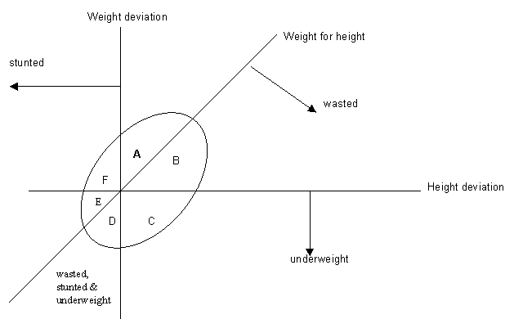

Diagram AIII.1 illustrates Svedberg's original model of anthropometric failure. Groups A to F represent the different combinations of anthropometric failure possible, which are summarised in Table AIII.1.

Table AIII.1 - Groups of anthropometric failure

Groups |  | Wasted | Stunted | Underweight
A | No failure | No | No | No
B | Wasted only | Yes | No | No
C | Wasted & Underweight | Yes | No | Yes
D | Wasted, Stunted & Underweight | Yes | Yes | Yes
E | Stunted & Underweight | No | Yes | Yes
F | Stunted only | No | Yes | No
Y | Underweight only | No | No | Yes

Children in group A have acceptable heights and weights and thus do not suffer from anthropometric failure - i.e. they are not stunted, wasted or underweight. Children in group B are wasted, although not stunted or underweight; those in group C are wasted and underweight but not stunted; those in group D are simultaneously wasted, stunted and underweight; those in group E are stunted and underweight, but not wasted and those in group F are only stunted. An additional group, Y, was revealed when the index was constructed, and these are children who are underweight only, but who are not stunted or wasted. This last group was missed by Svedberg's original model. The modified model is presented in Diagram AIII.2.

Diagram AIII.2 - Modification of Svedberg's Model

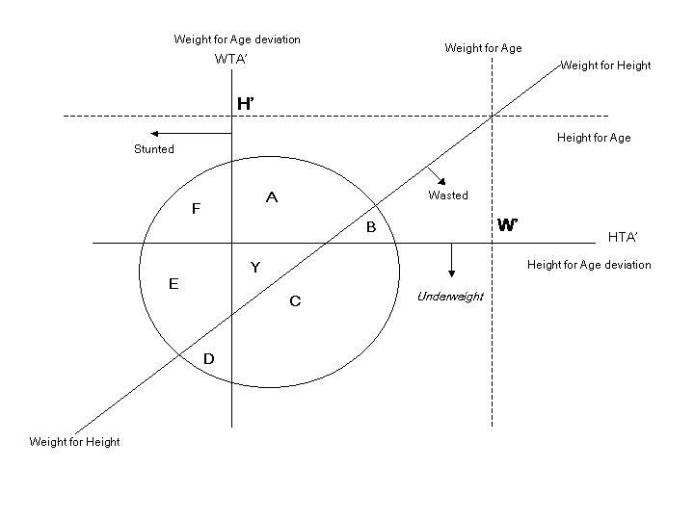

Svedberg argued that, if children who are stunted, wasted or underweight (i.e. groups B to F) are all considered to have anthropometric failure, then the only true estimate of overall anthropometric failure could be measured by the sum of areas B, C, D, E, F and Y. Thus, the CIAF includes all children in groups B to Y.

Showing distinct groups of anthropometric failure in this way can, in addition, show which groups (or what proportions of children) are missed by existing estimates based on the standard underweight and stunting measures. Tables AIII.2 and AIII.3 and Diagram AIII.3 provide an example.

Table AIII.2: Anthropometric failure at mild/moderate and severe levels in Indian children 0-2 years old (N=24,396)

 | Number of children | % children
Mild to moderate
Stunting | 11,024 | 45.2
Wasting | 3,904 | 15.9
Underweight | 11,493 | 47.1
Combined anthropometric failure | 14,590 | 59.8
Severe
Stunting | 5,557 | 22.8
Wasting | 716 | 2.9
Underweight | 4,366 | 17.9
Combined anthropometric failure | 7,105 | 29.1

The data in Table AIII.2 show rates of wasting, stunting and underweight at mild/moderate (i.e. below -2 standard deviations) and severe (i.e. below -3 standard deviations) levels. Also presented are the results of the new measure of combined anthropometric failure. As can be seen in Table AIII.2, the three standard anthropometric indices show quite different levels of anthropometric failure. Each, however, is considerably lower than the combined anthropometric failure figure. This is true at both mild/moderate and severe levels. Groups of anthropometric failure produced during the construction of the CIAF are shown below, at both mild/moderate and severe levels.

Table AIII.3: Groups of anthropometric failure at mild/moderate and severe levels (N=24,396)

Mild to Moderate | Number of children | % of children
Group A - No failure | 9,806 | 40.2
Group B - Wasted only | 630 | 2.6
Group C - Wasted & Underweight | 1,489 | 6.1
Group D - Wasted, Stunted & Underweight | 1,756 | 7.2
Group E - Stunted & Underweight | 6,801 | 27.9
Group F - Stunted only | 2,467 | 10.1
Group Y - Underweight only | 1,447 | 5.9
Total | 24,396 | 100.0

Severe | Number of children | % of children
Group A - No failure* | 1,7291 | 70.9
Group B - Wasted only | 256 | 1.0
Group C - Wasted & Underweight | 324 | 1.3
Group D - Wasted, Stunted & Underweight | 132 | 0.5
Group E - Stunted & Underweight | 2,941 | 12.1
Group F - Stunted only | 2,484 | 10.2
Group Y - Underweight only | 968 | 4.0
Total | 24,396 | 100

* Includes children with anthropometric failure at mild to moderate level.

Data from Table AIII.3 are illustrated in Diagram AIII.3 which shows which groups are missed by the commonly used anthropometric measures. The underweight (low weight for age) measure includes children in groups C, D, E and Y but misses those in groups B, and F. This means that, at the mild/moderate level, 12.7 % of children with anthropometric failure (i.e. those who are stunted only and wasted only) are missed. At the severe level, 11.2% of children suffering from anthropometric failure are missed. The stunting (low height for age) measure includes children in groups D, E and F but misses those in groups B, C and Y - i.e. 14.6% of children at the mild/moderate level, and 6.3% at the severe level. The wasting measure (low weight for height) misses the greatest proportion of children - those in groups E, F and Y, a total of 43.9% at the mild/moderate level and 26.3% at the severe level.

Diagram AIII.3: Groups of anthropometric failure

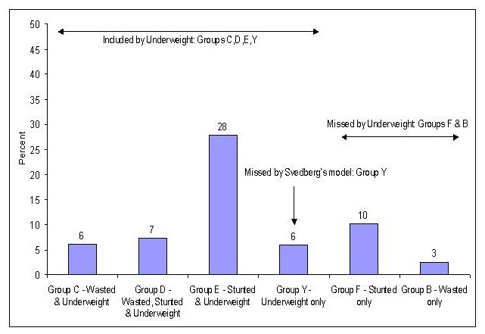

Extrapolations of anthropometric failure data
In the DHS, anthropometric data were collected for children 0-2 or 0-4, depending on the country. Overall rates of severe anthropometric failure were calculated, and results broken down by age, gender and place of residence (i.e. urban/rural).

When data were broken down by age (in years), it was observed that between 0-1 years, anthropometric failure (at both moderate and severe levels) was significantly lower than in years 2-4, which affected the overall figure. This meant those states that collected data only on children 0-2 years appeared to have lower rates compared to states with data on children 0-4. To adjust for this effect, data were extrapolated for years 3-4 in those states that only collected data on 0-2 year olds, by repeating the prevalence rate at age 2 for years 3 and 4.

This was done because, in those states where data were collected for years 3 and 4, a levelling of the anthropometric failure rate was observed after age 2 and 3. Diagrams AIII.5 and AIII.6 below illustrate the pattern of anthropometric failure by age (in months) for two states, Pakistan and Ethiopia.
Diagram AIII.5: Pattern of anthropometric failure in Pakistan, children 0-59 months

Diagram AIII.6: Pattern of anthropometric failure in Ethiopia, children 0-59 months

It is important to extrapolate beyond age 2 (in those countries where data are not collected), because gender differences only really begin to present themselves at this point. In most states, girls tend to have lower rates of anthropometric failure in years 0, 1 and 2 than boys. However, in years 3 and 4 the gap narrows and, in some states, (particularly in South Asia) girls start to have higher rates of anthropometric failure. The reasons for this have been widely discussed in the literature.

Table AIII.4 shows how extrapolations were made for countries in South Asia. Extrapolated data are italicised. The 'DHS total' figure is the original overall rate from the DHS data (i.e. based on children 0-2 or 0-4 years). The 'Adjusted total' is calculated from the AF prevalence rate for each year, extrapolating the data from year 2 to years 3 and 4 where necessary, and then taking an average.

Table AIII.4: Extrapolations of anthropometric failure data by age, South Asia (%)

 | Age in years |  |  |  |  | DHS total | Adjusted total
State | 0 | 1 | 2 | 3 | 4 | DHS total | Adjusted total
Bangladesh | 12.6 | 37.7 | 35.4 | 33.4 | 32.9 | 30.2
India | 9.6 | 30.2 | 30.6 | 30.6 | 30.6 | 23.2 | 26.3
Nepal | 7.3 | 30.6 | 33.0 | 33.0 | 33.0 | 23.6 | 27.4
Pakistan | 9.3 | 24.8 | 28.3 | 29.1 | 26.1 | 22.9

Had the DHS total been used for India and Nepal, the two states which only collected data on children 0-2 years, then countries like Nepal and Pakistan would have appeared to have had relatively higher rates of anthropometric failure, since their DHS totals include the higher rates observed in ages 3 and 4. It is for this reason that anthropometric failure rates were extrapolated for those states which did not collect data on children over two years old.

Extrapolating anthropometric failure rates for older children
Due to the lack of studies on anthropometric failure in older children, there are no reliable estimates of for children over the age of 5. Staff at the WHO Global Database on Child Growth and Malnutrition have confirmed that prevalence rates of stunting, wasting and underweight (i.e. anthropometric failure) are not the same across different age groups (i.e. from pre-school age to adolescence), and there are a number of studies which show this. A long-term study of the heights of first grade students (for ages 6 to 9) in Latin American and Caribbean countries, found that rates of stunting persist in older children, as Table AIII.5 shows. Thus, in households where children under 5 experience severe anthropometric failure, it is likely that older children will also be affected.

Table AIII.5: Stunting in 1st Grade schoolchildren in Latin America and the Caribbean

State | Year | Number of children | Stunting prevalence (%) by age in years
State | Year | Number of children | 6 | 7 | 8 |  | 9 | Total
Costa Rica | 1997 | 85,786 | 4.6 | 6.4 | 13.5 | 23.2 |  | 7.5
Belize | 1996 | 22,426 | 15.8 | 15.7 | 14.7 | 15.4 |  | 15.4
Mexico | 1993 | 2,589,577 | 13.1 | 19.6 | 32.7 | 40.3 |  | 18.4
Dominican Republic | 1995 | 188,091 | 12.1 | 18.6 | 24.0 | 30.9 |  | 19.0
Nicaragua | 1986 | 100,265 | 16.5 | 23.3 | 28.9 | 37.2 |  | 23.9
Panama | 1994 | 59,921 | 17.0 | 24.0 | 41.0 | 51.0 |  | 23.9
El Salvador | 1988 | 120,457 | 20.5 | 25.9 | 32.7 | 37.8 |  | 29.8
Honduras | 1997 | 234,111 | 17.0 | 28.0 | 43.0 | 51.0 |  | 40.6
Guatemala | 1986 | 205,959 | 35.0 | 43.6 | 56.5 | 67.2 |  | 50.6
Source: ACC/SCN (2000).

Similar rates and patterns in older children (i.e. over age five) have been reported in other regions (Partnership for Child Development, 1998).

There are studies that look at the risk of undernutrition in older children. The International Centre for Research on Women (ICRW) studied the heights of adolescent girls, and concluded that the Height for Age measure (in children who were already stunted) did not improve during the eight years of adolescence (Kurz and Johnson-Welch, 1994). Another study (Sellen, 2000) looked at the anthropometric status of children aged 0-18 years in an African pastoral community and noted that the risk of undernutrition was not uniformly distributed within the child population. It noted that "comparison of cross-sectional mean anthropometric scores suggested that children over 5 years, girls 5-8 years, boys 9-12 years and teenagers were found to be at highest risk of undernutrition as assessed by various indicators".

While the WHO is collecting data for development of an international reference population, data will only be available for young children (i.e. under 5). To assess properly the extent of anthropometric failure in all children in the developing world, data need to be collected on older children, ideally up to 18 years of age. Until that is done, the only estimates than can be made are of children under 5.

The combined index of anthropometric failure used in the report allows for more comprehensive and accurate estimates, and shows that the extent of anthropometric failure among children under 5 in the developing world is considerably higher than is currently thought.
Appendix IV: Severe Deprivation and Absolute Poverty of Children: Country Data

State | Child (<18) Population ('000s) in 2000 | % Water Deprived | % Sanitation Deprived | % Shelter Deprived | % Information Deprived | % Education Deprived | % Food Deprived | % Health Deprived | % Severely Deprived | % in Absolute Poverty | % Urban Children in Absolute Poverty | % Rural Children in Absolute Poverty
Bolivia | 3,830 | 14.8 | 37.1 | 43.9 | 13.1 | 1.3 | 9.2 | 9.5 | 58.9 | 32.9 | 11.7 | 64.9
Brazil | 59,515 | .. | 15.0 | 11.8 | 8.3 | 2.4 | 2.7 | 5.5 | 25.3 | 10.0 | 4.3 | 27.7
Colombia | 16,302 | 9.1 | 11.0 | 11.9 | 4.0 | 2.0 | 3.0 | 5.8 | 24.4 | 10.5 | 2.0 | 28.5
Dominican Republic | 3,359 | 23.0 | 11.1 | 17.1 | 8.1 | 4.2 | 2.9 | 3.4 | 40.7 | 15.2 | 4.3 | 30.2
Guatemala | 5,764 | 12.3 | 15.9 | 58.7 | 14.4 | 11.4 | 19.3 | 8.0 | 63.8 | 33.7 | 16.6 | 44.1
Haiti | 3,915 | 42.6 | 44.9 | 49.8 | 41.6 | 18.2 | 16.2 | 25.5 | 74.6 | 56.6 | 15.8 | 77.7
Nicaragua | 2,533 | 12.0 | 16.9 | 62.6 | 15.6 | 11.0 | 8.8 | 3.2 | 67.2 | 30.8 | 11.9 | 54.4
Peru | 10,198 | 22.9 | 25.6 | 56.1 | 7.9 | 0.9 | 7.4 | 5.7 | 62.0 | 35.4 | 11.9 | 66.2
Egypt | 28,663 | 8.3 | 6.2 | 41.9 | 27.6 | 11.3 | 14.0 | 8.0 | 56.7 | 26.6 | 8.5 | 38.9
Morocco | 12,302 | 37.1 | 43.5 | 40.7 | 14.4 | 34.6 | 9.0 | 10.3 | 64.0 | 47.0 | 7.2 | 72.3
Yemen | 10,295 | 49.8 | 58.9 | 59.1 | 19.0 | 36.3 | 6.5 | 45.6 | 86.6 | 67.6 | 17.8 | 78.5
Cambodia | 6,832 | 59.1 | 80.8 | 8.6 | 37.6 | 17.3 | 12.1 | 29.2 | 91.8 | 70.8 | 8.0 | 92.0
China | 378,939 | 3.7 | 1.7 | 3.0 | 3.3 | 0.3 | 4.5 | 0.3 | 13.1 | 1.6 | 1.8 | 1.5
Indonesia | 78,233 | 24.0 | 15.6 | 21.7 | 21.1 | 2.6 | .. | 9.8 | 51.2 | 19.8 | 5.3 | 27.3
Philippines | 33,835 | 18.7 | 15.6 | 23.9 | 11.9 | 2.7 | .. | 11.2 | 46.7 | 19.8 | 7.5 | 30.2
Bangladesh | 62,494 | 2.5 | 24.6 | 89.7 | 47.4 | 19.7 | 30.2 | 16.5 | 92.5 | 62.4 | 24.9 | 66.6
India | 399,798 | 19.4 | 68.3 | 36.8 | 38.3 | 15.6 | 26.3 | 21.4 | 79.9 | 57.2 | 21.2 | 68.4
Nepal | 10,921 | 37.0 | 85.1 | 93.9 | 41.6 | 28.7 | 27.4 | 32.6 | 98.3 | 90.3 | 52.5 | 93.2
Pakistan | 68,231 | 19.5 | 51.0 | 46.7 | 45.3 | 38.4 | 22.9 | 33.5 | 83.0 | 61.0 | 25.0 | 77.1
Benin | 3,360 | 29.2 | 74.5 | 49.7 | 65.7 | 47.7 | 13.0 | 19.1 | 92.6 | 74.7 | 48.0 | 89.4
Burkina Faso | 6,457 | 46.6 | 78.2 | 75.8 | 48.9 | 67.6 | 16.4 | 18.8 | 93.4 | 84.0 | 18.6 | 93.0
Cameroon | 7,453 | 53.1 | 10.3 | 57.9 | 29.7 | 16.4 | 12.3 | 20.0 | 77.4 | 54.3 | 17.3 | 70.6
Central African Republic | 1,844 | 51.9 | 24.0 | 80.7 | 30.7 | 30.7 | 18.9 | 24.2 | 88.9 | 65.4 | 39.2 | 85.6
Chad | 4,172 | 55.2 | 72.1 | 95.9 | 54.0 | 59.1 | 23.3 | 51.2 | 97.3 | 88.2 | 54.5 | 97.7
Comoros | 355 | 51.8 | 0.3 | 55.3 | 42.8 | 35.4 | 14.1 | 13.6 | 87.5 | 56.5 | 33.0 | 64.8
Côte d'Ivoire | 7,943 | 21.1 | 42.2 | 30.2 | 37.3 | 40.7 | 13.0 | 26.4 | 72.0 | 47.3 | 13.7 | 66.4
Ethiopia | 32,456 | 74.9 | 83.9 | 95.1 | 56.5 | 61.1 | 28.5 | 32.3 | 97.8 | 94.0 | 58.6 | 99.2
Ghana | 9,303 | 50.8 | 25.6 | 29.1 | 37.4 | 14.8 | 10.8 | 10.3 | 77.7 | 47.0 | 18.7 | 58.1
Guinea | 4,145 | 44.4 | 43.5 | 57.0 | 48.1 | 55.7 | 8.9 | 25.9 | 87.9 | 71.1 | 31.5 | 86.7
Kenya | 15,705 | 63.1 | 17.1 | 74.0 | 29.3 | 6.0 | 13.6 | 41.3 | 86.8 | 65.8 | 19.8 | 73.7
Madagascar | 8,174 | 70.8 | 63.0 | 38.6 | 43.1 | 24.8 | 25.2 | 24.0 | 89.7 | 74.2 | 45.7 | 82.5
Malawi | 6,002 | 52.8 | 24.9 | 85.1 | 42.6 | 30.1 | 22.6 | 9.9 | 91.6 | 74.6 | 28.9 | 80.9
Mali | 5,980 | 18.8 | 26.7 | 79.3 | 31.3 | 67.9 | 26.2 | 33.1 | 87.2 | 63.5 | 26.8 | 77.3
Mauritania | 1,353 | 37.5 | 51.6 | 77.1 | 44.2 | 19.7 | 17.8 | 22.3 | 90.1 | 70.5 | 47.4 | 85.9
Mozambique | 9,231 | 56.7 | 59.7 | 74.7 | 45.6 | 28.0 | 17.9 | 29.1 | 89.7 | 76.3 | 37.8 | 87.5
Namibia | 884 | 46.2 | 67.6 | 71.9 | 19.0 | 6.6 | 8.9 | 9.4 | 80.9 | 69.8 | 12.3 | 89.8
Niger | 6,123 | 37.1 | 79.8 | 85.3 | 42.8 | 69.2 | 30.0 | 46.3 | 91.8 | 85.2 | 31.9 | 97.4
Nigeria | 59,108 | 44.0 | 26.0 | 45.1 | 35.4 | 22.1 | 16.0 | 39.7 | 78.8 | 52.6 | 22.1 | 64.5
Rwanda | 3,941 | 88.7 | 5.8 | 89.2 | 39.4 | 23.9 | 20.5 | 9.2 | 97.3 | 86.9 | 39.2 | 89.3
Senegal | 4,804 | 23.1 | 33.3 | 45.8 | 22.4 | .. | .. | .. | 63.1 | 39.4 | 9.0 | 55.9
South Africa | 17,589 | 28.5 | 16.2 | 25.8 | 12.9 | 2.1 | .. | 3.5 | 45.5 | 24.3 | 3.9 | 42.2
Tanzania | 18,258 | 67.0 | 13.3 | 83.2 | 49.8 | 34.9 | 18.3 | 20.4 | 91.9 | 78.1 | 36.1 | 88.5
Togo | 2,310 | 31.4 | 66.9 | 33.3 | 45.5 | 21.1 | 12.0 | 19.4 | 83.5 | 61.9 | 23.4 | 73.0
Uganda | 13,062 | 87.2 | 16.8 | 87.7 | 38.6 | 17.0 | 16.6 | 22.0 | 96.7 | 85.4 | 39.7 | 91.1
Zambia | 5,571 | 45.8 | 26.9 | 59.8 | 34.2 | 20.1 | 18.1 | 7.3 | 75.6 | 56.8 | 17.9 | 81.9
Zimbabwe | 6,645 | 41.5 | 31.9 | 34.8 | 31.1 | 5.2 | 9.7 | 11.9 | 66.7 | 45.3 | 1.0 | 60.8
Note: Percentages for Health and Food Deprivation are for the population aged under 5 and for Education Deprivation it is for the population aged 7 to 18.

In 2000, an exhaustive and exacting end-of-decade review of progress towards the Summit goals was undertaken, drawing on a range of sources not previously available, from data collected in the Multiple Indicator Cluster Surveys (MICS), the Demographic and Health Surveys (DHS) and national progress reports from nearly 150 countries (UNICEF, 2002c).
For extended discussion, see Townsend and Gordon (2002, pp62-3 and pp356-364.
The tendency to define poverty differently for industrialised and ‘developing’ countries is entrenched in the practice of international agencies like the World Bank, UNDP and OECD and of individual governments. This obstructs reasoned identification of both the distribution of the problem and priorities for policy.
The problem was understood long ago. “No concept of income can be really equitable that stops short of the comprehensive definition which embraces all receipts which increase an individual’s command over the use of society’s scarce resources – in other words his ‘net accretion of economic power between two points of time.’” Memorandum of dissent by a minority of the Royal Commission on Taxation, Report of the Royal Commission on Taxation, Cmnd. 9474, 1955, p8.
See, in particular, Van Genugten and Perez-Bustillo (2001) and Jochnick (2001).
The chapter in the report from which this quotation is taken is attributed to the Nobel Prize winner, Amartya Sen.
A human rights approach to poverty reduction has been argued by other recent commentators. In a report prepared for the UN Office of the High Commissioner for Human Rights, poverty reduction strategies were formulated and explained in relation to specific rights (see Hunt et al (2002).
See the proposed international child allowance, Townsend and Gordon (2002) pp368 and 425-426.
This is a view supported by Mary Robinson, when UN High Commissioner for Human Rights, in a speech to the World Summit 2002 in Johannesburg: “a human rights approach adds value because it provides a normative framework of obligations that has the legal power to render governments accountable”. (Robinson, 29/8/02)
An approach shared by others, such as Ennew and Miljeteig (1996, p222) who have recognised the need for clusters of indicators to capture the range of rights covered in complex articles.
These include: i) Non discrimination (Article 2); ii) Best interests of the child (Article 3); (iii) The right to life, survival and development; (iv) Respect for the views of the child (Article 12).
This approach is similar to that adopted by UNICEF from the ‘Indicators for global monitoring of child rights’ conference held in Geneva (UNICEF, 1998a) in that we have sought to collect indicators of child rights clusters.
The purpose of Table 2.1 is to demonstrate the diverse nature of the Convention and how rights can be clustered (with illustrations of indicators of compliance or fulfilment). Table 2.2 below develops this by specifying those rights which can be measured in relation to material and social deprivation and, hence, poverty.
Data is given for regions. Source: http://www.ilo.org/public/english/standards/decl/download/global3/part1chapter2.pdf
Data coverage of nations is incomplete.
Data coverage of nations is incomplete. Source: http://www.rb.se:8082/www/childwar.nsf/HTML/Forsta?OpenDocument
Ennew and Miljeteig (1996, p221) note that one of the difficulties with developing indicators of child rights is the fact that children are only studied in ‘respect to the institutions of childhood, such as school and families’, which neglects, for instance, their exploitation economically and sexually.
The WHO and UNICEF estimate that a lack of safe drinking water and inadequate hygiene cause over three million child deaths in developing countries (UNICEF, 2000a) - every eight seconds a child dies of a water-related disease.
Previous estimates of the number of people who were water deprived used the term ‘access to safe water’. The 2000 GWSSA uses the term ‘improved water supplies’ since the data on the quality of water provided by countries was not considered reliable.
An article in New Scientist described how, in a poor settlement in Nairobi, people had resorted to using plastic bags for the disposal of faeces. One of the main problems however, was when they came to dispose of the bags - by throwing them out of windows – ‘flying toilets’ (New Scientist, 2002a). This is somewhat reminiscent of the way bedpans were emptied into the street in 18th Century Europe.
The effects of measles are particularly debilitating. When it does not kill, it may cause blindness, malnutrition, deafness or pneumonia. An infected child requires close attention (due to the contagiousness of the disease) and can miss many days or weeks of schooling until recovered.
In China’s Health and Nutrition Survey, access to information is recorded for each child not just for the adults. Results for China are more direct measures than for the other countries in this study which use adult information access as a proxy measure for children’s access.
Data concerning sanitation collected by UNICEF and the WHO under the Joint Monitoring Programme refer to 'improved' sanitation facilities (connections to public sewers or septic systems, simple and ventilated improved pit latrines, and pour/flush latrines). ‘Not improved’ facilities include public or shared latrines, open pit latrines and bucket latrines.
The Education For All 2000 Assessment – Statistical Document released for the World Education Forum in Dakar, Senegal, April 2000 showed that 82% of primary-school-age children were enrolled in and/or attended school. However, 120 million primary-school-age children were not in school.
The authors know of no previous attempts to measure information deprivation amongst children.
Similar numbers of children live in India and China but there are many more households with children in China than in India.
Approximately 530 million rural children suffer from severe shelter deprivation compared with 85 million urban children; 515 million rural children suffer from severe sanitation deprivation compared with 50 million urban children; 335 million rural children suffer from severe water deprivation compared with 40 million urban children – see Chapter 4 for details.
One NGO running such schemes is Gramalaya. Based in Tamil Nadu in India, the scheme came about after consultation with the local community. Facilities are constructed adjacent to community toilets. Water with soap is provided for hand washing after defecation. A caretaker from the community toilet teaches hand washing and its importance to the children and observes children’s hygiene behaviours. Facilities are provided free to children. (http://gramalaya.org/childtoilets.html)
Developing Countries Farm Radio Network is a Canadian-based, not-for-profit organisation working in partnership with approximately 500 radio broadcasters in over 70 countries to fight poverty and food insecurity. It supports broadcasters in meeting the needs of local small-scale farmers and their families in rural communities and helps broadcasters build the skills to develop content that responds to local needs. (http://www.farmradio.org/)
AMARC is an international NGO serving the community radio movement, with almost 3 000 members and associates in 106 countries. Its goal is to support and contribute to the development of community and participatory radio along the principals of solidarity and international cooperation (http://www.amarc.org/amarc/ang/).
www.radiorobinhood.fi/communityradios/artciles

