© Paul Rae, 2003, School of Arts, Middlesex University

Re:invention — On the Limits of Reflexive Practice.

I want to acknowledge the contributions of Chua Enlai, Norlina Mohamed, Ben Slater, Ruth Stroude, Tan Ngiap Heng and Kaylene Tan, whose work features in this presentation.

It begins soberly enough. This is the plan for the first rehearsal of Various Gangsters, a devised performance directed by me, and staged in Singapore a year ago.
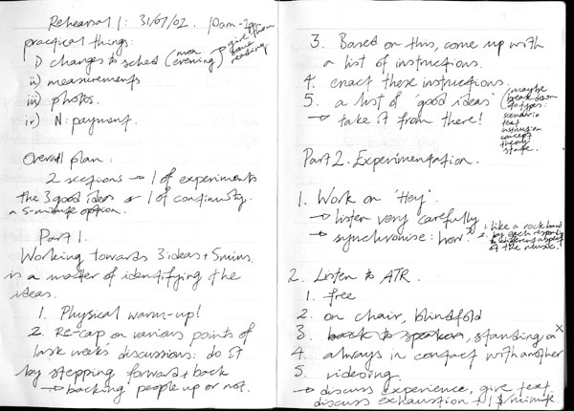

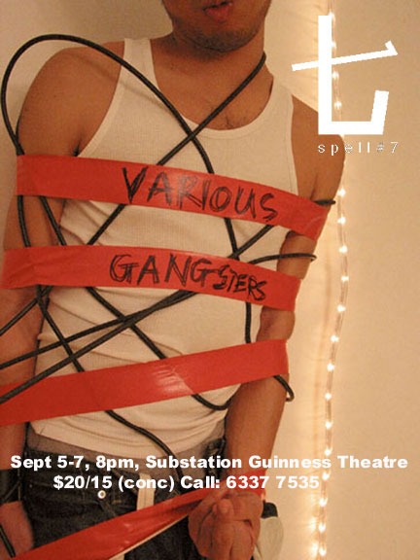
It includes the date and time, instructions, annotations, and on the next page, notes taken during the rehearsal, and brief post-rehearsal reflections. Various Gangsters was the 11th production made by spell#7, a company I co-founded in 1997. Since 2000, I have been pursuing a Ph.D. whose aim is to articulate what I rather grandly call a cosmopolitan aesthetics of contemporary performance, a way of addressing theatre within the context of globalization. Such a potentially vast topic needs an anchor, and for me it has been the experience of making and watching theatre in the highly globalized postcolonial society that is Singapore. I made an early decision that the work itself would not be subject to examination, since I was less interested in its status as a research outcome than as an artistic event marketed to and engaged with by fee-paying strangers. However, the demands such an end makes on its means is of great interest to me, and it is this that is reflected on, alongside performance analyses and theoretical discussion, in my written thesis.

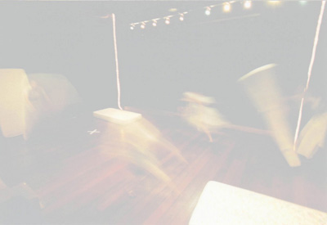

The phrase ‘the demands such an end makes on its means’ seems innocent enough, but it is a methodological minefield. It means that all the advance hypothesizing and pre-planning of Practitioner-Based Enquiry or Visual Ethnography, say, threatens to prejudice the research outcomes in ways that are inconsistent with the creative dynamic under investigation. It was in a spirit of remaining open to the emergent conditions of the work, therefore, that my rehearsal plan of 31st July 2002 initiated a twofold investigation: into the making of the show as a director, and the making of the making of the show as a researcher. And while I might conceivably be had up before the editorial board of Theory, Culture and Society for crimes against social science, I maintain that such a doubling is not so very great a sin in the research of artistic processes, as long as one remains alive to the contingent and contentious nature of one’s position.

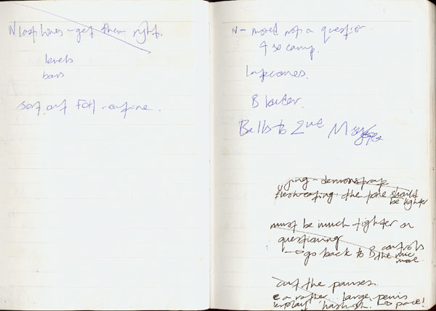
This, however, is easier said than done.

Cut to a few days before opening night, and the rehearsal diary tells a very different story. Exactly what story, I don’t know, not only because the writing is illegible, but because half the page has been torn out completely: a more literal rending of my research aspirations would be hard to find. But let’s not get carried away. The Jekyll and Hyde scenario is a trite cliché, and it’s not hard to work out what happened. There I am, in the auditorium, watching a run, taking notes. I’m watching, I’m writing, I’m watching, I’m writing, and then I’m doing both, and then I’m doing neither, because there is no distinction between them. ‘Page and stage’ is already a binary too far. Instead, there is absolute contiguity between the two surfaces, across which I’m occupying some sort of directorial consciousness that admits of no other, and is impervious to whether it responds in writing or thought, boredom or stimulation, cringe or grin, all jumbled up as they are in the blank but invigorating rush of theatrical affect. I don’t remember why I ripped the page, but I assume the action was benign (such as to write a note to the stage manager) rather than terrible: I don’t do tantrums. However, what is clear is that somewhere between the orderly, self-conscious instructions and annotations that open the diary and make it so conducive to critical reflection, and the later breakdown of any such aspirations, reflexive research became untenable. In tracing how this happened, I want to identify the limits of reflexivity in practice as research in the performing arts, and propose an alternative conceptualization of the process.

Let me say straight away that I was never so naïve as to believe that neater handwriting would make the difference between a theatre-making project and a researched theatre-making project. However, since an externally determined research methodology would have been inappropriate, I resolved to find an already integral aspect of the devising process and stretch it beyond the parameters of artistic functionality, with research interests taking up the slack.
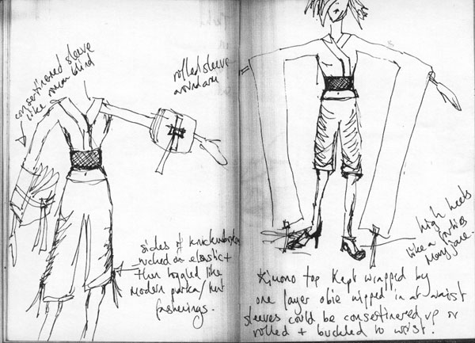
Thus it was that our England-based costume designer found herself on the receiving end of an improbably detailed series of emails that riffed on recent developments, digressed lengthily on criminality, Singaporean politics, and Deleuzean becomings and even included the odd academic citation. She wrote back with requests for inside leg measurements, which I also provided. I devoted an hour every other night to writing these despatches, which I called ‘directorial downtime’ — a secret euphemism for academic overtime.

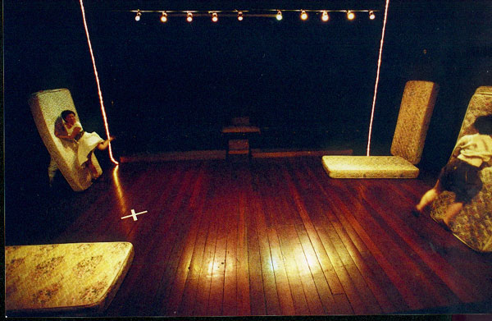
It was impossible to maintain. Long before the cast were delving into the parcel of handmade kimono-flimsy-bedwear n’ bondage-ghetto-fabulous-cheap-trash togs DHL’d from England a week before the show, I’d given up on the missives. At the time, I barely noticed, just as I was later unaware of my pen leaving the page during the run. However, going back to the last email, I am struck by this line: “The title of the show came first. So far, the process has consisted of finding out what we meant by it.” The fact that the closure of a distinct phase in the rehearsal process corresponded with the final email suggests that the emails were useful only for as long as they contributed to the overall development of the work. Contrary to my best intentions, therefore, there never was any critical reflexivity separate from the artistic process — nothing that exceeded the necessary procedures of theatre directing. Indeed, reflexive practice in the arts is a red herring, not because it doesn’t exist, but because all practice is inherently reflexive — as much as it needs to be and no more.

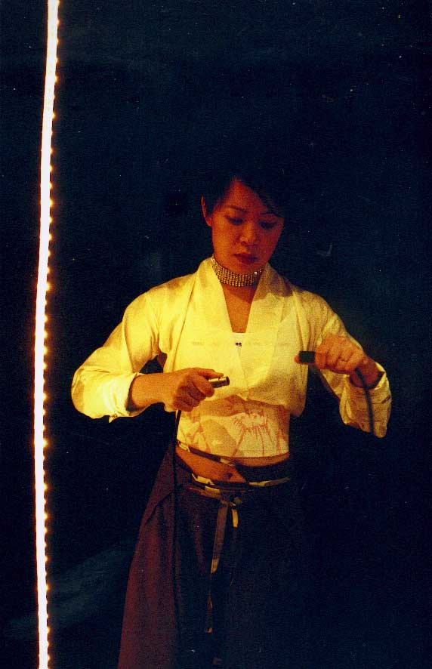
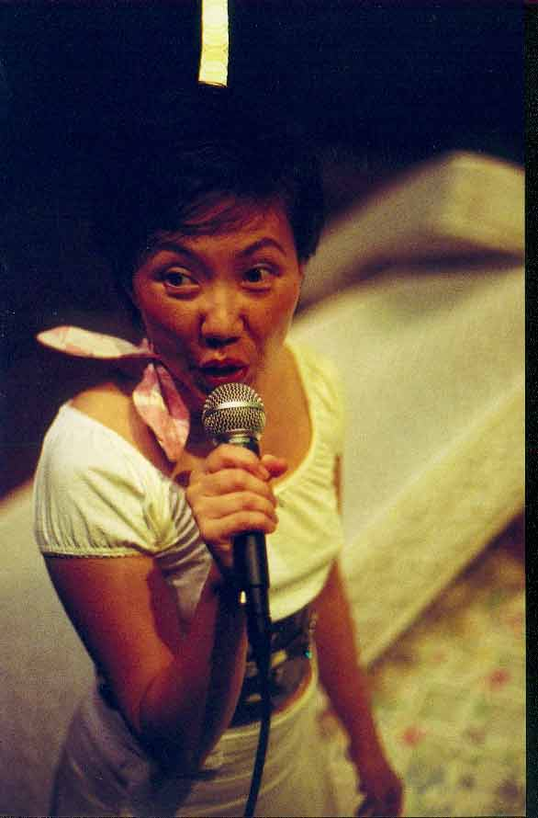
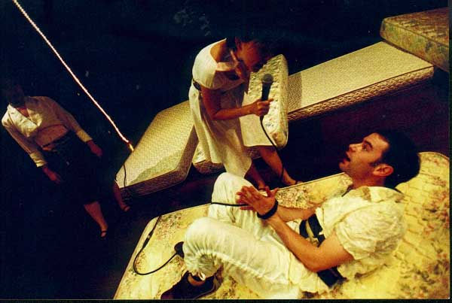
In research terms, this leaves me between a rock and a hard place. On one side, there are the social scientists, teasingly dangling their conventions of participant-observation just out of my conceptual reach. On the other, the artists with their artistic explanations, which in this context are no explanations at all, but rather strategic evasions. These tend to mystify the creative process. For example, the director Anne Castledine states in terms that foreclose critical reflection: “A director is…a visionary, someone who is not afraid to present the times as they see them….[A] child who can enable the performers to recover childhood at will and who understands the importance of play” (in Giannachi and Luckhurst 1999: 8). Or, the work itself is anthropomorphized — indeed, tetralogized: turned into a monster. Anyone who has quizzed members of Forced Entertainment on their devising processes will be familiar with the point where they stop talking about their own input, and start describing what the work demanded of them.

What is required, therefore, is a way of accounting for a paradoxically flexible — or variable — reflexivity, which at points may be entirely subsumed within an unreflexive process, but will always re-emerge; a reflexivity, that makes good both definitions of the term: as taking account of itself, and as happening without conscious thought. To this end I propose ‘Invention’, a blanket term that covers both research and artistic practice, and makes no hard and fast distinction between them, but at the same time allows for important internal differentiations. One of the reasons for this is the term’s historical richness. Hence although the OED states that the ‘chief current sense’ of ‘invent’ is ‘to create, produce or construct by original thought or ingenuity’, the term also conjours a host of related meanings less concerned with originality than its etymological roots in invenire: ‘to come upon, discover, find out, devise, contrive’ (OED). This recalls the rhetorical figure of inventio which, as Roland Barthes observes, “…refers less to an invention (of arguments) than to a discovery: it is more an ‘extractive’ notion than a ‘creative’ one” (1994 [1985]: 52). Jean-François Lyotard, too, is aware of the provenance of the term, and while his specific aim of distinguishing ‘inventive’ postmodern art from merely ‘innovative’ modernism need not detain us here, in the process he combines discovery with temporal dynamism in a particularly fruitful way. He writes:

The work [the artist] produces [is] not in principle governed by preestablished rules, and they cannot be judged according to a determining judgement, by applying familiar categories to the text or to the work. Those rules and categories are what the work of art itself is looking for. The artist and writer, then, are working without rules in order to formulate what will have been done. (1984 [1979]: 81).

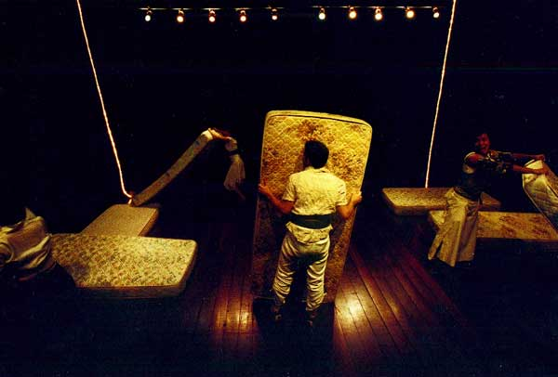
This observation is of special interest to the practitioner-researcher who is both artist and analyst, since it marks precisely the hinge where the one role folds back, sometimes imperceptibly, upon the other. Addressing ‘what will have been done’ provides a framework for understanding — if not entirely resolving — the temporal slippage inherent in my earlier phrase ‘the demands…an end makes on its means’. And while there remains a latent mysticism in Lyotard’s conceptually flaccid and overly romanticized idea of ‘working without rules’, this can be rectified without too many tears by tweaking the phrase to ‘working around or in proximity to rules’.
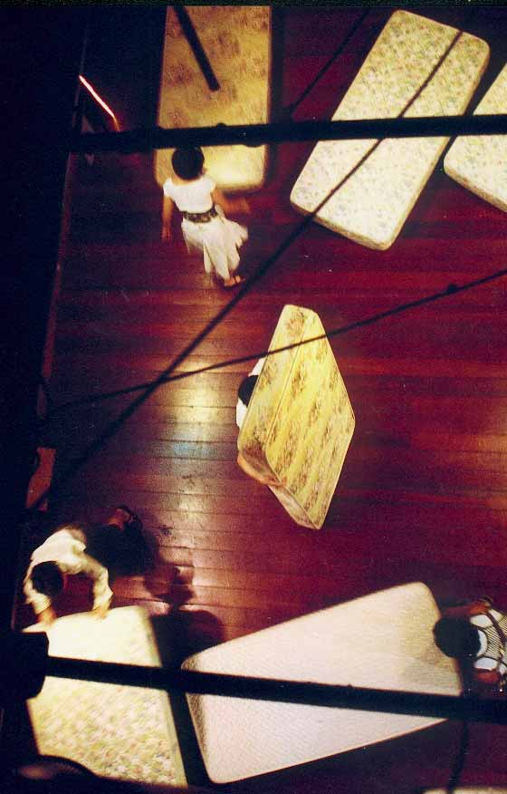
The inventive practitioner-researcher takes reflexivity as a given, to the extent that it is germane to the matter in hand, while sensing that such reflexivity will take different forms in different contexts. By understanding artistic and research practices as mutually implicated in a process of invention, one can be simultaneously invested in and led by the work as it unfolds, without ever fully relinquishing conceptual engagement (what the researcher fears), or artistically determined priorities (what the practitioner fears). This requires courage, for uncertainty is an integral part of the process. Operating across skewed temporalities, one is required to keep faith with certain features of a project even though they may pass temporarily from view, or even consciousness. However, a working sense of the future anterior — that this is the process by which I will have discovered what it was that inaugurated this research and led me to these conclusions — is predicated on accommodating anxiety as best one can, which means: never fully, but always productively.

Well and good —

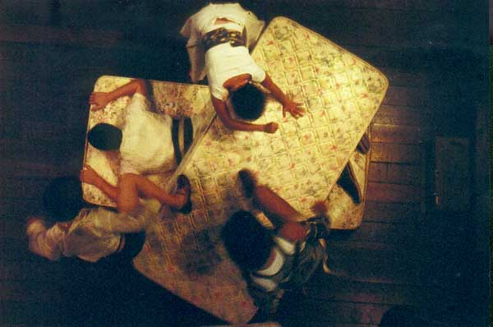

and perilously close to the most tendentious and self-validating of circular logics. The simultaneous strength and weakness of the inventive process is that it creates singularities, or as Gregory Ulmer puts it, it involves “…us[ing] the method that I am inventing while I am inventing it” (1994: 17). The danger is getting tied up in blunt misrecognitions of the sort Johannes Birringer rails against when he states: “When theory identifies itself as artistic, having abandoned a separate category of ‘art’, it often tends to be uninteresting, intellectually arcane, inorganic/simulative [and] baroquely quotational” (2000: 19). In response, I would simply state that singularities do not absolve one from the admittedly subjective virtues of critical incisiveness and stylistic moderation, and it is at this level, for all the attendant difficulties in examination and assessment, that the difference is to be found between inventive differentiations, and crass colonizations of one mode of practice by another. There is no reason for the outcome of an invention to be any less precisely focussed than the best artwork and conventional academic analysis.

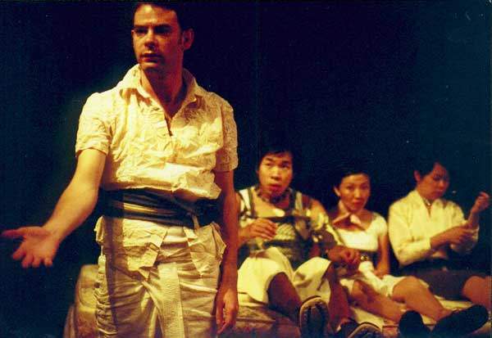

By rights, therefore, I should wind up with an example from Various Gangsters, but to be honest, this presentation is as far as I’ve got with it. Instead, let me finish with an

exemplar.

“For the artist, drawing is discovery”. So begins ‘Drawing’, an essay by the novelist and art writer John Berger, written at the age of 27 in 1953 (2001a: 10). In an essay on Van Gogh almost half a century later, Berger remains captivated by this insight: “He is loved, I said to myself in front of the drawing of olive trees, because for him the act of drawing or painting was a way of discovering and demonstrating why he loved so intensely what he was looking at…Everything his eye sees, he fingers” (2001b: 87-8, 91). Berger’s fifty-year span of writing on drawing represents a process of discovery about discovery, which makes it an exemplary case of invention in the sense that I have already outlined, a sense that means: to discover.

Berger’s invention is twofold. In his writing, he re-enacts the discovery of drawing, without ever betraying the specificity of the written word. Given the range of visual experimentation he has explored in other books on painting and photography, such a commitment is not to be taken lightly, and his writing thrives at the limits of its constraints. On Van Gogh: “…his drawings resemble a kind of writing, and he often drew on his own letters. The ideal project would be to draw the process of his drawing, to borrow his drawing hand. Nevertheless I will try with words” (2001b: 87). Then later, on Van Gogh’s love for what he looked at:

Words, words. How is it visible in his practice? Return to the drawing….What do we see? Thyme, other shrubs, limestone rocks, olive trees on a hillside, in the distance a plain, in the sky birds. He dips the pen into brown ink, watches and marks the paper. The gestures come from his hand, his wrist, arm, shoulder, perhaps even the muscles in his neck, yet the strokes he makes on the paper are following currents of energy which are not physically his and which only become visible when he draws them. Currents of energy? The energy of a tree’s growth, of a plant’s search for light, of a branch’s need for accommodation with its neighbouring branches, of the roots of thistles and shrubs, of the weight of rocks lodged on a slope, of the sunlight, of the attraction of the shade for whatever is alive and suffers from the heat, of the Mistral from the north which has fashioned the rock strata. My list is arbitrary; what is not arbitrary is the pattern his strokes make on the paper. The pattern is like a fingerprint. Whose? (2000b: 89).

Whose indeed. Berger’s words do for the reader what the drawing does for him and what, to his mind, the process of drawing did for Van Gogh. These are and are not the same. “The drawn image contains the experience of looking” he wrote in 1976 (2001a: 421), and the act and form of writing can never match this. Yet Berger’s writing on drawing is one of discovery because it has a performative quality that exceeds its own act and form. In this, one senses the second aspect of Berger’s invention, which is that he, himself, draws.

Where he infers the actions of painters, backforming them from the strokes on the canvas, he intuits the process of drawing from his own experience, “as if”, to cite him on the act of drawing a nude, “my nervous system inhabited his body” (2001a: 13). The description of Van Gogh’s gestures echo his own; indeed, his basic insight, that “to draw is to look, examining the structure of appearances” (2001a: 422) could only emerge from practice, and only develop through its continuation, through its on-going discovery. “Real drawing” he wrote in 1996 “is a constant question, is a clumsiness, which is often a form of hospitality towards what is being drawn. And, such hospitality once offered, the collaboration may sometimes begin” (2001b: 75).
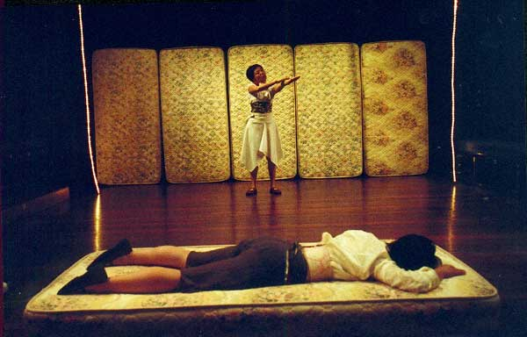
Real drawing? But I thought we were talking about performance! That, too. All the specificities of Berger’s invention — his skill as a novelist, his political tenacity, his focus on the fine arts, his non-academic status — do not compromise for one moment either his insights or his exemplarity. Quite simply, the terms he uses — practice, discovery, collaboration, pattern, gesture, energy — and the themes he investigates — process, embodiment, identification, performativity, love — are as pertinent to the researcher of performance as anybody else. Moreover, the condition of exemplarity, unlike that of the paradigm, is multiple. You will note in my abstract the rather rash promise to also discuss Don DeLillo’s recent book The Body Artist, which achieves distinction, laudable or laughable depending on your tastes, but indisputably rare, as a work of fiction that takes performance art seriously. Either because or in spite of the fact that it reads like the novelization of the film of the collected works of Herbert Blau, it provides another narrative of discovery about discovery that is clearly operating in a very different register from Berger’s, but is no less illuminating in the current context. A further example, which nods to the geographical provenance of the show that kick-started this presentation, is a remarkable project by the Singaporean artist Zai Kuning, whose film-making and performative screenings documenting his attempts at interaction with the Orang Laut, or Sea Gypies, of the Riau Archipelago in Indonesia, offer a multi-modal corrective to the scriptural form I have prioritized here. In their own very distinctive ways, both DeLillo’s and Kuning’s work echo Berger’s concern with hospitality as the condition of collaboration, not only with other people, but with the myriad slow events that make up the world. Upon which provocative but inconclusive note, and given that the outcome of the process initiated on 31st July 2002, while in plain view, remains temporarily hidden to me, the logic of the future anterior demands that I do not end

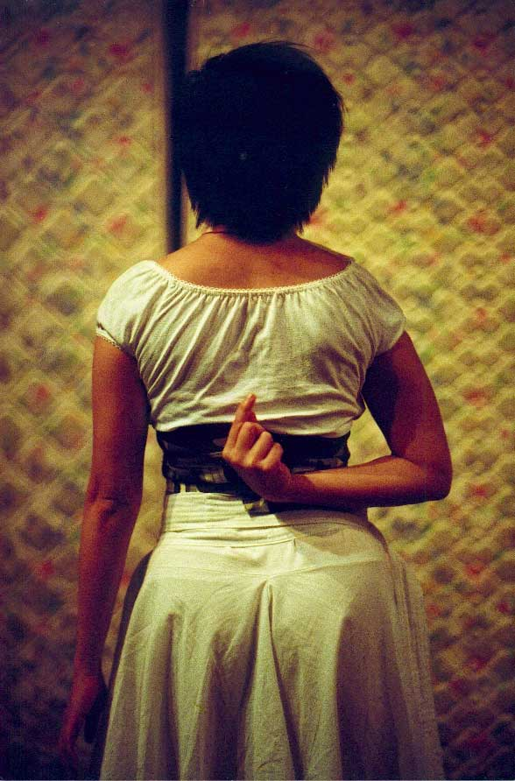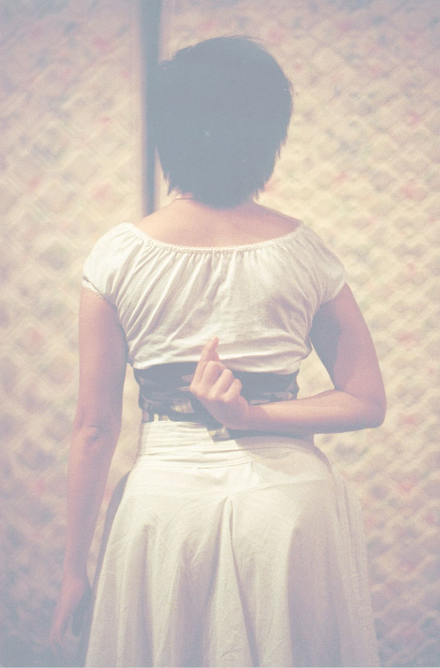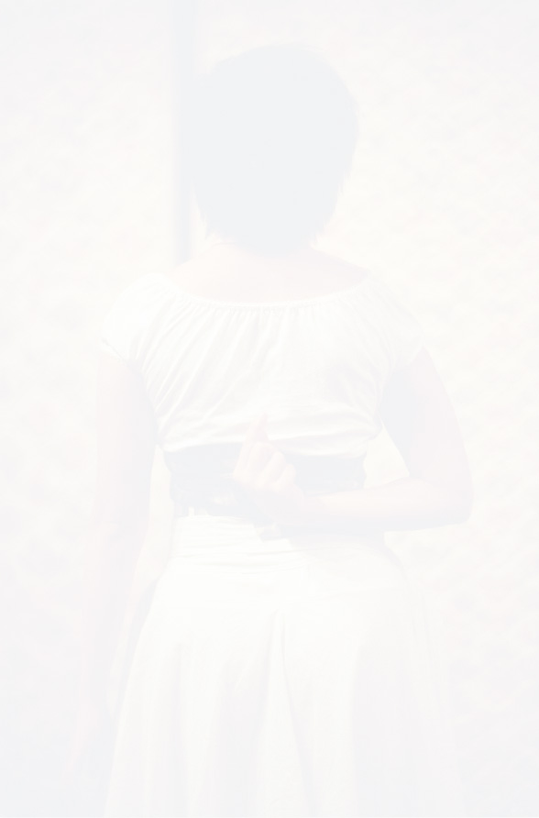

Barthes, Roland (1994 [1985]) The Semiotic Challenge (trans. R. Howard). Berkeley: University of California Press.

Berger, John (2001a) Selected Essays. London: Bloomsbury.

Berger, John (2001b) The Shape of a Pocket. London: Bloomsbury.

Birringer, Johannes (2000) Performance on the Edge: Transformations of Culture. London and New Brunswick, NJ: Athlone Press.

Giannachi, Gabriella and Luckhurst, Mary (eds.) (1999) On Directing: Interviews with Directors. London: Faber and Faber.

Lyotard, Jean-François (1984 [1979]) The Postmodern Condition: A Report on Knowledge (trans. G. Bennington and B. Massumi) Manchester: Manchester University Press.

Ulmer, Gregory L. (1994) Heuretics: The Logic of Invention. London: Johns Hopkins University Press.

