aroundthebend: Two artists are strengthened by the collaborative process

(Presented as a part of the symposium, Practice as Research in Performance, 10 November 2001, at the University of Bristol, by Beatrice Allegranti, choreographer, performer and dance-movement therapist & Ron Hagell, digital artist and filmmaker.)

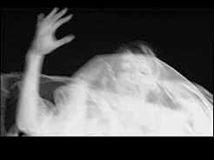 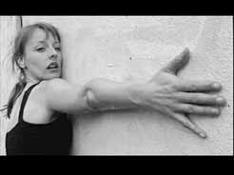 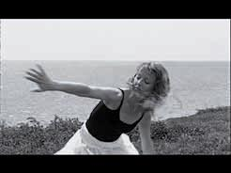 Figure 1

This work, aroundthebend – a film realized on digital video, is a triptych in motion (Figure 1).

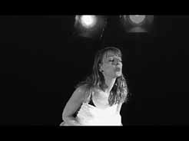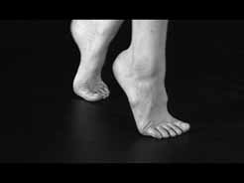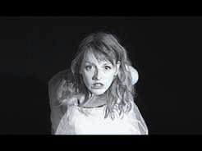
Figure 2

Part 1 makes a specific gender statement (Figure 2).

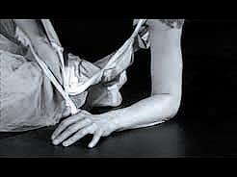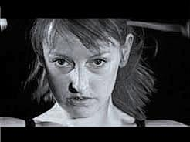
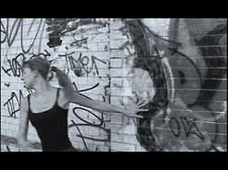
Figure 3

In the transition between Parts 1 and 2 (Figure 3), a definitive response takes shape.

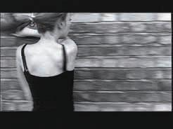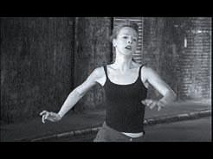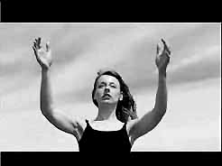
Figure 4 Figure 5 Figure 6

As the film moves through Part 2 (Figure 4 & 5) and into Part 3, responses to the gender statement are made clear. Part 2 is a strong and direct answer while Part 3 provides the dénouement – a classic construction. The film is a journey exploring a women’s relationship with her tutu costumed stereotype leading to an urban combative response and ending in a combination, which suggests a place of rest and resolution (Figure 6).

The choreographer’s practice: Beatrice Allegranti

As a woman and an arts and therapy professional, my ongoing process has been to playfully experimenting with a multiplicity of gendered expressions, rather than operating in restrictive ‘opposing’ categories. Such categories maintain ‘fixed’ notions of gender, which perhaps unwittingly perpetuate disempowerment. This positioning led to the development of a solo, which has become aroundthebend. Specifically, I have researched how components of voice, language and emotional expression unfold from movement improvisation and how these aspects impact on individual expressions of gender. aroundthebend takes this exploration directly into the choreographic and filmmaking process.

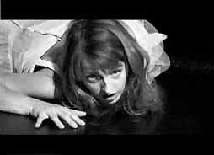
Figure 7

Practice-Based Research – Dance Movement Therapy
This choreographic and performance work is influenced by a specific approach to Dance Movement Therapy (DMT). The basis of this research can be found in; ‘Exploring the Social Construction of Gender through Movement Improvisation’ (Allegranti, 1997). This was a qualitative study where the evolved theory was grounded in practice. My aim was to dissolve a hierarchical approach to inquiry and to co-construct meaning in the context of participants’ experiences. As a result, the change of emphasis was from an observation of, to an interaction with, the social world. The subsequent ‘construction-site’ for knowledge in the research was based around two semi-structured interviews involving nine women and men, following two one-day movement improvisation workshops. The participants’ verbal processing of their movement experiences was the focus of my analysis.

The meanings, co-constructed in conversation, unfolded as themes - performing, observing and playing - with different gender roles. Within these themes the participants felt empowered to shift between positions. The group suggested this allowed a re-scripting of stereotypical gender patterns. In other words, performing a multiplicity of roles rather than remaining within restrictive, opposing categories.

Reflexively, the themes from the research are woven back into my practice, not only in DMT but also in both choreography and performance.

The reflexive practitioner
Continuing the deep interaction between DMT and choreographic/performance process has led me to create a series of professional lab/workshops for actors, dancers and therapists. These include informal ‘showings’, which I call personaltext/publicbody (1999). The workshops feel directly into my role in an academic context (as a trainer of therapists and performers) and a therapeutic context (as supervisor and clinician). They are also a precursor to my continued research with performance.

However, being both performer/choreographer and therapist raises another significant issue. This is, how the therapist ‘holds’ the choreographer in rehearsals and during filming. Perhaps she gives the choreographer permission to stay a little more comfortably in a ‘not-knowing’ space. Anderson and Goolishan (1993), although referring primarily to a linguistic context, also suggest adopting a ‘not-knowing’ approach to practice. The authors recommend thinking of communication as “originating in vague, not yet cognitively-formulated feelings, of ‘sensed movements’ or ‘sensuous repositions’ to which as a recipient they must reply in some way” (Shotter, 1993, p130). What does the dance of ‘sensed movements’ between the personal and ‘confidential’ identity of the therapist and the very public choreographer-performer look like in the same body? I would like to suggest that this is made possible by constantly shifting identities within the same body, by developing the ability to ‘move positions’, mindful of the different intentions that each role carries. Reflexively this has encouraged my practice based research to become research as practice in performance.

What does personaltext/publicbody mean?
As feminist psychotherapist Jocelyn Chaplin (2001) suggests anything which can be read for meaning can be considered as text and to extend this idea further, the body may be suggested as primary text acting as a bridge, between the personal and the public. Personal text communicates what I consider to be a fundamental questions; How do we ‘perform’ gender - in personal life - in public - in the creative process – in performance? The interface between a personal process and the act of bringing it into the public arena is transformative in the way we relate and express ourselves. It is this very interface I am now exploring further through the interplay between verbal and non-verbal exchange and re-presentation of the gendered body through film.

The Film as Text: a thematic reading of aroundthebend
Not unlike the experience of personaltext/bublicbody, the gender dyad underpins the relationship that Ron and I have as filmmaker and choreographer as well as thematically permeating the work. Both of these aspects can best be discussed with examples form the film.

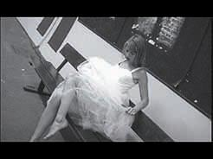
Figure 8

Themes in the choreography and the film
For me, ‘felt experience’ (Gendlin,1962) is a springboard for the choreographic process. This process-oriented approach to creating movement material cannot be pre-determined. So, I held myself in a ‘not-knowing’ place, both in rehearsal and at times in front of the camera, allowing awareness of the strong gender theme in the foreground to unfold at a visceral level. This process may be seen as one where I ‘re-inhabited’ my female body and as Tina Stromstead suggests this requires valuing an “embodied sense of knowing” (2001, p40). So I followed sensory nuances a memory, a feeling, an impulse, a vocalisation, standing next to someone, and the paradox of ‘knowing’ and ‘not-knowing’ all of which became part of the dance.

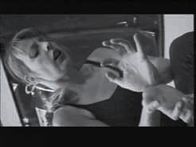
Figure 9

In the choreographic material for the film, one aim was to embrace the range rather than remaining in the polarity, to play with the stereotypes by ‘holding’ the opposites. This was manifest by moving between themes (e.g. submission/domination, joy/sorrow, terror/love, constriction/freedom, birth/death).

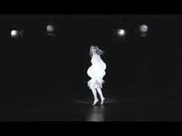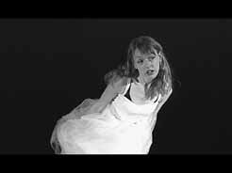
Figure 10

Subversion of gender images
The white tutu became a metaphor for innocence, wedding, spirituality, the ethereal, anti-gravitational woman - feet not touching the ground. These aspects of femininity I considered useful to retain and integrate but not to be dominated by. In the last section, the woman half dressed in the tutu, provokes this question, ‘Is 21st century woman mad to wear the tutu in her life?’.

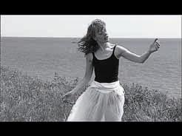
Figure 11

Queen Kong, (Carol Ann Duffy, 2000), was an early inspiration here. The character is a woman larger than life - a woman of distorted size. For me, ‘larger than life’ became a metaphor not only for dominance, but also for a larger than life range of feelings. She is capable of embracing a range, from dominance to vulnerability, rather than remaining in a stereotype.

The wearing of combats becomes a metaphor for her internal struggle. She is fighting to move away from the stereotype, where the woman is literally running for her life, away from fixed notions of gender.

The choreography in aroundthebend presents a relationship to ‘place’ and ‘space’. The woman expresses her discomfort with being in each space, until she reaches the open air/mother nature, which contrasts with her earlier run past a discarded pram on a street corner.

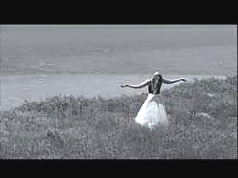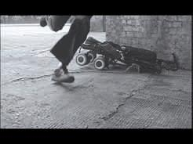
Figure 12

The dance between the female choreographer and the male filmmaker
Acknowledging our positions as gendered rather than neutral was an important step towards a both/and instead of either/or communication. I considered the social construction between Ron and myself and asked, ‘What kind of gender story is created between us and how do we dance together?’.

The key theme, which emerged from our gender dyad, was to observe and be observed. For example, in the relationship between movement expression and camera angle, the camera moves with performer when she is ‘on the run’. As performer, I am (unconsciously) affected and responding to Ron’s dance behind the camera. His dance is invisible to the world but visible to me.

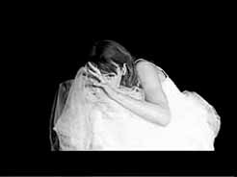
Figure 13

Layered with this is the fe/male gaze. There is a shifting of positions between my (female) gaze and Ron’s male (camera) gaze. There is a change of emphasis at different points in time and, as performer, my responses shift. For example, the woman hiding from the male gaze (part 1) contrasts with the reversed position of a confrontational gaze (part 2) and the overall view of seeing from her point of view (on the cliff edge by the sea in part 3).

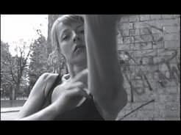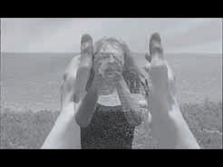
Figure 14

Post-production also involves a form of ‘gaze’. I am involved in the editing process in much the same way as Ron is involved in the movement/dance – production process. As Ron captured and clicked, I now stepped into the role of ‘actively witnessing’ the way the re-presented choreographic images were being arranged. My female presence actively affects the decision-making process whether I indicate my choices or not. On reflection, in both production and post-production, our gendered dance became reciprocal rather than polarised.

The filmmaker’s practice: Ron Hagell

We collaborate as individual artists and the ‘dance’ we do extends beyond the actual shooting phase of the process and into every other aspect as well. There are aspects of the filmmaking process, which are primarily the work of the choreographer and vice versa.

The structural context
As a filmmaker, aroundthebend, is a continuation of my personal work. The content is centred on gender roles as well as power and dysfunction in relationships. In making my films I have used both 16mm and video and apply montage and a fractured narrative form that breaks apart the linear plot line and time structure. These methods interest me because I am able to apply mainstream television or cinema methods with experimental techniques and non-traditional subject matter. It also offers a challenging way to explore my subject or even, as Beatrice suggests, offer pointers toward a re-scripting of gender assumptions or patterns.

Several of the content components of my former work also come together in aroundthebend and are connected to the choreographic content. Among these are: expressions of gender and relationships and references to representations of gender in the cinema and on the stage. Likewise, this film offers the opportunity to develop further my experimentation with variation in temporal juxtaposition, flashbacks, montage, and varieties of fractured narrative forms.

With these objectives, content and method, I have made a number of films. Some have diverged from this central core while others draw a clear line connecting them with this work. The first, Do You Live Here (1989), deals with male violence against women and may be read as simple traditional narrative. However it’s temporally displaced montage also prefigures the film, Watchman (1993), which pushes quite strongly against both objectives – dysfunctional relationship and temporal experimentation – a night watchman in a theatre imagines he is in a relationship with a dancer, which leads to real and/or imagined disaster.

Aroundthebend is a movement/dance film and these are elements central to Watchman as well, where the fact that the main character, through reverie and dream, sees himself as a dancer. I want to work with dance because it and the camera can be such strong allies for creative expression, but also because dance or expressive movement allows me freedom to explore both the temporal structure of filmmaking and a greater range of expressive potential. So, just as Beatrice is, ‘…exploring the social construction of gender through movement.’ I want to place that exploration in a cinematic setting, using the tools of filmmaking, as a central part of what I do.

Within this structure I broadly experiment with performance while applying both the content (gender/relationship) and methodology (e.g. temporal shift) as my objectives.

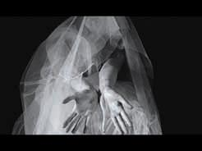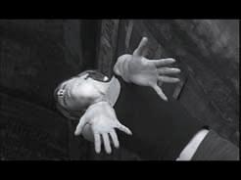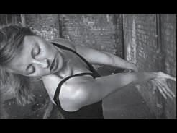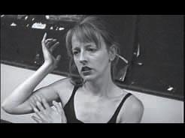
Figure 15

Shooting to edit: an extension of montage and historical reference
The method of delivering meaningful content by use of montage combined with time jumps, owes much to Ralph Rosenblum and other film cutters from the 1960s onwards. Rosenblum introduced the straight cut to flashback in a mathematical sequence while editing Sydney Lumet’s The Pawnbroker (1965). Combining these ideas ( Rosenblum/Karen, 1979 pp.159-166) with my own experience in montage is an important influence here.

What Rosenblum and Lumet gave us is a method of moving fluidly between the present and the past while prefiguring the future. The solo performer – in specific costume and location – offers the perfect opportunity to display and present these ideas.

Taken individually these are not new methods. What we are doing and hope to be communicating is the fact that this combination of ideas points in an interesting direction for both dance/movement and filmmaking while prefiguring both performance and filmmaking collaborative possibilities.

Looking through (and at) the camera
Among the various content issues are the questions of gender and the look or gaze, discussed above. Beatrice and I are gendered and as we examine that fact and question our gaze - as it forms a part of the creation, it in turn informs the work. This fact is also a guide in the work and points us in interesting and challenging new directions for the future. This is actually the most exciting part our collaboration.

From the filmmaker’s perspective we can see two aspects of significance: First, the relationship of camera to individual movement expression and, second, the expansion or deepening of meaning through presentation as choreography and camera meet (Figure 15).

In the relationship between the dance/movement expression and camera angle – the camera moves with performer or it does not – notice the difference between Parts 1 and 2 (Figures 15 &16).

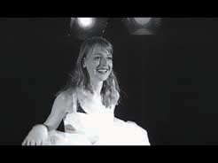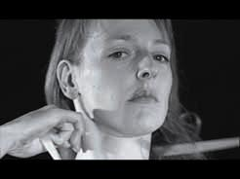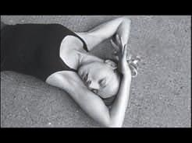
Figure 16

We, the makers, are affected by this factor and it affects this creative act. The performer knows she is being observed and she knows that this observation is being recorded. I am certainly aware of her at the same time. The image being recorded then takes on a third life. Here we might say that this looking is related to Laura Mulvey’s concept of the three ‘looks’ of cinema – camera, characters, and spectator (Mulvey, 1975). In this work the camera look or gaze and that of the actor/dancer is mixed. There is a shift here between the performer’s gaze, which informs this piece – a look out to an imaginary third person, a look to the camera operator or viewer and a look at herself.

There are also references here to documentary as well. In cinema varité, the performer knows the camera is there except in the case of Wiseman’s extended runs, as in High School (1968). Here, in aroundthebend, this woman knows this man is watching her and she also knows that many more men and women will be seeing her. The image is adjusted and a new image is created by this ‘knowing factor’, an ever-present issue in documentary. This affects both the ‘performance’ and the viewing of it. We know it is difficult, standing before the camera, or any audience, and not to have some form of ‘performance’ or for that performance to be affected.

What sort of performance is it we have created here? Granted it is a sort of naturalism from moment-to-moment or role-to-role but it is also related to Brecht (e.g. Figure 17, “I am here taking off my makeup, so what?”).

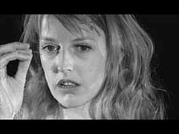
Figure 17

We are not working in any one construct of performance but more with a combination. In fact, this is what the work is about – dance for camera, stylisation, role play, naturalism and expression.

Like wise, some of the directorial decisions and the nature of the cutting add further to this combination and make references to a variety of specific historical or relevant cinema images that are linked to some of the individual roles, choreography or situations being presented. In this way we also see our work as an echo and comment upon the history of gender in cinema. Some of these references are:

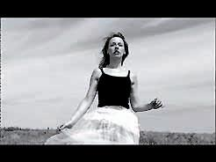
Figure 18

John Ford’s idealised woman from The Searchers (1956) (Figure 18)

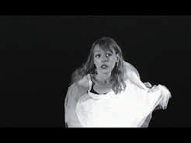
Figure 19

Howard Hawks shoots Monroe in Gentlemen Prefer Blondes (1953) (Figure 19)

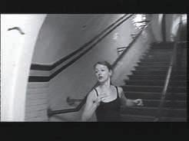
Figure 20

…and of course, the famed stairs cliché and montage, revisited again from Potemkin (1925) or possibly The Untouchables (1987) (Figure 20).

A fusion of collaborative styles
Finally, yet another aspect of this collaboration has to do with my experience in making dance films. A dance film requires that choreography and camera collide to provide a deepening of the experience. Martha Graham was among the first to see that a dancer could use the camera to get at the humanity of a performance in a way that the stage performance could not as in Lamentation (1930/ca.1950 –Tatge/WNET 1994). It’s a simple concept but we still find choreographers lamenting the fact that the camera view of their dancers was not recorded totally, from head to toe, in every frame.

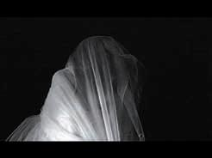
Figure 21
Here Beatrice Allegranti, in aroundthebend (2001), performs an homage to Martha Graham’s Lamentation (1930)

In our collaboration we are committed to the humanity in our work. We feel it is much more important to communicate the expressive quality of what we are about instead of fixed ideas of what movement/dance-on-camera can be. There is passion and communication between us and our intension is to transferred this to our audience. In film/video we seek to express as fully as we can the human content of the performance without preconceived notions of rules for either the choreographer or the camera.

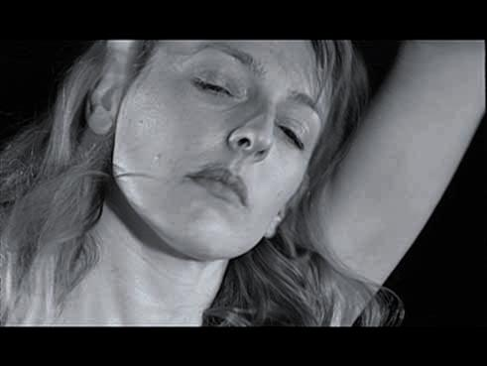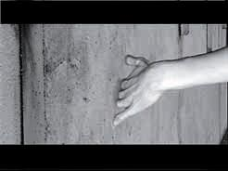
Figure 22

As the mediums collide we find interest and actually our ‘reason for being’. Both in this work and discussions of future work move toward this objective.

REFERENCES
* Subject to availability, copies of aroundthebend may be obtained from R.Hagell@rhul.ac.uk

Allegranti, B. 1997. Exploring the Social Construction of Gender Through Movement Improvisation, Unpublished Masters Manuscript, London: Roehampton Institute

Chaplin, J. 2000. in Feminism and Psychotherapy, Reflection on Contemporary Theory and Practice Heenan, C. and Sell. B (eds) London: Sage

Gendlin, E. I. 1962. Experiencing the Creation of Meaning, New York: Free Press of Glencoe

Mulvey, L. 1975. ‘Visual Pleasure and Narrative Cinema’ Screen 16(3) (Autumn), 6-18

Rosenblum, R & Karen, R. 1979. When the Shooting Stops …the Cutting Begins: A Film Editor’s Story, New York: Viking Press, 159-166

Serlin, I.A. 1996. ‘Body as Text: A Psychological and Cultural Reading’, The Arts in Psychotherapy, 23, no. 2, 141-148

Shotter, J. 1993. Conversational Realities, London: Sage

Stromstead, T. 2001. ‘Re-inhabiting the female body: Authentic Movement as a gateway to transformation’, The Arts in Psychotherapy, 28, no.1, 39-55.

Filmography
Potemkin (1925) Sergei Eisenstein
Gentlemen Prefer Blondes (1953) Howard Hawks
The Searchers (1956) John Ford
The Pawnbroker (1965) Sydney Lumet
The Untouchables (1987) Brian DePalma

Short Films: Ron Hagell
Do You Live Here (1989)
Watchman (1993)
aroundthebend (2001)

Documentary
High School (1968) Frederick Wiseman
Martha Graham: The Dancer Revealed (1994) Dir. Catherine Tatge, WNET/New York, Cameras Continentales, La Sept/Arte, BBC [Note: This is the source of the rare footage (ca. 1950) recorded of Martha Graham’s on-camera performance of Lamentation, a dance premiered in 1930 in New York City]

All photography by Ron Hagell © 2001 bfa/rah All Rights Reserved

