Malaria is preventable and treatable and yet it remains one of the major causes of death worldwide. It threatens the lives of about 40% of the world’s population. There were about 207 million cases of malaria in 2012 and an estimated 627,000 deaths.
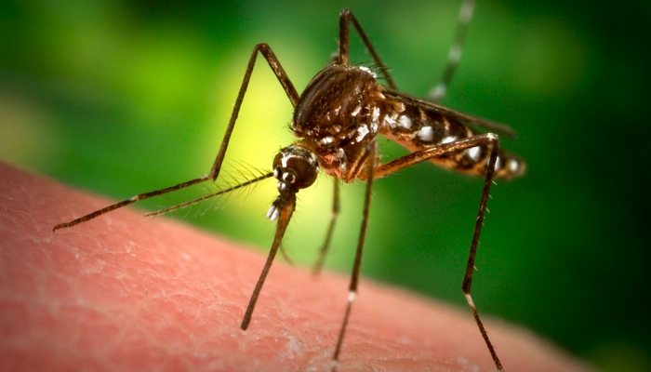

Malaria is a common and dangerous tropical disease caused by the bite of an infected mosquito. The mosquito bites mainly at night time, between dusk to dawn.

There were 1378 cases of malaria imported into the UK in 2012. The proportion (73%) were due to the more severe Plasmodium Falciparum, the majority were acquired in Africa. 70% of UK malaria cases were visiting friends and relatives and the majority had not taken antimalarial tablets or not taken them correctly.

Once you know your specific itinerary please check the following website for malaria maps and advice to ascertain which malaria medication is indicated for your destination: www.fitfortravel.scot.nhs.uk

If Chloroquine and/or Proguanil are recommended for your destination, these can be bought over the counter at any pharmacist and DO NOT require a prescription.

There are some areas in the world where you will have a choice of one or more type of chemoprophylaxis (antimalarial tablets). These will require either a private prescription or you can buy them from a commercial travel clinic (e.g. NOMAD or MASTA). As long as you have no contraindications to any, the choice of what to take is yours.

There is a charge of £14 for any private prescription at Students’ Health Service (SHS) which includes antimalarial prescriptions. The pharmacy will then charge for the tablets, prices vary with each type of malaria tablet. It is therefore in your interest to work out how much you require for your trip and then to shop around at various pharmacies to find the best price.

If you wish to acquire your prescription at SHS, please state you require a ‘malaria prescription’ when booking your appointment, so you can be booked with the appropriate person.
It is useful if you can research:

- Which antimalarial tablet you might want to take
- How long you are in the risk area for

Otherwise you are encouraged to book into a commercial travel clinic for further advice.

Counterfeit Medication Overseas
Wherever possible, you are advised to take sufficient supply of antimalarials with you for the duration of your trip. Counterfeit (fake) medications are an ongoing problem, with drugs bought by tourists often targeted (antimalarials, antibiotics), with estimates of >30% of medications on sale in parts of Africa, Asia and Latin America being counterfeit. They may be harmful or toxic or indeed have little or no active ingredient.
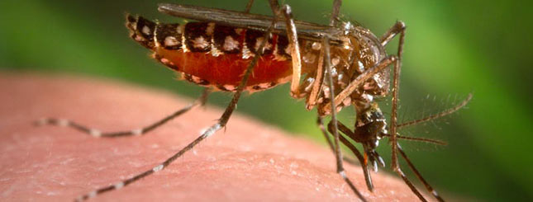

Mefloquine (Larium) has protective efficacy of approximately 90%, although there is significant resistance in some areas of South-East Asia
Contra-  indications | - History of convulsions (ever)  - Epilepsy  - Current or history of psychiatric disorders, eg depression  - Severe impairment of liver function  - Caution in pregnancy  - Women of child bearing age should take reliable contraceptive precautions for the entire duration of therapy and for 3 months after  - Severe hypersensitivity to Mefloquine or related compounds, eg quinine  - Infants less than 3 months old or weighing less than 5kg  - History of Cardiac Conduction Disorders
Drug  Interactions | Not to be taken with Digoxin, Beta Blockers, Calcium, Channel Blockers, Amiodarone, Rifampicin, Moxifloxacin
Dose | The dose of Mefloquine is 250mg (1 tablet) weekly.  If never taken before, it should be started 3 weeks before entering the malarial area (2 weeks before if taken previously), throughout exposure and for 4 weeks upon leaving the infected area.  Mefloquine is licensed for up to 1 year.
Potential  Side  Effects | Despite much media attention on them, major adverse events (convulsions, hallucinations and psychotic disturbances, anxiety and depression) are rare. More common minor side effects include:  - Dizziness  - Vivid Dreams  - Insomnia  - Headaches  - Diarrhoea  - Nausea and Vomiting  - Fatigue  If these happen to you, please discuss the symptoms further with a Nurse or Doctor if you are concerned.

Doxycycline has protective efficacy of approximately 90%
Contra-  indications |  | - Allergy to Tetracyclines  - Pregnancy  - Breastfeeding  - Children under the age of 12 years  - Caution in hepatic impairment and persons taking hepatotoxic drugs  - Persons with Systemic Lupus Erythematosis and Myasthenia Gravis  - Renal impairment  - Acute Porphyria
Dose |  | Daily capsule (100mg) taken 2 days before entering the malarial area, throughout exposure and for 4 weeks upon leaving the infected area.  Doxycycline can be used for up to 2 years
Drug Interactions |  | Check with your Travel Nurse or Doctor
Potential  Side  Effects |  | To minimise side effects of heartburn, Doxycycline must be taken after meals (preferably after breakfast) with large amounts of fluid.  Do not lie down immediately after taking the tablet (within ½ hour).  Other side effects include:  - Nausea, vomiting and diarrhoea.  - Skin photosensitivity.  Rarely, Doxycycline may cause photosensivity, manifested by a rash on sun exposed areas of the body, which is mostly mild and transient. The risk of this occurring can be reduced by avoiding prolonged direct exposure to sun and using high factor sunscreens.  - Doxycycline may cause thrush among female travellers, so it maybe advisable to take treatment with you which can be bought over-the-counter at a pharmacy here in the UK.
Atovaquone plus Proguanil (Malarone) has efficacy against Plasmodium Falciparum in excess of 90%
Contra-  indications | - Pregnancy  - Breastfeeding (unless no suitable alternative)  - Caution in renal impairment  - Severe diarrhoea and vomiting (can reduce absorption of atovaquone)  - Should not be taken with Rifampicin or Rifabutin, Tetracyclines or Metoclopramide  - Proguanil can delay the metabolism of Warfarin
Dose | Daily tablet (250mg Atovaquone plus 100mg Proguanil)  Started 1-2 days before entering the malarial area, throughout exposure and for 7 days upon leaving the infected area.  Malarone is licensed to be used for 28 days however it can be used for up to 1 year with caution.
Potential  Side  Effects | Abdominal pain, nausea, vomiting, diarrhoea, cough, headache, dizziness, rash, mouth ulcers, insomnia, loss of appetite
It is important to be aware that malaria chemoprophylaxis is not 100% effective.

The 4 main principles of malaria prevention are follows:

- Awareness of risk
- Bite prevention
- Chemoprophylaxis
- Prompt Diagnosis and treatment

A. AWARENESS of risk – All travellers to malarial areas must be made aware of the malarial risk, no matter how small. The mosquito bites mainly between dusk to dawn and therefore travellers are exposed to higher risks of being bitten if they participate in outdoor activities at night or if their living accommodation – whether room, hut or tent – is unscreened and non air-conditioned. However, Yellow Fever and Dengue Fever diseases are spread by mosquitoes which tend to bite during daylight hours, so bite prevention is advised during this time in areas of risk.
B. BITE prevention – The mosquito tends to bite where skin is close to bone e.g. ankles, shins, knees, elbows, arms, hands, jaw line, cheekbones, temples and behind the ears.
1) Apply insect repellent containing N,N-diethyl-m-toluamide (DEET) – available in lotions, sprays or roll-on formulations to exposed skin and apply on top of sunscreen. DEET concentrations need to be more than 20% (up 50% DEET repellents are available to apply on exposed skin) stronger concentrations can be used on clothing. Reapply as necessary especially after swimming or sweating. Different concentrations last varying lengths of time- the higher the concentration, the longer duration of action, therefore check and follow instructions on the packet.
2) Screening of windows and doors reduces exposure to flying insects. Air-conditioned rooms are considered ‘sealed’ and is a highly effective means to keeping mosquitoes out of a room. Knockdown (insecticide) sprays used before going to bed will kill any mosquitoes in the room. These should be sprayed preferably one hour before going to bed. If possible, sleep in a properly screened room.
3) If you are not able to sleep in a screened room, you should sleep under an undamaged mosquito net with mesh size no larger than 1.5mm, which has been impregnated with insecticide (such as permethrin). Net treatment kits are available from camping shops or travel stores.
An insecticide treated net (ITN) will reduce your chance of being bitten through the net considerably. Check the net every day for holes – you can easily tear the net during the night. It is advisable to take a small sewing kit and repair any holes discovered.
To prevent any mosquitoes entering the net, care should be taken to make sure that the net hits the floor around the bed or tucks under the mattress, ensuring it doesn’t touch your skin.
4) Wear loose fitting, long sleeved clothing and trousers and socks, especially if outdoors after dusk. Apply DEET onto your clothes for maximum protection.
5) “Mozzie Zapper” – an electric mat may be used to vaporise synthetic pyrethroids (remember you will require electricity for this) or mosquito coils may be burned overnight. These are very useful for travellers staying in unscreened accommodation.
6) Avoid staying near stagnant/standing water.
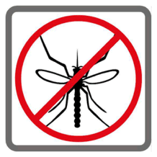
Electric buzzers,
garlic and
vitamin B are
ineffective

C. CHEMOPROPHYLAXIS – Not all insect-borne diseases are preventable with medication or immunisations and it is worth remembering that no prophylaxis can be 100% effective. Therefore strict adherence to Bite Prevention is strongly recommended along with compliance with taking your chemoprophylaxis.
The medication or immunisations you are advised may vary depending on which areas you are travelling to. For malaria chemoprophylaxis to be effective, the following is important:-
1) They must be started before entering the malarial area to ensure you have no side effects before you travel.
2) You must take the medication ALL the time you are in the malarial area AND continue the treatment for 4 weeks after leaving the malarial area (one week for Malarone)

3) Ensure you receive your immunisations for vaccine preventable diseases i.e. Yellow Fever, Japanese Encephalitis within adequate time before you travel.

D. Prompt DIAGNOSIS and treatment – The minimum incubation period between a bite by an infected mosquito and development of clinical symptoms of malaria is 7 days to 6 months for P. falciparum, whereas relapses of P. vivax and P. ovale can appear months, and rarely years (as long as 4 years) after exposure.

Suspected malaria is a medical emergency. Immediate medical advice should be sought for any ‘flu-like’ illness (fever, chills, sweating, shivering, headache, vomiting, fatigue, nausea, muscle pains, mild diarrhoea) that occurs while you are away and up to 12 months after returning home. Be especially careful within 3 months of returning from an endemic area, even if all recommended precautions have been taken. Most other insect-borne diseases have similar ‘flu-like’ symptoms.
Here are some useful links with more information

Malaria
http://www.malariahotspots.co.uk
http://www.who.int/topics/malaria/en

Yellow fever
http://www.nathnac.org/pro/documents/YFvaccineinfofortravellers.pdf.

Dengue Fever
http://www.nathnac.org/travel/factsheets/denguefever.htm.

Japanese Encephalitis
http://www.nathnac.org/travel/factsheets/japanese_enc.htm
