Global Insecurities Centre
School of Sociology, Politics and International Studies (SPAIS)
University of Bristol
Report for School Review, May 2013

Introduction
Established in 2009, the Global Insecurities Centre (GIC) conducts research on the emergent insecurities of our complex and interconnected world. Our work is multifaceted and interdisciplinary, with a focus on the uneven and contested nature of contemporary insecurities, the political consequences of the uncertainty this engenders, and the often emergent and bottom-up
nature of our responses to them. In this way, we emphasise a complex picture of multiple actors in dialogue with the insecurities that face them, and the opportunities for positive transformation and change that such circumstances present.  The Centre is currently undergoing a process of reconfiguration under its new director, Professor Timothy  Edmunds. Building on our existing strengths, our aim is to | 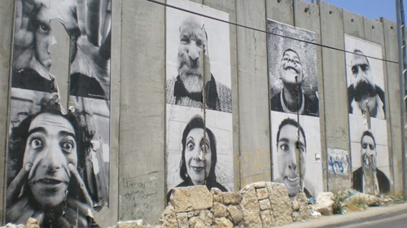
invigorate the collective research activity of GIC colleagues within the School and to significantly increase our profile and impact in the wider field. The GIC is characterised by:
- A vibrant research community, comprising academic staff, postdoctoral researchers and PhD students.
- Interdisciplinary scholarship, drawing on security studies, international relations, development studies, sociology and politics.
- Theoretical diversity, fostering conversations between colleagues working in traditions of constructivism, feminist political theory, historiography, institutionalism, post-structuralism and subaltern realism.
- Wide-ranging area studies expertise, including Latin America, South Asia, South East Asia, Sub-Saharan Africa and the Western Balkans.
- Critical impact and networking with policy makers and other stakeholder groups.
- Cross-disciplinary networking with the natural sciences and engineering. Research–led teaching in MSc’s on International Security, Development and Secuirty and across the SPAIS teaching programme as a whole.

Within this framework, the work of the Centre is organised around four overlapping research themes:
- Theorising Insecurity (Evans, Herring, Michel, Pelopidas, Weldes, Zhang)
- Insecurity Governance (Christie, Edmunds, Herring, Higate, Juncos, Zhang)
- Conflict, Insecurity and Development (Christie, Duffield, Evans Flint, Gainsborough, Herring, Hewitt, Payne, Tucker, Wyatt)
- Risk, Resilience and Technology (Downer, Edmunds, Pelopidas, Peoples, Weldes)

Our research themes provide a focused sense of intellectual purpose for research and collaboration amongst colleagues working on a range of different global insecurities, and are discussed in further detail below. Our work is united by the following common features which are present across all four themes:

Insecurities and security: We foreground the politics of insecurity in our work. In so doing, we focus our attention on the diverse and complex insecurities which characterise the emergent global order and the adaptive and often contested nature of local responses to them, rather than understanding the quest for ‘security’ in and of itself as a panacea for global ill.

Criticality and engagement: Much of our work is critical of mainstream orthodoxies in security studies, in so far as we shift away from narrow understandings of the security of the state or top-down approaches to security governance. Even so, we remain committed to engaged scholarship with an impact in the real world and maintain ongoing dialogue with policy makers, the general public and other stakeholders.  Agency and transformation: We believe that addressing global insecurities is as much a political endeavour as it is a strategic, economic or technocratic challenge. To this end, we are concerned to uncover opportunities for agency and positive transformation in the insecurities we examine, in order that people can better live in dignity, safety and prosperity.  Bridging disciplinary divides: As well as drawing on distinct | 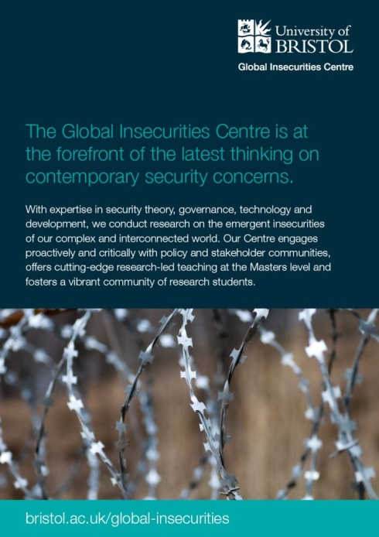
disciplinary traditions within the social sciences, we work closely with colleagues from the natural sciences and engineering. We employ science-derived approaches such as complex systems theory in our own research and contribute sociological and political perspectives to the work of colleagues in Earth Sciences, Engineering and elsewhere.

Key objectives 2013-2016
- To continue to carry out critically-informed research of the highest quality, and to ensure that our work is disseminated widely.
- To increase the proportion of this work that is externally funded, prioritising research council funding.
- To contribute strongly to the SPAIS submission to the 2014 REF and to consolidate and develop these strengths for subsequent reviews.
- To increase the impact of our work amongst stakeholder communities, including policy-makers, practitioners and the general public.
- To establish Bristol as a national and international reference point for critically-informed security research.

Strategies to achieve these goals
- The centre will continue to foster a vibrant, engaged and collegiate research community and atmosphere amongst our members, the aim of which is to encourage close knowledge of each other’s work, regular intellectual exchange and a habit of research collaboration around areas of mutual interest. We will do so through our programme of research seminars, visiting speakers and other events, as well regular formal and informal meetings of the centre working groups.

- The centre will continue to build links across disciplinary boundaries, with the sciences and elsewhere. We will do so through our active proactive engagement in cross-disciplinary fora such as the Cabot Institute and Institute for Advanced Studies (IAS). These links allow us to exploit research strengths elsewhere in the university in our own work, as well as to bring a GIC voice to research being conducted by others. In so doing we expect to create further opportunities for cross-disciplinary research collaboration, including large grant applications.
- The centre will support long term research collaborations by colleagues, with an emphasis on capacity-building for major grant applications. We will do so by encouraging pump priming initiatives such as expert workshops and pilot projects which will develop early research proposals and consolidate disciplinary and cross-disciplinary networks for subsequent funding bids. Examples include our foreign policy workshop and proposed civil-military nuclear distinctions project discussed below.  - The centre will continue to cultivate links with research collaborators from other institutions, including the Freeman Spogli Institute at Stanford University, the Centre for Science and Security Studies at King’s College London and the Committee on Global Thought at Columbia University.  - The centre will bring the best and most exciting scholars working on issues global insecurities to Bristol through our speaker programme, through GIC events and workshops and through visiting fellowships. In so doing, we will draw external attention to the scholarship taking place under the auspices of the GIC, engage a wider group of scholars in our collective intellectual conversation, and foster durable research networks which can be drawn on for future grant applications.  - We will disseminate our work proactively at national and | 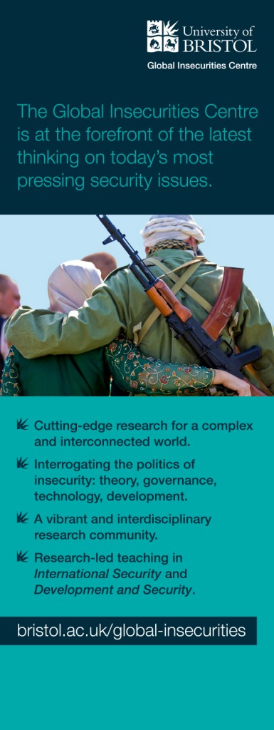
international conferences, seminar series and workshops, as well as continuing to publish in top-ranking peer-review journals and with academic publishers. The centre is also planning to edit a number of special issues of prestigious journals (International Affairs confirmed, Security Studies and Security Dialogue under discussion) to showcase our research agenda and emerging scholarly networks.

- The centre will encourage activities that disseminate our work with policy-makers, practitioners and the general public. Our work is of pressing interest to these communities and we already incorporate a variety of stakeholder engagement strategies in our current projects, as discussed below. We will work to consolidate and strengthen these relationships through applications to initiatives such as the ESRC Seminar Series to support policy workshops, through collaborative activities with the Bristol Military Education Committee (of which Edmunds is chair) and by working closely with the Faculty of Social Sciences and Law’s PolicyBristol initiative.

- The centre will compete for the editorship of an appropriate peer-review journal when the opportunity arises. Target journals include Security Dialogue, The Journal of Intervention and Statebuilding and Globalizations. Bringing a journal to Bristol will help to establish the GIC as a locus of attention in the discipline, and provide a forum through which we can develop and articulate a GIC ‘voice’ within this.
- In due course (2014-15) we are planning to position ourselves to bid for an ESRC Centre Grant to support the work of the GIC over the longer term and establish Bristol as an international focal point for research into contemporary global insecurities.  Staffing  The formation of the GIC permitted new strategic appointments to enhance our existing staff strengths (Peoples and Michel). A further expansion of GIC capacity accompanied the appointment of Edmunds as Director in 2012 (Downer, Evans, Payne, Pelopidas and Tucker). The GIC now comprises:  - 16 core funded (Pathway 1) staff (Christie, Downer, Edmunds, Evans, Flint, Gainsborough Herring, | 
Hewitt, Higate, Juncos, Michel, Pelopidas, Peoples Weldes, Wyatt, Zhang).
- 2 fixed term pathway 2 appointments (Payne, Tucker).
- 1 postdoctoral researcher (Kunz), 2 affiliated members (Duffield as professor emeritus, Jacobsen as research associate).
- 12 affiliated research students, including 1 funded GIC studentship (Faria).
- The GIC is allocated three hours of administrative support per week (Hemings).

Organisation and activities
Professor Tim Edmunds was appointed director of the GIC in September 2012 following the retirement of the GIC’s founding director, Professor Mark Duffield. Edmunds is responsible for the strategic direction of the GIC, management of the budget, coordination of the research themes, liaison with the wider university and other research centres, and organisation of Centre activities over the year. He is supported in these tasks by Dr Eric Herring, the deputy director. The centre meets collectively at least once each semester to discuss our research strategy and future plans. In addition, colleagues in our research themes meet together regularly, often in informal settings, to discuss future projects and to read and comment on each other’s’ work.

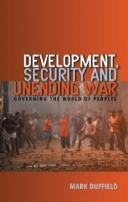 |  | 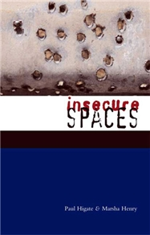 | 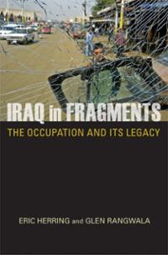 | 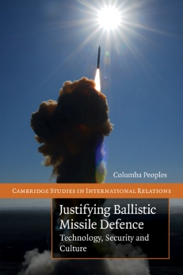

The GIC has had considerable grant success since its formation, with the award of over £832,000 in research funding, including a £157,704 ESRC grant on Transforming Insecurity through Non-Violent Grassroots Networks (awarded subject to satisfactory submission of full proposal), a £359,556 ESRC-DFID grant on Risk Management and Aid Culture in Sudan and Afghanistan (Duffield) and a £240,500 RCUK fellowship on Mercenary Masculinities Imagine Security (Higate). Over the current REF period, GIC members have published 19 authored or edited books, 76 articles in peer review journals and many more book chapters and other publications. GIC colleagues are active in a wide range of international research networks, including the British International Studies Association (BISA), Development Studies Association (DSA), Inter-University Seminar on Armed Forces and Society (IUS), Folke Bernadotte Academy Working Group on Security Sector Reform, International Network of Emergent Nuclear Specialists (INENS), International Studies Association (ISA) and Political Studies Association (PSA) amongst others.

In addition, and since the appointment of Edmunds September 2012, the GIC has:
- Instituted a speaker series, holding nine research seminars or public lectures in 2012-13.
- Established working groups under each of our themes to formulate specific collaborations, plan concrete activities and advance our own intellectual conversations.
- Created a new website, including regular blogs and commentary and a working paper series.
- Held a ‘New Security Futures’ public roundtable as part of the University of Bristol’s Festival of Social Sciences and Law in October 2012.
- Secured a Benjamin Meaker professorial fellowship from the Institute for Advanced Studies (IAS) to bring Professor Julian Reid (Lapland) to Bristol to work with Evans (£4800).
- Secured a GIC PhD studentship funded by University of Bristol alumni donations (£74,484).
- Led the engagement of the social sciences with other faculties and centres in the university, including with the Cabot Institute (on the Anthropocene), with the Nuclear Research Group (on nuclear insecurities), with the Institute for Advanced Studies (on futures); with the Systems Centre (on complexity) and with the Bristol Security Centre (on cyber-security), with the VUELCO project (natural hazards and risk).
- Held a half-day ‘sandpit’ event with colleagues from the Centre for Science and Security Studies (CSSS) at King’s College London to discuss future research collaboration (May 2013).
- Will have organised two policy workshops (on private security at the RUSI in September 2012 and on British Foreign Policy at Chatham House in July 2013).
- Expect to have applied for over £1,000,000 in new research funding by the end of the academic year (£736,484 applied for by March 2013, £88,500 pending, £243,988 awarded).

Recent and Current Work
The GIC is engaged in a wide range of on-going and developing research activities which take place across each of our research themes:

Theorising Insecurity
The GIC is home to the Histories of Violence project, an internationally celebrated online resource centre that provides innovative educational ways for dealing with the problem of violence. Since its launch by Evans in September 2011, the project has enjoyed over 120,000 hits from a user base that covers 129 different | 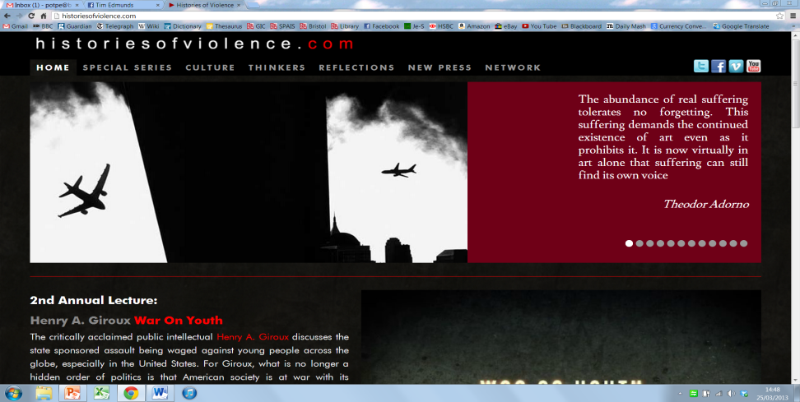
countries. The project features a number of critically acclaimed sections, including its special series on Ten Years of Terror which enjoyed 10 days dedicated video coverage on the Guardian’s Comment is Free website. An edited film from this footage was also screened in a number of prominent cultural centres, including the Solomon K. Guggenheim Museum in New York during the 10th anniversary of 9/11. The GIC (under Evans) has also been awarded a Benjamin Meaker Professorial Fellowship from the Institute for Advanced Studies (IAS) to bring Professor Julian Reid from the University of Lapland to Bristol for three months in 2014 (£4800). Reid and Evans will work together on a joint research project on Complexity, Resilience and Catastrophic Futures, which will ask the question of what it means to ‘live dangerously’, and consider the implications of this for approaches to security and insecurity. Reid’s visit will facilitate a number of GIC events, including two public lectures, a research seminar and a teaching contribution to our MSc unit on Liberalism, Terror and the Politics of Insecurity.

Governing Insecurity
The GIC is at the forefront of current academic and policy debates about the future of UK foreign policy and the politics of insecurity. We are concerned to bring more critical perspectives to foreign policy analysis and strategic studies, particularly with regard to the complex, contested and emergent nature of national interest and policy formation and to understanding the diversity of challenges the new insecurities pose for societies and states. The GIC under Edmunds will hold a conference on British Foreign Policy and the National Interest in London on 12 July 2013, which will bring together key academics | 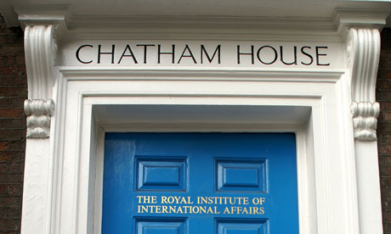
and policy makers to reflect on these issues (including Edmunds, Herring, Pelopias and Weldes from the GIC). The workshop is funded by the University of Bristol through the GIC (£4450) and with additional support (venue and facilities free of charge) from Chatham House and will lead to a special issue of the journal International Affairs in March 2014. The GIC (under Edmunds) has also applied to the ESRC seminar series to run a series of workshops on the future of British Defence (£21,623) in collaboration with colleagues from King’s College London and the University of Birmingham. The seminars will involve contributions from GIC members including Christie, Edmunds, Higate, Juncos, Pelopidas, Peoples and Weldes as well as extensive user engagement from policy makers and practitioners. Finally, the GIC (under Edmunds) is leading an application to the ESRC standard grants scheme (£500,000) on UK Grand Strategy: Complexity, Emergence and Policy for a four year project which applies insights from complexity theory to national strategy making.

The GIC is leading the field in its work on private security. Under Higate with Kunz, it has recently completed a £240,500 ESRC/AHRC Global Uncertainties research fellowship on Mercenary Masculinities Imagine Security: the Case of the Private Military Contractor. This research explores contractor identity and what this tells us about how security is understood and practiced in the role of the armed close protection officer. The findings point to the importance of previous military background, national identity and situational context for the ways in which identities are played out through different approaches to security. Here the binary of 'high' versus 'low profile' was quickly established as the chief organising category for professional versus professional approaches to security work. In turn these tended to be configured along a parallel binary of U.S versus British contractors often positioned in regard to the ways that host populations might see contractors. The research engaged closely with practitioners and policy-makers throughout, including a major two-day expert workshop at the Royal United Services Institute (RUSI) in Whitehall.

Conflict, insecurity and Development
The GIC has led critical academic engagement with the development and security agenda. It has recently completed a £359,556 ESRC-DFID funded project (under Duffield) on Risk Management and Aid Culture in Sudan and Afghanistan. This research investigated how perceptions of threat and actual risk-management practices by UN agencies and international NGOs challenge their ability to
achieve key programme aims in fragile states. The research included numerous in-depth and semi-structured interviews, together with extensive participant observation, among UN agencies, donor representatives, International NGOs, local NGOs and security contractors. Research outputs include journal articles and conference papers, a synthesis Policy Review published and disseminated through the ODI network, and an interactive Workshop Framework, which was piloted in Afghanistan, and is designed to help agencies explore the issue of risk | 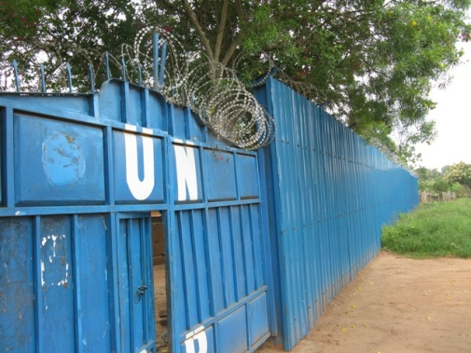
and security.

The GIC is advancing new thinking on insecurity and development through a project on Transforming Insecurity through Non-Violent Grassroots Networks (under Herring with Weldes). The project was chosen for funding under the ESRC Transforming Social Sciences initiative after two rounds of competitive selection, for £157,704. The research will examine how non-violent grassroots networks are exploiting hyperconnectivity (widespread internet access, mobile phone technology and social networking) to innovate, lesson learn and mitigate insecurity. This is in contrast to much work in mainstream security studies which tends to view hyperconnectivity as a security challenge through issues such as terrorism. The project examines three cases of viral innovation by distributed networks in relation to neighbourhood watch schemes to prevent suicide bombings in Somalia, ‘every casualty counts’ reporting, and initiatives to prevent the street harassment of women in the Global North and South. It will also act to support such strategic innovation through knowledge brokering and sharing best practice.

The GIC is also exploring themes of hyperconnectivity in its research on beneficiary-led aid. Under Flint and Payne, and in partnership with development practitioners MZN International, this project considers the impact of crowd-sourced information in order to better facilitate practical and meaningful forms of beneficiary-led aid. In the wake of initiatives like Mission 4636 in post-earthquake Haiti, and the Kibera Mapping Project in Kenya, ICT4D projects (information and communications technology for development) the research examines the potential of harnessing the ‘wisdom of crowds’ through the use of network technology and ‘big data’ analysis to speed up decision making, increase efficiency and democratise the delivery of aid ‘on the ground’.

Risk, Resilience and Technology
The GIC is fast emerging as a leading hub for innovative research on risk, resilience and technology. The centre established a Nuclear Insecurities Working Group (NIWG) in December 2012, which meets regularly to discuss draft papers contributed by members and is currently working on three
collaborative research projects. The first of these, on Assessing the South West’s Nuclear Futures and Legacies argues that the South West region provides a microcosm for the UK’s nuclear futures and legacies. The project (under Peoples, with Downer, Edmunds, Pelopidas and Weldes) examines the nuclear futures and legacies are envisaged by the various stakeholder communities involved in these decisions. The project is currently being considered for funding (£25k) by University of Bristol Alumni.

The NIWG also organising a retrospective workshop on the Cuban Missile crisis, which will focus on ‘subaltern’ constructions of nuclear risk from non-US stakeholders, including Turkey, Germany and other contemporary nuclear states. It builds on the work of GIC colleagues on the historiography of nuclear deterrence (Pelopidas) and the construction of nuclear threat (Weldes). The proposal is currently being considered by the International Network of Emergent Nuclear Specialists (INENS) for
funding (£5897). We are also in negotiation with the leading peer review journal Security Studies for a special issue on this theme. Finally, the group is preparing a bid to the University Strategic Research Initiatives Scheme (USRIS) on The Civil-Military Nuclear Distinction: Theory, Practice and Political Effects for £2500. This initiative will comprise a cross-disciplinary expert workshop the aim of which is twofold: First, to open a critical dialogue on how, in the light of shared nuclear materials, science and technology, the distinction between ‘civil’ and ‘military’ uses of nuclear | 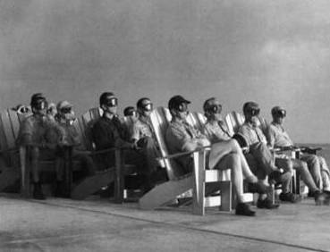
power has been constructed, institutionalised and maintained over time; second, to inform a larger and more ambitious grant application on the same theme for 2014-15.

The GIC is taking the lead in engaging across University faculties and disciplines in other ways too. Christie is the primary social science researcher on a €4 million, multi-institution EU Framework 7 project, led by Earth Sciences at Bristol on Volcanic Unrest in Europe and Latin American Countries (VUELCO). Christie has conducted extensive fieldwork amongst communities at risk from volcanic activity in Ecuador, exploring the ways in which volcanic risk is judged alongside other insecurities and how this may impact on risk communication and disaster management strategies, with the direct impact that the Instituto Geofisico in Equador is now revising its policies in these areas. Christie is also organising a workshop on Protocols Governing Volconology to examine the changing legal and ethical responsibilities of the scientific community on issues related to volcanic risks and society. The workshop will bring key social science perspectives to what has previously been a technical and hard science-led research endeavour and feed directly into the draft of a new European protocol on these themes.

GIC Speakers and Seminars
The GIC has hosted the following speakers and seminars in 2012-13:
- ‘Palestine and Israel: What Next? A Discussion with OneVoice’, GIC Israel-Palestine research group seminar, 18 October 2012.
- Dr Rahel Kunz (University of Bristol), ‘When International Gender Norms Travel: Gender Mainstreaming in Security Sector Reform’, GIC Research Seminar, 28 November 2012.
- Barry Gilder (Mapungubwe Institute for Strategic Reflection’, ‘South Africa: The Transition from Liberation Movement to Democratic Government’, GIC Research Seminar, 29 November 2012.
- Professor Paul Rogers (University of Bradford), ‘Lost Cause: Consequences and Implications of the Global War on Terror and its Wider Significance for Global Insecurities’, GIC Public Lecture, 10 December 2012.
- Dr Benoit Pelopidas (University of Bristol), ‘Innovation in Nuclear Thinking: Incompetent, Dangerous or Futile?’, GIC Research Seminar, 12 December 2012.
- Dr Shane Brighton (University of Sussex), ‘Dark Skin, Bright Future? British Grand Strategy as Postcolonial Politics, GIC Research Seminar, 21 February 2013.
- Dr Lise Storm (University of Exeter), ‘The Arab Spring: Parties and Prospects for Democracy in the Maghreb', GIC Research Seminar, 14 March 2013.
- Dr Mary Manjikian (Robertson School of Government/Durham University), ‘Do Drones have Gender? Militarised Masculinity and the Emergence of New Technologies’, GIC Public Lecture, 22 March 2014.
- Dr Ruth Jacobsen (University of Bristol), ‘Women and War’, GIC Book Launch, 24 April 2013.

GIC working papers and reports, 2012-13
- John Downer, Nuclear Safety: A (Charlie) Brownian Notion, July 2012.
- Christina Rowley and Jutta Weldes, The Evolution of International Security Studies and the Everyday: Suggestions from the Buffyverse, November 2012.
- Columba Peoples, New Nuclear, New Security? Framing Security in the Policy Case for New Nuclear Power in the United Kingdom, February 2013.
- Paul Higate, The Politics of Profile and the Private Military and Security Contractor, March 2013.

Professor Timothy Edmunds
May 2013

