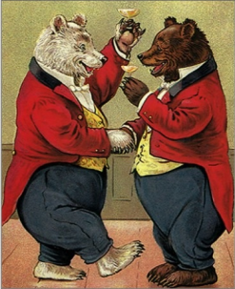

One-Day Conference
‘Public Drinking in the Nineteenth Century’
Centre for Romantic and Victorian Studies
Clifton Hill House, University of Bristol
Saturday 22 February 2014
Registration

First name:

Surname:

University/Institution:

e-mail address:

(please tick if you do not want your e-mail address to be included in the list of participants)

Telephone number:

Twitter Account:
(follow us on @UoBrisDrinkConf)

Dietary requirements: Y/N (please circle, or delete as appropriate)
If Yes, please specify:

Are you planning to attend the informal dinner* on the evening of 22nd February 2014?
Y/N (please circle, or delete as appropriate)
(*not included in conference fees)

Please e-mail registration form to Pam Lock (pam.lock@bristol.ac.uk).

Payment of delegate fees (£30 full delegate fee, £15 student/unwaged delegate fee) should be made online via the link on the conference website frontpage.

Tea/coffee and lunch will be provided as part of the conference delegate price.

